Supplementary Material: Persistent overcut regions dominate the terminus morphology of a rapidly melting tidewater glacier
Nicole ABIB¹, David A. SUTHERLAND¹, Jason M. AMUNDSON², Dan DUNCAN³, Emily EIDAM⁴, Rebecca H. JACKSON⁵, Christian KIENHOLZ², Mathieu MORLIGHEM⁷, Roman J. MOTYKA⁸, Jonathan D. NASH⁴, Bridget OVALL⁵, Erin C. PETTIT⁴

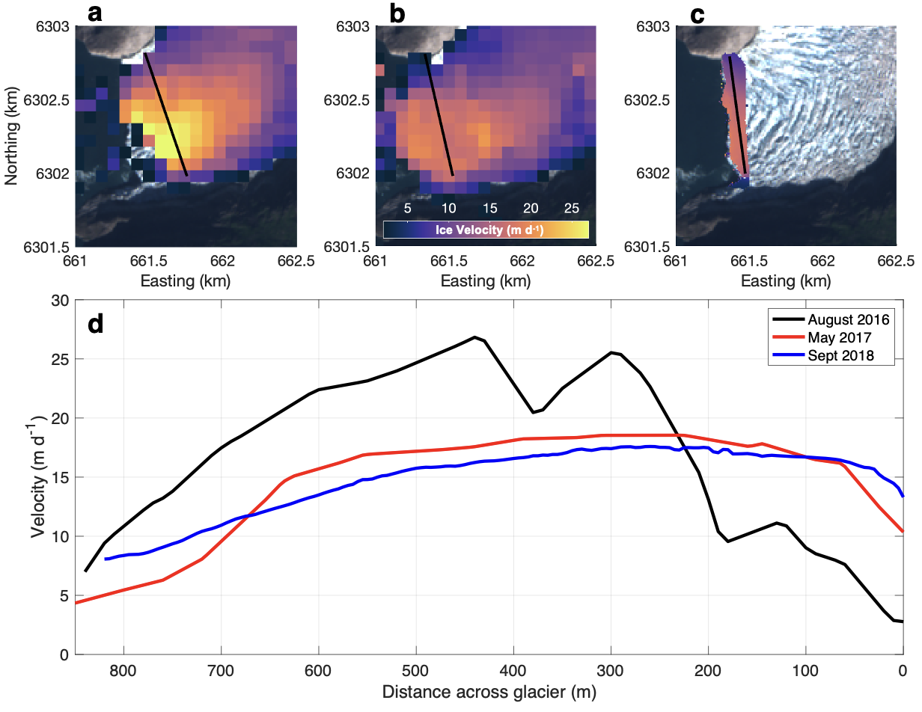
Figure S1. Campaign averaged ice velocity fields derived using the Terrestrial Radar Interferometer in August 2016 (a) and May 2017 (b) and drone imagery in September 2018 (c) with the reference transect superimposed (black line). For frontal ablation calculations, ice velocities were extracted across a transect that was as close to the terminus as possible while still capturing a complete across-glacier profile (d).
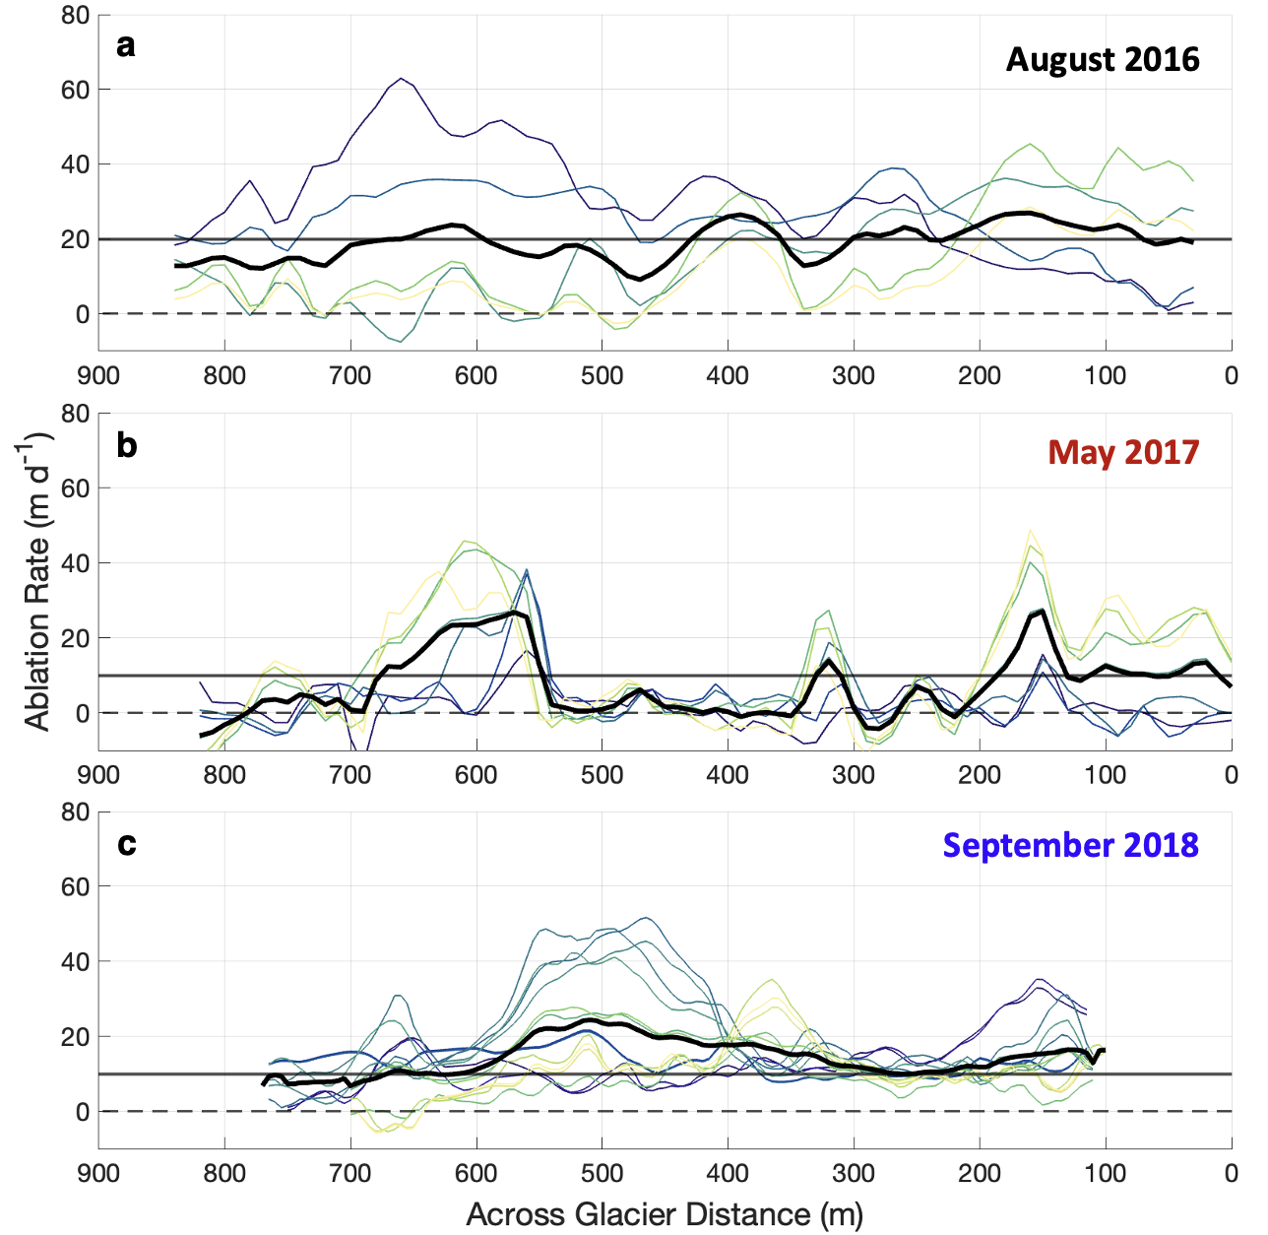
Figure S2. Change in waterline position between each multibeam pass derived from TRI in August 2016 (a) and May 2017 (b), and time-lapse imagery in September 2018 (c). Thick black line indicates the average waterline ablation between all multibeam passes. Horizontal line at 20 m/d in August 2016 and 10 m/d in May 2017 and September 2018 show the threshold used for the characteristic calving rate in the separation of frontal ablation between iceberg calving and submarine melting.
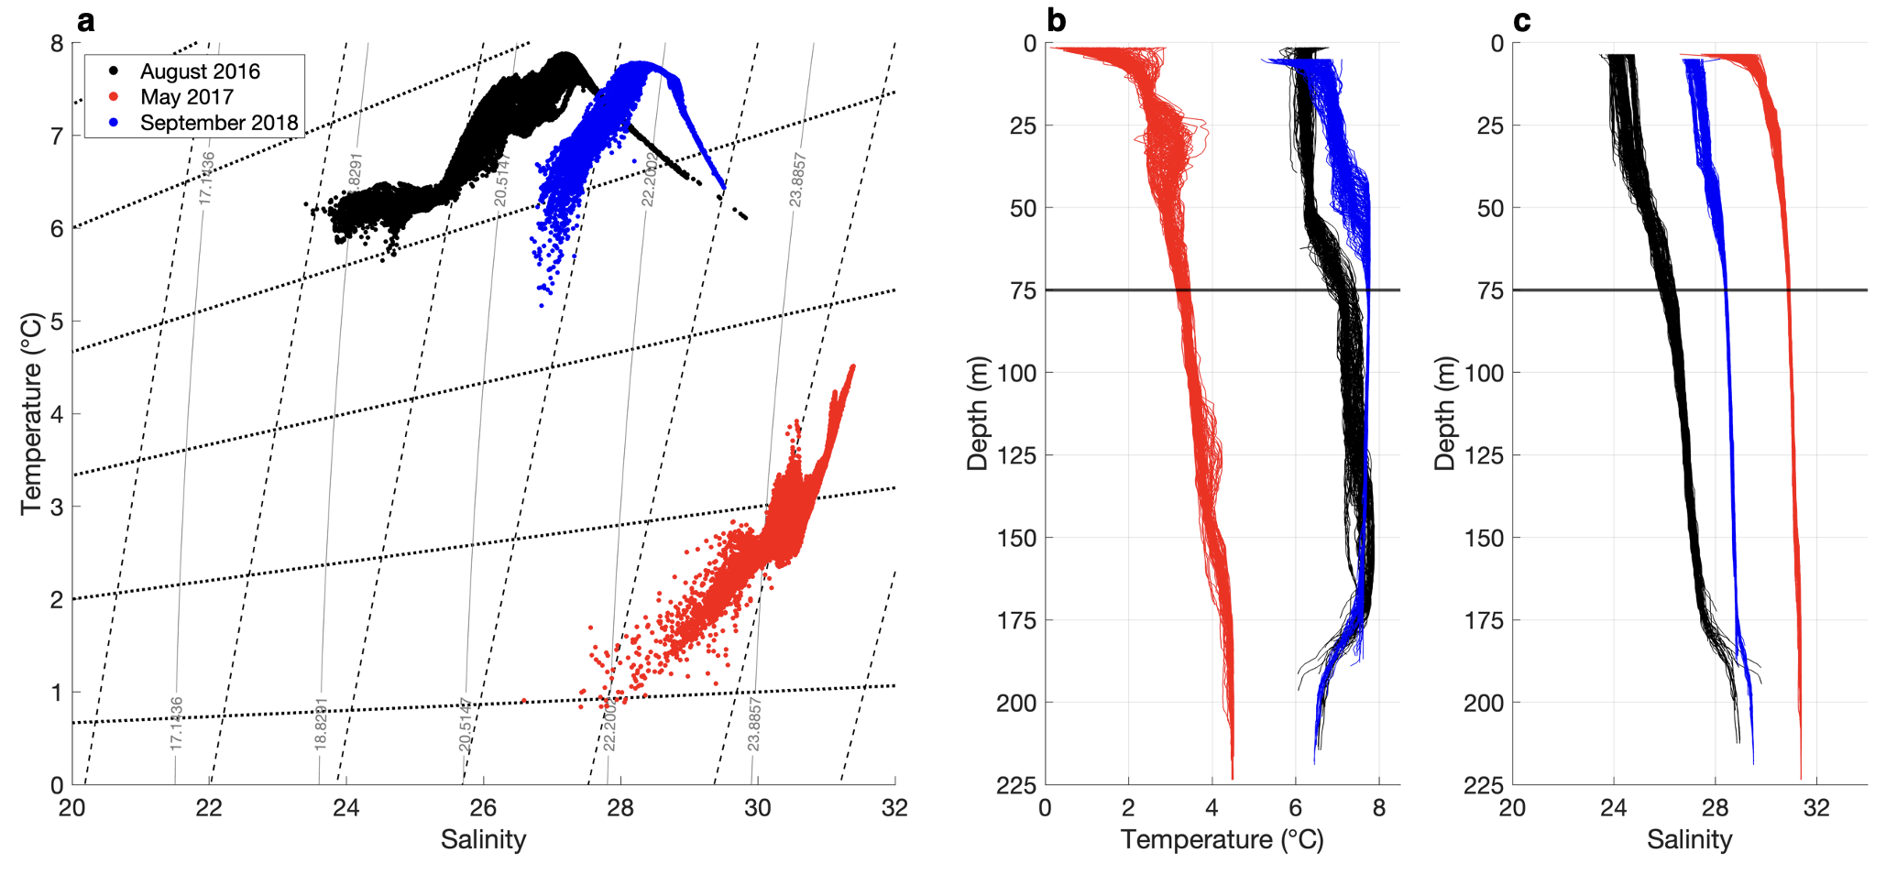
Figure S3. (a) Hydrographic data collected by the CTD casts located in Fig. 7c shown in T-S space and overlaid with melt and runoff mixing lines. Profiles of temperature (b) and salinity (c) with depth from the same CTD casts. Ocean temperature and salinity data were averaged from 75m depth (horizontal black line) to the grounding line to remove the influence of the outflowing glacially modified plume.
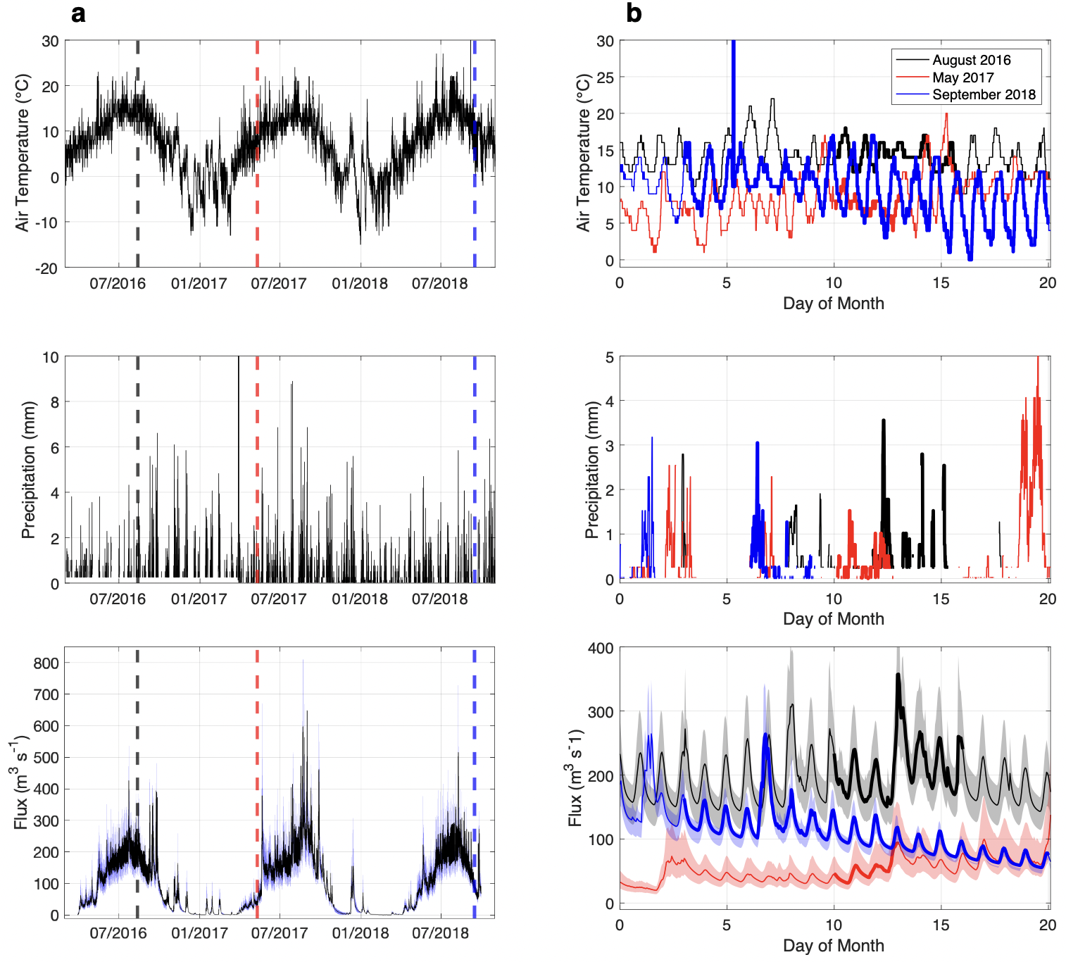
Figure S4. (a) Time series of air temperature (top row) and precipitation (middle row) taken from Petersburg Airport used to force the subglacial discharge model (bottom row) over the course of all field campaigns (August 2016: black dashed line, May 2017: red dashed line, September 2018: blue dashed line). (b) The same time series zoomed into the dates of each field campaign, with the bolded lines indicating the time period of multibeam data collection.

Videos
- multibeam_crossSections.mp4:
Short term changes in terminus morphology for August 2016 (top), May 2017 (middle), and September 2018 (bottom). (a) Across glacier cross-section taken at 100m depth. Each color indicates a different multibeam scan. (b) Vertical cross-section taken at the location of the moving vertical black line in (a).

