Appendix
Figure A.1. Annual accounts of Baracaldo in 1910 (Archivo Foral de Bizkaia, Archivo Administrativo, R-01857/003)
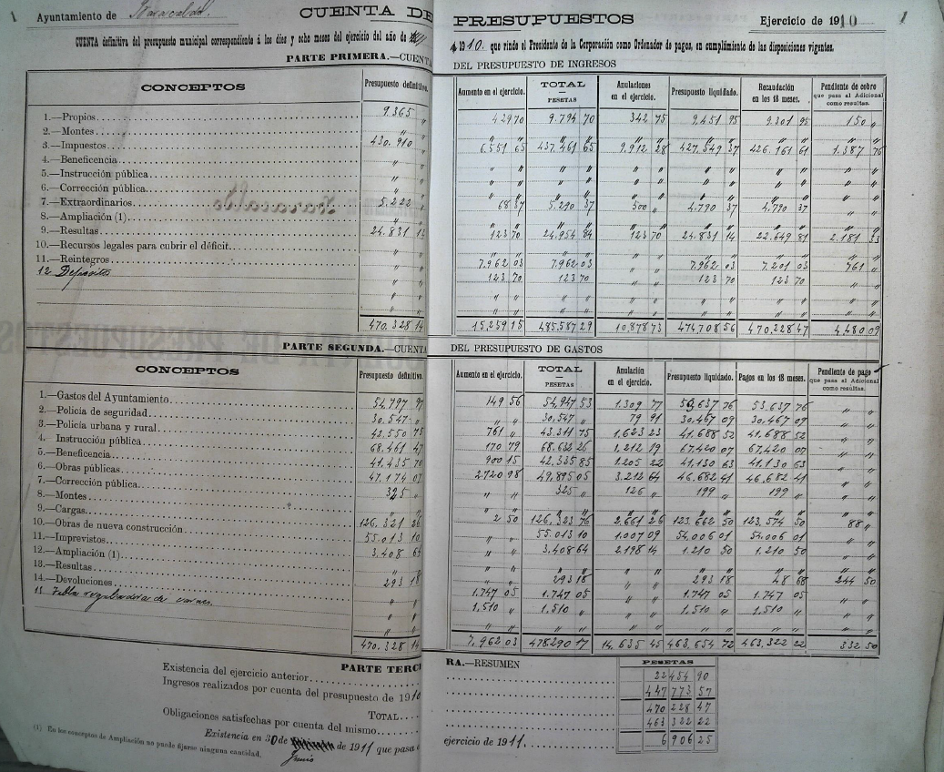

Figure A.2. Biscay municipalities analysed
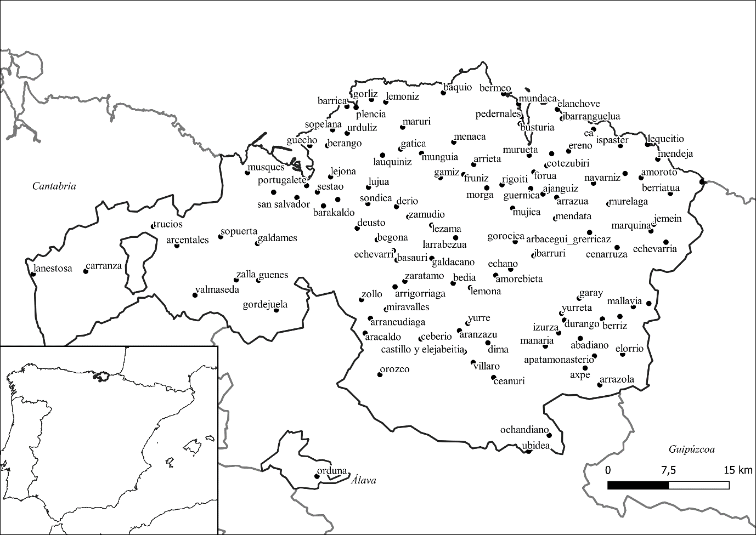

Table A.1. Summary Statistics, 1860-1910
 | Panel A. All Sample |  |  |  |  | Panel B. Mining Towns
Variable | Obs. | Mean | Std. Dev. | Min | Max | Obs. | Mean | Std. Dev. | Min | Max
Indirect Taxes/pc | 580 | 7.703 | 6.121 | .297 | 33.411 | 91 | 11.536 | 5.511 | 1.116 | 22.953
Expenditure/pc (without educ.) | 573 | 4.727 | 3.319 | .142 | 21.702 | 91 | 5.873 | 3.462 | .142 | 19.249
Education Expenditure/pc | 585 | 1.715 | 1.014 | 0 | 4.931 | 92 | 1.932 | .848 | .087 | 4.555
Iron tons/pc | 585 | 8.591 | 46.166 | 0 | 567.714 | 92 | 54.626 | 105.524 | 0 | 567.714
Other minerals tons/pc | 585 | .014 | .272 | 0 | 6.538 | 92 | .091 | .683 | 0 | 6.538
Metal/pc | 585 | .257 | 2.582 | 0 | 49.428 | 92 | 1.635 | 6.364 | 0 | 49.428
Presence of foreign companies (dummy) | 585 | .051 | .221 | 0 | 1 | 92 | .326 | .471 | 0 | 1
Education
Educ. Priv. Foundation | 585 | .306 | .83 | 0 | 9 | 92 | .739 | 1.54 | 0 | 9
Other Educ. Facilities | 585 | .279 | 1.115 | 0 | 13 | 92 | .457 | 1.083 | 0 | 5
Percentage of private funding | 585 | .039 | .154 | 0 | 1 | 92 | .029 | .089 | 0 | .633
Demographic
Pop. Threshold 1 (dummy) | 585 | .157 | .364 | 0 | 1 | 92 | .011 | .104 | 0 | 1
Pop. Threshold 2 (dummy) | 585 | .624 | .485 | 0 | 1 | 92 | .467 | .502 | 0 | 1
Pop. Threshold 3 (dummy) | 585 | .212 | .409 | 0 | 1 | 92 | .478 | .502 | 0 | 1
Pop. Threshold 3 (dummy) | 585 | .007 | .082 | 0 | 1 | 92 | .043 | .205 | 0 | 1
Population Growth (CAGR) | 585 | 1.103 | 2.023 | -5.444 | 17.345 | 92 | 2.245 | 3.178 | -5.444 | 17.345

Year | Statistics | % of Total Incomes
 |  | Rents from town’s properties | Indirect Taxes
1860 | Mean | 6.9 | 92.9
 | Min. | 0 | 47.6
 | Max. | 52.4 | 100
1877 | Mean | 5.1 | 94.1
 | Min. | 0 | 49.2
 | Max. | 50.8 | 100
1887 | Mean | 7.5 | 89.8
 | Min. | 0 | 46.5
 | Max. | 53.5 | 100
1900 | Mean | 8.8 | 89.8
 | Min. | 0 | 44
 | Max. | 56 | 100
1910 | Mean | 9.2 | 89.7
 | Min. | 0 | 25
 | Max. | 75 | 100
Total | Mean | 7.5 | 91.2
 | Min. | 0 | 25
 | Max. | 75 | 100
Note: Own elaboration using the annual accounts of each Biscay municipality
Table A.2. Statistics of Rents and Indirect Taxes for the 117 municipalities

Figure A.3. Percentage of alcohol consumption tax over total incomes

Source: Annual accounts for Abanto y Ciervana, Baracaldo, Ceberio and Bermeo.

Figure A.4. Mining report for 1910 in Boletín Oficial de la Provincia de Vizcaya nº 326, año 1910.
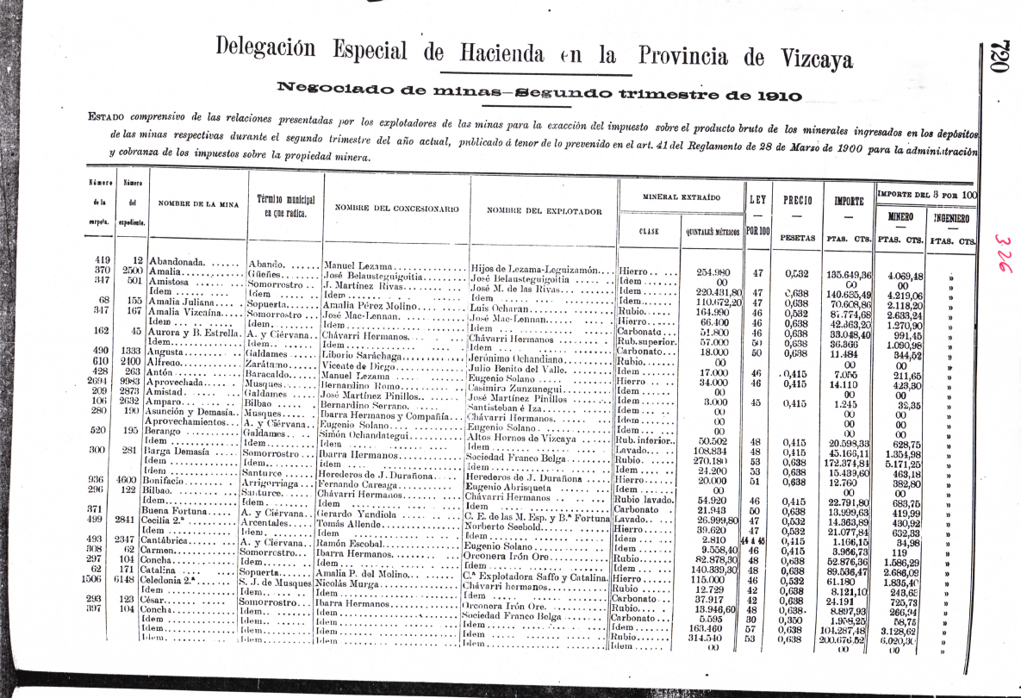
Figure A.5. Mining and industrial towns
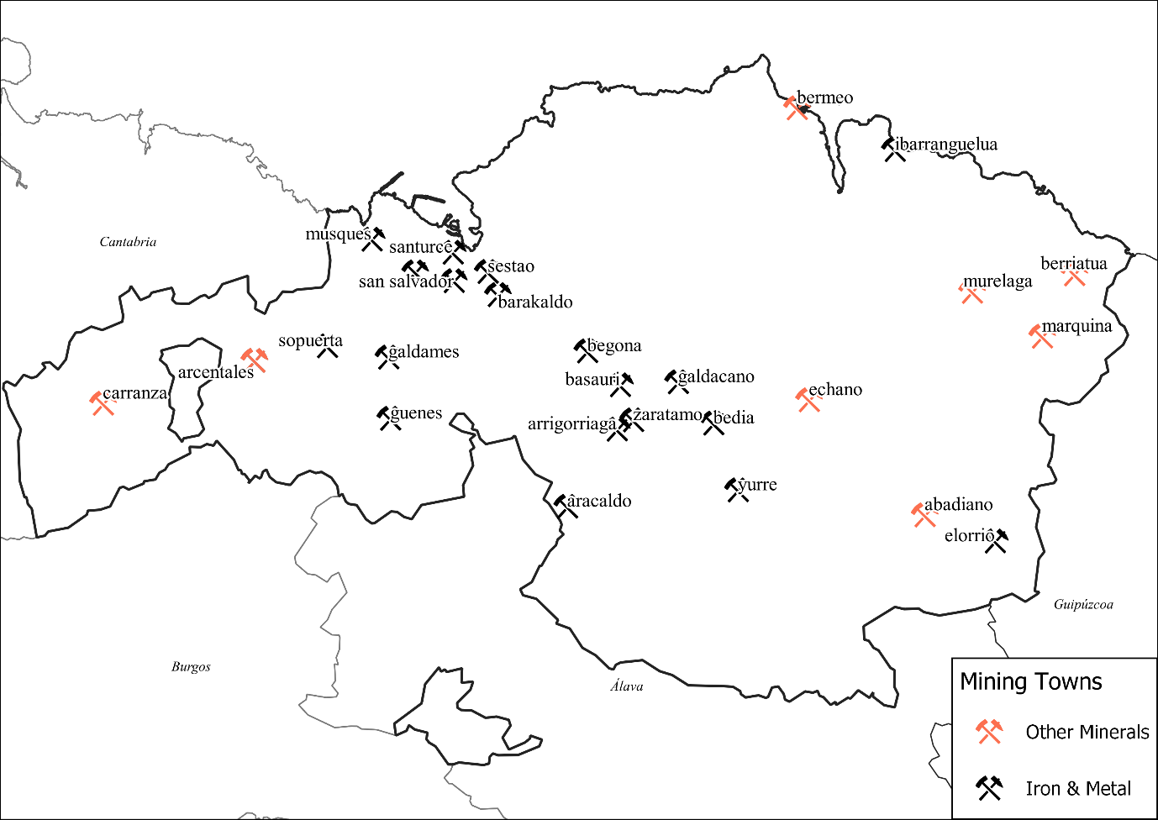
Table A.3. Source of the Educational controls
Variable | Source
Foundations | Estadística General de Primera Enseñanza correspondiente al decenio que terminó en 31 de diciembre de 1880. Dirección General de Instrucción Pública (1883) and Censo escolar de 1903
Other Education Facilities | Anuario del Comercio, de la Industria, de la Magistratura y de la Administración de España, Ultramar, Estados Hispano-Americanos y Portugal for the years 1887, 1900, and 1910. For 1877 and 1860 Diccionario de Madoz (1845-1850), checked with the Anuario del Comercio, de la Industria, de la Magistratura y de la Administración de España, Ultramar, Estados Hispano-Americanos y Portugal fo 1881
Percentage of private funding | Educational expenditure and item 5.º Instrucción Pública in Cuenta del Presupuesto de Ingresos, and computed as the percentage of this income over the total educational expenditure

Figure A.6. Number of Education Foundations and other Education Facilities (technical, art, music or nautical schools).
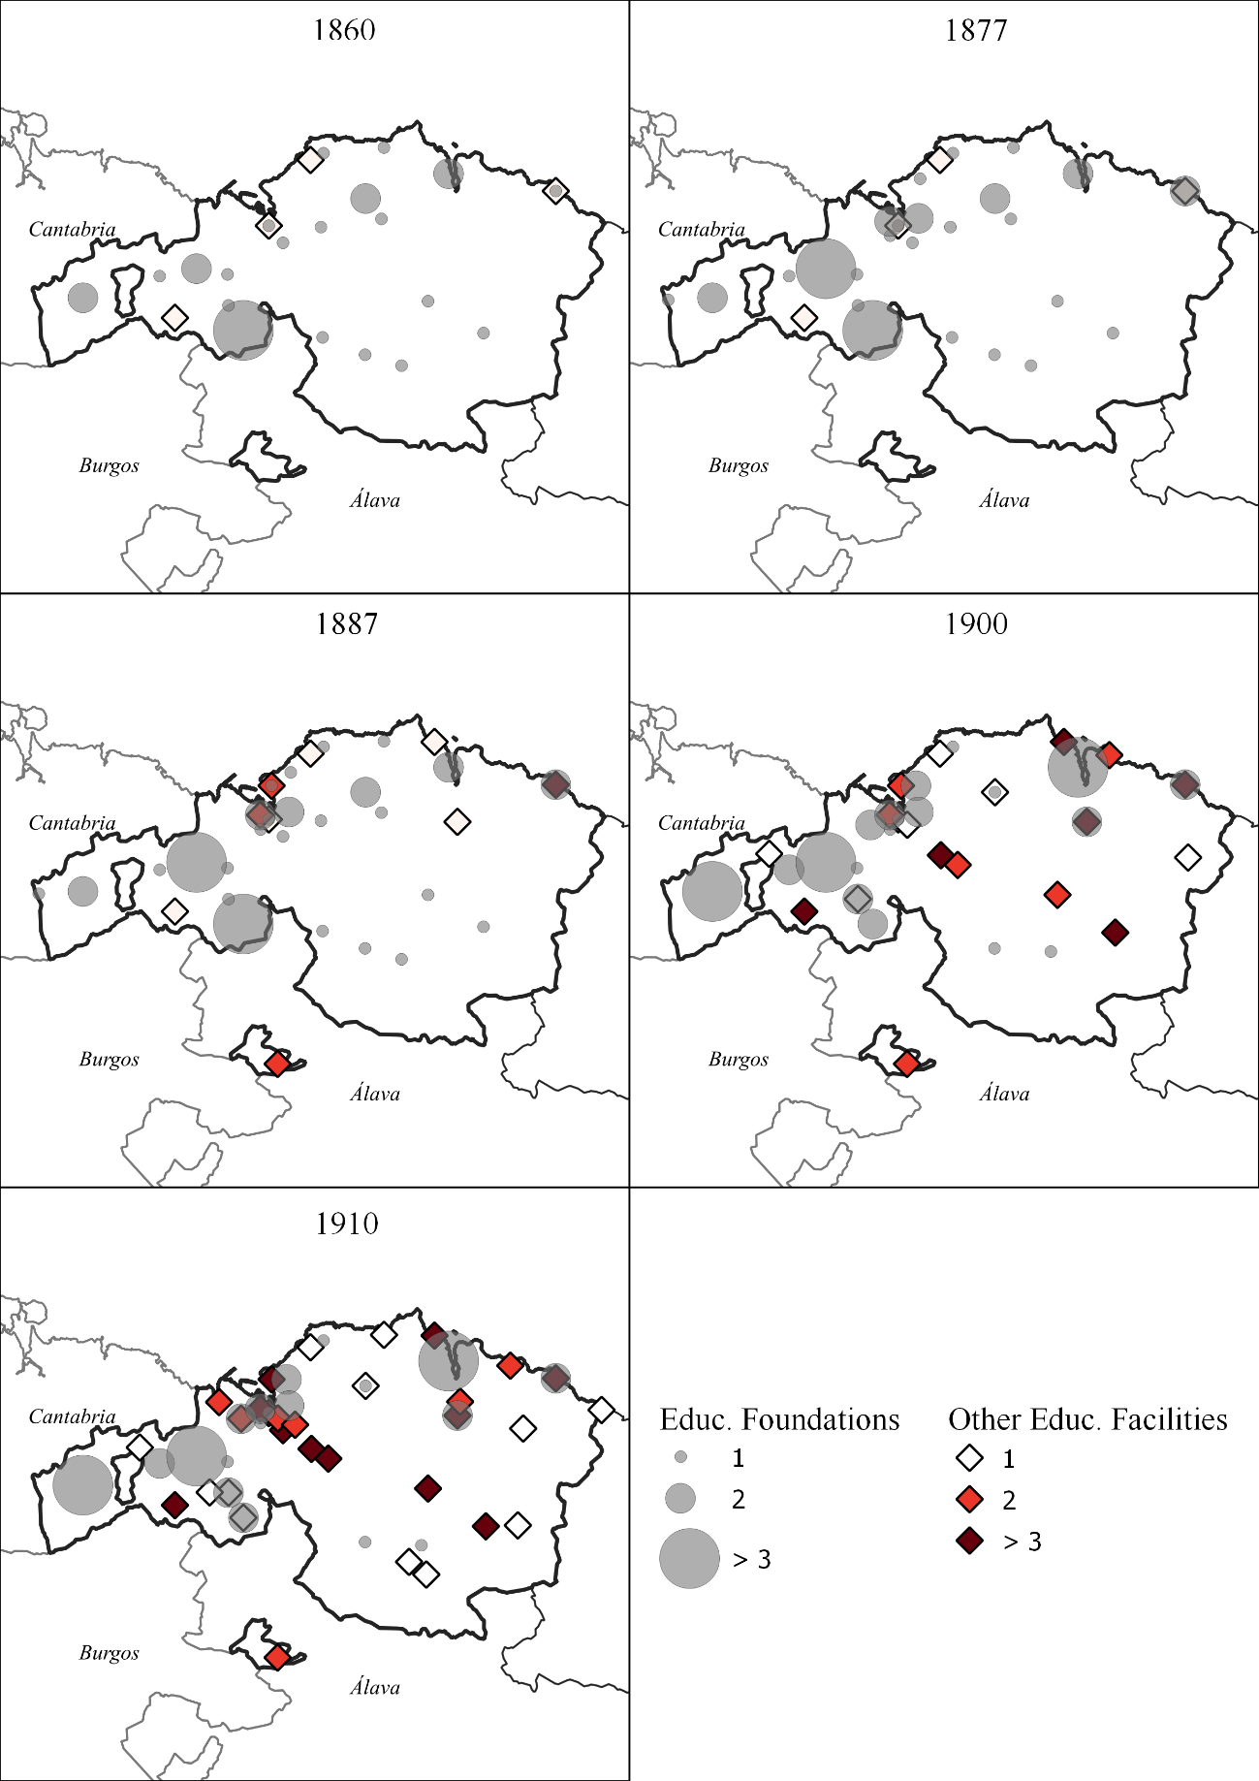
Source: See Table A.3

