ONLINE APPENDIX

APPENDIX 1
CONCENTRATION OF RURAL POPULATION 1938 AND 1993

1938 | 1993
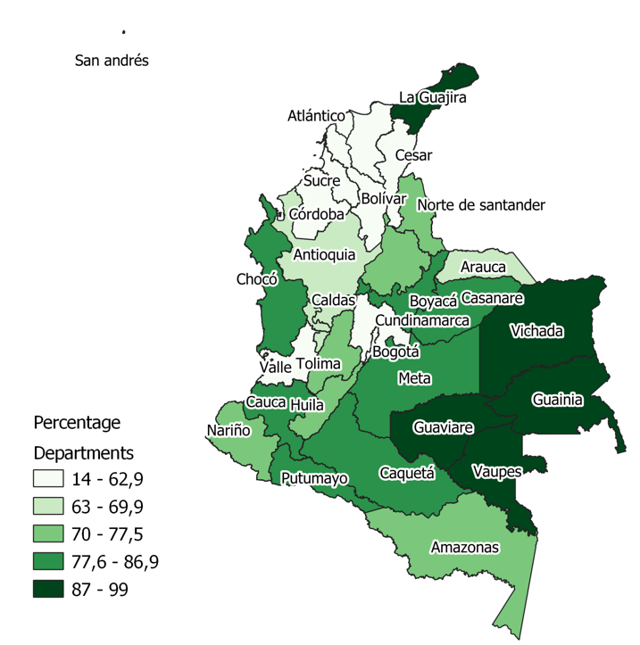 | 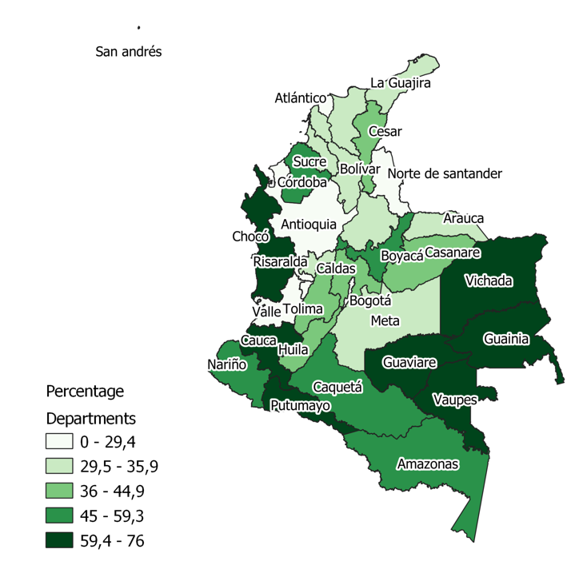
Source: Censuses of population.

APPENDIX 2
COMPLETION AND DROPOUT RATES 1943-1987

Completion rates | Dropout rates
Source: see text.
Note: the values are averages weighted by gender.

APPENDIX 3
NUMBERS OF RURAL TEACHERS PER 1,000 SCHOOL-AGE POPULATION BY DEPARTMENT 1940, 1970, 2010

Source: see text.
Note: school-age population 7-14.

APPENDIX 4
MAIN REGULATIONS IN RURAL PRIMARY SCHOOLING 1870-2019
Legislation | Initiatives in respect of primary schooling in rural areas | Effects
Organic decree 1870 | Implicit decentralized schooling provision (Jaramillo Uribe 1980) | No major effects.
Law of Education 89 of 1892 | As Decree of 1870. | No major effects.
Law 39 1903 and Decree 491 of 1904. | Three years of rural primary instruction, alternate schools, rural curricula. | Decontextualized rural school.
Law 56 of 1927 | Article 8: Farms with more 20 children should establish a school. | Ignored.
Decree 1487 of 1932 | Homogenization of rural and urban primary schooling (four years). | Ignored.
Law 12 of 1934 | Campaign of Village Culture and Scholar Colonies Project | Insufficient.
Decree 20 of 1948 | Introduces the overlooked Article 8 in Law 56 of 1927. | Ignored.
Program Popular Cultural Action (ACPO) 1947. | Catholic programme of a broadcasting system to instruct isolated peasants. | Private initiative.
Decree 3468 of 1950 | Two different programmes in rural primary education. Rural school: four years.  Alternate school: two years. Urban school: five years. | Insufficient.
Five-year plan 1956 | General plan of education. Five years for urban and rural schools. (Ramírez-Giraldo and Téllez-Corredor 2007) | Insufficient in increasing quality and resources.
Decree 1710 of 1963 | Homogenizes rural and urban primary instruction with five mandatory years and seven subjects. | Insufficient in offering contextualized rural schooling.
Decree 150 of 1967 | Proposes the Unitary School (Escuela Unitaria). Multigrade rural school. | Increased enrolment.
1975 The New School | Flexible rural primary school with a single instructor who has the responsibility for teaching the five primary grades. | Increased enrolment.
Decree 708 of 1973 | Programme of Rural Development Concentrations and Rural Integral Development. | Limited coverage.
National Plan of Government in 1982. | Support for Basic Education in Rural Areas. | Insufficient.
Educational Map | System of planning that allows local needs in rural areas to be identified | Limited coverage.
1991 Constitution | Decentralization of education. | Increased coverage.
Rural Education Service (SER) | Flexible programme. | Increased coverage.
Decree 3011 of 1997. | Flexible programme for adults (Ciclos Lectivos Especiales Integrados, CLEI) | Increased coverage.
Decree 3011 of 1997 | Institutional education projects (PEI).
Project Education for Rural Sector (PER) | Quality by expanding technologies, research, and training in the rural sector. | Increased coverage.
Decree 707 of 1996. | Establishes economic incentives for teachers working in rural territories. | Increased rural teachers.
Decennial Plan of Education | Reduces illiteracy to 2 percent, guarantees resources, and incentivize qualified personnel. | Increased coverage.
System of Tutorial Learning (SAT) | Programme. | Increased coverage.

APPENDIX 5
RACIAL COMPOSITION OF COLOMBIAN REGIONS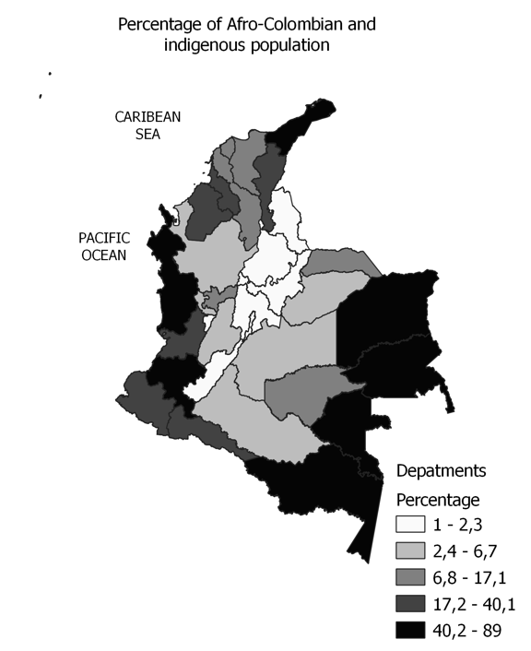
Source: DANE

APPENDIX 6
OVER-AGE STUDENTS BY DEPARTMENTS IN 2019 (PERCENTAGE)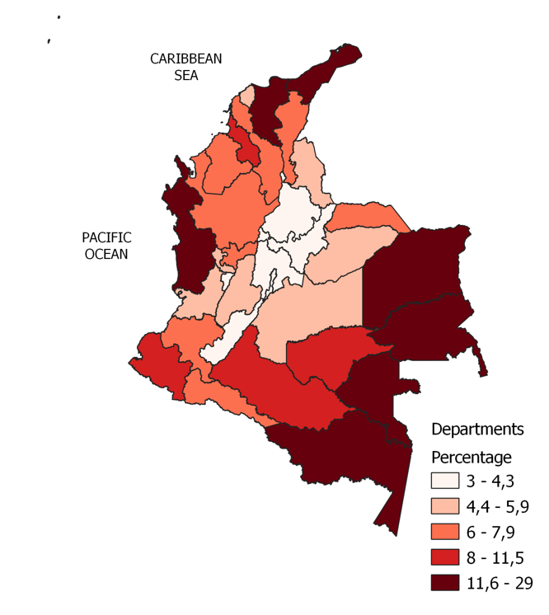
Source: MEN

APPENDIX 7
PERCENTAGE OF RURAL TEACHERS WITH GRADUATED AND HIGHER EDUCATION LEVELS IN 2000

Graduated | Higher education
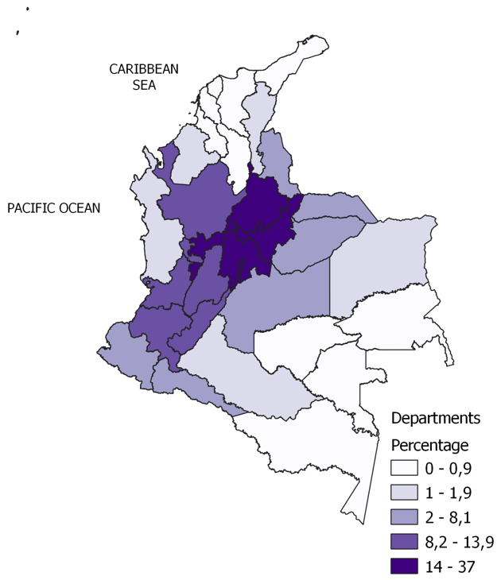 | 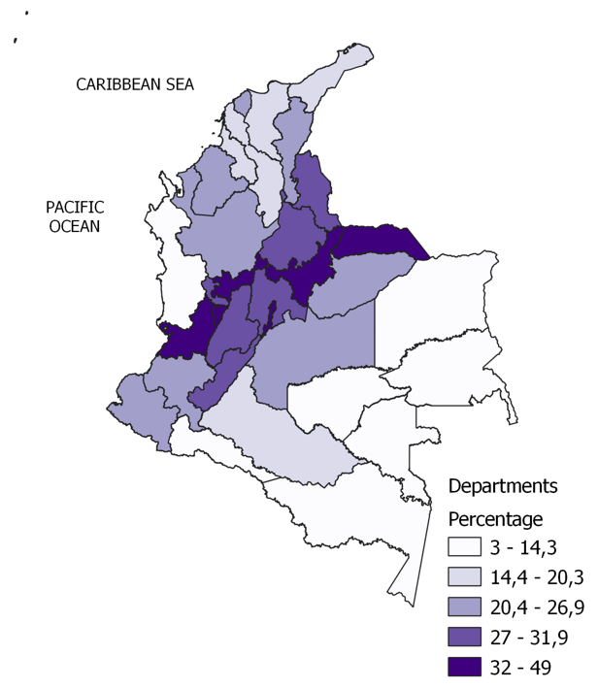
Source: DANE

DISCUSSION OF SOURCES
The urban and rural categories of the population we use are those specified in the official sources. The figures for students, teachers, and establishments are the totals reported in the sources we have already mentioned in the section on methodology. For figure 3 to 5 data are from DESL and DANE. Data beyond 1970 also include the New Schools, SAT, SER, and CAFAM programmes, and policies for primary education implemented by the Ministry of Education. We follow Fuentes-Vasquez (2019) to establish the standardization of the Colombian educational system. The data cover both the official and private sectors. This is not an issue since the coverage of primary schools in the rural private sector is marginal. Data on completion rates, teacher qualifications, and dropout rates are collected from the bulletin of statistics 446, DANE (1985), DNP (1991) and Baldión Waldrón et al. (2000). Dropout rates by grade from 1943 to 1983 are weighted averages for the male and female populations.
For population estimates, we use information from the eight censuses of population conducted between 1938 and 2018. We then estimate intercensal exponential growth rates computed for the national, departmental, total, urban, and rural population categories. The results for overall educational trends are quite like those given in Ramírez-Giraldo and Téllez-Corredor (2007), which allows a reasonable comparison.
Information on rural and urban illiteracy in Latin American countries comes from different data sources for populations over fifteen years old. For Argentina, we collected the population censuses for 1947 to 2001; for Colombia, censuses of population from 1938 to 2018 and PND (1994-1998); for Uruguay, censuses of population for 1996 and Del Valle (2013); for México, INEE (2008, 2018); for Peru, national censuses for 1981, 1993, and INEI (2015) and INEI (1992). For Costa Rica, national censuses from 1950 to 2000; and for Chile, censuses for 1952, 1960 and the Ministerio de Desarrollo Social (2018) for 1990, 2006, 2017. Other data come from Wilkie et al. (2002) and Padua (1979).
For subnational data, the departments of Bolívar, Sucre, and Córdoba belonged to the same administrative unit during the first half of the 20th century; therefore, the data for these three departments are recorded as Bolívar. The same goes for Caldas, which includes Quindío and Risaralda, and Vaupés, which includes Guainía. The 1938 census of population gives the total data for the National Territories of Putumayo, Meta, Chocó, San Andrés, and Arauca. For Amazonas, Guajira, Vichada, Vaupés, and Caquetá, the census gives the data for their respective capitals.

REFERENCES

DEL VALLE, L. (2013): «El analfabetismo en Uruguay: algunas aproximaciones». Intersecciones. Revista de Educación de Personas Jóvenes y Adultas 3, pp. 9-15.

INEI. (1992): Compendio de Estadísticas de la Mujer. Lima.

INEI. (2015): Perú: Indicadores de Educación por Departamentos, 2005-2015.

Instituto Nacional para la Evaluación de la Educación. (2018): CS03.

JARAMILLO URIBE, J. (1980): «Decreto orgánico instrucción pública Nov. 1/1870». Revista Colombiana de Educación I(5).

Ministerio de Desarrollo Social. (2018): Caracterización educacional de la población, CASEN 2017.

