**The rise of modern police forces in the United Kingdom: tracking legislative debates around police reform (1803-1945)**

**Version June 2024**

Appendix A. Dictionary 2

Appendix B. Keyword Assisted Topic Model 3

Appendix C. Number of police forces and personnel 10

Appendix E. Public order and crime 11

Appendix E. Party families 12

Appendix F. Parliamentary conflict 14

Appendix G. Debates on the Irish police 15

References 17

**Appendix A. Dictionary**

As mentioned in the text, we employ both supervised and semi-supervised approaches to assess the salience of police issues over time. Supervised methods follow a dictionary-based approach in which we generate a comprehensive dictionary of keywords related to policing. The dictionary is then used to measure “police salience” by dividing the number of times any of our keywords was mentioned in a debate over the total number of words in that discussion. The intuition is that debates that feature a police keyword several times are more likely to be related to police issues than other debates that do not include these keywords. The list of keywords is: “police”, “policeman”, “policemen”, “metropolitan police”, “police services”, “standing joint committee”, “standing joint committees”, “criminal investigation”, “law enforcement”, “policing”, “constabulary”, “constable”, “constables”, “Irish constabulary”, “Irish constable”, “Irish constables”, “petty constable”, “petty constables”, “parish constable”, “parish constables”, “chief constable”, “chief constables”, “watchman”, “watchmen”, “night watch”, “gendarmerie”, “bow street runners”, “watch committee”, “watch committees”, “police officers”, “police officer”, “bobbies”, “bobby”, “detective” and “detectives”.

We also use a dictionary-based approach to count the number of debates per year that mentioned at least one police keyword in their title. We then calculate their share over the total number of debates in that year. The titles were assigned by Hansard, and sometimes they are not informative enough, but we use this measure as a conservative indicator of debates that were focused on police reform. The previous measure, by contrast, includes debates that were not necessarily about police reform but that featured our police keywords (generally because police issues were part of the discussion, but not necessarily the main focus of attention). In this case we use a reduced list of keywords to make sure that we capture debates about police reforms, namely “police”, “policemen”, “policeman”, “policing”, “constabulary”, “constables” and “constable”.

**Appendix B. Keyword Assisted Topic Model**

As explained in the text, we rely on dynamic Keyword Assisted Topic Model to identify topics of interest through pre-selected lists of keywords (with decades as the time covariate). To do so, we first identify the 15 most frequent words in the debate titles on police issues to find relevant topics and keywords that emerged in these parliamentary sessions. To ensure that our pre-selected keywords reflect the evolution of police debates over time, we have chosen several periods that appear to be particularly relevant in terms of police salience and police reform, namely the period 1830-45 (initial modern police reforms), 1850-59 (second round of police reforms and discussions on the extension of modern police forces to the provinces), 1880-1905 (period of high police salience), 1906-1918 (run-up to World War I), 1919-1938 (inter-war period), 1939-1945 (World War II).

Figure B1. Word frequency in the titles of police debates

*Notes*: most frequent keywords in the titles of police debates in several periods of interest.

Figure B1 shows the results of this first step. Interestingly, each period contains some specific words that point towards distinctive topics of discussion. The first period includes words related to new police forces, such as “metropolitan police” and “new”, particularly in urban settings, such as “London”, “Birmingham”, “city”, “municipal” or “metropolis”.[1] The second period witnesses several keywords possibly related to the expansion of modern police forces to the provinces, such as “counties”, “boroughs”, “committee”, “parish” and “rural”. Ireland appears in several ways in both periods, but the topic takes off specially in the third period, when the “Royal Irish Constabulary” and “Ireland” are by far the most important words in the debate titles. This is a first rough indication that this period of increased attention to police issues could be related to debates about police forces in Ireland. The next three periods also include some interesting new words such as “pay”, “weekly”, “day”, “rest” and “superannuation” (fourth period) most likely related to the emergence of the aforementioned discussions on working conditions (with the appearance in the next two periods of the word “pensions” in very high positions), or others such as “military”, “war” and “defence”, most likely related to the role of the police in the war efforts during the World Wars. Apart from these two common themes, there are three other words that seem particularly interesting: “motor” (fifth period), “India” (fifth and sixth period), and “women” (sixth period). The word “Scotland” also appears in several periods.

Based on Figure B1, we have pre-selected ten different topics for our main analyses: Metropolitan Police, Ireland, expansion of police forces to the provinces, war, working conditions, Scotland, India, motorization, and women. We have added three other topics that are mentioned repeatedly in the previous literature and may be relevant (even though they do not emerge in the titles): crime, public order, and cost of service. We also include 5 additional topics for which we do not pre-select any keywords (allowing the model to find groups of words in an unsupervised manner). For each of the 12 pre-selected topics we have included several distinctive keywords:

* Topic 1. Ireland: "ireland", "irish", "dublin", "royal_irish_constabulary"; Topic 2. Provinces: "boroughs", "borough", "counties", "county", "magistrates", "local"; Topic 3. War: "war", "military", "army"; Topic 4. Women: "women", "woman", "policewomen"; Topic 5. Cost: “fund”, “cost”, “rate”, “ratepayers”;Topic 6. Motor: "motor", "cars", "car"; Topic 7. Crime: “crime”, “criminal”; Topic 8. Order: "disturbances", "disturbance", "riot", "riots", "disorder", "crowd"; Topic 9. Salary: “pay”, “pension”, “pensions”; Topic 10. India: "india", "indian", "imperial"; Topic 11. Scotland: "scotland", "scottish"; Topic 12. London Metropolitan Police: "metropolitan_police", "london"

Table B1 shows the 20 top words that define each of these topics after running the dynamic KeyATM. For most of the topics, not only several of our keywords are included in the list of top words but also some of the other words seem to be related to their corresponding themes. For instance, the topic “Women” includes our keywords “women” and “woman”, but it also includes words such as “children”, “young” and “age” (probably related to the fact that women in the police were mostly in charge of tasks associated with children and criminals of young age) or “men” and “man” (as opposed to women). The topic “Order” includes our keywords “disturbance”, “crowd” and “riot”, but also “meetings”, “peace”, “order” or “street”, while the topic “Crime” includes not only “crime” and “criminal”, but several words related to the criminal justice system. This instils confidence on the models and the reliability of the results.

Nevertheless, three topics display poor results: Scotland, India and the Metropolitan Police. In the first two of them, none of our pre-selected keywords is included in the list of top words, and these top words are not evidently related to these issues. This indicates that the model is not capturing well these two themes. In the case of the Metropolitan Police, our pre-selected keywords are included but the rest of the keywords do not seem related to this theme at all, which casts some doubts on the accuracy of the results. For these reasons, in the paper we focus on the results of a new model containing only the other 9 topics. While the findings for these well-identified topics are basically the same in both models, we prefer to focus only on those topics that display more meaningful results.

Table B2 displays the top words for the dynamic KeyATM models with only the aforementioned 9 pre-selected topics. Results are very similar to those reported in Table B1, which indicates that our results for these specific topics are robust to different model specifications. Table B3 displays the top words for the 5 topics without pre-selected keywords, although they do not seem to capture meaningful policy issues and are therefore not discussed in the text.

To show that the dynamic KeyATM models for our 9 topics of interest are robust to these different model specifications, we plot in Figure B2 the results of the models that included all 13 topics. We do not find large variations compared to our preferred models in Figure 2, which again indicates that our results are not affected by the exclusion of the 3 underspecified topics.

Table B1. Key-ATM top words (models with all potentially relevant topics)

|  |  |  |  |  |  |  |  |  |  |  |  |
| --- | --- | --- | --- | --- | --- | --- | --- | --- | --- | --- | --- |
| **London** | **Ireland** | **Provinces** | **War** | **Women** | **Cost** | **Motor** | **Crime** | **Order** | **Salary** | **India** | **Scotland** |
| police | ***ireland*** | police | force | ***women*** | police | ***motor*** | ***crime*** | police | men | will | right |
| force | police | force | special | police | ***cost*** | police | ***criminal*** | meeting | ***pension*** | police | think |
| will | chief | ***county*** | ***military*** | work | ***fund*** | ***car*** | case | people | will | one | will |
| service | ***irish*** | ***magistrates*** | ***war*** | home secretary | *local [3]* | certifying | jury | meetings | police | think | one |
| men | will | measure | ***army*** | regulations | *pay [10]* | accidents | cases | city | ***pensions*** | force | matter |
| ***metropolitan police*** | ***dublin*** | might | constables | miners | *london [1]* | road | grand | peace | service | right | time |
| home secretary | *county [3]* | ***local*** | international | ***woman*** | ***rate*** | cases | man | street | years | time | made |
| officers | lieutenant | power | country | children | per | ***cars*** | court | ***crowd*** | ***pay*** | home secretary | case |
| commissioner | men | act | will | girls | ***ratepayers*** | surgeons | law | right | force | country | put |
| chief | inspector | one | world | ***policewomen*** | money | duty | committed | ***disturbance*** | act | make | point |
| federation | constable | present | league | will | will | number | justice | procession | case | deal | know |
| union | district | ***borough*** | civil | young | amount | traffic | persons | place | man | point | friend |
| constables | made | ***counties*** | forces | regulation | sum | officers | trial | ***riot*** | cases | forces | now |
| constable | two | system | defence | number | expenditure | many | act | held | *war [4]* | hope | make |
| made | last | thought | nations | evidence | paid | surgeon | judge | *london [1]* | *royal irish constabulary [2]* | like | must |
| number | constabulary | town | air | done | authorities | factory | offence | conduct | constable | matter | give |
| ***london*** | ***royal irish constabulary*** | ***boroughs*** | constabulary | employed | increase | vehicles | offences | public | pensioners | far | given |
| discipline | aware | country | new | many | rates | home secretary | compensation | one | officers | present | quite |
| officer | general | city | naval | probation | extra | reports | juries | occasion | shall | good | place |
| forces | one | now | peace | powers | one | roads | magistrate | law | many | come | take |

*Notes*: Top 20 keywords for the pre-selected topics in the Key-ATM. Words in bold and italics represent the pre-selected keywords that emerge in the topic they were originally assigned. Words in italics and a number indicate the pre-selected keywords that emerge in the models but not in the topic that they were originally assigned (the number corresponds to their pre-selected topic).

Table B2. Key-ATM top words (models with only the final selected topics)

|  |  |  |  |  |  |  |  |  |
| --- | --- | --- | --- | --- | --- | --- | --- | --- |
| **Ireland** | **Provinces** | **War** | **Women** | **Cost** | **Motor** | **Crime** | **Order** | **Salary** |
| ***ireland*** | police | force | police | police | police | case | police | men |
| police | ***county*** | police | ***women*** | ***cost*** | ***motor*** | court | meeting | police |
| chief | force | will | force | ***rate*** | home secretary | ***crime*** | people | will |
| ***irish*** | might | ***war*** | men | *pay [9]* | ***car*** | cases | meetings | ***pension*** |
| ***dublin*** | one | forces | will | ***fund*** | number | law | peace | service |
| will | measure | country | man | *local [2]* | regulations | man | law | ***pensions*** |
| lieutenant | thought | special | work | london | many | police | ***disturbance*** | force |
| *county [2]* | present | ***military*** | service | will | coal | jury | city | years |
| inspector | power | ***army*** | years | amount | will | charge | ***crowd*** | ***pay*** |
| made | ***magistrates*** | union | home secretary | per | duty | grand | order | act |
| men | act | trade | young | money | employed | evidence | right | case |
| last | now | federation | ***woman*** | expenditure | road | ***criminal*** | street | officers |
| constabulary | noble | constables | metropolitan police | ***ratepayers*** | metropolitan police | offence | place | cases |
| two | ***local*** | service | children | extra | ***cars*** | constable | procession | man |
| general | made | organisation | short | paid | area | persons | held | *royal irish constabulary [1]* |
| district | ***borough*** | home secretary | college | sum | officers | judge | ***riot*** | many |
| constable | system | men | number | rates | traffic | trial | conduct | constables |
| ***royal irish constabulary*** | ***counties*** | time | promotion | increase | use | magistrate | persons | chief |
| aware | town | international | class | force | district | justice | public | constable |
| taken | time | new | age | authorities | regulation | person | men | *war [3]* |

*Notes*: Top 20 keywords for the pre-selected topics in the Key-ATM. Words in bold and italics represent the pre-selected keywords that emerge in the topic they were originally assigned. Words in italics and a number indicate the pre-selected keywords that emerge in the models but not in the topic that they were originally assigned (the number corresponds to their pre-selected topic).

Table B3. 20 top words for the Key-ATM topics without keywords

|  |  |  |  |  |
| --- | --- | --- | --- | --- |
| Other 1 | Other 2 | Other 3 | Other 4 | Other 5 |
| will | police | people | police | right |
| matter | chief | one | inquiry | will |
| noble | constable | country | case | one |
| think | commissioner | noble | public | think |
| police | made | every | made | men |
| friend | home secretary | party | evidence | know |
| made | force | men | officers | time |
| time | officers | even | court | put |
| right | constables | learned | conduct | point |
| lordships | officer | speech | gallant | matter |
| regard | metropolitan police | must | statement | way |
| point | will | political | yard | case |
| necessary | discipline | public | charges | going |
| shall | general | never | director | get |
| order | special | long | officer | made |
| make | board | might | statements | want |
| course | authority | force | blake | like |
| now | appeal | many | tribunal | make |
| case | right | first | scotland | people |
| one | last | course | prosecutions | see |

*Notes*: Top 20 keywords for the Key-ATM topics without keywords.

Figure B2. Key-ATM with all potentially relevant topics

**Appendix C. Number of police forces and personnel**

Figure C1. Number of police forces and number of police personnel

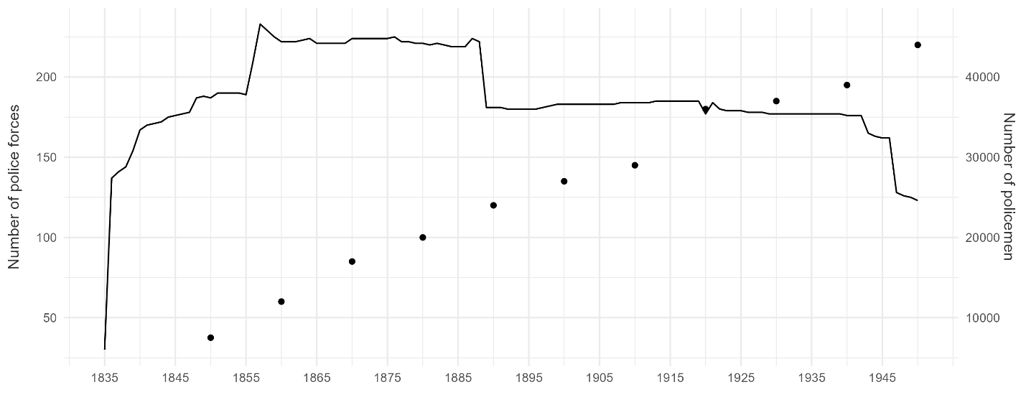

*Notes*: number of all independent provincial police forces in England and Wales, excluding Met. City of London and River Tyne and Wear Police (bold line, left axis); number of police (dots, right axis).

*Sources*: Wall (1998), Table 4, A1 and A2.

**Appendix D. Public order and crime**

Figure D1 suggests that crime and public order salience were to a certain extent related to the evolution of crime statistics and public disorder, at least during the twentieth century (when we have comprehensive annual data available). Crime salience in police debates increases during the century while the number of reported crimes were also on the rise. Similarly, public order concerns increased during the 1910s at a time of industrial disorder and heated social turmoil, such as the coal strike in south Wales (1910-11) or the nationwide rail strike (1911), which prompted an active police intervention mandated by the Home Secretary (Emsley, 2008).

Figure D1. Crime and public order evens and salience

*Notes and sources*: topic proportions based on the dynamic Key-ATM. Crime and public order events from <https://www.gov.uk/government/statistics/police-recorded-crime-open-data-tables>.

**Appendix E. Party families**

As mentioned in the text, MPs affiliations have been classified in seven categories. We list below the parties, factions, or groups (as they appear in the dataset) that belong to each of these categories.

1. *Conservative*: Conservative Party
2. *Liberal*: Liberal Party, National Liberal Party
3. *Labour*: Labour Party, Coalition Labour, Lib-Lab, Labour Co-operative, National Democratic and Labour Party, National Labour Organisation
4. *Irish nationalist*: Irish Parliamentary Party, Anti-Parnellite Nationalist (APN), Home Rule League, Repeal Association, Nationalist Party
5. *Irish unionist*: Irish Unionist Alliance, Ulster Unionist Labour Association, Ulster Unionist Party
6. *Liberal unionist*: Liberal Unionist Party
7. *Other*: Anti-Waste League, Chartist (MP Feargus O'Connor), Common Wealth Party, Communist Party of Great Britain, Irish Confederate (MP Thomas Chisholm Anstey), Constitutionalist (MP Thomas Chisholm Anstey), Independent, Crofters Party, National Association of Discharged Sailors and Soldiers, National Party, New Party, Scottish National Party, Scottish Prohibition Party, Silver Badge Party, Scottish Unionist Party

Interventions by the Speaker of the House of Commons are also coded as part of the “Other” category.

Figure E1 visualizes the number of interventions by all these political groups (including missing values) throughout our period of analysis (starting in 1835 since we do not have data on party affiliation before that year).

Figure E1. Importance of political parties in police debates

*Notes*: number of interventions in police debates by political group. “NA” stands for those MPs for whom we do not have data on their political affiliation.

**Appendix F. Parliamentary conflict**

Figure F1 replicates Figure 7 including all divisions and votes (and hence not restricting the sample only to divisions and votes related to police matters). Unlike Figure 7, this new graph shows that the 1880s and the 1890s were unexceptional when it comes to the overall level of contentiousness in Parliament (i.e., the number of divisions do not stand out compared to the rest of the period – if anything, they are lower than at the turn of the century – and the percentage of yes votes do not show any clear pattern). In other words, while we cannot rule out that part of the disagreement that we observe in this period was driven by political expediency (see Williams, 2000), the evidence at hand suggest that it was the debates about police issues that were exceptionally contentious at that time.

Figure F1. Divisions and votes in parliament

Notes: the left panel plots the number of divisions in the House of Commons by year. The right panel presents the percentage of yes votes. The two dashed red lines represent arbitrary boundaries to differentiate contentious votes (those within the two lines) and votes that gathered more consensus among MPs (above the upper line and below the lower line). Sources: Eggers & Spirling (2014)

**Appendix G. Debates on the Irish police**

In this appendix we show the results of an alternative approach to identify debates on police issues in Ireland. We first identify police debates following the method described in Figure 2 (i.e., based on police keywords in the titles of the debates), and then we select only those debates in which the keywords “Ireland” or “Irish” appear in their titles. Results are very much consistent with our main figure, in that the 1880s, and to a lesser extent the 1890s and the late-1910s and early 1920s witnessed major increases of parliamentary attention to the police in Ireland. There are however two relevant differences: first, the overall number of debates is lower if we use this identification approach. This is because we are now restricting the dataset to debates that were mostly about police reform (and as a second step, about Ireland), whereas in the main models we select debates that mentioned the police in the speeches but that were not necessarily focused on police reform (police issues could emerge in the discussion even though the main focus of the debates laid somewhere else). Second, and related to this previous point, in Figure G1 we do not identify so clearly the peak in parliamentary attention during the 1830s and 1840s, largely because most of these debates were not exclusively about the police but about the criminal justice system in general (and hence the keywords police do not feature in the titles of the debate). Nevertheless, the outstanding level of attention devoted to the police during the turn of the century remains clearly noticeable regardless of the identification method that we use.

Figure G1. Police debates about Ireland

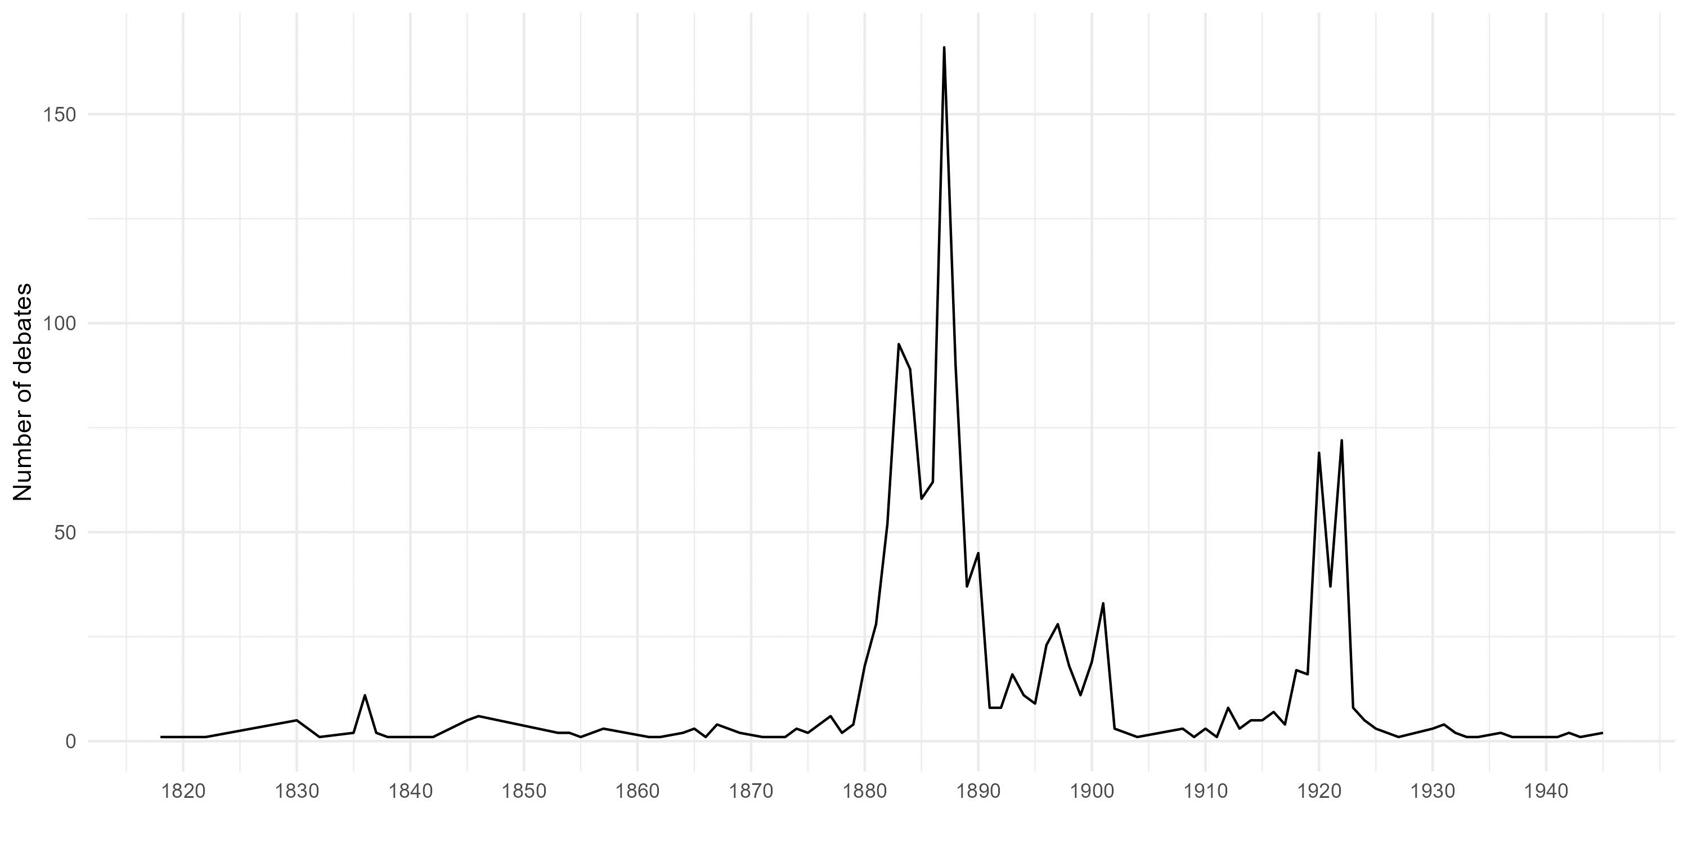

Notes: number of police debates (as in Figure 2) with the keywords “Ireland” or “Irish” in their titles.

**References**

Eggers, A. C., & Spirling, A. (2014). Party Cohesion in Westminster Systems: Inducements, Replacement and Discipline in the House of Commons, 1836-1910. *British Journal of Political Science*, *46*(3), 567–589. https://doi.org/10.1017/S0007123414000362

Emsley, C. (2008). The birth and development of the police. In *Handbook of Policing*. Routledge. https://doi.org/10.4324/9780203118238.ch4

Wall, D. S. (1998). *The chief constables of England and wales: The socio-legal history of a criminal justice elite*. Dartmouth and Ashgate Publishing.

Weaver, M. (1994). The New Science of Policing: Crime and the Birmingham Police Force, 1839–1842. *Albion*, *26*(02), 289–308. https://doi.org/10.2307/4052309

Williams, C. (2000). ’Expediency, authority and duplicity: reforming Sheffield’s police 1832-1840. In R. J. Morris & R. H. Trainor (Eds.), *Urban Governance: Britain and Beyond since 1750*. Routledge.

1. Beyond the creation of the London Metropolitan Police in 1929 and the 1835 Municipal Corporations Act, three bills were passed in 1839 to establish centralized police forces in Birmingham, Bolton and Manchester (Weaver, 1994).