Supplementary Materials
Appendix A: Heterogeneities
Figure A1: Urgency perceptions by education levels and occupational groups
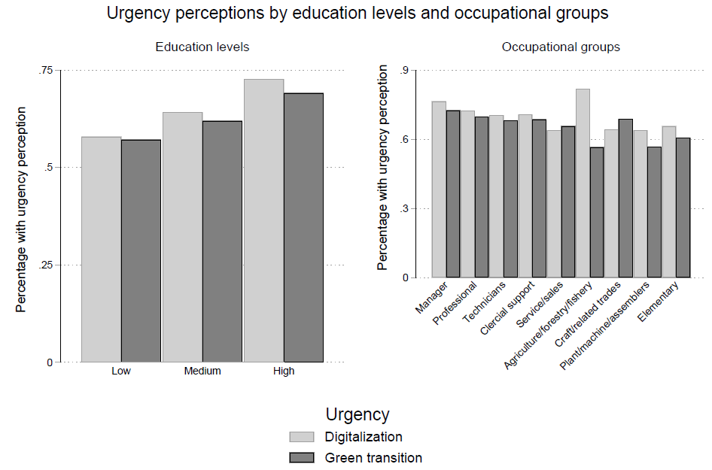
In Figures A1 and A2, we further display how urgency perceptions vary by education levels, occupational groups, and by the level of subjective labour market concern due to both transitions. It can be seen that urgency perceptions for both transitions increase with education levels, and that occupations with higher skill profiles, such as managers or professionals, have higher levels of urgency perceptions than occupations with lower skill profiles, such as elementary occupations. When it comes to subjective risk perceptions, those who are most concerned that the green transition threatens their jobs think it is least urgent, while there is no clear trend regarding digitalization.
Figure A2: Urgency perceptions by subjective labour market concerns
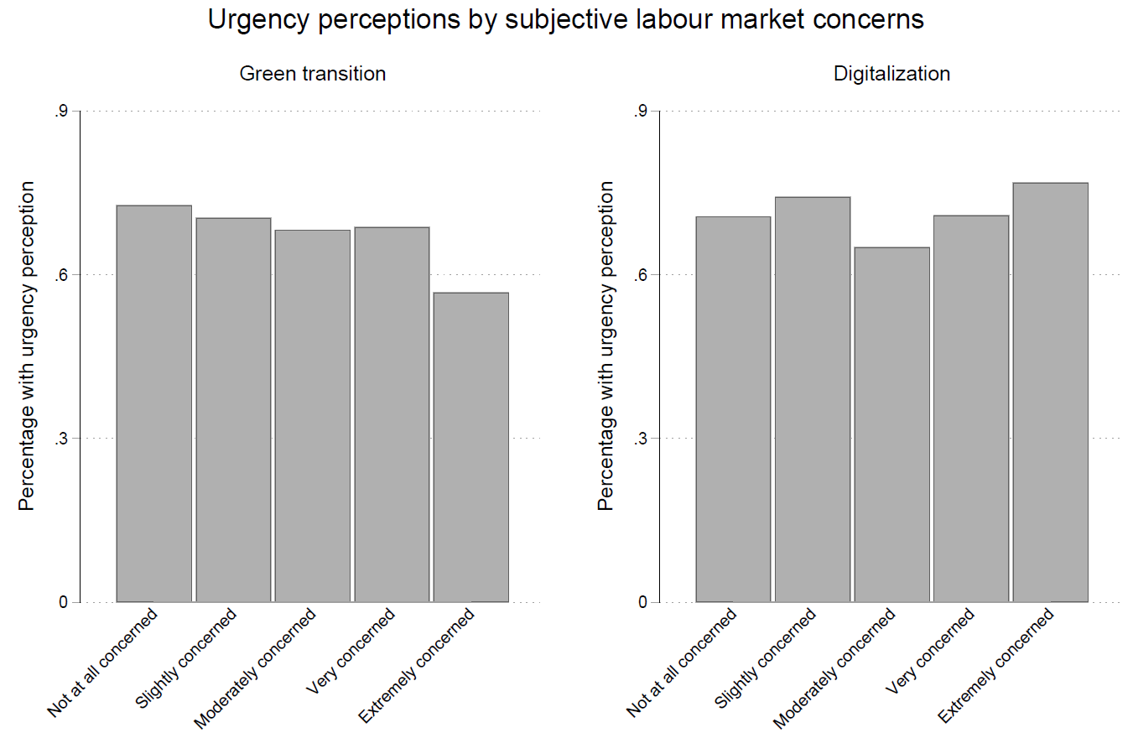

Figure A3: Distribution of high subjective labour market concern across occupational groups
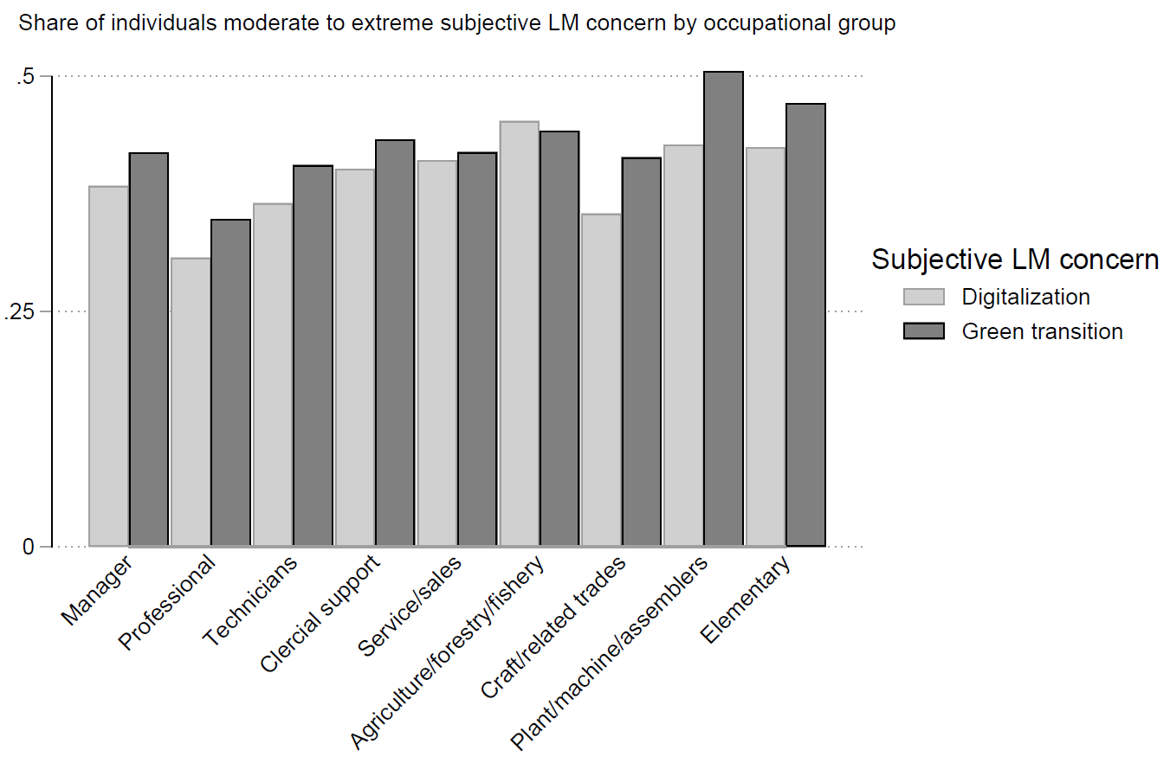
Regarding subjective labour market concerns, Figure A3 shows their distribution across occupational groups. It shows that, regarding the green transition as a perceived labour market risk, individuals in plant/machine/assemblers and agriculture/forestry/fishery occupations exhibit rather high levels of concern, which is plausible given the objective risks these occupations face. On the other hand, individuals in service/sales also report quite high levels of subjective concern about to the green transition, even though service-sector jobs are usually not emissions-intensive. When it comes to digitalization, individuals in agriculture/forestry/fishery exhibit the highest level of subjective concern, an area indeed disrupted by technological change. However, individuals in clerical support have rather average subjective risk perceptions, even though this occupational group is threatened by automation. This corroborates the previous picture that subjective concern about job loss does not necessarily correlate with objective risk.
Figure A4: Interactions between subjective labour market concern and objective labour market risk on relative spending preferences
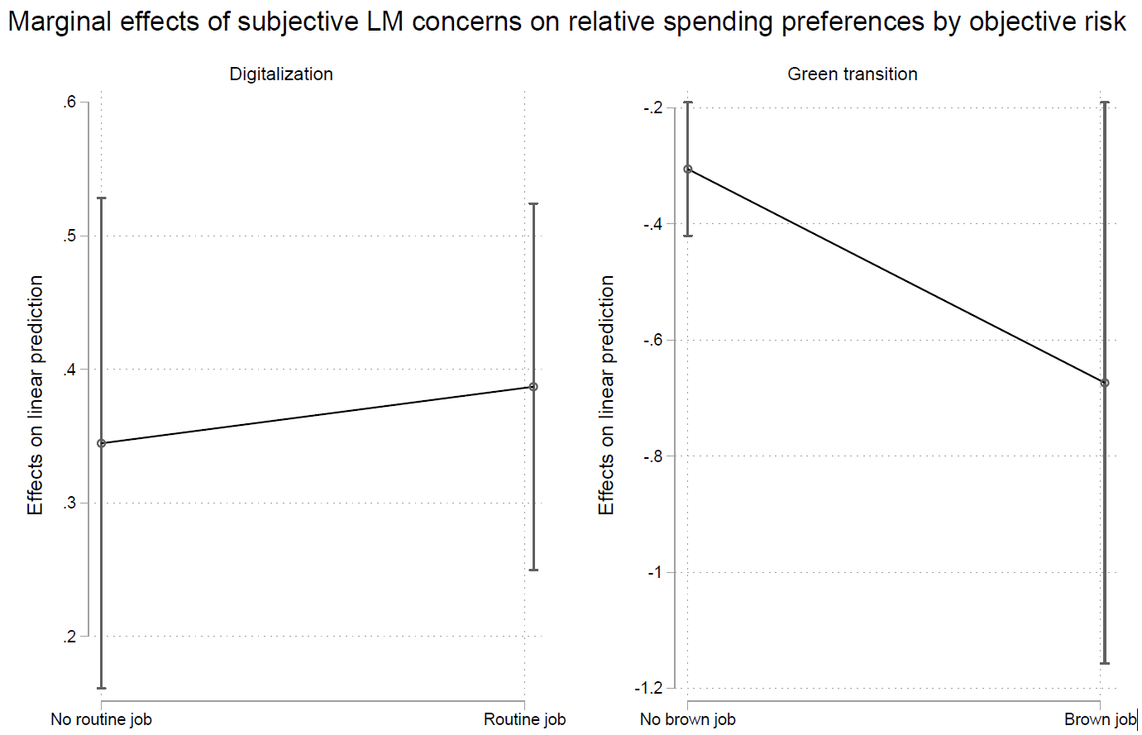
When it comes to heterogeneities in the impact of subjective labour market concern on relative spending preferences with respect to objective labour market risk for the respective transition, Figure A4 shows that there are no significant differences in the impact of perceiving digitalization as a labour market threat on relative spending preferences between individuals in routine jobs and those in non-routine jobs. On the other hand, the negative association between perceived labour market concern due to the green transition and preferences for relative public spending on the green transition is more pronounced among individuals in a brown job than among those in a non-brown job. However, this difference is not significant, with the confidence intervals for those in brown jobs being very large due to the small proportion of the sample working in brown jobs.
Next, we explore potential heterogeneities in the impact of subjective labour market concern on relative spending preferences across individuals’ education levels, income groups, and ideology. Figures A5 to A7 show that there are no significant patterns of how the association of labour market concern with relative spending preferences changes with an individual’s education level. This is similar for ideology – if anything, Figure A7 suggests that the impact of subjective labour market concern due to digitalization is concentrated among right-leaning individuals. In contrast, the impact of perceived risk due to the green transition is concentrated among individuals in the centre of the ideological spectrum. For individuals’ income levels, it can be seen that the negative association of perceived labour market threat with preferences for relative spending on the area perceived as threatening is concentrated among those who are coping and living comfortably for digitalization and among those with difficulties and who are coping for the green transition as a labour market threat.

Figure A5: Interactions between education level and subjective labour market concerns on relative spending preferences
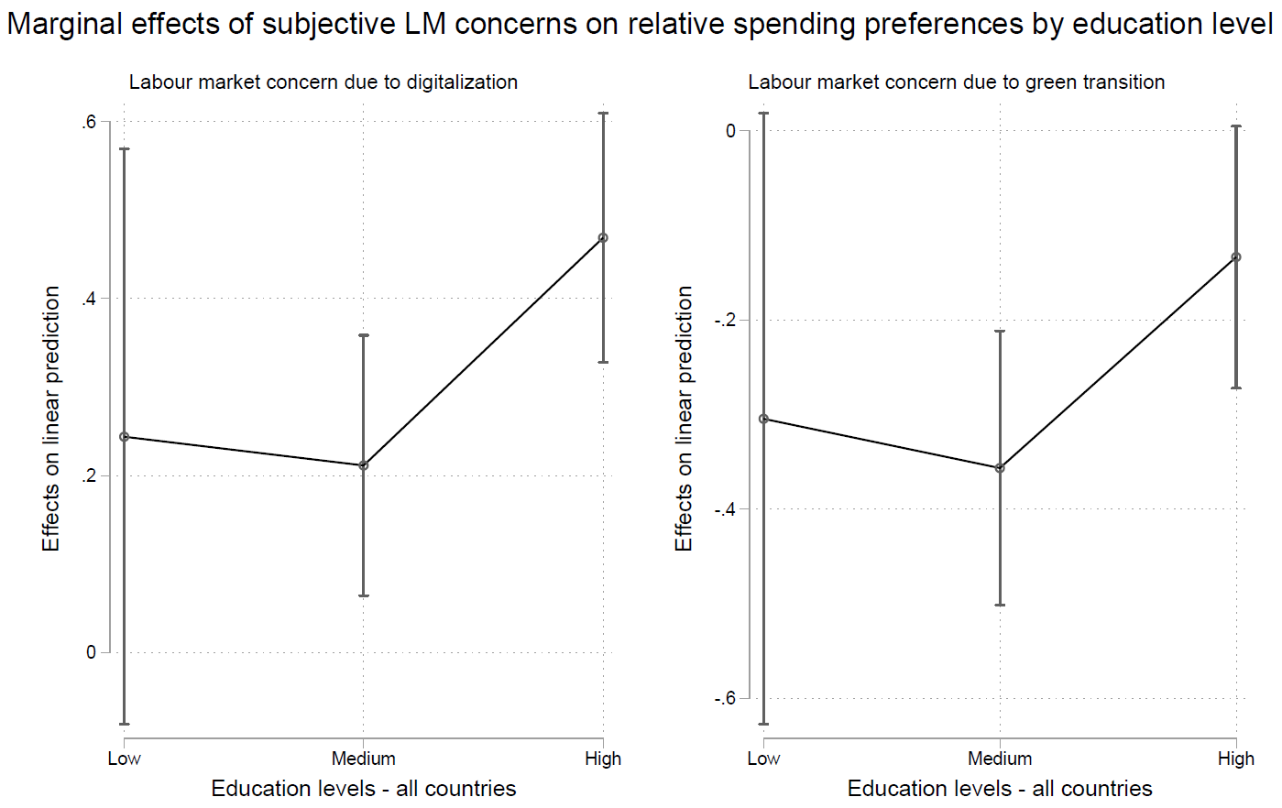

Figure A6: Interactions between income groups and subjective labour market concerns on relative spending preferences
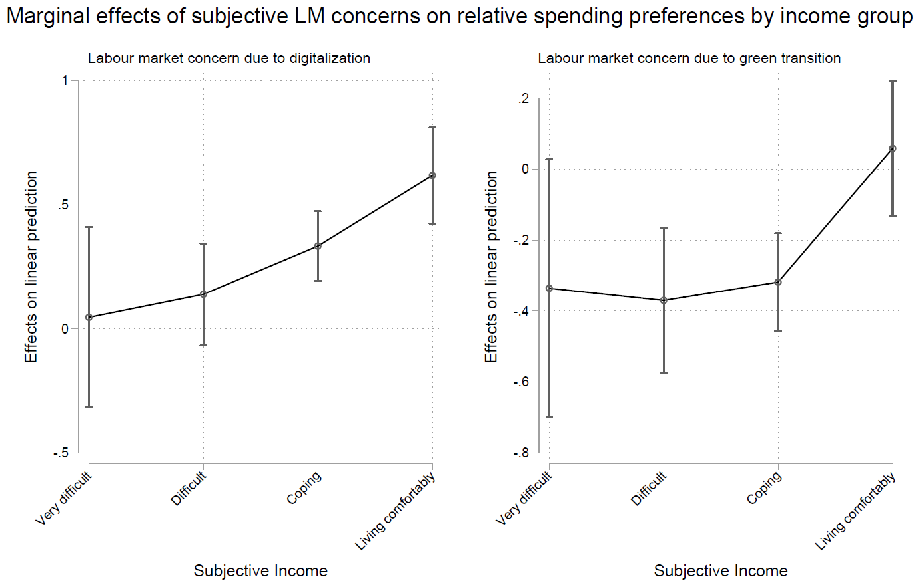

Figure A7: Interactions between ideology and subjective labour market concerns on relative spending preferences
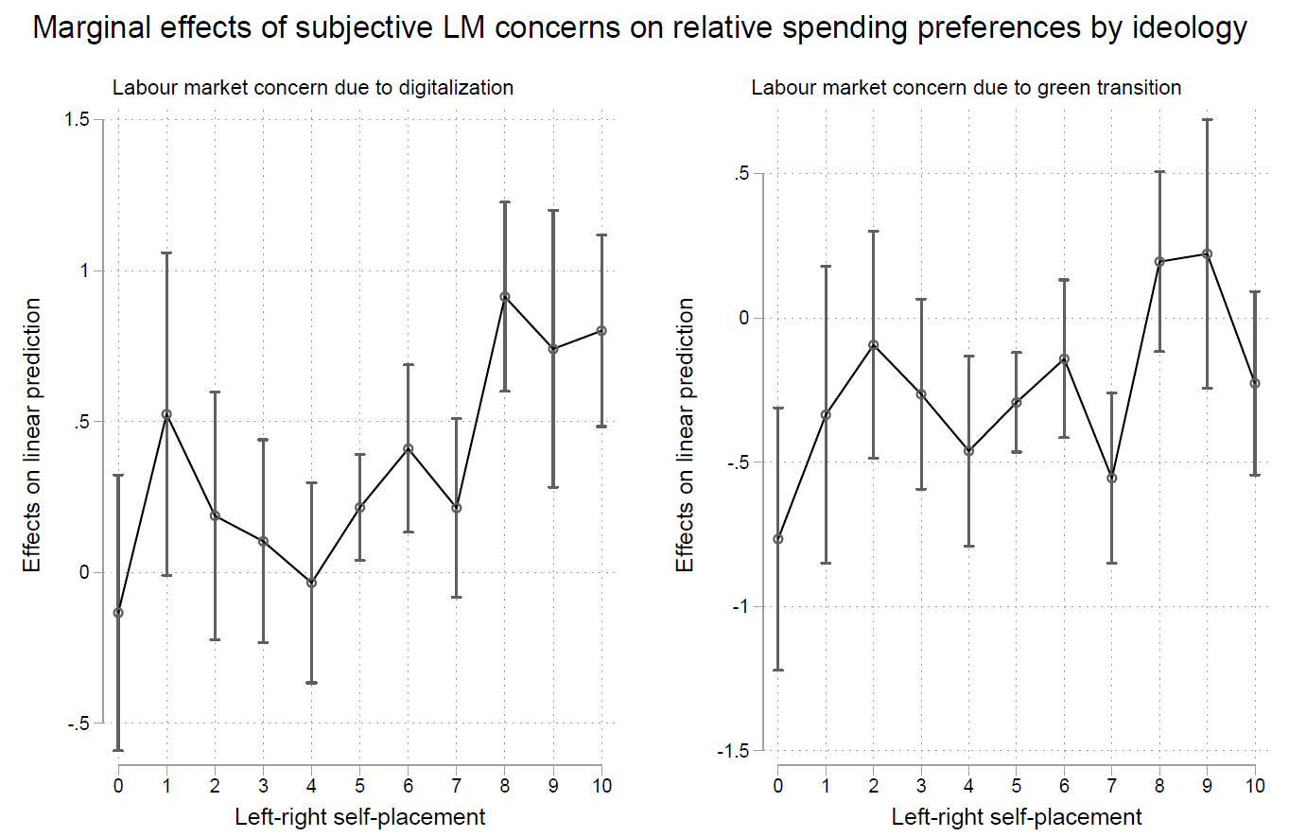

In addition to urgency perceptions portrayed in Figure A1 and subjective labour market concern shown in Figure A3, Figure A8 shows how occupational groups correlate with other social characteristics. As we would expect, the share of women in our sample is highest among clerical, service, and sales occupations and technicians, while it is lowest in trades and assembler occupations. Regarding the share of climate skeptics and the share who perceive a trade-off between digitalization and the green transition, variation across occupational groups is much lower. When it comes to climate skepticism, this is most widespread among assemblers and individuals in trades and elementary occupations, where the share reaches almost 50 percent. On the other hand, the belief that there is a trade-off between the two transitions is most widespread among managers, while it is lowest among professionals and those in clerical support and sales and services.
Figure A8: Distribution of gender, climate skeptics and perception of trade-off between green transition and digitalization across occupational groups
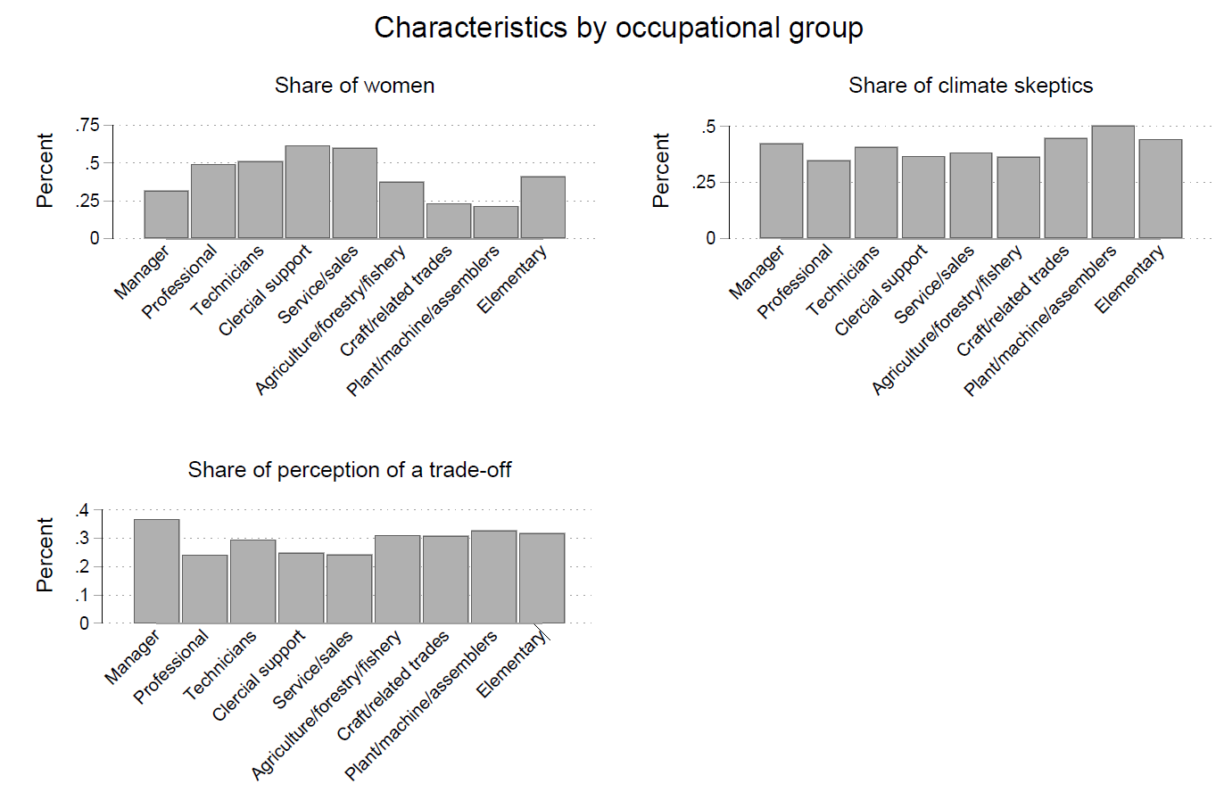

Appendix B: Descriptive results
Figure A9: Urgency perceptions of the green transition and digitalization across countries by environmental performance and digital competitiveness
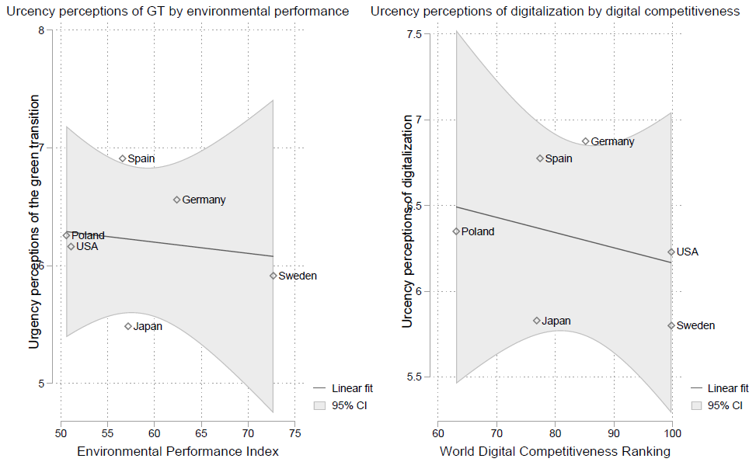
Figure A9 shows that the average perceptions of urgency of the two transitions across countries are not correlated with how advanced a country is in terms of either of the two transitions, as measured by the Environmental Performance Index (Wolf et al. 2022) and the World Digital Competitiveness Ranking (International Institute for Management Development 2022). In addition, there is considerable variation average urgency perceptions across countries for both transitions, even though climate change can be argued to threaten all the countries in our sample in a similar way, underscoring the point that individual perceptions may not always align with objective conditions.
Figure A10: Frequency distribution of respondents' individual labour market concern due to digitalization
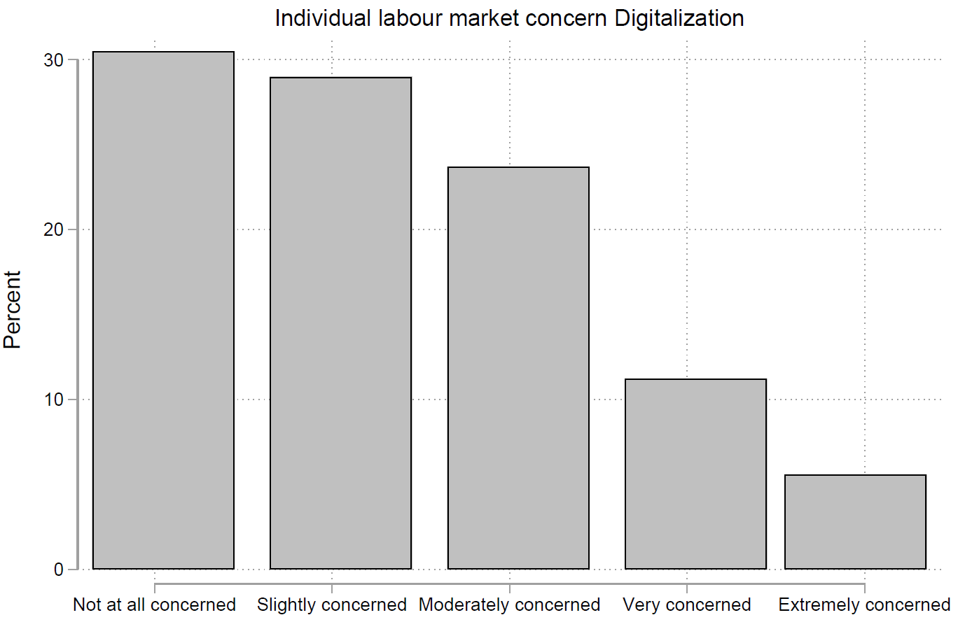
Figure A11: Frequency distribution of respondents' individual labour market concern due to the green transition
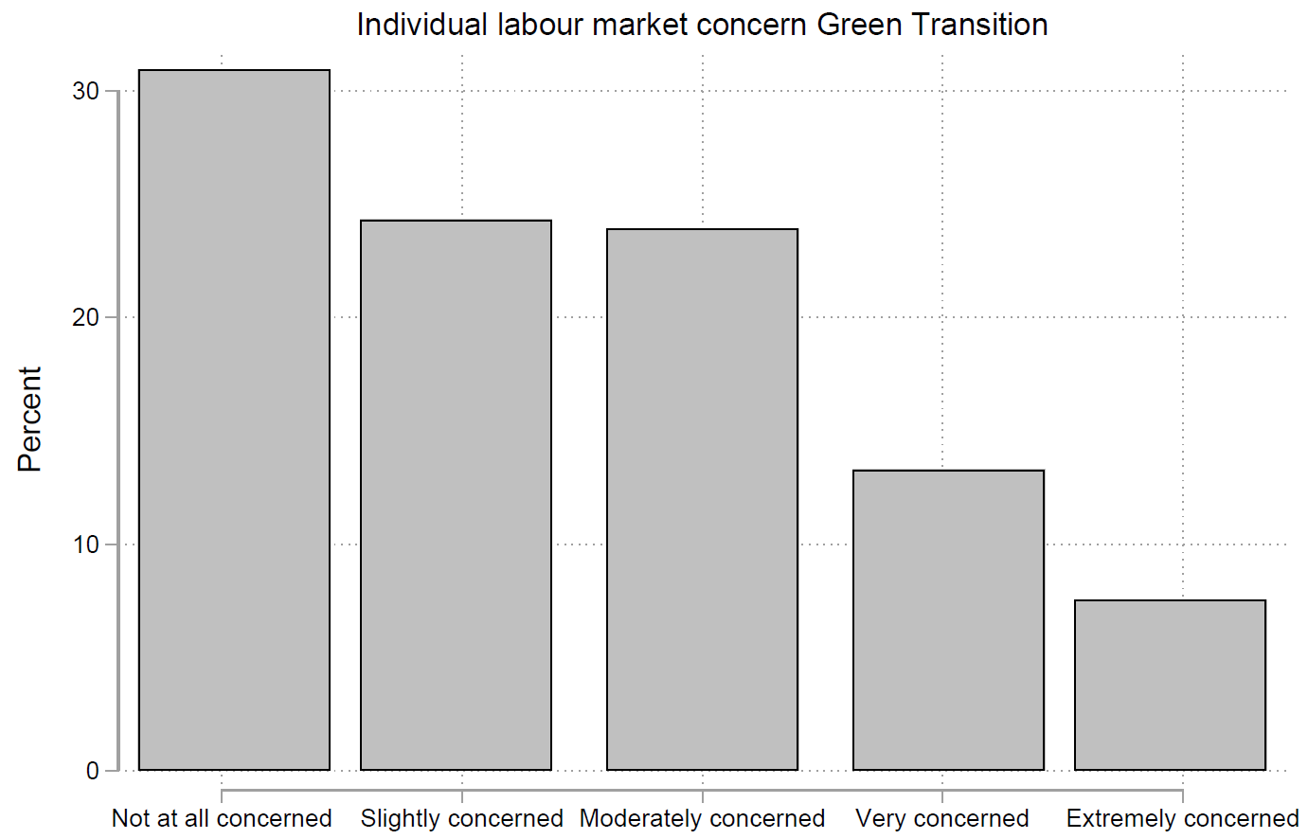

Figure A12: Distribution of high subjective labour market concern across countries
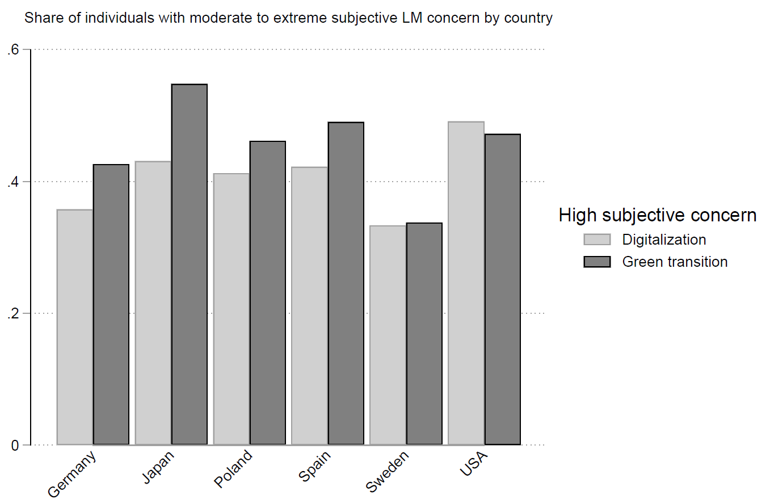
Appendix C: Tables and Figures for main regression analyses
Table A1: Regression output of main model and robustness models
DV: relative spending preferences
 | (1) | (2) | (3) | (4) | (5) | (6)
 | Model 1 | Model 2 | Model 3 | Model 4 | Model 5 | Model 6
Individual LM concern GT | -0.245***  (0.052) | -0.313***  (0.058) | -0.223**  (0.072) | -0.185**  (0.067) | -0.160**  (0.052) | -0.318***  (0.058)
Individual LM concern Digi | 0.334***  (0.053) | 0.366***  (0.059) | 0.383***  (0.073) | 0.216**  (0.067) | 0.335***  (0.053) | 0.369***  (0.058)
Female | 0.130**  (0.047) | 0.116*  (0.052) | 0.157*  (0.066) | 0.207***  (0.060) | 0.139**  (0.047) | 0.102⁺  (0.053)
Subjective Income | 0.164***  (0.028) | 0.098**  (0.032) | 0.066⁺  (0.039) | 0.028  (0.037) | 0.065*  (0.029) | 0.087**  (0.032)
Left-right self-placement | -0.007  (0.009) | -0.043***  (0.010) | -0.026*  (0.013) | -0.001  (0.012) | 0.013  (0.010) | -0.043***  (0.010)
Age - Ref: 18-34 years
Between 35 and 49 years | -0.028  (0.056) | -0.019  (0.064) | -0.022  (0.078) | 0.086  (0.071) | 0.005  (0.056) | -0.007  (0.063)
Between 50 and 64 years | -0.322***  (0.059) | -0.287***  (0.066) | -0.113  (0.083) | -0.098  (0.078) | -0.260***  (0.060) | -0.266***  (0.066)
Education - Ref: Low
Medium | -0.183⁺  (0.093) | -0.267*  (0.110) | -0.212  (0.133) | -0.013  (0.116) | -0.250**  (0.095) | -0.310**  (0.110)
High | -0.046  (0.091) | -0.181⁺  (0.108) | -0.202  (0.130) | 0.068  (0.114) | -0.212*  (0.092) | -0.237*  (0.112)
Brownness score |  | -0.714**  (0.231)
RTI score |  | 0.034  (0.038)
Preparedness for Digi in LM |  |  | 0.160***  (0.014)
Urgency of Digi |  |  | 0.172***  (0.017)
Preparedness for GT in LM |  |  |  | 0.156***  (0.013)
Urgency of GT |  |  |  | 0.288***  (0.014)
Distrust in government |  |  |  |  | -0.426***  (0.026)
Pro private business |  |  |  |  | -0.038  (0.024)
Climate skepticism |  |  |  |  | -0.456***  (0.043)
Occupational group - Ref: Manager
Professional |  |  |  |  |  | 0.039  (0.099)
Technicians |  |  |  |  |  | -0.031  (0.096)
Clerical support |  |  |  |  |  | 0.106  (0.105)
Service/sales |  |  |  |  |  | 0.101  (0.109)
Agriculture/forestry/fishery |  |  |  |  |  | -0.742*  (0.333)
Craft/related trades |  |  |  |  |  | -0.175  (0.134)
Plant/machine/assemblers |  |  |  |  |  | -0.318*  (0.142)
Elementary |  |  |  |  |  | 0.071  (0.121)
Country Fixed Effects | Yes | Yes | Yes | Yes | Yes | Yes
Observations | 7867 | 6013 | 3959 | 3908 | 7510 | 6132
R² | 0.036 | 0.034 | 0.097 | 0.198 | 0.085 | 0.036
Standard errors in parentheses
⁺ p < 0.1, * p < 0.05, ** p < 0.01, *** p < 0.001

Figure A13: Cross-pressuredness and relative spending preferences
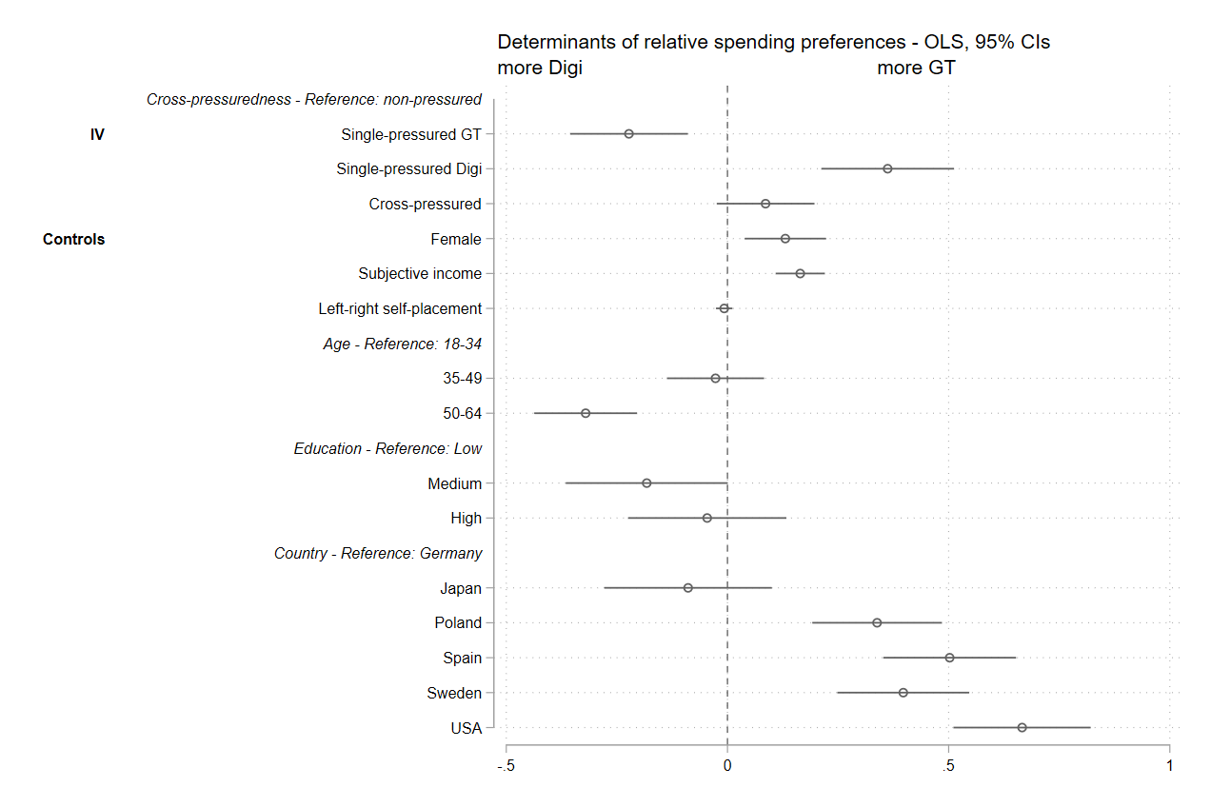

Table A2: Regression output of cross-pressuredness model
DV: relative spending preferences
 | (1)
 | Model 1
Cross-pressuredness - Ref: Non-pressured
Single-pressured GT | -0.223**  (0.068)
Single-pressured Digi | 0.362***  (0.077)
Cross-pressured | 0.086  (0.056)
Female | 0.131**  (0.047)
Subjective Income | 0.165***  (0.028)
Left-right self-placement | -0.007  (0.009)
Age - Ref: 18-34 years
Between 35 and 49 years | -0.027  (0.056)
Between 50 and 64 years | -0.321***  (0.059)
Education - Ref: Low
Medium | -0.182⁺  (0.093)
High | -0.046  (0.091)
Country Fixed Effects | Yes
Observations | 7867
R² | 0.036
Standard errors in parentheses
⁺ p < 0.1, * p < 0.05, ** p < 0.01, *** p < 0.001

Figure A14: Determinants of preferences on increasing unemployment benefits
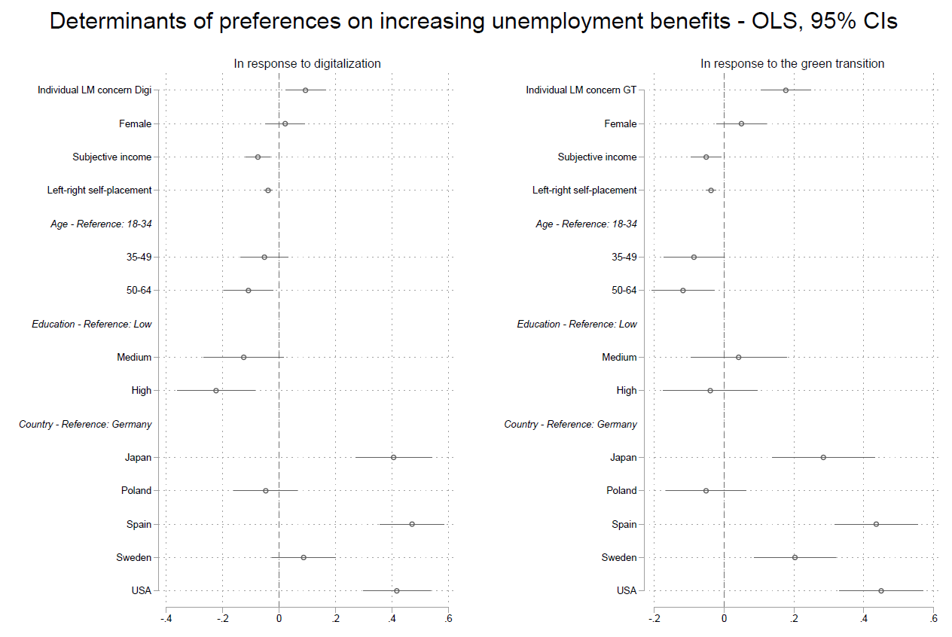

Figure A15: Determinants of preferences on subsidies to firms
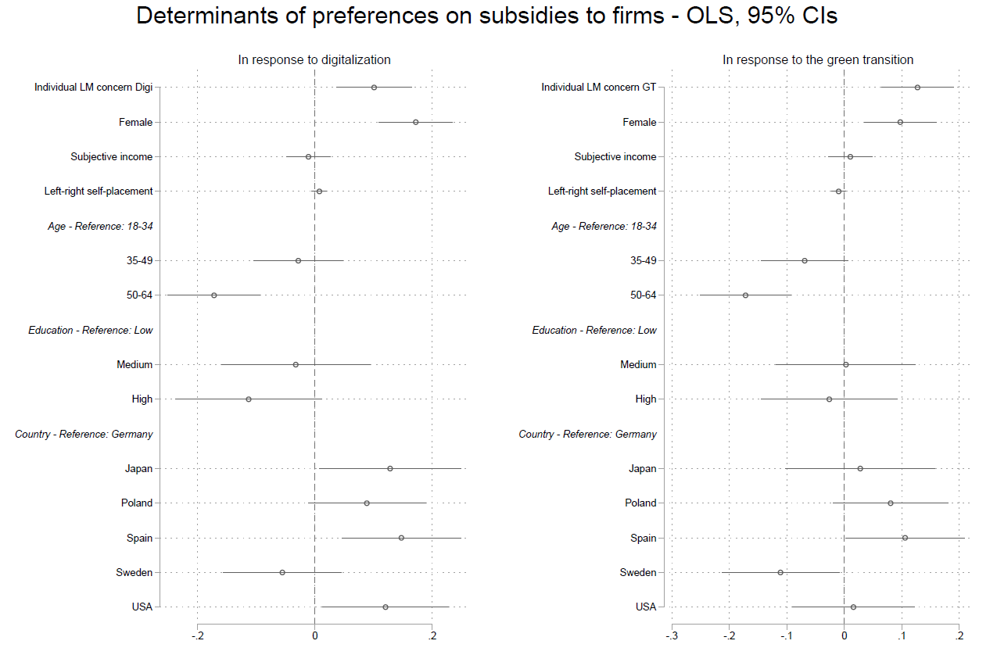

Appendix D: Tables and Figures for additional analyses and robustness checks
Table A3: Operationalization of additional control variables
Variable | Operationalization
Brownness indicator | Continuous scale from 0 to 1
RTI | Continuous scale from -1 to 1
Distrust in government | 4-point scale from ‘complete trust’ to ‘no trust at all’
‘Private enterprise is the best way to solve the country’s economic problems’ | 5-point scale from ‘strongly disagree’ to ‘strongly agree’
Climate skepticism | Categorical variable: 1 = ‘climate change mainly/entirely caused by human processes’, 2 = ‘climate change mainly/entirely caused by natural processes’, 3 = ‘climate change not happening’

Figure A16: Comparison of main model and additional controls I
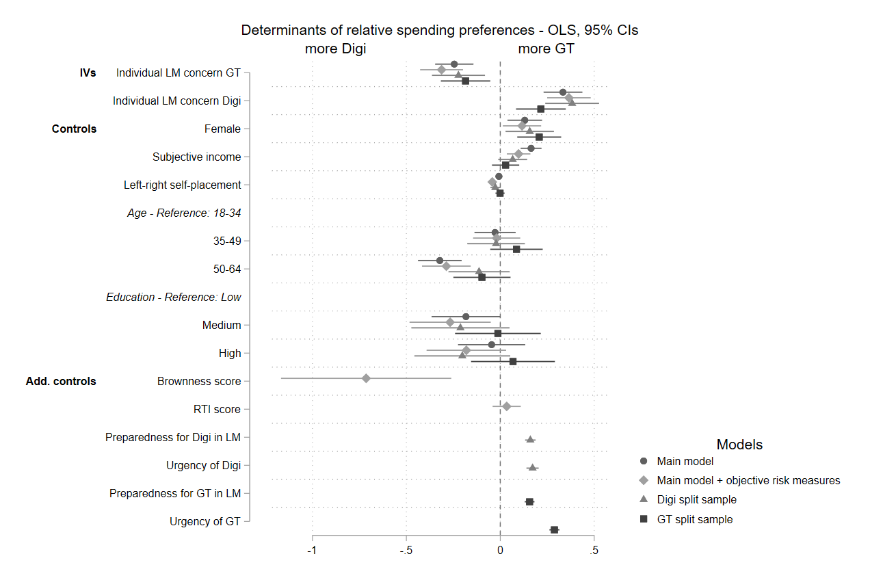
Figure A17: Comparison of main model and additional controls II
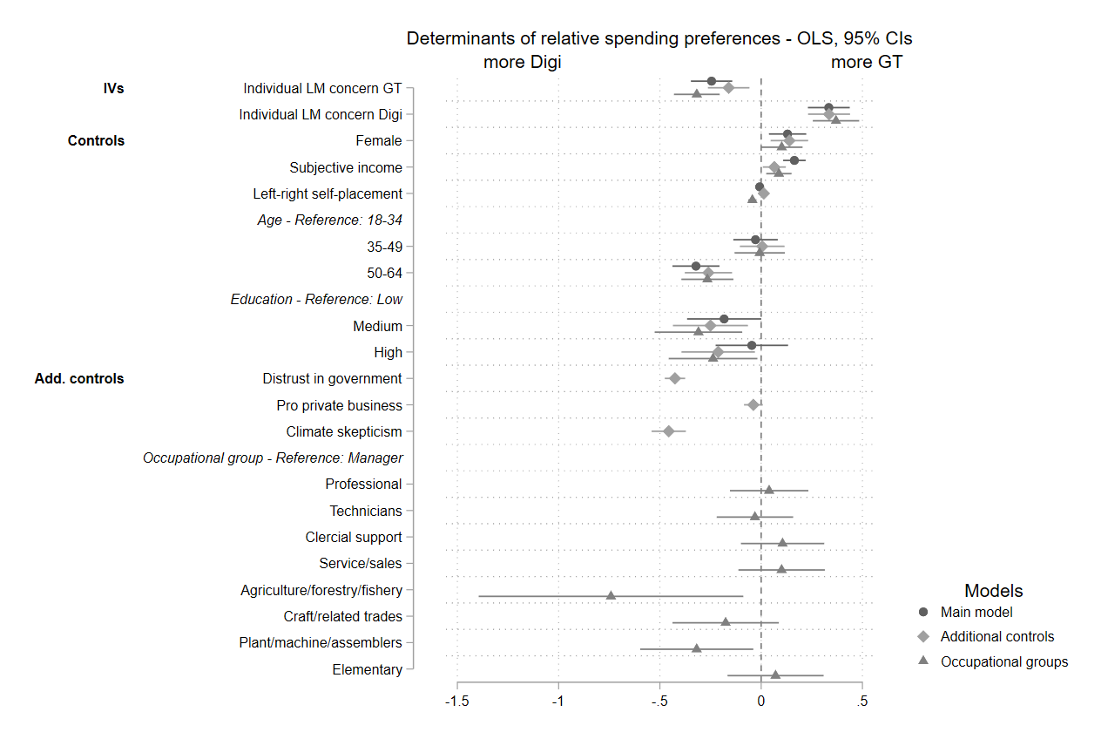
Figure A18: Comparison of pooled main model and model for each country
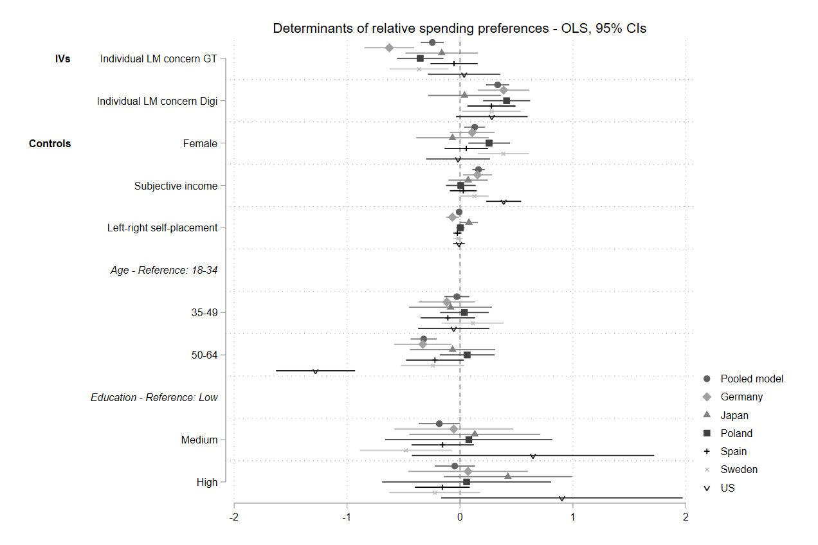
Figure A19: Multinomial logistic regression of determinants of relative spending preferences, main model
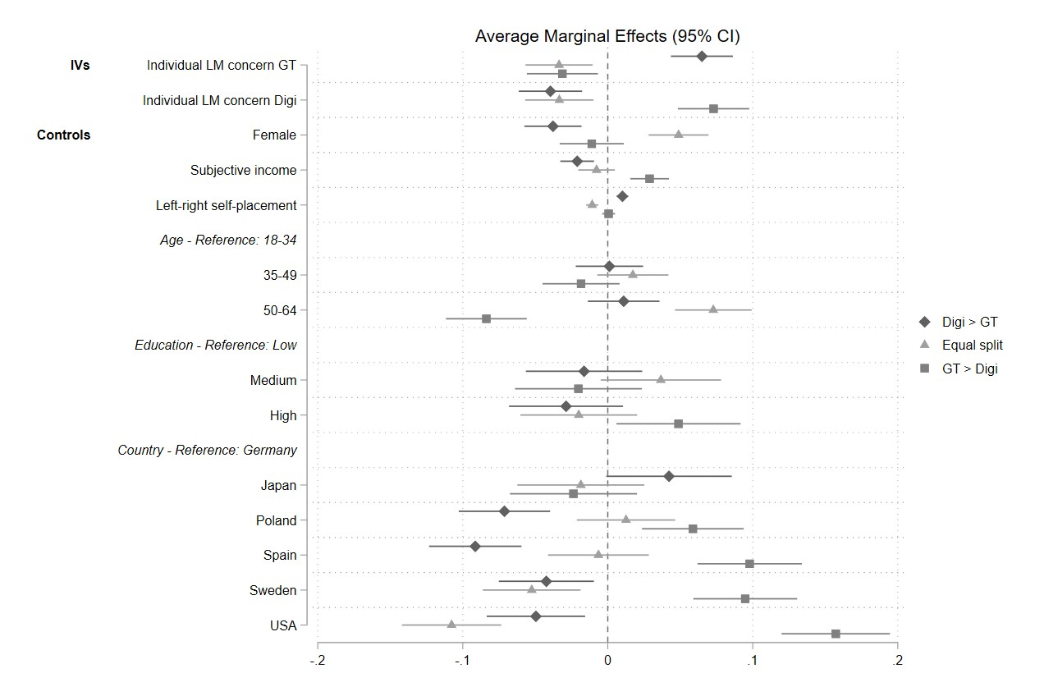
Figure A20: Multinomial logistic regression of determinants of relative spending preferences, additionally controlling for objective risk measures
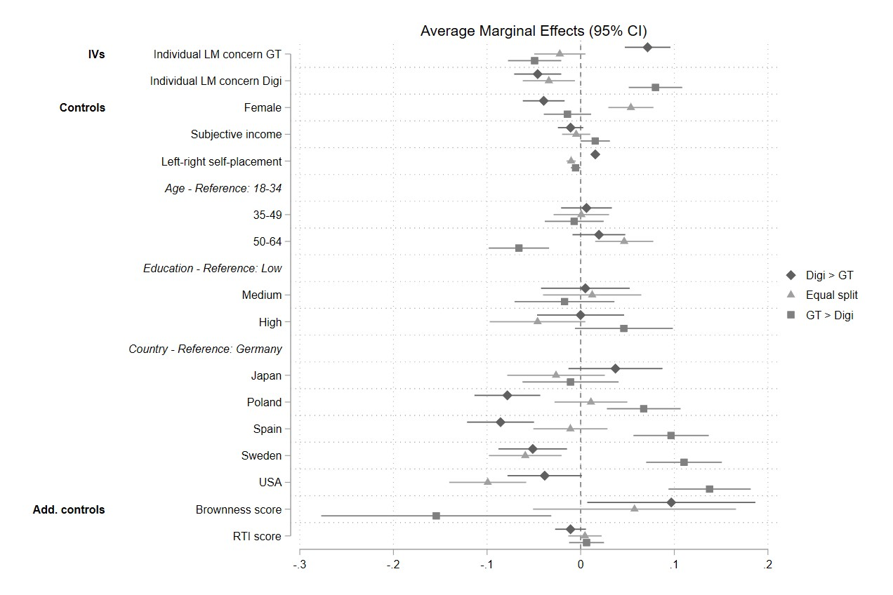

Figure A21: Multinomial logistic regression of determinants of relative spending preferences, additionally controlling for preparedness and urgency perceptions (green transition split sample)
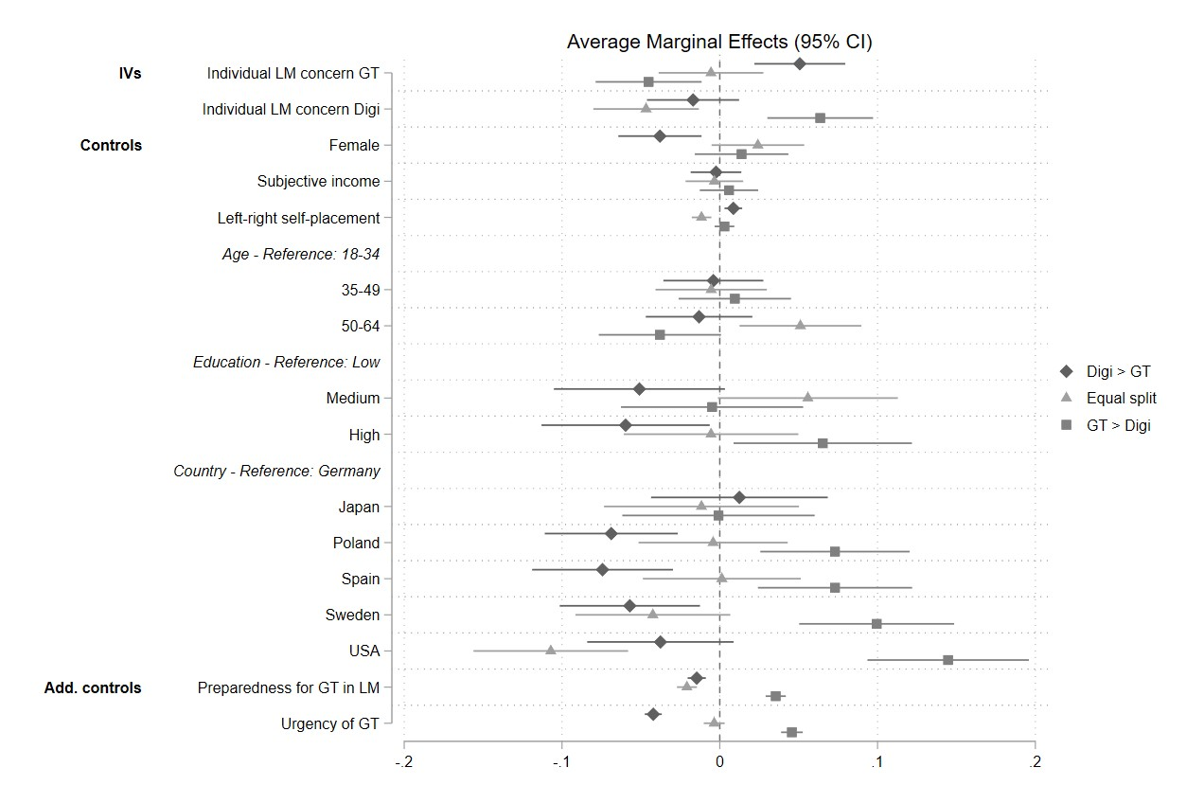
Figure A22: Multinomial logistic regression of determinants of relative spending preferences, additionally controlling for preparedness and urgency perceptions (digitalization split sample)
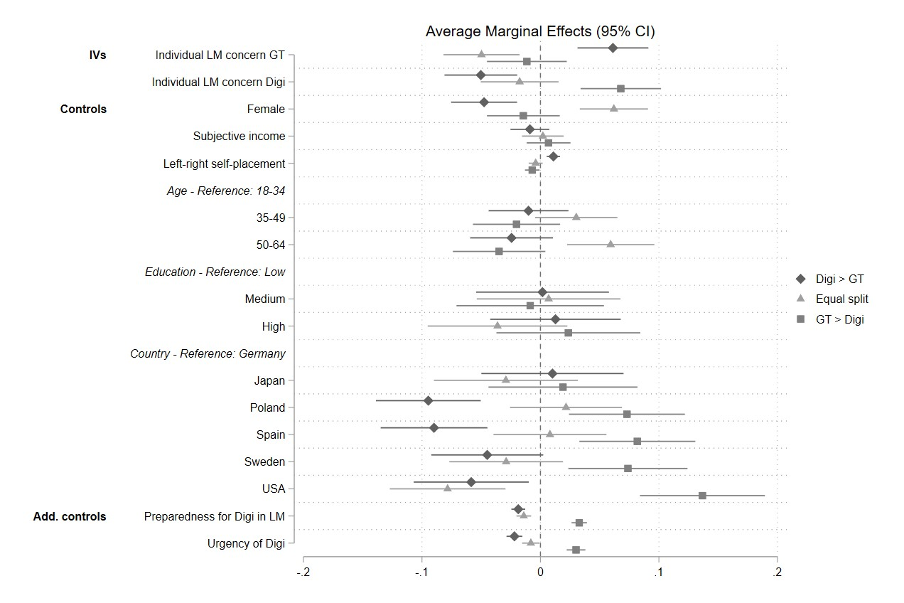
Figure A23: Multinomial logistic regression of determinants of relative spending preferences, additionally controlling for distrust in government, pro private business and climate skepticism
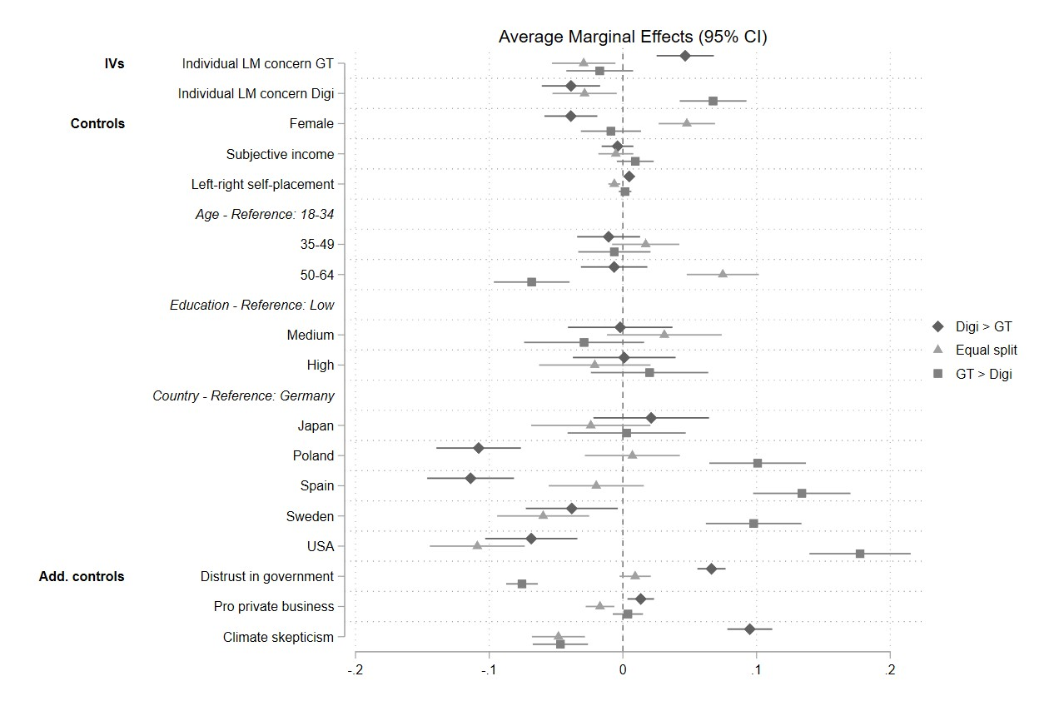
Figure A24: Multinomial logistic regression of determinants of relative spending preferences, additionally controlling for occupational groups
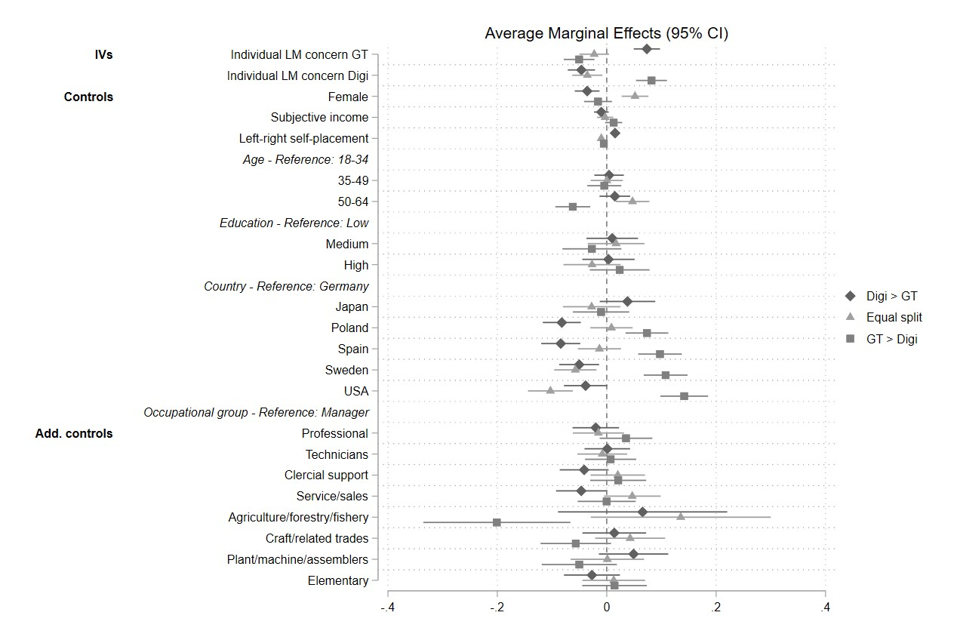

Figure A25: Determinants of relative spending preferences on digitalization and green transition with continuous measures of subjective labour market risk
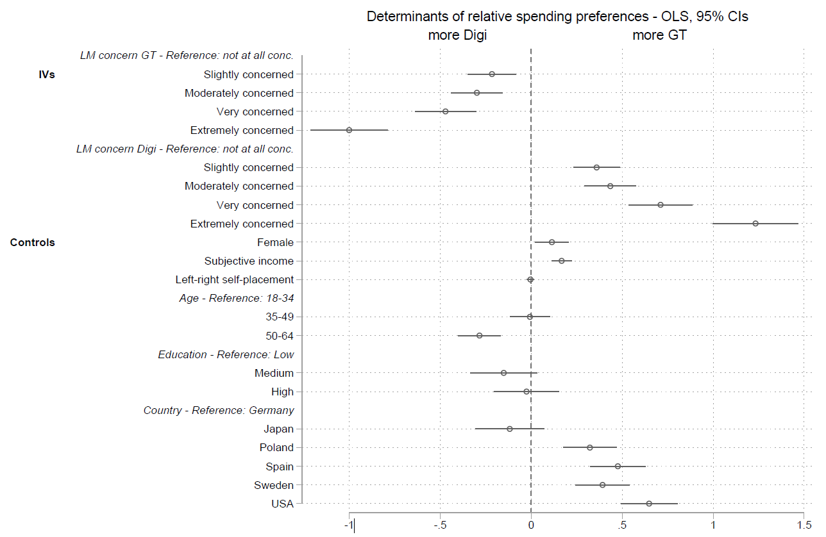
Figure A26: Cross-pressuredness with objective risk measures
