SUPPLEMENTARY MATERIAL
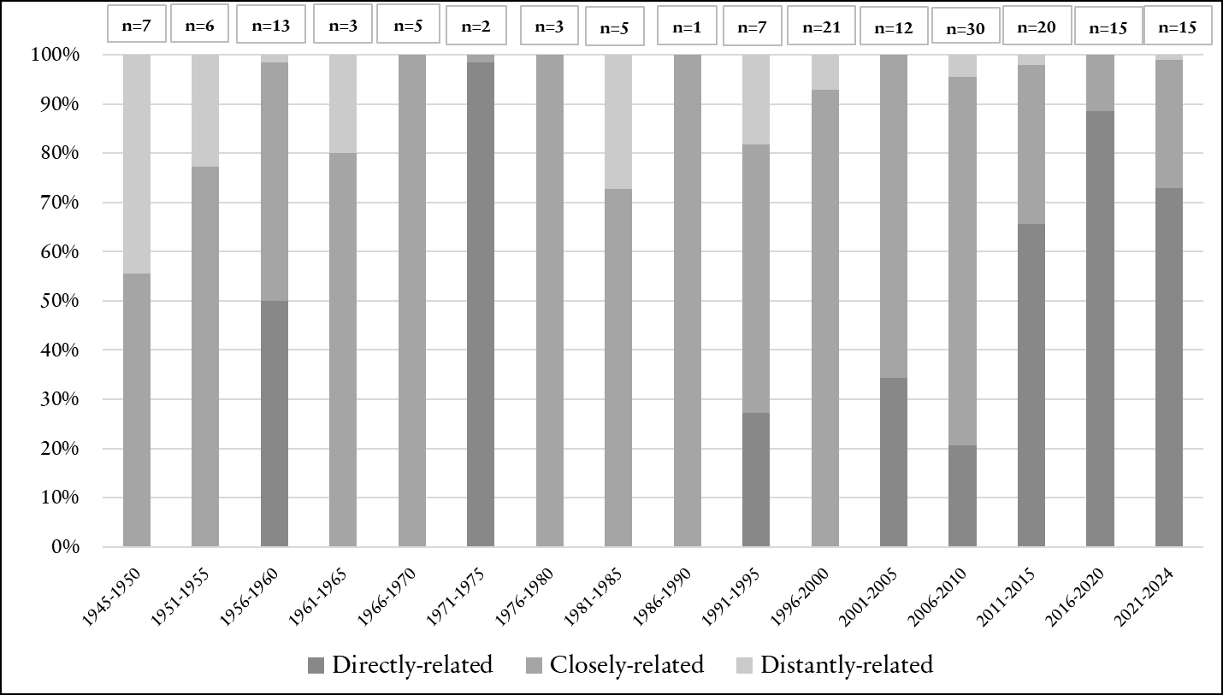
Figure 1. ‘Clean water’ keyword’s relatedness per time period and number of policy documents as per keyword-related
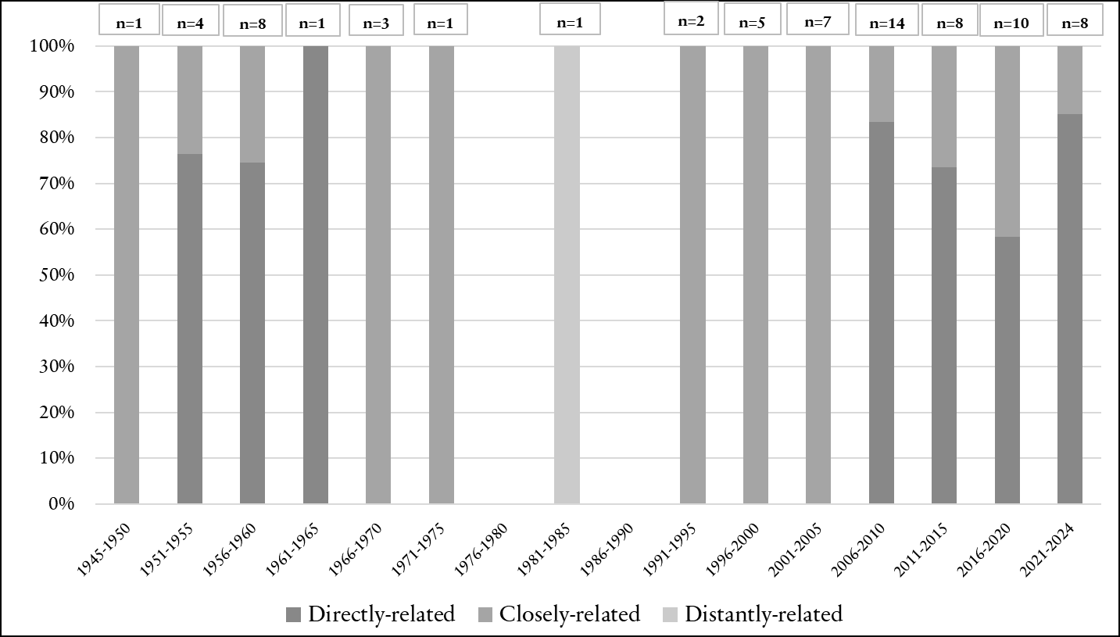
Figure 2. ‘Disease’ keyword’s relatedness per time period and number of policy documents as per keyword-related
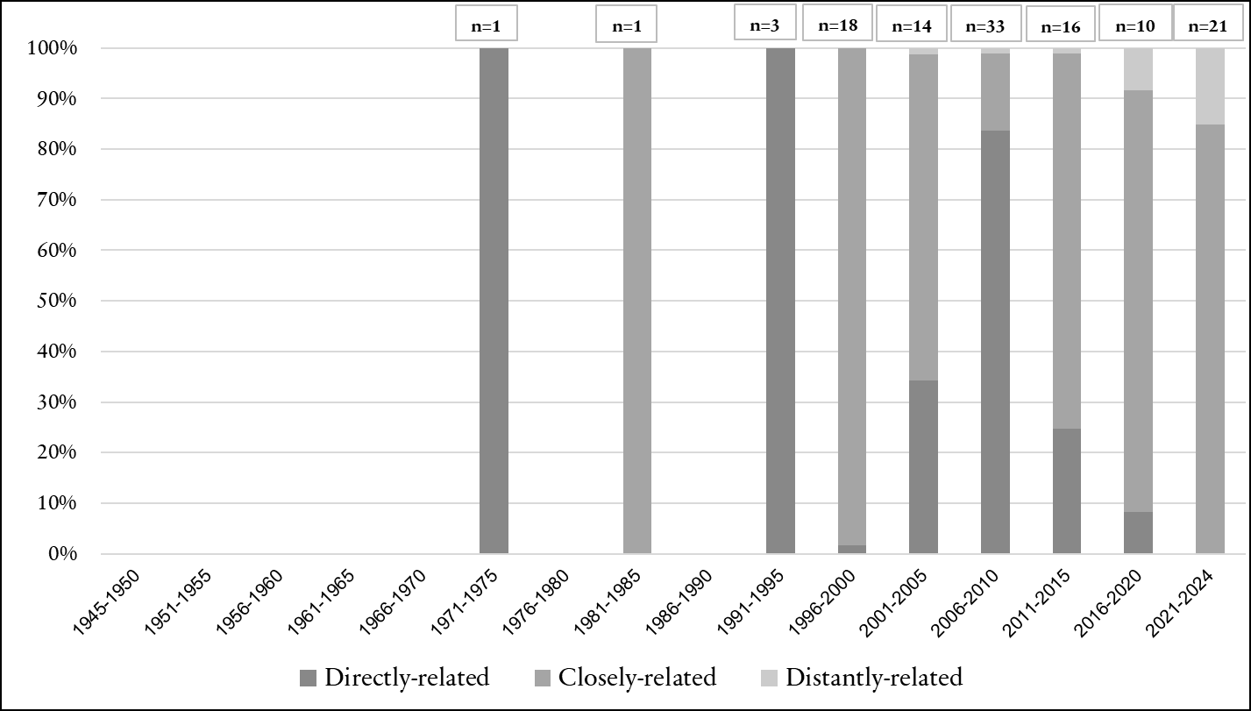
Figure 3. ‘Energy’ keyword’s relatedness per time period and number of policy documents as per keyword-related
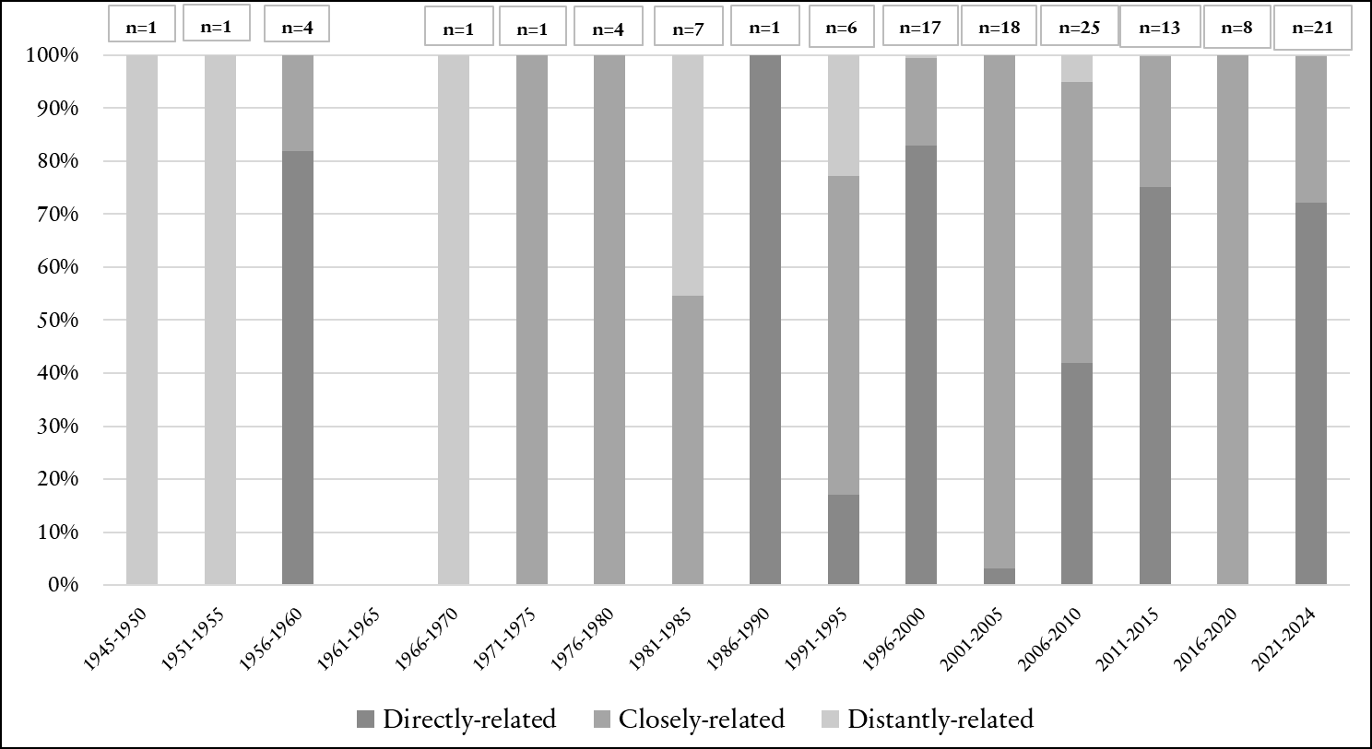
Figure 4. ‘Environment’ keyword’s relatedness per time period and number of policy documents as per keyword-related

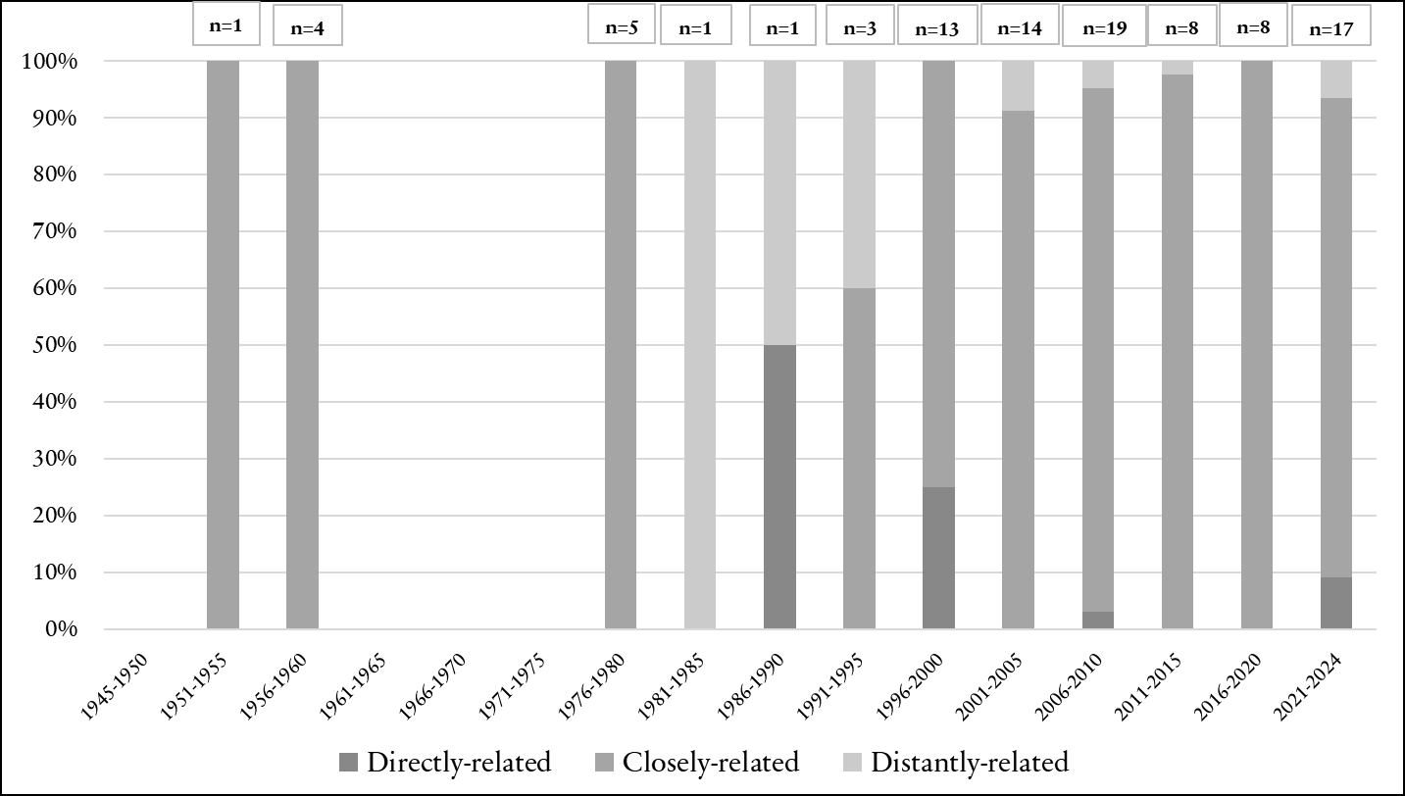
Figure 5. ‘Green space’ keyword’s relatedness per time period and number of policy documents as per keyword-related
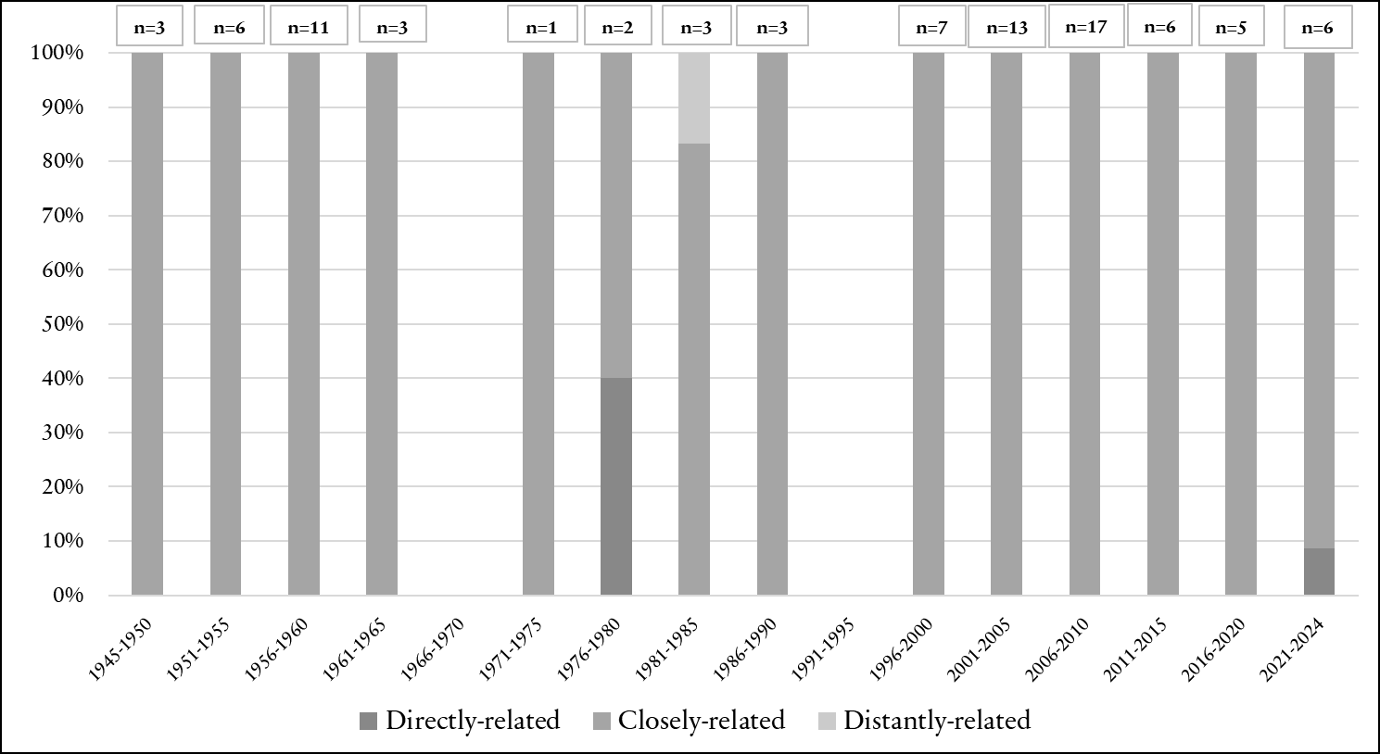
Figure 6. ‘Illness’ keyword’s relatedness per time period and number of policy documents as per keyword-related
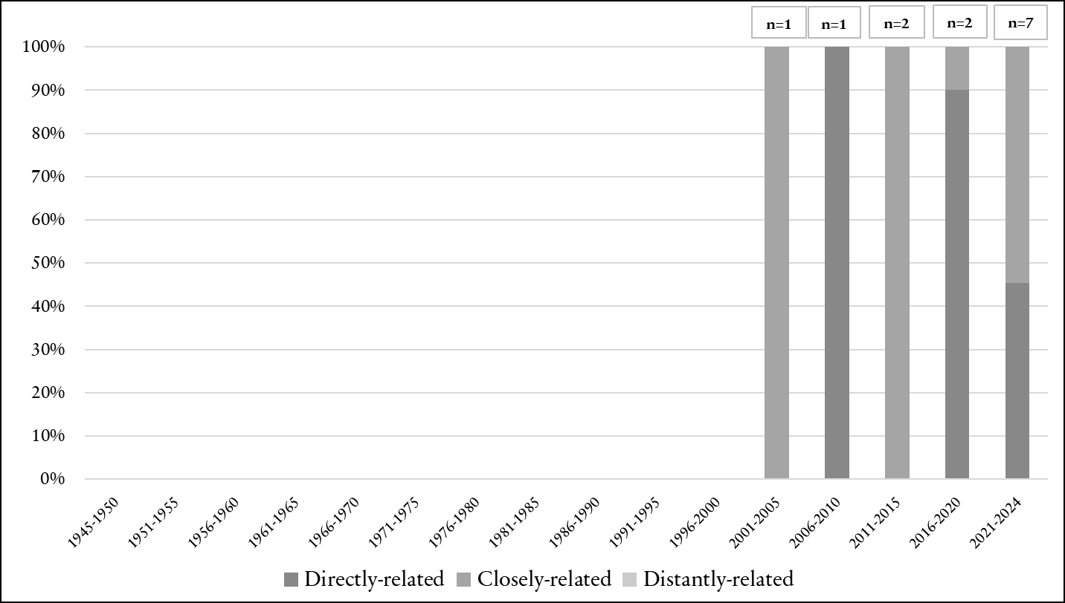
Figure 7. ‘Inclusivity’ keyword’s relatedness per time period and number of policy documents as per keyword-related
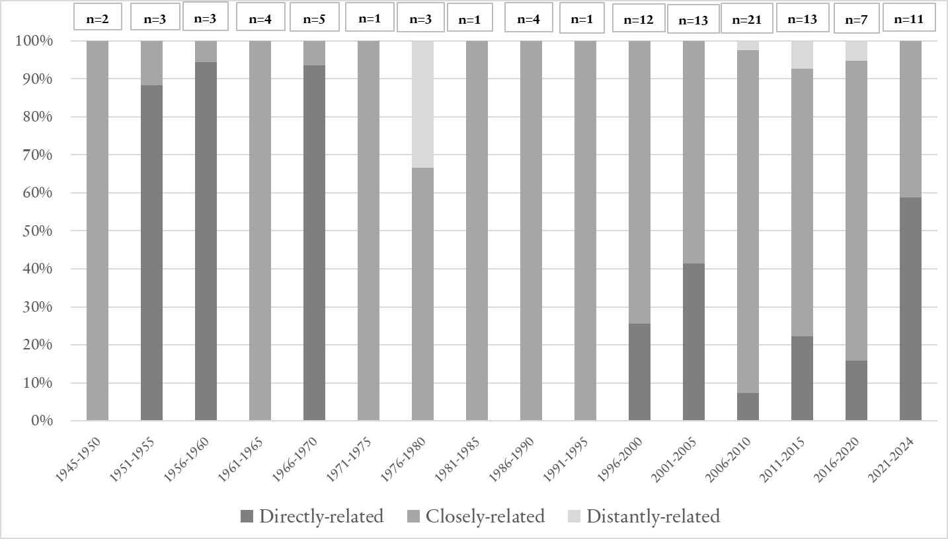
Figure 8. ‘Mental health’ keyword’s relatedness per time period and number of policy documents as per keyword-related
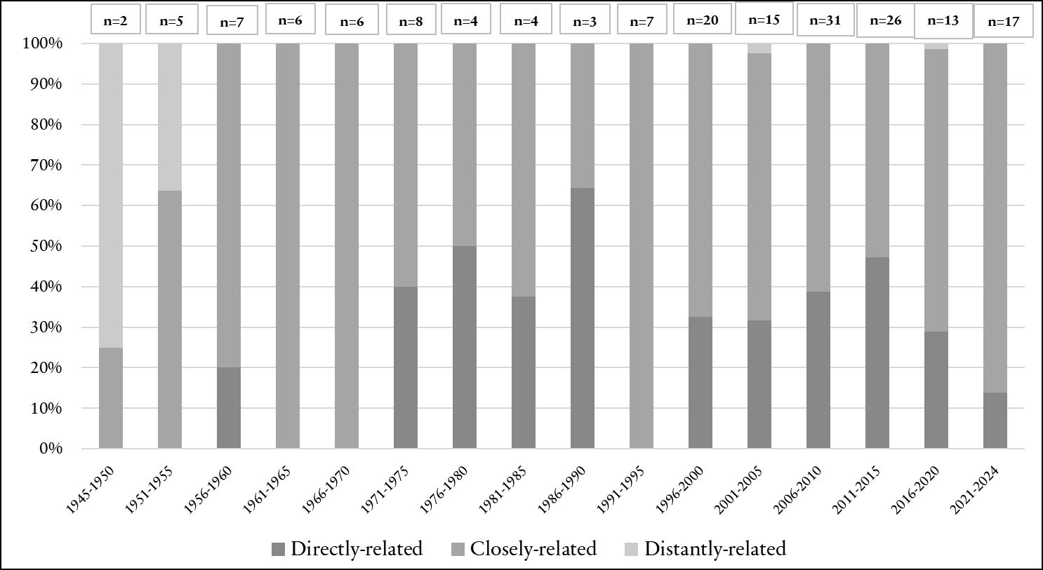
Figure 9. ‘Participatory’ keyword’s relatedness per time period and number of policy documents as per keyword-related
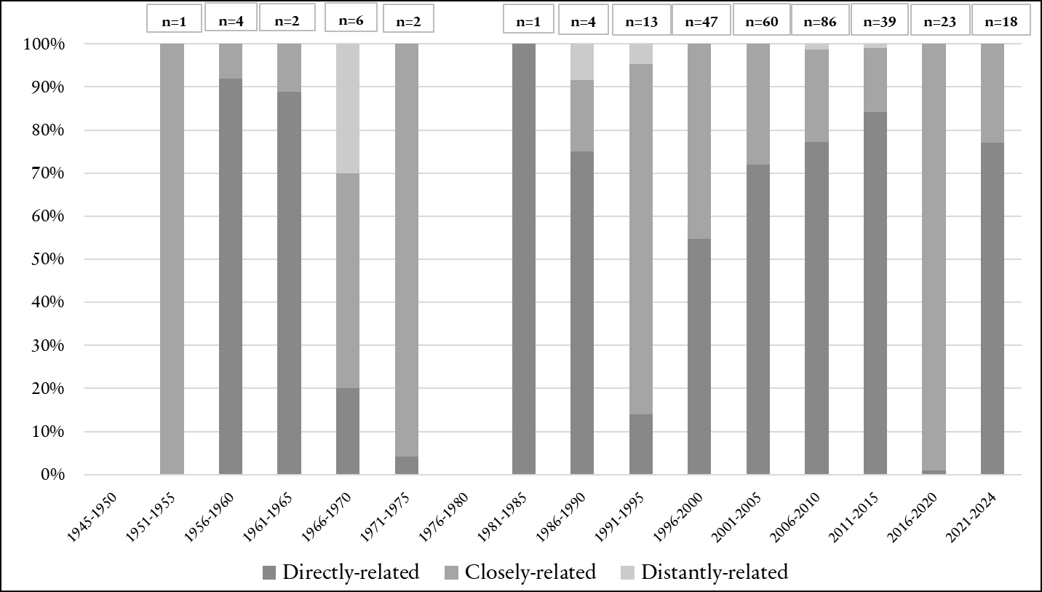
Figure 10. ‘Planning’ keyword’s relatedness per time period and number of policy documents as per keyword-related

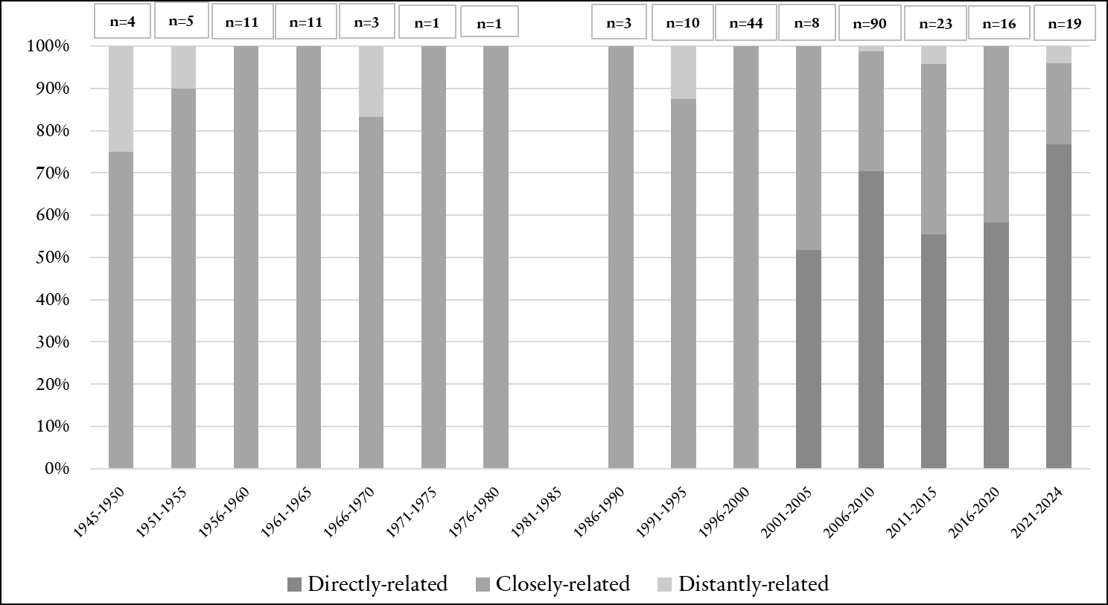
Figure 11. ‘Public space’ keyword’s relatedness per time period and number of policy documents as per keyword-related
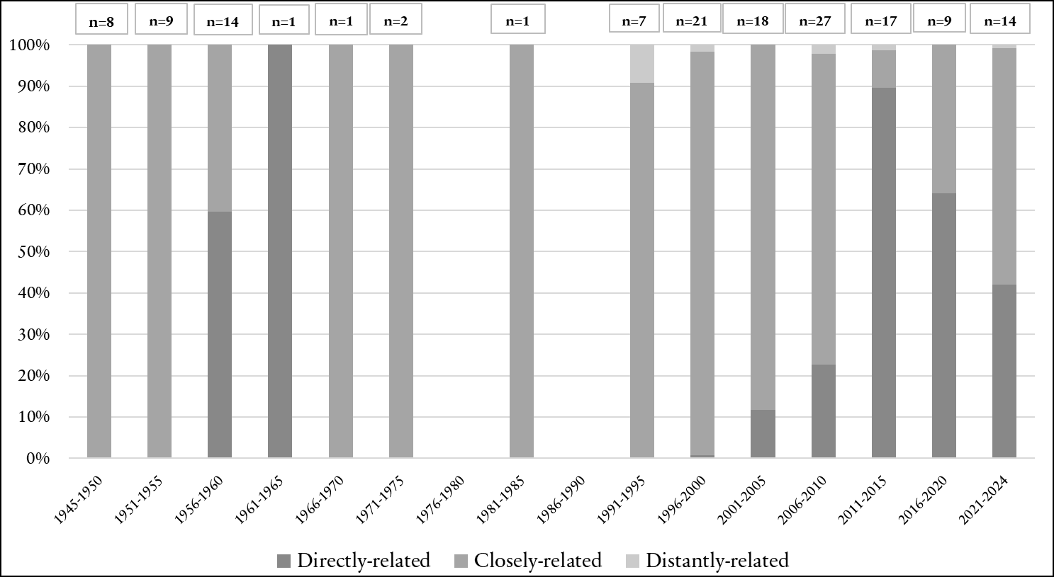
Figure 12. ‘Residential/Housing’ keyword’s relatedness per time period and number of policy documents as per keyword-related

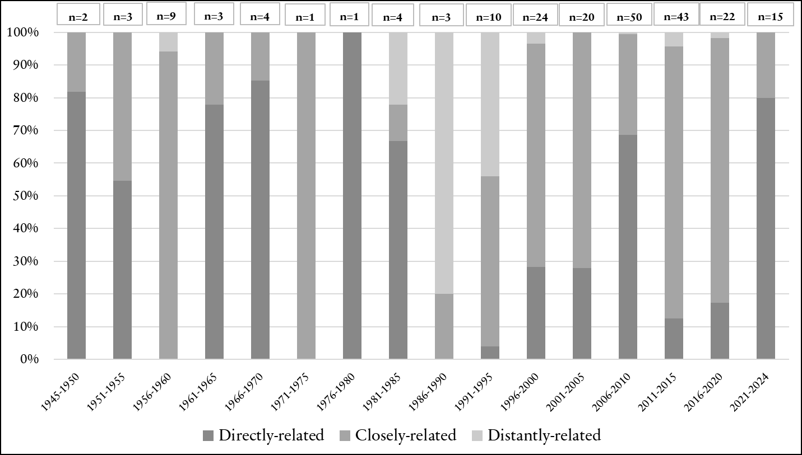
Figure 13. ‘Safety/safe’ keyword’s relatedness per time period and number of policy documents as per keyword-related
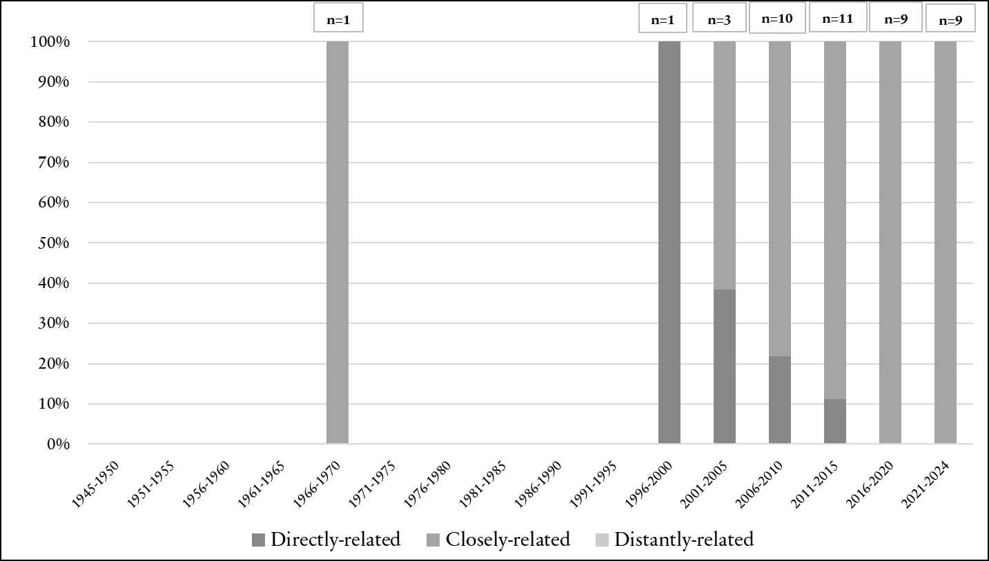
Figure 14. ‘Sanitation’ keyword’s relatedness per time period and number of policy documents as per keyword-related
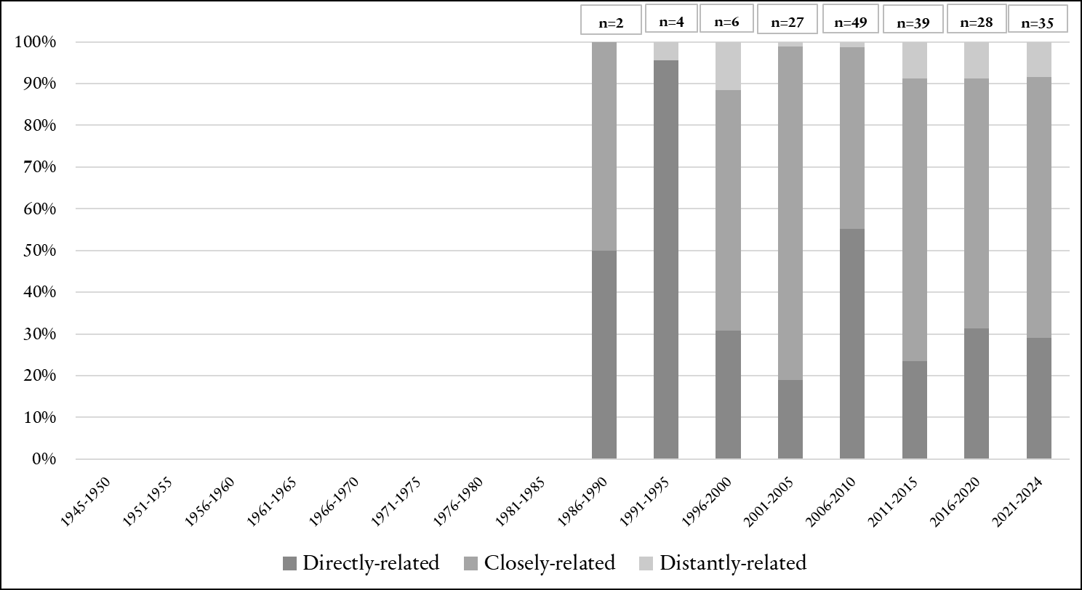
Figure 15. ‘Sustainable’ keyword’s relatedness per time period and number of policy documents as per keyword-related
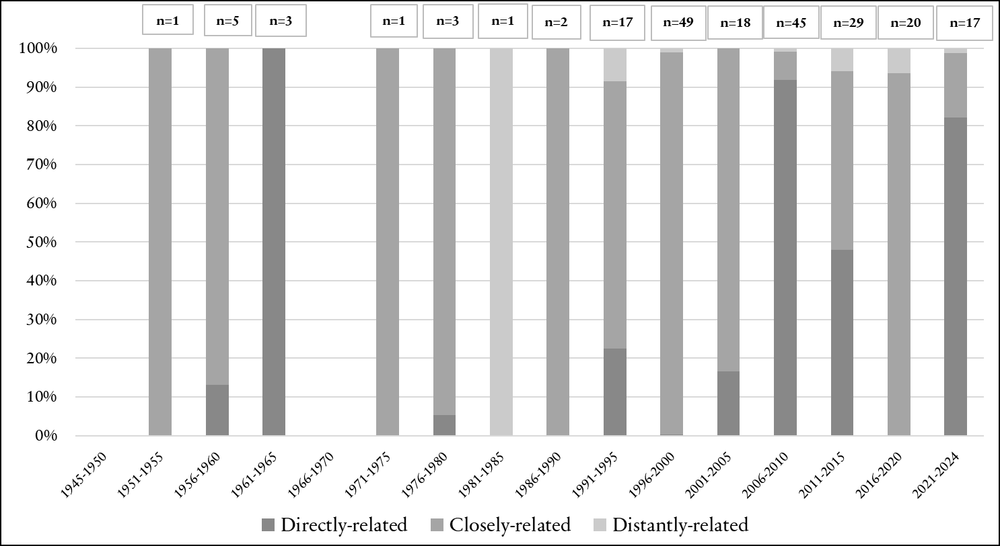
Figure 16. ‘Transportation’ keyword’s relatedness per time period and number of policy documents as per keyword-related
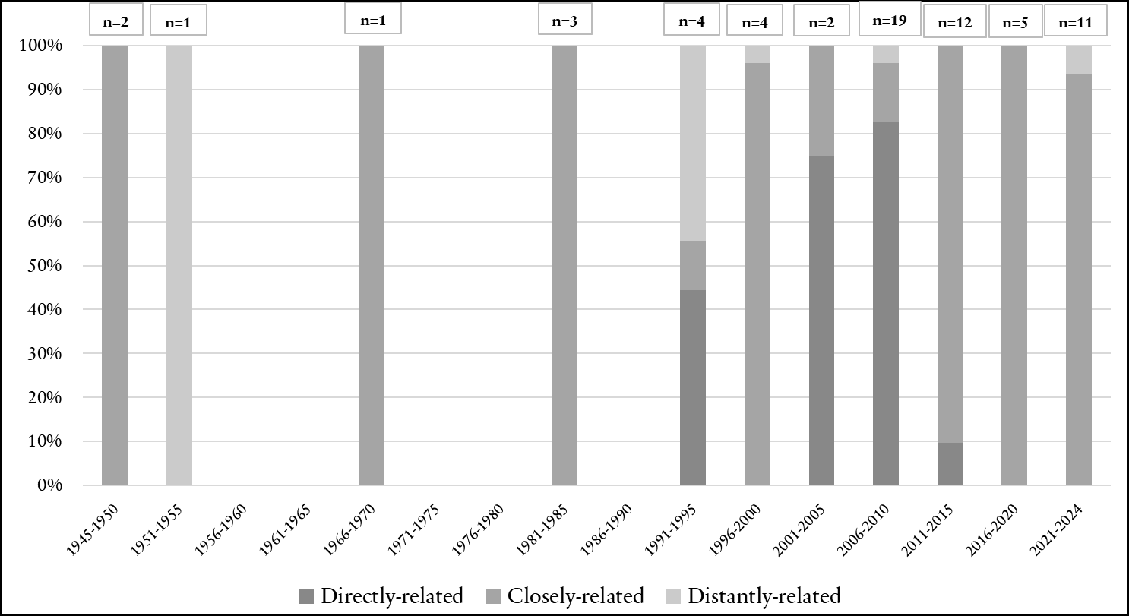
Figure 17. ‘Waste management’ keyword’s relatedness per time period and number of policy documents as per keyword-related

