**Appendix 1. Example of Policy Learning in the Text**

We present a specific example to illustrate policy learning from text. As mentioned in the Methods section, learning from text focuses on the similarity between two policies in their concrete implementation. Figure A1-1 shows the content of two clauses from Qinghai Province and one clause from Shaanxi Province, and calculates their similarity using the bag-of-words approach.

The first clause from Qinghai Province states that individuals can report units and individuals who pollute and damage the ecological environment. This content is essentially the same as the clause from Shaanxi Province. We use highlighting to show the parts that are nearly identical in Figure A1-1. There is a slight difference between the two provinces, where Qinghai Province supplements the right of individuals to obtain environment-related information, while Shaanxi Province emphasizes rewarding reporting behavior. In our algorithm, since their basic measures are similar, the similarity value is 0.75.

The second clause from Qinghai Province, however, discusses how to handle cross-administrative regional environmental pollution, which is completely unrelated to the clause from Shaanxi Province. Therefore, the calculated similarity value is relatively low at 0.24.

**Figure A1-1 Example of Policy Learning in the Text**

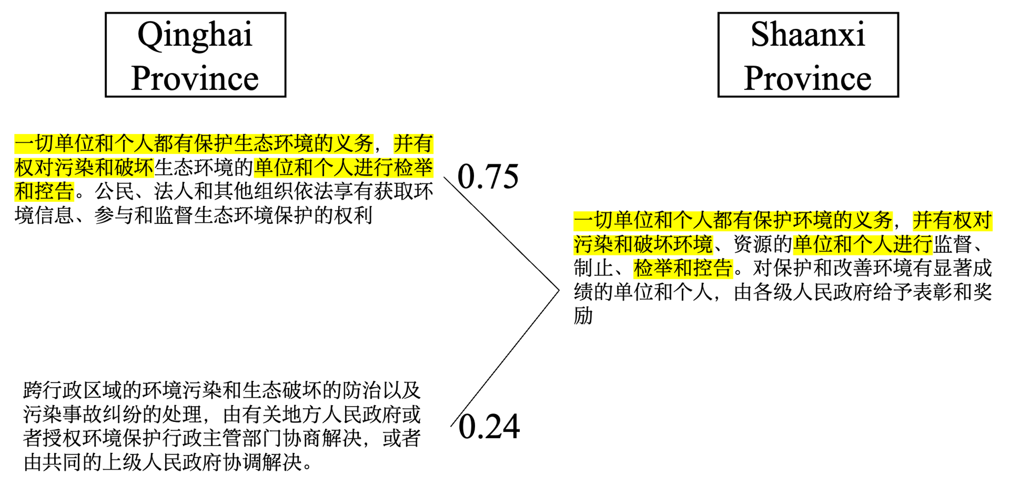

To further illustrate the difference between vertical and horizontal textual learning in Figure A1-2, we used another example. In this example, all clauses are about wetland restoration, but the details vary. The two texts in the first row come from two provincial administrative units, Jiangsu and Liaoning, while the two texts in the second row come from cities under the same provinces, Lianyungang (Jiangsu) and Panjin (Liaoning). In this case, the similarity between the two provincial texts is relatively high. However, the vertical learning similarity between the provincial texts and their corresponding municipal texts is comparatively low. The pattern in this example is consistent with the findings of our empirical research.

**Figure A1-2 Example of Vertical and Horizontal Policy Learning in the Text**

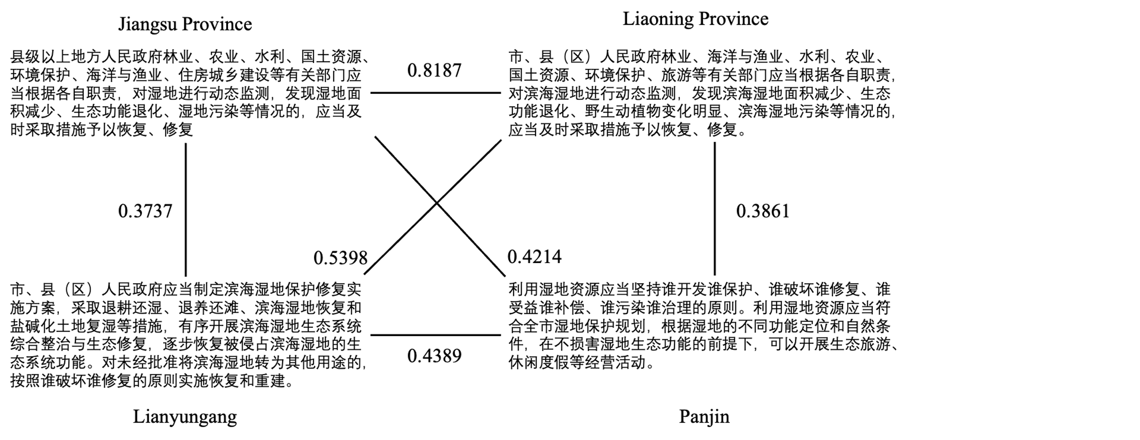

**Appendix 2. Similarity Score Calculation**

We follow some steps to construct the *Similarity Score* between regulation documents, as shown in Figure A2, with documents A and B as an example, where document A is assumed to be issued after document B and hence has the potential to learn from document B.

First, we divide each document into a collection of clauses using regular expressions. We only keep the texts in clauses that articulate substantive policy content worthy of learning and copying. In China, policy documents are mostly formatted into organized sections and clauses, with clauses being the smallest unit of a document. On top of Figure A2, documents A and B respectively comprise four clauses and three clauses. Here, we assume that the textual learning happens in these smallest clause units with a focus on specific policy issues and with identifiable plans, solutions, and tools. A similar data processing approach is found in Wilkerson et al. (2015) and Linder et al. (2020) that partitions legislation documents into portions for similarity calculation.

**Figure A2 Data Processing for Similarity Score** 

Second, we calculate the textual similarity of clauses from two documents as shown in matrix A. The potential similarity calculation methods include word embedding (Ballard 2022) , the text reuse approach (Wilkerson, Smith, and Stramp 2015), and the bag-of-words-based method. By comparison, we pin down to employ the bag-of-words-based method for calculating the similarity in each pair of clauses. Word embedding focuses on the semantic meaning of sentences so that when two words are semantically similar, the distance between the two words will be short in the vector space (Mikolov 2013). The word embedding overestimates the similarity by treating the synonyms the same in text, driving up the textual similarity score. We, therefore, disregard this method. Regarding the text reuse approach, it emphasizes the matching sequence and local alignment of text, which is useful for boilerplate detection (Scott, Marantz, and Ulibarri 2021). The text reuse approach is computationally expensive, but it will not produce a better result than the bag-of-words-based method in similarity calculation between clauses consisting of a few sentences, because in Chinese policy text, the sentence structure of the clauses is similar. Hence, we discard this text reuse approach. In terms of the bag-of-words-based method, each word is considered a column, and each clause is considered a row. Each row will record the frequency or weight of the words in a clause. The bag-of-words-based method ignores the order of words and allows us to treat all words equally, some of which might render significant meaning for a short clause corpus. In most cases, it is a drawback that ignores the semantic meanings, as it underestimates the similarity. However, words chosen by policy documents are rigorous and with specific intentions, which makes it safe to ignore the semantic similarities between words for comparing clauses. By using the bag-of-words-based method, the clause similarity matrix is calculated through cosine similarity, which is one of the most established measurements for similarity (Garrett and Jansa 2015). In order to validate the accuracy of our proposed methodology, we conducted experiments using three different methods on a sample dataset. In the present dataset, a random selection was made of two clauses, and subsequently, the similarity between the two was labeled as either 1 or 0. A value of 1 was assigned to indicate similarity, while a value of 0 was assigned to indicate dissimilarity. The outcome is presented in Table A10, which indicates that the Bag of Words approach exhibits the highest accuracy rate and requires the least amount of time.

Third, we convert matrix A into matrix B according to the cosine similarity. If the cell in matrix A is larger than 0.5, then it is assigned with 1 as shown in matrix B, signifying that the clauses in the two documents are textually similar. By looking at each row in matrix B, document A’s clauses 1, 3, and 4 have at least one cell with a value of 1, denoting that the three clauses in document A share textual similarity with the clauses in document B. The number of three is used as the numerator, and the number of clauses in document A is used as the denominator in the calculation of the similarity score, which is the unit of observation in our analysis. The similarity score of document A and document B is hence ¾. A higher similarity score indicates that documents have a higher tendency to textually learn from document Bs, because they share a higher percentage of similar clauses.

**Table A1. Variables, Measures, and Data Sources**

|  |  |  |  |
| --- | --- | --- | --- |
| **Variables** |  | **Measures** | **Data Sources** |
| Dependent variable | Similarity Score | The Similarity Score of policy documents A and B | Constructed by authors |
| Independent variables | Horizontal Learning (H1) | Coded as 1 when the policy A and policy B are issued by the same level of governments, coded as 0 when they are issued by different level of governments | Constructed by authors |
| Spatial Distance (H2) | Geographic distance (in 1000 km) between the governments issuing policy A and policy B | Constructed by authors |
| Temporal Distance (H3) | Difference in the publication year between policy A and policy B | Constructed by authors |
| Initial Learning (H4) | Coded as 1 when the policy A and policy B are first-ever adopted locally, coded as 0 when either of them is not adopted the first time locally | Constructed by authors |
| Control variables | Similar Judiciary System | Coded as 1 if policy B’s and policy A’s issuing governments have similar judiciary system, either with or without specialized collegial panels for environmental protection trials | Constructed by authors |
| City Learner | Coded as 1 when the policy A is issued by cities, coded as 0 when the policy A is issued by provinces | Constructed by authors |
| Self-Learning | Coded as 1 when the policy A and policy B are issued by the same governments, coded as 0 when they are issued by different governments | Constructed by authors |
| Foreign Investment Difference | Absolute difference of the foreign investment (in billion RMB) of policy A’s and policy B’s issuing governments | China City Statistical Yearbook  China City Statistical Yearbook  China City Statistical Yearbook  China City Statistical Yearbook |
| Population Difference | Difference in population (in millions) of policy B’s and policy A’s issuing governments by deducting the latter from the former |
| Birthrate Difference | Difference in birthrate percentage of policy B’s and policy A’s issuing governments by deducting the latter from the former |
| Secondary Industry Difference | Difference in secondary industry proportion of policy B’s and policy A’s issuing governments by deducting the latter from the former |

**Table A2. Descriptive Statistics**

|  | **Air Pollution (N=7391)** | **Green Space (N=14920)** | **Noise Pollution (N=913)** | **Water Pollution (N=4514)** | **Water Resource Protection (N=4019)** | **Water Saving (N=3954)** | **Wetland Protection (N=1943)** | **Total (N=37654)** |
| --- | --- | --- | --- | --- | --- | --- | --- | --- |
| **Similarity** |  |  |  |  |  |  |  |  |
| Mean (SD) | 19.73 (14.03) | 32.18 (14.79) | 27.80 (18.16) | 19.72 (14.54) | 27.11 (17.10) | 30.56 (17.26) | 65.69 (16.17) | 29.15 (18.33) |
| Range | 1.23 - 100.00 | 1.54 - 100.00 | 1.64 - 100.00 | 1.06 - 100.00 | 1.64 - 100.00 | 1.69 - 100.00 | 9.09 - 100.00 | 1.06 - 100.00 |
| **Horizontal Learning** |  |  |  |  |  |  |  |  |
| 0 | 2800 (37.9%) | 3043 (20.4%) | 326 (35.7%) | 1535 (34.0%) | 1976 (49.2%) | 1550 (39.2%) | 943 (48.5%) | 12173 (32.3%) |
| 1 | 4591 (62.1%) | 11877 (79.6%) | 587 (64.3%) | 2979 (66.0%) | 2043 (50.8%) | 2404 (60.8%) | 1000 (51.5%) | 25481 (67.7%) |
| **Spatial Distance** |  |  |  |  |  |  |  |  |
| Mean (SD) | 1.27 (0.79) | 1.37 (0.92) | 1.51 (0.88) | 1.23 (0.70) | 1.61 (0.96) | 1.60 (0.95) | 1.72 (0.96) | 1.41 (0.89) |
| Range | 0.00 - 4.99 | 0.00 - 5.00 | 0.00 - 4.05 | 0.00 - 3.89 | 0.00 - 4.16 | 0.00 - 4.39 | 0.00 - 4.83 | 0.00 - 5.00 |
| **Temporal Distance** |  |  |  |  |  |  |  |  |
| Mean (SD) | 10.38 (8.07) | 11.37 (7.93) | 10.40 (6.80) | 11.19 (7.76) | 10.44 (7.12) | 9.37 (6.27) | 5.53 (4.02) | 10.52 (7.63) |
| Range | 1.00 - 32.00 | 1.00 - 33.00 | 1.00 - 28.00 | 1.00 - 35.00 | 1.00 - 38.00 | 1.00 - 29.00 | 1.00 - 16.00 | 1.00 - 38.00 |
| **Initial Learning** |  |  |  |  |  |  |  |  |
| 0 | 4701 (63.6%) | 11726 (78.6%) | 727 (79.6%) | 3906 (86.5%) | 3247 (80.8%) | 2948 (74.6%) | 896 (46.1%) | 28151 (74.8%) |
| 1 | 2690 (36.4%) | 3194 (21.4%) | 186 (20.4%) | 608 (13.5%) | 772 (19.2%) | 1006 (25.4%) | 1047 (53.9%) | 9503 (25.2%) |
| **Similar Judiciary System** |  |  |  |  |  |  |  |  |
| 0 | 2948 (39.9%) | 4411 (29.6%) | 203 (22.2%) | 1327 (29.4%) | 565 (14.1%) | 853 (21.6%) | 756 (38.9%) | 11063 (29.4%) |
| 1 | 4443 (60.1%) | 10509 (70.4%) | 710 (77.8%) | 3187 (70.6%) | 3454 (85.9%) | 3101 (78.4%) | 1187 (61.1%) | 26591 (70.6%) |
| **City Learner** |  |  |  |  |  |  |  |  |
| 0 | 1455 (19.7%) | 1190 (8.0%) | 263 (28.8%) | 3580 (79.3%) | 1604 (39.9%) | 1162 (29.4%) | 943 (48.5%) | 10197 (27.1%) |
| 1 | 5936 (80.3%) | 13730 (92.0%) | 650 (71.2%) | 934 (20.7%) | 2415 (60.1%) | 2792 (70.6%) | 1000 (51.5%) | 27457 (72.9%) |
| **Self-Learning** |  |  |  |  |  |  |  |  |
| 0 | 7315 (99.0%) | 14740 (98.8%) | 872 (95.5%) | 4372 (96.9%) | 3921 (97.6%) | 3881 (98.2%) | 1922 (98.9%) | 37023 (98.3%) |
| 1 | 76 (1.0%) | 180 (1.2%) | 41 (4.5%) | 142 (3.1%) | 98 (2.4%) | 73 (1.8%) | 21 (1.1%) | 631 (1.7%) |
| **Foreign Investment Difference** |  |  |  |  |  |  |  |  |
| Mean (SD) | 1.51 (1.77) | 1.56 (2.04) | 1.41 (1.28) | 3.25 (6.32) | 2.08 (3.47) | 2.40 (3.14) | 2.87 (4.58) | 1.97 (3.31) |
| Range | 0.00 - 7.73 | 0.00 - 13.05 | 0.00 - 5.11 | 0.00 - 30.82 | 0.00 - 18.51 | 0.00 - 13.60 | 0.00 - 21.13 | 0.00 - 30.82 |
| **Population Difference** |  |  |  |  |  |  |  |  |
| Mean (SD) | 0.34 (4.17) | -0.36 (3.80) | -1.20 (3.01) | -0.94 (8.70) | -1.61 (10.08) | -0.71 (3.85) | -1.82 (6.18) | -0.55 (5.72) |
| Range | -12.44 - 13.16 | -12.21 - 10.98 | -7.96 - 7.34 | -33.36 - 32.23 | -33.04 - 32.71 | -13.87 - 12.13 | -33.52 - 11.69 | -33.52 - 32.71 |
| **Birthrate Difference** |  |  |  |  |  |  |  |  |
| Mean (SD) | -0.12 (5.79) | 0.91 (6.09) | 0.74 (6.15) | 0.60 (6.55) | 1.47 (5.41) | 0.74 (6.74) | 0.79 (6.23) | 0.70 (6.13) |
| Range | -28.92 - 32.93 | -23.55 - 28.29 | -18.48 - 20.60 | -23.25 - 28.34 | -19.73 - 29.36 | -31.28 - 30.69 | -19.63 - 31.36 | -31.28 - 32.93 |
| **Secondary Industry Difference** |  |  |  |  |  |  |  |  |
| Mean (SD) | 1.80 (16.04) | -1.22 (17.44) | -4.57 (13.47) | -0.87 (13.82) | -2.38 (14.45) | -2.74 (13.98) | 1.28 (17.33) | -0.74 (16.12) |
| Range | -60.91 - 71.33 | -68.16 - 67.31 | -43.46 - 36.71 | -49.47 - 46.11 | -45.90 - 42.25 | -46.50 - 45.43 | -55.29 - 58.81 | -68.16 - 71.33 |

**Table A3. Correlation Tables**

|  |  |  |  |  |  |  |  |  |  |  |  |  |  |  |  |  |  |  |  |  |  |  |  |  |  |  |  |  |  |  |  |
| --- | --- | --- | --- | --- | --- | --- | --- | --- | --- | --- | --- | --- | --- | --- | --- | --- | --- | --- | --- | --- | --- | --- | --- | --- | --- | --- | --- | --- | --- | --- | --- |
|  |  |  |  | **Overall** | | |  |  |  |  |  |  |  | |  |  | |  | |  | | **Air** | | |  |  |  | |  | |  |
| 1. Similarity Score | 1 | 2 | 3 | 4 | 5 | 6 | 7 | 8 | 9 | 10 | 11 |  | 1 | | 2 | 3 | | 4 | | 5 | | 6 | | | 7 | 8 | 9 | | 10 | | 11 |
| 2. Horizontal Learning | .06** |  |  |  |  |  |  |  |  |  |  |  | .05** | |  |  | |  | |  | |  | | |  |  |  | |  | |  |
| 3. Spatial Distance | -.10** | -.04** |  |  |  |  |  |  |  |  |  |  | -.09** | | -.05** |  | |  | |  | |  | | |  |  |  | |  | |  |
| 4. Temporal Distance | -.40** | 0.01 | -.02** |  |  |  |  |  |  |  |  |  | -.58** | | -0.01 | -0.01 | |  | |  | |  | | |  |  |  | |  | |  |
| 5. Initial Learning | .02** | -.02** | 0 | .06** |  |  |  |  |  |  |  |  | 0.01 | | 0.01 | 0.01 | | .12** | |  | |  | | |  |  |  | |  | |  |
| 6. Similar Judiciary System | .01** | 0.01 | 0.01 | -.10** | -.02** |  |  |  |  |  |  |  | .05** | | 0 | -.05** | | -.06** | | -0.02 | |  | | |  |  |  | |  | |  |
| 7. City Learner | .06** | .24** | -.03** | .02** | .10** | -.03** |  |  |  |  |  |  | .10** | | .34** | -.10** | | -0.01 | | .12** | | 0 | | |  |  |  | |  | |  |
| 8. Self-Learning | .24** | .09** | -.21** | 0.01 | -.08** | .08** | -.05** |  |  |  |  |  | .24** | | .08** | -.16** | | 0.01 | | -.08** | | .08** | | | 0 |  |  | |  | |  |
| 9. Foreign Investment Difference | .02** | -0.01 | -.03** | -.02** | -.11** | -.06** | -.12** | -.02** |  |  |  |  | .04** | | .04** | 0 | | -.06** | | -.15** | | -0.01 | | | .08** | -0.02 |  | |  | |  |
| 10. Population Difference | .02** | 0 | -.02** | -.06** | .02** | -.04** | .06** | -0.01 | -.21** |  |  |  | -0.02 | | -.05** | .04** | | .04** | | 0 | | -.06** | | | -.09** | -.03* | 0 | |  | |  |
| 11. Birthrate Difference | 0 | .01* | .05** | .04** | 0.01 | -.01** | 0 | 0 | .02** | -.05** |  |  | -0.01 | | .03** | .06** | | -.06** | | -0.02 | | 0 | | | .04** | 0 | -.07** | | 0 | |  |
| 12. Secondary Industry Difference | .03** | .02** | .06** | -.13** | 0.01 | -.05** | -.07** | -.02** | .02** | .07** | -.04** |  | .09** | | .05** | .08** | | -.13** | | 0.02 | | -.09** | | | -.18** | -0.01 | -.04** | | .17** | | .05** |
|  |  |  |  | **Greening** | | | |  |  |  |  |  |  |  | | |  | |  | | **Noise Pollution** | | | | | |  |  | |  | | |
| 1. Similarity Score | 1 | 2 | 3 | 4 | 5 | 6 | 7 | 8 | 9 | 10 | 11 |  | 1 | 2 | | | 3 | | 4 | | 5 | | 6 | 7 | | 8 | 9 | 10 | | 11 | | |
| 2. Horizontal Learning | -0.01 |  |  |  |  |  |  |  |  |  |  |  | 0.03 |  | | |  | |  | |  | |  |  | |  |  |  | |  | | |
| 3. Spatial Distance | -.29** | 0.01 |  |  |  |  |  |  |  |  |  |  | -.31** | .13** | | |  | |  | |  | |  |  | |  |  |  | |  | | |
| 4. Temporal Distance | -.41** | -.03** | .04** |  |  |  |  |  |  |  |  |  | -.31** | 0 | | | 0.03 | |  | |  | |  |  | |  |  |  | |  | | |
| 5. Initial Learning | -.03** | .05** | -0.01 | .15** |  |  |  |  |  |  |  |  | -.20** | 0.03 | | | .11** | | 0.03 | |  | |  |  | |  |  |  | |  | | |
| 6. Similar Judiciary System | -0.01 | 0 | .06** | -.10** | -.06** |  |  |  |  |  |  |  | 0.04 | .15** | | | -0.04 | | -.25** | | 0.05 | |  |  | |  |  |  | |  | | |
| 7. City Learner | -.12** | .47** | -.02* | .04** | .07** | -.08** |  |  |  |  |  |  | 0 | .64** | | | .15** | | -.07* | | 0.05 | | .09** |  | |  |  |  | |  | | |
| 8. Self-Learning | .29** | .06** | -.16** | 0 | -.06** | .07** | -0.02 |  |  |  |  |  | .59** | .16** | | | -.37** | | 0 | | -.11** | | .12** | 0.02 | |  |  |  | |  | | |
| 9. Foreign Investment Difference | .04** | -.04** | -.07** | -.06** | -.25** | -.03** | -.04** | 0 |  |  |  |  | -.08* | .11** | | | -0.04 | | 0.07 | | -.16** | | -.08* | .15** | | -.09* |  |  | |  | | |
| 10. Population Difference | .12** | -0.01 | -.07** | -.12** | 0.01 | -.06** | -.04** | -0.01 | -.06** |  |  |  | .27** | -0.05 | | | -0.05 | | -.29** | | 0.02 | | 0.01 | -0.05 | | 0 | -.20** |  | |  | | |
| 11. Birthrate Difference | 0 | 0 | .08** | .04** | .08** | -.03** | .10** | -0.01 | -0.01 | -0.01 |  |  | -.14** | 0.03 | | | .12** | | .08* | | .07* | | 0 | 0.01 | | -0.03 | -0.05 | -.26** | |  | | |
| 12. Secondary Industry Difference | .05** | .06** | .08** | -.13** | -0.01 | -0.01 | -0.02 | -0.01 | -.02* | .07** | -.09** |  | 0.02 | .11** | | | 0.05 | | -.20** | | 0.03 | | .12** | .33** | | 0 | -0.05 | .14** | | -.49** | | |
|  |  |  |  | **Water Resource** | | | |  |  |  |  |  |  |  | | |  | | **Water Saving** | | | | | | |  |  |  | |  | | |
| 1. Similarity Score | 1 | 2 | 3 | 4 | 5 | 6 | 7 | 8 | 9 | 10 | 11 |  | 1 | 2 | | | 3 | | 4 | | 5 | | 6 | 7 | | 8 | 9 | 10 | | 11 | | |
| 2. Horizontal Learning | .15** |  |  |  |  |  |  |  |  |  |  |  | .22** |  | | |  | |  | |  | |  |  | |  |  |  | |  | | |
| 3. Spatial Distance | -.22** | -.14** |  |  |  |  |  |  |  |  |  |  | -.09** | -0.02 | | |  | |  | |  | |  |  | |  |  |  | |  | | |
| 4. Temporal Distance | -.26** | -0.02 | -.09** |  |  |  |  |  |  |  |  |  | -.23** | -0.01 | | | 0 | |  | |  | |  |  | |  |  |  | |  | | |
| 5. Initial Learning | -.07** | 0.03 | -.07** | -.04** |  |  |  |  |  |  |  |  | -.08** | -0.03 | | | -.05** | | -0.02 | |  | |  |  | |  |  |  | |  | | |
| 6. Similar Judiciary System | 0.02 | .08** | -0.03 | -.22** | .11** |  |  |  |  |  |  |  | .06** | -0.01 | | | -.03* | | -.25** | | .12** | |  |  | |  |  |  | |  | | |
| 7. City Learner | .14** | .16** | -.17** | -.05** | .13** | .06** |  |  |  |  |  |  | .27** | .50** | | | .05** | | -.05** | | -.06** | | 0.02 |  | |  |  |  | |  | | |
| 8. Self-Learning | .31** | .16** | -.26** | 0 | -.08** | .06** | -.07** |  |  |  |  |  | .39** | .11** | | | -.23** | | 0.02 | | -.08** | | .07** | -0.01 | |  |  |  | |  | | |
| 9. Foreign Investment Difference | -.10** | -.05** | -0.02 | .13** | -.07** | -.23** | -.19** | -0.02 |  |  |  |  | -.05** | .05** | | | -0.01 | | .16** | | -.12** | | -.18** | .13** | | -0.03 |  |  | |  | | |
| 10. Population Difference | .10** | 0.01 | .04* | -.11** | .06** | 0.01 | .22** | -0.01 | -.38** |  |  |  | -0.01 | -.06** | | | -.04* | | -.10** | | .10** | | .08** | -.13** | | 0 | -.31** |  | |  | | |
| 11. Birthrate Difference | -.06** | 0.01 | -0.01 | .20** | 0.02 | -.10** | .10** | -0.03 | .08** | -.05** |  |  | -.05** | -.09** | | | -0.03 | | .09** | | .06** | | -.03* | -.19** | | 0.02 | -.04* | -.17** | |  | | |
| 12. Secondary Industry Difference | -.08** | 0.01 | .07** | -.10** | .11** | -.05* | .09** | -0.03 | .08** | -.07** | .12** |  | 0 | -.11** | | | .04* | | -.17** | | -.13** | | 0.03 | -.26** | | 0.03 | -.10** | .11** | | -0.01 | | |
|  |  |  |  | **Wetland** | | | |  |  |  |  |  |  |  | | |  | | **Water Pollution** | | | | | | |  |  |  | |  | | |
| 1. Similarity Score | 1 | 2 | 3 | 4 | 5 | 6 | 7 | 8 | 9 | 10 | 11 |  | 1 | 2 | | | 3 | | 4 | | 5 | | 6 | 7 | | 8 | 9 | 10 | | 11 | | |
| 2. Horizontal Learning | .17** |  |  |  |  |  |  |  |  |  |  |  | .07** |  | | |  | |  | |  | |  |  | |  |  |  | |  | | |
| 3. Spatial Distance | -.05* | 0.02 |  |  |  |  |  |  |  |  |  |  | -.06** | -.07** | | |  | |  | |  | |  |  | |  |  |  | |  | | |
| 4. Temporal Distance | -.29** | -.06* | 0.02 |  |  |  |  |  |  |  |  |  | -.53** | 0.01 | | | -.06** | |  | |  | |  |  | |  |  |  | |  | | |
| 5. Initial Learning | -.06** | -.06* | -.10** | .11** |  |  |  |  |  |  |  |  | -.03* | -.13** | | | .09** | | .09** | |  | |  |  | |  |  |  | |  | | |
| 6. Similar Judiciary System | -0.02 | -0.04 | -.09** | -0.01 | .07** |  |  |  |  |  |  |  | .03* | .06** | | | -.12** | | -.12** | | .04* | |  |  | |  |  |  | |  | | |
| 7. City Learner | -.26** | -.49** | -.06** | 0.03 | .20** | 0 |  |  |  |  |  |  | .06** | -.48** | | | .07** | | -0.01 | | .23** | | -.05** |  | |  |  |  | |  | | |
| 8. Self-Learning | .17** | .10** | -.19** | 0.04 | -.11** | .08** | -.07** |  |  |  |  |  | .28** | .13** | | | -.32** | | 0.01 | | -.07** | | .12** | -.05** | |  |  |  | |  | | |
| 9. Foreign Investment Difference | .14** | 0.01 | -.13** | -.07** | 0 | -0.03 | -.11** | -0.04 |  |  |  |  | 0.02 | .06** | | | -.09** | | -0.02 | | -.07** | | -.10** | -.10** | | -.04* |  |  | |  | | |
| 10. Population Difference | -0.03 | 0 | 0.01 | -.08** | -.08** | 0.01 | .08** | 0.03 | -.34** |  |  |  | .11** | -0.02 | | | 0.02 | | -.06** | | 0.03 | | -.04* | .06** | | 0.01 | -.18** |  | |  | | |
| 11. Birthrate Difference | .06* | -0.03 | .09** | -.05* | -.09** | -0.04 | .07** | 0.03 | 0.02 | -.11** |  |  | -.07** | .11** | | | -0.02 | | .08** | | -.11** | | 0.01 | -.16** | | 0.03 | .09** | -.07** | |  | | |
| 12. Secondary Industry Difference | 0 | .06** | -0.02 | -.09** | -.12** | -0.04 | -.16** | 0.01 | .09** | .15** | -0.04 |  | .07** | -0.01 | | | .12** | | -.13** | | 0.02 | | -.13** | -.09** | | -.04** | .14** | .05** | | -.06** | | |

Note: * indicates *p* < .05. ** indicates *p* < .01.

**Figure A3. Histogram of Similarity Score**

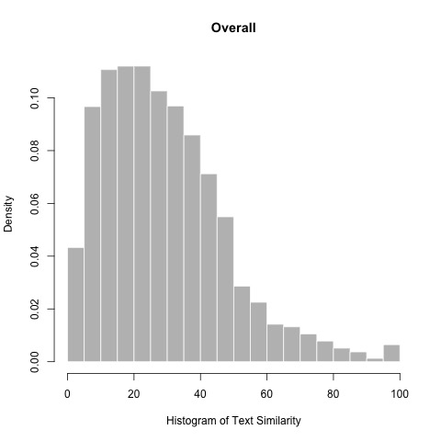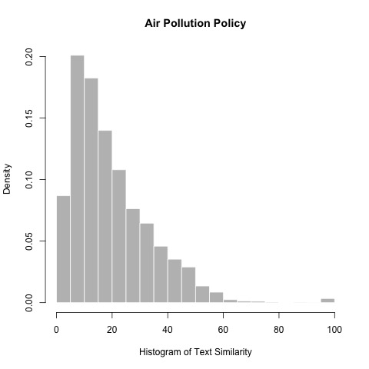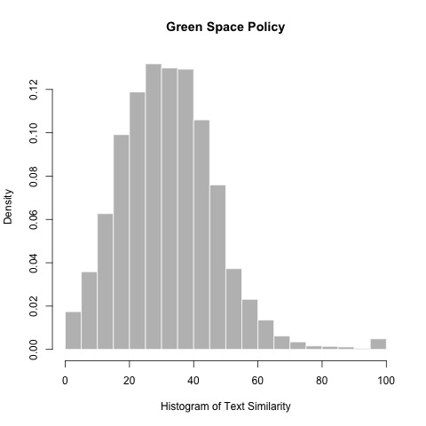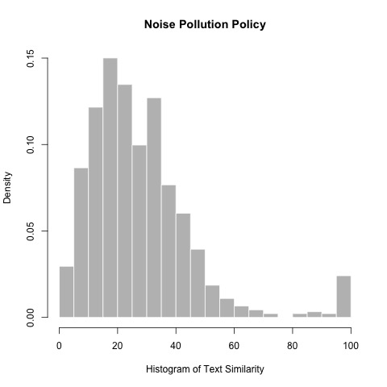

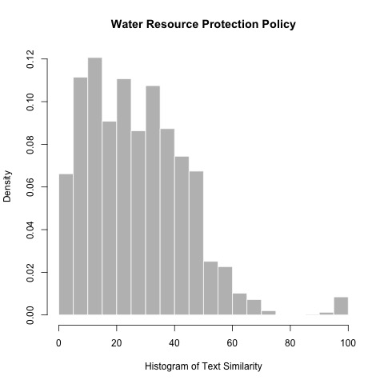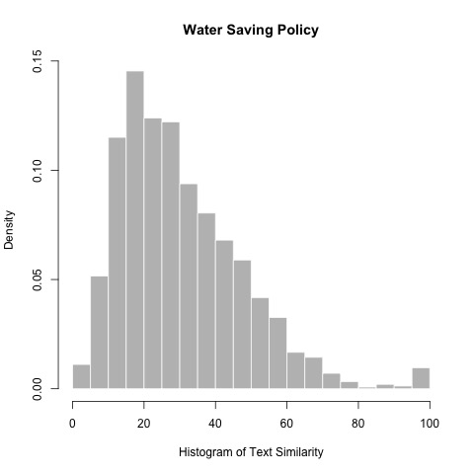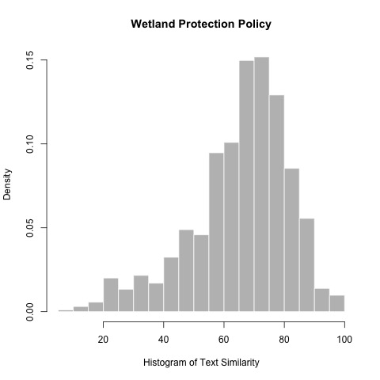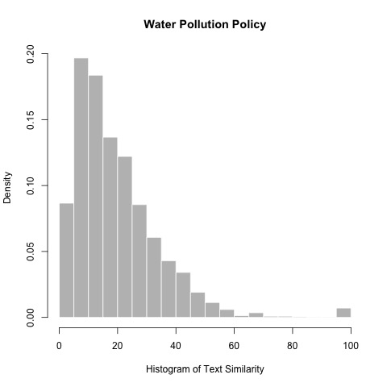

**Table A4s: OLS Linear Regression with Separated Entered Predictor**

All below models have Learner Location Dummies, Learner Year Dummies, and Leader Location Dummies across. The overall models have Policy Dummies entered across. Standard errors are in the Parentheses. (*p<0.1; **p<0.05; ***p<0.01)

**Table A4-1: OLS Linear Regression for Testing H1**

|  |  |  |  |  |  |  |  |  |
| --- | --- | --- | --- | --- | --- | --- | --- | --- |
|  | | | | | | | | |
|  | Dependent variable: Similarity Score | | | | | | | |
|  |  | | | | | | | |
|  |  | | | | | | | |
|  | Overall | Air Pollution | Green Space | Noise Pollution | Water Resource | Water Saving | Wetland | Water Pollution |
|  | (1) | (2) | (3) | (4) | (5) | (6) | (7) | (8) |
|  | | | | | | | | |
| Horizontal Learning | 3.442*** | 1.984*** | 6.468*** | 6.697*** | 4.338*** | 6.043*** | 2.457*** | 2.876*** |
| (0.203) | (0.330) | (0.463) | (1.565) | (0.368) | (0.511) | (0.407) | (0.538) |
|  |  |  |  |  |  |  |  |  |
| Constant | 48.617*** | 74.243*** | 36.926*** | 13.236 | -24.564*** | 30.335** | 79.127*** | 15.504 |
|  | (17.137) | (8.346) | (11.954) | (12.021) | (4.918) | (12.603) | (3.099) | (12.127) |
|  |  |  |  |  |  |  |  |  |
|  | | | | | | | | |
| Policy Fixed effects | Yes | N/A | N/A | N/A | N/A | N/A | N/A | N/A |
| Observations | 37,654 | 7,391 | 14,920 | 913 | 4,019 | 3,954 | 1,943 | 4,514 |
| R2 | 0.198 | 0.489 | 0.456 | 0.309 | 0.586 | 0.507 | 0.794 | 0.337 |
| Adjusted R2 | 0.194 | 0.477 | 0.449 | 0.266 | 0.575 | 0.492 | 0.783 | 0.323 |
| Residual Std. Error | 16.451 | 10.146 | 10.976 | 15.568 | 11.144 | 12.304 | 7.530 | 11.965 |
| F Statistic | 51.133*** | 39.731*** | 64.386*** | 7.105*** | 51.350*** | 33.951*** | 69.715*** | 23.148*** |
|  | | | | | | | | |
| Note: | *p<0.1; **p<0.05; ***p<0.01 | | | | | | | |
|  | Standard Error in the Parentheses | | | | | | | |

|  |  |  |  |  |  |  |  |  |
| --- | --- | --- | --- | --- | --- | --- | --- | --- |
| **Table A4-2: OLS Linear Regression for Testing H2** | | | | | | | | |
|  | | | | | | | | |
|  | Dependent variable: Similarity Score | | | | | | | |
|  |  | | | | | | | |
|  | Overall | Air Pollution | Green Space | Noise Pollution | Water Resource | Water Saving | Wetland | Water Pollution |
|  | (1) | (2) | (3) | (4) | (5) | (6) | (7) | (8) |
|  | | | | | | | | |
| Spatial Distance | -2.367*** | -2.676*** | -4.046*** | -5.407*** | -4.007*** | -3.933*** | -1.651*** | -3.505*** |
|  | (0.117) | (0.259) | (0.168) | (0.687) | (0.274) | (0.285) | (0.256) | (0.334) |
|  |  |  |  |  |  |  |  |  |
| Constant | 53.166*** | 78.705*** | 65.101*** | 25.742** | -18.606*** | 52.028*** | 82.002*** | 21.920* |
|  | (17.108) | (8.307) | (11.828) | (11.653) | (4.886) | (12.599) | (3.093) | (12.010) |
|  |  |  |  |  |  |  |  |  |
|  | | | | | | | | |
| Policy Fixed effects | Yes | N/A | N/A | N/A | N/A | N/A | N/A | N/A |
| Observations | 37,654 | 7,391 | 14,920 | 913 | 4,019 | 3,954 | 1,943 | 4,514 |
| R2 | 0.201 | 0.494 | 0.470 | 0.342 | 0.594 | 0.513 | 0.795 | 0.349 |
| Adjusted R2 | 0.197 | 0.482 | 0.463 | 0.300 | 0.583 | 0.498 | 0.784 | 0.335 |
| Residual Std. Error | 16.425 | 10.097 | 10.837 | 15.194 | 11.042 | 12.228 | 7.520 | 11.857 |
| F Statistic | 51.958*** | 40.519*** | 68.019*** | 8.250*** | 52.970*** | 34.789*** | 69.951*** | 24.411*** |
|  | | | | | | | | |
| Note: | *p<0.1; **p<0.05; ***p<0.01 | | | | | | | |
|  | Standard Error in the Parentheses | | | | | | | |

|  |  |  |  |  |  |  |  |  |
| --- | --- | --- | --- | --- | --- | --- | --- | --- |
| **Table A4-3: OLS Linear Regression for Testing H3** | | | | | | | | |
|  | | | | | | | | |
|  | Dependent variable: Similarity Score | | | | | | | |
|  |  | | | | | | | |
|  | Overall | Air Pollution | Green Space | Noise Pollution | Water Resource | Water Saving | Wetland | Water Pollution |
|  | (1) | (2) | (3) | (4) | (5) | (6) | (7) | (8) |
|  | | | | | | | | |
| Temporal Distance | -0.961*** | -0.771*** | -0.673*** | -0.857*** | -0.571*** | -0.455*** | -0.704*** | -0.992*** |
|  | (0.013) | (0.018) | (0.014) | (0.111) | (0.039) | (0.048) | (0.066) | (0.027) |
|  |  |  |  |  |  |  |  |  |
| Constant | 40.114** | 62.087*** | 32.091*** | 21.728* | -22.757*** | 28.798** | 81.288*** | 21.943** |
|  | (16.015) | (7.507) | (11.224) | (11.649) | (4.870) | (12.689) | (3.028) | (10.628) |
|  |  |  |  |  |  |  |  |  |
|  | | | | | | | | |
| Policy Fixed effects | Yes | N/A | N/A | N/A | N/A | N/A | N/A | N/A |
| Observations | 37,654 | 7,391 | 14,920 | 913 | 4,019 | 3,954 | 1,943 | 4,514 |
| R2 | 0.300 | 0.587 | 0.520 | 0.340 | 0.595 | 0.500 | 0.803 | 0.490 |
| Adjusted R2 | 0.296 | 0.577 | 0.514 | 0.298 | 0.583 | 0.485 | 0.792 | 0.479 |
| Residual Std. Error | 15.375 | 9.122 | 10.311 | 15.215 | 11.035 | 12.382 | 7.379 | 10.496 |
| F Statistic | 88.530*** | 59.003*** | 83.163*** | 8.182*** | 53.090*** | 33.109*** | 73.339*** | 43.727*** |
|  | | | | | | | | |
| Note: | *p<0.1; **p<0.05; ***p<0.01 | | | | | | | |
|  | Standard Error in the Parentheses | | | | | | | |

|  |  |  |  |  |  |  |  |  |
| --- | --- | --- | --- | --- | --- | --- | --- | --- |
| **Table A4-4: OLS Linear Regression for Testing H4** | | | | | | | | |
|  | | | | | | | | |
|  | Dependent variable: Similarity Score | | | | | | | |
|  |  | | | | | | | |
|  | Overall | Air Pollution | Green Space | Noise Pollution | Water Resource | Water Saving | Wetland | Water Pollution |
|  | (1) | (2) | (3) | (4) | (5) | (6) | (7) | (8) |
|  | | | | | | | | |
| Initial Learning | -0.865*** | -6.279*** | -4.623*** | -5.934*** | -3.951*** | -2.089*** | -2.195*** | -7.008*** |
|  | (0.212) | (0.327) | (0.282) | (1.858) | (0.667) | (0.693) | (0.619) | (0.647) |
|  |  |  |  |  |  |  |  |  |
| Constant | 54.211*** | 91.704*** | 55.048*** | 28.612** | -23.973*** | 35.311*** | 82.987*** | 25.793** |
|  | (17.199) | (8.200) | (11.936) | (12.271) | (4.982) | (12.837) | (3.182) | (12.015) |
|  |  |  |  |  |  |  |  |  |
|  | | | | | | | | |
| Policy Fixed effects | Yes | N/A | N/A | N/A | N/A | N/A | N/A | N/A |
| Observations | 37,654 | 7,391 | 14,920 | 913 | 4,019 | 3,954 | 1,943 | 4,514 |
| R2 | 0.192 | 0.512 | 0.459 | 0.303 | 0.576 | 0.490 | 0.792 | 0.350 |
| Adjusted R2 | 0.188 | 0.500 | 0.452 | 0.259 | 0.564 | 0.474 | 0.780 | 0.336 |
| Residual Std. Error | 16.510 | 9.922 | 10.949 | 15.640 | 11.290 | 12.512 | 7.579 | 11.848 |
| F Statistic | 49.286*** | 43.444*** | 65.083*** | 6.892*** | 49.104*** | 31.742*** | 68.596*** | 24.519*** |
|  | | | | | | | | |
| Note: | *p<0.1; **p<0.05; ***p<0.01 | | | | | | | |
|  | Standard Error in the Parentheses | | | | | | | |

**Table A5. OLS Linear Regression with new DV**

|  |  |  |  |  |  |  |  |  |
| --- | --- | --- | --- | --- | --- | --- | --- | --- |
|  |  | Dependent variable: Similarity Score | | | | |  |  |
|  | Overall | Air Pollution | Green Space | Noise Pollution | Water Resource | Water Saving | Wetland | Water Pollution |
|  | (1) | (2) | (3) | (4) | (5) | (6) | (7) | (8) |
|  | | | | | | | | |
| Horizontal Learning | 2.118*** | 1.335*** | 4.498*** | -1.006 | 2.248*** | 3.166*** | 1.944*** | 1.900*** |
|  | (0.167) | (0.310) | (0.461) | (1.032) | (0.393) | (0.459) | (0.380) | (0.483) |
|  |  |  |  |  |  |  |  |  |
| Spatial Distance | -0.978*** | -0.587** | -1.873*** | -1.370** | 0.069 | -0.323 | -0.554** | -0.775** |
|  | (0.120) | (0.260) | (0.179) | (0.564) | (0.291) | (0.279) | (0.264) | (0.304) |
|  |  |  |  |  |  |  |  |  |
| Temporal Distance | -0.937*** | -1.007*** | -0.752*** | -0.309*** | -0.341*** | -0.647*** | -0.977*** | -1.135*** |
|  | (0.013) | (0.026) | (0.018) | (0.093) | (0.050) | (0.049) | (0.086) | (0.031) |
|  |  |  |  |  |  |  |  |  |
| Initial Learning | 1.675*** | 1.363*** | 2.487*** | 0.008 | -1.914** | 1.496** | 3.496*** | -0.324 |
|  | (0.195) | (0.387) | (0.317) | (1.404) | (0.745) | (0.651) | (0.782) | (0.622) |
|  |  |  |  |  |  |  |  |  |
| Similar Judiciary System | 0.031 | 0.108 | 0.612*** | -0.656 | 0.003 | -0.078 | 0.013 | 0.058 |
|  | (0.162) | (0.251) | (0.219) | (1.040) | (0.620) | (0.534) | (0.404) | (0.386) |
|  |  |  |  |  |  |  |  |  |
| City Learner | 9.303*** | -0.980 | -5.173*** | 16.572*** | 35.414*** | 5.909*** | -2.838* | -1.767 |
|  | (1.740) | (1.755) | (1.352) | (2.766) | (3.013) | (1.995) | (1.719) | (2.090) |
|  |  |  |  |  |  |  |  |  |
| Self-Learning | 35.583*** | 33.679*** | 37.232*** | 55.021*** | 36.670*** | 48.963*** | 24.828*** | 23.472*** |
|  | (0.550) | (1.221) | (0.844) | (2.064) | (1.372) | (1.446) | (1.657) | (0.989) |
|  |  |  |  |  |  |  |  |  |
| Foreign Investment Difference | 0.098*** | -0.404*** | 0.293*** | 0.771* | -0.244* | 0.066 | -0.161 | -0.164*** |
| (0.029) | (0.122) | (0.063) | (0.458) | (0.128) | (0.123) | (0.128) | (0.050) |
|  |  |  |  |  |  |  |  |  |
| Population Difference | -0.090*** | -0.233*** | -0.098** | -0.571** | 0.178*** | 0.012 | 0.033 | -0.153** |
|  | (0.030) | (0.061) | (0.048) | (0.275) | (0.054) | (0.104) | (0.120) | (0.062) |
|  |  |  |  |  |  |  |  |  |
| Birthrate Difference | -0.013 | -0.003 | -0.020 | 0.219 | -0.055 | -0.057 | 0.185*** | -0.142*** |
|  | (0.021) | (0.046) | (0.029) | (0.142) | (0.080) | (0.066) | (0.066) | (0.052) |
|  |  |  |  |  |  |  |  |  |
| Secondary Industry Difference | -0.005 | -0.014 | -0.029*** | 0.020 | -0.062** | -0.023 | -0.012 | -0.026 |
| (0.008) | (0.016) | (0.010) | (0.059) | (0.026) | (0.028) | (0.023) | (0.023) |
|  |  |  |  |  |  |  |  |  |
| Constant | 32.924*** | 43.335*** | 54.032*** | 20.130* | -5.451 | 16.416*** | 78.014*** | 29.097*** |
|  | (4.064) | (6.819) | (4.927) | (12.129) | (6.094) | (5.711) | (3.101) | (3.640) |
|  |  |  |  |  |  |  |  |  |
|  | | | | | | | | |
| Learner Location Dummies | Yes | Yes | Yes | Yes | Yes | Yes | Yes | Yes |
| Learner Year Dummies | Yes | Yes | Yes | Yes | Yes | Yes | Yes | Yes |
| Source Location Dummies | Yes | Yes | Yes | Yes | Yes | Yes | Yes | Yes |
| Policy Fixed effects | Yes | N/A | N/A | N/A | N/A | N/A | N/A | N/A |
| Observations | 30,531 | 5,940 | 11,801 | 710 | 2,936 | 3,438 | 1,832 | 3,874 |
| R2 | 0.643 | 0.651 | 0.590 | 0.744 | 0.709 | 0.650 | 0.835 | 0.603 |
| Adjusted R2 | 0.639 | 0.641 | 0.583 | 0.721 | 0.698 | 0.638 | 0.824 | 0.593 |
| RMSE | 11.07 | 8.43 | 9.10 | 9.03 | 9.46 | 10.08 | 6.62 | 9.18 |
|  | | | | | | | | |
| Note: | *p<0.1; **p<0.05; ***p<0.01 | | | | | | | |
|  | Standard Error in the Parentheses  DV is constructed by calculating the average of clauses similarity between two policies | | | | | | | |

**Table A6: OLS Linear Regression to Testing Interaction Between Horizontal Learning and Spatial Distance**

|  |  |  |  |  |  |  |  |  |
| --- | --- | --- | --- | --- | --- | --- | --- | --- |
|  |  | Dependent variable: Similarity Score | | | | |  |  |
|  | Overall | Air Pollution | Green Space | Noise Pollution | Water Resource | Water Saving | Wetland | Water Pollution |
|  | (1) | (2) | (3) | (4) | (5) | (6) | (7) | (8) |
|  | | | | | | | | |
| Horizontal Learning | 2.400*** | 2.150*** | 4.008*** | -3.758** | 2.750*** | 2.661*** | 0.948 | 2.728*** |
|  | (0.301) | (0.517) | (0.614) | (1.657) | (0.860) | (0.798) | (0.722) | (0.845) |
|  |  |  |  |  |  |  |  |  |
| Spatial Distance | -0.986*** | -0.212 | -2.215*** | -2.278*** | -0.084 | -0.523 | -0.693** | -0.648 |
|  | (0.159) | (0.315) | (0.303) | (0.772) | (0.350) | (0.347) | (0.321) | (0.416) |
|  |  |  |  |  |  |  |  |  |
| Temporal Distance | -0.970*** | -0.889*** | -0.703*** | -0.017 | -0.311*** | -0.837*** | -1.009*** | -1.189*** |
|  | (0.014) | (0.033) | (0.025) | (0.118) | (0.063) | (0.072) | (0.119) | (0.043) |
|  |  |  |  |  |  |  |  |  |
| Initial Learning | 1.799*** | 1.688*** | 2.444*** | -0.315 | -2.357*** | 1.162* | 3.952*** | -0.334 |
|  | (0.195) | (0.374) | (0.316) | (1.384) | (0.747) | (0.655) | (0.777) | (0.623) |
|  |  |  |  |  |  |  |  |  |
| Similar Judiciary System | 0.023 | 0.192 | 0.592*** | -0.660 | -0.107 | -0.158 | -0.115 | 0.026 |
|  | (0.161) | (0.241) | (0.218) | (1.025) | (0.620) | (0.531) | (0.402) | (0.386) |
|  |  |  |  |  |  |  |  |  |
| City Learner | 7.216*** | -4.332** | -9.438*** | 15.738*** | 31.690*** | 8.623*** | -4.166 | -5.404* |
|  | (1.822) | (1.744) | (1.975) | (3.288) | (3.103) | (2.096) | (7.304) | (2.809) |
|  |  |  |  |  |  |  |  |  |
| Self-Learning | 35.937*** | 34.268*** | 37.564*** | 56.807*** | 35.529*** | 49.079*** | 25.466*** | 23.836*** |
|  | (0.545) | (1.171) | (0.843) | (2.105) | (1.356) | (1.448) | (1.679) | (0.986) |
|  |  |  |  |  |  |  |  |  |
| Foreign Investment | 0.088*** | -0.536*** | 0.257*** | 0.603 | -0.170 | -0.059 | -0.135 | -0.195*** |
| Difference | (0.029) | (0.111) | (0.063) | (0.421) | (0.122) | (0.121) | (0.112) | (0.049) |
|  |  |  |  |  |  |  |  |  |
| Population Difference | -0.066 | 2.923*** | 0.826*** | 1.926*** | 0.703*** | -1.959*** | 2.168 | -0.373 |
|  | (0.078) | (0.371) | (0.313) | (0.596) | (0.095) | (0.494) | (3.336) | (0.399) |
|  |  |  |  |  |  |  |  |  |
| Birthrate Difference | -0.052** | -0.522*** | 0.010 | 0.617*** | -0.107 | -0.097 | -0.168 | -0.033 |
|  | (0.021) | (0.059) | (0.033) | (0.230) | (0.085) | (0.118) | (0.209) | (0.062) |
|  |  |  |  |  |  |  |  |  |
| Secondary Industry | -0.070*** | -0.257*** | 0.006 | 0.170* | -0.101*** | -0.101*** | 0.200*** | -0.080*** |
| Difference | (0.010) | (0.026) | (0.014) | (0.102) | (0.035) | (0.034) | (0.066) | (0.029) |
|  |  |  |  |  |  |  |  |  |
| Horizontal Learning* | -0.126 | -0.552* | 0.363 | 1.912** | -0.260 | 0.279 | 0.560 | -0.585 |
| Spatial Distance | (0.171) | (0.329) | (0.309) | (0.926) | (0.414) | (0.405) | (0.371) | (0.507) |
| Constant | 31.370*** | 42.514*** | 58.155*** | 34.621*** | -10.035 | 15.071*** | 81.222*** | 28.324*** |
|  | (3.947) | (6.696) | (5.150) | (12.860) | (6.115) | (5.704) | (7.646) | (3.674) |
|  | | | | | | | | |
| Learner Location Dummies | Yes | Yes | Yes | Yes | Yes | Yes | Yes | Yes |
| Learner Year Dummies | Yes | Yes | Yes | Yes | Yes | Yes | Yes | Yes |
| Source Location Dummies | Yes | Yes | Yes | Yes | Yes | Yes | Yes | Yes |
| Policy Fixed effects | Yes | N/A | N/A | N/A | N/A | N/A | N/A | N/A |
| Observations | 30,715 | 6,179 | 11,797 | 710 | 2,894 | 3,438 | 1,832 | 3,865 |
| R2 | 0.642 | 0.659 | 0.590 | 0.752 | 0.708 | 0.654 | 0.835 | 0.602 |
| Adjusted R2 | 0.638 | 0.649 | 0.583 | 0.729 | 0.697 | 0.641 | 0.825 | 0.591 |
| Residual Std. Error | 11.107 | 8.425 | 9.166 | 9.305 | 9.533 | 10.202 | 6.811 | 9.309 |
| F Statistic | 163.108*** | 67.395*** | 87.849*** | 32.824*** | 65.720*** | 52.208*** | 80.820*** | 57.436*** |
|  | | | | | | | | |
| Note: | *p<0.1; **p<0.05; ***p<0.01 | | | | | | | |
|  | Standard Error in the Parentheses | | | | | | | |

**Table A7: OLS Linear Regression to Testing Interaction Between Initial Learning and Temporal Distance**

|  |  |  |  |  |  |  |  |  |
| --- | --- | --- | --- | --- | --- | --- | --- | --- |
|  |  | Dependent variable: Similarity Score | | | | |  |  |
|  | Overall | Air Pollution | Green Space | Noise Pollution | Water Resource | Water Saving | Wetland | Water Pollution |
|  | (1) | (2) | (3) | (4) | (5) | (6) | (7) | (8) |
|  | | | | | | | | |
| Horizontal Learning | 2.189*** | 1.360*** | 4.485*** | -1.074 | 2.263*** | 3.069*** | 1.653*** | 1.927*** |
|  | (0.166) | (0.297) | (0.459) | (1.010) | (0.394) | (0.451) | (0.377) | (0.485) |
|  |  |  |  |  |  |  |  |  |
| Spatial Distance | -1.060*** | -0.530** | -1.914*** | -1.069** | -0.209 | -0.361 | -0.367 | -0.980*** |
|  | (0.118) | (0.250) | (0.178) | (0.541) | (0.292) | (0.269) | (0.254) | (0.300) |
|  |  |  |  |  |  |  |  |  |
| Temporal Distance | -0.911*** | -0.842*** | -0.664*** | 0.056 | -0.305*** | -0.759*** | -0.799*** | -1.188*** |
|  | (0.015) | (0.034) | (0.026) | (0.120) | (0.063) | (0.072) | (0.124) | (0.043) |
|  |  |  |  |  |  |  |  |  |
| Initial Learning | 4.743*** | 4.402*** | 6.009*** | 5.226** | -1.561 | 7.723*** | 6.591*** | -0.140 |
|  | (0.303) | (0.543) | (0.520) | (2.207) | (1.157) | (0.984) | (0.912) | (1.029) |
|  |  |  |  |  |  |  |  |  |
| Similar Judiciary System | 0.025 | 0.185 | 0.598*** | -0.178 | -0.075 | -0.150 | 0.028 | 0.017 |
|  | (0.160) | (0.240) | (0.218) | (1.021) | (0.619) | (0.525) | (0.399) | (0.386) |
|  |  |  |  |  |  |  |  |  |
| City Learner | 6.983*** | -4.536*** | -9.665*** | 15.565*** | 31.468*** | 9.000*** | -4.579 | -5.510** |
|  | (1.817) | (1.737) | (1.969) | (3.274) | (3.118) | (2.055) | (7.244) | (2.808) |
|  |  |  |  |  |  |  |  |  |
| Self-Learning | 35.988*** | 34.550*** | 37.451*** | 55.363*** | 35.764*** | 48.765*** | 24.585*** | 24.133*** |
|  | (0.536) | (1.152) | (0.836) | (1.996) | (1.300) | (1.405) | (1.633) | (0.952) |
|  |  |  |  |  |  |  |  |  |
| Foreign Investment | 0.083*** | -0.540*** | 0.267*** | 0.494 | -0.171 | -0.082 | -0.137 | -0.196*** |
| Difference | (0.029) | (0.110) | (0.063) | (0.419) | (0.122) | (0.120) | (0.111) | (0.049) |
|  |  |  |  |  |  |  |  |  |
| Population Difference | -0.051 | 2.794*** | 0.890*** | 2.085*** | 0.704*** | -2.181*** | 2.063 | -0.374 |
|  | (0.078) | (0.370) | (0.312) | (0.595) | (0.095) | (0.489) | (3.309) | (0.400) |
|  |  |  |  |  |  |  |  |  |
| Birthrate Difference | -0.054** | -0.503*** | 0.013 | 0.607*** | -0.102 | -0.063 | -0.247 | -0.033 |
|  | (0.021) | (0.059) | (0.033) | (0.229) | (0.085) | (0.116) | (0.208) | (0.062) |
|  |  |  |  |  |  |  |  |  |
| Secondary Industry | -0.073*** | -0.265*** | -0.0001 | 0.174* | -0.102*** | -0.126*** | 0.235*** | -0.080*** |
| Difference | (0.010) | (0.026) | (0.014) | (0.101) | (0.035) | (0.033) | (0.066) | (0.029) |
|  |  |  |  |  |  |  |  |  |
| Initial Learning * | -0.289*** | -0.242*** | -0.275*** | -0.569*** | -0.104 | -0.718*** | -0.467*** | -0.015 |
| Temporal Distance | (0.023) | (0.035) | (0.032) | (0.179) | (0.115) | (0.081) | (0.085) | (0.071) |
| Constant | 27.879*** | 39.164*** | 52.920*** | 30.694** | -9.950 | 7.162 | 78.815*** | 28.688*** |
|  | (3.943) | (6.687) | (5.165) | (12.747) | (6.111) | (5.689) | (7.592) | (3.691) |
|  | | | | | | | | |
| Learner Location Dummies | Yes | Yes | Yes | Yes | Yes | Yes | Yes | Yes |
| Learner Year Dummies | Yes | Yes | Yes | Yes | Yes | Yes | Yes | Yes |
| Source Location Dummies | Yes | Yes | Yes | Yes | Yes | Yes | Yes | Yes |
| Policy Fixed effects | Yes | N/A | N/A | N/A | N/A | N/A | N/A | N/A |
| Observations | 30,715 | 6,179 | 11,797 | 710 | 2,894 | 3,438 | 1,832 | 3,865 |
| R2 | 0.644 | 0.661 | 0.592 | 0.754 | 0.708 | 0.662 | 0.838 | 0.602 |
| Adjusted R2 | 0.640 | 0.652 | 0.586 | 0.732 | 0.697 | 0.650 | 0.828 | 0.591 |
| Residual Std. Error | 11.078 | 8.394 | 9.138 | 9.263 | 9.533 | 10.084 | 6.757 | 9.311 |
| F Statistic | 164.444*** | 68.148*** | 88.788*** | 33.217*** | 65.734*** | 54.082*** | 82.378*** | 57.403*** |
|  | | | | | | | | |
| Note: | *p<0.1; **p<0.05; ***p<0.01 | | | | | | | |
|  | Standard Error in the Parentheses | | | | | | | |

**Table A8: OLS Linear Regression to Test the Interaction Between Initial Learning and Spatial Distance**

|  |  |  |  |  |  |  |  |  |
| --- | --- | --- | --- | --- | --- | --- | --- | --- |
|  |  | Dependent variable: Similarity Score | | | | |  |  |
|  | Overall | Air Pollution | Green Space | Noise Pollution | Water Resource | Water Saving | Wetland | Water Pollution |
|  | (1) | (2) | (3) | (4) | (5) | (6) | (7) | (8) |
|  | | | | | | | | |
| Horizontal Learning | 2.214*** | 1.436*** | 4.485*** | -1.050 | 2.262*** | 3.135*** | 1.848*** | 1.931*** |
|  | (0.167) | (0.298) | (0.461) | (1.018) | (0.394) | (0.455) | (0.378) | (0.485) |
|  |  |  |  |  |  |  |  |  |
| Temporal Distance | -0.970*** | -0.890*** | -0.703*** | -0.019 | -0.309*** | -0.845*** | -1.000*** | -1.189*** |
|  | (0.014) | (0.033) | (0.025) | (0.119) | (0.063) | (0.072) | (0.119) | (0.043) |
|  |  |  |  |  |  |  |  |  |
| Spatial Distance | -1.097*** | -0.462* | -1.913*** | -1.077* | -0.131 | -0.120 | -0.159 | -1.063*** |
|  | (0.125) | (0.274) | (0.187) | (0.573) | (0.302) | (0.288) | (0.316) | (0.315) |
|  |  |  |  |  |  |  |  |  |
| Initial Learning | 1.580*** | 1.945*** | 2.535*** | 0.516 | -1.414 | 3.203*** | 4.710*** | -1.199 |
|  | (0.332) | (0.544) | (0.507) | (2.470) | (1.266) | (1.005) | (0.989) | (1.198) |
|  |  |  |  |  |  |  |  |  |
| Similar Judiciary System | 0.022 | 0.187 | 0.599*** | -0.503 | -0.077 | -0.181 | -0.072 | 0.018 |
|  | (0.161) | (0.241) | (0.218) | (1.026) | (0.619) | (0.531) | (0.402) | (0.386) |
|  |  |  |  |  |  |  |  |  |
| City Learner | 7.191*** | -4.400** | -9.443*** | 15.961*** | 31.789*** | 8.980*** | -4.140 | -5.526** |
|  | (1.821) | (1.744) | (1.976) | (3.299) | (3.099) | (2.078) | (7.307) | (2.808) |
|  |  |  |  |  |  |  |  |  |
| Self-Learning | 35.957*** | 34.671*** | 37.489*** | 55.581*** | 35.925*** | 49.333*** | 25.437*** | 24.038*** |
|  | (0.541) | (1.166) | (0.842) | (2.028) | (1.310) | (1.429) | (1.686) | (0.958) |
|  |  |  |  |  |  |  |  |  |
| Foreign Investment | 0.088*** | -0.538*** | 0.257*** | 0.568 | -0.168 | -0.052 | -0.136 | -0.194*** |
| Difference | (0.029) | (0.111) | (0.063) | (0.422) | (0.122) | (0.121) | (0.112) | (0.049) |
|  |  |  |  |  |  |  |  |  |
| Population Difference | -0.066 | 2.905*** | 0.825*** | 1.947*** | 0.703*** | -2.046*** | 2.233 | -0.382 |
|  | (0.078) | (0.372) | (0.313) | (0.598) | (0.095) | (0.495) | (3.336) | (0.399) |
|  |  |  |  |  |  |  |  |  |
| Birthrate Difference | -0.052** | -0.521*** | 0.010 | 0.620*** | -0.110 | -0.088 | -0.176 | -0.035 |
|  | (0.021) | (0.059) | (0.033) | (0.230) | (0.085) | (0.117) | (0.209) | (0.062) |
|  |  |  |  |  |  |  |  |  |
| Secondary Industry | -0.070*** | -0.257*** | 0.005 | 0.167 | -0.099*** | -0.100*** | 0.208*** | -0.080*** |
| Difference | (0.010) | (0.026) | (0.014) | (0.102) | (0.035) | (0.034) | (0.066) | (0.029) |
|  |  |  |  |  |  |  |  |  |
| Initial Learning * | 0.159 | -0.206 | -0.074 | -0.477 | -0.567 | -1.320*** | -0.514 | 0.613 |
| Spatial Distance | (0.195) | (0.324) | (0.322) | (1.245) | (0.609) | (0.494) | (0.396) | (0.712) |
| Constant | 31.614*** | 43.096*** | 58.037*** | 31.817** | -9.775 | 13.743** | 80.163*** | 29.167*** |
|  | (3.945) | (6.688) | (5.154) | (12.847) | (6.111) | (5.697) | (7.667) | (3.674) |
|  | | | | | | | | |
| Learner Location Dummies | Yes | Yes | Yes | Yes | Yes | Yes | Yes | Yes |
| Learner Year Dummies | Yes | Yes | Yes | Yes | Yes | Yes | Yes | Yes |
| Source Location Dummies | Yes | Yes | Yes | Yes | Yes | Yes | Yes | Yes |
| Policy Fixed effects | Yes | N/A | N/A | N/A | N/A | N/A | N/A | N/A |
| Observations | 30,715 | 6,179 | 11,797 | 710 | 2,894 | 3,438 | 1,832 | 3,865 |
| R2 | 0.642 | 0.659 | 0.590 | 0.751 | 0.708 | 0.655 | 0.835 | 0.602 |
| Adjusted R2 | 0.638 | 0.649 | 0.583 | 0.728 | 0.697 | 0.642 | 0.825 | 0.591 |
| Residual Std. Error | 11.107 | 8.427 | 9.167 | 9.334 | 9.532 | 10.192 | 6.812 | 9.310 |
| F Statistic | 163.109*** | 67.354*** | 87.832*** | 32.549*** | 65.735*** | 52.369*** | 80.786*** | 57.421*** |
|  | | | | | | | | |
| Note: | *p<0.1; **p<0.05; ***p<0.01 | | | | | | | |
|  | Standard Error in the Parentheses | | | | | | | |

**Table A9: OLS Linear Regression to Test the Interaction Between Similar Judiciary Systems and Spatial Distance**

|  |  |  |  |  |  |  |  |  |
| --- | --- | --- | --- | --- | --- | --- | --- | --- |
|  |  | Dependent variable: Similarity Score | | | | |  |  |
|  | Overall | Air Pollution | Green Space | Noise Pollution | Water Resource | Water Saving | Wetland | Water Pollution |
|  | (1) | (2) | (3) | (4) | (5) | (6) | (7) | (8) |
|  | | | | | | | | |
| Horizontal Learning | 2.217*** | 1.442*** | 4.496*** | -1.059 | 2.261*** | 3.105*** | 1.853*** | 1.924*** |
|  | (0.167) | (0.298) | (0.461) | (1.018) | (0.395) | (0.456) | (0.378) | (0.485) |
|  |  |  |  |  |  |  |  |  |
| Temporal Distance | -0.970*** | -0.889*** | -0.703*** | -0.020 | -0.310*** | -0.839*** | -1.001*** | -1.189*** |
|  | (0.014) | (0.033) | (0.025) | (0.119) | (0.063) | (0.072) | (0.119) | (0.043) |
|  |  |  |  |  |  |  |  |  |
| Initial Learning | 1.801*** | 1.691*** | 2.442*** | -0.240 | -2.363*** | 1.167* | 3.950*** | -0.330 |
|  | (0.195) | (0.374) | (0.316) | (1.393) | (0.747) | (0.655) | (0.777) | (0.623) |
|  |  |  |  |  |  |  |  |  |
| Spatial Distance | -0.900*** | -0.481 | -1.770*** | -1.347 | -0.048 | -0.135 | -0.645* | -1.252*** |
|  | (0.169) | (0.307) | (0.248) | (1.007) | (0.527) | (0.448) | (0.347) | (0.437) |
|  |  |  |  |  |  |  |  |  |
| Similar Judiciary System | 0.338 | 0.295 | 0.869** | -0.884 | 0.246 | 0.374 | -0.774 | -0.550 |
|  | (0.281) | (0.448) | (0.369) | (1.974) | (1.103) | (0.948) | (0.778) | (0.768) |
|  |  |  |  |  |  |  |  |  |
| City Learner | 7.199*** | -4.419** | -9.476*** | 15.923*** | 31.711*** | 8.758*** | -4.776 | -5.480* |
|  | (1.821) | (1.744) | (1.975) | (3.298) | (3.106) | (2.080) | (7.312) | (2.808) |
|  |  |  |  |  |  |  |  |  |
| Self-Learning | 35.904*** | 34.533*** | 37.379*** | 55.579*** | 35.719*** | 48.754*** | 25.235*** | 24.332*** |
|  | (0.543) | (1.166) | (0.845) | (2.053) | (1.308) | (1.435) | (1.666) | (0.980) |
|  |  |  |  |  |  |  |  |  |
| Foreign Investment | 0.089*** | -0.538*** | 0.257*** | 0.567 | -0.169 | -0.059 | -0.132 | -0.196*** |
| Difference | (0.029) | (0.111) | (0.063) | (0.422) | (0.122) | (0.121) | (0.112) | (0.049) |
|  |  |  |  |  |  |  |  |  |
| Population Difference | -0.068 | 2.913*** | 0.827*** | 1.944*** | 0.703*** | -1.970*** | 2.419 | -0.377 |
|  | (0.078) | (0.372) | (0.313) | (0.598) | (0.095) | (0.494) | (3.339) | (0.399) |
|  |  |  |  |  |  |  |  |  |
| Birthrate Difference | -0.052** | -0.522*** | 0.010 | 0.619*** | -0.110 | -0.094 | -0.176 | -0.033 |
|  | (0.021) | (0.059) | (0.033) | (0.230) | (0.085) | (0.118) | (0.209) | (0.062) |
|  |  |  |  |  |  |  |  |  |
| Secondary Industry | -0.070*** | -0.258*** | 0.005 | 0.165 | -0.101*** | -0.101*** | 0.199*** | -0.079*** |
| Difference | (0.010) | (0.026) | (0.014) | (0.102) | (0.035) | (0.034) | (0.066) | (0.029) |
|  |  |  |  |  |  |  |  |  |
| Spatial Distance * | -0.236 | -0.089 | -0.225 | 0.263 | -0.191 | -0.320 | 0.412 | 0.429 |
| Similar Judiciary System | (0.172) | (0.305) | (0.247) | (1.102) | (0.530) | (0.476) | (0.392) | (0.503) |
| Constant | 31.297*** | 43.094*** | 57.949*** | 32.345** | -10.056 | 14.496** | 81.595*** | 29.210*** |
|  | (3.945) | (6.688) | (5.148) | (12.917) | (6.128) | (5.705) | (7.672) | (3.681) |
|  | | | | | | | | |
| Learner Location Dummies | Yes | Yes | Yes | Yes | Yes | Yes | Yes | Yes |
| Learner Year Dummies | Yes | Yes | Yes | Yes | Yes | Yes | Yes | Yes |
| Source Location Dummies | Yes | Yes | Yes | Yes | Yes | Yes | Yes | Yes |
| Policy Fixed effects | Yes | N/A | N/A | N/A | N/A | N/A | N/A | N/A |
| Observations | 30,715 | 6,179 | 11,797 | 710 | 2,894 | 3,438 | 1,832 | 3,865 |
| R2 | 0.642 | 0.659 | 0.590 | 0.751 | 0.708 | 0.654 | 0.835 | 0.602 |
| Adjusted R2 | 0.638 | 0.649 | 0.583 | 0.727 | 0.697 | 0.641 | 0.825 | 0.591 |
| Residual Std. Error | 11.106 | 8.427 | 9.167 | 9.335 | 9.534 | 10.202 | 6.813 | 9.310 |
| F Statistic | 163.119*** | 67.348*** | 87.841*** | 32.543*** | 65.711*** | 52.208*** | 80.754*** | 57.421*** |
| Note: |  | *p<0.1; **p<0.05; ***p<0.01 | | | | | | |
|  |  | Standard Error in the Parentheses | | | | | | |

|  |  |  |  |
| --- | --- | --- | --- |
| **Table A10: Accuracy Rate and Execution Time for Each Method** | | | |
|  | Accuracy |  | Time |
| Text Reuse | 97.50% |  | 0.011727 |
| Word Vectors | 2% |  | 0.562836 |
| Bag of Words | 99% |  | 0.00172 |