The Price of Creativity:
A Conjoint Experiment in Copyrights

Jaroslaw Kantorowicz

Elena Kantorowicz-Reznichenko

Yifat Nahmias

Supplementary Material

Experimental Instructions
For the purpose of this study, we ask you to imagine you are a photographer who specialises in landscape photography. Please think of a photo you have taken of a landscape in the UK. The photo should depict a beautiful landscape or a vivid natural scene.
Please describe here the photo you have in mind (e.g. where was it taken? What kind of landscape does it depict?):
---
Now please imagine that we are working on a travel guidebook in the [UK/U.S.] and would like to purchase the copyrights to the photo you have described in order to include it in the guidebook.
In what follows, we will present you with several pairs of hypothetical contracts (Contract A and Contract B) to purchase these copyrights and will ask you to choose the contract you prefer. Note that we are the buyers in these contracts, and you are the photographer.
These contracts include a combination of rights, which come on top of the right to use your photo in our guidebook. Each contract also includes the price we offer for the given rights. Please assume that all the offered contracts are for 30 years.
---
[Attention check]
Based on the instructions you have just read, what is your hypothetical role in this study?
- Buyer
- Photographer
- Author of the guide
---
In the following screens, your task will be to choose one copyrights contract out of a pair of hypothetical contracts. In total, we will show you six such contract pairs. On each page, the "next"-button will appear only after 20 seconds.
---
Please note, the contractual rights stated in the offered contracts:
- Are additional to the right you transfer to us to use the photo in our guidebook.
- Are exclusive (so either we or you have the right).
- The exploitation of the contractual rights does not require the authorisation of the other party (who does not hold the right).

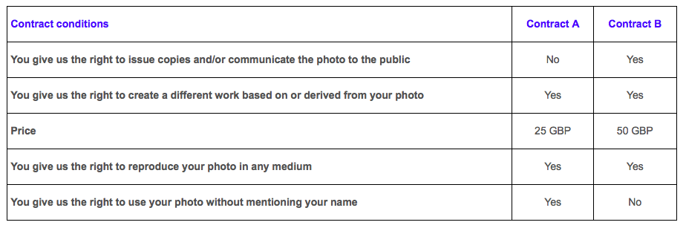
Please indicate which contract – Contract A or Contract B - you would choose to sell us the rights to your photo.
---
In your own words, please explain how you made your choices? What elements of the contracts were the most important to you?
---
What is your gender?
- Male
- Female
- Other

Indicate if you are working or you have been working in any of the following sectors?
- Entertainment
- design and engineering
- Creative and media
- Architecture
- e-commerce and web content
- editorial writing
- law and legal
- research and development
- No, I am not working and I have never worked in the above sector

What is your highest attained level of education?
- Secondary school
- Bachelor
- Master
- PhD
- Other

Have you ever signed a copyrights contract?
- Yes
- No

What is your employment status?
- Working full time
- Working part time
- Unemployed
- Student
- Retired
- Other

What is your profession?

Are you engaging in a creative hobby (writing/painting/creating music/photography etc.)?
- Yes
- No

What is your total personal weekly income, after tax and compulsory deductions, from all sources? If you don't know the exact figure, please give an estimate.
- Below 200 GBP
- Between 200 GBP and 400 GBP
- Between 401 GBP and 600 GBP
- Between 601 GBP and 800 GBP
- Above 800 GBP

If you find a photo online, but it is not explicitly stated that the photo is copyrighted, you can use it freely for all purposes.
- True
- False

Marginal Means (MMs)

Figure A1. MMs for UK Population
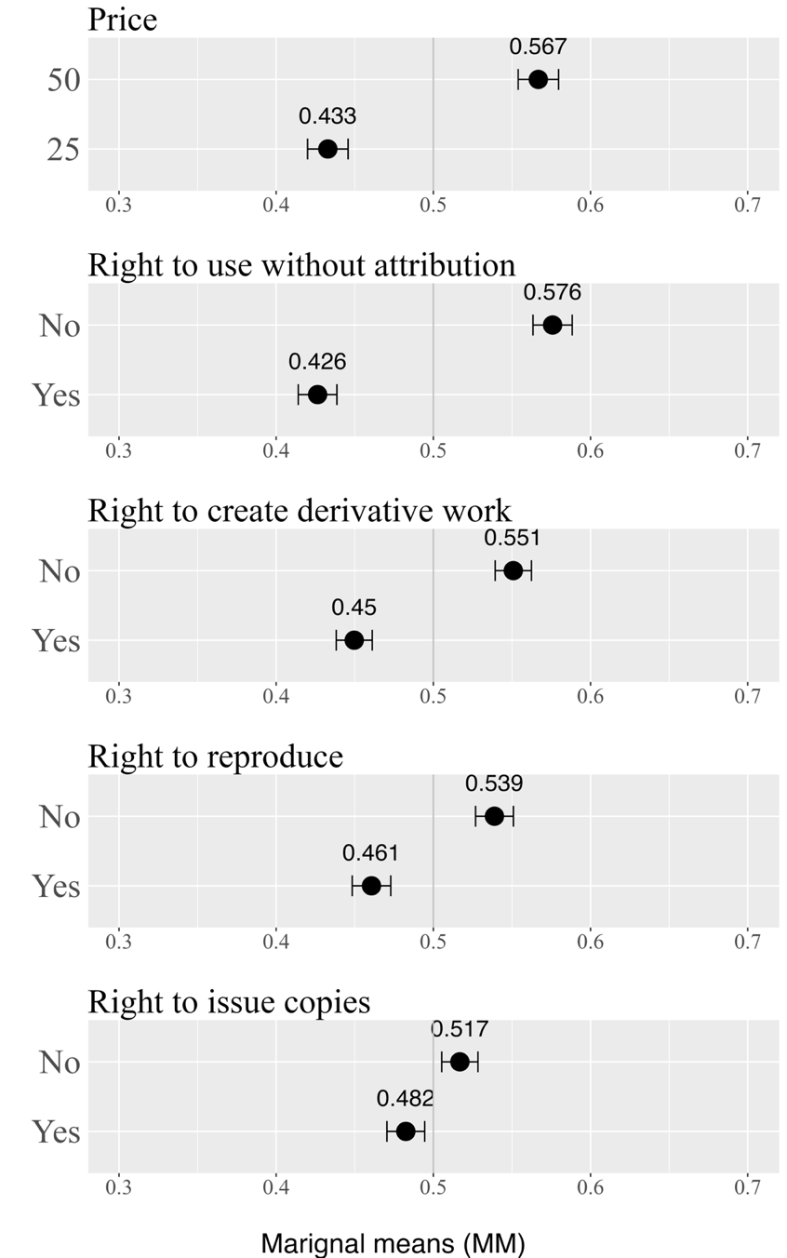
Note: The figure presents point estimates of the Marginal Means (MMs), along with 95% confidence intervals. The MM represents the probability of choosing a contract when a certain price or right is realized.

Figure A2. MMs for UK Professional
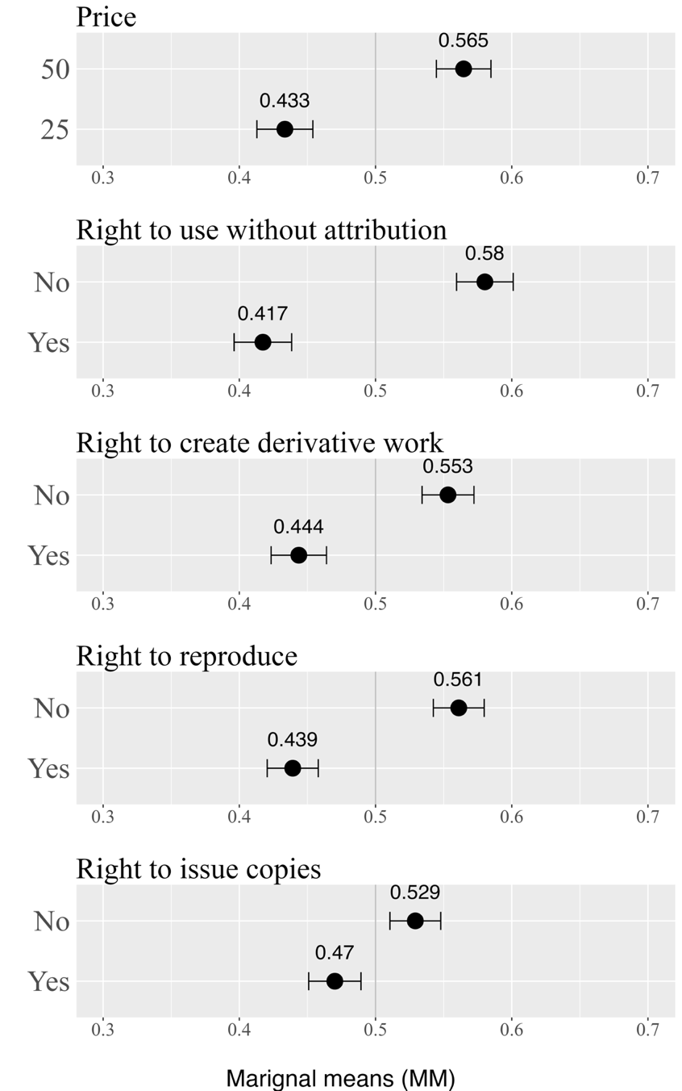
Note: The figure presents point estimates of the Marginal Means (MMs), along with 95% confidence intervals. The MM represents the probability of choosing a contract when a certain price or right is realized.

Figure A3. MMs for US Professionals
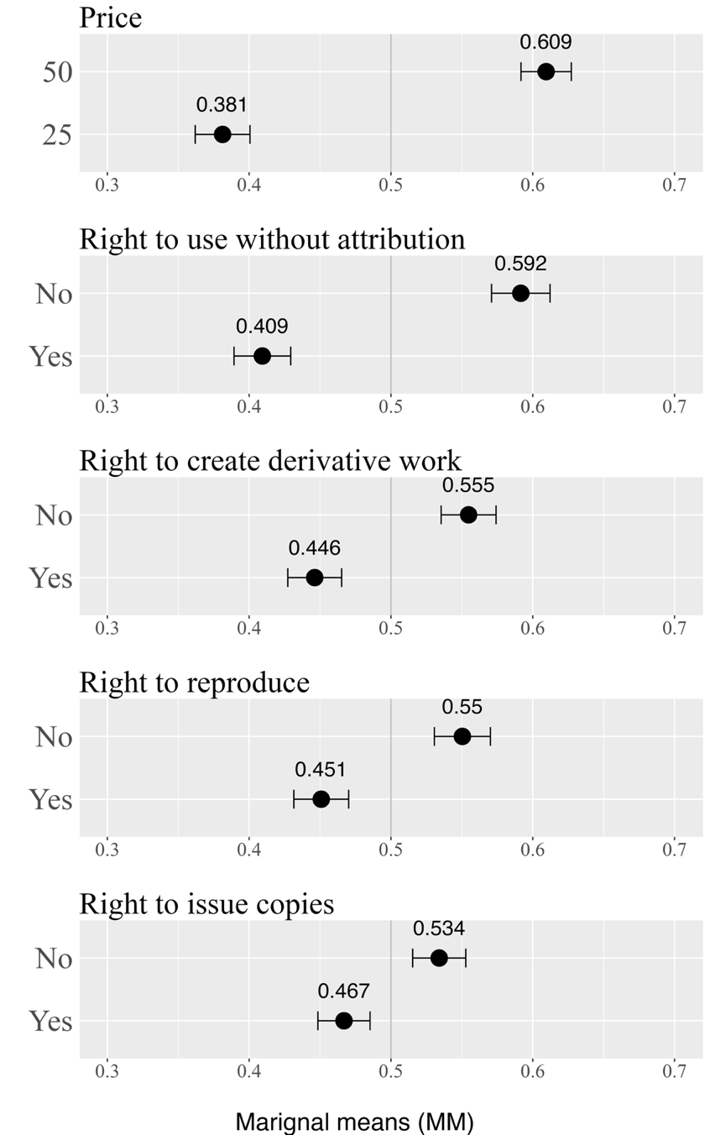
Note: The figure presents point estimates of the Marginal Means (MMs), along with 95% confidence intervals. The MM represents the probability of choosing a contract when a certain price or right is realized.

Figure A4. MMs for Professionals (UK and US combined)
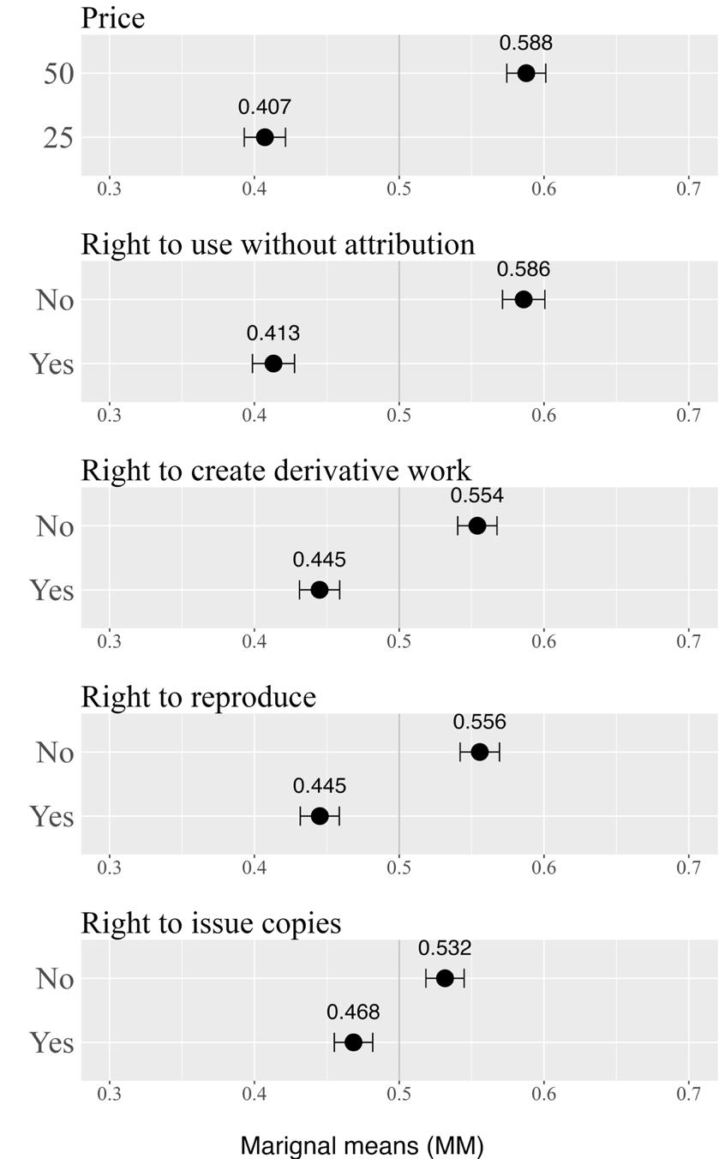
Note: The figure presents point estimates of the Marginal Means (MMs), along with 95% confidence intervals. The MM represents the probability of choosing a contract when a certain price or right is realized.

Figure A5. Differences between UK General Population for Professionals
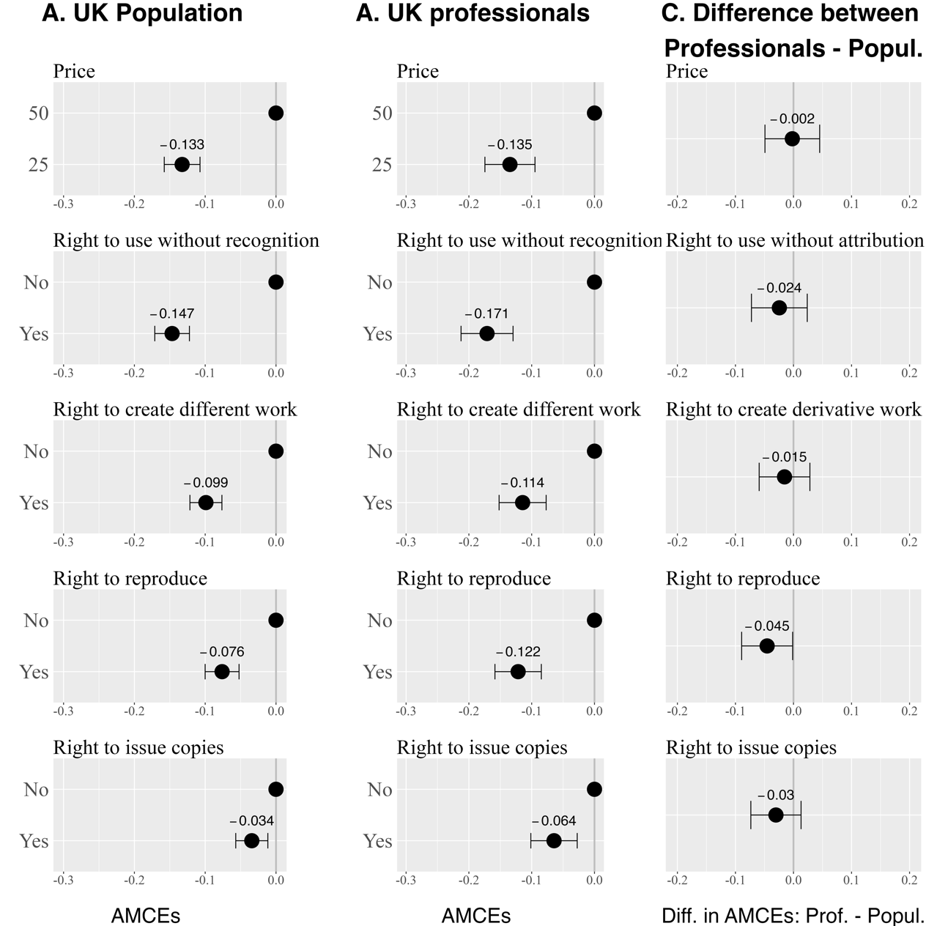
Note: The figure presents point estimates of the Average Marginal Component Effects (AMCEs) and the differences in AMCEs, along with 95% confidence intervals. The AMCE represents the change in the probability of choosing a contract when a certain price or right is realized, as compared to its baseline level. Panel A presents the AMCEs for the UK lay respondents, Panel B displays the AMCEs for UK professionals, and Panel C shows the differences in AMCEs between these two groups.

Figure A6. Distribution of Age across Samples
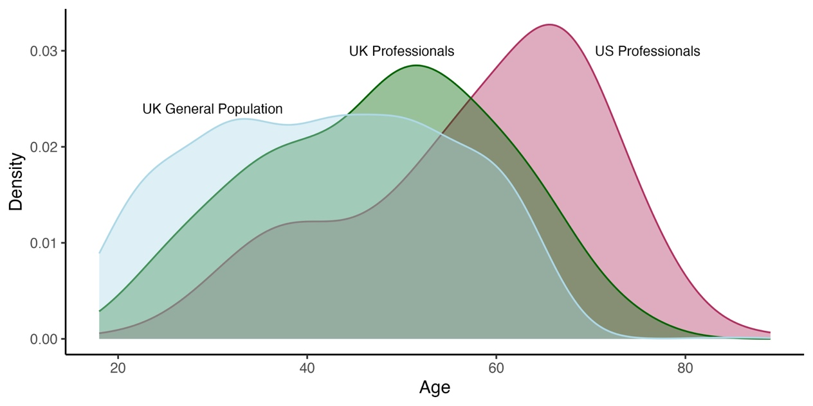

Figure A7. Distribution of Education Levels across Samples
