**SUPPLEMENTARY MATERIALS (NOT FOR PUBLICATION)**

**ANNEX 1. BRIEF DESCRIPTIONS OF THE CASE STUDIES**

- The eruption of the Icelandic volcano Eyjafjallajökull in April 2010 marked the onset of the Icelandic ash cloud crisis. Immediately perceived as a major threat to flight safety, the detection of high ash concentrations in Northern and Central Europe with an origin in Eyjafjallajökull led to a temporary interruption of airspace operations all over the European continent. Flight cancellations disrupted international trade and tourist flows, quickly generating important financial losses and threatening many airlines with bankruptcy. Negotiations between a network of actors that included national airspace operators, the European Commission, airlines, pilot associations, international organizations, and engine manufacturers resulted in an agreement to modify the existing airspace regulations. The unprecedented regulatory change that allowed for flights to resume immediately in areas whose ash concentration had been deemed safe was completed in only four days. Factors explaining this extraordinarily quick reaction include the successful integration of a diverse range of actors in the deliberations, the smooth dialogue between airspace operators and regulatory bodies at the national and supranational levels, and the flexibility to divert from the existing standard operating procedures when these proved incapable to mitigate damages.

**-** The 2014-2016 Ebola Virus Disease outbreak claimed over 11,000 lives, most of which corresponded to Guinean, Liberian, and Sierra Leonean citizens. To date, it is the deadliest outbreak of this disease in recorded history. The 2014-2016 Ebola outbreak also disrupted international trade, mining, and tourism significantly in West Africa. Led by a network including foreign governments, international organizations, NGOs, and private actors, the response lasted until 2016, when the outbreak was declared to be over. Different circumstances resulted in the outbreak spiraling out of control and infecting individuals located thousands of kilometers away from its original epicenter. These include the porousness of country borders in West Africa, the limited capacity of the most affected country governments to counter the spread of the disease, and the sluggish response of the international community to the warnings sent by organizations operating on the ground. In turn, such a delayed reaction had its roots in the relatively low geopolitical importance of the region and the reluctance of the affected governments to acknowledge the seriousness of the threat. This outbreak resulted in calls for reform of the global health governance regime, which among other aspects highlighted the lack of independence and authority of the World Health Organization (WHO) to fulfil its prescribed mandate.

- Cyclones Idai and Kenneth caused thousands of casualties and financial losses amounting to billions of dollars in Mozambique, Malawi, Zimbabwe, and the Comoros Islands in Spring 2019. They also threatened to trigger a wave of refugees across the African continent. Among the worst disasters of this kind in the Southern Hemisphere, the effects of Cyclones Idai and Kenneth were handled in the subsequent months by a humanitarian response network that involved a constellation of actors, including national governments, NGOs, and international organizations. Among these, the most prominent organizations included the United Nations Office for the Coordination of Humanitarian Affairs (UN-OCHA), USAID, DFID, and the NGO consortium COSACA. All these actors efficiently engaged in tasks as diverse as the reconstruction of local telecommunications, food safety provision, and disease prevention. In Mozambique, the success of the response was attributed to a number of factors, including prior preparation work, the overall smooth coordination across the network, and the readiness of forces to intervene on the ground as soon as the cyclones hit the affected areas. In contrast, the low involvement of the local community in the response network and the insufficient funding of the operation were identified as relevant deficiencies of this response.

**ANNEX 2. QUESTIONNAIRE**

1. Could you please indicate the name of the institution that you were affiliated with throughout the response to the (insert crisis)?

(For response options, see the actors included in each network in Tables 2-4)

2. Were you in touch with any of the following organizations throughout the response to the (insert crisis)? Please check all that apply.

(For response options, see the actors included in each network in Tables 2-4)

3. Were you in touch with any organization throughout the response to the (insert crisis) that was not included in the previous list? Click an option if this was the case AND write the name(s) of the institution(s). Please do not write the name of more than one institution per box. Please note that it is not mandatory to answer this question.

4. This is the end of the survey. Would you like to add any comments?

**ANNEX 3. LIST OF CLIQUES**

1. **Ash cloud crisis**

**3-actor cliques (11 in total):**

1. Commission, Iceland DCPEM, UK Met.
2. Danish CAA, EASA, Norwegian CAA.
3. Eurocontrol, Iceland Met, UK Met.
4. Eurocontrol, Icelandic CAA, Iceland Met.
5. Commission, Council, Eurocontrol.
6. Commission, Council, EASA.
7. CANSO, Commission, Irish CAA.
8. EASA, Icelandic CAA, Norwegian CAA.
9. Icelandic CAA, Iceland DCPEM, Iceland Met.
10. EASA, Icelandic CAA, Iceland Met.
11. Commission, EASA, ECA.

**4-actor cliques (13 in total):**

1. Iceland DCPEM, Iceland Earth, Iceland Met, UK Met.
2. Commission, Danish CAA, EASA, Irish CAA.
3. Commission, Danish CAA, EASA, ICAO.
4. Eurocontrol, IATA, Rolls Royce, UK Met.
5. Commission, Eurocontrol, IATA, UK Met.
6. British CAA, EASA, Rolls Royce, UK Met.
7. British CAA, EASA, GE, Rolls Royce.
8. CANSO, Commission, IATA, ICAO.
9. Commission, EASA, IATA, UK Met.
10. EASA, IATA, Rolls Royce, UK Met.
11. Commission, EASA, IATA, ICAO.
12. AEA, Commission, EASA, IATA.
13. AEA, CANSO, Commission, IATA.

**5-actor cliques (2 in total):**

1. British CAA, EASA, Icelandic Met, Irish CAA, UK Met.
2. British CAA, Commission, EASA, Irish CAA, UK Met.

Names of the organizations: AEA = Association of European Airlines; British CAA = British Civil Aviation Authority; Danish CAA = Civil Aviation Administration Denmark; Icelandic CAA = Civil Aviation Administration Iceland; Norwegian CAA = Civil Aviation Authority of Norway; CANSO = Civil Aviation Services Organization; Council = Council of the European Union; EURCONTROL = EUROCONTROL; EASA = European Aviation Safety Agency; ECA = European Cockpit Association; Commission = European Commission; GE = General Electric; Iceland DCPEM = Icelandic Department of Civil Protection and Emergency Management; Iceland Met = Icelandic Meteorological Office; Iceland Earth = Institute of Earth Sciences – University of Iceland; IATA = International Air Transport Association; ICAO = International Civil Aviation Organization; Irish CAA = Irish Aviation Authority (government); Rolls Royce = Rolls Royce; UK Met = UK Met Office.

1. **Ebola outbreak**

**3-actor cliques (11 in total):**

1. AFD, Guinea, UN SG

2. Samaritan, US CDC, USAID

3. Conc, EC, Red Cross

4. Care, DFID, Rescue

5. Care, Conc, Rescue

6. DFID, Oxfam, SL

7. Aspen, DFID, SL

8. Liberia, UNMEER, WHO

9. ADB, Guinea, UNDP

10. ADB, AU, Guinea

11. AFD, EEAS, Guinea

**4-actor cliques (28 in total):**

1. Guinea, Save Child, US CDC, USAID

2. Conc, Medical, Rescue, UNMIL

3. Medical, Save Child, US CDC, USAID

4. OCHA, UNICEF, UNMEER, WHO

5. OCHA, UNMEER, US CDC, WHO

6. DFID, Rescue, Plan, UNICEF

7. EU Eb, Rescue, UNMEER, UNMIL

8. EU Eb, EC, Guinea, UNMEER

9. EEAS, EU Eb, EC, UNICEF

10. EEAS, EC, UNDP, UNICEF

11. EEAS, EC, Guinea, UNDP

12. Guinea, UNMEER, US CDC, USAID

13. Guinea, UN SG, UNMEER, US CDC

14. EU Eb, Guinea, UN SG, UNMEER

15. EEAS, EC, Spain, UNDP

16. EEAS, EU Eb, EC, Spain

17. EU Eb, Rescue, IOM, UNMIL

18. EU Eb, EC, EP, MSF

19. EEAS, EU Eb, EC, Guinea

20. DFID, EEAS, EU Eb, UNICEF

21. AGI, SL, UNMEER, UNMIL

22. ADB, SL, UNMIL, WHO

23. ADB, ECOWAS, SL, UNMIL

24. ADB, SL, UNICEF, WHO

25. ADB, UNDP, UNICEF, WB

26. UNDP, UNFPA, UNMEER, UNMIL

27. UNDP, UNFPA, UNICEF, UNMEER

28. ADB, AU, ECOWAS, SL

**5-actor cliques (35 in total):**

1. Medical, IOM, UNDP, UNMIL, WB

2. Medical, UNDP, UNMEER, UNMIL, WB

3. Medical, IOM, SL, US CDC, USAID

4. Medical, IOM, SL, UNMIL, US CDC

5. Medical, SL, UNMEER, UNMIL, US CDC

6. Medical, Rescue, IOM, OCHA, US CDC

7. Medical, Rescue, OCHA, UNMEER, US CDC

8. Medical, Rescue, OCHA, UNICEF, UNMEER

9. Medical, Rescue, IOM, OCHA, UNICEF

10. Conc, EC, Medical, Rescue, UNICEF

11. SL, UNICEF, UNMEER, USAID, WHO

12. DFID, SL, UNICEF, UNMEER, USAID

13. SL, UNMEER, US CDC, USAID, WHO

14. SL, UNMEER, US CDC, WFP, WHO

15. DFID, SL, UNMEER, US CDC, USAID

16. SL, UN SG, UNICEF, UNMEER, WHO

17. EU Eb, SL, UN SG, UNMEER, UNMIL

18. EU Eb, SL, UN SG, UNICEF, UNMEER

19. DFID, EU Eb, SL, UNICEF, UNMEER

20. DFID, Rescue, UNICEF, UNMEER, USAID

21. DFID, Rescue, UNMEER, US CDC, USAID

22. DFID, EU Eb, Rescue, UNICEF, UNMEER

23. EC, Guinea, UNDP, UNMEER, USAID

24. EU Eb, EC, Rescue, UNICEF, UNMEER

25. EU Eb, EC, SL, UNICEF, UNMEER

26. EU Eb, EC, IOM, SL, UNICEF

27. EU Eb, EC, Rescue, IOM, UNICEF

28. MSF, SL, UNMEER, WFP, WHO

29. EU Eb, EC, MSF, SL, UNMEER

30. AGI, Rescue, UNMEER, UNMIL, WB

31. ECOWAS, UNDP, UNMEER, UNMIL, WB

32. ADB, ECOWAS UNDP, UNMIL, WB

33. ECOWAS, EU Eb, SL, UNMEER, UNMIL

34. ECOWAS, IOM, UNDP, UNMIL, WB

35. ECOWAS, EU Eb, IOM, SL, UNMIL

**6-actor cliques (9 in total):**

1. Medical, Rescue, UNMEER, UNMIL, US CDC, WB

2. Medical, PIH, UNMEER, US CDC, USAID, WB

3. Medical, PIH, SL, UNMEER, US CDC, USAID

4. Medical, Rescue, IOM, UNMIL, US CDC, WB

5. EC, Medical, SL, UNICEF, UNMEER, USAID

6. EC, Medical, IOM, SL, UNICEF, USAID

7. Medical, Rescue, IOM, US CDC, USAID, WB

8. Medical, Rescue, UNMEER, US CDC, USAID, WB

9. SL, UN SG, UNMEER, UNMIL, US CDC, WHO

**7-actor cliques (4 in total)**

1. EC, Medical, Rescue, UNICEF, UNMEER, USAID, WB

2. EC, Medical, UNDP, UNICEF, UNMEER, USAID, WB

3. EC, Medical, IOM, UNDP, UNICEF, USAID, WB

4. EC, Medical, Rescue, IOM, UNICEF, USAID, WB

Names of the organizations: AFD = French Development Agency, ADB = African Development Bank, AGI = The Tony Blair Africa Governance Initiative, AU = African Union, Aspen = Aspen Medical, Care = Care International, Conc = Concern Worldwide, DFID = United Kingdom Department for International Development, ECDC = European Centre for Disease Prevention and Control, ECOWAS = Economic Community of West African States, EEAS = European External Action Service, EU Eb = EU Ebola Response Coordinator, EC = European Commission, EP = European Parliament, GIZ = German Corporation for International Cooperation, Medical = International Medical Corps, Rescue = International Rescue Committee, IOM = International Organization for Migration, Liberia = Liberian government, MSF = Doctors without Borders, OCHA = United Nations Office for the Coordination of Humanitarian Affairs, Oxfam = Oxfam, Phoenix = Phoenix Air, PiH = Partners in Health, Plan = Plan International, Red Cross = International Red Cross and Red Crescent Movement, Samaritan = Samaritan’s Purse, Save Child = Save the Children, SL = Sierra Leonean government, Spain = Government of Spain, UN SG = United Nations Secretary General, UNDP = United Nations Development Program, UNFPA = United Nations Population Fund, UNICEF = United Nations International Children’s Fund, UNMEER = United Nations Mission for Ebola Emergency Response, UNMIL = United Nations Mission in Liberia, US CDC = United States Centres for Disease Control and Prevention, USAID = United States Agency for International Development, WFP = United Nations World Food Programme, WHO = World Health Organization, World Bank = World Bank.

1. **Cyclones Idai and Kenneth**

**3-actor cliques (6 in total):**

1. IOM, USA, WFP.
2. Italy, Red Cross, WHO.
3. IOM, Italy, Red Cross.
4. IOM, Mozambique, Portugal.
5. Oxfam, Sweden, UNICEF.
6. Mozambique, Oxfam, UNICEF.

**4-actor cliques (4 in total):**

1. Canada, Save Child, UK, WHO.
2. OCHA, Save Child, UK, WHO.
3. Oxfam, Save Child, UK, UNICEF.
4. Mozambique, OCHA, Red Cross, WHO.

**5-actor cliques (10 in total):**

1. Commission, FAO, IOM, UNFPA, World Bank.
2. Commission, FAO, UNICEF, WFP, WVI.
3. Commission, FAO, IOM, WFP, World Bank.
4. FAO, IOM, OCHA, UNFPA, World Bank.
5. FAO, IOM, OCHA, WFP, World Bank.
6. Commission, Mozambique, UNFPA, UNICEF, WVI.
7. Commission, Mozambique, UNFPA, USA, WVI.
8. Commission, IOM, Mozambique, UNICEF, WFP.
9. IOM, Mozambique, OCHA, UNICEF, WFP.
10. Commission, IOM, Mozambique, UNFPA, UNICEF.

**6-actor cliques (5 in total):**

1. Commission, FAO, Save Child, UNFPA, UNICEF, WVI.
2. Commission, FAO, IOM, UK, UNICEF, WFP.
3. FAO, IOM, OCHA, UK, UNICEF, WFP.
4. IOM, Mozambique, OCHA, Red Cross, UNFPA, UNICEF.
5. Canada, IOM, Save Child, UK, UNFPA, UNICEF.

**7-actor cliques (2 in total):**

1. FAO, IOM, OCHA, Save Child, UK, UNFPA, UNICEF.
2. Commission, FAO, IOM, Save Child, UK, UNFPA, UNICEF.

Names of the organizations: Commission = European Commission; FAO = Food and Agriculture Organization; Canada = Government of Canada; Italy = Government of Italy; Mozambique = Government of Mozambique; Portugal = Government of Portugal; Sweden =Government of Sweden; UK = Government of the United Kingdom; USA = Government of the United States; IOM = International Organization for Migration; Red Cross = International Red Cross and Red Crescent Movement; Oxfam = Oxfam; Save Child = Save the Children; UNICEF = United Nations International Children’s Fund; OCHA = United Nations Office for the Coordination of Humanitarian Affairs; UNFPA = United Nations Population Fund; WFP = United Nations World Food Programme; World Bank = World Bank; WHO = World Health Organization; WVI = World Vision International.

**ANNEX 4. GOODNESS-OF-FIT DIAGNOSTICS. SOURCE: OWN ELABORATION.**

Model 1

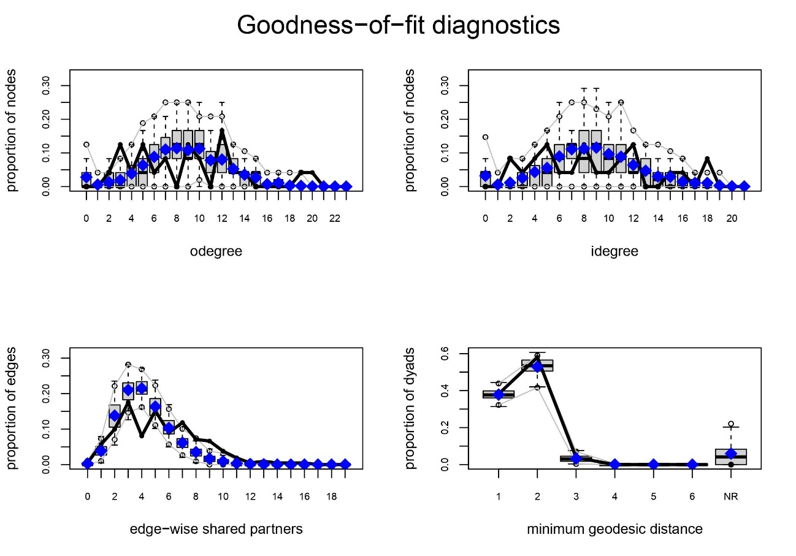

Model 2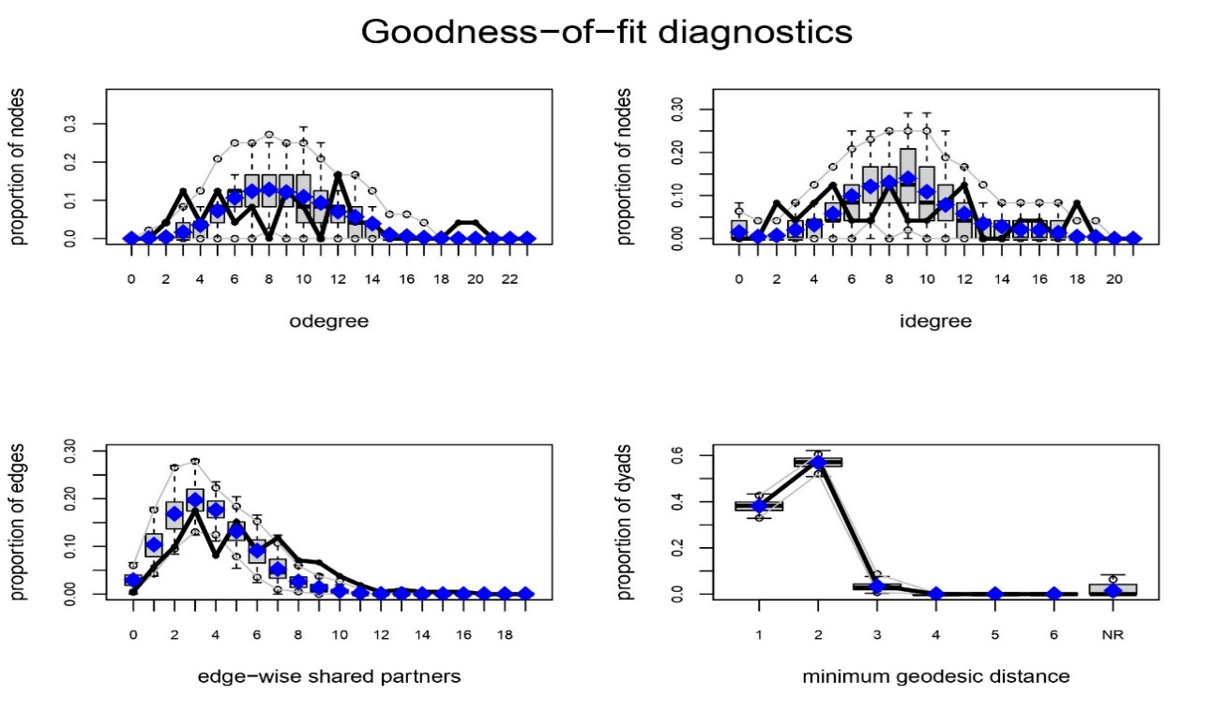

Model 3

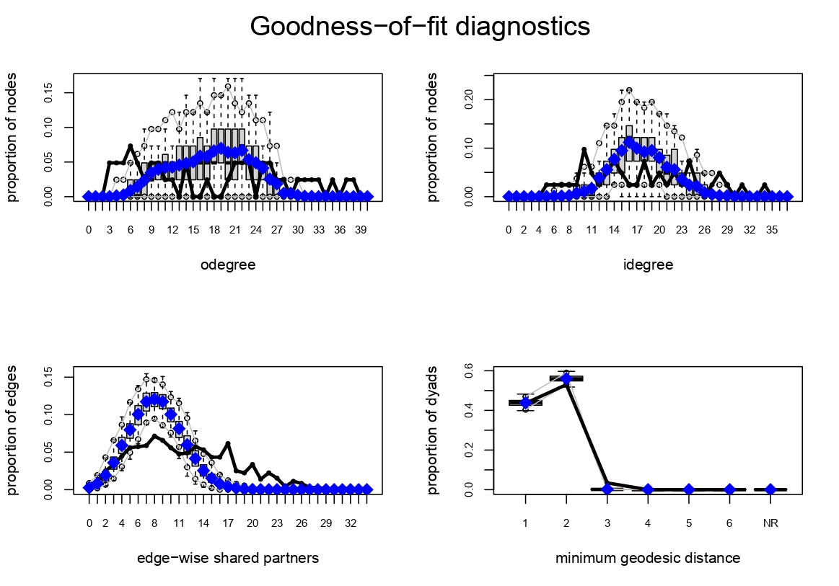

Model 4

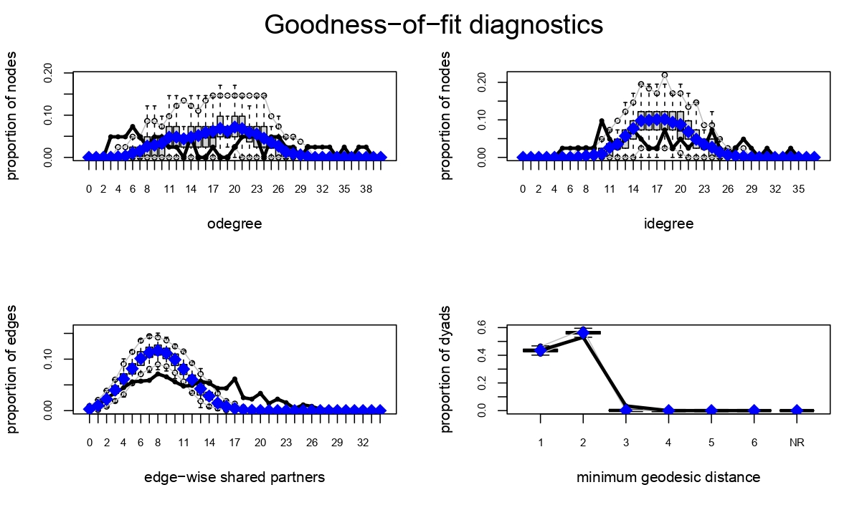

Model 5

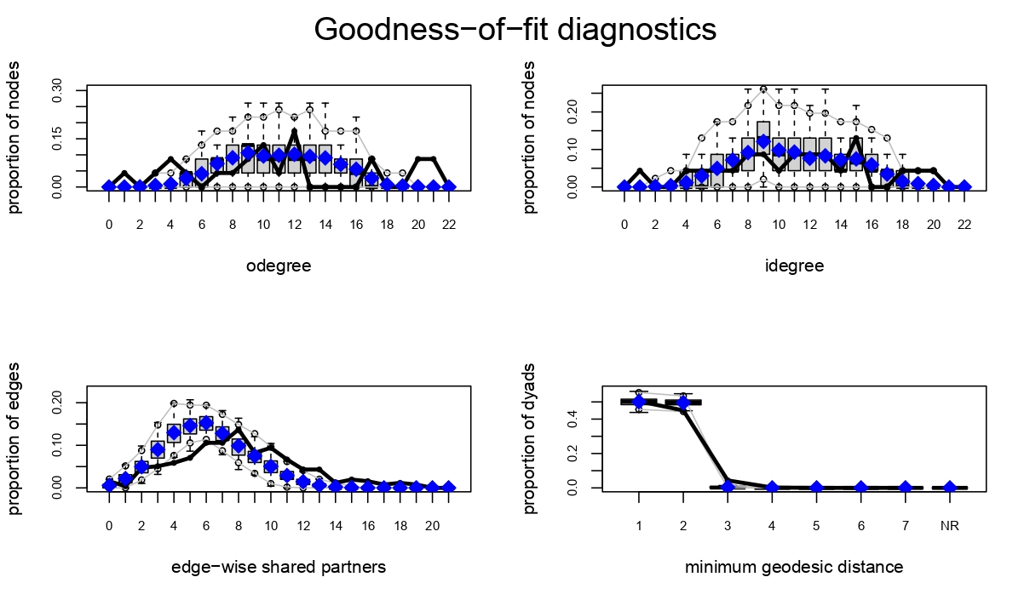

Model 6

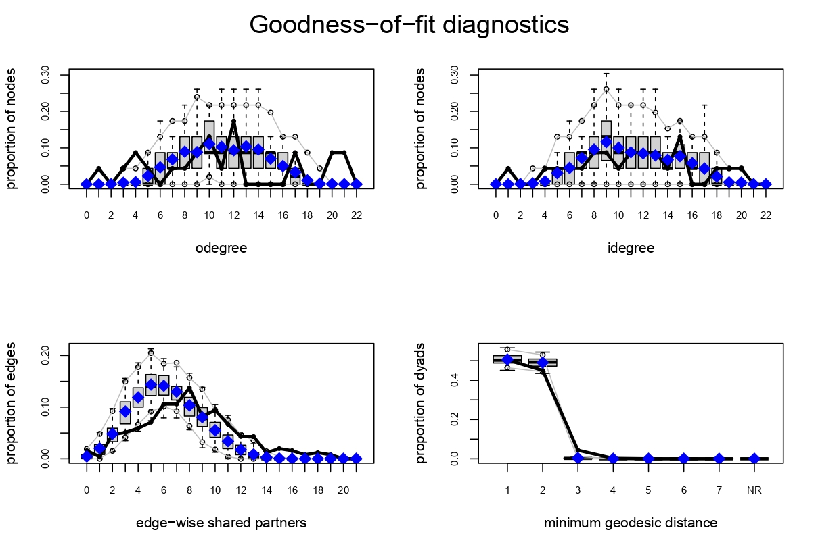

**ANNEX 5. VISUAL REPRESENTATIONS OF THE NETWORKS**

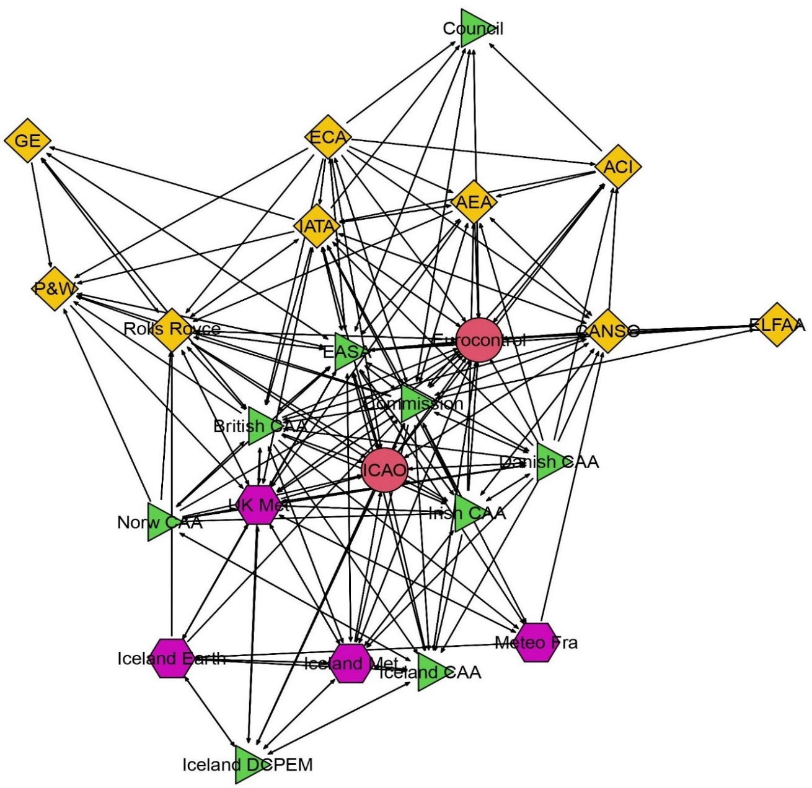

**Annex 5.1.** Ash cloud crisis network. Source: own elaboration. The ties show information exchanges between the nodes. The shape and color of the nodes indicate the nature of organizations as follows: national and supranational government bodies (green triangles), private organizations (yellow squares), scientific organizations (purple hexagons), international organizations (red circles).

Names of the nodes: ACI = Airports Council International; AEA = Association of European Airlines; British CAA = British Civil Aviation Authority; CANSO = Civil Air Navigation Services Organization; Commission = European Commission; Council = Council of the European Union; Danish CAA = Civil Aviation Administration Denmark; EASA = European Aviation Safety Agency; ECA = European Cockpit Association; ELFAA = European Low Fares Airline Association; Eurocontrol = EUROCONTROL; GE = General Electric; IATA = International Air Transport Association; ICAO = International Civil Aviation Organization; Iceland CAA = Civil Aviation Administration Iceland; Iceland DCPEM = Icelandic Department of Civil Protection and Emergency Management; Iceland Met = Icelandic Meteorological Office; Icelandic Earth = Institute of Earth Sciences, University of Iceland; Irish CAA = Irish Aviation Authority; Méteo Fra = Méteo France; Norw CAA = Civil Aviation Authority of Norway; P&W = Pratt & Whitney; Rolls Royce = Rolls Royce; UK Met = Met Office.

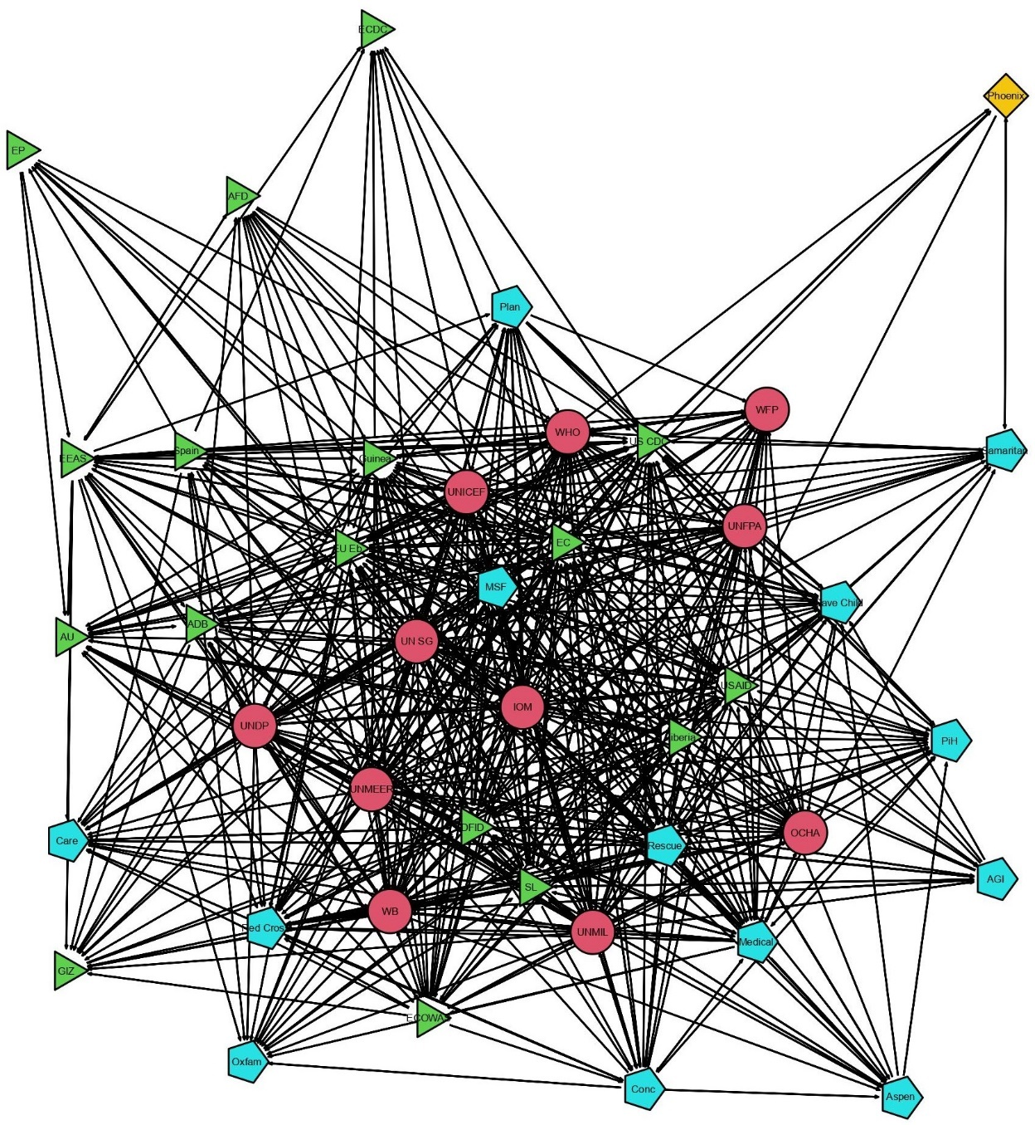

**Annex 5.2**. Ebola Virus Disease outbreak network. Source: own elaboration. The ties show information exchanges between the nodes. The shape and color of the nodes indicate the nature of organizations as follows: national and supranational government bodies (green triangles), private organizations (yellow squares), non-governmental organizations (light blue pentagons), international organizations (red circles).

Names of the nodes: ADB = African Development Bank; AFD = French Development Agency; AGI = The Tony Blair Africa Governance Initiative; Aspen = Aspen Medical; AU = African Union; Care = Care International; Conc = Concern Worldwide; DFID = United Kingdom Department for International Development; EC = European Commission; ECDC = European Centre for Disease Prevention and Control; ECOWAS = Economic Community of West African States; EEAS = European External Action Service; EP = European Parliament; EU Eb = EU Ebola Response Coordinator; GIZ = German Corporation for International Cooperation; IOM = International Organization for Migration; Liberia = Liberian government; Medical = International Medical Corps; MSF = Doctors without Borders; OCHA = United Nations Office for the Coordination of Humanitarian Affairs; Oxfam = Oxfam; Phoenix = Phoenix Air; PiH = Partners in Health; Plan = Plan International; Red Cross = International Red Cross and Red Crescent Movement; Rescue = International Rescue Committee; Samaritan = Samaritan’s Purse; Save Child = Save the Children; SL = Sierra Leonean government; Spain = Government of Spain; UN SG = United Nations Secretary General; UNDP = United Nations Development Program; UNFPA = United Nations Population Fund; UNICEF = United Nations International Children’s Fund; UNMEER = United Nations Mission for Ebola Emergency Response; UNMIL = United Nations Mission in Liberia; US CDC = United States Centres for Disease Control and Prevention; USAID = United States Agency for International Development; WFP = United Nations World Food Programme; WHO = World Health Organization; World Bank = World Bank.

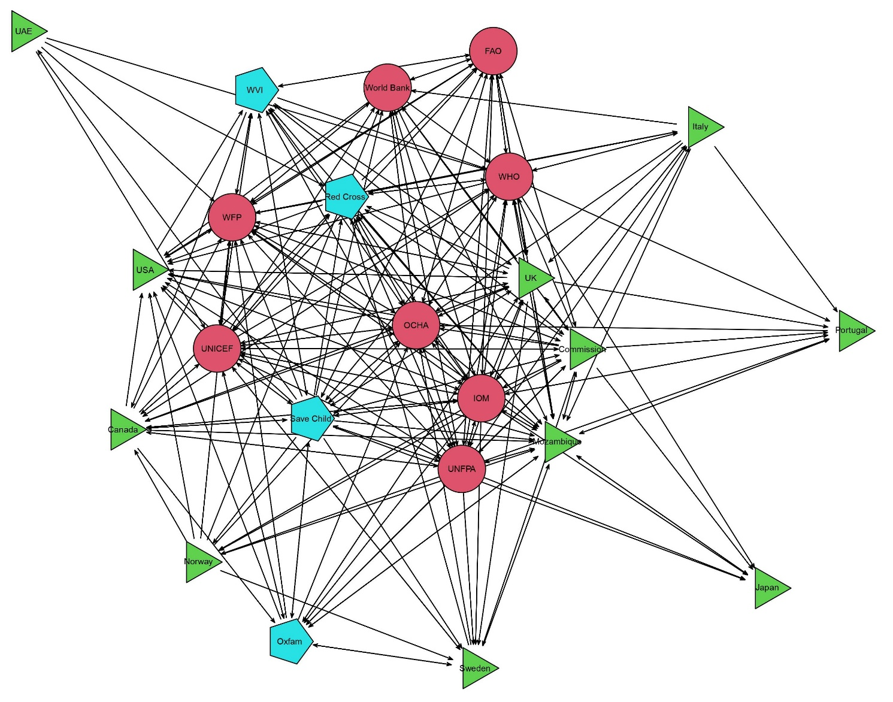

**Annex 5.3**. Cyclones Idai and Kenneth network. Source: own elaboration. The ties show information exchanges between the nodes. The shape and color of the nodes indicate the nature of organizations as follows: national and supranational government bodies (green triangles), private organizations (yellow squares), non-governmental organizations (light blue pentagons), international organizations (red circles).

Names of the nodes: Canada = Government of Canada; Commission = Commission; FAO = Food and Agriculture Organization; IOM = International Organization for Migration; Italy = Government of Italy; Japan = Government of Japan (government); Mozambique = Government of Mozambique; Norway = Government of Norway (government); OCHA = United Nations Office for the Coordination of Humanitarian Affairs; Oxfam = Oxfam; Portugal = Government of Portugal (government); Red Cross = International Red Cross and Red Crescent Movement; Save Child = Save the Children; Sweden =Government of Sweden; UAE = International Humanitarian City / Government of the United Arab Emirates (government); UK = Government of the United Kingdom; UNFPA = United Nations Population Fund; UNICEF = United Nations International Children’s Fund; USA = Government of the United States; WFP = United Nations World Food Programme; World Bank = World Bank; WHO = World Health Organization; WVI = World Vision International.