Supplementary Materials
(For Online Publication Only)

Perceiving Welfare State Sustainability:
Fiscal Costs, Group Deservingness, or Ideology?

Staffan Kumlin and Miroslav Nemčok

Correspondence to: miroslav.nemcok@stv.uio.no

This file contains:
Table A1. Experimental design and operationalizations 3
Table A2. Distribution of participants into the groups 4
Table A3. Results of regression analysis while controlling for socio-economic background variables 5
Table A4. Effect heterogeneity: Results of regression when left, centre left, centre, centre right, and right ideological orientations are entered as dummies 7
Table A5. Comparison of the socio-demographic composition of the experimental groups 9
Table A6. Results of the OLS regression analysis: Estimated future sustainability perceptions of welfare schemes per experimental groups interacted with (personal gross) income. 10

Figure A1. Effect heterogeneity: Visualization of the predicted values when left-right ideology orientations enter the models as dummies 8

Table A1. Experimental design and operationalizations: Comparison of the texts that participants were randomly exposed to.
Note: This table replicates the experimental texts presented in Table 1 in the main text. On top of that, for the sake of easier replication, it adds (1) variable identification code in parenthesis (see table header) which indicates the variable name as used in the Support for the affluent welfare state (SuppA): A Norwegian panel study on welfare state orientations, social capital, and local context data (Kumlin et al., 2020) and (2) response variable operationalizations included in the bottom of the table.
(QC1x_*)  Group A: | (QC2x_*)  Group B: | (QC3x_*)  Group C: |  | (QC4x_*)  Group D: | (QC5x_*)  Group E:
General problem reminder | Cost problem | Deservingness problem |  | Cost and deservingness problem | Control Group
There is some debate about people at an employable age who are not working, and how this affects social security systems and public services in Norway. | There is some debate about people at an employable age who are not working, and how this affects social security systems and public services in Norway. | There is some debate about people at an employable age who are not working, and how this affects social security systems and public services in Norway. |  | There is some debate about people at an employable age who are not working, and how this affects social security systems and public services in Norway.
 | Many believe that the high proportion of people on various social benefits generates costs that will eventually make it difficult to maintain the current levels of social security and public services. |  |  | Many believe that the high proportion of people on various social benefits generates costs that will eventually make it difficult to maintain the current levels of social security and public services.
 |  | Many (also) believe that too many people receive unemployment benefits although they could have been working, or receive sickness benefits while they are actually healthy enough to work. |  | Many (also) believe that too many people receive unemployment benefits although they could have been working, or receive sickness benefits while they are actually healthy enough to work.
Think ten years ahead in time. For each of the following social security systems and public services, where would you place yourself on a scale from 1-7, where 1 means that Norway will not be able to afford the present level of social security and public services, and 7 means that Norway will be able to afford to increase the level? | Think ten years ahead in time. For each of the following social security systems and public services, where would you place yourself on a scale from 1-7, where 1 means that Norway will not be able to afford the present level of social security and public services, and 7 means that Norway will be able to afford to increase the level? | Think ten years ahead in time. For each of the following social security systems and public services, where would you place yourself on a scale from 1-7, where 1 means that Norway will not be able to afford the present level of social security and public services, and 7 means that Norway will be able to afford to increase the level? |  | Think ten years ahead in time. For each of the following social security systems and public services, where would you place yourself on a scale from 1-7, where 1 means that Norway will not be able to afford the present level of social security and public services, and 7 means that Norway will be able to afford to increase the level? | Think ten years ahead in time. For each of the following social security systems and public services, where would you place yourself on a scale from 1-7, where 1 means that Norway will not be able to afford the present level of social security and public services, and 7 means that Norway will be able to afford to increase the level?
Respondents are inquired about two schemes:
*_1 "Sickness benefits" |  |  | *_2 "Unemployment benefits"
Range of the continuous scale offered to respondents and anchors:
1 = Norway will not be able to afford the present level |  | [… 2 … 3 … 4 … 5 … 6 …] |  | 7 = Norway will be able to afford to increase the level

Table A2. Distribution of participants into the groups. The numbers represent total number of participants included in a respective group who responded to the response question.
 | Group A: | Group B: | Group C: | Group D: | Group E:
 | General problem reminder | Cost problem | Deservingness problem | Cost and deservingness problem | Control  Group
Sickness benefits | 320 | 309 | 328 | 320 | 297
Unemployment benefits | 329 | 307 | 338 | 330 | 301

Table A3. Results of regression analysis while controlling for socio-economic background variables–i.e., gender, age, education, and income.
 | Dependent variable:
 | Sickness benefits | Unemployment benefits | Sickness benefits | Unemployment benefits
 | (A1) | (A2) | (A3) | (A4)
Constant | 0.452*** | 0.401*** | 0.587*** | 0.573***
 | (0.056) | (0.054) | (0.065) | (0.063)
Group E: Control groups | (Reference category)
Group A: General problem reminder | 0.056** | 0.041* | 0.120** | 0.028
 | (0.024) | (0.023) | (0.054) | (0.051)
Group B: Cost problem | 0.010 | 0.013 | 0.096* | 0.089*
 | (0.024) | (0.023) | (0.053) | (0.052)
Group C: Deservingness problem | -0.005 | 0.004 | 0.065 | 0.008
 | (0.024) | (0.023) | (0.054) | (0.052)
Group D: Cost & deservingness problem | -0.0004 | 0.009 | 0.043 | 0.0002
 | (0.024) | (0.024) | (0.054) | (0.052)
Left-Right |  |  | -0.030*** | -0.037***
 |  |  | (0.007) | (0.007)
Controls:
Female | 0.030* | 0.031** | 0.015 | 0.016
 | (0.016) | (0.015) | (0.015) | (0.015)
Age | 0.010* | 0.021*** | 0.007 | 0.019***
 | (0.005) | (0.005) | (0.005) | (0.005)
Education:
Primary school | (Reference category)
Higher education | -0.024 | -0.030 | -0.040 | -0.044
 | (0.049) | (0.047) | (0.047) | (0.046)
Vocational education | 0.059 | 0.014 | 0.059 | 0.006
 | (0.051) | (0.049) | (0.049) | (0.048)
University (up to 4 years) | -0.013 | -0.011 | -0.030 | -0.027
 | (0.047) | (0.045) | (0.046) | (0.044)
University (4+ years) | -0.046 | -0.051 | -0.076 | -0.078*
 | (0.049) | (0.047) | (0.047) | (0.046)
Income:
Less than 200 000 NOK | (Reference category)
200 000-299 999 NOK | -0.007 | -0.0004 | 0.047 | 0.047
 | (0.036) | (0.035) | (0.035) | (0.034)
300 000-399 000 NOK | -0.024 | -0.026 | 0.008 | 0.0002
 | (0.034) | (0.033) | (0.034) | (0.032)
400 000–499 999 NOK | -0.032 | -0.053* | 0.002 | -0.023
 | (0.032) | (0.031) | (0.031) | (0.030)
500 000-599 999 NOK | -0.064* | -0.098*** | -0.021 | -0.056*
 | (0.035) | (0.034) | (0.034) | (0.032)
600 000-699 999 NOK | -0.031 | -0.019 | -0.006 | 0.008
 | (0.039) | (0.038) | (0.038) | (0.036)
700 000-799 999 NOK | -0.091* | -0.124*** | -0.012 | -0.065
 | (0.050) | (0.046) | (0.048) | (0.044)
800 000-999 999 NOK | -0.094* | -0.150*** | -0.017 | -0.062
 | (0.050) | (0.046) | (0.047) | (0.044)
1 000 000 NOK or more | -0.128** | -0.042 | -0.030 | 0.058
 | (0.055) | (0.050) | (0.052) | (0.048)
Interactions:
Group A * Left-Right |  |  | -0.011 | 0.004
 |  |  | (0.010) | (0.010)
Group B * Left-Right |  |  | -0.014 | -0.012
 |  |  | (0.010) | (0.009)
Group C * Left-Right |  |  | -0.012 | 0.0003
 |  |  | (0.010) | (0.010)
Group D * Left-Right |  |  | -0.009 | 0.001
 |  |  | (0.010) | (0.010)
Observations | 1,436 | 1,466 | 1,378 | 1,406
R² | 0.036 | 0.046 | 0.130 | 0.141
Adjusted R² | 0.024 | 0.034 | 0.116 | 0.127
Note: *p<0.1; **p<0.05; ***p<0.01; Shown are coefficients of OLS regression with standard errors in parentheses.

Table A4. Effect heterogeneity: Results of regression when left, centre left, centre, centre right, and right ideological orientations are entered as dummies.
 | Dependent variable:
 | Sickness benefits | Unemployment benefits
 | (A5) | (A6)
Constant | 0.563*** (0.040) | 0.558*** (0.039)
Group A: General problem reminder | 0.024 (0.057) | 0.001 (0.054)
Group B: Economic problem | 0.108** (0.054) | 0.111** (0.053)
Group C: Deservingness problem | -0.008 (0.059) | -0.020 (0.057)
Group D: Economic and deservingness problem | 0.053 (0.054) | 0.016 (0.053)
Left-Right: Centre left [3-4] | -0.119** (0.048) | -0.108** (0.047)
Left-Right: Centre [5] | -0.067 (0.062) | -0.119** (0.059)
Left-Right: Centre right [6-7] | -0.150*** (0.053) | -0.149*** (0.052)
Left-Right: Right [8-10] | -0.181*** (0.059) | -0.246*** (0.059)
Group A * Centre left [3-4] | 0.134** (0.068) | 0.085 (0.065)
Group B * Centre left [3-4] | -0.022 (0.069) | -0.044 (0.067)
Group C * Centre left [3-4] | 0.100 (0.070) | 0.074 (0.068)
Group D * Centre left [3-4] | -0.010 (0.067) | 0.043 (0.065)
Group A * Centre [5] | 0.099 (0.088) | 0.102 (0.083)
Group B * Centre [5] | -0.158* (0.087) | -0.099 (0.084)
Group C * Centre [5] | -0.072 (0.084) | -0.046 (0.082)
Group D * Centre [5] | -0.153* (0.085) | -0.060 (0.082)
Group A * Centre right [6-7] | 0.029 (0.073) | 0.040 (0.070)
Group B * Centre right [6-7] | -0.159** (0.070) | -0.183*** (0.068)
Group C * Centre right [6-7] | 0.0004 (0.073) | -0.012 (0.071)
Group D * Centre right [6-7] | -0.095 (0.072) | -0.042 (0.070)
Group A * Right [8-10] | -0.136* (0.083) | -0.037 (0.081)
Group B * Right [8-10] | -0.109 (0.078) | -0.075 (0.077)
Group C * Right [8-10] | -0.010 (0.085) | 0.076 (0.084)
Group D * Right [8-10] | -0.082 (0.081) | 0.025 (0.080)
Observations | 1,505 | 1,533
R² | 0.116 | 0.108
Adjusted R² | 0.101 | 0.094
Note: *p<0.1; **p<0.05; ***p<0.01; Shown are coefficients of OLS regression with standard errors in parentheses.

Figure A1. Effect heterogeneity: Visualization of the predicted values when left-right ideology orientations enter the models as dummies (based on coefficients displayed in Table A4). The horizontal lines represent 95% confidence intervals.
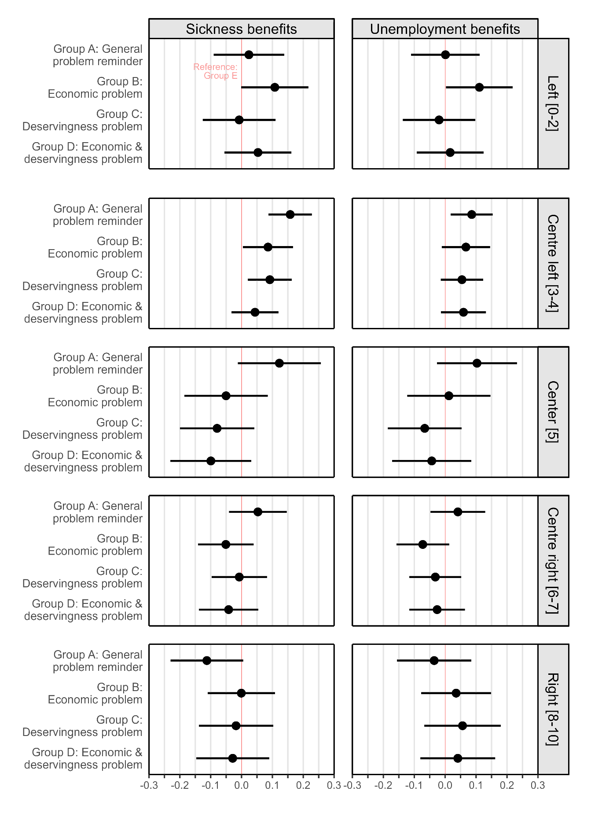

Table A5. Comparison of the socio-demographic composition of the experimental groups.
 |  | Sickness benefits |  |  |  |  |  |  |  |  |  | Unemployment benefits
 |  | Group A |  | Group B |  | Group C |  | Group D |  | Group E |  | Group A |  | Group B |  | Group C |  | Group D |  | Group E
 |  | N | % | N | % | N | % | N | % | N | % | N | % | N | % | N | % | N | % | N | %
Age | (average) | 52.0 |  | 52.5 |  | 51.5 |  | 53.2 |  | 53.7 |  | 51.5 |  | 52.3 |  | 51.5 |  | 52.7 |  | 53.6
Education
Primary school |  | 13 | 4.1 | 12 | 3.9 | 15 | 4.6 | 16 | 5.0 | 9 | 3.0 | 14 | 4.3 | 12 | 3.9 | 16 | 4.7 | 16 | 4.9 | 9 | 3.0
Higher education |  | 66 | 20.6 | 50 | 16.2 | 60 | 18.3 | 57 | 17.8 | 58 | 19.5 | 67 | 20.4 | 51 | 16.6 | 61 | 18.1 | 58 | 17.6 | 59 | 19.6
Vocational education |  | 44 | 13.8 | 46 | 14.9 | 48 | 14.6 | 48 | 15.0 | 48 | 16.2 | 44 | 13.4 | 44 | 14.3 | 47 | 13.9 | 48 | 14.6 | 48 | 16.0
University (up to 4 years) |  | 114 | 35.6 | 129 | 41.8 | 126 | 38.4 | 130 | 40.6 | 113 | 38.1 | 117 | 35.6 | 126 | 41.0 | 129 | 38.2 | 139 | 42.1 | 112 | 37.2
University (4+ years) |  | 83 | 25.9 | 72 | 23.3 | 79 | 24.1 | 69 | 21.6 | 69 | 23.2 | 87 | 26.4 | 74 | 24.1 | 85 | 25.2 | 69 | 20.9 | 73 | 24.3
(missing value) |  | 0 | 0.0 | 0 | 0.0 | 0 | 0.0 | 0 | 0.0 | 0 | 0.0 | 0 | 0.0 | 0 | 0.0 | 0 | 0.0 | 0 | 0.0 | 0 | 0.0
Gender
Female |  | 170 | 53.1 | 149 | 48.2 | 162 | 49.4 | 150 | 46.9 | 141 | 47.5 | 172 | 52.3 | 149 | 48.5 | 166 | 49.1 | 157 | 47.6 | 144 | 47.8
Male |  | 150 | 46.9 | 160 | 51.8 | 166 | 50.6 | 170 | 53.1 | 156 | 52.5 | 157 | 47.7 | 158 | 51.5 | 172 | 50.3 | 173 | 52.4 | 157 | 52.2
(missing value) |  | 0 | 0.00 | 0 | 0.0 | 0 | 0.0 | 0 | 0.0 | 0 | 0.0 | 0 | 0.0 | 0 | 0.0 | 0 | 0.0 | 0 | 0.0 | 0 | 0.0
Income
Less than 200.000 NOK |  | 23 | 7.2 | 18 | 5.8 | 20 | 6.1 | 21 | 6.6 | 13 | 4.4 | 23 | 7.0 | 18 | 5.9 | 20 | 5.9 | 23 | 7.0 | 14 | 4.7
200.000-299.999 NOK |  | 38 | 11.9 | 29 | 9.4 | 30 | 9.2 | 27 | 8.4 | 28 | 9.4 | 40 | 12.2 | 29 | 9.5 | 30 | 8.9 | 28 | 8.5 | 27 | 9.0
300.000-399.999 NOK |  | 56 | 17.5 | 52 | 16.8 | 63 | 19.2 | 66 | 20.6 | 55 | 18.5 | 55 | 16.7 | 51 | 16.6 | 63 | 18.6 | 66 | 20.0 | 55 | 18.3
400.000-499.999 NOK |  | 79 | 24.7 | 84 | 27.2 | 75 | 22.9 | 73 | 22.8 | 75 | 25.3 | 81 | 24.6 | 83 | 27.0 | 77 | 22.8 | 72 | 21.8 | 75 | 24.9
500.000-599.999 NOK |  | 45 | 14.1 | 52 | 16.8 | 51 | 15.6 | 33 | 10.3 | 47 | 15.8 | 45 | 13.7 | 50 | 16.3 | 53 | 15.7 | 36 | 10.9 | 47 | 15.6
600.000-699.999 NOK |  | 23 | 7.2 | 24 | 7.8 | 25 | 7.6 | 30 | 9.4 | 23 | 7.7 | 24 | 7.3 | 24 | 7.8 | 27 | 8.0 | 31 | 9.4 | 23 | 7.6
700.000-799.999 NOK |  | 8 | 2.5 | 5 | 1.6 | 14 | 4.3 | 17 | 5.3 | 15 | 5.1 | 10 | 3.0 | 6 | 2.0 | 16 | 4.7 | 17 | 5.2 | 15 | 5.0
800.000-999.999 NOK |  | 14 | 4.4 | 9 | 2.9 | 15 | 4.6 | 9 | 2.8 | 10 | 3.4 | 15 | 4.6 | 10 | 3.3 | 16 | 4.7 | 12 | 3.6 | 11 | 3.7
1.000.000 NOK or more |  | 3 | 0.1 | 10 | 3.2 | 13 | 4.0 | 10 | 3.1 | 6 | 2.0 | 4 | 1.2 | 11 | 3.6 | 14 | 4.1 | 11 | 3.3 | 8 | 2.7
(missing value) |  | 31 | 9.7 | 26 | 8.4 | 22 | 6.7 | 34 | 10.6 | 25 | 8.4 | 32 | 9.7 | 25 | 8.1 | 22 | 6.5 | 34 | 10.3 | 26 | 8.6
Group total N |  | 320 |  | 309 |  | 328 |  | 320 |  | 297 |  | 329 |  | 307 |  | 338 |  | 330 |  | 301

Table A6. Results of the OLS regression analysis: Estimated future sustainability perceptions of welfare schemes per experimental groups interacted with (personal gross) income.
 | Dependent variable:
 | Sickness benefits | Unemployment benefits
 | (A7) | (A8)
Constant | 0.555*** | 0.523***
 | (0.045) | (0.043)
Group A: General problem reminder | -0.005 | 0.017
 | (0.060) | (0.058)
Group B: Economic problem | 0.0004 | -0.011
 | (0.060) | (0.058)
Group C: Deservingness problem | -0.088 | -0.090
 | (0.059) | (0.057)
Group D: Economic and deservingness problem | -0.002 | 0.023
 | (0.061) | (0.058)
Income | -0.024** | -0.022**
 | (0.010) | (0.009)
Group A * Income | 0.015 | 0.005
 | (0.014) | (0.013)
Group B * Income | 0.002 | 0.007
 | (0.013) | (0.013)
Group C * Income | 0.020 | 0.022*
 | (0.013) | (0.012)
Group D * Income | 0.001 | -0.002
 | (0.013) | (0.013)
Observations | 1,436 | 1,466
R² | 0.021 | 0.017
Adjusted R² | 0.014 | 0.011
Note: *p<0.1; **p<0.05; ***p<0.01; Shown are coefficients of OLS regression with standard errors in parentheses.

