Supplementary Materials (For Online Publication) for « Why do citizens support algorithmic government?”
Dario Sidhu, Beatrice Magistro, Benjamin Allen Stevens, Peter John Loewen

Appendix A
Independent Variables

All continuous independent variables used in the analyses are rescaled from 0 to 1. Education has 4 categories: incomplete secondary education, secondary education, vocational or professional certification, university education or higher. We recode it to go from 0 to 1 and treat it as continuous (from low — 0 — to high — 1). Income was recoded into a simplified "Low income" variable, equal to 1 if the respondent was "Finding it very difficult on present income" or "Finding it difficult on present income", or 0 if they were more comfortable on present income (see Appendix B for details on how the Canadian income data was recoded to match the EPIS data). Left-to-right scale is a self-placement scale where individuals place themselves from 0, left, to 10 right. We rescaled it to go from 0 to 1.
The populism scale (also rescaled from 0 to 1) was based on the questions below:
“Do you agree or disagree with the following statements?”
 | Strongly disagree (1) | Somewhat disagree  (2) | Neither agree nor disagree (3) | Somewhat agree  (4) | Strongly agree  (5)
Traditional parties and politicians don’t care about people like me (1) | o | o | o | o | o
To fix [your country], we need a strong leader willing to break the rules (2) | o | o | o | o | o
I trust the government to do the right thing (3)1 | o | o | o | o | o
Table A1: Summary statistics of all independent variables. Frequency and percent for categorical variables and mean, median, mode and standard deviation for numerical variables.
Variable | Frequency |  | Percent
Gender
Not Female | 8457 |  | 48.58
Female | 8952 |  | 51.42
Income
Not low income | 11325 |  | 65.05
Low income | 5623 |  | 32.30
Missing | 461 |  | 2.65
Education
Incomplete secondary education | 1708 |  | 9.81
Secondary education completed | 7246 |  | 51.43
Vocational or professional certification | 3444 |  | 19.78
University education or higher | 4983 |  | 28.62
Missing | 28 |  | 0.16
Country
Austria | 978 |  | 5.62
Belgium (FR) | 980 |  | 5.63
Belgium (NL) | 865 |  | 4.97
Canada | 1995 |  | 11.46
Denmark | 997 |  | 5.73
Finland | 977 |  | 5.61
France | 977 |  | 5.61
Germany | 935 |  | 5.37
Greece | 788 |  | 4.53
Ireland | 989 |  | 5.68
Italy | 990 |  | 5.69
Netherlands | 975 |  | 5.60
Norway | 992 |  | 5.70
Portugal | 1003 |  | 5.76
Spain | 992 |  | 5.70
Sweden | 1001 |  | 5.75
UK | 975 |  | 5.60
Variable (min-max) | Mean | Median | Mode | Standard Deviation
Age (18-99) | 45.97 | 46 | 55 | 15.80
Left to right scale (0-1) | 0.52 | 0.5 | 0.5 | 0.24
Populism scale (0-1) | 0.55 | 0.58 | 0.5 | 0.22

Appendix B: Weighted Canadian Pilot study results
The Canadian data in the combined dataset, presented in the main results, has some differences from the Canadian pilot. The following changes were made to the Canadian variables to make it match the EPIS:

- Education category simplified from 9 levels to 4.
- The Canadian absolute income and EPIS subjective income measures were recoded into a simplified "Low income" variable, equal to 1 if annual pre-tax income was below $40,000 (Canada), or if the respondent was "Finding it very difficult on present income" or "Finding it difficult on present income" (EPIS), or 0 if they had a higher income or were more comfortable, respectively. This results in about 30% of respondents in each dataset being categorized as "low income".
- Only 3 of the 7 populism items in the Canadian data were replicated in the EPIS, so only those 3 were used in the combined data. The Canadian data also had an additional 4 items (going from strongly disagree — 1 — to strongly agree — 5) which were used in the individual country analyses: The Canadian economy is rigged to advantage the rich and powerful; Experts in this country don’t understand the lives of people like me; Canada needs a strong leader to take the country back from the rich and powerful; Politicians should be able to say what’s on their minds regardless of what anyone else thinks about their views.

Figure B2: Frequency of support for reasons for government use of algorithms and AI, Canada
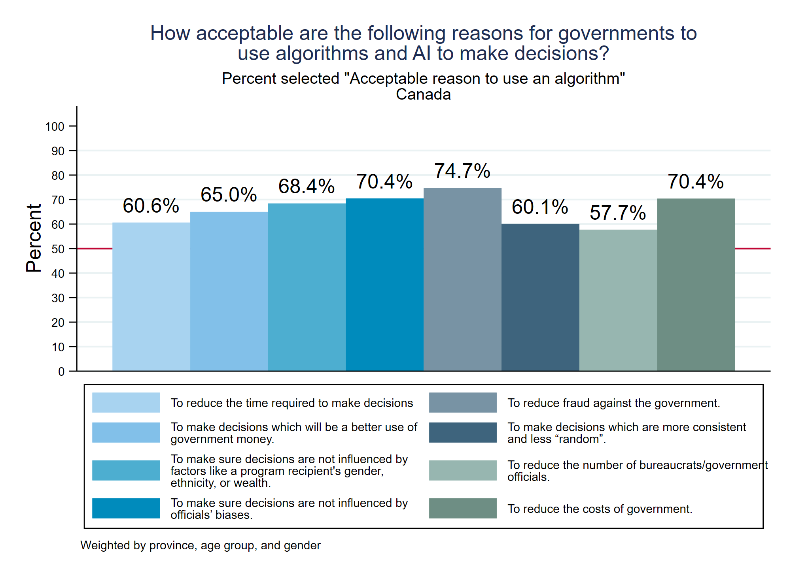Figure B3: Frequency of the number of reasons for government use of algorithms and AI individuals deem acceptable, Canada
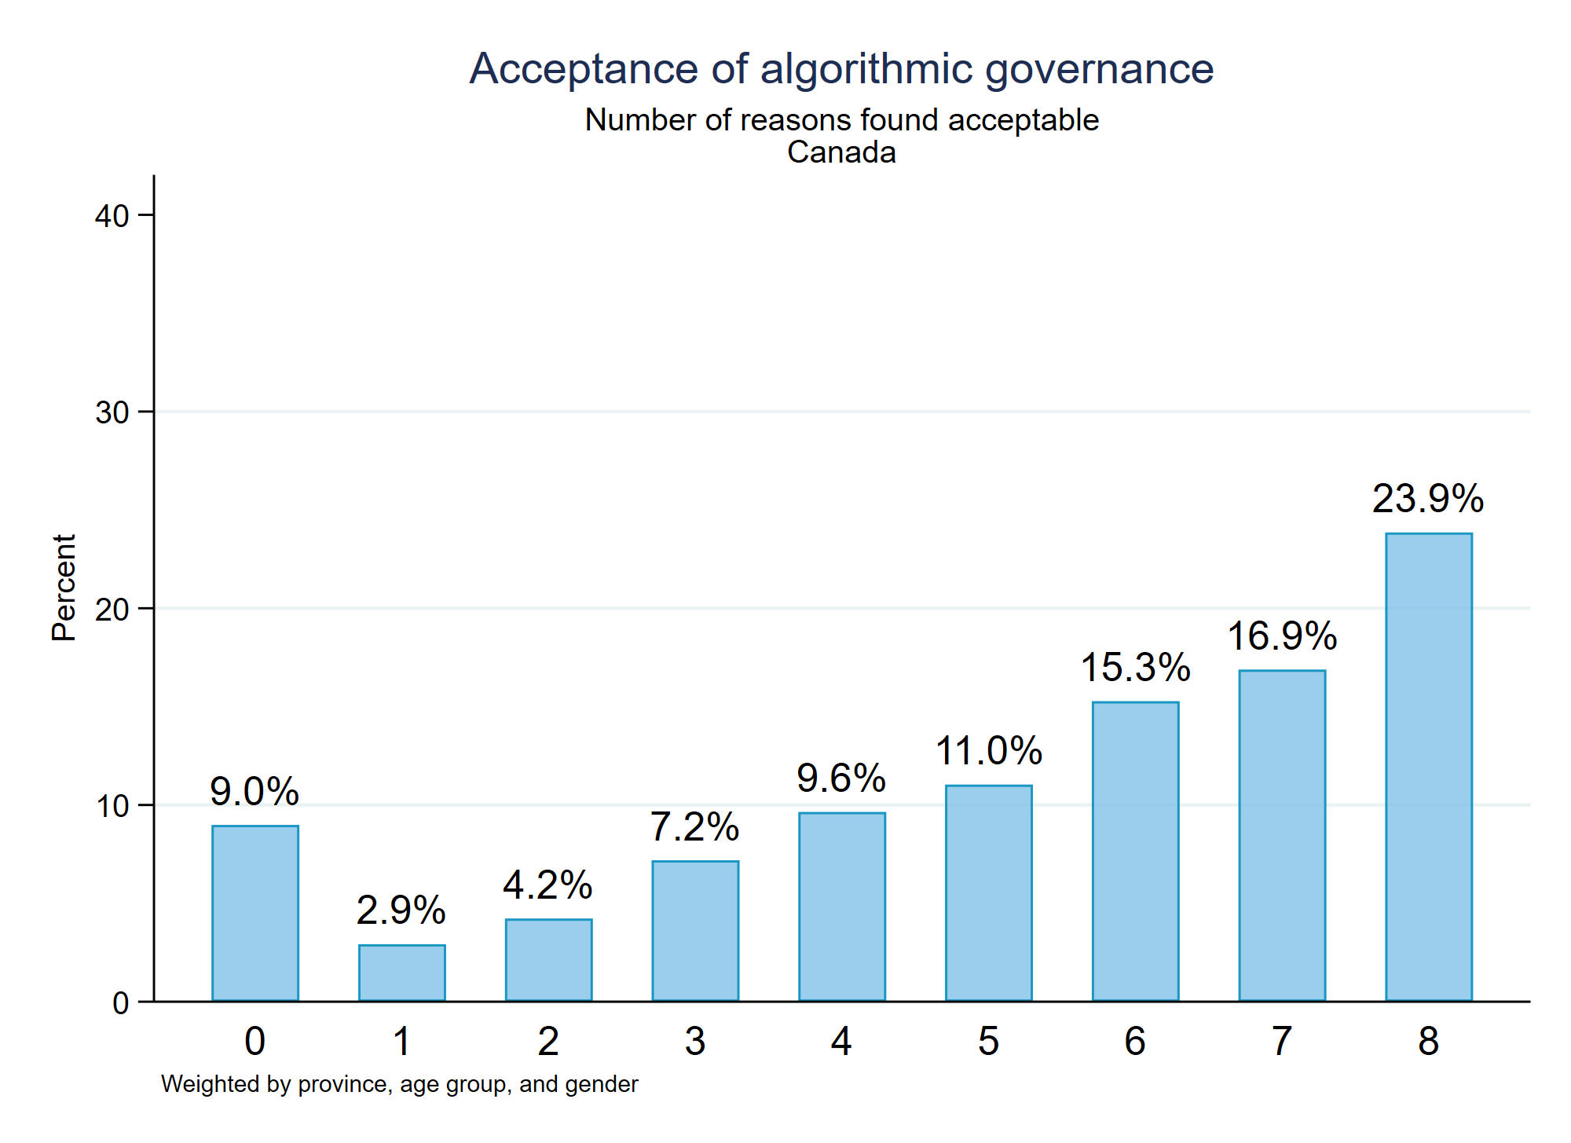

Table B1: OLS regressions of support for algorithmic government, Canada
 | Model 1: Full scale | Model 2: Efficiency | Model 3: Fairness
Age in years | 0.19*** | 0.21*** | 0.15***
(rescaled 0-1) | (0.03) | (0.04) | (0.04)
Female (0/1) | -0.07*** | -0.08*** | -0.05**
 | (0.01) | (0.02) | (0.02)
Income category | 0.10** | 0.09* | 0.12**
(rescaled 0-1) | (0.03) | (0.03) | (0.04)
Education category | 0.15*** | 0.14*** | 0.17***
(rescaled 0-1) | (0.04) | (0.04) | (0.04)
Left-Right scale | 0.00 | 0.05 | -0.07
(rescaled 0-1) | (0.03) | (0.04) | (0.04)
Populism (0-1) | 0.10* | 0.15** | 0.03
 | (0.05) | (0.05) | (0.06)
Constant | 0.47*** | 0.43*** | 0.55***
 | (0.04) | (0.04) | (0.05)
Observations | 1876 | 1876 | 1876
Notes: * (p<0.05), ** (p<0.01), *** (p<0.001)
Weighted by province, age group, and gender

Appendix C: Individual country results

Figure C1: Percent of respondents in country that say reason is acceptable.
 | CAN | AUS | BEL  (FR) | BEL  (NL) | DEN | FIN | FRA | GER | GRC | ITA | IRL | NLD | NOR | POR | ESP | SWE | GBR | EPIS full
To reduce the time required to make decisions. | 60.6 | 45.0 | 35.8 | 49.2 | 37.1 | 42.6 | 39.6 | 45.2 | 60.7 | 54.6 | 49.4 | 48.7 | 36.7 | 55.5 | 45.5 | 42.3 | 47.4 | 45.8
To make decisions which will be a better use of government money. | 65.0 | 44.2 | 40.6 | 58.0 | 39.5 | 52.5 | 40.2 | 44.4 | 54.3 | 60.1 | 54.6 | 52.8 | 46.7 | 58.2 | 52.6 | 49.7 | 48.3 | 49.7
To make sure decisions are not influenced by factors like a program recipient's gender, ethnicity, or wealth. | 68.4 | 58.1 | 46.9 | 54.3 | 47.5 | 59.7 | 45.7 | 54.4 | 49.9 | 65.1 | 62.2 | 52.6 | 49.7 | 56.0 | 53.3 | 55.9 | 53.4 | 54.1
To make sure decisions are not influenced by officials’ biases. | 70.4 | 63.5 | 48.6 | 62.1 | 51.8 | 66.4 | 45.6 | 58.3 | 63.7 | 65.5 | 67.1 | 60.4 | 56.1 | 60.3 | 56.2 | 58.5 | 58.0 | 58.8
To reduce fraud against the government. | 74.7 | 62.6 | 57.1 | 66.4 | 59.8 | 66.3 | 59.2 | 55.0 | 59.8 | 71.0 | 68.5 | 64.2 | 60.2 | 71.3 | 63.2 | 61.5 | 59.5 | 62.9
To make decisions which are more consistent and less “random”. | 60.1 | 50.4 | 45.3 | 56.3 | 43.3 | 57.8 | 44.2 | 47.9 | 57.7 | 62.3 | 58.4 | 52.6 | 48.1 | 56.1 | 53.2 | 49.3 | 51.3 | 52.1
To reduce the number of bureaucrats/government officials. | 57.7 | 48.6 | 49.2 | 55.1 | 44.8 | 54.3 | 44.9 | 49.5 | 65.4 | 68.1 | 58.3 | 40.6 | 43.8 | 49.9 | 54.2 | 47.8 | 50.4 | 51.4
To reduce the costs of government. | 70.4 | 63.6 | 58.8 | 66.1 | 49.3 | 64.6 | 54.7 | 59.6 | 62.4 | 73.4 | 68.6 | 58.1 | 47.7 | 66.3 | 61.5 | 55.7 | 57.1 | 60.4
Average within country | 65.9 | 54.5 | 47.8 | 58.4 | 46.6 | 58.0 | 46.8 | 51.8 | 59.2 | 65.0 | 60.9 | 53.8 | 48.6 | 59.2 | 55.0 | 52.6 | 53.2 | 54.4

Models for each country
Figure C2: Coefficients from OLS regressions of support for algorithmic government by country
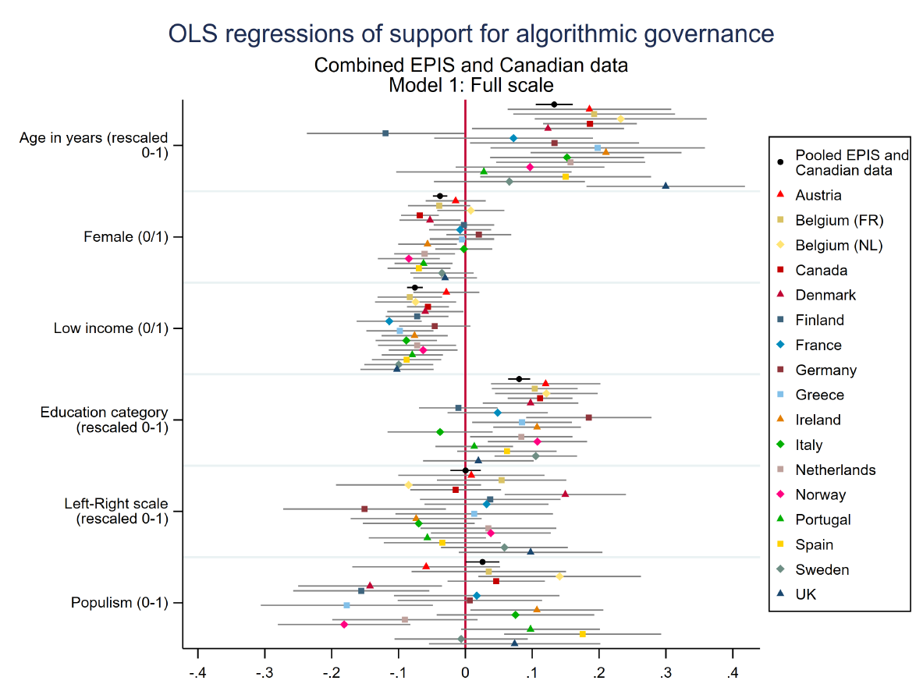

Table C1: OLS regressions of support for algorithmic government, full scale: countries (A-G). Standard errors in parentheses.
 | Austria | Belgium  (FR) | Belgium  (NL) | Canada | Denmark | Finland | France | Germany | Greece
Age in years | 0.186** | 0.193** | 0.232*** | 0.186*** | 0.124* | -0.119* | 0.072 | 0.133* | 0.198*
(rescaled 0-1) | (0.062) | (0.062) | (0.066) | (0.036) | (0.058) | (0.060) | (0.060) | (0.064) | (0.082)
Female (0/1) | -0.014 | -0.039 | 0.008 | -0.068*** | -0.053* | -0.002 | -0.008 | 0.020 | -0.005
 | (0.023) | (0.024) | (0.026) | (0.014) | (0.023) | (0.023) | (0.024) | (0.025) | (0.025)
Low income (0/1) | -0.028 | -0.083*** | -0.074* | -0.056*** | -0.060* | -0.072** | -0.114*** | -0.046 | -0.098***
 | (0.025) | (0.025) | (0.031) | (0.016) | (0.029) | (0.024) | (0.025) | (0.027) | (0.026)
Education category | 0.120** | 0.104** | 0.121** | 0.112*** | 0.098** | -0.010 | 0.048 | 0.185*** | 0.085*
(rescaled 0-1) | (0.042) | (0.033) | (0.039) | (0.025) | (0.036) | (0.030) | (0.038) | (0.048) | (0.038)
Left-Right scale | 0.009 | 0.054 | -0.085 | -0.015 | 0.149** | 0.037 | 0.032 | -0.151* | 0.013
(rescaled 0-1) | (0.056) | (0.049) | (0.055) | (0.035) | (0.046) | (0.054) | (0.047) | (0.062) | (0.060)
Populism (0-1) | -0.059 | 0.035 | 0.141* | 0.046 | -0.143** | -0.156** | 0.017 | 0.007 | -0.177**
 | (0.056) | (0.059) | (0.062) | (0.037) | (0.055) | (0.052) | (0.063) | (0.055) | (0.066)
Constant | 0.477*** | 0.368*** | 0.435*** | 0.551*** | 0.420*** | 0.721*** | 0.440*** | 0.433*** | 0.661***
 | (0.051) | (0.053) | (0.057) | (0.037) | (0.046) | (0.047) | (0.057) | (0.057) | (0.067)
Observations | 932 | 955 | 847 | 1876 | 954 | 961 | 961 | 913 | 775
Notes: * (p<0.05), ** (p<0.01), *** (p<0.001)

Table C3: OLS regressions of support for algorithmic government, full scale: countries (H-Z). Standard errors in parentheses.
 | Ireland | Italy | Netherlands | Norway | Portugal | Spain | Sweden | UK
Age in years | 0.210*** | 0.152** | 0.157** | 0.097 | 0.028 | 0.150* | 0.066 | 0.300***
(rescaled 0-1) | (0.058) | (0.059) | (0.057) | (0.057) | (0.067) | (0.065) | (0.058) | (0.060)
Female (0/1) | -0.057* | -0.002 | -0.061** | -0.085*** | -0.063** | -0.069** | -0.035 | -0.030
 | (0.022) | (0.022) | (0.023) | (0.024) | (0.022) | (0.024) | (0.024) | (0.024)
Low income (0/1) | -0.076** | -0.088*** | -0.072* | -0.063* | -0.079*** | -0.088*** | -0.100*** | -0.102***
 | (0.025) | (0.023) | (0.030) | (0.026) | (0.023) | (0.026) | (0.026) | (0.028)
Education category | 0.107** | -0.038 | 0.084* | 0.108** | 0.013 | 0.062 | 0.105*** | 0.019
(rescaled 0-1) | (0.033) | (0.040) | (0.039) | (0.038) | (0.030) | (0.038) | (0.031) | (0.042)
Left-Right scale | -0.074 | -0.070 | 0.034 | 0.038 | -0.057 | -0.034 | 0.059 | 0.098
(rescaled 0-1) | (0.050) | (0.043) | (0.052) | (0.046) | (0.045) | (0.045) | (0.048) | (0.055)
Populism (0-1) | 0.107* | 0.075 | -0.090 | -0.181*** | 0.098 | 0.175** | -0.006 | 0.074
 | (0.051) | (0.060) | (0.055) | (0.051) | (0.053) | (0.060) | (0.051) | (0.065)
Constant | 0.494*** | 0.648*** | 0.507*** | 0.526*** | 0.607*** | 0.441*** | 0.470*** | 0.363***
 | (0.056) | (0.047) | (0.055) | (0.051) | (0.050) | (0.054) | (0.046) | (0.066)
Observations | 962 | 961 | 950 | 966 | 996 | 964 | 983 | 955
Notes: * (p<0.05), ** (p<0.01), *** (p<0.001)

Figure C3: Coefficients from OLS regressions of support for algorithmic government by country, efficiency subscale
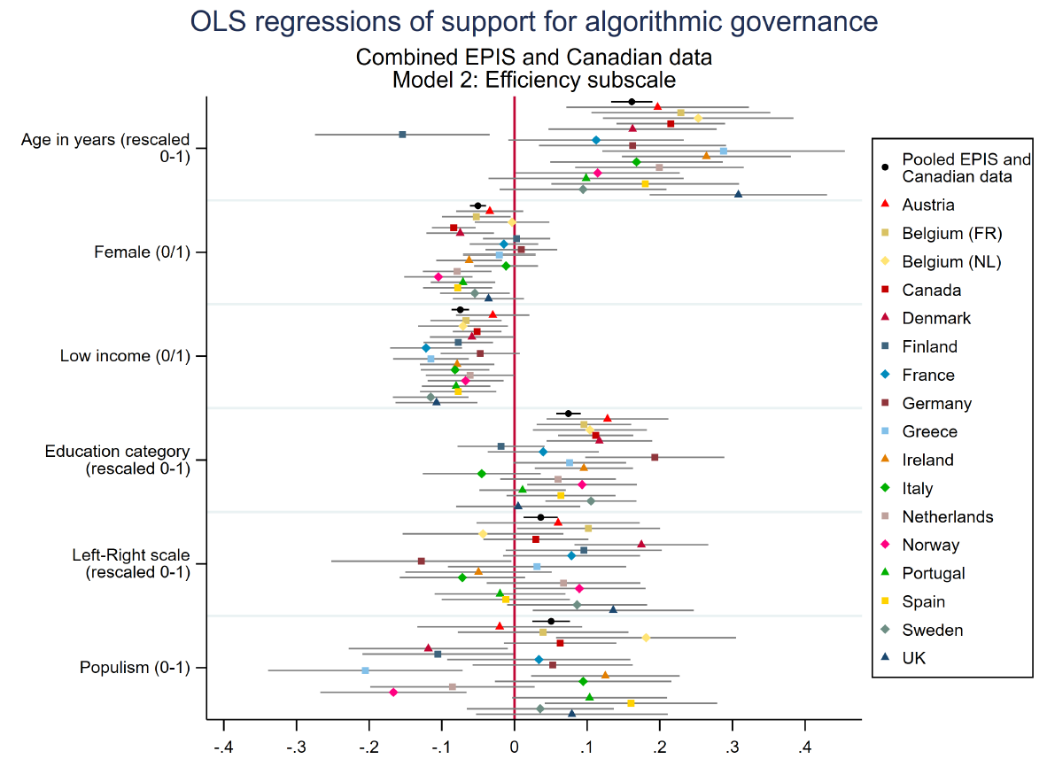

Table C3: OLS regressions of support for algorithmic government, efficiency subscale: countries (A-G). Standard errors in parentheses.
 | Austria | Belgium  (FR) | Belgium  (NL) | Canada | Denmark | Finland | France | Germany | Greece
Age in years | 0.197** | 0.229*** | 0.253*** | 0.215*** | 0.163** | -0.154* | 0.112 | 0.163* | 0.288***
(rescaled 0-1) | (0.064) | (0.063) | (0.067) | (0.038) | (0.059) | (0.061) | (0.062) | (0.066) | (0.085)
Female (0/1) | -0.034 | -0.053* | -0.003 | -0.084*** | -0.075** | 0.003 | -0.015 | 0.009 | -0.021
 | (0.024) | (0.024) | (0.026) | (0.015) | (0.024) | (0.024) | (0.024) | (0.025) | (0.026)
Low income (0/1) | -0.030 | -0.067** | -0.071* | -0.051** | -0.059* | -0.077** | -0.122*** | -0.047 | -0.115***
 | (0.026) | (0.025) | (0.032) | (0.017) | (0.030) | (0.024) | (0.025) | (0.028) | (0.027)
Education category | 0.128** | 0.096** | 0.104** | 0.112*** | 0.117** | -0.018 | 0.040 | 0.193*** | 0.076
(rescaled 0-1) | (0.043) | (0.033) | (0.040) | (0.026) | (0.037) | (0.031) | (0.039) | (0.049) | (0.040)
Left-Right scale | 0.060 | 0.102* | -0.043 | 0.030 | 0.175*** | 0.095 | 0.079 | -0.128* | 0.031
(rescaled 0-1) | (0.057) | (0.050) | (0.056) | (0.037) | (0.047) | (0.055) | (0.048) | (0.063) | (0.062)
Populism (0-1) | -0.020 | 0.039 | 0.181** | 0.063 | -0.119* | -0.105* | 0.034 | 0.053 | -0.205**
 | (0.058) | (0.060) | (0.063) | (0.040) | (0.056) | (0.053) | (0.064) | (0.056) | (0.068)
Constant | 0.419*** | 0.336*** | 0.399*** | 0.513*** | 0.378*** | 0.661*** | 0.410*** | 0.376*** | 0.681***
 | (0.052) | (0.054) | (0.058) | (0.039) | (0.046) | (0.048) | (0.058) | (0.058) | (0.069)
Observations | 932 | 955 | 847 | 1876 | 954 | 961 | 961 | 913 | 775
Notes: * (p<0.05), ** (p<0.01), *** (p<0.001)

Table C4: OLS regressions of support for algorithmic government, efficiency subscale: countries (H-Z). Standard errors in parentheses.
 | Ireland | Italy | Netherlands | Norway | Portugal | Spain | Sweden | UK
Age in years | 0.264*** | 0.168** | 0.200*** | 0.115* | 0.099 | 0.180** | 0.094 | 0.308***
(rescaled 0-1) | (0.059) | (0.061) | (0.059) | (0.058) | (0.069) | (0.066) | (0.058) | (0.062)
Female (0/1) | -0.062** | -0.012 | -0.079** | -0.105*** | -0.071** | -0.078** | -0.055* | -0.036
 | (0.023) | (0.022) | (0.024) | (0.024) | (0.023) | (0.024) | (0.024) | (0.025)
Low income (0/1) | -0.079** | -0.082*** | -0.061* | -0.067* | -0.080*** | -0.077** | -0.115*** | -0.107***
 | (0.026) | (0.024) | (0.031) | (0.027) | (0.024) | (0.027) | (0.027) | (0.029)
Education category | 0.096** | -0.045 | 0.060 | 0.093* | 0.011 | 0.064 | 0.105*** | 0.005
(rescaled 0-1) | (0.034) | (0.041) | (0.041) | (0.038) | (0.030) | (0.038) | (0.032) | (0.043)
Left-Right scale | -0.049 | -0.072 | 0.068 | 0.089 | -0.020 | -0.012 | 0.086 | 0.136*
(rescaled 0-1) | (0.051) | (0.044) | (0.054) | (0.046) | (0.046) | (0.045) | (0.049) | (0.056)
Populism (0-1) | 0.125* | 0.095 | -0.085 | -0.167** | 0.103 | 0.160** | 0.035 | 0.079
 | (0.052) | (0.062) | (0.058) | (0.051) | (0.054) | (0.061) | (0.052) | (0.067)
Constant | 0.455*** | 0.642*** | 0.484*** | 0.488*** | 0.577*** | 0.433*** | 0.426*** | 0.342***
 | (0.057) | (0.048) | (0.057) | (0.052) | (0.052) | (0.054) | (0.047) | (0.068)
Observations | 962 | 961 | 950 | 966 | 996 | 964 | 983 | 955
Notes: * (p<0.05), ** (p<0.01), *** (p<0.001)
Figure C4: Coefficients from OLS regressions of support for algorithmic government by country, fairness subscale
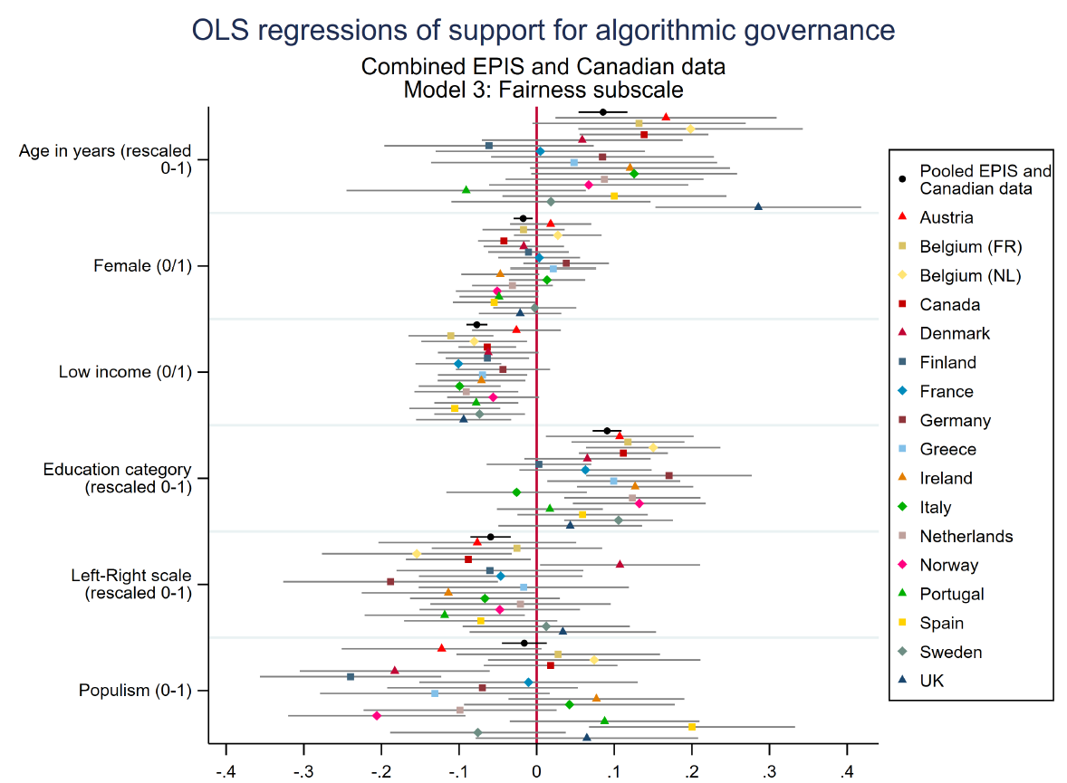

Table C5: OLS regressions of support for algorithmic government, fairness subscale: countries (A-G). Standard errors in parentheses.
 | Austria | Belgium  (FR) | Belgium  (NL) | Canada | Denmark | Finland | France | Germany | Greece
Age in years | 0.167* | 0.132 | 0.198** | 0.138** | 0.059 | -0.061 | 0.005 | 0.085 | 0.048
(rescaled 0-1) | (0.073) | (0.070) | (0.074) | (0.042) | (0.066) | (0.069) | (0.069) | (0.073) | (0.094)
Female (0/1) | 0.018 | -0.017 | 0.027 | -0.042* | -0.017 | -0.011 | 0.003 | 0.038 | 0.021
 | (0.027) | (0.027) | (0.029) | (0.017) | (0.026) | (0.026) | (0.027) | (0.028) | (0.028)
Low income (0/1) | -0.026 | -0.111*** | -0.080* | -0.064*** | -0.062 | -0.064* | -0.101*** | -0.044 | -0.070*
 | (0.029) | (0.028) | (0.035) | (0.019) | (0.033) | (0.027) | (0.028) | (0.031) | (0.029)
Education category | 0.107* | 0.118** | 0.150*** | 0.112*** | 0.065 | 0.003 | 0.063 | 0.170** | 0.099*
(rescaled 0-1) | (0.049) | (0.037) | (0.044) | (0.029) | (0.041) | (0.034) | (0.043) | (0.054) | (0.044)
Left-Right scale | -0.076 | -0.025 | -0.154* | -0.088* | 0.107* | -0.060 | -0.046 | -0.188** | -0.017
(rescaled 0-1) | (0.065) | (0.056) | (0.062) | (0.041) | (0.053) | (0.061) | (0.054) | (0.071) | (0.069)
Populism (0-1) | -0.122 | 0.028 | 0.074 | 0.018 | -0.183** | -0.240*** | -0.011 | -0.070 | -0.131
 | (0.066) | (0.067) | (0.070) | (0.044) | (0.062) | (0.059) | (0.072) | (0.063) | (0.075)
Constant | 0.575*** | 0.420*** | 0.494*** | 0.614*** | 0.490*** | 0.823*** | 0.489*** | 0.529*** | 0.627***
 | (0.059) | (0.060) | (0.064) | (0.044) | (0.052) | (0.054) | (0.065) | (0.065) | (0.077)
Observations | 932 | 955 | 847 | 1876 | 954 | 961 | 961 | 913 | 775
Notes: * (p<0.05), ** (p<0.01), *** (p<0.001)

Table C6: OLS regressions of support for algorithmic government, fairness subscale: countries (H-Z). Standard errors in parentheses.
 | Ireland | Italy | Netherlands | Norway | Portugal | Spain | Sweden | UK
Age in years | 0.120 | 0.126 | 0.087 | 0.067 | -0.091 | 0.100 | 0.018 | 0.286***
(rescaled 0-1) | (0.066) | (0.068) | (0.065) | (0.065) | (0.079) | (0.074) | (0.065) | (0.068)
Female (0/1) | -0.047 | 0.013 | -0.031 | -0.051 | -0.049 | -0.055* | -0.003 | -0.021
 | (0.026) | (0.025) | (0.026) | (0.027) | (0.026) | (0.027) | (0.027) | (0.027)
Low income (0/1) | -0.071* | -0.099*** | -0.091** | -0.056 | -0.078** | -0.106*** | -0.074* | -0.094**
 | (0.029) | (0.027) | (0.034) | (0.030) | (0.028) | (0.030) | (0.030) | (0.031)
Education category | 0.127*** | -0.026 | 0.123** | 0.132** | 0.017 | 0.059 | 0.106** | 0.043
(rescaled 0-1) | (0.038) | (0.046) | (0.045) | (0.044) | (0.035) | (0.043) | (0.036) | (0.047)
Left-Right scale | -0.114* | -0.067 | -0.021 | -0.047 | -0.119* | -0.072 | 0.012 | 0.034
(rescaled 0-1) | (0.057) | (0.049) | (0.059) | (0.053) | (0.053) | (0.050) | (0.055) | (0.061)
Populism (0-1) | 0.077 | 0.042 | -0.099 | -0.206*** | 0.088 | 0.200** | -0.076 | 0.065
 | (0.058) | (0.069) | (0.063) | (0.058) | (0.062) | (0.068) | (0.058) | (0.073)
Constant | 0.559*** | 0.658*** | 0.546*** | 0.588*** | 0.656*** | 0.453*** | 0.544*** | 0.398***
 | (0.063) | (0.054) | (0.063) | (0.058) | (0.059) | (0.061) | (0.053) | (0.074)
Observations | 962 | 961 | 950 | 966 | 996 | 964 | 983 | 955
Notes: * (p<0.05), ** (p<0.01), *** (p<0.001)
Appendix D: Variance components analysis
Model | Country variance | Residual variance | Intraclass Correlation
Only country | 0.003  (0.001) | 0.128  (0.001) | 0.023  (0.008)
Full DV scale | 0.003  (0.001) | 0.124  (0.001) | 0.025  (0.009)
Efficiency subscale | 0.004  (0.001) | 0.131  (0.001) | 0.027  (0.009)
Fairness subscale | 0.003  (0.001) | 0.163  (0.002) | 0.018  (0.007)
Full DV scale with country-level index variables2 | 0.003  (.) | 0.128  (.) | 0.022  (0)
Efficiency subscale with country-level index variables | 0.003  (.) | 0.134  (.) | 0.024  (0)
Fairness subscale with country-level index variables | 0.003  (0.001) | 0.165  (0.002) | 0.016  (0)

Appendix E: OLS regressions of ordinal support for algorithmic government

Table E1: OLS regressions of ordinal support for algorithmic government, combined EPIS and Canadian data
 | Full DV scale | Efficiency subscale | Fairness subscale
Age in years (rescaled | 0.114*** | 0.134*** | 0.079***
0-1) | (0.010) | (0.011) | (0.012)
Female (0/1) | -0.009* | -0.019*** | 0.007
 | (0.004) | (0.004) | (0.005)
Low income (0/1) | -0.050*** | -0.050*** | -0.050***
 | (0.004) | (0.005) | (0.005)
Education category | 0.040*** | 0.035*** | 0.049***
(rescaled 0-1) | (0.006) | (0.006) | (0.007)
Left-Right scale | -0.008 | 0.019* | -0.054***
(rescaled 0-1) | (0.009) | (0.009) | (0.010)
Populism (0-1) | -0.006 | 0.014 | -0.039***
 | (0.009) | (0.010) | (0.011)
Constant | 0.658*** | 0.630*** | 0.706***
 | (0.009) | (0.009) | (0.010)
Observations | 16911 | 16911 | 16911
Notes: * (p<0.05), ** (p<0.01), *** (p<0.001)

1 Populism scale item 3 is reverse-coded.
2 The country-level variables we use are: country level trust in others re-scaled 0-1 (data for European countries come from the European Values Study 2008-10 and 2017-22 waves, available at: https://europeanvaluesstudy.eu/, while data for Canada and the UK come from the World Values Survey 2005-2009 wave, available at https://www.worldvaluessurvey.org), UN E-Government index re-scaled 0-1 (available at https://publicadministration.un.org/egovkb/Data-Center), digital skills index re-scaled 0-1 (The World Bank Global Competitiveness Index, GCI 4.0: Digital skills among population, values from 2019, available at: https://tcdata360.worldbank.org/indicators/h4c7a0d37?country=BRA&indicator=41400&viz=line_chart&years=2017,2019#table-link).

