Table S1. Output model- offline tasks
Predictors |  |  | Est. | SE | CI | Statistic | p
(Intercept) |  |  | 3.91 | 0.18 | 3.56 – 4.26 | 22.15 | <0.001
Modality [Reading vs. Listening] |  |  | -0.81 | 0.09 | -0.98 – -0.63 | -9.18 | <0.001
ViolationType[None vs. Pragmatic Violation] |  |  | 2.21 | 0.17 | 1.88 – 2.53 | 13.31 | <0.001
ViolationType[None vs. Syntactic Violation] |  |  | -0.07 | 0.08 | -0.23 – 0.09 | -0.87 | 0.386
ViolationPosition[Subject vs. Object] |  |  | -0.56 | 0.13 | -0.80 – -0.31 | -4.45 | <0.001
Modality[Reading vs. Listening] × ViolationType[None vs. Pragmatic Violation] |  |  | 0.90 | 0.17 | 0.58 – 1.23 | 5.45 | <0.001
Modality[Reading vs. Listening] × ViolationType [None vs. Syntactic Violation] |  |  | 0.11 | 0.08 | -0.05 – 0.27 | 1.36 | 0.174
Modality[Reading vs. Listening] × SyntPosition  [Subject vs. Object] |  |  | 0.39 | 0.12 | 0.15 – 0.63 | 3.21 | 0.001
ViolationType[None vs. Pragmatic Violation] × SyntPosition  [Subject vs. Object] |  |  | 0.47 | 0.23 | 0.01 – 0.93 | 1.99 | 0.046
ViolationType[None vs. Syntactic Violation] × SyntPosition  [Subject vs. Object] |  |  | 0.25 | 0.12 | 0.03 – 0.48 | 2.18 | 0.029
(Modality [Reading vs. Listening] × ViolationType[None vs. Pragmatic Violation])  × ViolationPosition[Subject vs. Object] |  |  | -0.63 | 0.23 | -1.09 – -0.17 | -2.70 | 0.007
(Modality[Reading vs. Listening] × ViolationType[None vs. Syntactic Violation])  × ViolationPosition[Subject vs. Object] |  |  | -0.19 | 0.12 | -0.41 – 0.04 | -1.59 | 0.113
Random Effects
σ² | 3.05
τ₀₀ _{ItemNumber} | 0.03
τ₀₀ _{Participant} | 0.79
ICC | 0.21
N _{Participant} | 36
N _{ItemNumber} | 48
Observations | 1533
Marginal R² / Conditional R² | 0.309 / 0.455
Formula | Model <- lmer(Rating ~ Modality * ViolationType* ViolationPosition+ (1| Participant) + (1| ItemNumber), data = dataset)

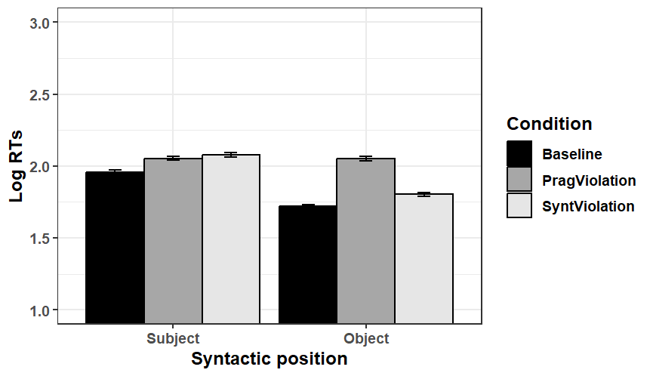
Figure S1. Mean Log-transformed RTs per condition- Experiment 3 (self-paced reading task; critical regions)
None
Position of Violation

Figure S2. Mean Log-transformed RTs per condition- Experiment 4 (self-paced listening task; critical regions)
None
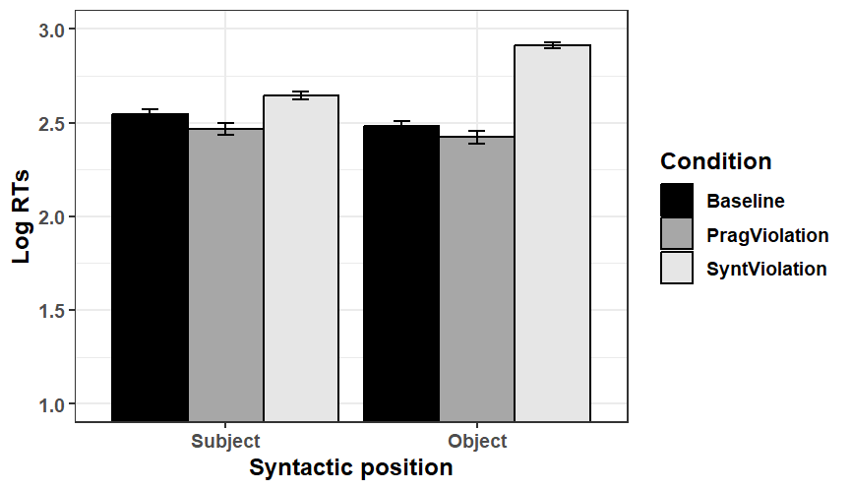
None
Position of Violation

