Appendix A Semantic features of the broad-range rules
Broad range rules for PO-dative ("A causes B to go to C")
a | A acts on B, causing it to go (either literally or metaphorically) to C
b | The verb can denote a change of possession but does not necessarily do so
c | The verb's meaning is defined by the identity of B more than the identity of C
d | B literally moves
e | The verb specifies both the event that causes the transfer (either literal or metaphorical) of B and the movement (either literal or metaphorical) of B
f | The event that causes the transfer (either literal or metaphorical) of B and the movement (either literal or metaphorical) of B take place at the same time
g | The verb highlights the manner of the transfer, more than its end result
Broad range rules for DO-dative ("A causes C to have B")
h | A has B and then causes it to enter into the possession of C
i | The transfer (either literal or metaphorical) is successful and complete
j | A no longer possesses B after he/she has transferred possession of B to C
k | After the event, C is in possession of B
l | C is capable of possessing (either literally or metaphorically) B
m | A acts on C, causing him/her to possess (either literally or metaphorically) B
n | When A performs the action, he/she must have C in mind
o | C's reaction to the event is part of the meaning of the verb
p | The verb's meaning is defined by the identity of C more than the identity of B
q | C is usually animate
r | The verb highlights the end result of the transfer, more than the manner in which it occurs
(from Ambridge et al., 2014, Appendix, Section B)

Appendix B Pinker’s (1989) narrow-range semantic verb classes for the dative alternation
Narrow range alternating verb classes
a | Verbs signifying acts of giving e.g., ‘give’, ‘hand’, ‘sell’, etc.
b | Verbs of instantaneous causation of ballistic motion e.g., ‘throw’, ‘toss’, ‘kick’, etc.
c | Verbs of sending e.g., ‘send’, ‘mail’, ‘ship’, etc.
d | Verbs of accompanied motion in a direction e.g., ‘bring’ and ‘take’.
e | Verbs of future having e.g., ‘offer’, ‘promise’, ‘allow’, etc.
f | Verbs of type of communicated message. e.g., ‘tell’, ‘show’, ‘teach’, etc.
g | Verbs of instrument communication e.g., ‘radio’, ‘telephone’, ‘fax’, ‘wire’, etc.
h | Verbs of creation e.g., ‘bake’, ‘make’, ‘build’, ‘cook’, etc.
i | Verbs of obtaining e.g., ‘find’, ‘order’, etc.
Narrow range non-alternating verb classes
j | Verbs of fulfilling e.g., ‘credit’, ‘present’, etc.
k | Verbs of accompanied motion in some manner e.g., ‘carry’, ‘pull’, ‘push’, etc.
l | Verbs of manner of speaking e.g., ‘shout’, ‘whisper’, ‘scream’ , etc.
m | Verbs of choosing e.g., ‘choose’, ‘pick’, ‘select’, etc.
n | Verbs of communication of proposition and propositional attitudes e.g., ‘say’,  ‘assert’, etc.
(from Gropen, et al., 1989:243-244)

Appendix C Stimuli in the Experiment
1 | PO | Cindy fed the milk to Julia.
1 | DO | Cindy fed Julia the milk.
2 | PO | Joyce gave the card to Eva.
2 | DO | Joyce gave Eva the card.
3 | PO | Diana passed the pen to Jack.
3 | DO | Diana passed Jack the pen.
4 | PO | Simon sold the cake to Diana.
4 | DO | Simon sold Diana the cake.
5 | PO | Andy posted the book to Jane.
5 | DO | Andy posted Jane the book.
6 | PO | Steven sent the flower to Mary.
6 | DO | Steven sent Mary the flower.
7 | PO | Jennifer hit the ball to Linda.
7 | DO | Jennifer hit Linda the ball.
8 | PO | John kicked the ball to David.
8 | DO | John kicked David the ball.
9 | PO | Jack threw the apple to Susan.
9 | DO | Jack threw Susan the apple.
10 | PO | Lucy tossed the coat to Diana.
10 | DO | Lucy tossed Diana the coat.
11 | PO | Peter brought the tea to Wendy.
11 | DO | Peter brought Wendy the tea.
12 | PO | Mike took the bread to Kelly.
12 | DO | Mike took Kelly the bread.
13 | PO | David awarded the house to Alex.
13 | DO | David awarded Alex the house.
14 | PO | Nina offered the fruit to Sandy.
14 | DO | Nina offered Sandy the fruit.
15 | PO | Lucy owed $100 to Tina.
15 | DO | Lucy owed Tina $100.
16 | PO | Jack promised the hat to Susan.
16 | DO | Jack promised Susan the hat.
17 | PO | Bob read the news to Donald.
17 | DO | Bob read Donald the news.
18 | PO | Judy showed the photo to Kate.
18 | DO | Judy showed Kate the photo.
19 | PO | Bruce taught the history to Colin.
19 | DO | Bruce taught Colin the history.
20 | PO | Jim emailed the news to Peter.
20 | DO | Jim emailed Peter the news.
21 | PO | Kathy telephoned the choice to Bob.
21 | DO | Kathy telephoned Bob the choice.
22 | PO | Julie told the fact to Simon.
22 | DO | Julie told Simon the fact.
23 | PO | Lucia carried the chair to Kevin.
23 | DO | Lucia carried Kevin the chair.
24 | PO | Maggie hauled the luggage to Lucy.
24 | DO | Maggie hauled Lucy the luggage.
25 | PO | Franklin pulled the desk to Jackson.
25 | DO | Franklin pulled Jackson the desk.
26 | PO | Lisa pushed the bike to Andy.
26 | DO | Lisa pushed Andy the bike.
27 | PO | Diana dragged the motor to John.
27 | DO | Diana dragged John the motor.
28 | PO | Monica dropped the key to Peter.
28 | DO | Monica dropped Peter the key.
29 | PO | Nancy heaved the box to Peter.
29 | DO | Nancy heaved Peter the box.
30 | PO | James sang the song to Mike.
30 | DO | James sang Mike the song.
31 | PO | Lynn lifted the notebook to Mike.
31 | DO | Lynn lifted Mike the notebook.
32 | PO | Jason lowered the mirror to Ken.
32 | DO | Jason lowered Ken the mirror.
33 | PO | Mandy raised the flag to Cherry.
33 | DO | Mandy raised Cherry the flag.
34 | PO | Jimmy mumbled the song to Roger.
34 | DO | Jimmy mumbled Roger the song.
35 | PO | Tony screeched the danger to David.
35 | DO | Tony screeched David the danger.
36 | PO | Bob shouted the news to David.
36 | DO | Bob shouted David the news.
37 | PO | John whispered the secret to Edison.
37 | DO | John whispered Edison the secret.
38 | PO | Susan yelled the word to Betty.
38 | DO | Susan yelled Betty the word.
39 | PO | Emma mentioned the bill to Emily.
39 | DO | Emma mentioned Emily the bill.
40 | PO | Peter said the excuse to Jack.
40 | DO | Peter said Jack the excuse.
41 | PO | Lucy stated the policy to Tina.
41 | DO | Lucy stated Tina the policy.
42 | PO | Selina entrusted the cash to Ann.
42 | DO | Selina entrusted Ann the cash.
43 | PO | David presented the picture to Lydia.
43 | DO | David presented Lydia the picture.
44 | PO | Peter supplied the coffee to Joyce.
44 | DO | Peter supplied Joyce the coffee.
45 | PO | Bob guaranteed the car to David.
45 | DO | Bob guaranteed David the car.
46 | PO | Andy issued the book to Frank.
46 | DO | Andy issued Frank the book.
47 | PO | David cost the coin to Jack.
47 | DO | David cost Jack the coin.
48 | PO | Jim spared the time to John.
48 | DO | Jim spared John the time.
49 | PO | Kevin envied the ring to Mike.
49 | DO | Kevin envied Mike the ring.
50 | PO | Peter refused the computer to Simon.
50 | DO | Peter refused Simon the computer.
51 | PO | John asked the question to Tina.
51 | DO | John asked Tina the question.
52 | PO | Susan saved the food to Eva.
52 | DO | Susan saved Eva the food.
53 | PO | Emily forgave the mistake to Diana.
53 | DO | Emily forgave Diana the mistake.
54 | PO | Ben denied the invitation to Eric.
54 | DO | Ben denied Eric the invitation.
55 | PO | Bill bet the book to Paul.
55 | DO | Bill bet Paul the book.
56 | PO | Edward billed the lunch to Ken.
56 | DO | Edward billed Ken the lunch.
57 | PO | John charged the expense to Robert.
57 | DO | John charged Robert the expense.
58 | PO | Peter fined the money to Daniel.
58 | DO | Peter fined Daniel the money.
59 | PO | Henry overcharged the phone to James.
59 | DO | Henry overcharged James the phone.
60 | PO | Diana declared the decision to Jack.
60 | DO | Diana declared Jack the decision.
61 | PO | Martin mulcted the wallet to Steven.
61 | DO | Martin mulcted Steven the wallet.
62 | PO | Michael taxed $10 to Oliver.
62 | DO | Michael taxed Oliver $10.
63 | PO | Sam tipped the money to Roger.
63 | DO | Sam tipped Roger the money.
64 | PO | Tom undercharged the bag to William.
64 | DO | Tom undercharged William the bag.
65 | PO | Alice wagered the gold to Barbara.
65 | DO | Alice wagered Barbara the gold.
66 | PO | Daisy wrote the letter to Betty.
66 | DO | Daisy wrote Betty the letter.

Appendix E Figures depicting the relationship between other predictors and DO and PO ratings (Figure S1-S6)

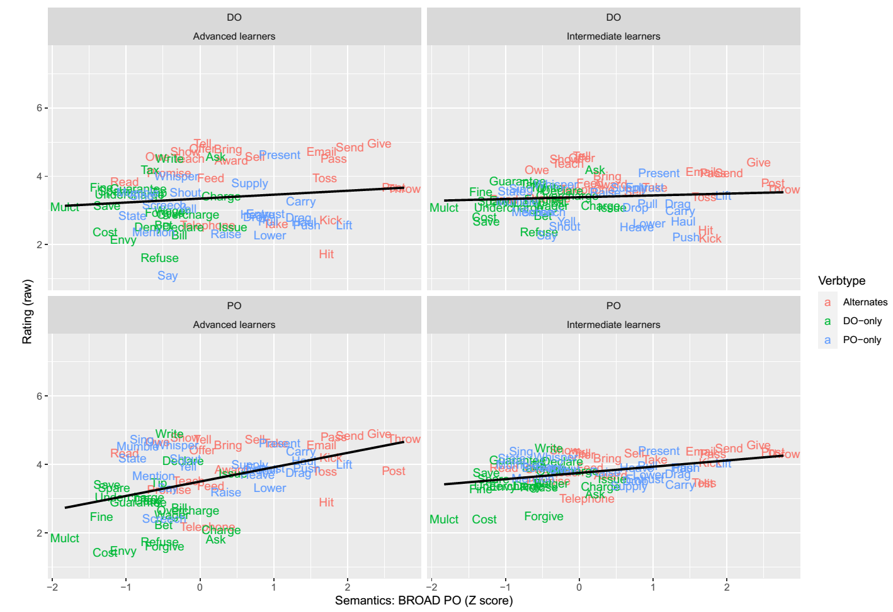
Figure S1 Relationship between the semantics “Broad PO” predictor and participants’ raw sentence ratings on the 5-point scale.

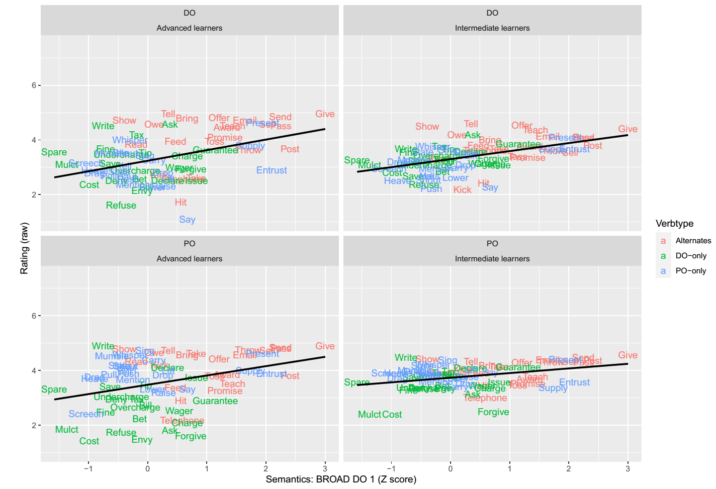
Figure S2 Relationship between the semantics “Broad DO-1” predictor and participants’ raw sentence ratings on the 5-point scale.

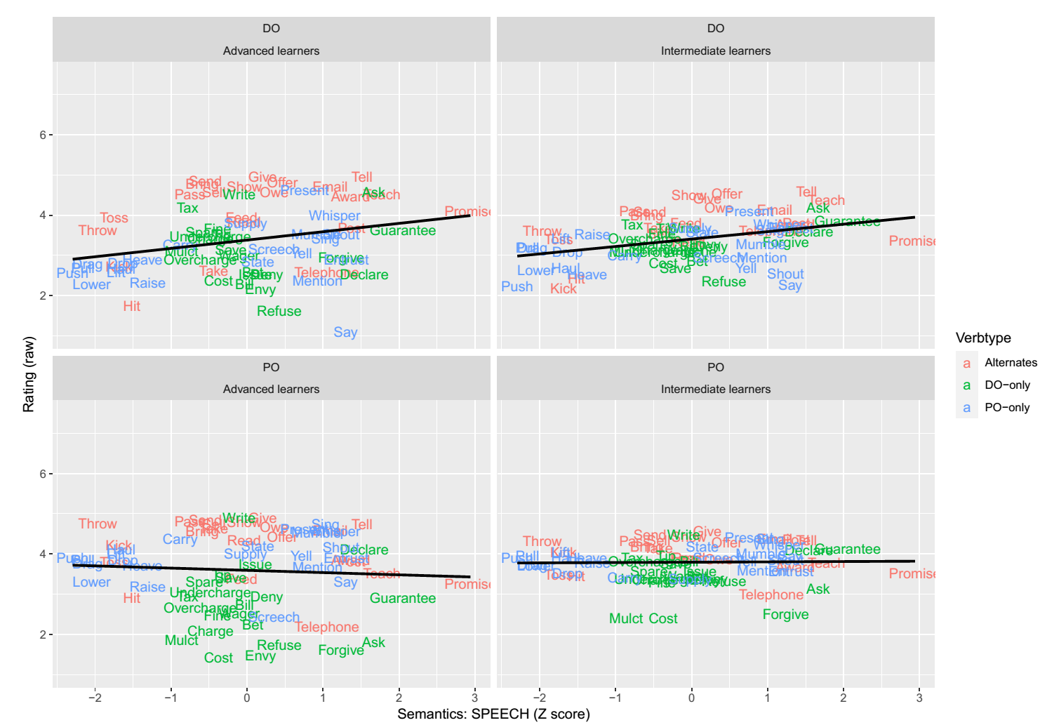
Figure S3 Relationship between the semantics “Speech” predictor and participants’ raw sentence ratings on the 5-point scale.

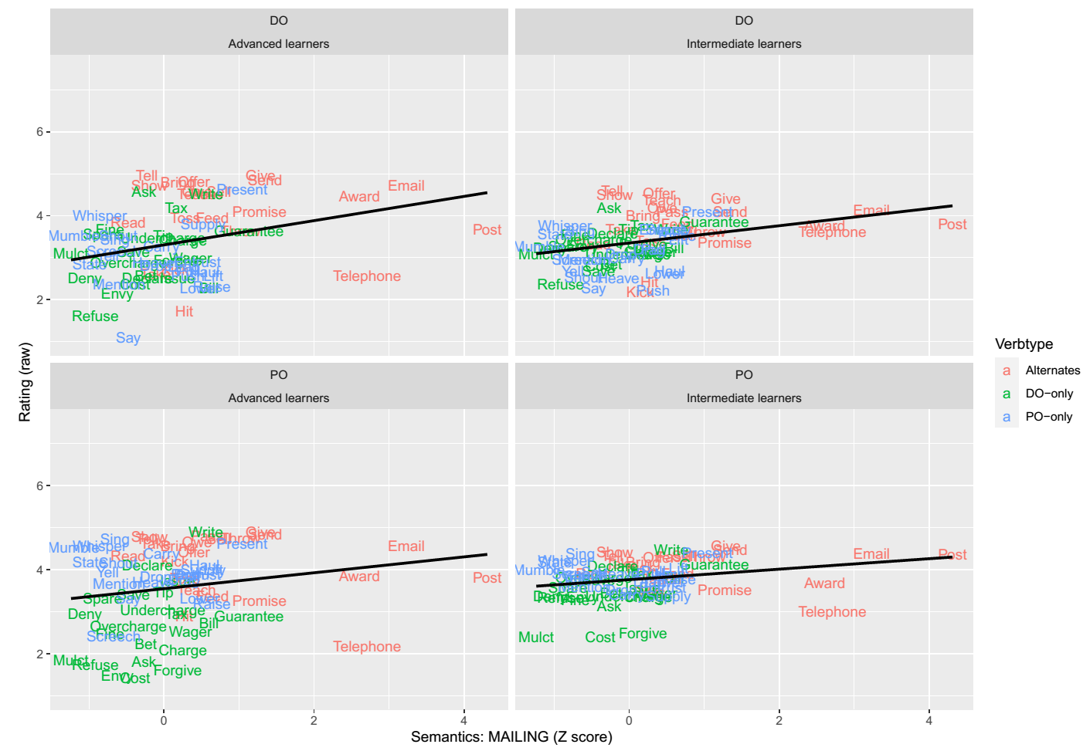

Figure S4 Relationship between the semantics “Mailing” predictor and participants’ raw sentence ratings on the 5-point scale.

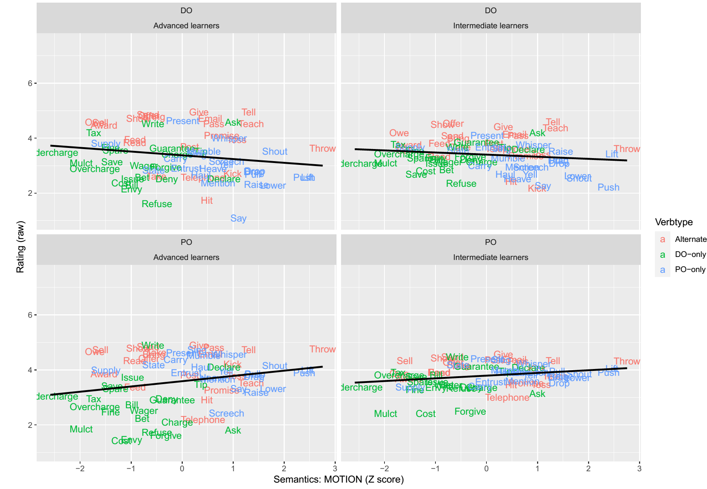
Figure S5 Relationship between the semantics “Motion” predictor and participants’ raw sentence ratings on the 5-point scale.

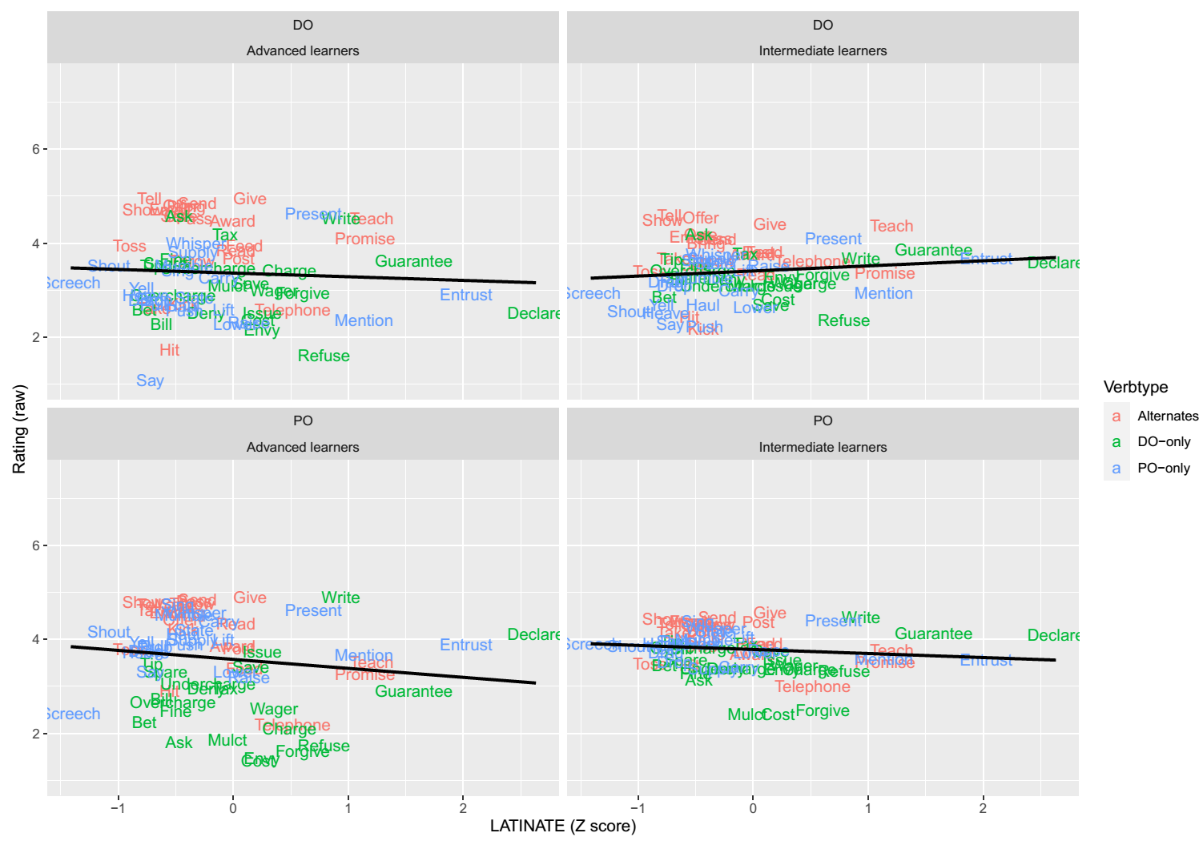
Figure S6 Relationship between the morphophonological “Latinate” predictor and participants’ raw sentence ratings on the 5-point scale.

