Phonology, homophony, and eyes-closed rest in Mandarin novel word learning: An eye-tracking study in adult native and non-native speakers

Online Supplementary Materials (publicly available at Open Science Framework: https://osf.io/dt2sk/?view_only=43e947688375443c907cbee3cf5e7e11)

Included in this document are the following appendices that will be published as online supplementary materials:
- Appendix A: The Novel Word-Object Mappings

Appendix B: Novel Objects Used as Distractors in Test Phase II

Appendix C: Trials in Test Phase I

Appendix D: Trials in Test Phase II
- Appendix E: Averaged Proportion Looks in Different Visual Settings

Appendix A. The novel word-object mappings
No. | Novel Word | Novel Object
Practice 1 | /musa/ | 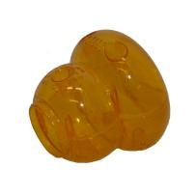
Practice 2 | /t^{h}usa/ | 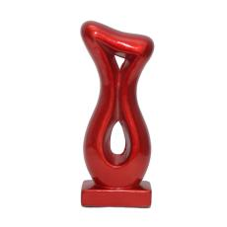
1 | /p^{h}a¹sa¹/ | 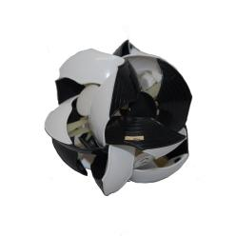  (Learned in a tone contrast with /p^{h}a²sa¹/)
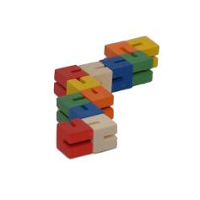
(Learned in a consonant contrast with /k^{h}a¹sa¹/)
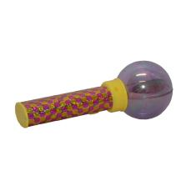
(Learned in both contrasts with /na²sa¹/)
2 | /p^{h}a²sa¹/ | 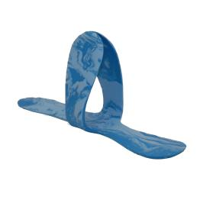
3 | /t^{h}a¹sa¹/ | 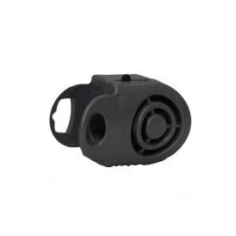  (Learned in a tone contrast with /t^{h}a³sa¹/)
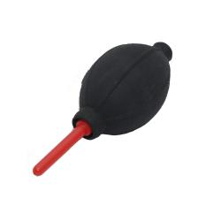
(Learned in both contrasts with /la³sa¹/)
4 | /t^{h}a³sa¹/ | 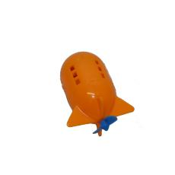
5 | /k^{h}u¹sa¹/ | 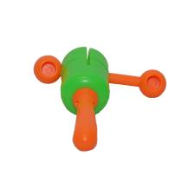  (Learned in a tone contrast with /k^{h}u⁴sa¹/)
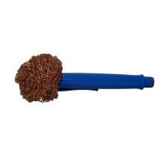
(Learned in both contrasts with /p^{h}u⁴sa¹/)
6 | /k^{h}u⁴sa¹/ | 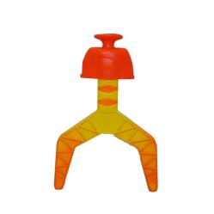
7 | /mu²sa¹/ | 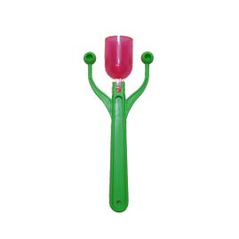  (Learned in a tone contrast with /mu³sa¹/)
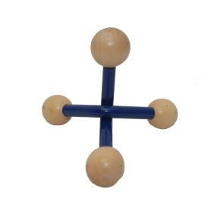
(Learned in both contrasts with /t^{h}u³sa¹/)
8 | /mu³sa¹/ | 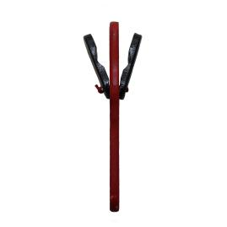
9 | /ni⁴sa¹/ | 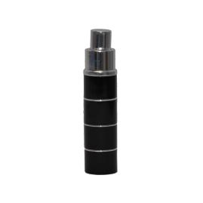
10 | /ni²sa¹/ | 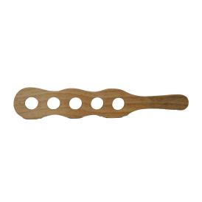  (Learned in a tone contrast with /ni⁴sa¹/)
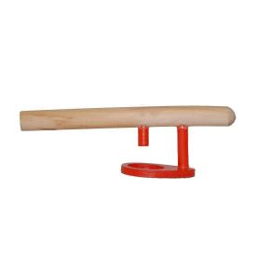
(Learned in both contrasts with /mi⁴sa¹/)
11 | /li³sa¹/ | 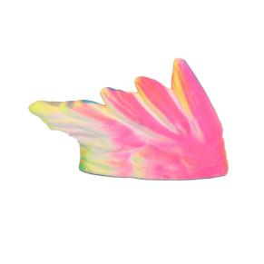  (Learned in a tone contrast with /li⁴sa¹/)
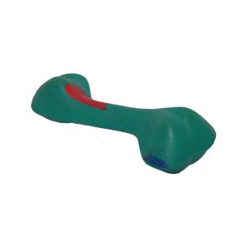
(Learned in both contrasts with /k^{h}i⁴sa¹/)
12 | /li⁴sa¹/ | 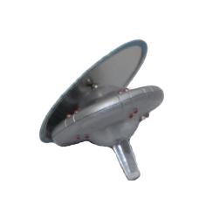  (Learned in a tone contrast with /li³sa¹/)
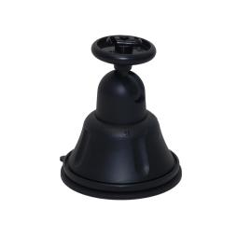
(Learned in a consonant contrast with /p^{h}i⁴sa¹/)
13 | /k^{h}a¹sa¹/ | 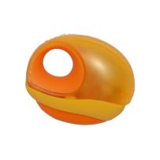
14 | /t^{h}a²sa¹/ | 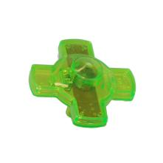
15 | /ma²sa¹/ | 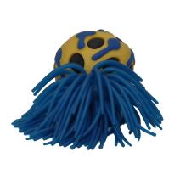
16 | /k^{h}u³sa¹/ | 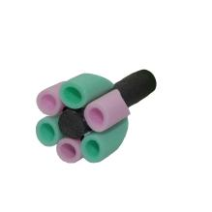
17 | /nu³sa¹/ | 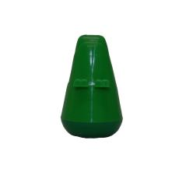
18 | /mu⁴sa¹/ | 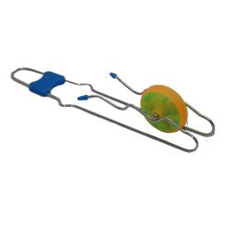
19 | /lu⁴sa¹/ | 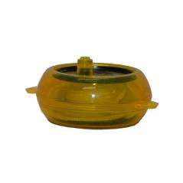
20 | /ni¹sa¹/ | 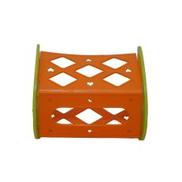
21 | /t^{h}i¹sa¹/ | 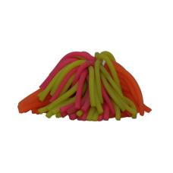
22 | /p^{h}i⁴sa¹/ | 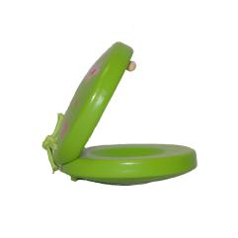
23 | /na²sa¹/ | 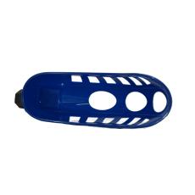
24 | /la³sa¹/ | 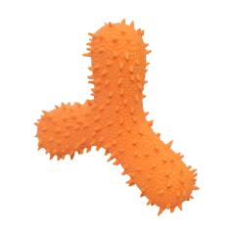
25 | /p^{h}u⁴sa¹/ | 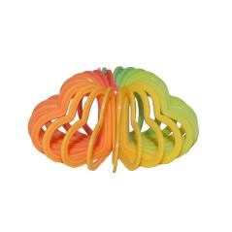
26 | /t^{h}u³sa¹/ | 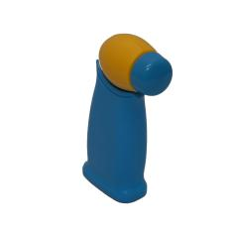
27 | /mi⁴sa¹/ | 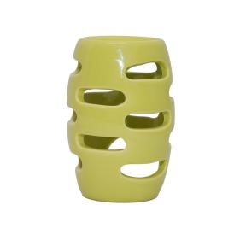
28 | /k^{h}i⁴sa¹/ | 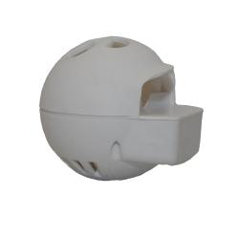

Appendix B. Novel Objects Used as Distractors in Test Phase II
No. | Novel Object | No. | Novel Object
1 | 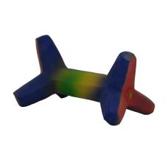 | 6 | 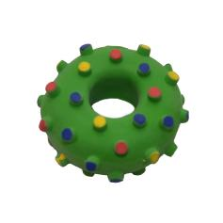
2 | 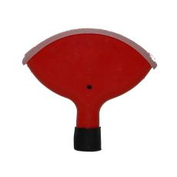 | 7 | 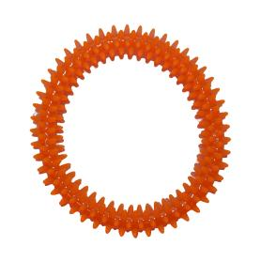
3 | 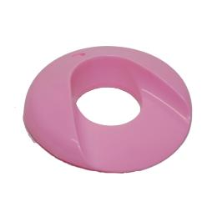 | 8 | 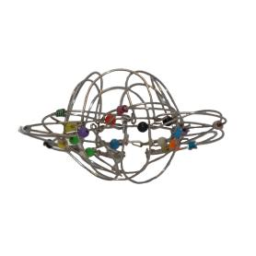
4 | 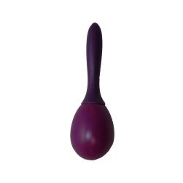 | 9 | 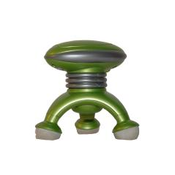
5 | 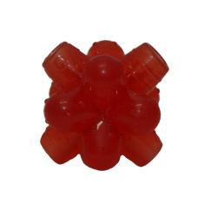

Appendix C. Trials in Test Phase I
Trial | Novel Word Pair | Phonological Contrast | Word Code
1 | /p^{h}a¹sa¹/ - /k^{h}a¹sa¹/ | Consonant contrast | 1
2 | /mu⁴sa¹/ - /lu⁴sa¹/ | Consonant contrast | 6
3 | /k^{h}u³sa¹/ - /nu³sa¹/ | Consonant contrast | 7
4 | /ni¹sa¹/ - /t^{h}i¹sa¹/ | Consonant contrast | 10
5 | /t^{h}a²sa¹/ - /ma²sa¹/ | Consonant contrast | 11
6 | /li⁴sa¹/ - /p^{h}i⁴sa¹/ | Consonant contrast | 14
7 | /li³sa¹/ - /li⁴sa¹/ | Tone contrast | 2
8 | /k^{h}u¹sa¹/ - /k^{h}u⁴sa¹/ | Tone contrast | 4
9 | /p^{h}a¹sa¹/ - /p^{h}a²sa¹/ | Tone contrast | 8
10 | /t^{h}a¹sa¹/ - /t^{h}a³sa¹/ | Tone contrast | 3
11 | /ni²sa¹/ - /ni⁴sa¹/ | Tone contrast | 13
12 | /mu²sa¹/ - /mu³sa¹/ | Tone contrast | 15
13 | /li³sa¹/ - /k^{h}i⁴sa¹/ | Both contrasts | 9
14 | /mu²sa¹/ - /t^{h}u³sa¹/ | Both contrasts | 12
15 | /p^{h}a¹sa¹/ - /na²sa¹/ | Both contrasts | 5
16 | /t^{h}a¹sa¹/ - /la³sa¹/ | Both contrasts | 3
17 | /k^{h}u¹sa¹/ - /p^{h}u⁴sa¹/ | Both contrasts | 4
18 | /ni²sa¹/ - /mi⁴sa¹/ | Both contrasts | 13

Note. In the “Nowel Word Pair” column, underlined novel words indicate targets that were tested. In the “Phonological Contrast” column, “Consonant contrast” indicates novel words learned in a pair with consonant contrasts; “Tone contrast” indicates novel words learned in a pair with tone contrasts; “Both contrasts” indicates novel words learned in a pair with both consonant and tone contrasts. In the “Word Code” column, word codes indicate numbers assigned to the 15 underlined target novel words and were used as random intercepts in statistical modelling.

Appendix D. Trials in Test Phase II
Trial | Target Novel Word | Phonological Contrast | Competition Setting | Word Code
1 | /p^{h}a¹sa¹/ | Consonant contrast | Yes | 1
2 | /mu⁴sa¹/ | Consonant contrast | No | 5
3 | /k^{h}u³sa¹/ | Consonant contrast | Yes | 6
4 | /li⁴sa¹/ | Consonant contrast | No | 11
5 | /t^{h}a²sa¹/ | Consonant contrast | Yes | 8
6 | /k^{h}a¹sa¹/ | Consonant contrast | No | 13
7 | /lu⁴sa¹/ | Consonant contrast | Yes | 17
8 | /nu³sa¹/ | Consonant contrast | No | 18
9 | /ni¹sa¹/ | Consonant contrast | Yes | 7
10 | /t^{h}i¹sa¹/ | Consonant contrast | No | 22
11 | /k^{h}a¹sa¹/ | Consonant contrast | Yes | 13
12 | /ma²sa¹/ | Consonant contrast | No | 24
13 | /p^{h}i⁴sa¹/ | Consonant contrast | Yes | 27
14 | /p^{h}a¹sa¹/ | Consonant contrast | No | 1
15 | /mu⁴sa¹/ | Consonant contrast | Yes | 5
16 | /k^{h}u³sa¹/ | Consonant contrast | No | 6
17 | /nu³sa¹/ | Consonant contrast | Yes | 18
18 | /ni¹sa¹/ | Consonant contrast | No | 7
19 | /li⁴sa¹/ | Consonant contrast | Yes | 11
20 | /t^{h}a²sa¹/ | Consonant contrast | No | 8
21 | /t^{h}i¹sa¹/ | Consonant contrast | Yes | 22
22 | /lu⁴sa¹/ | Consonant contrast | No | 17
23 | /ma²sa¹/ | Consonant contrast | Yes | 24
24 | /p^{h}i⁴sa¹/ | Consonant contrast | No | 27
25 | /ni²sa¹/ | Tone contrast | Yes | 10
26 | /li³sa¹/ | Tone contrast | No | 2
27 | /mu²sa¹/ | Tone contrast | Yes | 9
28 | /k^{h}u¹sa¹/ | Tone contrast | No | 4
29 | /p^{h}a²sa¹/ | Tone contrast | Yes | 19
30 | /p^{h}a¹sa¹/ | Tone contrast | No | 1
31 | /t^{h}a³sa¹/ | Tone contrast | Yes | 21
32 | /t^{h}a¹sa¹/ | Tone contrast | No | 3
33 | /li⁴sa¹/ | Tone contrast | Yes | 11
34 | /mu³sa¹/ | Tone contrast | No | 28
35 | /k^{h}u⁴sa¹/ | Tone contrast | Yes | 15
36 | /ni⁴sa¹/ | Tone contrast | No | 26
37 | /li³sa¹/ | Tone contrast | Yes | 2
38 | /k^{h}u⁴sa¹/ | Tone contrast | No | 15
39 | /k^{h}u¹sa¹/ | Tone contrast | Yes | 4
40 | /mu²sa¹/ | Tone contrast | No | 9
41 | /p^{h}a¹sa¹/ | Tone contrast | Yes | 1
42 | /li⁴sa¹/ | Tone contrast | No | 11
43 | /t^{h}a¹sa¹/ | Tone contrast | Yes | 3
44 | /ni²sa¹/ | Tone contrast | No | 10
45 | /ni⁴sa¹/ | Tone contrast | Yes | 26
46 | /p^{h}a²sa¹/ | Tone contrast | No | 19
47 | /mu³sa¹/ | Tone contrast | Yes | 28
48 | /t^{h}a³sa¹/ | Tone contrast | No | 21
49 | /t^{h}a¹sa¹/ | Both contrasts | Yes | 3
50 | /k^{h}u¹sa¹/ | Both contrasts | No | 4
51 | /p^{h}a¹sa¹/ | Both contrasts | Yes | 1
52 | /mu²sa¹/ | Both contrasts | No | 9
53 | /mi⁴sa¹/ | Both contrasts | Yes | 12
54 | /ni²sa¹/ | Both contrasts | No | 10
55 | /li³sa¹/ | Both contrasts | Yes | 2
56 | /la³sa¹/ | Both contrasts | No | 14
57 | /p^{h}u⁴sa¹/ | Both contrasts | Yes | 23
58 | /na²sa¹/ | Both contrasts | No | 16
59 | /t^{h}u³sa¹/ | Both contrasts | Yes | 25
60 | /k^{h}i⁴sa¹/ | Both contrasts | No | 20
61 | /ni²sa¹/ | Both contrasts | Yes | 10
62 | /t^{h}a¹sa¹/ | Both contrasts | No | 3
63 | /k^{h}u¹sa¹/ | Both contrasts | Yes | 4
64 | /p^{h}a¹sa¹/ | Both contrasts | No | 1
65 | /mu²sa¹/ | Both contrasts | Yes | 9
66 | /li³sa¹/ | Both contrasts | No | 2
67 | /la³sa¹/ | Both contrasts | Yes | 14
68 | /mi⁴sa¹/ | Both contrasts | No | 12
69 | /na²sa¹/ | Both contrasts | Yes | 16
70 | /t^{h}u³sa¹/ | Both contrasts | No | 25
71 | /k^{h}i⁴sa¹/ | Both contrasts | Yes | 20
72 | /p^{h}u⁴sa¹/ | Both contrasts | No | 23

Note. In the “Competition Setting” column, “Yes” means that there was a competitor on the computer screen (i.e., the three objects were the target, its competitor, and a distractor); “No” means that there was no competitor (i.e., the three objects were the target and two distractors). In the “Word Code” column, word codes indicate numbers assigned to the 28 target novel words and were used as random intercepts in statistical modelling.

Appendix E. Averaged Proportion Looks in Different Visual Settings

Figure E.1. Averaged Proportion Looks to Different Interest Areas in the Competitor Setting

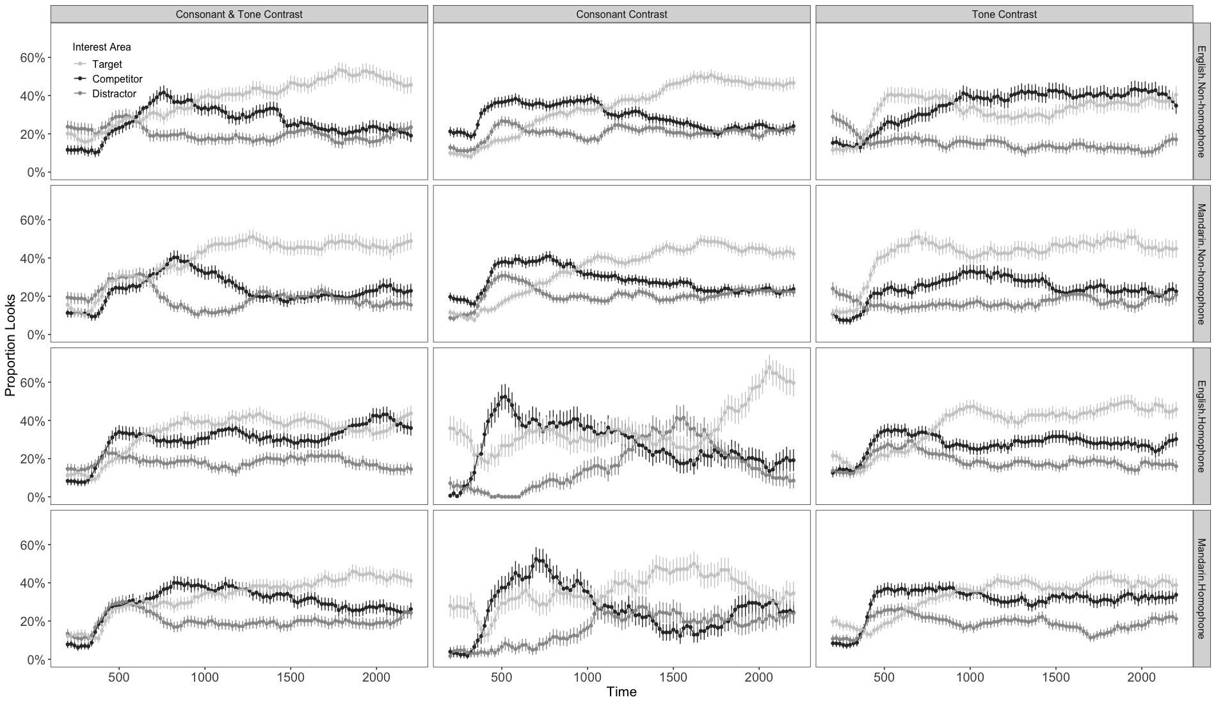
Note. The columns represent different phonological contrast environments: consonant & tone contrast, consonant contrast, and tone contrast. The rows represent different conditions of the interaction between language backgrounds and homophony: native English & non-homophone, native Mandarin & non-homophone, native English & homophone, native Mandarin & homophone. In each panel, the x-axis indicates time after the target stimulus onset, from 200 ms onwards; the y-axis indicates accuracy proportions; light gray, black, and dark gray lines signify averaged proportion looks to the target, competitor, and distractor objects, respectively.
Figure E.2. Averaged Proportion Looks to Different Interest Areas in the No-Competitor Setting

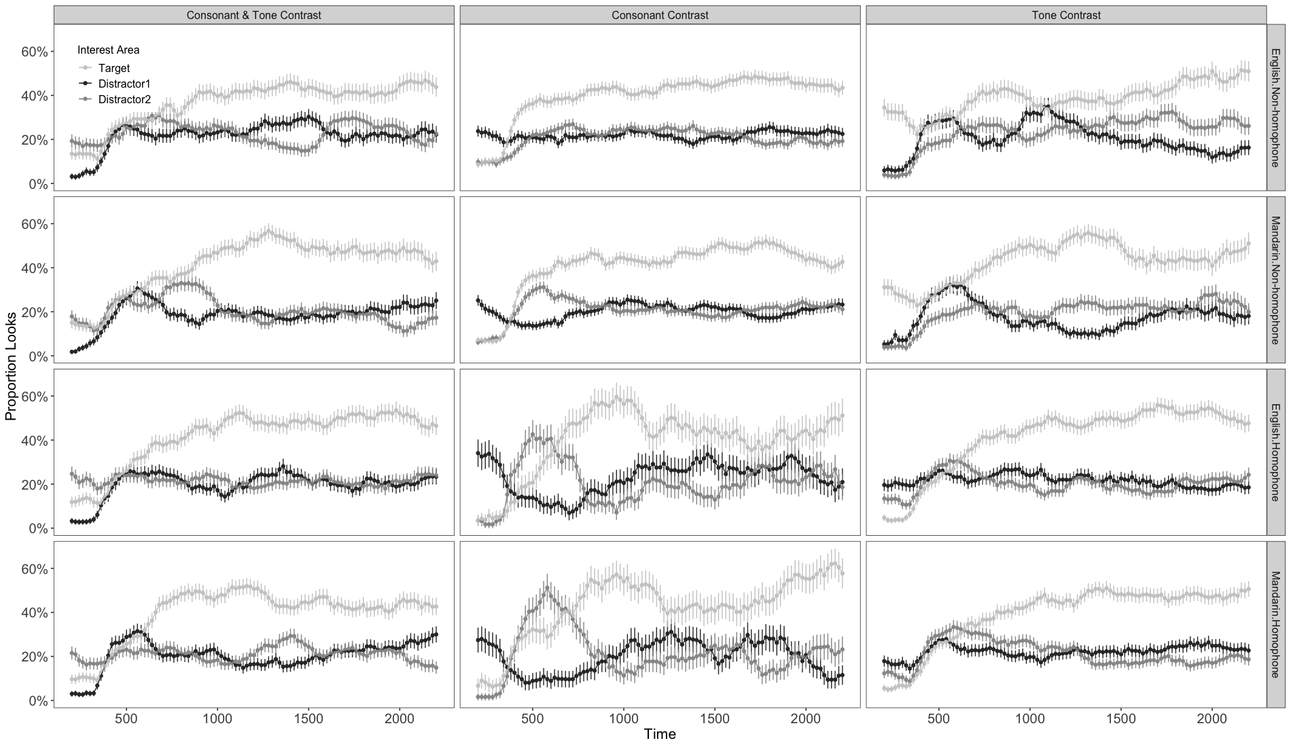
Note. The columns represent different phonological contrast environments: consonant & tone contrast, consonant contrast, and tone contrast. The rows represent different conditions of the interaction between language backgrounds and homophony: native English & non-homophone, native Mandarin & non-homophone, native English & homophone, native Mandarin & homophone. In each panel, the x-axis indicates time after the target stimulus onset, from 200 ms onwards; the y-axis indicates accuracy proportions; light gray, black, and dark gray lines signify averaged proportion looks to the target, and two distractor objects, respectively.

