CATALOGUE[1]*

1. Chamber tomb cemeteries

**Theb 001.** BE 423. Kolonaki chamber tomb cemetery, 1910. Tomb 26.

Fine decorated. Piriform jar FS 30. Mended and restored. Three vertical strap handles on the shoulder. Decoration linear, scale pattern FM 70 on the upper part of the body, bars on the rim. Light brown clay. Red-brown paint.

H. 0.20, max. diam. 0.17m

LH IIB.

*Keramopoullos 1917, 199, fig. 143.4, 202 (no. 32); Mountjoy 1999, 653, fig. 248.23; Tzavella-Evjen 2014, 79, no. 10.*

NAA result: TheB.

**Theb 002.** BE 453. Agia Anna chamber tomb cemetery, 1905. Tomb 2, among the sherds on the chamber floor.

Fine decorated. Piriform jar FS 20. Mended and restored. Three horizontal grooved handles on the shoulder. Decoration linear, horizontal row of “sacral ivy” leaves FM 12v on a dotted background. Light greenish clay, whitish brown 10YR 7.5/3 surfaces. Dark brown paint.

H. 0.35, max. diam. 0.32m

LH IIA.

*Keramopoullos 1910, 213-14, fig. 10b, 223 (no. 4), pl. 10.2; Tzavella-Evjen 2014, 74, no. 3.*

NAA result: OlyB.

**Theb 003.** BE 447. Agia Anna chamber tomb cemetery, 1905. Tomb 2, among the sherds on the chamber floor.

Fine decorated. Bridge-spouted jug FS 103. Mended and restored. Decoration on the body: ogival canopy FM 13, on the neck: quirk FM 48. Light brown clay, fine, greenish white slip, polished. Black-brown paint.

H. 0.20, max. diam. 0.23m

LH IIA.

*Keramopoullos 1910, 213-14, fig. 10b, 225 (no. 9), pl. 9.2; Mountjoy 1999, 650, fig. 247.13; Tzavella-Evjen 2014, 91, no. 40.*

NAA result: single.

**Theb 004.** BE 455. Agia Anna chamber tomb cemetery, 1905. Tomb 2, among the sherds on the chamber floor.

Fine decorated. Piriform jar FS 24. Mended and restored. Three horizontal grooved handles on the shoulder, with firing hole on either end. Decoration linear, palm trees FM 14.3 on the body. Light brown clay, greenish white slip. Dark brown paint.

H. 0.33, max. diam. 0.238m

LH IIA.

*Keramopoullos 1910, 213-14, fig. 10b, 224 (no. 6), pl. 8.1; Tzavella-Evjen 2014, 77, no. 8.*

NAA result: MYBE.

**Theb 005.** BE 429. Kolonaki chamber tomb cemetery, 1910. Tomb 26.

Fine decorated. Piriform jar FS 25. Mended and restored. Three vertical strap handles on the shoulder. Decoration linear, palm tree and wavy lines FM 14.5 on the upper part of the body, bars on the rim. Light brown 10YR 7.5/3 clay. Brown-black paint.

H. 0.385, max. diam. 0.275m

LH IIB.

*Keramopoullos 1917, 202 (no. 30), fig. 146; Furumark* *et al.1992, pl. 19.25.2; Tzavella-Evjen 2014, 79, no. 11.*

NAA result: single.

**Theb 006.** Kolonaki chamber tomb cemetery, 1910. Tomb 26, found inside Theb 005.

Mainland-Polychrome-Ware(?). Open vase. Rim fragment. Fine, light brown clay, lighter slip, streaky and polished.

R. diam. ca. 0.42m

MH.

NAA result: EuA.

**Theb 007.** Kolonaki chamber tomb cemetery, 1910. Tomb 26, found inside Theb 005.

Fine undecorated. Kylix FS 267. Base to lower bowl fragment. Fine, light red clay. Red 7.5YR 7.5/4 wiped surface.

B. diam. ca. 0.072m

LH III.

NAA result: EuA.

**Theb 008.** BE 480. Kolonaki chamber tomb cemetery, 1910. Tomb 14.

Fine decorated. Beaked jug FS 143. Mended and restored, completely at the neck, mouth and handle. Decoration on the body: argonauts FM 22, round the base of the neck: zigzag FM 61. Yellowish red 5YR 7/5 clay, big white (lime) grains, slip. Red paint.

H. 0.305, max. diam. 0.245m

LH IIB – LH IIIA1.

*Keramopoullos 1917, 155-6 (no. 29), fig. 116.2*; *Tzavella-Evjen 2014, 85, no. 26.*

NAA result: TheA.

**Theb 009.** BE 683. Kolonaki chamber tomb cemetery. Tomb 12.

Fine decorated. Stirrup jar FS 175. Mended and slightly restored. Decoration on the shoulder: antithetical tongue pattern FM 19 between the handles, elaborate triangles FM 71 on both sides of the spout, zigzag FM 61 framing the decorative field. Light brown to dark brown clay on either side of the vase probably due to uneven firing. Black-brown paint.

H. 0.0195, max. diam. 0.18m

LH IIIC Middle.

*Keramopoullos 1917, 148-9 (no. 4), fig. 110a; Mountjoy 1999, 690, fig. 265.211; Tzavella-Evjen 2014, 118, no. 102.*

NAA result: EuA.

**Theb 010.** BE 544. Ismenion chamber tomb cemetery, 1910. Tomb 2 (probably).

Fine decorated. Jug FS 114. Intact. Band decoration. Red-orange 7.5YR 7/5 clay, fine, sparse grit, slip polished. Dark brown paint.

H. 0.085, max. diam. 0.08m

LH IIIA2-IIIB1.

*Keramopoullos 1917, 82-3 (for the find place), 83 (no. 11); Tzavella-Evjen 2014, 92, no. 41.*

NAA result: X166.

**Theb 011.** BE 677. Kolonaki chamber tomb cemetery, 1910. Tomb 10.

Fine decorated. Straight-sided alabastron FS 99. Mended and restored. Decoration on the shoulder: panels filled with cross hatched lozenges FM 73 or bivalve shell FM 25, round the body: connected semicircles FM 43, on the legs: bivalve shell, under the base: spiral. Brown to light brown clay, light red to dark brown paint.

H. 0.14, max. diam. 0.147m

LH IIIC Middle.

*Keramopoullos 1917, 147 (no. 4), fig. 109γ; Furumark et al. 1992, pl. 55:99.2; Mountjoy 1999, 688, fig. 264.207; Tzavella-Evjen 2014, 106, no. 74.*

NAA result: X166.

**Theb 012.** BE 543. Ismenion chamber tomb cemetery, 1910. Tomb 2 (probably).

Fine decorated. Carinated cup FS 230. Intact. Decoration linear, curtailed running spiral FM 46. Fine, light brown clay, sparse lime grains visible on surface, whitish brown 10YR 8/4 slip, polished. Red brown paint.

H. 0.07, r. diam. 0.116m

LH IIIA2.

*Keramopoullos 1917, 82-3 (for the find place), 84 (no. 14), 85, fig. 61a; Mountjoy 1986, 86, fig. 102.1; - 1999, 668, fig. 254.95; Tzavella-Evjen 2014, 126, no. 125.*

NAA result: MYBE.

**Theb 013.** BE 448. Agia Anna chamber tomb cemetery, 1905. Tomb 2, among the sherds on the chamber floor.

Fine decorated. Piriform jar FS 20. Mended and restored. Three horizontal grooved handles on the shoulder. Two pairs of mend holes on either side of one handle. Linear decoration of five horizontal stripes filled with alternating bunches of oblique lines FM 61. Light brown clay, whitish brown 10YR 7.5/3 surfaces. Brown paint.

H. 0.255, max. diam. 0.23m

LH IIA.

*Keramopoullos 1910, 213-14, fig. 10b, 223 (no. 5), pl. 9.1;* Mountjoy 1999, 649, fig. 246.2; *Tzavella-Evjen 2014, 74, no. 2.*

NAA result: MYBE.

**Theb 014.** BE 434. Kolonaki chamber tomb cemetery, 1910. Tomb 26.

Fine decorated. Beaked jug FS 143. Mended and restored. Decoration on the body: argonauts FM 22.4, round the base of the neck: scale pattern FM 70, on the neck: foliate band FM 64. At the lower end of the handle a vertical firing hole. Light brown clay, dark brown to light red paint.

H. 0.26, max. diam. 0.236m

LH IIB.

*Keramopoullos 1917, 197 (no. 7), 198, fig. 143.1; Furumark et al. 1992, pl. 79.143.3;, Tzavella-Evjen 2014, 86, no. 27.*

NAA result: single.

**Theb 015.** Kolonaki chamber tomb cemetery, 1910. Tomb 26, found inside Theb 005.

Fine decorated. Goblet FS 255(?). Rim-wall fragment. Decoration on body: spirals with solid painted eye and vertical stem, on top of the rim: thin band. Red clay, light brown/whitish gray 10YR/7.5/2.5 slip.

LH II/IIIA1.

NAA result: MYBE.

B. *House of Kadmos*

**Theb 041.** BE 846. House of Kadmos 1921. Destruction deposit in corridor Δ.

Coarse decorated, dark-on-light. Stirrup jar FS 164. Mended and largely restored.

Linear B inscription on the belly. Decoration similar to Theb 042 – 044. Clay with dense medium and big size grains and lime, whitish thin slip. Red matt paint.

H. 0.46m

LH IIIB.

*Keramopoullos 1921, 33 (no. 6); - 1930 33, Pugliese Carratelli 1944, pl. XXXIV.Th VI; Raison 1968, 9, 16, n. 67, 17, n. 77, 18, n. 85, 90, 92, 19, n. 103, 20, n. 107, 108, 26, fig. 13.2,63-65,* *TH Z 846, pl. XL.82; Dakouri-Hild 2001, 86.*

NAA result: TheE.

**Theb 042.** BE 854. House of Kadmos 1921. Destruction deposit in corridor Δ.

Coarse decorated, dark-on-light. Stirrup jar FS 164. Mended and restored. Linear B inscription on the belly. Decoration similar to Theb 041, 043, 044. Red clay with dense medium and big size grains and lime, whitish thin slip. Red matt paint.

H. 0.48m

LH IIIB.

*Keramopoullos 1921, 33 (no. 6); - 1930 33; Pugliese Carratelli 1944, pl. XXXIV.Th Via; Raison 1968, 9, 16, n. 67, 17, n.72, 77, 18, n. 85, 92, 19, n. 103, 20, n. 107, 108d, 21, fig. 11d, 65, TH Z 854, pl. XLI; Catling et al. 1980, 86 (W Cretan β), 105, no. 9; Dakouri-Hild 2001, 86.*

NAA result: TheE.

**Theb 043.** BE 853. House of Kadmos 1921. Destruction deposit in corridor Δ.

Coarse decorated, dark-on-light. Stirrup jar FS 164. Intact. Linear B inscription on the belly. Decoration similar to Theb 041 – 042, 044. Clay with dense medium and big size grains and lime, whitish pink thin slip. Red matt paint.

H. 0.445m

LH IIIB.

*Keramopoullos 1921, 33 (no. 6); - 1930 33, Pugliese Carratelli 1944, pl. XXXI.Th II; Raison 1968, 9, 17, n. 78, 18, n. 85, 92, 19, n. 103, 105, 20, n. 107, 108c, 33, 61-63, TH Z 853, pls V.20, XXXIX; Dakouri-Hild 2001, 86.*

NAA result: TheE*.*

**Theb 044.** BE 852. House of Kadmos 1921. Destruction deposit in corridor Δ.

Coarse decorated, dark-on-light. Stirrup jar FS 164. Mended and slightly restored. Linear B inscription on the belly. Decoration similar to Theb 041 – 043. Clay with dense medium and big size grains and lime, whitish pink thin slip. Red matt paint.

H. 0.445m

LH IIIB.

*Keramopoullos 1921, 33 (no. 6); - 1930 33, Pugliese Carratelli 1944, pl. XXXII.Th IIIa; Raison 1968, 9, 17, n. 78, 18, n. 85, 92, 19, n.103, 20, n. 107, 23, n. 109, 28, fig. 15.14, 69-70, TH Z 852, pl. XLVI; Catling et al. 1980, 86 (W Cretan β), 105, no. 8; Dakouri-Hild 2001, 86.*

NAA result: TheE.

**Theb 045.** BE 845. House of Kadmos 1921. Destruction deposit in corridor Δ.

Coarse decorated, light-on-dark. Stirrup jar FS 164. Mended and restored. Linear B inscription on the shoulder. Decoration similar to Theb 046, 047, 051, 052. Dark orange clay, lime and other grains. Thin slip varying in colour from darker to lighter than the clay colour. Added white.

H. 0.435m

LH IIIB.

*Keramopoullos 1921, 33 (no. 6); - 1930 33, Raison 1968, 9, 17, n. 72, 80, 18, n. 91, 92, 19, n. 104, 20, n. 107, 108h, 22, fig. 12h, 110, TH Z 845; Dakouri-Hild 2001, 86.*

NAA result: TheE.

**Theb 046.** BE 844. House of Kadmos 1921. Destruction deposit in corridor Δ.

Coarse decorated, light-on-dark. Stirrup jar FS 164. Mended and restored. Linear B inscription on the shoulder. Decoration similar to Theb 045, 047, 051, 052. Dark orange clay, lime and other grains. Thin slip varying in colour from darker to lighter than the clay colour. Added white.

H. 0.435m

LH IIIB.

*Keramopoullos 1921, 33 (no. 6); - 1930 33, Pugliese Carratelli 1944, pl. XXXVI.Th XIV, Raison 1968, 9, 17, n. 72, 79, 18, n. 91, 92, 19, n. 104, 20, n.107, 108h, 22, fig. 12h, 116-117, TH Z 844; Catling et al. 1980, 86 (W Cretan α), 104, no. 4; Dakouri-Hild 2001, 86.*

NAA result: TheE.

**Theb 047.** BE 848. House of Kadmos 1921. Destruction deposit in corridor Δ.

Coarse decorated, light-on-dark. Stirrup jar FS 164. Mended and restored. Linear B inscription on the shoulder. Decoration similar to Theb 045, 046, 051, 052. Dark orange clay, lime and other grains. Thin slip varying in colour from darker to lighter than the clay colour. Added white.

H. 0.415m

LH IIIB.

*Keramopoullos 1921, 33 (no. 6); - 1930 33; Pugliese Carratelli 1944, pl.XXXVI.Th XIVa; Raison 1968, 9, 17, n. 72, 80, 18, n. 91, 92, 19, n. 104, 20, n. 107, 108h, 22, fig. 12h, 115-116, TH Z 848; Dakouri-Hild 2001, 86.*

NAA result: TheE.

**Theb 048.** BE 839. House of Kadmos 1921. Destruction deposit in corridor Δ.

Coarse decorated, light-on-dark. Stirrup jar FS 164. Mended and slightly restored. Linear B inscription on the belly. Inferior quality in shape and decoration in comparison to Theb 045 – 047. Dark orange clay, lime and other grains. Thin slip varying in colour from darker to lighter than the clay colour. Added white.

H. 0.44m

LH IIIB.

*Keramopoullos 1921, 33 (no. 6); - 1930 33, Pugliese Carratelli 1944, pl. XXX.Th I; Raison 1968, 9, 17, n. 72, 80, 18, n. 91, 19, n. 103, 20, n. 107, 23, n. 110, 29, fig. 16.18, 108-109, TH Z 839; Dakouri-Hild 2001, 86.*

NAA result: TheE.

**Theb 051.** BE 841. House of Kadmos 1921. Destruction deposit in corridor Δ.

Coarse decorated, light-on-dark. Stirrup jar FS 164. Mended and slightly restored. Linear B inscription on the shoulder. Similar to Theb 045-047, 052. Dark orange clay, lime and other grains. Thin orange slip, added white.

H. 0.425m

LH IIIB.

*Keramopoullos 1921, 33, no. 6; - 1930 33, Pugliese Carratelli 1944, pl. XXXVI.Th XII, Raison 1968, 9, 17, n.72, 77, 18, n.92, 19, n.104, 20, n. 107, 108h, 22, fig. 12h, 111, TH Z 841, Catling et al. 1980, 86 (W Cretan α), 104, no. 2; Dakouri-Hild 2001, 86.*

NAA result: TheE.

**Theb 052.** BE 842. House of Kadmos 1921. Destruction deposit in corridor Δ.

Coarse decorated, dark-on-light. Stirrup jar FS 164. Mended and largely restored. Linear B inscription on the shoulder. Dark orange clay, lime and other grains. Thin orange slip. Comparable in many aspects to the light-on-dark Theb 045-047.

H. 0.40m

LH IIIB.

*Keramopoullos 1921, 33, no. 6; - 1930 33, Pugliese Carratelli 1944, pl. XXXV.Th IX; Raison 1968, 9, 16, n. 67, 17, n. 72, 18, n. 85, 86, 90, 92, 19, n.104, 28, fig. 15.15, 103-104; Catling et al. 1980, 86 (W Cretan α), 104, no. 3; Dakouri-Hild 2001, 86.*

NAA result: single.

1. Habitation areas on Kadmeia

hill

**Theb 016.** BE 28828. Pelopidas St. DEYATH. Trench V, group 202/1994/1994. Embedded in the hearth on Floor 5.

Fine decorated. Deep bowl FS 284. Rim-wall fragment with handle, mended, partially burnt. Group A decoration. Pink clay 7.5YR 7/4, nearly fine (sparse white grains), wash, polished surfaces. Brown-black paint.

Pr. h. 0.11, r. diam. 0.17m

LH IIIC Early.

*Andrikou 2006, 5,0 Floor 5, 80 cat. no.264, pl. 16, 73.136.*

NAA result: TheA.

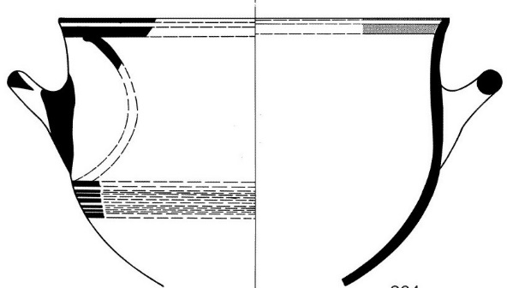

**Theb 017.** BE 28821. Pelopidas St. DEYATH. Trench VI, group 345/1994. From the area with dense concentration of Linear B tablets.

Fine undecorated. Low stemmed kylix FS 267. Mended, parts of the bowl and rim missing. Brown-pink clay 5YR 7/4, nearly fine, cracks on the surfaces. Slip.

Pr. h. 0.095, diam.: b. 0.06, r. 0.15m

LH IIIB2 Late.

*Andrikou 2006, 13, Deposit 2a, 70, cat. no. 137, pls 9, 40.46.*

NAA result: TheB.

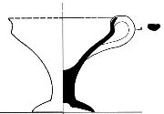

**Theb 018.** BE 28823. Pelopidas St. DEYATH. Trench VI, group 345+351/1994. From the area with dense concentration of Linear B tablets.

Fine undecorated. Shallow bowl FS 295. Mended, part of the bowl and rim and presumably one handle missing. Light pink clay, with white grains, cracks mainly outside and on base. Wash. Wheel marks on both sides.

H. 0.045, diam.: b. 0.05, r. 0.13m

LH IIIB2 Late.

*Andrikou 2006, 13, Deposit 2a, 71, cat. no. 149, pl. 9, 40.48.*

NAA result: TheA.

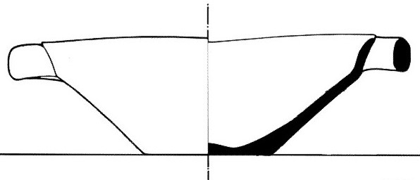

**Theb 019.** BE 28832. Pelopidas St. DEYATH. Trench VI, group 385/1994. From the area with dense concentration of Linear B tablets.

Fine undecorated. High stemmed kylix FS 274. Part of the bowl with one handle, mended. Pink clay 7.5YR 7/4, nearly fine (sparse white grains). Wash.

Pr. h. 0.07, r. diam. 0.18m

LH IIIB2 Late.

*Andrikou 2006, 13, Deposit 2a, 70, cat. no. 139, pls 9, 40.47.*

NAA result: EuA.

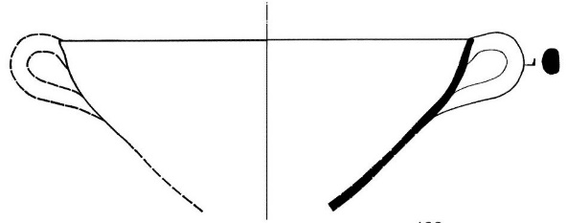

**Theb 020.** Pelopidas St. DEYATH. Trench VI, group 385/1994. From the area with dense concentration of Linear B tablets.

Fine undecorated. Deep bowl. Rim-wall fragment, Light orange clay, light yellow wash.

LH IIIB2 Late.

*For excavation context, see Andrikou 2006, 13, Deposit 2a.*

NAA result: UI53.

**Theb 021.** BE 28830. Pelopidas St. DEYATH. Trench V, group 232/1994. Intrusion in LH IIIA2 layer.

Fine decorated. One-handled cup FS 215, 216. Rim-wall fragment, mended. Wide horizontal wavy band outside. Dark pink clay 5YR 7/5, with sparse white grains, wash, slightly cracked surfaces. Red paint.

Pr. h. 0.073, r. diam. 0.14m

LH III C Late**.**

*Andrikou 2006, 11, Deposit 3a, 67, cat. no. 103, pls 6, 39.43.*

NAA result: TheB.

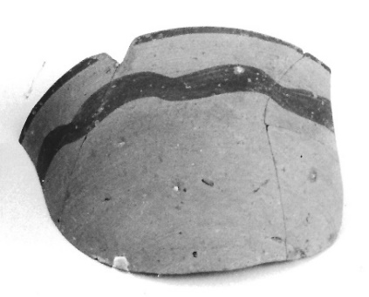 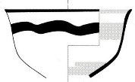

**Theb 022.** BE 28820. Pelopidas St. DEYATH. Trench VI, group 391/1994. From LH IIIA2 layer.

Fine undecorated. Low stemmed kylix FS 267. Mended, nearly half of the bowl missing. Light pink clay, nearly fine (tiny white grains). Wash. Wheel marks on both surfaces.

H. 0.092, diam.: b. 0.052, r. 110-0.12m

LH IIIA2.

*Andrikou 2006, 11, Deposit 3a, 60, cat. no. 9, pls 1, 25.4.*

NAA result: UI53.

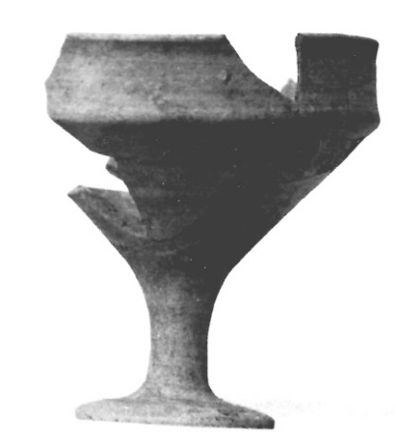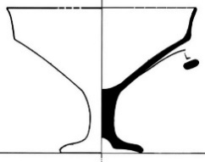

**Theb 023.** BE 28829. Pelopidas St. DEYATH. Trench V, group 205/1994. From LH IIIA2 destruction layer.

Fine undecorated. Handleless cup FS 204. Mended, parts of bowl and rim missing. Thin walled. Red-pink clay 5YR 7/4, nearly fine (few white grains). Wash, lighter in colour outside. Wheel marks on the base.

H. 0.047, diam.: b. 0.034, r. 0.11m

LH IIIA2.

*Andrikou 2006, 11-13, 62, Deposit 3b, cat. no. 42, pls 3, 31.18.*

NAA result: EuA

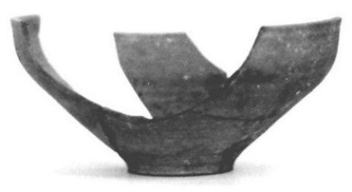

**Theb 024, Theb 030.** BE 28827. Pelopidas St. DEYATH. Trench IV, group 121/1994, Trench VI, group 298/1994. One part from LH IIIB2 Late and one from LH IIIC Early layer.

Fine decorated. Deep bowl FS 284. Two parts of the bowl with handle, each mended, probably from the same vase. Group A decoration. In the handle zone row of N-pattern (FM 60). Pink clay, thin white grains and mica. Wash. Red paint.

Pr. h. 0.075 and 0.07, r. diam. 0.16m

LH IIIB/C.

*Andrikou 2006, 13-14, Deposit 2b, 1c, 85, cat. no. 315, pls* 20, 52.80.

NAA result: TheA.

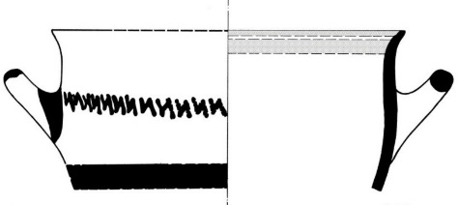

**Theb 025.** BE 29537. Pelopidas St. DEYATH. Trench V, group 192/1994 Π 107. From the underlay of Floor 4.

Fine undecorated. One handled cup FS 215. Mended, parts of the bowl and rim missing. Vivid pink clay, nearly fine, mica. Light yellow wash, flaking.

H. 0.052, diam.: b. 0.032, r. 0.077m

LH IIIC Early.

*Andrikou 2006, 50, Floor 4, 79, cat. no. 253, pls 15, 71.133.*

NAA result: single.

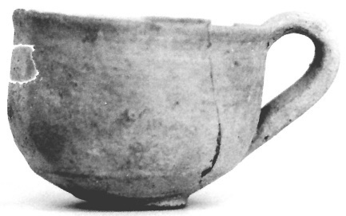

**Theb 026.** BE 29542. Pelopidas St. DEYATH. Trench V, group 175/1994. From LH IIIC Early layer.

Fine decorated. Crater FS 282. Wall fragment from the lower part of the bowl, mended. Pictorial decoration in silhouette: legs of a horse (?) to the right. Pink clay, orange-pink on the surfaces 7.5YR 7.5/6, sparse white grains and mica. Slip lighter in colour, cracked, lustrous outside. Brown-red paint.

Pr. h. 0.15, w. 0.105m

LH IIIC Early.

*Andrikou 2006, 13-14, Deposit 1c, 41, 51-52, 85, cat. no. 312, pls 19, 75.143.*

NAA result: TheB.

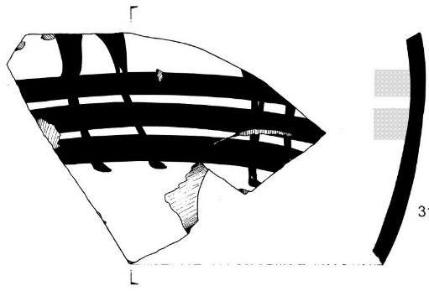

**Theb 027.** BE 29536. Pelopidas St. DEYATH. Trench V, group 200/1994/1994, Π110. From LH IIIC Middle layer.

Fine decorated. Crater FS 282. Rim – wall fragment, applied rope band outside below the rim. Pictorial decoration in silhouette: part of a frontal soldier with hedgehog helmet and axe. Light red clay, lighter on the surfaces, sparse grains and mica. Wash lighter in colour. Black / black-brown paint.

Pr. h. 0.07, w. 0.051, thickn. 0.01 / 0.023m

LH IIIC Middle.

*Andrikou 2006, 14, Deposit 1a, 46, 51-52, 89, cat. no. 359, pls 23, 75.146.*

NAA result: TheB.

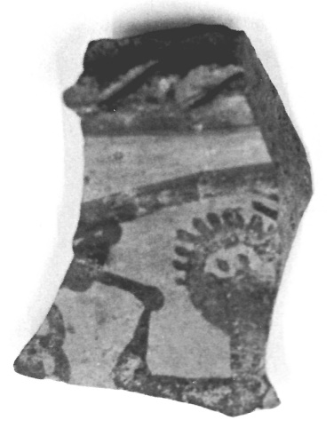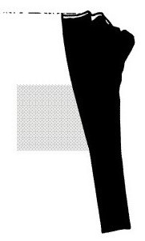

**Theb 028.** BE 29538. Pelopidas St. DEYATH. Trench V, group 152/1994. From a LH IIIC Middle layer. LH IIIC Middle.

Fine decorated. Crater FS 282. Wall fragment from the lower part of the bowl. Pictorial decoration in outline: fish to the right, hind legs of an animal. Pink clay, lighter on the surfaces 7.5YR 7.5/4, thin grains. Wash lighter in colour. Brown-red paint.

Pr. h. 0.05, w. 0.071m

*Andrikou 2006, 14, Deposit 1a, 46, 51-52, 89, cat. no. 360, pls 23,75.142.*

NAA result: TheB.

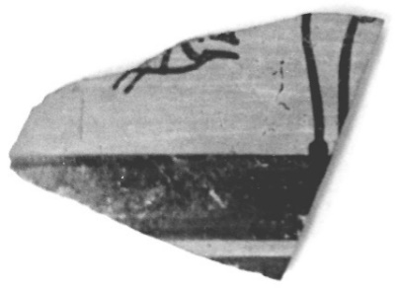

**Theb 029.** BE 29541. Pelopidas St. DEYATH. Trench V, group 239/1994. From LH IIIA2 destruction layer.

Fine decorated. Closed vase. Wall fragment. Marine Style decoration: two octopus tentacles (FM 21.1), rock pattern (FM 28). Whitish pink clay, reddish on the outside 10 YR/ 8/3. Whitish pink slip. Inside, clear wheel marks. Red-brown / brown paint.

Pr. h. 0.068, w. 0.046, thickn. 0.006m

LH IIA.

*Andrikou 2006, 11-13, Deposit 3b, 64, cat. no. 71, pls 5, 35.9.*

NAA result: single.

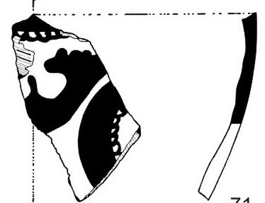

**Theb 031.** BE 28826. Pelopidas St. DEYATH. Trench V, group 201/1994, Trench VI, groups 426, 345(?). Partly from Floor 5 and partly from LH IIIA2 destruction layer.

Fine decorated. Deep bowl FS 284. Part of the bowl - rim, mended from two pieces. Base probably from the same vase. Group A decoration, antithetic spirals with panelled pattern (FM 50). Vivid pink clay 7.5YR 7/4, white grains. Cracks on the surfaces. Slip lighter in colour. Red paint.

Pr. h. 0.15, r. diam. 0.016m

LH IIIB2 Late.

*Andrikou 2006, 13 (Deposit 3c), 50, 80, cat. no. 263, pls 16, 40.51, 74.139.*

NAA result: TheA.

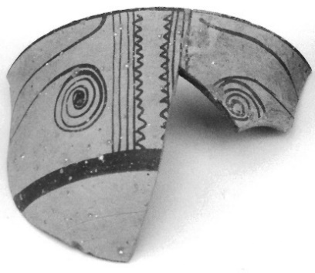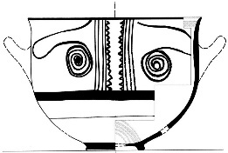

**Theb 032.** BE 28822. Pelopidas St. DEYATH. Trench V, group 202/1994. Embedded in the hearth on Floor 5.

Semi-coarse, decorated. Collar - necked jar FS 63/64, preserving most part of the belly and neck, mended. Horizontal handle on the belly and a pair of lugs horizontally pierced on the shoulder. Band decoration. Pink clay, hard, with red-brown and white grains. Slight cracking on the outer surface. Yellowish white wash outside and on the neck inside. Red-brown paint.

Pr. h. 0.245, max. diam. 0.276, r. diam. 0.118m

LH IIIC Early

*Andrikou 2006, 50, Floor 5, 80 cat.no.257, pls 15, 72.134.*

NAA result: TheA.

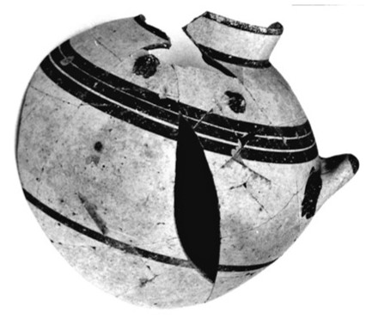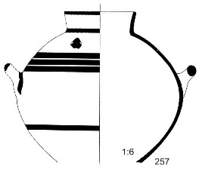

**Theb 033.** BE 28825. Pelopidas St. DEYATH. Trench V, group 201/1994. Embedded in Floor 5.

Fine decorated. Deep bowl FS 284. Mended, part of the bowl and rim and one handle missing. Group A decoration: repeated narrow panelled patterns FM 75.22. Vivid pink clay, lighter on the surfaces, nearly fine with white grains. Wash lighter in colour. Brown / brown-black paint.

H. 0.106 - 0.11, diam.: b. 0.055, r. 0.146m

LH IIIB2 Late or LH IIIC Early.

*Cf Theb 036. Andrikou 2006, 50, Floor 5, 80 cat.no.262, pls 16, 73.137, 74.138.*

NAA result: TheA.

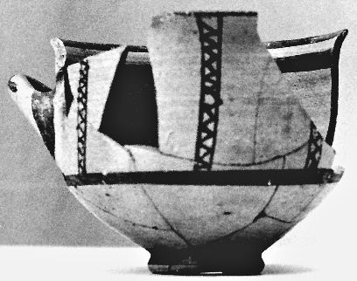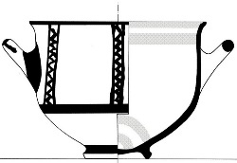

**Theb 034.** BE 28819. Pelopidas St. DEYATH. Trench V, group 205/1994. From LH IIIA2 destruction layer.

Fine, undecorated. Low - stemmed kylix FS 267. Mended, part of the bowl and rim missing. Two more fragments not joining. Red-pink clay 7.5YR 7/4, nearly fine (slight gray and white grains). Yellow wash. Wheel marks inside and out.

H. 0.095, diam.: b. 0.055, r. 0.11m

LH IIIA2.

*Andrikou 2006, 11-13, Deposit 3b, 62, cat. no. 53, pls 4, 32.22.*

NAA result: single.

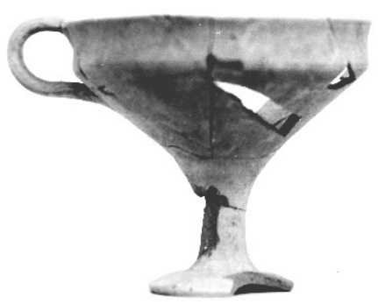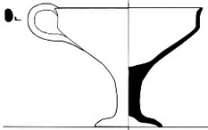

**Theb 035.** BE 29544. Pelopidas St. DEYATH. Trench VI, group 379/1994. From LH IIIA2 destruction layer.

Fine decorated. Bowl. Preserved from base to rim, mended. Band decoration on both sides. Rim painted on both sides. Pink clay, nearly fine (thin white grains and sparse mica). Slip 5YR 7/4. Red paint.

H. 0.065, diam.: b. 0.039, r. 0.145m

LH IIIA2/B1.

*Andrikou 2006, 13, Deposit 3c, 27, 70, cat. no. 131, pls 8, 39.45.*

NAA result: TheA.

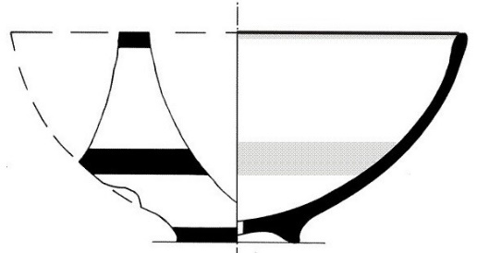

**Theb 036.** BE 28824. Pelopidas St. DEYATH. Trench VI, group 351/1994. From the area with dense concentration of Linear B tablets.

Fine decorated. Deep bowl FS 284. Mended, part of the bowl and rim and one handle missing. Some fragments burnt gray, either inside or out. Group A decoration, repeated narrow panelled patterns FM 75.22. Light pink clay with white grains. Cracks on inner surface. Wash. Black-brown paint.

H. 0.11, diam.: b. 0.063, r. 0.13m

LH IIIB2 Late.

*Cf. Theb 033. Andrikou 2006, 13, Deposit 2a, 71-72, cat. no. 154, pls 10, 40.50, 73.137*.

NAA result: TheA.

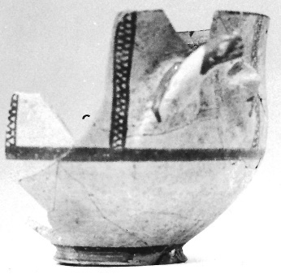

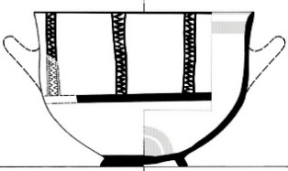

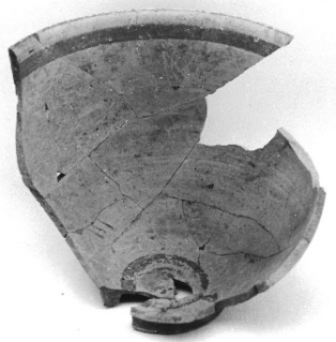

**Theb 037, Theb 038.** BE 28831. Pelopidas St. DEYATH. Trench V, group 190/1994. Embedded in Floor 4.

Handmade Burnished jar (HBP). Two rim-wall fragments, mended, not joining. Outside, below the rim applied rope band and prints of fingertips and fingernails. Gray clay. In most part burnt black-gray. Gray-brown / pink surfaces. Thick white grains and sparse red-brown. Burnished surfaces, partly worn. Horizontal marks from the burnishing tool. Cracks.

Pr. h.: 0.12 and 0.145, r. diam 0.19m

LH IIIC Early.

*Andrikou 2006, 50, Floor 4, 53-54, 79, cat. no. 255, pls 15, 76.155.*

NAA result: TheF.

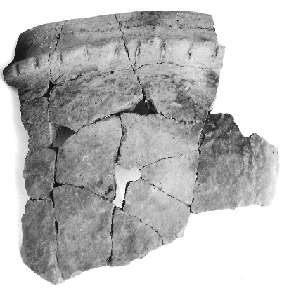 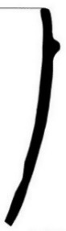

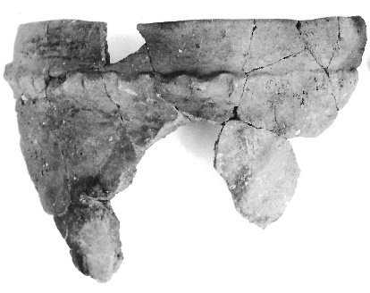

**Theb 039.** BE 27121. Neroutsou - Kretikou and Panagiotides heirs plot, Area 10, group 387/1995, A26. From the mixed stratum A.

Handmade burnished small jar (HBP). Base-rim fragment, mended. Nearly half preserved. On the shoulder applied band. Yellowish gray clay, dark brown at spots, dense various grains and mica. Burnishing marks visible on surface.

H. 0.11, diam.: b. 0.08, r. 0.10m

LH IIIC Early (?).

*Andrikou 1995, 286.*

NAA result: pair with Theb 040 (=008).

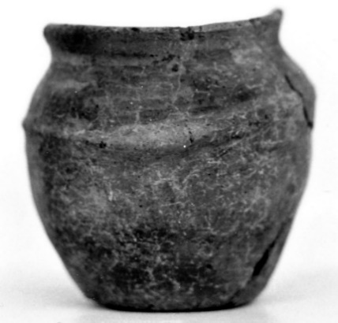

**Theb 040.** BE 28950. Neroutsou - Kretikou and Panagiotides heirs plot, Area 1, group 119+305/1995. Among the sherds packed around the hearth in Area 1 (Stratum B).

Handmade burnished jar (HBP). Rim-wall fragment, mended. Below rim applied band. Dark gray to whitish gray clay, surfaces spotted brown and gray, dense various grains, soft fired.

R. diam. 0.24m

LH IIIC Early (?).

*Andrikou 1995, 287.*

NAA result: pair with Theb 039 (=008).

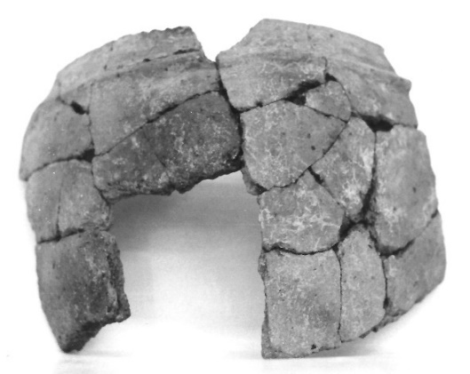

**Theb 049.**Pelopidas St. DEYATH. Trench VI. From the destruction layer with the Linear B tablets.

Clay lump for making a Linear B tablet. Clay rust red in colour, dark and white grains.

LH IIIB2 Late.

NAA result: TheF.

**Theb 050**. BE 29757. Pelopidas St. DEYATH. Trench VI, group 326/1994, Π199. From LH IIIB2 Late destruction layer.

Linear B tablet. Uninscribed fragment from the short side. Light brown clay, fine and medium size grains. On the short side, a hole was apparently deliberately opened through the tablet.

W. 0.022m.

LH IIIB2 Late.

*For the excavation context, see Andrikou 2006, 13, Deposit 2b. For the Linear B tablets of the Pelopidou St. site, see* *Aravantinos, Godart and Sacconi 2001.*

NAA result: TheF.

**Theb 053.** BE 26972. MCCTh plot, Trench 14, group 32+41/1995. On the border of a circular earth platform on the floor of Room 2.

Semi-fine decorated. Jug FS 105. Mended, slightly restored. Firing holes at the ends of the handle. Band decoration on the upper half. Light brown clay 10YR 8/4, lighter slip, fine grains white and dark. The area on the left of the handle worn, maybe slightly burnt whitish brown in colour 10YR 7/2. Black paint, flaking off.

H. 0.26, diam.: b. 0.085, r. 0.109, max. 0.215m

LH IIIB2 Late.

*Andrikou forthcoming, cat. no. V.527*

NAA result: TheA.



**Theb 054, Theb 059** BE 26998. MCCTh plot, Trench 13/14, group 329/1995, A23. From the upper destruction layer in Trenches 13 - 14.

Fine decorated. Hydria FS 128 or belly-handled amphora FS58. Mended, part of the belly with horizontal handle, neck and vertical handle missing. Neck-rim fragment not joining. The lower part mended in antiquity with lead braces. Band decoration, traces of possible motif on the shoulder. Red-brown clay 5YR 6/4, light brown slip 10YR 7/4, sparse white and brown grains, visible on surface. Few bigger white ones have caused spalling of the surface. Red-brown to black-brown paint.

H. without neck 0.30, diam.: b. 0.115, r. 0.13m

LH IIIC Early.

*Andrikou forthcoming, cat. no. IV.387.*

NAA result: TheB.



**Theb 055.** BE 26999. MCCTh plot, Trench 13/14, group 337+343/1995, A29+A31. From the lower destruction layer in Trenches 13-14.

Fine decorated. Deep bowl FS 284. Mended, part of the bowl with one handle missing. Disproportional. Group A decoration, antithetic spirals with simple panelled pattern (FM 50). Brown pink clay 7.5YR 7/4, slip, very sparse white grains have caused spalling of the surface. Brown paint.

H. 0.14, diam.: b. 0.068, r. 0,16m

LH IIIB2 Late.

*Andrikou forthcoming, cat. no. V.563.*

NAA result: single.



**Theb 056.** BE 27004. MCCTh plot, Trench III2, group 383a/1995, Α33. From the south part of the plot.

Fine undecorated. Kylix FS 274. The bowl with two vertical handles and the beginning of the stem, mended. Clay gray in core 10YR 7/1, pink on surfaces 5YR 7/4, slip, sparse fine brown grains and bigger white ones.

H. 0.12, diam. r. 0.161, stem 0.02m

LH IIIC Early.

*Andrikou forthcoming, cat. no. I.57.*

NAA result: TheA.



**Theb 057.** BE 26990. MCCTh plot, Trench 20, Area A, group 72/1995, Π91. From disturbed layer.

Cooking ware. Cooking pot. Mended, more than half preserved. Round vertical handle. Circular permeable hole (diam. 1,1cm) in the centre of the base, opened after firing. Brown-red clay 2.5YR 5/4 – 4/4, burnt black at spots, dense medium size gray and white grains. Wash.

H. 0.225, diam.: b. 0.092, r. 0.16m

Post-mycenaean (? roman/byzantine).

NAA result: single.

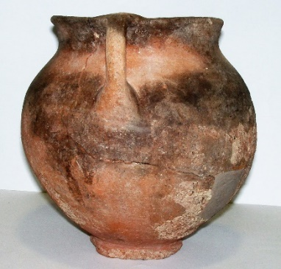

**Theb 058.** BE 27424. MCCTh plot, Trench13/14, group 337/1995, A27. From the lower destruction layer in Trenches 13-14.

Roof tile. Pan tile. Flat fragment preserving the plain edge on the short side and the raised border on the long side of the tile. Partially burnt gray. Pink clay 5YR 6/3, dense grains of quarz (diam. ca. 1-2mm) and lime. Wash on the upper surface, lower surface plain and uneven.

H. 0.061 – 0.093, pr. l. 0.24 and w. 0.325m

LH IIIb2 Late.

*Andrikou forthcoming, cat. no. V.Κε7. For complete roof tiles, see Aravantinos, Fappas and Galanakis 2020, 191-94.*

NAA result: single.





**Theb 060.** BE 27003. MCCTh plot, Trench III2, group 366/1995, A32. From the upper mixed Mycenaean layer in the south part of the plot.

Fine decorated. Crater FS 282. Wall fragment. Pictorial decoration: forepart of a stag to the right, in silhouette. Light orange clay, slip, fine, medium and big size grains, red, dark and white, the latter having caused slight spalling of the surface. Dark brown paint.

H. 0.224, thickn. 0.095m

LH IIIB2.

*Pliatsika 2000, 292-94, fig. 3,* Mommsen - Maran 2000-2001, 98, Table 1 (27003).

NAA result: TheB.



**Theb 061.** BE 26996. MCCTh plot, Trench 12, group 95/1995, A11. From mixed Mycenaean and byzantine layer.

Fine decorated. Crater FS 282. Mended, almost half bowl and handles missing. Pictorial decoration in silhouette: side A, pair of sphinxes facing each other - side B, chariot scene. Vivid pink-red clay 5YR 7/4, almost fine, sparse big size lime (white) grains (diam. 4mm). Slip. Red-brown paint and added white.

H. 0.345, b. diam. 0,124m

LH IIIC Early.

*Pliatsika 2000, 287-92, fig. 1-2.*

NAA result: EuA.



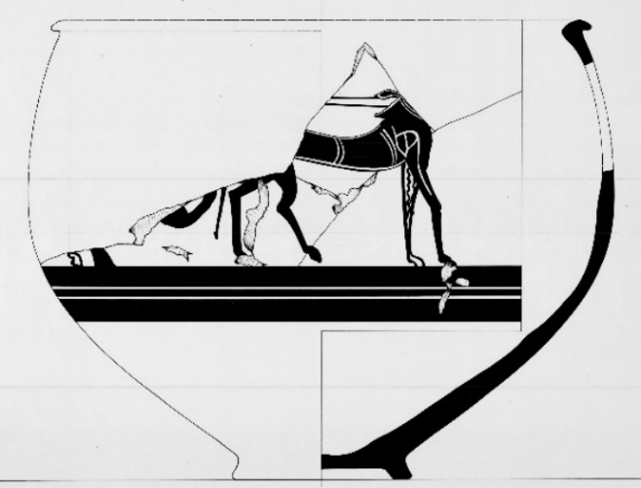

**Theb 062.** MCCTh plot, Trench 18, group 40d/1995. Among the pottery discarded in Trenches 17 and 18.

Fine decorated. Closed vase. Wall fragment. Banded decoration. Light red clay 2.5YR 6/8, fine. Outside, yellowish white 5Y/8/2 slip. Dark brown paint. Thin rotation marks inside.

LH IIIB2 Late.

NAA result: EuA.

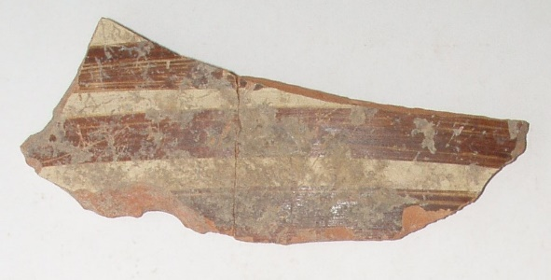

**Theb 063.** MCCTh plot, Trench 18, group 40d/1995. Among the pottery discarded in Trenches 17 and 18.

Fine decorated. Amphoriskos FS 59. Wall fragment with the beginning of a horizontal cylindrical handle. Mended. Clay gray 5YR 7/1 in core, orange surfaces 5YR 7/8, light brown 10YR 8/3 slip. Black paint. Burnt.

Diam. 0.15m

LH IIIB2 Late.

NAA result: TheB.

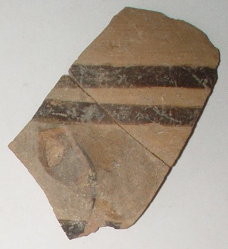

**Theb 064.** MCCTh plot, Trench 18, group 40d/1995. Among the pottery discarded in Trenches 17 and 18.

Fine decorated. Deep bowl FS 284. Wall fragment with the beginning of a horizontal cylindrical handle. Group Α decoration. Light brown clay 10YR 8/4, fine (one medium size dark grain visible), slip. Black matt paint.

LH IIIB2 Late.

NAA result: TheA.

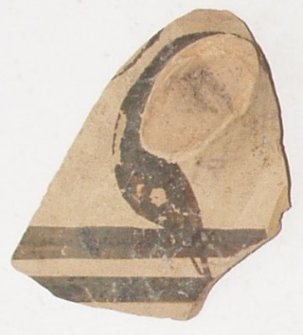

**Theb 065, Theb 100.** MCCTh plot, Trench 18, group 40d/1995. Among the pottery discarded in Trenches 17 and 18.

Fine decorated. Deep bowl FS 284. Rim-wall fragment with the beginning of the handle. Mended. Group A decoration, N-pattern FM 60. Light brown 10YR 8/3 clay, fine and medium size grains red-brown and white, whitish yellow 2.5Y/8/2 slip. Dark brown matt paint.

R. diam. 0.15m

LH IIIB2 Late.

*Andrikou forthcoming, cat. no. VI.771.*

NAA result: 065: ThBC; 100: ThBC or TheB.

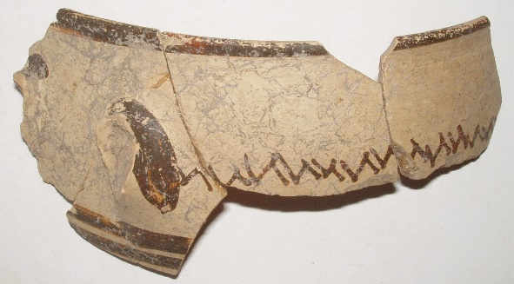

**Theb 066.** MCCTh plot, Trench 18, group 40d/1995. Among the pottery discarded in Trenches 17 and 18.

Fine decorated. Strainer feeding bottle FS 162. Shoulder fragment with part of the cylindrical spout. Linear decoration. Orange-red 5YR 7/6 clay, fine, sparse white grains visible on surfaces, light pink 7.5YR 8/4 slip outside. Brown-red paint.

LH IIIB2 Late.

NAA result: TheA.

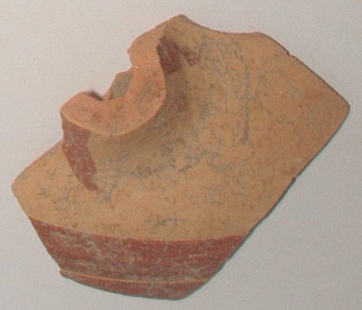

**Theb 067.** MCCTh plot, Trench 18, group 40d/1995. Among the pottery discarded in Trenches 17 and 18.

Fine decorated. Deep bowl FS 284. Rim-wall fragment. Mended. Decoration: wide horizontal wavy band outside. Vivid orange 5YR 7/8 clay, fine. Wash. Wheel marks inside. Red paint.

Pr. H. 0.125, r. diam. 0.20m

LH IIIB2 Late.

*Andrikou forthcoming, cat. no. VI.768.*

NAA result: KnoL or TheB.

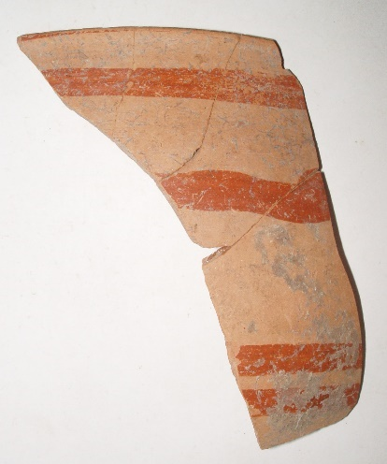 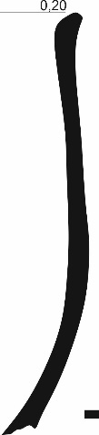

**Theb 068.** MCCTh plot, Trench 18, group 40d/1995. Among the pottery discarded in Trenches 17 and 18.

Fine undecorated. Cup FS 222 or kylix FS 267. Rim-wall fragment with vertical handle. Orange-red clay 5YR 7/8, fine white grains, wash.

R. diam. 0.146m

LH IIIB2 Late.

NAA result: single.

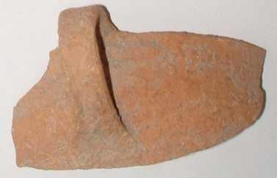

**Theb 069.** MCCTh plot, Trench 18, group 40d/1995. Among the pottery discarded in Trenches 17 and 18.

Fine undecorated. Kylix FS 267. Rim-wall fragment. Brown clay, orange 5YR 7/5 surfaces, fine.

LH IIIB2 Late.

NAA result: TheB.

**Theb 070.** MCCTh plot, Trench 18, group 40d/1995. Among the pottery discarded in Trenches 17 and 18.

Fine undecorated. Cup FS 222 or kylix FS 267. Rim-wall fragment. Red-brown clay 2.5YR 6/4, wash 5YR 8/4, fine (very sparse lime grit), well fired.

R. diam. 0.112m

LH IIIB2 Late.

NAA result: TheA.

**Theb 071.** MCCTh plot, Trench 18, group 40d/1995. Among the pottery discarded in Trenches 17 and 18.

Fine undecorated. Kylix FS 267. Rim fragment. Orange clay, light brown surfaces, fine except some big white grains.

R. diam. ca 0.115m

LH IIIB2 Late.

NAA result: TheB associated: Ce low

**Theb 072.** MCCTh plot, Trench 18, group 40d/1995. Among the pottery discarded in Trenches 17 and 18.

Fine undecorated. Cup FS 222 or kylix FS 267. Rim-wall fragment. Brown clay 10YR 6/3, wash, sparse white grains.

R. diam. ca 0.13m

LH IIIB2 Late.

NAA result: TheA.

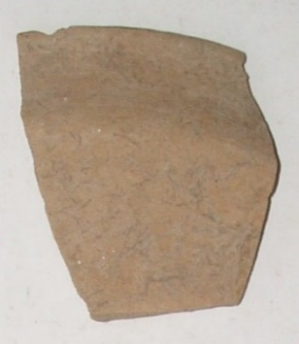

**Theb 073.** MCCTh plot, Trench 18, group 40d/1995. Among the pottery discarded in Trenches 17 and 18.

Fine undecorated. Deep bowl FS 284. Rim-wall fragment. Light orange clay 7.5YR 8/6, whitish brown wash 10YR 8/2, fine.

R. diam. 0.116m

LH IIIB2 Late.

NAA result: TheA.

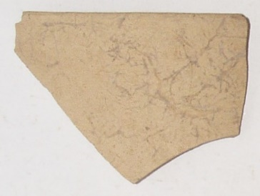

**Theb 074.** MCCTh plot, Trench 18, group 40d/1995. Among the pottery discarded in Trenches 17 and 18.

Fine undecorated. Kylix FS 274. Rim-wall fragment. Light red 7.5YR 7/4clay, fine, sparse white grains, wash.

R. diam. 0.158m

LH IIIB2 Late.

NAA result: TheA.

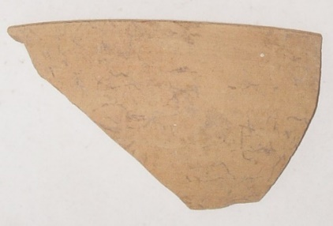

**Theb 075.** MCCTh plot, Trench 18, group 40d/1995. Among the pottery discarded in Trenches 17 and 18.

Fine undecorated. Kylix FS 274. Rim-wall fragment. Orange-red 5YR 7/6 clay, fine, sparse white grains, wash.

R. diam. 0.162m

LH IIIB2 Late.

NAA result: TheA.

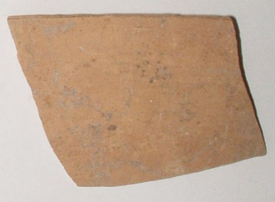

**Theb 076.** MCCTh plot, Trench 18, group 40d/1995. Among the pottery discarded in Trenches 17 and 18.

Fine undecorated. Shallow bowl FS 295(?). Base-wall fragment. Flat base with traces of removal from the wheel. Orange-pink 7.5YR 7/6 clay, fine, sparse white grains, wash.

B. diam. 0.045m

LH IIIB2 Late.

NAA result: TheA.

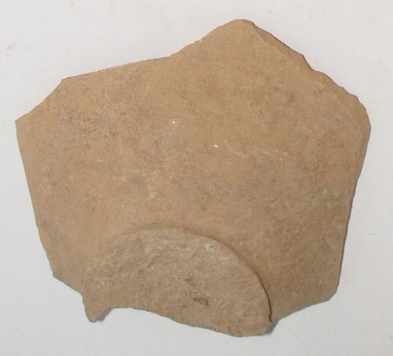

**Theb 077.** MCCTh plot, Trench 18, group 40d/1995. Among the pottery discarded in Trenches 17 and 18.

Fine undecorated. Kylix FS 267. Stem-bowl fragment. Light pink 7.5YR 8/4 clay, fine, sparse fine white grains, wash. It probably belongs with Theb 080.

Stem diam. 0.019m

LH IIIB2 Late.

NAA result: pair with Theb 080 (=305).

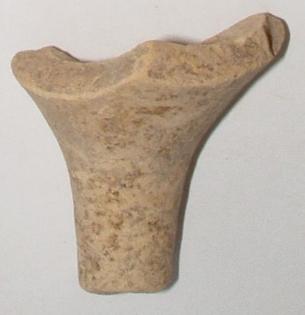

**Theb 078.** MCCTh plot, Trench 18, group 40d/1995. Among the pottery discarded in Trenches 17 and 18.

Fine undecorated. Deep bowl FS 284. Rim-wall fragment with part of the handle. Light yellowish brown clay, fine, wash.

R. diam. ca 0.15m

LH IIIB2 Late.

NAA result: TheA.

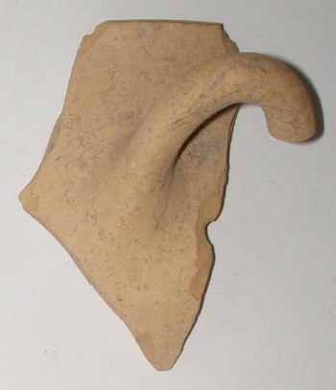

**Theb 079.** MCCTh plot, Trench 18, group 40d/1995. Among the pottery discarded in Trenches 17 and 18.

Fine undecorated. Shallow bowl FS 295. Rim-wall fragment with part of horizontal strap handle. Light orange clay 7.5YR 8/6, fine, sparse fine white grains, wash 7.5YR 8/4.

R. diam. 0.132m

LH IIIB2 Late.

NAA result: TheA.

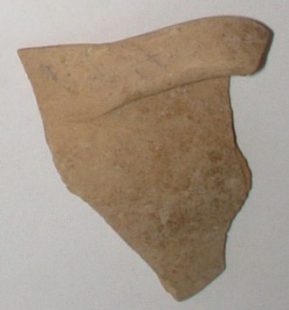

**Theb 080.** MCCTh plot, Trench 18, group 40d/1995. Among the pottery discarded in Trenches 17 and 18.

Fine undecorated. Kylix. Base-stem fragment. Light pink 7.5YR 8/4clay, fine, sparse fine white grains, wash. It probably belongs with with Theb 077.

Diam.: b. 0.065, stem 0.018m

LH IIIB2 Late.

NAA result: pair with Theb 077 (=305).

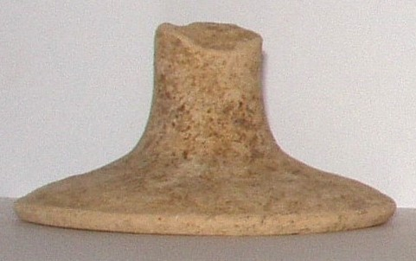

**Theb 081.** MCCTh plot, Trench 18, group 40d/1995. Among the pottery discarded in Trenches 17 and 18.

Fine undecorated. Kylix FS 267. Base to lower bowl fragment. Orange-red 5YR 7/6 clay in core, whitish brown surfaces 10YR/7.5/3, fine, sparse fine white grains (<0,1mm), wash.

Diam.: b. 0.055, stem 0.019m

LH IIIB2 Late.

NAA result: TheA.

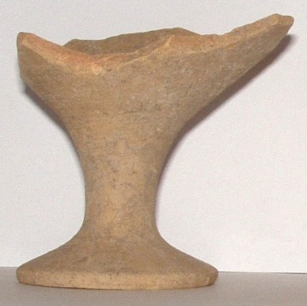

**Theb 082.** MCCTh plot, Trench 18, group 40d/1995. Among the pottery discarded in Trenches 17 and 18.

Fine undecorated. Kylix FS 267. Stem with the beginning of the base disc and the bowl. Orange-red 7.5YR 7/6 clay, fine, sparse medium size grains, light pink 7.5YR 8/4 wash.

Stem diam.: 0.019m

LH IIIB2 Late.

NAA result: TheA.

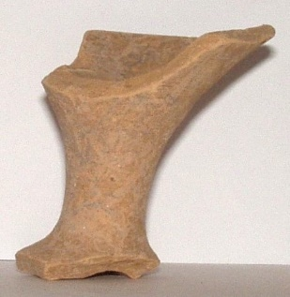

**Theb 083.** MCCTh plot, Trench 18, group 40d/1995. Among the pottery discarded in Trenches 17 and 18.

Fine undecorated. Kylix FS 267. Stem with the beginning of the base disc and the bowl. Orange 5YR 7/8 clay, light pink wash 7.5YR 8/4, fine.

Stem diam.: 0.019m

LH IIIB2 Late.

NAA result: single.

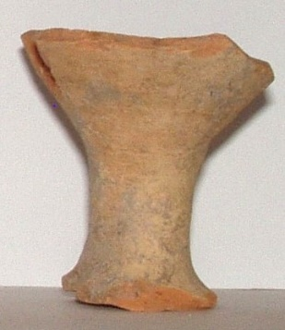

**Theb 084.** MCCTh plot, Trench 18, group 40d/1995. Among the pottery discarded in Trenches 17 and 18.

Fine undecorated. Kylix FS 267. Stem with the beginning of the base disc and the bowl. Light orange 7.5YR 8/6 clay, fine, sparse fine white grains, whitish brown 10YR 7.5/3, wash.

Stem diam.: 0.018m

LH IIIB2 Late.

NAA result: X029.

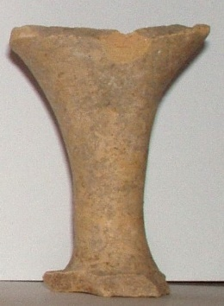

**Theb 085.** MCCTh plot, Trench 18, group 40d/1995. Among the pottery discarded in Trenches 17 and 18.

Fine undecorated. Kylix. Stem-bowl fragment. Light pink 5YR 8/3clay, fine, sparse fine white grains, light brown 10YR 7/3wash.

Stem diam. 0.024m

LH IIIB2 Late.

NAA result: single.

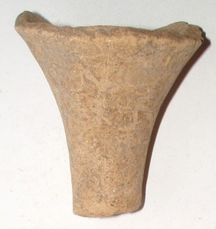

**Theb 086.** MCCTh plot, Trench 18, group 40d/1995. Among the pottery discarded in Trenches 17 and 18.

Fine undecorated. Kylix FS 267. Stem with the beginning of the base disc and the bowl. Light pink 5YR 8/3 clay, fine, sparse fine white grains, wash.

Stem diam. 0.018m

LH IIIB2 Late.

NAA result: TheA.

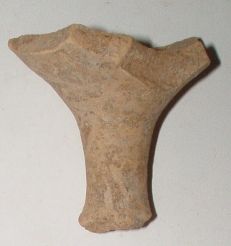

**Theb 087.** MCCTh plot, Trench 18, group 40d/1995. Among the pottery discarded in Trenches 17 and 18.

Fine undecorated. Kylix. Stem-bowl fragment. Light brown clay 10YR 7/3, fine, sparse fine white grains (<0.1mm), wash.

Stem diam. 0.02m

LH IIIB2 Late.

NAA result: TheA.

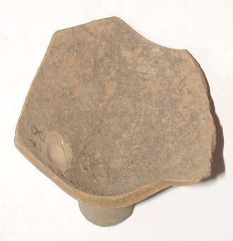

**Theb 088.** MCCTh plot, Trench 18, group 40d/1995. Among the pottery discarded in Trenches 17 and 18.

Fine undecorated. Kylix FS 267. Rim-wall fragment with handle. Orange clay 5YR 7/8, fine, wash whitish pink 7.5YR 8/2, fine.

R. diam. 0.10m

LH IIIB2 Late.

NAA result: single.

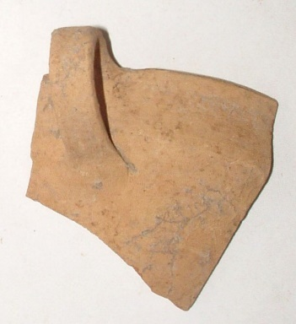

**Theb 089.** MCCTh plot, Trench 18, group 40d/1995. Among the pottery discarded in Trenches 17 and 18.

Fine undecorated. Kylix FS 267. Rim – wall fragment. Light brown 10YR 8/3 clay, fine, wash.

R. diam. 0.106m

LH IIIB2 Late.

NAA result: TheA.

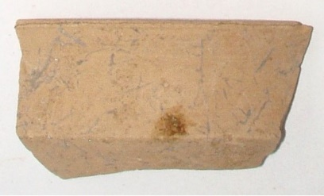

**Theb 090.** MCCTh plot, Trench 18, group 40d/1995. Among the pottery discarded in Trenches 17 and 18.

Fine undecorated. Kylix FS 267. Rim-wall

fragment. Pink clay 7.5YR 7/4, fine, wash.

R. diam. 0.138m

LH IIIB2 Late.

NAA result: TheA.

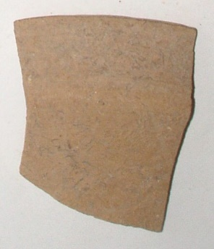

**Theb 091.** MCCTh plot, Trench 18, group 40d/1995. Among the pottery discarded in Trenches 17 and 18.

Fine undecorated. Crater FS 281. Rim-wall

fragment. Light brown 10YR 8/4 clay, fine, lighter slip 10YR 8/3.

Pr. h. 0.115, r. diam. 0.31m

LH IIIB2 Late.

*Andrikou forthcoming, cat. no. VI.679.*

NAA result: TheA.

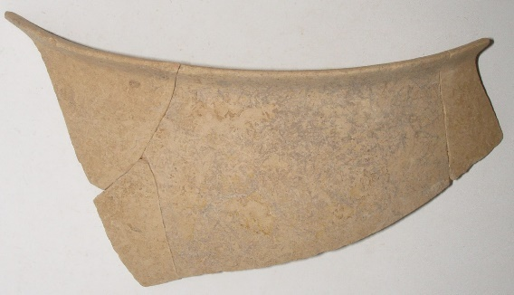

**Theb 092.** MCCTh plot, Trench 18, group 40d/1995. Among the pottery discarded in Trenches 17 and 18.

Semi-fine undecorated. Basin FS 295. Rim-wall fragment with strap horizontal handle. Light red 2.5YR 6/6 clay, dense medium size grains and mica, light pink 7.5YR 8/4 slip.

Pr. h. 0.067, r. diam. 0.27m

LH IIIB2 Late.

*Andrikou forthcoming, cat. no. VI.700.*

NAA result: TheA.

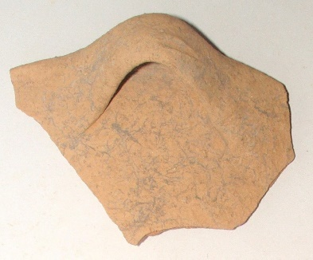

**Theb 093.** MCCTh plot, Trench 18, group 40d/1995. Among the pottery discarded in Trenches 17 and 18.

Fine undecorated. Cup FS 222. Rim to base fragment. Light red-brown 2.5YR 6/4 clay, fine, wash. Well fired.

Diam.: b. 0.04, r. 0.114m

LH IIIB2 Late.

*Andrikou forthcoming, cat. no. VI.625.*

NAA result: ThBC.

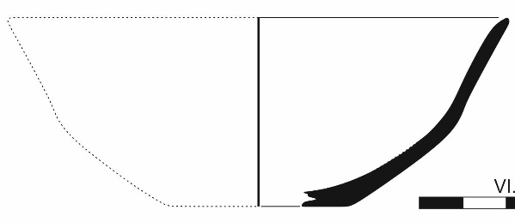

**Theb 094.** MCCTh plot, Trench 18, group 40d/1995. Among the pottery discarded in Trenches 17 and 18.

Fine undecorated. Deep rounded bowl FS 280(?). Rim - wall fragment. Light pink clay 5YR 8/3, grains visible on surfaces, light brown wash 10YR 8/3.

R. diam. 0.216m

LH IIIB2 Late.

NAA result: TheB.

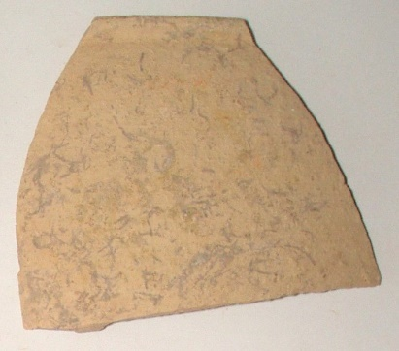

**Theb 095.** MCCTh plot, Trench 18, group 40d/1995. Among the pottery discarded in Trenches 17 and 18.

Fine undecorated. Cup FS 222(?) Base – wall fragment. Flat base with traces of removal from the wheel. Orange-red clay 5YR 7/6, light pink wash 5YR 8/3, almost fine.

Diam. 0.039m

LH IIIB2 Late.

NAA result: ThBC or TheB.

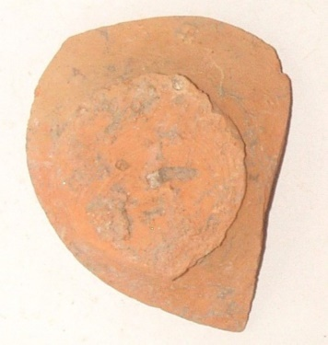

**Theb 096.** MCCTh plot, Trench 18, group 40d/1995. Among the pottery discarded in Trenches 17 and 18.

Fine undecorated. Closed vase(?) Base-wall fragment. Ring base. Light red clay 2.5YR 6/6, sparse white grains, light pink 5YR 8/3 wash.

Diam. 0.055m

LH IIIB2 Late.

NAA result: TheA associated: Cr high.

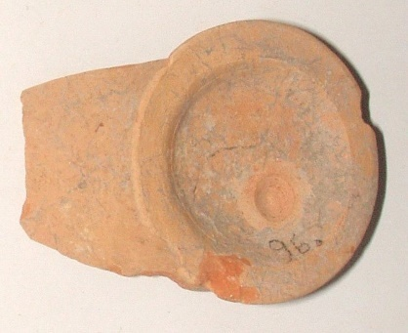

**Theb 097.** MCCTh plot, Trench 18, group 40d/1995. Among the pottery discarded in Trenches 17 and 18.

Fine decorated. Deep bowl FS 284. Base-wall fragment. Ring base. Band inside and out the base. Orange-red clay 5YR 7/6, almost fine, light pink wash 5YR 8/4. Red paint.

Diam. 0.056m

LH IIIB2 Late.

NAA result: TheA.

**Theb 098.** MCCTh plot, Trench 18, group 40d/1995. Among the pottery discarded in Trenches 17 and 18.

Fine decorated. Deep bowl FS 284. Wall fragment with the beginning of the handle. Group A decoration. Pink clay 5YR 7/4, almost fine, light pink wash 5YR 8/3. Red to dark brown paint.

LH IIIB2 Late.

NAA result: TheA.

**Theb 099.** MCCTh plot, Trench 18, group 40d/1995. Among the pottery discarded in Trenches 17 and 18.

Fine decorated. Deep bowl FS 284. Rim - wall fragment with handle. Mended. Group A decoration, antithetic spiral FM 50. Light red clay 2.5YR 6/8, fine, light pink 7.5YR 8/4 slip. Red-orange paint.

LH IIIB2 Late.

NAA result: Kofu.

**Theb 101.** MCCTh plot, Trench 18, group 40d/1995. Among the pottery discarded in Trenches 17 and 18.

Fine decorated. Deep bowl FS 284. Rim - wall fragment and wall fragment mended. Group A decoration, narrow horizontal wavy band FM 53. Orange-pink clay, 7.5YR 7/6, fine, sparse fine white grains, wash. Red paint.

LH IIIB2 Late.

NAA result: TheA.

**Theb 102.** MCCTh plot, Trench 18, group 40d/1995. Among the pottery discarded in Trenches 17 and 18.

Fine decorated. Deep bowl FS 284. Rim - wall fragment. Group A decoration, wide horizontal wavy band FM 53. Pink 7.5YR 7/4 clay, almost fine, fine white grains (<1mm) and mica, light brown 10YR 8/3 slip. Black paint.

LH IIIB2 Late.

NAA result: TanA.

**Theb 103.** MCCTh plot, Trench 18, group 40d/1995. Among the pottery discarded in Trenches 17 and 18.

Semi-fine undecorated. Amphora/hydria. Rim fragment with vertical cylindrical handle. Firing holes at the ends of the handle. Light pink 5YR 8/4 clay, dense fine and medium size grains visible on surfaces. Wash.

LH IIIB2 Late.

NAA result: single.

**Theb 104.** MCCTh plot, Trench 18, group 40d/1995. Among the pottery discarded in Trenches 17 and 18.

Fine decorated. Collar-necked jar FS 64. Shoulder fragment with vertical pierced lug. Band decoration. Clay gray 5YR 7/1 in core, light red 2.5YR 6/6 on surfaces, “sandy”, brown pink 7.5YR 7/4 wash. Black paint.

Diam. max. ca. 0.15m

LH IIIB2 Late.

*Andrikou forthcoming, cat. no. VI.714.*

NAA result: TheB.

**Theb 105.** MCCTh plot, Trench 18, group 40d/1995. Among the pottery discarded in Trenches 17 and 18.

Coarse decorated. Cylindrical closed vase. Body - base fragment. Band decoration. Clay gray in core, light orange 5YR 6/8 on surfaces, dense fine and medium size grains, visible on surfaces, and mica, brown-pink 7.5YR 7/4 slip outside. Red paint.

Diam. 0.25m

LH IIIB2 Late.

NAA result: X029.

**Theb 106.** MCCTh plot, Trench 18, group 40d/1995. Among the pottery discarded in Trenches 17 and 18.

Fine decorated. Closed vase. Wall fragment. Band decoration. Orange-pink 7.5YR 7/6 clay, “sandy” with dense fine grains (lime, quartz) visible on surface, whitish brown 10YR 8/2 slip outside. Brown-red paint.

LH IIIB2 Late.

NAA result: TheA.

**Theb 107.** MCCTh plot, Trench 18, group 40d/1995. Among the pottery discarded in Trenches 17 and 18.

Fine decorated. Rhyton FS 199. Wall fragment. Linear decoration and probably the end of a whorl-shell body FM 23. Light brown 10YR 8/4 clay, light pink 5YR 8/4 on surfaces, fine, light brown 10YR 8/3 slip outside. Brown-red paint.

LH IIIB.

*Andrikou forthcoming, cat. no. VI.741.*

NAA result: X029.

**Theb 108.** MCCTh plot, Trench 18, group 40d/1995. Among the pottery discarded in Trenches 17 and 18.

Roof tile. Cover tile. Small fragment preserving the edge on the long side. Wheel-made. Orange-red clay 5YR 7/6, light pink slip 5YR 8/3.

LH IIIB.

NAA result: TheB.

**Theb 109.** Pelopidas St. DEYATH. Trench VI, group 381/1994. From LH IIIA2 destruction layer.

Fine undecorated. Mug FS 225. Base-wall fragment. Band decoration. Light yellow clay, pure, sparse fine grains. Slip outside. Red/red- brown lustrous paint.

Pr. h. 0.035, diam. 0.06m

LH IIIA2/B1.

*Andrikou 2006, 13, Deposit 3, 69, cat. no. 120, pl. 8.*

NAA result: MBKR.

**Theb 110.** Pelopidas St. DEYATH. Trench VI, Pit H, group 396/1994. From LH IIIA2 layer.

Fine undecorated. Low stemmed kylix FS 264. Rim-wall fragment with vertical handle, mended. Light red clay 5YR 7/4, fine. Wash. Outside, partially yellowish surface.

Pr. h. 0.048, r. diam. 0.09m

LH IIIA2.

*Andrikou 2006, 11, Deposit 3a, 60, cat. no. 7, pl. 1.*

NAA result: EuA.

**Theb 111.** Pelopidas St. DEYATH. Trench VI, Pit H, group 396/1994. From LH IIIA2 layer.

Fine undecorated. Goblet. Base. Light pink clay, sparse mica. Monochrome outside in red glossy paint.

Diam. 0.055m

LH IIIA2.

*For “Pit H”, see Andrikou 2006, 11, Deposit 3a.*

NAA result: single.

**Theb 112.** Pelopidas St. DEYATH. Trench VI, Pit Z, group 395/1994. From LH IIIA2 layer.

Aeginetan, decorated. Closed vase. Wall fragment. Light gray clay 10YR 7/2, gray at spots with sparse golden mica. Red-brown paint 5YR 6/4.

MH/LH I.

*For “Pit Z”, see Andrikou 2006, 11, Deposit 3a.*

NAA result: AegA.

**Theb 113.** Pelopidas St. DEYATH. Trench VI, Pit Z, group 395/1994. From LH IIIA2 layer.

Aeginetan, semi-coarse, mattpainted. Amphora/ Pithos(?) handmade. Wall fragment. Clay similar to Theb 112.

MH/LH I.

*See, Theb 112.*

NAA result: AegA.

**Theb 114.** Pelopidas St. DEYATH. Trench VI, Pit Z, group 395/1994. From LH IIIA2 layer.

Gray minyan. Open vase(?), wheel-made. Rim-wall fragment. Gray clay, fine, polished surfaces.

R. diam. > 0.30m

MH/LH I.

*See, Theb 112.*

NAA result: EuA.

**Theb 115.** Pelopidas St. DEYATH. Trench VI, Pit Z, group 395/1994. From LH IIIA2 layer.

Gray minyan. Goblet(?) wheel-made. Rim-wall fragment. Light brown/gray clay 10YR 6/2, fine, well fired.

Diam. 0.20m

MH/LH I.

*See, Theb 112.*

NAA result: EuA.

**Theb 116.** Pelopidas St. DEYATH. Trench VI, Pit Z, group 395/1994. From LH IIIA2 layer.

Gray minyan. Open vase(?), wheel-made. Wall fragment. Light gray clay, fine.

MH/LH I.

*See, Theb 112.*

NAA result: EuA.

**Theb 117.** Pelopidas St. DEYATH. Trench VI, Pit Z, group 395/1994. From LH IIIA2 layer.

Fine undecorated. Goblet/kylix. Base. Pink clay, whitish brown slip 10YR 8/3, polished.

Diam. 0.071m

LH IIIA.

*See, Theb 112.*

NAA result: EuA.

**Theb 118.** Pelopidas St. DEYATH. Trench VI, Pit Z, group 395/1994. From LH IIIA2 layer.

Fine undecorated. Kylix. Base. Pink clay, gray in core, sparse white grains and silver mica. Slip polished on upper side.

Diam. 0.065m

LH IIIA.

*See, Theb 112.*

NAA result: TheB.

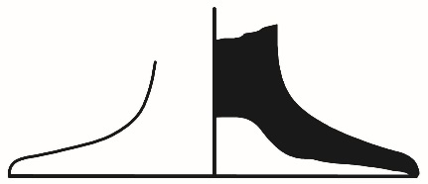

**Theb 119.** Pelopidas St. DEYATH. Trench VI, Pit Z, group 395/1994. From LH IIIA2 layer.

Aeginetan, red slipped and burnished. Open vase (crater?). Rim fragment. Red clay, light brown in core. On both sides red-brown paint.

MH/LH I.

*See, Theb 112.*

NAA result: AegA.

**Theb 120.** Pelopidas St. DEYATH. Trench VI, Pit Z, group 395/1994. From LH IIIA2 layer.

Fine decorated. Closed vase. Shoulder fragment. Running spiral. Greenish clay, fine. Slip. Black / brown-black paint.

LH IIIA2.

*Andrikou 2006, 11, Deposit 3a, 60, cat. no. 12, pl. 1.*

NAA result: MBKR.

**Theb 121.** Pelopidas St. DEYATH. Trench VI, group 305/1994. From LH IIIB2 Late destruction layer.

Fine undecorated. Kylix. Base. Light brown clay 10YR 8/3, fine, one quartz grain (c. 2mm) visible.

Diam. 0.07m

LH IIIB2 Late.

*For excavation context, see Andrikou 2006, 13, Deposit 2b, 55-56.*

NAA result: ThBC.

**Theb 122.** Pelopidas St. DEYATH. Trench VI, group 305/1994. From LH IIIB2 Late destruction layer.

Fine undecorated. Kylix. Base. Light red clay, light brown 10YR 8/3 on surfaces fine.

LH IIIB2 Late.

*See, Theb 121.*

NAA result: UI53.

**Theb 123.** Pelopidas St. DEYATH. Trench VI, group 305/1994. From LH IIIB2 Late destruction layer.

Fine undecorated. Kylix. Stem – wall fragment. Yellowish red clay 7.5YR 7.5/5, weathered.

LH IIIB2 Late.

*See, Theb 121.*

NAA result: single.

**Theb 124.** Pelopidas St. DEYATH. Trench VI, group 305/1994. From LH IIIB2 Late destruction layer.

Roof tile. Cover tile. Small fragment preserving the edge on the long side. Red clay, whitish brown wash 10YR 8/2, dense quartz and lime grains (mainly <1mm), one golden mica grit visible.

LH IIIB2 Late.

*For excavation context, see Andrikou 2006, 13, Deposit 2b, 54-56.*

NAA result: TheB.

**Theb 125.** Pelopidas St. DEYATH. Trench VI, group 305/1994. From LH IIIB2 Late destruction layer.

Roof tile. Cover tile. Small fragment preserving the edge on the long side. Light orange clay, dense grains in various colours (including white), fine or medium sized.

LH IIIB2 Late.

*See, Theb 124.*

NAA result: =321 pair with Tan24 (unpublished).

**Theb 126.** Pelopidas St. DEYATH. Trench VI, group 305/1994. From LH IIIB2 Late destruction layer.

Fine decorated. Closed vase. Rim-neck fragment. Painted rim. Yellow-pink clay, fine (very fine lime grains). Light brown wash 10YR 8/3. Black paint.

Pr. h. 0.045, diam. 0.14m

LH IIIB2 Late.

*Andrikou 2006, 13, Deposit 2b, 74, cat. no. 185, pl. 11.*

NAA result: TheA.

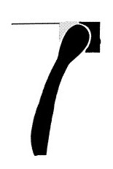

**Theb 127.** Pelopidas St. DEYATH. Trench VI, group 305/1994. From LH IIIB2 Late destruction layer.

Fine decorated. Closed vase. Vertical handle fragment. Decoration: “ladder” pattern. Light orange clay, light brown slip, very fine. Black-brown paint.

LH IIIB2 Late.

*See, Theb 121.*

NAA result: KnoL.

**Theb 128.** Pelopidas St. DEYATH. Trench VI, group 305/1994. From LH IIIB2 Late destruction layer.

Cooking ware. Cooking pot. Rim-wall fragment. Orange-red clay 5YR 6/6, thin (1-2mm) white and dark grains. Wash. Partially burnt.

Pr. h. 0.044, r. diam. 0.14m

LH IIIB2 Late.

*Andrikou 2006, 13, Deposit 2b, 72, cat. no. 162, pl. 10.*

NAA result: single.



**Theb 129.**Pelopidas St. DEYATH. Trench VI, group 305/1994. From LH IIIB2 Late destruction layer.

Cooking ware. Cooking pot FS 66(?). Vertical strap handle fragment.

Light orange clay 5YR 6/6, red-gray spots, white (lime) and dark grains.

LH IIIB2 Late.

*See, Theb 121.*

NAA result: X167.

**Theb 130.** Pelopidas St. DEYATH. Trench VI, group 305/1994. From LH IIIB2 Late destruction layer.

Cooking ware. Cooking pot FS 66(?). Rim fragment with part of the round vertical handle. Orange clay, orange-brown surfaces, small white (lime) and dark medium sized grains, mica.

Diam. 0.13m

LH IIIB2 Late.

*See, Theb 121.*

NAA result: single.

**Theb 131.** Pelopidas St. DEYATH. Trench VI, group 305/1994. From LH IIIB2 Late destruction layer.

Fine, undecorated. Closed vase. Rim - neck fragment. Pink clay, nearly fine (sparse lime grains <2mm), light gray wash 10YR 7/2.

Pr. h. 0.05, diam. 0.14m

LH IIIB2 Late.

*Andrikou 2006, 13, Deposit 2b, 73, cat. no. 169, pl. 10.*

NAA result: TheB.

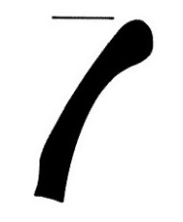

**Theb 132.** Pelopidas St. DEYATH. Trench VI, group 305/1994. From LH IIIB2 Late destruction layer.

Fine undecorated. Ladle FS 236? Wall – strap handle fragment. Red clay 7.5YR 7/4, fine white (lime) grains.

LH IIIB2 Late.

*See, Theb 121.*

NAA result: EuA.

**Theb 133.** Pelopidas St. DEYATH. Trench VI, group 305/1994. From LH IIIB2 Late destruction layer.

Fine decorated. Crater. Wall fragment. Running spiral (FM 46). Orange clay, gray in core, orange-red slip 7.5YR 7/6 polished, fine grains. Wheel marks inside. Brown-black paint. Pr. h. 0.049m

LH IIIB2 Late.

*Andrikou 2006, 13, Deposit 2b, 34, pl. 41.53.*

NAA result: EuA.

**Theb 134.** Pelopidas St. DEYATH. Trench VI, group 305/1994. From LH IIIB2 Late destruction layer.

Fine decorated. Deep bowl FS 284. Rim-wall fragment. Group A decoration, antithetic spirals with elaborate panelled pattern (FM 50). Light gray clay, nearly fine (lime grains <1mm). yellowish white slip 2.5 Y 8/2. Brown-black paint.

Pr. h. 0.06m

LH IIIB2 Late.

*Andrikou 2006, 13, Deposit 2b, 76, pl. 12, 45.60.*

NAA result: TheA.

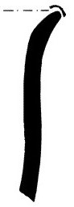

**Theb 135.** Pelopidas St. DEYATH. Trench VI, group 305/1994. From LH IIIB2 Late destruction layer.

Fine decorated. Stirrup-jar FS 174. False neck with one handle and part of the shoulder. On the handle disc, solid painted disc inside a circle. In the handle zone, bivalve shell (FM 11.15). Vivid pink clay, sparse white grains, some sizeable. Wash lighter in colour. Red paint.

Pr. h. 0.041, max. est. diam. 0.085, handle disc diam. 0.028m

LH IIIB2 Late.

*Andrikou 2006, 13, Deposit 2b, 31, 74, cat. no. 187, pls 11, 41.53.*

NAA result: TheA.

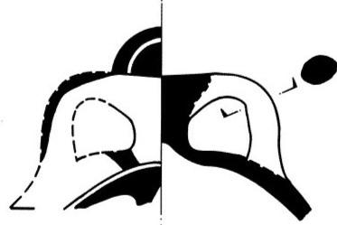

**Theb 136.** Pelopidas St. DEYATH. Trench VI, group 305/1994. From LH IIIB2 Late destruction layer.

Fine decorated. Deep bowl FS 284(?). Flat base. Bands on both sides. Orange red clay 7.5YR 8/5, fine, sparse mica. Red paint.

LH IIIB2 Late.

*See, Theb 121.*

NAA result: single.

**Theb 137.** Pelopidas St. DEYATH. Trench VI, group 305/1994. From LH IIIB2 Late destruction layer.

Fine decorated. Deep bowl FS 284. Wall fragment with part of the handle. Probably Group A decoration. Red clay 5YR 7.5/3, sparse white grains and mica. Red paint.

LH IIIB2 Late.

*See, Theb 121.*

NAA result: TheA.

**Theb 138.** Pelopidas St. DEYATH. Trench VI, group 305/1994. From LH IIIB2 Late destruction layer.

Fine decorated. Deep bowl FS 284. Ring base. Bands on both sides. Light orange clay, sparse fine and medium size grains. Dark red-red paint.

Diam. 0.06m

LH IIIB2 Late.

*See, Theb 121, cf. Theb 031.*

NAA result: TheA.

**Theb 139.** Pelopidas St. DEYATH. Trench VI, group 305/1994. From LH IIIB2 Late destruction layer.

Fine decorated. Deep bowl FS 284. Rim-wall fragment. Group A decoration, spiral (FM 46?). Red clay 7.5YR 7.5/6, inside 7.5YR 7.5/4, sparse fine white grains and mica. Dark brown-red paint.

R. diam. 0.17m

LH IIIB2 Late.

*See, Theb 121.*

NAA result: TheA.

**Theb 140.** Pelopidas St. DEYATH. Trench VI, group 305/1994. From LH IIIB2 Late destruction layer.

Fine decorated. Deep bowl FS 284. Rim-wall fragment. Group A decoration, vertical whorl - shell with solid painted body (FM 23.18). Pink clay with sparse white grains and mica. Slip. Brown-black paint.

Pr. h. 0.052, r. diam. 0.13m

LH IIIB2 Late.

*Andrikou 2006, 13, Deposit 2b, 31-32, 34, 75-76, cat. no. 205, pls 12, 45.60.*

NAA result: TheA.

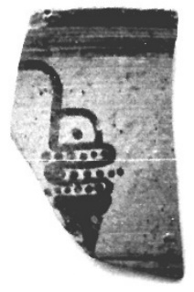

**Theb 141.** Pelopidas St. DEYATH. Trench VI, group 305/1994. From LH IIIB2 Late destruction layer.

Fine decorated. Deep bowl FS 284. Rim-wall fragment. Group A decoration, spiral (FM 46?). Red clay 7.5YR 7/4, sparse fine (<1mm) white grains. Dark brown paint.

Diam. 0.14m

LH IIIB2 Late.

*See, Theb 121.*

NAA result: TheA.

**Theb 142.** Pelopidas St. DEYATH. Trench VI, group 305/1994. From LH IIIB2 Late destruction layer.

Fine decorated. Stemmed bowl FS 305. Rim-wall fragment. Wide horizontal wavy band outside. Light brown clay with sparse white grains. Wash. Brown-black paint.

Pr. h. 0.065m

LH IIIB2 Late.

*Andrikou 2006, 13, Deposit 2b, 34, 35, 78, cat. no. 229, pls 13, 45.60.*

NAA result: TheA.

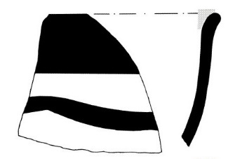

**Theb 143.** Pelopidas St. DEYATH. Trench VI, group 305/1994. From LH IIIB2 Late destruction layer.

Fine decorated. Deep bowl FS 284. Rim-wall fragment. Group A decoration, antithetic spirals with panelled pattern (FM 50). Pink clay, nearly fine, mica. Slip. Red paint.

Pr. h. 0.065, r. diam. 0.14m

LH IIIB2 Late.

*Andrikou 2006, 13, Deposit 2b, 31-32, 34-35, 76, cat. no. 207, pls 12, 43.57a.*

NAA result: TheA.

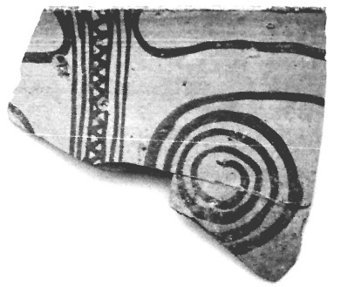 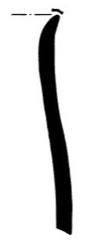

**Theb 144.** Pelopidas St. DEYATH. Trench VI, group 305/1994. From LH IIIB2 Late destruction layer.

Fine decorated. Deep bowl FS 284. Rim-wall fragment. Group A decoration, running spiral (FM 46.55). Pink clay, nearly fine, mica. Wash. Red paint.

Pr. h. 0.075, r. diam. 0.12m

LH IIIB2 Late.

*Andrikou 2006, 13, Deposit 2b, 31-32, 34, 76, cat. no. 206, pls 12, 43.57a.*

NAA result: TheA.

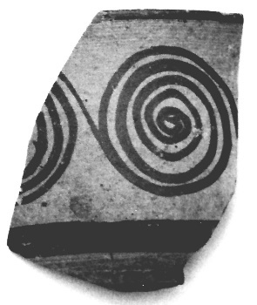

**Theb 145.** Pelopidas St. DEYATH. Trench VI, group 305/1994. From LH IIIB2 Late destruction layer.

Fine decorated. Deep bowl FS 284. Rim-wall fragment. “Rosette bowl”: dotted rim, "sea anemone" outside (FM 27). Brown-yellow clay with thin grains and mica. Slip. Black paint.

Pr. h. 0.067m

LH IIIB2 Late.

*Andrikou 2006, 13, Deposit 2b, 33, 34, 77, cat. no. 222, pls 13, 45.60.*

NAA result: TheA.

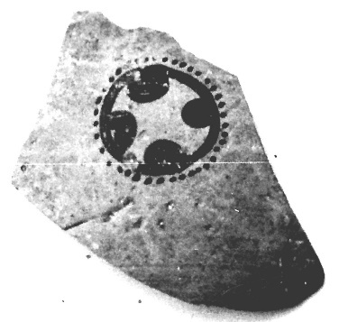 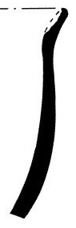

**Theb 146.** Pelopidas St. DEYATH. Trench VI, group 305/1994. From LH IIIB2 Late destruction layer.

Fine decorated. Deep bowl FS 284. Ring base. Bands on both sides. Light yellow clay, fine grains, sparse bigger ones red. Dark brown paint.

Diam. 0.066m

LH IIIB2 Late.

*See, Theb 121, cf. Theb 031.*

NAA result: TheA.

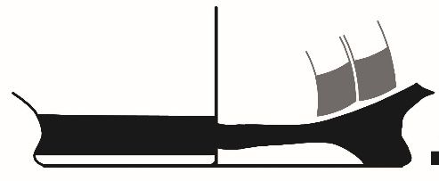

**Theb 147.** Pelopidas St. DEYATH. Trench VI, group 305/1994. From LH IIIB2 Late destruction layer.

Fine decorated. Deep bowl FS 284. Wall fragment. Group A decoration, running spiral FM 46. Red clay 7.5YR 7.5/4, sparse mica. Dark brown to brown paint.

LH IIIB2 Late.

*Andrikou 2006, 13, Deposit 2b, 34, pl. 44.58J.*

NAA result: TheA.



**Theb 148.** Pelopidas St. DEYATH. Trench VI, group 305+310/1994. From LH IIIB2 Late destruction layer.

Fine decorated. Deep bowl FS 284. Wall fragment. Group A decoration: running spiral FM 46. Light yellow clay, fine white grains, sparse bigger ones red. Dark brown paint.

LH IIIB2 Late.

*Andrikou 2006, 13, Deposit 2b, 34, pl. 44.58B.*

NAA result: TheA.

**Theb 149.** Pelopidas St. DEYATH. Trench VI, group 305/1994. From LH IIIB2 Late destruction layer.

Fine decorated. Deep bowl FS 284. Wall fragment. Group A decoration, running spiral FM 46. Light yellow clay, fine grains, sparse bigger ones. Light to dark brown paint.

LH IIIB2 Late.

*Andrikou 2006, 13, Deposit 2b, 34, pl. 44.58C.*

NAA result: TheA.

**Theb 150.** Pelopidas St. DEYATH. Trench VI, group 305/1994. From LH IIIB2 Late destruction layer.

Fine decorated. Deep bowl FS 284. Wall fragment. Group A decoration: isolated semicircles (FM 43) in metope. Light brown 10YR 8/3 clay, slightly porous, one golden mica grain visible. Dark brown to brown paint.

LH IIIB2 Late.

*Andrikou 2006, 13, Deposit 2b, 34, pl. 44.58G.*

NAA result: MYBE.

**Theb 151.** Pelopidas St. DEYATH. Trench VI, group 305/1994. From LH IIIB2 Late destruction layer.

Fine decorated. Deep bowl FS 284. Wall fragment. Group A decoration, spiral. Orange clay 7.5YR 7.5/5, sparse mica (<2mm). Red orange paint.

LH IIIB2 Late.

*Andrikou 2006, 13, Deposit 2b, 34, pl. 44.58F.*

NAA result: TheB.

**Theb 152.** Pelopidas St. DEYATH. Trench VI, group 305/1994. From LH IIIB2 Late destruction layer.

Fine decorated. Open vase(?). Wall fragment. Not recognizable motif. Clay burnt gray, fine grains. Black paint, originally brown. Dark brown paint.

Diam. 0.14m

LH IIIB2 Late.

*See, Theb 121.*

NAA result: single.

REFERENCES

Andrikou, Ε. 1995. **“**Οδός Πελοπίδου 26, οικόπεδο κληρονόμων Νερούτσου-Κρητικού και Α. Παναγιωτίδη, Ο.Τ. 338 – Συμβολή οδών Λ. Μπέλλου και Ι. Θρεψιάδου, oικόπεδο Δημοτικού Συνεδριακού Κέντρου (ΔΣΚ) δήμου Θηβών Ο.Τ. 377**”**, *ArchDelt* 50 (Β’ 1), 281-88, 290-94.

Andrikou, E. 2006. ‘The Late Helladic III Pottery’, in E. Andrikou, V.L. Aravantinos, L. Godart, A. Sacconi and J. Vroom, *Thèbes. Fouilles de la Cadmée II.2. Les Tablettes en Linéaire B de la Odos Pelopidou. Le Contexte Archéologique*. *La céramique de la odos Pelopidou et la chronologie du Linéaire B* (Pisa and Rome) 11 – 177.

Andrikou, Ε. forthcoming. *Μυκηναϊκή ανακτορική και μετανακτορική εγκατάσταση στο ΒΔ άκρο της Καδμείας στη Θήβα. Το οικόπεδο του Δημοτικού Συνεδριακού Κέντρου Θηβών.*

Aravantinos, V.L., Godart, L., Sacconi, A. 2001. *Thèbes. Fouilles de la Cadmée I. Les tablettes en Linéaire B de la odos Pelopidas. Édition et commentaire* (Pisa and Rome).

Aravantinos, V.L, Fappas, I., and Galanakis, Y. 2020. ‘Atop of the Kadmeia: Mycenaean roof tiles from Thebes in context’, *BSA* 115, 175-245, (<https://doi.org/10.1017/S006824542000009X>).

Catling, H.W., [Cherry, J.F.](javascript:open_window(%22http://83.212.248.218:8991/F/DDUGAMEP6S3A4ATTLL17BAFFCKGED47FMIM26CKXDBY275V8CP-01391?func=service&doc_number=000196287&line_number=0013&service_type=TAG%22);), [Jones, R.E.](javascript:open_window(%22http://83.212.248.218:8991/F/DDUGAMEP6S3A4ATTLL17BAFFCKGED47FMIM26CKXDBY275V8CP-01392?func=service&doc_number=000196287&line_number=0014&service_type=TAG%22);) and Killen, J.T.  1980. ‘The Linear B Inscribed Stirrup Jars and West Crete’, *BSA* 75, 49-113, (<https://doi.org/10.1017/S0068245400006328>).

Dakouri-Hild, A. 2001. ‘The House of Kadmos in Mycenaean Thebes reconsidered: architecture, chronology, and context’, *BSA* 96, 81-122, (<https://doi.org/10.1017/S0068245400005232>).

Furumark, A. 1941. *Mycenean Pottery: Analysis and Classification* (Stockholm).

Furumark, A., Aström, P., Hägg, R. and Walberg, G. 1992. *Mycenaean Pottery III. Plates* (Stockholm).

Keramopoullos, A.D. 1910. **“**Μυκηναϊκοί τάφοι εν Αιγίνηι και Θήβαις**”**, *ΑrchΕph*, 177- 252.

Keramopoullos, A.D. 1917. *Θηβαϊκά*, *ArchDelt* 3.

Keramopoullos, A.D. 1921. **“**Ανασκαφή του ανακτόρου του Κάδμου εν Θήβαις**”**, *Prakt* 76, 32-4.

Keramopoullos, A.D. 1930. **“**Αι βιομηχανίαι και το εμπόριον του Κάδμου**”**, *ΑrchΕph*, 29-58.

Mommsen, H., and Maran, J. 2000-2001. ‘Production places of some Mycenaean pictorial vessels. The contribution of chemical pottery analysis’, *OpAth* 25-26, 95-106.

Mountjoy, P.A. 1986. *Mycenaean Decorated Pottery* (Göteborg).

Mountjoy, P.A. 1999. *Regional Mycenaean Decorated Pottery* (Leidorf).

Pliatsika, V. 2000. **“**Μυκηναϊκή κεραμεική εικονιστικού ρυθμού από την Θήβα**”**, in V. Aravantinos (ed.) 2000. *Γ΄ Διεθνές Συνέδριο Βοιωτικών Μελετών*, *Θήβα, 4-8 Σεπτεμβρίου 1996. Επετηρίς της Εταιρείας Βοιωτικών Μελετών,* τόμος Γ΄ (Athens), 286-97.

Pugliese Carratelli, G. 1944. ‘Le iscrizioni preelleniche di Agia Triada in Creta e della Grecia peninsulare’, *MonAnt* 40, 421-610.

Raison, J. 1968. *Les vases à inscriptions peintes de l’âge mycénien et leur contexte archéologique*. Incunabula Graeca 19 (Rome).

Tzavella-Evjen, H. 2014. *Mycenaean Pottery and Figurines. Keramopoullos’ Excavations from the Cemeteries of Thebes* (Athens).

1. * Pottery stored at the Archaeological Museum of Thebes sampled and analysed with Neutron Activation Analyss (NAA).

   Photographs and drawings: Archive of the Ephorate of Antiquities of Boeotia.

   Abbreviations

   MH Middle Helladic l. length

   LH Late Helladic max. maximum

   b. base pr. preserved

   diam. diameter r. rim

   h. height thickn. thickness

   w. width

  