Italy, the EU–9, and the double-sided gap: A longitudinal analysis of mass-elite congruence on European integration (1979–2016)

Supplementary Material

Introduction.
This Supplementary material, accompanying the article “Italy, the EU–9, and the double-sided gap: A longitudinal analysis of mass-elite congruence on European integration (1979–2016)”, contains supplementary information to complement the content presented in the main text. Section 1 (S1) provides a quick summary of the datasets employed for our analysis and detailed information on countries and time points. Section 2 (S2) provides summary statistics concerning mass-elite attitudes on European integration by country, year, and macro-group. Section 3 (S3) provides descriptive robustness checks for partisan sorting through party closeness and prospective vote intention, respectively (for the four datasets which allow for comparison and contrast between the two routes). Section 4 (S4) provides a detailed list of all the parties included in the analysis, showcasing descriptive statistics which concern the overall number of citizens and candidates/parliamentarians in the dataset. Section 5 (S5) shows a table detailing the hypotheses of our article and the ways they are tested through our empirical analyses. Section 6 (S6) shows an MLM regression with the inclusion of random effects at the country level. Section 7 (S7) presents a series of MLM REML regressions, examining the impact of various determinants of support for European integration. Finally, Section 8 (S8) builds on the analysis shown in Model 7 (M7) in the main text by showing predicted support for European integration, among political elites and citizens, across different levels of Euroscepticism (1-7). Essentially, S8 compares Italian political elites and the mass public to their counterparts in other EU-9 countries.

S1. The study’s datasets: a brief overview.
Candidates for the European Parliament, April-May 1979: This data collection provides information on the goals and attitudes toward current political issues of a sample of 742 candidates for seats in the first elections to the European Parliament, held in June 1979. Interviews were conducted during the two months preceding the election in each of the nine nations that were members of the European Communities. The sample includes 62 percent of those who were elected to the European Parliament.
Candidates were asked about their reasons for choosing to become candidates, plus their views on the goals, priorities, and powers of the European Parliament and the European Communities. In addition, the study includes data on each respondent's career history and political affiliation, as well as information on the contacts the candidates had with other parties and the subjective sense of closeness they felt toward them, both in their own nations and across national boundaries within the European Communities.
The study was designed to permit comparison of opinions between the general public and candidates, which is why it includes a large number of questions that were also administered to the general public in EURO-BAROMETER 11: YEAR OF THE CHILD IN EUROPE, APRIL 1979 (ICPSR 7752). Demographic information collected on the elite respondents includes age, occupation (other than any political position already held), religion and frequency of religious observation, number of foreign languages spoken, and self-assigned political position on a left-right scale. Background information on the respondents' parents was also obtained, including foreign languages spoken by parents, political affiliation, and occupation.
Eurobarometer 12 (Oct 1979): The survey gauged the attitudes towards the European Parliament and the European Communities in general, from the viewpoint of the population of the European Communities themselves, shortly after the first election to the European Parliament.
Topics: degree of familiarity of the elections; judgment on the significance of elections; personal election participation and personal behaviour at the polls; expectations of the European Parliament and its members; most important political goals of the country in the next 10 years; attitude to society and satisfaction with the functioning of democracy in the country; general attitude to the European Communities; attitude to own country’s membership of the European Communities; approval of an acceleration of the European unification movement; self-assessment on a left-right continuum; party preference (Sunday question) and party ties; religiousness; personal opinion leadership. Demography: marital status; company size; household income; degree of urbanisation; behaviour at the polls in the last European election.
European Candidate Study 1994: The survey delved into the political views, motivation, political career, and social and political networks of candidates standing for election to the European Parliament.
Topics: motivation behind candidateship; political and administrative career before candidateship; political office of parents or other family members; duration of own party membership; weekly time budget for party activities in average as well as for campaigning; division of time spent for campaigning, public events, party sessions, publicity campaigns and contacting mass media; assessment of nomination procedures regarding candidateship for European parliament; supporting groups and one’s own organisations for European Parliament candidateship, plus general estimation of the influence selected groups and organisations have on candidate election; preference for the division of political resorts into national or European responsibility; attitude regarding efforts to unify Western Europe; priority of economic or political aspects in the EU; attitudes concerning common European currency; assumed attitude of the national government, of members of Parliament, of one’s own party, of the voters of one’s own party; information concerning one’s own position regarding the employment creation programme created by the President of the European Commission, as well as regarding further removal of national border control within the EU; self-classification on a left-right continuum; classification of voters, as well as members of Parliament of one’s own party, on a left-right-continuum; post-materialism (Inglehart Index) attitude towards European unification and judgment of the political and social consequences of the European unification (scale); most important political issue; preferable political level to solve the most significant issues; most important tasks as a member of the European Parliament; decisional preference in the event of a conflict in matters before the European Parliament between personal judgment, the policy of the national party, or the policy of one’s own fraction in the European Parliament; aspired political career; self-assessment of the probability of being elected as a member of the European Parliament; frequency of contact with selected groups, like lobbyists, parties, national ministers, national citizens and bureaucrats, and perceived influence of the lobbyists on members of the European Parliament; amount of correspondence received each week from citizens and others; sense of responsibility concerning voters, citizens, or one’s party; preferred degree of decision-making power of selected groups in the fields of legislation, deciding the household budget, political control of Commission activities and choosing members of the Commission; perceived conflicts between party fractions, parties as well as voters concerning national and European interests; satisfaction with how democracy works within the EU and in one’s own country; confidence in European decisions made in the interest of one’s own country; preferred decision-making by the Council of Ministers; attitude towards the passing of laws which are valid for all EU member countries; emotional closeness to different geographical units, i.e. town of residence, place of birth, country, Europe, or the world.
Demography: age (classified); sex; marital status; sector of employment; employment in public sector; education; denomination; church attendance. Additionally coded: dispatch date; reply date; follow-up telephone call; electoral district; party) list position, electoral success, European political group membership, number of elected candidates, as well as those on record.
European Election Study 1994, Voter Study: The EES Voter Study 1994 consisted of a single wave of interviews conducted immediately after the European elections of June 1994 with freshly drawn samples in all EU member states. The questions were added to a special post-election Eurobarometer (EB 41.1). Variables of three other surrounding Eurobarometer surveys are also documented and included. The first two of these (EB 40 and EB 41) were realised before the European elections in October-November 1993 and April-May 1994. The third (EB 42) was conducted in November-December 1994.
The number of interviews in the different countries was approximately 1,000 in each of the three waves. (For Luxembourg, this number was lower, approximately 500. The sample size in the UK was approximately 1,300, of which about 300 interviews were conducted in Northern Ireland.) The total number of interviews conducted for the four waves amounts to almost 52,000 individuals. The questionnaires were identical in all member states (apart from unavoidable variations due to language and institutional differences). A large number of questions were identical to those used in the 1989, 1999 and 2004 studies, thus permitting over-time comparisons of voter behaviour in the corresponding elections. While the main wave is the post-electoral survey, the other three interviews partially overlap in content. Some of the questions have been included in two, a few in three or all four of the interviews, thus offering opportunities for longitudinal comparison of voting behaviour and voter orientations. The four waves of interviews constitute a repeated cross-section study; that is, they have been conducted on independently drawn random samples of the population of EU member states.
The selection of topics and questions encompasses: electoral behaviour including questions on party choices, past voting behaviour, voting behaviour at the national level, party preferences, and propensity to support particular parties; general political attitudes and behaviour, based on a question of interest in politics, campaign, most important problems, attitudes regarding EU, left-right self-placement, placement of parties; background characteristics including gender, age, education, religion, media consumption.
European Members of Parliament Study 1996: Topics: Most important future problems of the EU; attitudes towards legislation by the European Parliament that applies to all member states; attitudes towards an increased transfer of responsibilities to the EU; attitudes towards the admission of new member states into the EU; preferred countries and admission times; preference for deepening vs. expanding the EU; preference for the division of political portfolios into national or European responsibilities; assessment of the EU in various political areas; political or economic interests as a driver of progress for European integration; alignment of EU decision with the interests of one's own country; assessment of national parliamentary control of the national government’s agency in the Council of Ministers; assumed position of the voters, one's own party and one's own position regarding the new European currency, the job creation programme of the European Commission, and border controls; assessment of positions on a left-right continuum; most important political issues and preferred political level (regional, national, European) for dealing with these issues; attitude towards Europe and characterisation of European identity (scale); satisfaction with democracy at national and European level; the European Parliament or national Parliaments as sources of democratic legitimation of the EU; assessment of proposals to eliminate the EU ‘democratic deficit’ in the EU (scale); actual and desired influence of European and national institutions on decision-making in the EU; attitude towards the unification of Western Europe; importance of selected aspects of the work of a member of parliament; role orientation of a member of parliament; assessment of one's own influence on politics; frequency of contact with citizens, organised groups, and institutions; consideration of interest groups in one's own political decisions; post-materialism (Inglehart index); frequency of contact with national and European interest groups; sources of information for parliamentary work; attitude towards selected social and political issues (scale).
Demographics: year of birth; gender; marital status; school education; denomination; church attendance; political experience in the form of membership in other Parliaments; previous positions and employment before starting parliamentary work; previous employment in the public sector or self-employment; span of control in the activity at the time; goal of one's political career. Also coded are the country, region, date of sending, and date of return of the questionnaire.
Eurobarometer 44.2bis (Jan-Mar 1996): The mass survey explored ideas about the further development of the EU: attitudes, knowledge, expectations and preferences.
Topics: Nationality; general satisfaction with life; preferred national and regional daily newspaper, TV station and radio station; regularity of use of selected sources of information; interest in politics; personal opinion leadership; intensity of use of news on TV, radio and daily newspapers; self-assessment of extent of own knowledge of the policies and institutions of the EU; attention regarding European topics in the last three months, e.g. common European market, Treaty of Maastricht, two-speed Europe, discussion about new member countries, summit meeting in Madrid, and European currency union; description of expected development of the EU in paired comparisons; approval of unification of Europe; approval of the country’s membership of the EU; benefit of the country’s EU membership; assessment of the current speed of unification and desired speed of unification of Europe; perceived obstacles for unification of Europe; attitude to an expansion of the EU; European citizenship or national consciousness; personal decision o a hypothetical referendum for/against EU membership; attitude to the slogan ´let us shape a common Europe´; most important steps for further development of a common Europe; preferred countries for admission into the EU; selected political areas in which the EU should be more active; feared negative developments in the EU and assessment of their probability of occurrence; assessment of the influence of people’s opinion on decisions of the national government, as well as decisions of EU institutions; preference for national or European decision-making authority in selected political areas; national politicians, associations, organisations, parties, institutions and media that stand for believable information about the EU; most important rights of a European citizen; hope in the common European market; judgment on selected recommendations for the development of European policies; attitude to treating the newly arriving Eastern European countries equally with the less developed regions in Europe; knowledge test about the correct number of member countries, European personalities, the name of the common currency, currency questions, flag and presidency; acceptance of the name EURO for the new currency; knowledge about the primary domain of expenditure in the European budget; interest in increased information about the EU; interest in new sources of information about the EU, e.g. telephone queries, special fax queries and opportunities of computer queries, as well as special information offices about the EU; availability of information technology such as video recorder, fax device, satellite reception, decoder for Pay-Tv, teletext, computer, CD-ROM, modem and Internet; trust in the European Commission, the national government, the European Parliament, the national Parliament, and the Council of Ministers; attitude towards a federal structure for the EU; assumed attitude of selected occupational groups, associations and organizations to European unification, and designation of those gaining the greatest advantages from unification; countries profiting the most from the EU; self-classification on a left-right continuum; party preference (closeness and Sunday question); rural or urban residential area; possession of a telephone and reasons for not having a telephone. The following question was also posed to farmers and those helping in agricultural companies: primary harvest month.
Additionally encoded were the date of the interview, time at the start of the interview, length of the interview, number of persons present during the interview, and willingness of the respondents to cooperate.
MEP Survey 2000: Topics: Member state of election; National political party; Party group in the European Parliament; Represented region, locality, or city; Date of becoming an MEP; Membership in national Parliament; Membership in national party's executive organ; Positions as President, Vice-President, or Quaestor of the EP; Membership in the Bureau of EP party group; Chairperson or Vice-Chairperson of EP Committees; Age at the beginning of July 1999; Gender; Social class background (occupation of father); Age at stopping full-time education; Held or current positions (e.g., member of national Parliament, official in EU institutions, local elected office, etc.); Desired position 10 years from now; Placement on the Left-Right spectrum; Agreement with statements on various social and economic issues (e.g., income inequality, criminal justice, government role in economy, abortion rights, welfare spending, marijuana decriminalization, inflation vs. unemployment); Placement on European integration spectrum; Perception of benefits from EU membership for one's country; Identification with Europe, member state, or region (first, second, third preference); Preference for more or less EU-wide regulation in areas like health and safety, labour rights, consumer protection, environmental standards, food safety, taxation, and media standards; Preference for more or less EU budget spending in areas like agricultural support, economic and social cohesion, scientific R&D, development aid, unemployment assistance, and refugee support; Agreement with statements on EMU and EU monetary policies (e.g., ECB interest rates, inflation targets, EP's power in EMU, public availability of ECB minutes, government deficits); Agreement with statements on EU trade policies (e.g., global free trade, WTO rules, global labor standards, global environmental standards, EU-USA trade barriers); Agreement with statements on EU Justice and Home Affairs policies (e.g., asylum rules, EU citizenship rules, cross-border police arrest warrants, mutual recognition of court rulings, QMV in JHA issues, co-decision in JHA policies); Agreement with statements on EU foreign and defence policies (e.g., power of ‘Mr. CFSP’, Commission's power in foreign policy, QMV for joint actions, EP's power in foreign policy decisions, EU's own military units, EU vs. NATO for Europe's defence); Agreement with statements on EU reform (e.g., central role of member states, Commission as EU government, QMV in legislative decisions, voting weights for larger states, Commissioner allocation, ECJ powers, EP's legislative powers, Commission President nomination, Commissioner approval, EP's plenary sessions location); Importance of different aspects of MEP work (e.g., legislation, oversight, articulation of societal needs, EU policy strategies, mediation, representation of individual interests); Importance of representing various groups in the European Parliament (e.g., people in Europe, member state, party voters, constituency, national party, EP party group, specific societal groups); Time spent on political work in home country vs. European Parliament; Frequency of requests from constituents and interest groups in a typical week; Forms of contact with individual voters; Frequency of contact with various groups, people, or institutions (e.g., citizens, organised groups, lobbyists, journalists, EP party group leaders, MEPs from other parties, Commission officials, European Commissioners, Council Secretariat officials, COREPER members, Council ministers, ESC members, ECJ officials, COR members, national party executive, national MPs, national government ministers, national civil servants); Frequency of contact with national and European interest groups (e.g., consumer associations, environmental organisations, trade unions, professional associations, agriculture/fisheries organisations, industry organisations, transport associations, trade and commerce associations, banking and insurance associations, human rights organisations); Frequency of receiving voting recommendations from various parties or groups (e.g., national party leadership, EP party group leadership, national party delegation of MEPs, EP committee leadership, European Commission, national government, European interest groups, national interest groups, private citizens); Frequency of alignment with the majority in various Party Groups (e.g., PPE/DE, PSE, ELDR, Greens/EFA, GUE/NGL, UEN, TDI, EDD); Basis for decision-making in the European Parliament (e.g., own judgment, views of party voters, national party leadership, EP party group); Preferred positions to achieve in the European Parliament (e.g., President of EP party group, leader of national party delegation, President of European Parliament, Chairperson of EP committee); Importance of reasons for choosing EP Committee membership after the 1999 European elections (e.g., personal interest, importance to constituents, professional expertise, topic importance, request by EP party group, request by national party, prior Committee membership).
Demographics: Year of birth; Gender; Marital status; Education; Denomination; Church attendance; Political experience (e.g., membership in other Parliaments, previous positions); Employment before parliamentary work; Public sector or self-employment history; Span of control in current activity; Political career goals; Country; Region; Date of questionnaire sending and return.
Eurobarometer 53 (April-May 2000): This round of the Eurobarometer queried respondents on standard Eurobarometer measures, such as satisfaction with their life, discussion of political matters, and need for societal change. Additional questions focused on the respondents' knowledge of and opinions on the EU, including how well-informed they felt about the EU, what sources of information about the EU they used, whether their country had benefited from being an EU member, and the extent of their personal interest in EU matters. Respondents were asked how their present situation compared with five years ago; whether they thought it would improve over the next five years; and if in the last five years they themselves, a family member, or a close friend had been unemployed or if the company they worked for had ‘made people redundant’, i.e., laid people off.
Respondents were also asked about how much news they currently watched on TV, read about in newspapers, or listened to on the radio; how fair they felt the media coverage of the EU was; whether their image of the EU was positive or negative; and which groups or types of people (e.g., children, the elderly, politicians, teachers, lawyers, factory workers, farmers, etc.) had more and which had less advantages from their country's EU membership. Other questions focused on how satisfied respondents were with the way democracy worked in their country and in the EU; how important various European institutions were in the life of the EU, and whether they trusted them; the amount of pride they had in their nationality; and if they were for or against EU features such as a single currency, an independent European Central Bank, a common foreign policy, a common defence and security policy, and an EU that is responsible beyond national, regional, and local governments. Opinions were sought on possible EU social and political actions, on which non-member countries should become members, on the role of the European Parliament, and whether the EU should have a constitution.
Other topics included racism, general services, food labelling, and information and communication technologies. Several questions about people of different nationalities, religions, or cultures queried respondents as to whether they found these people disturbing, whether they themselves felt they were part of the majority or minority in their country, and if they had a parent or grandparent of a different nationality, race, religion, or culture. Respondents were asked to agree or disagree with a number of statements about issues involving minority groups and education, housing, social benefits, international sport, cultural life, religious practices, employment, and the economy. Additionally, respondents' opinions were sought on the size of minority populations in their country, how relations with minorities could be improved, whether restrictions should be placed on minority workers from outside the EU, and the proper place in society for these minorities. A few questions addressed cultural and religious differences that immigrants (i.e., people who were not citizens of an EU member state) brought to the EU and how the EU should handle various situations involving this group of people.
Questions regarding services of general interest, specifically mobile and fixed telephone services, electric, gas, and water supply services, postal services, transport services within towns/cities, and rail services between towns/cities, probed for respondent opinion on ease of access, price and contract fairness, quality of service, and clearness of service-provided information. Another section of the surveys queried respondents on how often they read food labels, if they thought there was too much or too little information on food labels, if they trusted and understood food labels, whether potential harm or benefit information should appear on the labels, who should be responsible for the information, and if food labels affected their inclination to purchase food products. Several questions gauged respondent sentiment on genetically modified organisms in food.
Questions about technology asked if respondents currently had a satellite dish, cable TV, a digital TV, a DVD player, a game console, a computer, a computer with a CD-ROM, an Internet connection, a fax without a computer, a mobile phone, or an ISDN line. They were asked which of these they used personally, which they were interested in but didn't use, which they planned to buy in the next six months, and the reasons why for those without an ISDN line. Those using the Internet were given a list of Internet activities and asked to identify which they had engaged in in the last three months and if they had reduced time spent on non-Internet activities such as watching TV, reading, listening to the radio, interacting with family and friends, or playing sports. Internet users were asked additional related questions.
Standard demographic information collected on respondents included: left-right political self-placement, party they would vote for if an election were held tomorrow, marital status, age at completion of education, current age, sex, number of people in household, number of children in household, current occupation, previous occupation, household income, size of locality, region of residence, availability of telephone in household, and language of interview.
IntUne Elite Survey Wave 1, January–July 2007: IntUne was an integrated project on European citizenship, funded by the EU within the scope of the Sixth Framework Programme. Coordinated by the University of Siena, it involved 29 European institutions and over 100 scholars across Eastern and Western Europe. The first wave of the elite survey, carried out as part of the IntUne project in 16 EU member states and two non-EU countries, targeted political elites and business leaders' attitudes towards developing European identity and citizenship in the context of EU change and enlargement.
An extensive array of questions was posed to respondents. First, whether they had lived in other European countries; spoken languages; frequency of contacts with EU characters and institutions, and with characters and institutions from other countries (not from EU or international organisations) in their political activity (political elite) and professional activity (economic elite), in the last year. Furthermore, they were asked how much they related themselves to their city or village, their region, their country, or Europe. Respondents also evaluated the importance of different things when being a countryman/countrywoman.
What threatened EU integrity also constituted a question. Respondents were asked if the purpose of the EU should be to increase Europe’s economic competitiveness in the world market or to ensure better social security for all EU citizens. Self-placement on the left-right scale was also asked. Political elites were asked about their first thoughts about whom they represent. Further, all respondents were asked if the unification of Europe should be reinforced or if it has already gone too far.
Afterwards, respondents were asked whether member states should remain the main EU actors or the European Commission should become an authentic EU government, and whether the powers of the European Parliament should be reinforced. Whether there should be a joint European army or every country should have their own national army also formed a question. Respondents indicated their trust in the European Parliament, the European Commission and the Council of Ministers’ respective ability to make right decisions. Economic elites were asked how much they trusted the national Parliament, the national government and the regional authority's respective ability to make right decisions. Further questions were asked whether people who adopt decisions at the EU level do not consider member states’ interests enough and whether some member states’ interests have a larger weight at the EU level. Different ways in which national MPs and national economic elites of state can affect EU political decisions were assessed.
Furthermore, items dealt with the amount of budget resources (collected through taxes) that should be allocated to regional, national, and EU levels. After a list of political fields was presented, respondents were asked whether each field should entail the highest degree of decisions at the regional, the national or the EU level. Respondents also evaluated the importance of different things when being European. When thinking about the EU 10 years from now, respondents were asked to evaluate statements such as a common tax system in Europe, a common social security system, a common foreign policy towards countries outside the EU, and greater help for EU regions facing economic and social difficulties.
Respondents were also requested to evaluate the respective influence of different actors with regard to important issues: ordinary citizens; members of national Parliament, with or without experience in government or important committee of parliament; leaders of biggest state companies, banks or business organisations; and people with a similar position as the respondent. Interviewees were asked whether they were planning to pursue a political career (political elite) or a professional career (economic elite) at the European level.
Respondents were asked whether they had any close relatives or friends living in, or coming from, other European countries. They were also asked how often they used media sources other than their own country's ones to get information. Respondents were asked if, in the last year, they had had contacts with interest groups of Europe, social movements of Europe (not from their own country), non-governmental organisations, and parties of other EU member states. Lastly, respondents were requested to state if their country had or had not benefited from being a member of the EU.
IntUne Mass Survey Wave 1, 2007: In 2007, the first wave of the IntUne mass survey was conducted in 16 EU member states and two non-EU countries. EU member states included Austria, Belgium, Bulgaria, Denmark, Estonia, France, Germany, Greece, Hungary, Italy, Poland, Portugal, Slovakia Republic, Slovenia, Spain, and the United Kingdom; non-EU countries included Serbia and Turkey. IntUne aimed to study changes in the scope, nature, and characteristics of citizenship that result from the process of deepening and enlarging the European Union. More specifically, IntUne focused on how integration and disintegration processes, at both the national and European levels, affected three major dimensions of citizenship: identity, representation, and scope of governance.
Mass respondents were polled on their level of interest and involvement in politics, their assessment of the general economic situation in their country, and whether they were satisfied with the democratic processes in their country. Survey participants were also asked to rate their degree of trust in government at the regional, national and EU level. A large number of survey items concerned citizens’ relationship with European integration and the EU level. Opinions were gathered concerning the advantages of EU membership, whether citizens currently living in the EU would benefit from the accession of Serbia and Turkey, and whether Serbia and Turkey would benefit from becoming European Union Member States. Demographic information included age, sex, country of birth, education level, employment status, marital status, socioeconomic status, religious affiliation and political party affiliation.
European Parliament Election Study 2009, Elite Study: This study is a module of the EES 2009. The Elite Behaviour Team of the PIREDEU project was responsible for designing the Candidate Survey Study. The topics of the survey included attitudes towards political issues, value orientations, political background, the experience of candidates for the European Parliament, political career, engagement and mobilisation, usage of campaign instruments, importance of media for election, domestic and European issues, representation and attitudes towards European identity.
The scientific objectives entailed achieving sample surveys among all candidates for the European elections of 2009 in all 27 EU member states and ensuring that the data could be linked to the other PIREDEU/EES2009 data, notably at the mass level. The survey built on the general framework of the so-called ‘responsible party model’, in which parties play a central role in the recruitment, supply and electoral behaviour of candidates, but within which voters also have their input in mandating parties and related candidates. The model implies both an electoral and a representative linkage.
European Parliament Election Study 2009, Voter Study: The EES 2009 Voter Study is a sample survey of the electorates of the EU-27. The group responsible for the Design of the Voter Survey set out to perform a survey among representative samples of enfranchised citizens in all 27 EU member states immediately after the European elections of June 2009, ensuring that the data could be linked to the other PIREDEU/EES2009 data. The sample size was roughly 1,000 interviews in each EU member state. Data collection was done through a CATI phone interview. In nine countries (Bulgaria, Czech Republic, Estonia, Hungary, Latvia, Lithuania, Poland, Romania, and Slovakia), representative phone sampling was not feasible. In these countries, 70 percent of interviews were conducted face-to-face, while the remaining 30 percent were conducted by phone. The total sample size is approximately 27,000. The questionnaires for the study were identical in the various member states, apart from minor but unavoidable differences generated by differences in party names and country-specific institutions. A large number of questions were identical to those used in the 1989, 1994, 1999 and 2004 studies, thus permitting over-time comparisons of voter behaviour.
The final selection of topics and questions comprised: electoral behaviour, including questions on party choices, past voting behaviour, voting behaviour at the national level, party preferences, and propensity to support particular parties; general political attitudes and behaviour, rooted in questions on interest in politics, campaign, most important problems, attitudes regarding EU, left-right self-placement, placement of parties; background characteristics, including gender, age, education, religion, media consumption.
European National Elites and the Eurozone Crisis (ENEC-2014): European National Elites and the Crisis (ENEC) is an international study conducted in several European countries in 2014. The study examined the attitudes of members of national parliaments (MPs) in ten EU member states, and it partly served as a replication of the IntUne project. Exploring and tracing the views of national elites, their variety, stability and change, it offered a crucial perspective for understanding the legitimacy of the integration process and the politics of the EU in an age of greater politicisation of these issues. In this respect, the project aimed to shed greater light on the present and the future of the EU by examining the attitudes of national political elites during a critical juncture.
A survey of members of national Parliaments was carried out in each participating country. More specifically, 472 face-to-face and 189 phone interviews were carried out using a structured questionnaire. The questions were related to the workings of the EU and its future. The participant countries were Bulgaria, Croatia, Germany, Greece, Hungary, Italy, Lithuania, Portugal, Slovenia and Spain. The basic questions were aimed at identifying and mapping the views and attitudes of political elites towards the EU, as well as the factors explaining the configuration of those attitudes; their evaluation on the role played by EU institutions in the management of the crisis; and their perception on the future of European integration. Other questions dealt with how the crisis had affected the mediating role of elites between EU and their fellow citizens and whether elites were influenced by a ‘constraining dissensus’ towards the EU, leading to a conflictual politicisation of EU issues in national arenas.
EUENGAGE Dataset 2016-2018: The EUENGAGE Dataset collects data from the EUENGAGE Project, which ran from 2015 to 2018. For more information on the EUENGAGE Project, the dedicated website can be accessed at www.euengage.eu. It includes data from several strands. The EUENGAGE Mass and Businesspeople panel surveys were conducted in 2016 and 2017 in ten EU member states: Czech Republic, France, Germany, Greece, Italy, Netherlands, Poland, Portugal, Spain, and the UK. The EUENGAGE elite surveys were conducted in the same ten member states, again in two waves, in 2016 and 2017. The Pre- and Post-Deliberation surveys were conducted in October 2016, respectively before and after the online deliberation named “E-Voice”. The EUENGAGE Datasets also include Chapel Hill Expert Survey (CHES) data for party positioning, with special reference to the CHES FLASH Survey of 2017. Values for each variable of CHES 2014 and CHES 2017 datasets have been matched to relevant variables contained in the EUENGAGE mass, businesspeople and elite surveys, such as survey respondents’ voting intentions, party identification (mass and B2B), or party of election (politicians).

Table A1. Datasets used in the present study (1979 – 2016)

Year | Elite survey | Countries | Elite N | Mass survey | Countries | Mass N
1979 | Candidates for the European Parliament, April-May 1979 | Belgium, Denmark, Germany, France, Ireland, Italy, Luxembourg, Netherlands, United Kingdom | 742 | Eurobarometer 12 | Belgium, Denmark, Germany, France, Ireland, Italy, Luxembourg, Netherlands, United Kingdom | 8884
1994 | European Candidates Study 1994 | Belgium, Denmark, Germany, France, Ireland, Italy, Luxembourg, Netherlands, United Kingdom, Spain, Portugal, Sweden | 1770 | European Election Study 1994, Voter  Study | Belgium, Denmark, Germany, France, Ireland, Italy, Luxembourg, Netherlands, United Kingdom, Spain, Portugal, Greece | 52634
1996 | Members of the European Parliament Study 1996 | Austria, Belgium, Denmark, Finland, France, Germany, Greece, Ireland, Italy, Luxembourg, Netherlands, Portugal, United Kingdom, Sweden, Spain | 314 | Eurobarometer 44.2BIS Mega-  Survey | Austria, Belgium, Denmark, Finland, France, Germany, Greece, Ireland, Italy, Luxembourg, Netherlands, Norway, Portugal, Spain, Sweden, United Kingdom | 65168
2000 | EPRG MEP Survey Dataset: Combined Data 2016 Release (2000  Wave) | Austria, Belgium, Denmark, Finland, Germany, France, Ireland, Italy, Luxembourg, Netherlands, United Kingdom, Sweden, Spain, Portugal, Greece | 626 | Eurobarometer 53 | Austria, Belgium, Denmark, Finland, Germany, France, Ireland, Italy, Luxembourg, Netherlands, United Kingdom, Sweden, Spain, Portugal, Greece | 16078
2007 | INTUNE Elites (Wave 1) | Austria, Belgium, Bulgaria, Czechia, Denmark, Estonia, Germany, France, Hungary, Italy, Lithuania, Poland, United Kingdom, Serbia, Slovakia, Spain, Portugal, Greece | 2141 | INTUNE  Public Opinion (Wave 1) | Austria, Belgium, Bulgaria, Czechia, Denmark, Estonia, Germany, France, Hungary, Italy, Lithuania, Poland, United Kingdom, Serbia, Slovakia, Spain, Portugal, Greece | 16033
2009 | European Parliament Election Study 2009, Candidate Study | Austria, Belgium, Bulgaria, Cyprus, Czechia, Denmark, Estonia, Finland, France, Germany, Greece, Hungary, Ireland, Italy, Lithuania, Latvia, Luxembourg, Malta, Netherlands, Poland, Portugal, Romania, Slovakia, Slovenia, Spain, Romania, United Kingdom | 1222 | European Parliament Election Study 2009, Voter Study | Austria, Belgium, Bulgaria, Cyprus, Czechia, Denmark, Estonia, Finland, France, Germany, Greece, Hungary, Ireland, Italy, Lithuania, Latvia, Luxembourg, Malta, Netherlands, Poland, Portugal, Romania, Slovakia, Slovenia, Spain, Romania, United Kingdom | 27069
2014 | ENEC | Bulgaria, Germany, Greece, Spain, Italy, Hungary, Lithuania, Portugal, Slovenia | 3271 | ENEC | Bulgaria, Germany, Greece, Spain, Italy, Hungary, Lithuania, Portugal, Slovenia | 32749
2016 | EUENGAGE Elites (Wave 1) | Czechia, France, Germany, Greece, Italy, Netherlands, Poland, Portugal, Spain, United Kingdom | 373 | EUENGAGE  Public Opinion (Wave 1) | Czechia, France, Germany, Greece, Italy, Netherlands, Poland, Portugal, Spain, United Kingdom | 11975

S2. Summary statistics
The following tables (Table A2–A7) contain information on the mean positions of the political elites and the citizens by country and year. The first two tables (Tables A2–A3) refer to the country level, the next two (Tables A4–A5) refer to the pro-European macro-group, and the last two (Tables A6–A7) refer to the Eurosceptic macro-group.
Elite
 | 1979 | 1994 | 1996 | 2000 | 2007 | 2009 | 2014 | 2016 | Mean
Belgium | 9.80 | 8.72 | 8.33 |  | 7.27 | 7.98 |  |  | 8.42
Denmark | 8.15 | 5.65 |  |  |  | 6.76 |  |  | 6.86
France | 9.77 | 9.29 | 7.97 | 6.71 | 7.41 | 7.60 | 7.68 | 6.27 | 7.84
Germany | 7.81 | 7.95 | 6.91 | 7.99 | 6.72 | 7.68 | 6.84 | 6.83 | 7.34
Ireland | 8.75 | 7.33 | 5.83 |  |  | 5.17 |  |  | 6.77
Italy | 8.85 | 9.29 | 8.68 | 7.22 | 8.05 | 6.00 | 7.57 | 7.62 | 7.91
Netherlands | 8.45 | 6.78 | 7.11 | 6.15 |  | 6.40 |  | 3.88 | 6.46
UK | 6.86 | 7.49 | 5.51 | 4.41 | 4.93 | 3.57 |  | 3.57 | 5.19
Average | 8.56 | 7.81 | 7.19 | 6.50 | 6.88 | 6.39 | 7.36 | 5.63 | 7.04
Table A2. Average elite attitudes towards European integration by country (1979–2016)

Public
 | 1979 | 1994 | 1996 | 2000 | 2007 | 2009 | 2014 | 2016 | Mean
Belgium | 7.78 | 6.66 | 6.16 |  | 6.76 | 5.24 |  |  | 6.52
Denmark | 5.43 | 5.76 |  |  |  | 5.61 |  |  | 5.60
France | 7.85 | 6.96 | 6.36 | 6.00 | 7.04 | 5.28 | 6.16 | 4.56 | 6.28
Germany | 7.27 | 6.80 | 6.44 | 6.41 | 6.54 | 5.14 | 5.86 | 5.77 | 6.28
Ireland | 7.09 | 7.48 | 7.64 |  |  | 5.42 |  |  | 6.91
Italy | 8.10 | 7.69 | 7.46 | 7.99 | 7.77 | 5.70 | 5.94 | 6.80 | 7.18
Netherlands | 7.75 | 6.66 | 6.66 | 6.15 |  | 5.94 |  | 4.90 | 6.34
UK | 6.48 | 5.96 | 5.47 | 5.51 | 5.61 | 3.78 |  | 3.83 | 5.23
Average | 7.22 | 6.74 | 6.60 | 6.41 | 6.74 | 5.26 | 5.99 | 5.17 | 6.27
Table A3. Average public attitudes towards European integration by country (1979–2016)

Pro-European elite
 | 1979 | 1994 | 1996 | 2000 | 2007 | 2009 | 2014 | 2016 | Mean
Belgium | 9.80 | 9.07 | 8.33 |  | 7.85 | 8.19 |  |  | 8.65
Denmark | 8.15 | 7.58 |  |  |  | 6.76 |  |  | 7.50
France | 9.77 | 9.60 | 7.97 | 6.71 | 7.45 | 7.59 | 7.73 | 6.51 | 7.92
Germany | 8.74 | 8.71 | 7.25 | 7.99 | 6.72 | 7.68 | 7.10 | 6.70 | 7.61
Ireland | 8.75 | 10.00 | 5.83 |  |  | 5.17 |  |  | 7.44
Italy | 8.74 | 9.54 | 8.79 | 7.22 | 7.98 | 6.00 | 8.86 | 8.93 | 8.26
Netherlands | 8.45 | 8.77 | 7.94 | 6.92 |  | 7.44 |  | 4.50 | 7.34
UK | 6.14 | 9.07 | 6.43 | 6.43 | 5.75 | 6.58 |  | 5.56 | 6.56
Average | 8.57 | 9.04 | 7.51 | 7.05 | 7.15 | 6.93 | 7.89 | 6.44 | 7.57
Table A4. Average pro-European elite attitudes towards European integration by country (1979–2016)

Pro-European public
 | 1979 | 1994 | 1996 | 2000 | 2007 | 2009 | 2014 | 2016 | Mean
Belgium | 7.78 | 6.72 | 6.16 |  | 6.95 | 5.31 |  |  | 6.58
Denmark | 5.57 | 6.26 |  |  |  | 5.61 |  |  | 5.81
France | 7.85 | 7.10 | 6.36 | 6.00 | 7.05 | 5.32 | 6.23 | 5.47 | 6.42
Germany | 7.54 | 6.99 | 6.61 | 6.41 | 6.54 | 5.14 | 5.87 | 5.80 | 6.36
Ireland | 7.09 | 7.47 | 7.64 |  |  | 5.45 |  |  | 6.91
Italy | 8.09 | 7.73 | 7.61 | 7.99 | 7.67 | 5.70 | 6.37 | 7.93 | 7.39
Netherlands | 7.75 | 6.79 | 6.80 | 6.23 |  | 6.12 |  | 5.49 | 6.53
UK | 6.04 | 6.15 | 5.67 | 5.72 | 6.13 | 4.92 |  | 5.01 | 5.66
Average | 7.21 | 6.90 | 6.69 | 6.47 | 6.87 | 5.45 | 6.16 | 5.94 | 6.46
Table A5. Average pro-European public attitudes towards European integration by country (1979–2016)

Eurosceptic elite
 | 1979 | 1994 | 1996 | 2000 | 2007 | 2009 | 2014 | 2016 | Mean
Belgium |  | 5.67 |  |  | 3.30 | 3.00 |  |  | 3.99
Denmark | 8.15 | 1.67 |  |  |  |  |  |  | 4.91
France |  | 2.67 |  |  | 6.67 | 7.80 | 7.46 | 2.00 | 5.32
Germany | 4.00 | 2.42 | 5.00 |  |  |  | 1.50 | 8.33 | 4.25
Ireland |  | 5.56 |  |  |  | 5.17 |  |  | 5.36
Italy | 10.00 | 8.00 | 8.00 |  | 8.50 |  | 5.43 | 5.47 | 7.57
Netherlands |  | 1.92 | 0.00 | 1.11 |  | 3.25 |  | 2.00 | 1.66
UK | 8.17 | 4.79 | 4.07 | 2.75 | 2.00 | 0.49 |  | 1.47 | 3.39
Average | 7.58 | 4.09 | 4.27 | 1.93 | 5.12 | 3.94 | 4.80 | 3.85 | 4.45
Table A6. Average Eurosceptic elite attitudes towards European integration by country (1979–2016)

Eurosceptic public
 | 1979 | 1994 | 1996 | 2000 | 2007 | 2009 | 2014 | 2016 | Mean
Belgium |  | 5.77 |  |  | 3.79 | 3.88 |  |  | 4.48
Denmark | 4.92 | 3.30 |  |  |  |  |  |  | 4.11
France |  | 2.96 |  |  | 6.87 | 4.84 | 5.71 | 2.51 | 4.58
Germany | 6.30 | 4.22 | 4.54 |  |  |  | 5.80 | 5.60 | 5.29
Ireland |  | 7.54 |  |  |  | 4.94 |  |  | 6.24
Italy | 8.25 | 7.52 | 7.18 |  | 8.27 |  | 5.53 | 6.43 | 7.20
Netherlands |  | 4.66 | 4.57 | 4.44 |  | 4.93 |  | 3.86 | 4.49
UK | 6.88 | 5.54 | 5.02 | 4.89 | 4.38 | 2.94 |  | 2.85 | 4.64
Average | 6.59 | 5.19 | 5.33 | 4.67 | 5.83 | 4.31 | 5.68 | 4.25 | 5.23
Table A7. Average Eurosceptic public attitudes towards European integration by country (1979–2016)

S3. Robustness checks
Tables A8–A9 contain robustness checks on average mass positions, calculated through prospective vote intention and party closeness, respectively. The table entries are averaged by country. Table A10 reports the differences-in-means between entries obtained according to the two approaches.
Table A8. Robustness checks at the mass level (vote intention)
Public (vote intention)
 | 1994 | 1996 | 2009 | 2016
Belgium | 6.66 | 6.16 | 5.24
Denmark | 5.76 |  | 5.61
France | 6.96 | 6.36 | 5.14 | 4.56
Germany | 6.80 | 6.44 | 5.28 | 5.77
Ireland | 7.48 | 7.64 | 5.42
Italy | 7.69 | 7.46 | 5.70 | 6.80
Netherlands | 6.66 | 6.66 | 5.94 | 4.90
UK | 5.96 | 5.47 | 3.78 | 3.83
Total | 6.74 | 6.60 | 5.26 | 5.17

Table A9. Robustness checks at the mass level (vote intention)
Public (Party Closeness)
 | 1994 | 1996 | 2009 | 2016
Belgium | 6.72 | 6.23 | 5.29
Denmark | 6.01 |  | 5.27
France | 6.85 | 6.42 | 5.11 | 4.70
Germany | 7.14 | 6.61 | 5.36 | 5.70
Ireland | 7.70 | 7.67 | 5.54
Italy | 7.81 | 7.46 | 5.64 | 6.77
Netherlands | 6.80 | 6.67 | 5.96 | 5.07
UK | 6.14 | 5.68 | 3.94 | 3.73
Total | 6.89 | 6.68 | 5.26 | 5.19

Table A10. Robustness checks at the mass level (difference)
diff. = Vote Intention (mean) - Party Closeness (mean)
 | 1994 | 1996 | 2009 | 2016
Belgium | -0.06 | -0.07 | -0.05
Denmark | -0.25 |  | 0.34
France | 0.11 | -0.06 | 0.17 | -0.13
Germany | -0.34 | -0.17 | -0.22 | 0.07
Ireland | -0.22 | -0.03 | -0.13
Italy | -0.13 | -0.01 | 0.06 | 0.03
Netherlands | -0.14 | -0.01 | -0.03 | -0.18
UK | -0.18 | -0.21 | -0.16 | 0.09
Total | -0.15 | -0.08 | 0.00 | -0.02

S4. Party list
Table A11 shows information on the parties included in the study on the basis of the criteria for relevance specified in the article. It also reports on the sample of elite and mass respondents by party, year, and at large.

Table A11. Party list (1979–2016)
1979
Belgium | Elite | Mass
Christian People's Party | 12 | 47
Christian Social Party | 4 | 148
Parti Socialiste | 6 | 53
Party for Freedom and Progress | 5 | 44
People's Union | 2 | 50
Socialist Party | 4 | 47
Denmark
Green Left | 2 | 33
Progress Party | 7 | 66
Social Democrats | 11 | 272
Venstre | 7 | 98
France
Europe Ecology | 5 | 50
French Communist Party | 10 | 87
Rally for the Republic | 2 | 94
Socialist Party | 33 | 279
Union for French Democracy | 26 | 118
Germany
Free Democratic Party | 11 | 43
Social Democratic Party of Germany | 60 | 325
Union (CDU, CSU) | 73 | 355
Ireland
Fianna Fáil | 11 | 258
Fine Gael | 9 | 158
Labour Party | 4 | 86
Italy
Christian Democracy | 38 | 300
Italian Communist Party | 38 | 171
Italian Republican Party | 4 | 42
Italian Social Movement | 12 | 42
Italian Socialist Party | 28 | 141
Radical Party | 5 | 33
The Netherlands
Christian Democratic Appeal | 14 | 258
Democrats 66 | 3 | 78
Labour Party | 16 | 296
People's Party for Freedom and Democracy | 10 | 137
United Kingdom
Conservative Party | 42 | 336
Labour Party | 53 | 238
Liberal Democrats | 23 | 77
Total | 590 | 4860
1994
Belgium | Elite | Mass
Green | 12 | 133
Belgian liberal parties (PRL/FDP) | 10 | 186
Christian People's Party | 7 | 351
Ecolo | 13 | 115
Flemish Block | 9 | 108
Christian Social Party | 10 | 125
Open Flemish Liberals and Democrats | 9 | 230
Parti Socialiste | 3 | 280
People's Union | 11 | 41
Socialist Party | 11 | 162
Denmark
Centre Democrats | 12 | 37
Christian People's Party | 7 | 39
Conservative People's Party | 13 | 337
Danish Social Liberal Party | 16 | 141
Green Left | 9 | 61
People's Movement against the EU | 11 | 274
Progress Party | 10 | 80
Social Democrats | 8 | 816
Venstre | 6 | 667
France
Ecology Generation | 27 | 95
National Front | 11 | 109
Radical Movement of the Left | 14 | 110
Socialist Party | 25 | 592
The Greens | 5 | 101
Union for French Democracy / Rally for the Republic | 9 | 569
Germany
Alliance 90/The Greens | 7 | 241
Free Democratic Party | 72 | 111
Social Democratic Party of Germany | 66 | 832
The Republicans | 10 | 71
Union (CDU, CSU) | 70 | 749
Ireland
Fianna Fáil | 2 | 800
Green Party | 3 | 107
Italy
Communist Refoundation Party | 9 | 88
Democratic Party of the Left | 14 | 346
Federation of the Greens | 19 | 59
Forza Italia | 6 | 348
Italian Popular Party | 11 | 113
Italian Socialist Party | 9 | 30
Lega Nord | 12 | 51
National Alliance | 6 | 174
Radical Party | 8 | 31
The Netherlands
Centre Democrats | 10 | 60
Christian Democratic Appeal | 18 | 528
Democrats 66 | 16 | 535
GreenLeft | 16 | 42
Labour Party | 8 | 549
Orthodox parties (SGP, GPV, RPF) | 23 | 44
People's Party for Freedom and Democracy | 23 | 447
United Kingdom
Conservative Party | 18 | 647
Green Party of England and Wales | 30 | 58
Labour Party | 30 | 1078
Liberal Democrats | 46 | 441
Scottish National Party | 6 | 58
Total | 846 | 14397
1996
Belgium | Elite | Mass
Christian People's Party | 2 | 369
Christian Social Party | 2 | 104
Open Flemish Liberals and Democrats | 2 | 157
Parti Socialiste | 3 | 304
Socialist Party | 3 | 232
France
French Communist Party | 4 | 245
Radical Energy | 3 | 101
Radical Party of the Left | 5 | 50
Rally for the Republic | 3 | 772
Socialist Party | 6 | 1599
Union for French Democracy | 6 | 173
Germany
Alliance 90/The Greens | 6 | 651
Social Democratic Party of Germany | 21 | 1298
Union (CDU, CSU) | 19 | 1545
Ireland
Fianna Fáil | 5 | 862
Fine Gael | 3 | 430
Italy
Communist Refoundation Party | 2 | 264
Democratic Party of the Left | 10 | 736
Federation of the Greens | 2 | 121
Forza Italia | 8 | 466
Italian Popular Party | 7 | 107
Italian Socialist Party | 2 | 44
Lega Nord | 2 | 92
National Alliance | 3 | 645
Pannella List | 2 | 47
The Netherlands
Christian Democratic Appeal | 5 | 526
Democrats 66 | 4 | 465
Labour Party | 4 | 571
Orthodox parties (SGP, GPV, RPF) | 2 | 146
People's Party for Freedom and Democracy | 4 | 675
United Kingdom
Conservative Party | 9 | 1927
Labour Party | 12 | 1150
Liberal Democrats | 2 | 619
Total | 173 | 17493
2000
France | Elite | Mass
Rally for the Republic | 2 | 82
Socialist Party | 7 | 196
The Greens | 5 | 64
Union for French Democracy | 2 | 32
Germany
Alliance 90/The Greens | 2 | 51
Social Democratic Party of Germany | 8 | 232
Union (CDU, CSU) | 14 | 209
Italy
Democrats of the Left | 8 | 99
Forza Italia | 6 | 107
The Netherlands
Christian Democratic Appeal | 4 | 121
GreenLeft | 2 | 83
Labour Party | 4 | 201
Orthodox parties (SGP, GPV, RPF) | 2 | 27
People's Party for Freedom and Democracy | 3 | 169
UK
Conservative Party | 18 | 118
Labour Party | 9 | 278
Liberal Democrats | 5 | 80
Total | 101 | 2149
2007
Belgium | Elite | Mass
Christian Democratic and Flemish | 9 | 103
Ecolo | 3 | 39
Flemish Interest | 10 | 29
Humanist Democratic Centre | 3 | 44
Open Flemish Liberals and Democrats | 14 | 59
Parti Socialiste | 14 | 70
Reformist Movement | 14 | 54
Socialist Party | 12 | 68
France
Socialist Party | 14 | 216
Union for a Popular Movement | 47 | 205
Union for French Democracy | 4 | 78
Germany
Alliance 90/The Greens | 10 | 73
Christian Democratic Union | 18 | 197
Christian Social Union | 5 | 45
Free Democratic Party | 9 | 41
Social Democratic Party of Germany | 35 | 235
The Left | 3 | 31
Italy
Communist Refoundation Party | 7 | 48
Forza Italia | 16 | 99
National Alliance | 9 | 52
The Olive Tree | 29 | 78
United Kingdom
Conservative Party | 11 | 143
Labour Party | 23 | 260
Liberal Democrats | 9 | 76
Total | 328 | 2343
2009
Belgium | Elite | Mass
Christian Democratic and Flemish | 4 | 121
Ecolo | 5 | 85
Flemish Interest | 2 | 33
Green | 8 | 44
Humanist Democratic Centre | 2 | 52
New Flemish Alliance | 4 | 53
Open Flemish Liberals and Democrats | 5 | 43
Parti Socialiste | 4 | 75
Reformist Movement | 3 | 54
Socialist Party | 4 | 74
Denmark
Conservative People's Party | 4 | 85
Danish Social Liberal Party | 3 | 34
Green Left | 5 | 227
Social Democrats | 3 | 202
Venstre | 2 | 193
France
Europe Ecology – The Greens | 13 | 106
Socialist Party | 20 | 120
Union for a Popular Movement | 23 | 215
Germany
Alliance 90/The Greens | 7 | 83
Free Democratic Party | 46 | 104
Social Democratic Party of Germany | 33 | 160
The Left | 10 | 51
Union (CDU, CSU) | 30 | 287
Ireland
Fianna Fáil | 2 | 141
Fine Gael | 2 | 319
Labour Party | 2 | 34
Italy
Italy of Values | 4 | 42
Democratic Party | 11 | 159
The People of Freedom | 5 | 208
The Netherlands
Christian Democratic Appeal | 7 | 172
Democrats 66 | 10 | 132
GreenLeft | 4 | 76
Labour Party | 5 | 127
Orthodox parties (SGP, CU) | 7 | 32
People's Party for Freedom and Democracy | 10 | 79
Socialist Party | 5 | 75
United Kingdom
Conservative Party | 11 | 321
Labour Party | 16 | 165
Liberal Democrats | 24 | 97
United Kingdom Independence Party | 28 | 36
Total | 279 | 2900
2014
France | Elite | Mass
Europe Ecology – The Greens | 3 | 54
Left Front | 2 | 41
Socialist Party | 27 | 171
Union for a Popular Movement | 12 | 147
Germany
Alliance 90/The Greens | 4 | 123
The Left | 13 | 138
Social Democratic Party of Germany | 28 | 320
Union (CDU, CSU) | 23 | 368
Italy
Democratic Party | 35 | 174
Five Star Movement | 12 | 78
Forza Italia | 6 | 54
Lega Nord | 3 | 47
Total | 168 | 1715
2016
France | Elite | Mass
Socialist Party | 24 | 131
Europe Ecology – The Greens | 2 | 68
The Republicans | 9 | 219
National Front | 2 | 185
Germany
Christian Democratic Union | 12 | 173
Social Democratic Party of Germany | 17 | 168
The Left | 3 | 93
Alliance 90/The Greens | 2 | 146
Christian Social Union | 2 | 47
Italy
Democratic Party | 27 | 180
Five Star Movement | 6 | 345
Forza Italia | 4 | 60
Lega Nord | 4 | 108
Italian Left | 4 | 37
The Netherlands
People's Party for Freedom and Democracy | 3 | 114
Labour Party | 3 | 93
Socialist Party | 2 | 118
United Kingdom
Conservative Party | 14 | 284
Labour Party | 11 | 270
Scottish National Party | 7 | 46
United Kingdom Independence Party | 3 | 101
Total | 161 | 2986
Total (1979 - 2016) | 2646 | 48843

S5. Expected effects on support for European integration
The following Table A12 is aimed at displaying, at a glance, how we set out to test each hypothesis in the article, based on the design of the regression models we employ.

Table A12. Expected effects on support for European integration
Hypothesis | Explanatory variable | Effect on support for European integration
H0 | Cohort Group | No effect
H1a | Cohort Group | Political elites (+)
H2a | Cohort Group * Year | Political elites (+)
H3a | Cohort Group * Euroscepticism (1-7) | Political elites of pro-European parties (+)
H4a | Cohort Group * Euroscepticism (1-7) | Political elites of Eurosceptic parties (–)
H1b | Cohort Group * Italy | Italian political elites (+)
H2b | Cohort Group * Italy * Year | Italian political elites (+)
H3b | Cohort Group * Italy * Euroscepticism (1-7) | Italian political elites of pro-European parties (+)
H4b | Cohort Group * Italy * Euroscepticism (1-7) | Italian political of Eurosceptic parties (–)
Note: The table reports the sign (in parentheses) of the expected impact of each explanatory variable on the DVs.

S6. Effects of predictors on support for European integration (1979–2016) with Random Effects at the Country Level for Support of European Integration
Table A13 presents an MLM REML regression utilising the same variables as the main model presented in our article (M1), the key distinction being the inclusion of random effects at the country level. These random effects allow us to account for country-specific intercept variations, shedding light on how support for European integration differs across the EU MSs included in our analysis.
The random effects show that several countries have statistically significant deviations from the overall average level of support for European integration. Specifically, Denmark, France, and Italy exhibit significant country-level intercepts. Denmark’s negative intercept (-1.01*, p < 0.05) indicates that, on average, support for European integration is lower in Denmark compared to the baseline. On the other hand, both France (0.99*, p < 0.05) and Italy (0.97*, p < 0.05) show positive intercepts, suggesting that these countries have higher baseline levels of support for European integration than the reference group.
These findings highlight the notable variation in support for European integration across EU-9 MSs, with Denmark exhibiting a distinctively lower level of support. At the same time, France and Italy demonstrate higher support levels than the overall trend captured by the fixed effects in the model.
Table A13. Effects of predictors on support for European integration (1979–2016) with Random Effects at the Country Level for Support of European Integration
Variables (DV: support for European Integration) | Model 1
Fixed Effects
Cohort Group | 0.91***  (0.16)
Left-Right | -0.20***  (0.04)
Government | 0.66***  (0.18)
Party Size | 0.01  (0.01)
Gallagher Index (Disproportionality) | -0.08**  (0.02)
Laakso-Taagepera Index (ENEP) | 0.01  (0.08)
Random Effects: Country
Belgium: Intercept | 0.40  (0.46)
Denmark: Intercept | -1.01*  (0.40)
France: Intercept | 0.99*  (0.44)
Germany: Intercept | -0.05  (0.36)
Ireland: Intercept | 0.07  (0.44)
Italy: Intercept | 0.97*  (0.34)
Netherlands: Intercept | -0.77  (0.37)
UK: Intercept | -0.59  (0.43)
AIC | 1873.95
BIC | 1882.22
N. observations | 468
N. Groups | 8

S7. Effects of predictors on support for European integration (1979–2016) with determinants of mass-elite congruence
Table A14 presents a series of MLM REML regressions examining the predictors of support for European integration from 1979 to 2016. Such regressions contain most of the variables featured in the seven main models of our work. By consistently using these variables, we ensure comparability with the primary analysis, while allowing for a more thorough exploration of the factors influencing support for European integration over time.
Additionally, Table A14 introduces interactions between our main independent variable, Cohort Group, and several control variables—Government, Party Size, Left-Right (0-10), Gallagher Index, and Laakso-Taagepera Index (ENEP). These interaction terms—and the analysis of their predictive margins—are crucial for understanding how each one of the predictors may have a different impact on the political elites forming a party vis-à-vis their voters, in effect swaying congruence (see Vogel and Göncz 2019). Through these interactions, we aim to capture the dynamics in the relationship between political elites, party characteristics, and public opinion regarding European integration.

Table A14. Effects of predictors on support for European integration (1979–2016) with determinants of mass-elite congruence
Variables (DV: support for European Integration, 0-10) | Model 1S | Model 2S | Model 3S | Model 4S | Model 5S
Fixed Effects
Cohort Group (0=Mass) | 1.56*** (0.33) | 0.91*** (0.17) | 1.15*** (0.19) | -0.35  (0.41) | 1.04*** (0.23)
Left-Right (0-10) | -0.04 (0.04) | -0.11*** (0.03) | -0.11*** (0.03) | -0.11*** (0.03) | -0.11*** (0.03)
Government (0=Not in Government) | 0.17 (0.16) | -0.15 (0.21) | 0.17  (0.16) | 0.17  (0.16) | 0.17 (0.16)
Gallagher Index (Disproportionality) | -0.03 (0.02) | -0.03 (0.02) | -0.01 (0.02) | -0.03  (0.02) | -0.03 (0.02)
Laakso-Taagepera Index (ENEP) | -0.01 (0.07) | -0.01 (0.07) | -0.01 (0.07) | -0.12  (0.08) | -0.01 (0.07)
Party size | -0.01 (0.01) | -0.01 (0.07) | -0.01 (0.01) | -0.01  (0.01) | -0.00 (0.01)
Euroscepticism (1-7) | 0.67*** (0.05) | 0.67*** (0.05) | 0.67*** (0.05) | 0.67*** (0.05) | 0.67*** (0.05)
Cohort Group*Left-Right (0-10) | -0.13* (0.06)
Cohort Group*Government |  | 0.63** (0.27)
Cohort Group*Gallagher Index |  |  | -0.03 (0.02)
Cohort Group*ENEP |  |  |  | 0.22*** (0.07)
Cohort Group*Party size |  |  |  |  | -0.01 (0.01)
Constant | 3.54*** (0.59) | 4.00*** (0.57) | 3.74*** (0.57) | 4.50*** (0.60) | 3.80*** (0.58)
Variance of Random Intercepts (Country) | 0.42 (0.25) | 0.42  (0.25) | 0.42  (0.25) | 0.42  (0.25) | 0.42 (0.25)
Residual Variance (Country) | 2.08 (0.14) | 2.08  (0.14) | 2.09  (0.14) | 2.06  (0.14) | 2.10 (0.14)
Log restricted-likelihood | -859.48 | -857.60 | -861.41 | -856.51 | -863.30
LR Test | 52.10*** | 52.20*** | 51.90*** | 52.87*** | 51.53***
No. Observations | 468 | 468 | 468 | 468 | 468
No. Groups | 8 | 8 | 8 | 8 | 8
AIC | 1740.96 | 1737.21 | 1744.83 | 1735.02 | 1748.60
BIC | 1786.59 | 1782.84 | 1790.46 | 1780.65 | 1794.23
ICC | 0.17 | 0.17 | 0.17 | 0.17 | 0.16
Note: The table presents fixed and random effects estimations and standard errors in parentheses.
Significance levels: *** at P ≤ 0.001; ** at P ≤ 0.01; * at P ≤ 0.05.

Figure A1: Predicted Support for European Integration by Cohort Group and Political Orientation
(Left-Right, CHES 0-10)
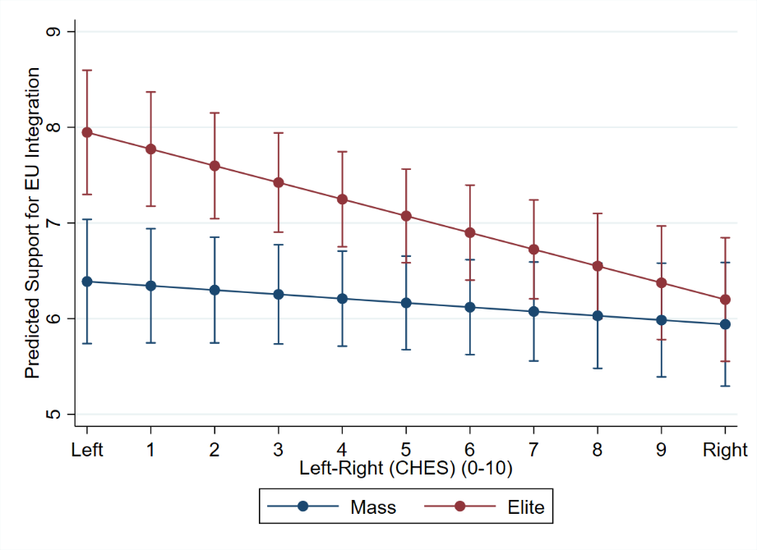
The analysis of the predictive margins (Figure A1) of the interaction between Cohort Group and Left-Right (0-10) in M1S differs between political elites and the mass public across the political spectrum. When examining the interaction between Cohort Group and political orientation, we observe that the mass-elite gap varies significantly across the political spectrum. On the right, support for European integration sees pronounced congruence between elites and masses, with both groups showing similar levels of support. However, a clear discrepancy emerges on the left side of the spectrum, where political elites exhibit much stronger support for European integration than the general public. This divergence challenges earlier studies (Mattila and Raunio 2006, 2012; McEvoy 2012), which found a greater deal of mass-elite congruence in left-wing parties, aligning to some extent with more recent research (Walczak and van der Brug 2013). These findings suggest that attitudes toward European integration differ markedly between elites and the mass public at the political extremes, with the gap widening on the left and less divergence observed on the right.

Figure A2: Predicted Support for European Integration by Cohort Group and Government Participation
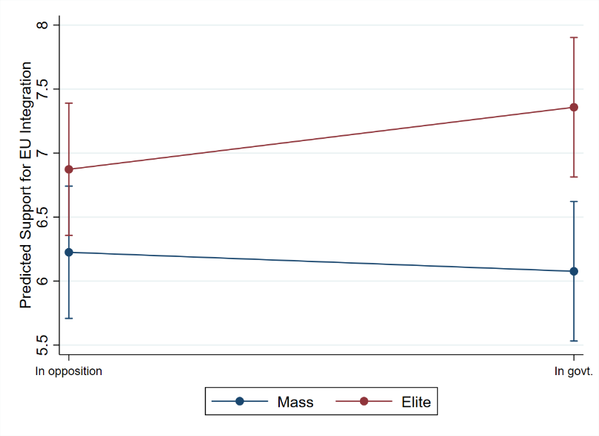
Concerning the interaction between Cohort Group and Government (Figure A2) in M2S, the analysis of predictive margins reveals a distinct divergence between elites and the public based on government status (consistent with Mattila and Raunio, 2006). The confidence intervals show that the integration gap is more pronounced when the party to which elites belong—and which voters support—is in government, with the opposite trend observed when their party is in opposition. This pattern is not surprising, as political elites in government typically bear a greater responsibility for decisions related to European integration and are more directly involved in formulating and implementing EU-related strategies. Moreover, historically, most parties in government have tended to adopt pro-European positions, aligning themselves with the broader goals of European integration.

Figure A3: Predicted Support for European Integration by Cohort Group and Laakso-Taagepera Index (ENEP)
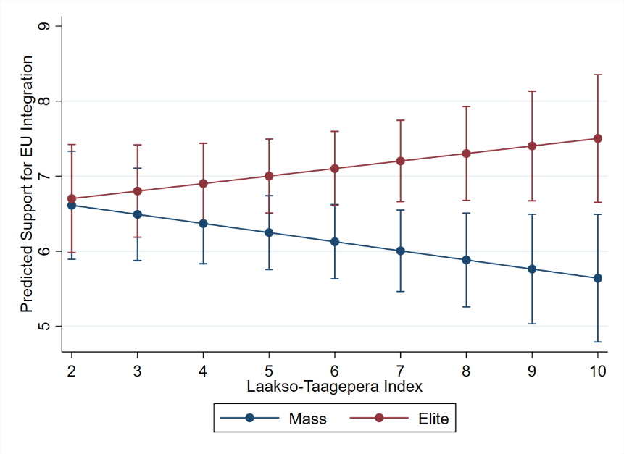
The interaction between Cohort Group and the Laakso-Taagepera Index (ENEP) in M3S (Figure A3)—which can be easily paired with the interaction between Cohort Group and Gallagher Index in M4S (Figure A4)—regards the impact of the number of parties in a political system. According to the predictive margins analysis, the mass-elite gap would widen as the effective number of political parties increases. A similar picture arises from M4S, which contains an interaction term between Cohort Group and the Gallagher Index of electoral disproportionality. The confidence intervals for elites and the public diverge as the Gallagher Index increases, suggesting that mass-elite congruence would decrease in more disproportional electoral systems.

Figure A4: Predicted Support for European Integration by Cohort Group and Gallagher Index
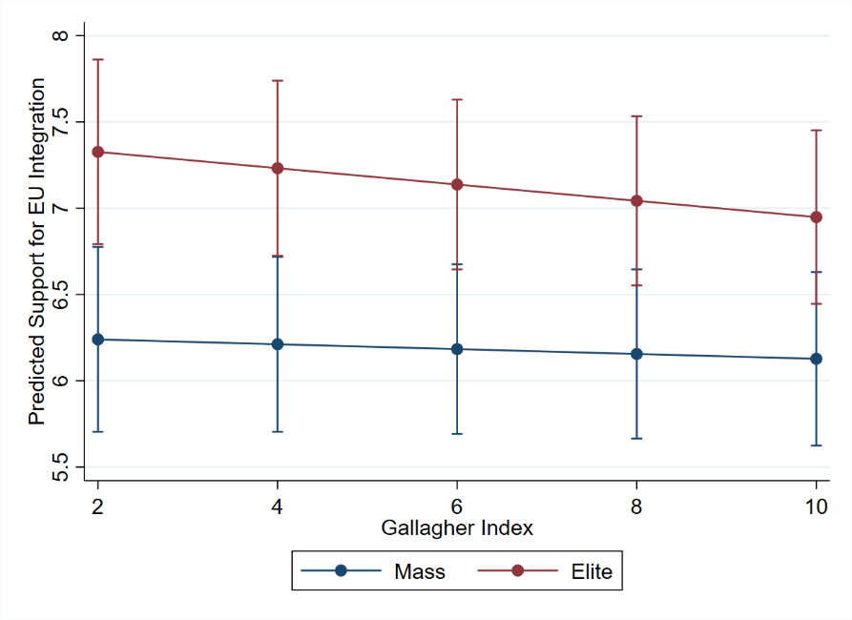
This finding is puzzling, as one might expect that more fragmented party systems, represented by a higher Laakso-Taagepera Index (ENEP), would lead to greater mass-elite congruence. Similarly, as disproportionality (reflected in higher Gallagher Index values) increases, the mass-elite gap grows wider, which is also contrary to what one might expect, for a higher level of disproportionality might be expected to yield stronger congruence. As such findings do not align with previous research on the topic (Marsh and Wessels 1997; Mattila and Raunio 2006, 2012; Dolný and Baboš 2015), this calls for additional research in a multivariate setting to further explore the role of such predictors.

Figure A5: Predicted Support for European Integration by Cohort Group and Party Size
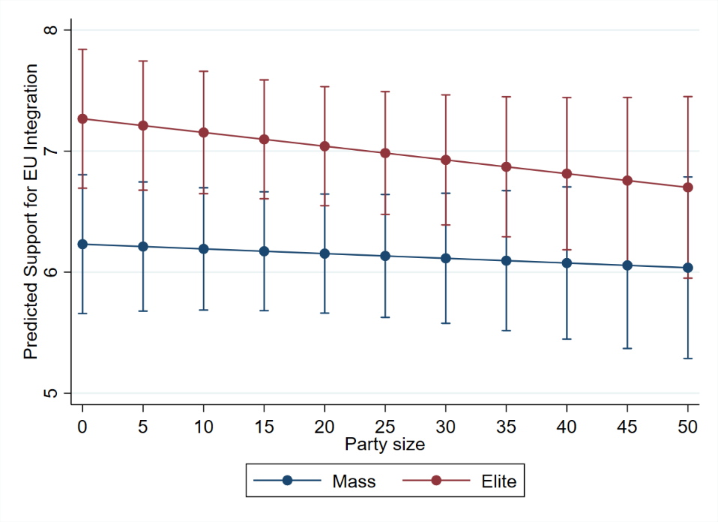
Finally, the analysis of the predictive margins stemming from the interaction between Cohort Group and Party size in M5S (Figure A5) reveals no significant evidence, thus leading us to conclude that party size does not substantially affect mass-elite congruence concerning European integration. In any case, we should not forget that this non-finding could also be due to operationalisation issues (for more, see Footnote 10 in the main text). This outcome adds another layer of complexity to the conflicting literature findings on the issue (Mattila and Raunio 2006, 2012; McEvoy 2012).

S8. Predicted Support for European Integration by Cohort Group, Italy, and Euroscepticism (1-7) (1979–2016)
Figure A6 presents the predicted support for European integration across different levels of Euroscepticism (1-7), comparing Italian political elites and the mass public, respectively, to their counterparts in the other EU-9 countries. The left panel illustrates the trend among elites, while the right panel focuses on the general public.

Figure A6: Predicted Support for European Integration by Cohort Group, Italy, and Euroscepticism (1-7) (1979–2016)
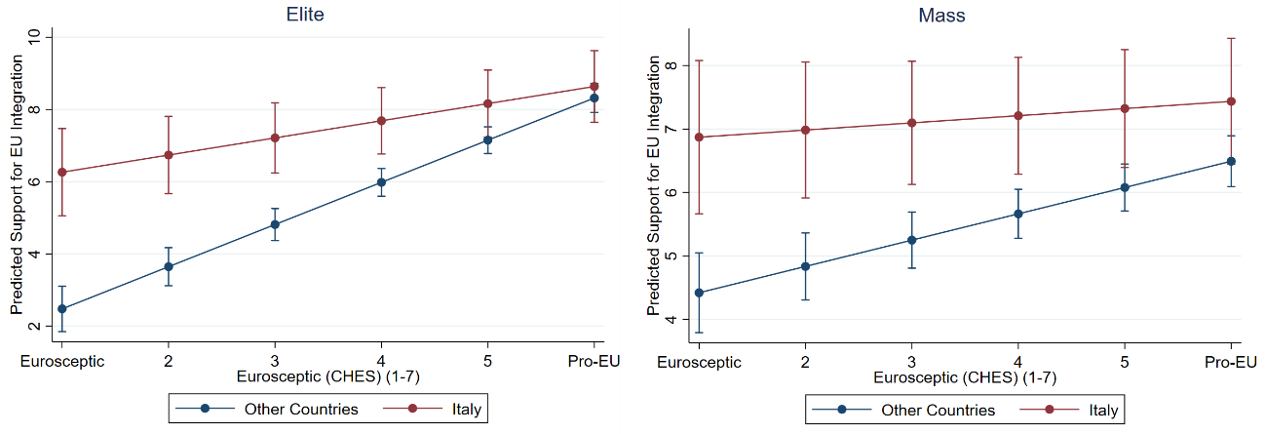
The results indicate that both Italian elites and masses generally express higher support for European integration than their EU-9 counterparts. This pro-European distinction is particularly pronounced among respondents of parties having stronger Eurosceptic orientations (1-4 on the CHES scale), whereby Italians—both elites and citizens—consistently display significantly more pro-European attitudes than their EU-9 counterparts. Only at the pro-European end of the spectrum (5-7 on the CHES scale) this gap narrows, and Italian respondents align more closely with the broader EU-9 pattern. These findings reinforce the notion of Italy as an outlier of sorts in the context of European integration. While Euroscepticism dampens support for integration more noticeably in other EU-9 countries, Italy remains comparatively pro-European across the board.

References
Cotta M (Principal investigator), Isernia P, Basile L, Borri R, Marangoni F, Olmastroni F and Verzichelli L (2021) EUENGAGE Dataset 2016-2018 (2.0) [Data set]. Zenodo. https://doi.org/10.5281/ZENODO.5167557 .
Cotta M, Isernia P and Bellucci P (2007) IntUne Mass Survey Wave 1. Ann Arbor, MI: Inter-university Consortium for Political and Social Research, 2013-04-11. https://doi.org/10.3886/ICPSR34421.v1.
Cotta M, Isernia P, Bellucci P, Quaglia L, Chelala P, Pochet P, Swyngedouw M, de Winter L, Mansfeldova Z, Pedersen MN, Radaelli C, Sanders D, Thornborrow JS, Nikolakopoulos H, Mir MJ, Torcal M, Segatti P, Lewandowska-Tomaszcz B, Markowski R, Wesolowski W, Matonytė I, Malgalhaes P, Gaxie D, Howorth J, Williams G, Szomolanyi S, Ilonszki G, Toka G, Best H, Rattinger H, Schmitt HFJ and Westle B (2022) IntUne Elite Survey Wave 1, January - July 2007. https://hdl.handle.net/21.12137/NUOOIH.
de Winter L, Bryder T, Linch P, Norris P, Chavel C, Weßels B, Kielhorn R, Marsh M, Sola G, Gardella L, Thomassen J, Geurts P, van der Kolk H, Stock MJ, López-Nieto L, Delgado I, Holmberg S, Esaiasson P and Brothen M (1999) European Candidates Study 1994. GESIS Data Archive, Cologne. ZA3077 Data file Version 1.0.0, https://doi.org/10.4232/1.3077.
European Commission (2012). Eurobarometer 44.2bis (Jan-Mar 1996). GESIS Data Archive, Cologne. ZA2828 Data file Version 1.0.1, https://doi.org/10.4232/1.10919.
Commission of the European Communities (1979). Eurobarometer 12. GESIS Data Archive, Cologne. ZA1037 Data file Version 1.0.1, https://doi.org/10.4232/1.10867.
Hartung H (2000). Eurobarometer 53: Racism, Information Society, General Services, and Food Labeling, April-May 2000. Ann Arbor, MI: Inter-university Consortium for Political and Social Research. https://doi.org/10.3886/ICPSR03064.v5.
Hix S, Farrell D, Scully R, Whitaker R and Zapryanova G (2016) EPRG MEP Survey Dataset: Combined Data 2016 Release, https://mepsurvey.eu/wp/data-objects/data/.
Meijers M (2017) Contagious Euroscepticism: The impact of Eurosceptic support on mainstream party positions on European integration. Party Politics 23, 413–423. https://doi.org/10.1177/1354068815601787.
Rabier J, Sorensen C, Inglehart R and Gordon I (1979) Candidates for the European Parliament, April-May 1979. Inter-university Consortium for Political and Social Research. https://doi.org/10.3886/ICPSR09033.v1.
Real-Dato J (2022) European National Elites and the Eurozone Crisis (ENEC-2014), https://doi.org/10.17903/FK2/ALQSGU.
Schmitt H, van der Eijk C, Scholz E and Klein M (1997) European Election Study 1994 (EES 1994). GESIS Data Archive, Cologne. ZA2865 Data file Version 1.0.0, https://doi.org/10.4232/1.2865.
Van Egmond M, van der Brug W, Hobolt S, Franklin M and Sapir EV (2009) European Parliament Election Study 2009, Voter Study. GESIS Data Archive, Cologne. ZA5055 Data file Version 1.1.1, https://doi.org/10.4232/1.12732.
Whitaker R, Hix S and Zapryanova G (2017) Understanding members of the European parliament: Four waves of the European parliament research group MEP survey. European Union Politics, 18(3), 491-506.
Weßels B (2013) European Parliament Election Study 2009, Candidate Study. GESIS Data Archive, Cologne. ZA5053 Data file Version 2.0.0, https://doi.org/10.4232/1.12961.
Weßels B, Kielhorn A, de Winter L, Dumont P, Ysmal C, Kakepati M, Marsh M, O’ Sullivan MC, Gardella L, Thomassen J, Bandeira CL, Delgado I, López-Nieto L, Holmberg S, Brothen M, Esaiasson P, Weßels B and Thomassen J. (1999) European Members of Parliament Study 1996. GESIS Data Archive, Cologne. ZA3079 Data file Version 1.0.0,
https://doi.org/10.4232/1.3079.

