**Appendix**

**The party politics of diplomatic engagements: Evidence from Italy**

p. ii • **Descriptive statistics**

p. iii • **Table A1-A3** – Supplementary models with alternative democracy data

p. iv • **Table A4-A5** – Supplementary models inclusive of Foreign Minister data

p. iv • **Figure A4** – Margins model A4

p. v • **Table A6** – Supplementary models with GAL-TAN values

p. v • **Figure A6** – Margins model A6

p. vi • **Table A7** – List of top-5 most visited countries by each Italian government

p. vii • **Table A8-A9** – Supplementary models with additional controls related to Italian military exports and Italian migrant communities abroad

**Descriptive statistics**

|  |  |  |  |  |  |
| --- | --- | --- | --- | --- | --- |
| **Variables** | **N** | **Mean** | **Std. Dev.** | **min** | **max** |
| PM outgoing visits (rate per 100 days)  [=PM outgoing visits (count) / Government duration in days * 100] | 2418 | .024 | 0.080 | 0 | .756 |
| PM incoming visits (rate per 100 days)  [=PM incoming visits (count) / Government duration in days * 100] | 2418 | .039 | 0.105 | 0 | 1.333 |
| PM outgoing visits (count) | 2418 | .149 | 0.500 | 0 | 7 |
| PM incoming visits (count) | 2418 | .275 | 0.726 | 0 | 7 |
| PM+FM outgoing visits (rate per 100 days)  [=PM outgoing visits (count) / Government duration in days * 100] | 2418 | .039 | 0.120 | 0 | 1.149 |
| PM+FM incoming visits (rate per 100 days)  [=PM incoming visits (count) / Government duration in days * 100] | 2418 | .055 | 0.155 | 0 | 3.254 |
| PM+FM outgoing visits (count) | 2418 | .251 | 0.823 | 0 | 10 |
| PM+FM incoming visits (count) | 2418 | .388 | 1.083 | 0 | 15 |
| Political ideology (L-R scale values) | 2418 | 5.385 | 1.687 | 2.665 | 8.192 |
| Democracy | 2198 | .409 | 0.492 | 0 | 1 |
| Democracy (alternative 1) | 2198 | .515 | 0.500 | 0 | 1 |
| Democracy (alternative 2) | 2198 | .54 | 0.499 | 0 | 1 |
| World share of democracies | 2418 | .322 | 0.044 | .245 | .389 |
| World economy status (% GDP growth) | 2418 | 3.105 | 1.203 | -.239 | 4.552 |
| Government duration (days) | 2418 | 666.7 | 340.4 | 300 | 1412 |

NB: PM=Prime Minister; FM=Foreign Minister. Square brackets show the operationalization of a given variable, when it is based on other variables in the list. The unit of analysis is the government-partner dyad. Thus, for instance, the count of PM outgoing visits refers to the number of PM-led visits towards a specific partner during the entire government mandate. The sample used for the empirical analysis excludes dyads in which, over the past two decades, there has never been a visit, primarily those with small, remote states as partners.

**Table A1-A3. Supplementary models with softer democracy variables**

|  |  |  |  |
| --- | --- | --- | --- |
|  | (A1) | (A2) | (A3) |
| DV: PM outgoing visits (rate) | M2 | M2a | M2b |
|  |  |  |  |
| Government ideology | -0.0250** | -0.0254** | -0.0249** |
|  | (0.0115) | (0.0116) | (0.0116) |
| *Ideology x* *Ideology* | 0.00262** | 0.00265** | 0.00262** |
|  | (0.00110) | (0.00111) | (0.00111) |
| Democracy | 0.0191 |  |  |
|  | (0.0179) |  |  |
| Democracy (softer alternative 1) |  | 0.0234 |  |
|  |  | (0.0146) |  |
| Democracy (softer alternative 2) |  |  | 0.0210 |
|  |  |  | (0.0145) |
| *Democracy x Ideology* | -0.00798*** | -0.00657*** | -0.00663*** |
|  | (0.00252) | (0.00244) | (0.00243) |
| Incoming (rate) | 0.0943*** | 0.0930*** | 0.0934*** |
|  | (0.0363) | (0.0360) | (0.0361) |
| World share of democracies | 0.130** | 0.128** | 0.124** |
|  | (0.0567) | (0.0569) | (0.0569) |
| World economy status (% GDP growth) | 0.000537 | 0.000592 | 0.000590 |
|  | (0.00164) | (0.00163) | (0.00163) |
| Government duration (days) | -1.77e-05*** | -1.80e-05*** | -1.73e-05*** |
|  | (6.72e-06) | (6.78e-06) | (6.73e-06) |
| Constant | 0.0617* | 0.0596* | 0.0601* |
|  | (0.0351) | (0.0348) | (0.0347) |
| Observations | 1,574 | 1,574 | 1,574 |
| R-squared | 0.350 | 0.348 | 0.348 |
| Adj R-squared | 0.292 | 0.289 | 0.289 |
| Partner FE | Yes | Yes | Yes |

*** p<0.01, ** p<0.05, * p<0.1. Standard errors in parentheses, clustered at government (13 clusters) and partner (123 clusters) level, estimated using cluster bootstrapping to account for the limited number of government clusters.

**Table A4-A5. Supplementary models inclusive of Foreign Ministers data**

|  |  |  |
| --- | --- | --- |
|  | (A4) | (A5) |
| DV: PM+FM outgoing visits | Continuous DV | Count DV |
|  |  |  |
| Government ideology | -0.0604*** | -1.157*** |
|  | (0.0171) | (0.262) |
| *Ideology x* *Ideology* | 0.00584*** | 0.104*** |
|  | (0.00164) | (0.0245) |
| Democracy | -0.000559 | -0.476 |
|  | (0.0234) | (0.394) |
| *Democracy x Ideology* | -0.00590* | -0.0124 |
|  | (0.00341) | (0.0520) |
| Incoming PM+FM (rate) | 0.175*** |  |
|  | (0.0358) |  |
| Incoming PM+FM (count) |  | 0.153*** |
|  |  | (0.0345) |
| World share of democracies | 0.275*** | 4.962*** |
|  | (0.0732) | (1.500) |
| World economy status (% GDP growth) | 0.000125 | 0.0221 |
|  | (0.00239) | (0.0449) |
| Government duration (days) | -1.22e-05 | 0.000708*** |
|  | (8.42e-06) | (0.000187) |
| Constant | 0.117** | 0.643 |
|  | (0.0469) | (0.785) |
| Observations | 1,574 | 1,086 |
| R-squared | 0.461 |  |
| Adj R-squared | 0.413 |  |
| Partner FE | Yes | Yes |

*** p<0.01, ** p<0.05, * p<0.1. Standard errors in parentheses, clustered at government (13 clusters) and partner (123 clusters) level, estimated using cluster bootstrapping to account for the limited number of government clusters.

**Figure A4. Margins**

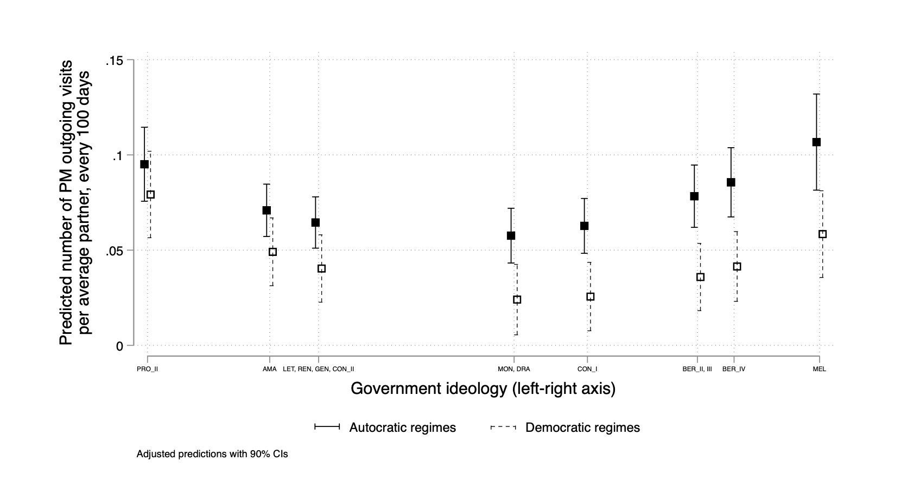

**Table A6. Supplementary models with GAL-TAN values**

|  |  |  |
| --- | --- | --- |
|  | (A6) | (A7) |
| DV: PM outgoing visits | Continuous DV | Count DV |
|  |  |  |
| Government ideology (GAL-TAN) | -0.0111 | -0.399* |
|  | (0.00837) | (0.223) |
| *Ideology(GAL-TAN) x* *Ideology(GAL-TAN)* | 0.00144* | 0.0437** |
|  | (0.000807) | (0.0199) |
| Democracy | 0.00112 | -0.112 |
|  | (0.0158) | (0.410) |
| *Democracy x Ideology(GAL-TAN)* | -0.00500** | -0.0856* |
|  | (0.00212) | (0.0481) |
| Incoming (rate) | 0.0973*** |  |
|  | (0.0359) |  |
| Incoming (count) |  | 0.216*** |
|  |  | (0.0644) |
| World share of democracies | 0.151** | 3.819** |
|  | (0.0607) | (1.849) |
| World economy status (% GDP growth) | 0.00172 | 0.0849* |
|  | (0.00168) | (0.0516) |
| Government duration (days) | -1.80e-05*** | 0.000490** |
|  | (6.64e-06) | (0.000220) |
| Constant | 0.0132 | -1.735* |
|  | (0.0350) | (1.007) |
| Observations | 1,574 | 1,047 |
| R-squared | 0.349 |  |
| Adj R-squared | 0.290 |  |
| Partner FE | Yes | Yes |

*** p<0.01, ** p<0.05, * p<0.1. Standard errors in parentheses, clustered at government (13 clusters) and partner (123 clusters) level, estimated using cluster bootstrapping to account for the limited number of government clusters.

**Figure A6. Margins model A6**

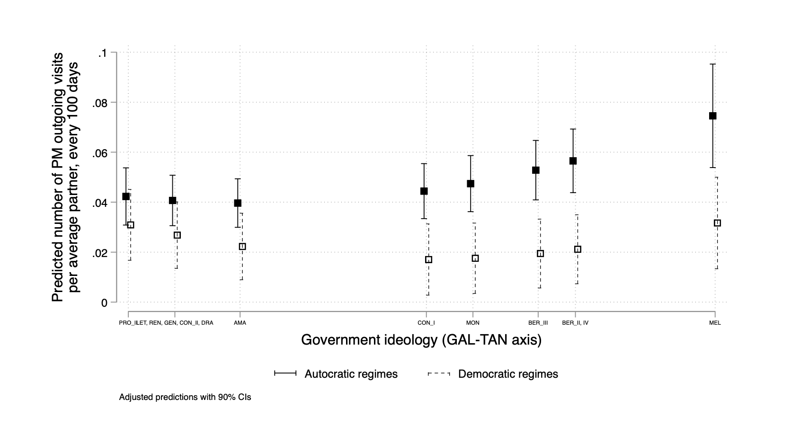

**Table A7 – List of the top-5 most visited countries per government**

|  |  |  |  |  |  |
| --- | --- | --- | --- | --- | --- |
| Government | 1 | 2 | 3 | 4 | 5 |
| Amato | France | UK | *multiple* |  |  |
| Berlusconi II | UK | US | Russia | Libya | Egypt |
| Berlusconi III | US | Israel | France | Tunisia | *multiple* |
| Prodi II | France | Germany | Russia | Egypt | *multiple* |
| Berlusconi IV | Libya | Russia | Germany | Egypt | US |
| Monti | France | Germany | Greece | Israel | Lebanon |
| Letta | France | Poland | Russia | *multiple* |  |
| Renzi | Israel | *multiple* |  |  |  |
| Gentiloni | France | Germany | UAE | *multiple* |  |
| Conte I | Tunisia | UAE | *multiple* |  |  |
| Conte II | Spain | *multiple* |  |  |  |
| Draghi | France | Algeria | *multiple* |  |  |
| Meloni (until 12/2023) | Tunisia | UAE | Germany | India | UK |
| TOTAL | **France** | **Germany** | **Russia** | **US** | **UK** |

**Table A8-A9. Supplementary models with additional controls related to Italian military exports and Italian migrant communities abroad**

|  |  |  |
| --- | --- | --- |
|  | (A8) | (A9) |
| DV: PM outgoing visits | Continuous DV (M2) | Continuous DV (M2) |
|  |  |  |
| Government ideology | -0.0250** | -0.0243** |
|  | (0.0116) | (0.0115) |
| *Ideology x* *Ideology* | 0.00262** | 0.00256** |
|  | (0.00111) | (0.00110) |
| Democracy | 0.0191 | 0.0193 |
|  | (0.0179) | (0.0178) |
| *Democracy x Ideology* | -0.00797*** | -0.00804*** |
|  | (0.00252) | (0.00252) |
| Incoming (rate) | 0.0945*** | 0.0955*** |
|  | (0.0364) | (0.0361) |
| World share of democracies | 0.130** | 0.134** |
|  | (0.0571) | (0.0572) |
| World economy status (% GDP growth) | 0.000534 | 0.000557 |
|  | (0.00165) | (0.00164) |
| Government duration (days) | -1.76e-05*** | -1.76e-05*** |
|  | (6.73e-06) | (6.66e-06) |
| Italian military export | .0197 |  |
|  | (0.0988) |  |
| Italian migrant communities abroad |  | 0.4175 |
|  |  | (0.5439) |
| Constant | 0.0617* | 0.0540 |
|  | (0.0352) | (0.0370) |
| Observations | 1,574 | 1,574 |
| R-squared | 0.350 | 0.352 |
| Adj R-squared | 0.291 | 0.293 |
| Partner FE | Yes | Yes |

*** p<0.01, ** p<0.05, * p<0.1. Standard errors in parentheses, clustered at government (13 clusters) and partner (123 clusters) level, estimated using cluster bootstrapping to account for the limited number of government clusters. Models A8 and A9 are based on the main text’s M2 model, but each has an additional variable: *Italian military exports* and *Italian migrant communities abroad*, respectively. Italian migrant communities abroad are sourced from the International Migrant Stock of the United Nations Department of Economic and Social Affairs, Population Division (2020), and are reported in millions. Replacing the latter with its logarithm does not change the statistical significance of the results. Italian military exports are sourced from SIPRI and are reported in billion SIPRI TIV (https://www.sipri.org/databases/armstransfers/sources-and-methods). The coefficients of these two controls show they have a positive effect, but not in a statistically significant way, thus suggesting that these factors do not systematically influence Italian PMs’ outgoing visits.