Did the citizenship income scheme do it?
The supposed electoral consequence of a flagship policy
Marco Giuliani
Department of Social and Political Sciences, Università degli studi di Milano

Online appendix

Contents
Descriptive statistics 2
Survey evidence 5
Complete models reported in the article 7
Robustness tests 16
References 22

Descriptive statistics
Table A.1 Variables, definition, source and descriptive statistics
Variable | Measure | Source | Obs | Mean | Std. dev. | Min | Max
Citizenship income | Pct population | Inps | 7818 | 3.25 | 3.34 | 0.00 | 28.50
M5S votes | Pct votes | Eligendo | 7829 | 11.83 | 8.68 | 0.00 | 84.33
Change in turnout | Pct | Eligendo | 7829 | -9.19 | 4.96 | -75.81 | 28.10
Employment rate | Pct15-64 | Istat | 7903 | 59.76 | 10.01 | 38.53 | 73.80
Youth employment rate | Pct 15-29 | Istat | 7903 | 33.13 | 8.78 | 14.90 | 50.50
Unemployment rate | Pct 15-64 | Istat | 7903 | 10.55 | 5.84 | 2.93 | 28.01
Inactive population pct | Pct 15-64 | Istat | 7903 | 33.63 | 7.64 | 23.13 | 52.57
NEETs pct | Pct 15-29 | Istat-Bes | 7903 | 21.35 | 8.16 | 9.70 | 47.70
Education pct diplomats | Pct 25-64 | Tagliacarne | 7903 | 61.11 | 6.96 | 43.30 | 75.00
Continuous formation | Pct 25-64 | Istat-Bes | 7903 | 7.81 | 2.15 | 3.40 | 16.00
Newspapers reading | Per 1000 people | AGM-Istat | 7903 | 38.23 | 18.92 | 3.92 | 99.40
Literacy problems | Pct students lower secondary | Istat-Bes | 7903 | 33.12 | 7.12 | 22.30 | 57.90
Numeracy problems | Pct students lower secondary | Istat-Bes | 7903 | 37.60 | 10.34 | 19.60 | 69.20
Income dependent work | Euros | Istat-Bes | 7691 | 20055.18 | 3936.77 | 11992.60 | 30111.90
Taxpayers < 1000 euro | Pct | MEF | 7903 | 31.38 | 10.07 | 11.11 | 77.98
Income per taxpayer | Euros pc | MEF | 7903 | 18170.61 | 3825.15 | 6198.24 | 48186.21
Bank deposits | Euros pc | Bank of Italy | 7903 | 16719.45 | 3532.99 | 7964.53 | 24843.94
Non-performing loans | Pct on loans | Istat-Bes | 7903 | 1.06 | 0.34 | 0.30 | 2.20
Protests | Euros per 1000 people | Infocamere | 7903 | 4109.66 | 3755.26 | 254.19 | 15132.45
Export | Pct on added value | Prometeia | 7903 | 29.80 | 20.70 | 0.63 | 103.04
Online municipal services | Pct mucipalities | Istat-Bes | 7830 | 25.31 | 16.41 | 4.20 | 100.00
Population | Log | Istat | 7904 | 7.82 | 1.37 | 3.43 | 14.83
ONG | Per 10000 people | Istat-Bes | 7903 | 66.18 | 16.71 | 32.10 | 118.90

Apart from the Citizenship income policy, and the electoral covariates, the other variables potentially confounding the relationship can be clustered into four groups. The first five variables reflect characteristics of the provincial labour market, such as employment and unemployment rates, the share of inactive population, and the percentage of NEETs, i.e. young people not engaged in education, employment or training. A precondition for the supposed association between M5S votes and RdC to be dependent on the economic hardship is that there is a negative relationship between yellow support and the overall and youth employment level, and a positive relationship between the former and unemployment levels, inactive population and NEETs.
A second cluster of five variables relates more to the cultural situation, and includes the percentage of the adult population with a diploma, the level of continuous training, newspaper readership, and the share of young people with literacy and numeracy problems. In order to potentially generate a spurious relationship, the first three factors should be negatively related with support for the M5S, while the latter two should exhibit a positive association.
A third group of factors reflects local well-being, including an estimate of the average income of dependent workers, the average taxable income, the share of taxpayers with incomes below 10,000 euros, together with the per capita magnitude of bank deposits.
Finally, a last heterogeneous group of potentially confounding factors comprises the following: two measures of the stagnating and unsafe economic market – the incidence of non-performing loans and of protests; two measures of dynamism – the share of exports and the presence of online municipal services; the size of the municipality; and one typical proxy for social capital – the number of non-profit organizations per population.

Table A.2 Matrix of correlation between each pair of covariates
 | M5S vote | RdC. | Emp. | Youth em | Unemp. | Inactive | Neet
RdC | 0.75
Employment | -0.79 | -0.77
Youth employm. | -0.78 | -0.73 | 0.93
Unemployment | 0.78 | 0.76 | -0.94 | -0.88
Inactive | 0.76 | 0.75 | -0.98 | -0.90 | 0.86
Neet | 0.76 | 0.76 | -0.94 | -0.90 | 0.91 | 0.91
Education | -0.45 | -0.48 | 0.64 | 0.47 | -0.56 | -0.66 | -0.61
Formation | -0.46 | -0.46 | 0.62 | 0.45 | -0.56 | -0.63 | -0.63
Newspapers | -0.62 | -0.57 | 0.71 | 0.70 | -0.68 | -0.68 | -0.69
Literacy problem | 0.70 | 0.72 | -0.84 | -0.75 | 0.84 | 0.80 | 0.84
Numeracy prob. | 0.76 | 0.76 | -0.89 | -0.85 | 0.89 | 0.85 | 0.88
Income dep.work | -0.67 | -0.64 | 0.85 | 0.79 | -0.78 | -0.84 | -0.78
Poor taxpayers | 0.61 | 0.63 | -0.80 | -0.74 | 0.73 | 0.78 | 0.74
Tax income | -0.52 | -0.52 | 0.69 | 0.64 | -0.63 | -0.68 | -0.64
Deposits | -0.66 | -0.67 | 0.83 | 0.78 | -0.80 | -0.81 | -0.80
Nonperf. loans | 0.62 | 0.59 | -0.72 | -0.70 | 0.69 | 0.70 | 0.72
Protests | 0.46 | 0.43 | -0.47 | -0.53 | 0.44 | 0.46 | 0.44
Export | -0.50 | -0.51 | 0.59 | 0.58 | -0.55 | -0.58 | -0.52
Online municip. | -0.34 | -0.34 | 0.46 | 0.43 | -0.44 | -0.44 | -0.47
Log population | 0.04 | 0.04 | -0.07 | -0.07 | 0.06 | 0.08 | 0.04
ONGs | -0.54 | -0.51 | 0.59 | 0.54 | -0.57 | -0.56 | -0.57
 | Education | Formation | News | Literacy | Numeracy | Income | Poor tax.
Formation | 0.73
Newspapers | 0.47 | 0.57
Literacy problem | -0.59 | -0.52 | -0.54
Numeracy prob. | -0.61 | -0.55 | -0.65 | 0.96
Income dep.work | 0.56 | 0.55 | 0.53 | -0.71 | -0.76
Poor taxpayers | -0.49 | -0.50 | -0.54 | 0.68 | 0.73
Tax income | 0.46 | 0.47 | 0.47 | -0.57 | -0.62 | 0.74 | -0.88
Deposits | 0.66 | 0.56 | 0.58 | -0.73 | -0.81 | 0.77 | -0.64
Loans | -0.37 | -0.61 | -0.64 | 0.57 | 0.64 | -0.66 | 0.58
Protests | -0.06 | -0.17 | -0.49 | 0.37 | 0.44 | -0.33 | 0.40
Export | 0.29 | 0.19 | 0.31 | -0.53 | -0.56 | 0.63 | -0.55
Online municip. | 0.33 | 0.47 | 0.23 | -0.44 | -0.46 | 0.56 | -0.47
Log population |  | 0.05 |  |  |  | -0.08 | 0.02
ONGs | 0.37 | 0.44 | 0.65 | -0.46 | -0.53 | 0.28 | -0.36

 | Tax inc. | Deposits | Loans | Protests | Export | Online | Logpop
Deposits | 0.60
Loans | -0.54 | -0.67
Protests | -0.29 | -0.25 | 0.47
Export | 0.45 | 0.50 | -0.29 | -0.32
Online municip. | 0.48 | 0.33 | -0.36 |  | 0.26
Log population |  | -0.09 | 0.05 | 0.06 | -0.06 | 0.12
ONGs | 0.26 | 0.48 | -0.55 | -0.50 | 0.19 | -0.15 | -0.07
Note: All reported coefficients are statistically significant (p<0.01). Empty cells p>0.05

Survey evidence
As is customary, the 2022 legislative election has sparked the interest of many scholars, in the tradition of Italian electoral studies based on survey results. Amongst them, it is worth noting the books edited by Roncarolo and Vezzoni (2023) and by Vassallo and Verzichelli (2023), which provide important empirical evidence.
These works, along with analyses performed by the Italian Center for Electoral Studies (CISE), detail the context in which citizens were called to the ballot boxes, legitimize the application of a policy vote framework to the M5S electorate, and help to identify the relevant covariate for our analysis.
To begin with, Improta et al. (2022) highlight how the citizenship income policy was the second most salient issue for voters before the election, but also the most polarizing one. According to the survey, 39% of respondents supported its maintenance while 61% preferred its abolition. Only the war in Ukraine had a more evenly split number of respondents, though with slightly lower priority. The authors confirm that “the M5S has by far been perceived by voters as the top promoter and guarantor of basic income” and suggest that “as such, tended to get higher shares of vote support among basic income receptors” (14).
Survey studies indicate that citizens in uncertain and needy economic conditions, such as the unemployed and inactive population, are traditionally over-represented amongst the M5S voters (Tuorto 2019). They are also the ones who least identify themselves along the left-right spectrum (Azzollini, Baldassarri, and Segatti 2023; Maggini and Vezzoni 2023), which supports the possibility of an “easy-issue vote” mobilized by the RdC policy. Furthermore, this “legitimizes the question of whether the intense electoral campaign of the Five Star Movement in support of the citizenship income generated a larger consensus among the most disadvantaged groups, such as citizens with low income or those who are unemployed” (Barisione et al. 2023). In fact, the M5S electorate is the only one that is evenly split when asked to choose between supporting those in need through the RdC, or investing those resources in reducing labour taxation to increase employment opportunities (Fonda and Vassallo 2023). Supporters of all other parties largely prefer the second option.

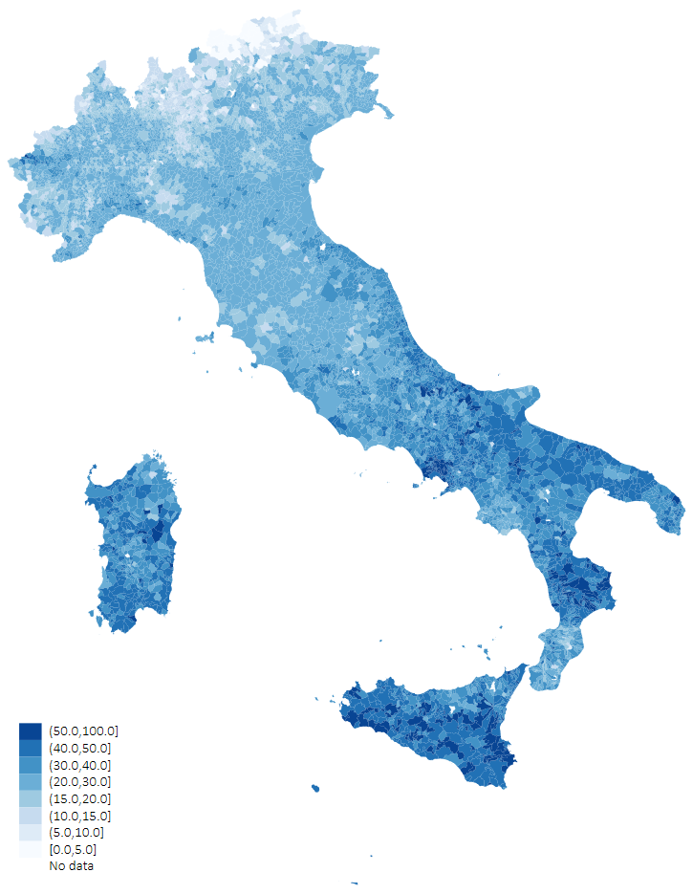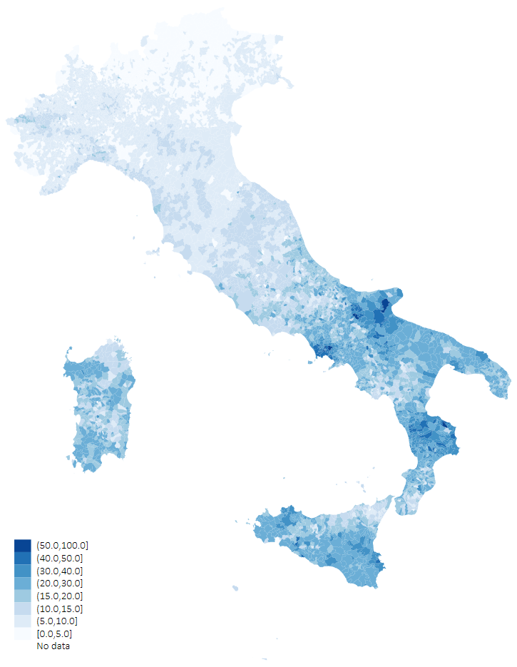
Figure A.1 Percentage of votes for the Five Star Movement in 2018 (left) and 2022 (right) – same scale

The relevance of the geographic divide has been confirmed also in the 2022 election, with large parts of the yellow electorate coming from southern regions, and the M5S movement being particularly attractive in larger municipalities (D'Alimonte and Emanuele 2023; Mancosu 2023; Pedrazzani 2023). This evidence suggests controlling for the hypothesis in different Italian areas – as shown in Table 1 and 2 in the article – and including the size of the municipality among the wide range of covariates tested in Figure 2 (see also Tables A.3 and A.4 below) and Figure A.1 (see also Table A.7 below).

Complete models reported in the article

Table A.3 Baseline model and complete model 2 of Table 1 in the article
 | (1) |  | (2)
Citizenship income | 0.90*** | (0.02) | 0.61*** | (0.10)
M5S 2018 vote | 0.47*** | (0.01) | 0.43*** | (0.03)
Change in turnout | -0.18*** | (0.01) | -0.07*** | (0.03)
Basilicata |  |  | 3.12*** | (0.48)
Calabria |  |  | 4.92*** | (1.74)
Campania |  |  | 3.70*** | (0.95)
Emilia-Romagna |  |  | -1.40** | (0.59)
Friuli V.G. |  |  | -2.52*** | (0.62)
Lazio |  |  | -1.02** | (0.50)
Liguria |  |  | -1.46** | (0.74)
Lombardia |  |  | -1.11* | (0.60)
Marche |  |  | -1.66*** | (0.57)
Molise |  |  | 1.92*** | (0.60)
Piemonte |  |  | -1.44** | (0.56)
Puglia |  |  | 6.10** | (2.82)
Sardegna |  |  | -0.12 | (0.50)
Sicilia |  |  | -0.93 | (1.31)
Toscana |  |  | 0.01 | (0.57)
Trentino A.A. |  |  | -1.30 | (1.29)
Umbria |  |  | 0.68 | (0.51)
Veneto |  |  | -3.40*** | (0.57)
Constant | -5.68*** | (0.14) | -2.37** | (1.05)
Observations | 7816 |  | 7816
R-squared | 0.80 |  | 0.84
Clustered standard errors in parentheses: *** p<0.01, ** p<0.05, * p<0.1

Table A.4 Complete models originating Figure 2 left panel
 | (1) | (2) | (3) | (4) | (5) | (6) | (7)
M5S 2018 vote | 0.47*** | 0.44*** | 0.46*** | 0.44*** | 0.47*** | 0.46*** | 0.60***
 | (0.03) | (0.02) | (0.03) | (0.02) | (0.03) | (0.03) | (0.03)
Change turn. | -0.18*** | -0.17*** | -0.18*** | -0.21*** | -0.17*** | -0.20*** | -0.20***
 | (0.04) | (0.06) | (0.05) | (0.07) | (0.05) | (0.05) | (0.05)
Citizenship inc. | 5.98***
 | (0.45)
Employment |  | -6.29***
 |  | (0.80)
Youth empl. |  |  | -5.38***
 |  |  | (0.58)
Unemployment |  |  |  | 5.96***
 |  |  |  | (1.15)
Inactive |  |  |  |  | 5.61***
 |  |  |  |  | (0.71)
NEETs |  |  |  |  |  | 5.65***
 |  |  |  |  |  | (0.71)
Education |  |  |  |  |  |  | -2.50***
 |  |  |  |  |  |  | (0.62)
Constant | -5.68*** | 16.98*** | 7.60*** | -7.68*** | -15.03*** | -10.07*** | 4.43
 | (0.63) | (2.99) | (1.54) | (0.73) | (1.44) | (0.90) | (2.91)
Observations | 7816 | 7827 | 7827 | 7827 | 7827 | 7827 | 7827
R-squared | 0.80 | 0.79 | 0.77 | 0.78 | 0.78 | 0.78 | 0.75
Clustered standard errors in parentheses: *** p<0.01, ** p<0.05, * p<0.1

Table A.4 (continue)
 | (8) | (9) | (10) | (11) | (12) | (13) | (14)
M5S 2018 vote | 0.60*** | 0.56*** | 0.50*** | 0.46*** | 0.55*** | 0.56*** | 0.60***
 | (0.03) | (0.03) | (0.03) | (0.02) | (0.04) | (0.03) | (0.03)
Change turn. | -0.21*** | -0.19*** | -0.21*** | -0.20*** | -0.17*** | -0.16*** | -0.18***
 | (0.05) | (0.04) | (0.05) | (0.05) | (0.05) | (0.05) | (0.05)
Formation | -2.59***
 | (0.61)
Newspapers |  | -3.33***
 |  | (0.84)
Literacy prob. |  |  | 5.28***
 |  |  | (0.60)
Numeracy pr. |  |  |  | 5.81***
 |  |  |  | (0.58)
Dependent inc. |  |  |  |  | -3.59***
 |  |  |  |  | (0.79)
Poor taxpayers |  |  |  |  |  | 3.56***
 |  |  |  |  |  | (0.45)
Taxable inc. |  |  |  |  |  |  | -2.14***
 |  |  |  |  |  |  | (0.43)
Constant | -1.80 | -1.91* | -16.07*** | -13.26*** | 4.40 | -10.69*** | -1.23
 | (1.29) | (1.14) | (1.40) | (1.12) | (2.72) | (1.01) | (1.54)
Observations | 7,827 | 7,827 | 7,827 | 7,827 | 7,615 | 7,827 | 7,827
R-squared | 0.75 | 0.75 | 0.79 | 0.79 | 0.76 | 0.76 | 0.74
Clustered standard errors in parentheses: *** p<0.01, ** p<0.05, * p<0.1

Table A.4 (continue)
 | (15) | (16) | (17) | (18) | (19) | (20) | (21)
M5S 2018 vote | 0.55*** | 0.56*** | 0.61*** | 0.59*** | 0.63*** | 0.64*** | 0.58***
 | (0.03) | (0.03) | (0.04) | (0.03) | (0.03) | (0.03) | (0.03)
Change turn. | -0.20*** | -0.21*** | -0.17*** | -0.19*** | -0.20*** | -0.20*** | -0.20***
 | (0.05) | (0.04) | (0.04) | (0.05) | (0.05) | (0.05) | (0.04)
Bank deposits | -3.11***
 | (0.73)
Non-perf. loan |  | 3.17***
 |  | (0.59)
Protests |  |  | 2.09***
 |  |  | (0.74)
Export |  |  |  | -2.44***
 |  |  |  | (0.53)
Municipal onl. |  |  |  |  | -1.17**
 |  |  |  |  | (0.49)
Population |  |  |  |  |  | 0.37*
 |  |  |  |  |  | (0.21)
ONGs |  |  |  |  |  |  | -3.15***
 |  |  |  |  |  |  | (0.67)
Constant | 2.17 | -10.35*** | -7.68*** | -4.53*** | -6.40*** | -8.81*** | 0.27
 | (2.22) | (1.24) | (0.91) | (0.98) | (1.00) | (0.98) | (1.40)
Observations | 7,827 | 7,827 | 7,827 | 7,827 | 7,754 | 7,827 | 7,827
R-squared | 0.75 | 0.75 | 0.74 | 0.75 | 0.74 | 0.73 | 0.75
Clustered standard errors in parentheses: *** p<0.01, ** p<0.05, * p<0.1

Table A.5 Complete models originating Figure 2 right panel
 | (1) | (2) | (3) | (4) | (5) | (6) | (7)
Citizenship inc. | 5.98*** | 4.12*** | 4.87*** | 4.36*** | 4.41*** | 4.45*** | 5.59***
 | (0.45) | (0.74) | (0.61) | (0.73) | (0.72) | (0.70) | (0.54)
M5S 2018 vote | 0.47*** | 0.41*** | 0.41*** | 0.41*** | 0.42*** | 0.42*** | 0.46***
 | (0.03) | (0.02) | (0.02) | (0.02) | (0.02) | (0.02) | (0.02)
Change turn. | -0.18*** | -0.17*** | -0.17*** | -0.19*** | -0.17*** | -0.18*** | -0.18***
 | (0.04) | (0.06) | (0.05) | (0.06) | (0.05) | (0.05) | (0.05)
Employment |  | -3.62***
 |  | (1.02)
Youth empl. |  |  | -2.64***
 |  |  | (0.62)
Unemployment |  |  |  | 3.25**
 |  |  |  | (1.31)
Inactive |  |  |  |  | 3.08***
 |  |  |  |  | (0.89)
NEETs |  |  |  |  |  | 2.98***
 |  |  |  |  |  | (0.91)
Education |  |  |  |  |  |  | -0.99
 |  |  |  |  |  |  | (0.61)
Constant | -5.68*** | 7.89** | 1.47 | -6.20*** | -10.22*** | -7.43*** | -0.96
 | (0.63) | (3.76) | (1.63) | (0.69) | (1.58) | (0.95) | (2.74)
Observations | 7,816 | 7,816 | 7,816 | 7,816 | 7,816 | 7,816 | 7,816
R-squared | 0.80 | 0.81 | 0.81 | 0.81 | 0.81 | 0.81 | 0.80
Clustered standard errors in parentheses: *** p<0.01, ** p<0.05, * p<0.1

Table A.5 (continue)
 | (8) | (9) | (10) | (11) | (12) | (13) | (14)
Citizenship inc. | 5.54*** | 5.39*** | 4.24*** | 4.21*** | 5.44*** | 5.28*** | 5.79***
 | (0.51) | (0.56) | (0.64) | (0.69) | (0.56) | (0.59) | (0.51)
M5S 2018 vote | 0.46*** | 0.44*** | 0.43*** | 0.42*** | 0.45*** | 0.46*** | 0.46***
 | (0.02) | (0.02) | (0.02) | (0.02) | (0.02) | (0.02) | (0.02)
Change turn. | -0.18*** | -0.18*** | -0.19*** | -0.18*** | -0.17*** | -0.17*** | -0.17***
 | (0.05) | (0.05) | (0.05) | (0.05) | (0.05) | (0.05) | (0.05)
Formation | -1.24**
 | (0.57)
Newspapers |  | -1.71**
 |  | (0.66)
Literacy pr. |  |  | 3.08***
 |  |  | (0.69)
Numeracy pr. |  |  |  | 3.32***
 |  |  |  | (0.74)
Dependent inc. |  |  |  |  | -1.55**
 |  |  |  |  | (0.63)
Poor taxpayers |  |  |  |  |  | 1.50***
 |  |  |  |  |  | (0.49)
Taxable inc. |  |  |  |  |  |  | -0.57
 |  |  |  |  |  |  | (0.37)
Constant | -2.99*** | -2.88*** | -11.13*** | -9.44*** | -0.66 | -7.16*** | -4.01***
 | (1.05) | (0.78) | (1.57) | (1.20) | (2.02) | (0.87) | (1.08)
Observations | 7,816 | 7,816 | 7,816 | 7,816 | 7,604 | 7,816 | 7,816
R-squared | 0.80 | 0.80 | 0.81 | 0.81 | 0.80 | 0.80 | 0.80
Clustered standard errors in parentheses: *** p<0.01, ** p<0.05, * p<0.1

Table A.5 (continue)
 | (15) | (16) | (17) | (18) | (19) | (20) | (21)
Citizenship inc. | 5.70*** | 5.49*** | 5.72*** | 5.64*** | 5.91*** | 5.97*** | 5.43***
 | (0.52) | (0.49) | (0.49) | (0.48) | (0.46) | (0.45) | (0.51)
M5S 2018 vote | 0.46*** | 0.45*** | 0.46*** | 0.46*** | 0.47*** | 0.47*** | 0.45***
 | (0.03) | (0.02) | (0.03) | (0.02) | (0.03) | (0.03) | (0.02)
Change turn. | -0.18*** | -0.18*** | -0.17*** | -0.18*** | -0.18*** | -0.18*** | -0.18***
 | (0.05) | (0.04) | (0.04) | (0.05) | (0.05) | (0.04) | (0.04)
Bank deposits | -0.65
 | (0.56)
Non-perf. Loan |  | 1.40***
 |  | (0.43)
Protests |  |  | 0.93*
 |  |  | (0.48)
Export |  |  |  | -0.93**
 |  |  |  | (0.38)
Municipal onl. |  |  |  |  | -0.36
 |  |  |  |  | (0.34)
Population |  |  |  |  |  | 0.19
 |  |  |  |  |  | (0.16)
ONGs |  |  |  |  |  |  | -1.71***
 |  |  |  |  |  |  | (0.52)
Constant | -3.70** | -7.00*** | -5.74*** | -4.57*** | -5.28*** | -6.21*** | -1.50
 | (1.69) | (0.91) | (0.63) | (0.68) | (0.66) | (0.84) | (1.01)
Observations | 7,816 | 7,816 | 7,816 | 7,816 | 7,743 | 7,816 | 7,816
R-squared | 0.80 | 0.80 | 0.80 | 0.80 | 0.80 | 0.80 | 0.80
Clustered standard errors in parentheses: *** p<0.01, ** p<0.05, * p<0.1

Table A.6 Imbalances in the raw and in the matched sample with treatment defined by the median value of the variable RdC

Raw sample | L₁ | Avg
Employment rate | 0.62 | -12.868
Unemployment | 0.64 | 7.338
Youth employment | 0.64 | -11.657
Inactive | 0.61 | 9.305
NEETs | 0.63 | 10.223
Numeracy problems | 0.62 | 13.217
Literacy problems | 0.53 | 7.962
Poor taxpayers | 0.55 | 11.352
Non-performing loans | 0.51 | 0.339
Multivariate | 0.732
Balanced sample | L₁ | Avg
Employment rate | 0.00 | 0.001
Unemployment | 0.00 | -0.002
Youth employment | 0.01 | -0.017
Inactive | 0.00 | 0.001
NEETs | 0.01 | 0.023
Numeracy problems | 0.01 | 0.006
Literacy problems | 0.00 | -0.004
Poor taxpayers | 0.12 | 0.029
Non-performing loans | 0.00 | 0.00
Multivariate | 0.399

Table A.6 above compares the imbalance levels between raw and balanced sample. Apart from the multivariate L₁ statistics, which is commented in the article, also the univariate measures are clearly reduced between the original sample – composed by 3909 ‘non-treated’ municipalities, and 3995 ‘treated’ ones – and the reduced sample – matching 3266 ‘non-treated’ municipalities with 2189 ‘treated’ ones. Also the average differences between the two groups are almost entirely cancelled. For example, while in the raw sample the average unemployment rate in the municipalities with an incidence of people receiving the RdC benefits above median is 7.3 percent higher than in the control group, in the balanced sample the values are entirely similar (just 0.002 points lower).
The map in figure A.2 shows the geographical distribution of the matched cases. It is important to emphasize that, for the purpose of supporting causal hypotheses, the quality of the subsample – i.e. its capacity to offset the confounding effects of the other covariates, making the policy treatment “as good as random” - is more important than its numerosity or its territorial representativity. The limits of standard regression adjustments derives exactly from very skewed distribution of the covariates, reducing the overlap between treated and non-treated observations (Martini and Sisti 2009). However, it is worth noting that all regions contribute to the matched sample.

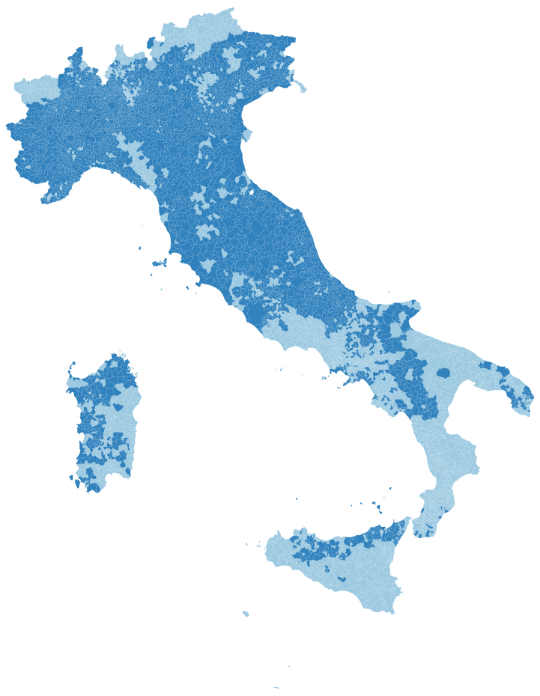
Figure A.2 Distribution of the matched observations (darker blue municipalities)

Robustness tests

Table A.7 below replicates the model originally presented in Table 1 in the article splitting the sample in the different areas. The positive relationship between the citizenship income and the vote for the M5S remains highly statistically significant.

Table A.7 Split sample regressions by area
 | (1) | (2) | (3) | (4) | (5)
 | North-West | North-East | ex-Red  zone | Center | South
Citizenship income | 0.34*** | 0.36*** | 0.48*** | 0.26*** | 0.66***
 | (0.05) | (0.09) | (0.11) | (0.07) | (0.12)
M5S 2018 vote | 0.35*** | 0.19*** | 0.27*** | 0.44*** | 0.48***
 | (0.02) | (0.01) | (0.03) | (0.02) | (0.04)
Change in turnout | 0.02 | 0.01 | -0.13** | -0.16** | -0.35***
 | (0.02) | (0.02) | (0.05) | (0.06) | (0.07)
Constant | -1.03*** | 0.34* | 0.64 | -2.43*** | -4.90***
 | (0.31) | (0.17) | (1.00) | (0.81) | (1.44)
Observations | 3,131 | 839 | 919 | 1,196 | 1,731
R-squared | 0.56 | 0.63 | 0.47 | 0.50 | 0.53
Clustered standard errors in parentheses: *** p<0.01, ** p<0.05, * p<0.1

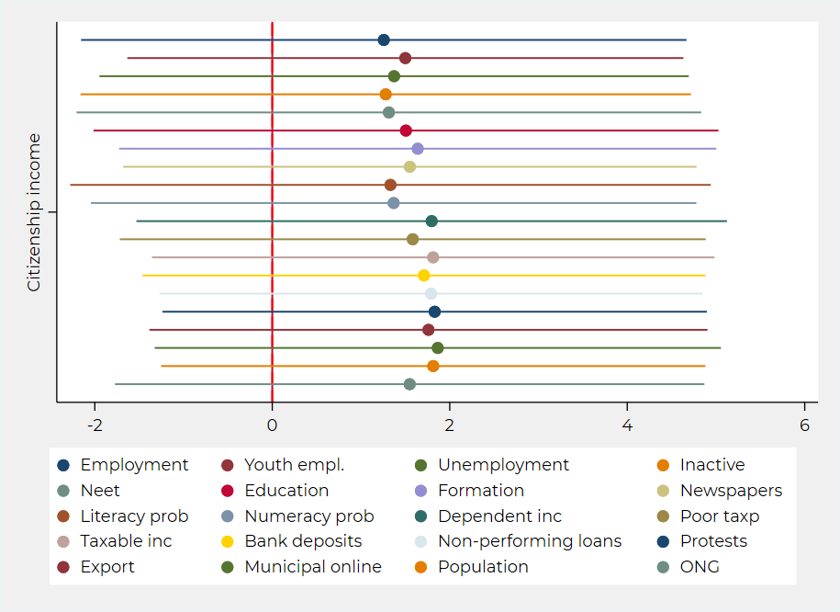
Figure A.3 Main coefficients of the 20 original regression models run with the balanced sample

Similarly to what has been done in the text in Figure 2, Figure A.3 reports the coefficients of the 20 variables included as confounders in the models regressing M5S vote on RdC. Their null effects reflect the good balancing procedure produced by the CEM matching. What was originally a variable in the raw sample is similar to a constant in the balanced one.

Table A.8 Citizenship income and M5S vote (CEM balanced sample, OLS regression)
 | (1) |  | (2) |  | (3)
Citizenship income | 0.16 | (0.29) | 0.21 | (0.29) | 0.17 | (0.32)
M5S 2018 vote | 0.55*** | (0.13) | 0.57*** | (0.13) | 0.56*** | (0.14)
Change in turnout | -0.01 | (0.12) | 0.01 | (0.14) | 0.01 | (0.12)
Employment | 2.95 | (2.84) |  |  | 2.68 | (2.83)
Youth employment | 0.06 | (0.15) |  |  | 1.53 | (1.63)
Unemployment | 1.79 | (1.66) |  |  | -0.06 | (0.09)
Inactive | 2.67 | (2.52) |  |  | 2.25 | (2.38)
Neet | 0.09 | (0.13) |  |  | -0.01 | (0.08)
Literacy problem | -0.42 | (0.33) |  |  | 0.40 | (0.26)
Numeracy problem | 0.29 | (0.18) |  |  | -0.44 | (0.42)
Poor taxpayers | 0.08 | (0.07) |  |  | 0.17* | (0.09)
Non-performing loans | -0.03 | (1.23) |  |  | 1.55 | (1.63)
Education |  |  | -0.15 | (0.14) | -0.15 | (0.10)
Formation |  |  | -0.2 | (0.36) | -0.29 | (0.40)
Newspapers |  |  | -0.04 | (0.03) | -0.03 | (0.03)
Dependent income |  |  | -0.00 | (0.00) | -0.00 | (0.00)
Taxable income |  |  | -0.00 | (0.00) | 0.00 | (0.00)
Bank deposits |  |  | 0.00 | (0.00) | 0.00 | (0.00)
Protests |  |  | 0.00 | (0.00) | -0.00 | (0.00)
Export |  |  | -0.01 | (0.03) | -0.01 | (0.02)
Municipal online |  |  | 0.02 | (0.03) | 0.04 | (0.03)
Population |  |  | 0.43 | (0.35) | 0.44 | (0.28)
ONG |  |  | -0.04 | (0.04) | -0.03 | (0.04)
Constant | -293.24 | (279.92) | 3.50 | (4.25) | -260.55 | (265.86)
Observations | 5443 |  | 5227 |  | 5227
Adj R-squared | 0.56 |  | 0.57 |  | 0.58
Clustered standard errors in parentheses: *** p<0.01, ** p<0.05, * p<0.1

CEM requires a binary distinction between the treatment and the control group. In the article, we first dichotomized the RdC variable using the median as cut-off point before assessing the imbalances between the two groups (Table A.6) and proceed with the matching procedure.
We recognize that the used cut-off point may represent a poor approximation of the required binary treatment, especially in the surrounding of the median value. We thus decide to test an alternative distinction that creates a larger separation between the two groups. We first dropped all cases in the interquartile range, and then proceed to assess the imbalances between the lower 25 percentile and the upper 75 percentile of the distribution of the Citizenship income, and match the cases using CEM (see Table A.9)

Table A.9 Imbalances in the raw and in the matched sample with the treatment group defined by the upper 75 percentile of the variable RdC and control group defined by the lower 25 percentile

Raw sample | L₁ | Avg
Employment rate | 0.86 | -18.990
Unemployment | 0.85 | 10.865
Youth employment | 0.97 | -16.816
Inactive | 0.86 | 13.829
NEETs | 0.82 | 15.133
Numeracy problems | 0.83 | 19.304
Literacy problems | 0.72 | 11.742
Poor taxpayers | 0.73 | 15.309
Non-performing loans | 0.73 | 0.503
Multivariate | 0.947
Balanced sample | L₁ | Avg
Employment rate | 0.00 | 0.001
Unemployment | 0.00 | -0.001
Youth employment | 0.00 | -0.006
Inactive | 0.00 | 0.001
NEETs | 0.01 | 0.008
Numeracy problems | 0.01 | 0.002
Literacy problems | 0.00 | -0.001
Poor taxpayers | 0.12 | -0.29
Non-performing loans | 0.00 | 0.00
Multivariate | 0.431

Starting with the original 7818 observations, and after cancelling those in the interquartile range, we remained with 3994 cases – 1994 in the control group and 2040 in the treated one. Only 74 strata were matched by CEM, including 896 matched cases – 586 in the control group and 310 in the treated one. The map of the matched cases is shown in Figure A.4.

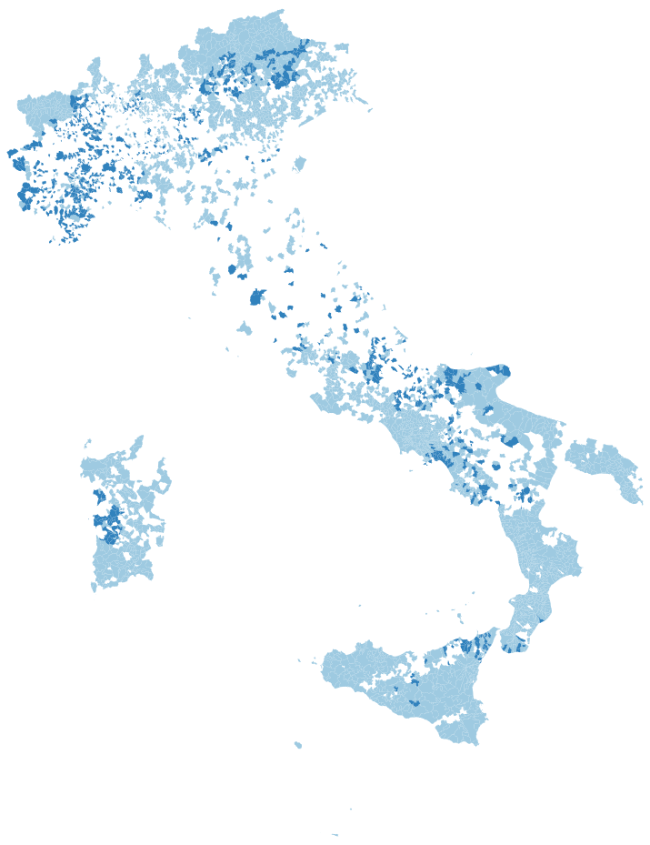
Figure A.4 Distribution of the matched observations (darker blue municipalities)

Table A.10 replicates the same analyses of Table 2 in the article using this new approach to matching, and producing the same null electoral effect of the Citizenship income policy on the M5S vote in the 2022 Italian legislative election.

Table A.10. Citizenship income and M5S vote (CEM balanced sample as in Table A.9, OLS regression)
 | (4) | (5) | (6) | (7) | (8)
Citizenship income | -0.37 | -0.44 | -0.06 | -0.33 | -0.14
 | (0.40) | (0.45) | (0.30) | (0.32) | (0.28)
M5S 2018 vote | 0.95** | 0.97** | 0.62** | 0.89*** | 0.59**
 | (0.35) | (0.41) | (0.23) | (0.26) | (0.22)
Change in turnout | 0.24 | 0.17 | 0.33 | 0.32 | 0.41
 | (0.33) | (0.28) | (0.26) | (0.20) | (0.28)
North-East |  | -0.64
 |  | (1.75)
Red zone |  | 1.21
 |  | (1.79)
Center |  | -2.36
 |  | (4.24)
South |  | 1.33
 |  | (2.54)
Regional dummies
Control variables
Constant | -11.56* | -12.28* | -3.26 | -1217.61 | 543.04
 | (6.65) | (6.79) | (4.93) | (778.55) | (587.43)
Observations | 887 | 887 | 887 | 875 | 875
R-squared | 0.52 | 0.53 | 0.84 | 0.69 | 0.86
Clustered standard errors in parentheses: *** p<0.01, ** p<0.05, * p<0.1

References

Azzollini L, Baldassarri D, and Segatti P (2023) Marginalità economica e ideologia: come disoccupati e precari percepiscono la competizione elettorale tra sinistra e destra. In Roncarolo F and Vezzoni C (eds.), Svolta a destra? Cosa ci dice il voto del 2022. Bologna: il Mulino.
Barisione M, Keeling S, Ladini R, and Maraffi M (2023) Come cambiano le basi sociali del voto. In Roncarolo F and Vezzoni C (eds.), Svolta a destra? Cosa ci dice il voto del 2022. Bologna: il Mulino.
D'Alimonte R and Emanuele V (2023) La vittoria della destra. Partecipazione, risultati e differenze territoriali. In Roncarolo F and Vezzoni C (eds.), Svolta a destra? Cosa ci dice il voto del 2022. Bologna: il Mulino.
Fonda R and Vassallo S (2023) I temi e i leader. In Vassallo S and Verzichelli L (eds.), Il bipolarismo asimmetrico. L'Italia al voto dopo il decennio populista. Bologna: il Mulino, pp. 174-201.
Improta M, Mannoni E, Marcellino C, and Trastulli F (2022) Voters, issues, and party loyalty: the 2022 Italian election under the magnifying glass. Quaderni dell'Osservatorio elettorale QOE - IJES
Maggini N and Vezzoni C (2023) Competizione e spazio elettorale nelle elezioni del 2022. In Roncarolo F and Vezzoni C (eds.), Svolta a destra? Cosa ci dice il voto del 2022. Bologna: il Mulino.
Mancosu M (2023) I luoghi del consenso per i partiti maggiori. In Vassallo S and Verzichelli L (eds.), Il bipolarismo asimmetrico. L'Italia al voto dopo il decennio populista. Bologna: il Mulino, pp. 118-130.
Martini A and Sisti M (2009) Valutare il successo delle politiche pubbliche. Bologna: il Mulino.
Pedrazzani A (2023) La nuova geografia del voto. In Vassallo S and Verzichelli L (eds.), Il bipolarismo asimmetrico. L'Italia al voto dopo il decennio populista. Bologna: il Mulino, pp. 97-116.
Roncarolo F and Vezzoni C (eds.) (2023) Svolta a destra? Cosa ci dice il voto del 2022. Bologna: il Mulino.
Tuorto D (2019) Il voto per il Movimento5 Stelle al Sud tra disagio economico e antipolitica. Meridiana 96, 21-38.
Vassallo S and Verzichelli L (eds.) (2023) Il bipolarismo asimmetrico. L'Italia al voto dopo il decennio populista. Bologna: il Mulino.

