**Supplementary file (online appendix) to:**

**Between ideology and self-interest: Exploring variations in public support for basic income schemes in Germany**

Table A1: Distribution of socio-demographic variables in sample and comparison with German population data.

|  |  |  |  |
| --- | --- | --- | --- |
|  |  | **Sample** | **German population** |
| *Number of respondents (total) Excluded (failed attention test; straightliners) Final sample* | | *4.882 382 4,500* |  |
| Gender | female  male  other | 51.4 %  48.4 %  0.2 % | 50.8 %  49.2 %  n/a |
| Age (years) | 18-29  30-39  40-49  50-59  60+ | 16.9 %  15.7 %  15.1 %  20.1 %  32.2 % | 17.3 %  14.4 %  17.6 %  17.6 %  33.2 % |
| Educational achievement | Low | No school leaving certificate (yet); lower secondary school leaving certificate with vocational training  Medium | Secondary school without Abitur  High | High-school diploma (Abitur) or higher | 32.9 %  32.2 %  35.0 % | 35.8 %  30.5 %  33.6 % |

*Note: Population data are derived from the Mikrozensus.*

Table A2: Coefficients of policy design characteristics (full sample)

*(corresponding to Figure 2: Impact of policy design characteristics on support for basic income)*

|  |  |
| --- | --- |
|  |  |
|  | Support for UBI  (Full sample) |
| EUR 400 | 0 (.) |
| EUR 800 | 0.503*** (0.0697) |
| EUR 1200 | 0.783*** (0.0690) |
| EUR 1600 | 0.729*** (0.0699) |
| All age groups | 0 (.) |
| Only adults | 0.155* (0.0605) |
| Entire household | -0.103 (0.0601) |
| German citizenship | 0 (.) |
| Lived 5 yrs in GER | -0.0756 (0.0602) |
| Lived 1 yr in GER | -0.280*** (0.0601) |
| No restrictions | 0 (.) |
| Unemployed / job-seeking | -0.939*** (0.0694) |
| Seeking further education | -0.389*** (0.0685) |
| Seeking voluntary & social work | -0.360*** (0.0695) |
| Cut other benefits | 0 (.) |
| Increase in income & wealth taxes | 0.962*** (0.0693) |
| Increase in CO2 tax | 0.0207 (0.0698) |
| Increase in VAT | -0.448*** (0.0699) |
| _cons | 4.293*** (0.0962) |
| *N (obs/groups)* | 13500/4500 |

Coefficients from random-intercept model with generalized least squares (GLS).

Standard errors in parentheses.

* *p* < 0.05, ** *p* < 0.01, *** *p* < 0.001

Table A3: Coefficients of policy design characteristics (income groups)

*(corresponding to Figure 4: Heterogeneous treatment effects for different income groups)*

|  |  |  |  |  |  |
| --- | --- | --- | --- | --- | --- |
|  |  |  |  |  |  |
|  | (1) Very low income | (2) Low income | (3) Medium income | (4) High income | (5) Very high income |
| EUR 400 | 0 (.) | 0 (.) | 0 (.) | 0 (.) | 0 (.) |
| EUR 800 | 0.885*** (0.219) | 0.693*** (0.180) | 0.209 (0.125) | 0.686*** (0.133) | 0.374* (0.170) |
| EUR 1200 | 1.642*** (0.214) | 1.298*** (0.173) | 0.541*** (0.125) | 0.776*** (0.130) | 0.225 (0.174) |
| EUR 1600 | 2.076*** (0.219) | 1.144*** (0.175) | 0.468*** (0.126) | 0.586*** (0.133) | 0.179 (0.174) |
| All age groups | 0 (.) | 0 (.) | 0 (.) | 0 (.) | 0 (.) |
| Only adults | 0.301 (0.187) | 0.123 (0.156) | 0.352** (0.108) | -0.0387 (0.115) | -0.00857 (0.149) |
| Entire household | 0.0439 (0.190) | -0.109 (0.154) | -0.0668 (0.108) | -0.241* (0.114) | -0.137 (0.148) |
| German citizenship | 0 (.) | 0 (.) | 0 (.) | 0 (.) | 0 (.) |
| Lived 5 yrs in GER | -0.0489 (0.189) | -0.0347 (0.151) | -0.0718 (0.109) | -0.0643 (0.114) | -0.184 (0.152) |
| Lived 1 yr in GER | -0.261 (0.184) | -0.131 (0.154) | -0.259* (0.109) | -0.297** (0.115) | -0.447** (0.147) |
| No restrictions | 0 (.) | 0 (.) | 0 (.) | 0 (.) | 0 (.) |
| Unemployed / job-seeking | -1.271*** (0.216) | -0.981*** (0.174) | -0.829*** (0.126) | -1.038*** (0.132) | -0.660*** (0.172) |
| Seeking further education | -0.723*** (0.215) | -0.886*** (0.175) | -0.280* (0.125) | -0.274* (0.129) | 0.00492 (0.166) |
| Seeking voluntary & social work | -0.546* (0.217) | -0.732*** (0.175) | -0.361** (0.126) | -0.367** (0.132) | 0.232 (0.171) |
| Cut other benefits | 0 (.) | 0 (.) | 0 (.) | 0 (.) | 0 (.) |
| Increase in income & wealth taxes | 0.868*** (0.217) | 0.890*** (0.174) | 1.298*** (0.125) | 1.044*** (0.133) | 0.298 (0.170) |
| Increase in CO2 tax | 0.374 (0.216) | 0.0721 (0.179) | 0.0916 (0.125) | -0.142 (0.133) | -0.171 (0.174) |
| Increase in VAT | 0.0208 (0.213) | -0.455* (0.177) | -0.364** (0.126) | -0.582*** (0.135) | -0.830*** (0.172) |
| _cons | 3.653*** (0.297) | 4.347*** (0.240) | 4.176*** (0.174) | 4.396*** (0.185) | 4.712*** (0.238) |
| *N (obs/groups)* | 1446/482 | 2316/772 | 3954/1318 | 3516/1172 | 2169/723 |

Coefficients from random-intercept models with generalized least squares (GLS).

Standard errors in parentheses.

* *p* < 0.05, ** *p* < 0.01, *** *p* < 0.001

Table A4: Coefficients of policy design characteristics (age groups)

*(corresponding to Figure 5: Heterogeneous treatment effects for different age groups)*

|  |  |  |  |  |  |
| --- | --- | --- | --- | --- | --- |
|  |  |  |  |  |  |
|  | 18-29 | 30-39 | 40-49 | 50-59 | 60+ |
| EUR 400 | 0 (.) | 0 (.) | 0 (.) | 0 (.) | 0 (.) |
| EUR 800 | -0.0247 (0.154) | 0.411* (0.163) | 0.475** (0.178) | 0.843*** (0.165) | 0.587*** (0.126) |
| EUR 1200 | 0.0750 (0.154) | 0.747*** (0.161) | 0.647*** (0.176) | 1.281*** (0.166) | 0.876*** (0.124) |
| EUR 1600 | 0.244 (0.155) | 0.510** (0.164) | 0.553** (0.180) | 1.101*** (0.168) | 0.913*** (0.124) |
| All age groups | 0 (.) | 0 (.) | 0 (.) | 0 (.) | 0 (.) |
| Only adults | 0.227 (0.135) | 0.0901 (0.138) | -0.00714 (0.155) | 0.0449 (0.145) | 0.270* (0.109) |
| Entire household | -0.118 (0.136) | 0.0708 (0.139) | -0.166 (0.152) | -0.304* (0.142) | -0.0349 (0.109) |
| German citizenship | 0 (.) | 0 (.) | 0 (.) | 0 (.) | 0 (.) |
| Lived 5 yrs in GER | 0.0614 (0.135) | 0.0797 (0.140) | -0.0499 (0.152) | -0.370** (0.142) | -0.0574 (0.109) |
| Lived 1 yr in GER | -0.0484 (0.135) | 0.0606 (0.139) | -0.410** (0.156) | -0.446** (0.142) | -0.410*** (0.108) |
| No restrictions | 0 (.) | 0 (.) | 0 (.) | 0 (.) | 0 (.) |
| Unemployed / job-seeking | -1.044*** (0.154) | -0.884*** (0.162) | -1.224*** (0.177) | -1.106*** (0.164) | -0.680*** (0.126) |
| Seeking further education | -0.237 (0.151) | -0.733*** (0.160) | -0.467** (0.172) | -0.469** (0.163) | -0.258* (0.125) |
| Seeking voluntary & social work | -0.175 (0.156) | -0.402* (0.160) | -0.487** (0.180) | -0.331* (0.164) | -0.385** (0.125) |
| Cut other benefits | 0 (.) | 0 (.) | 0 (.) | 0 (.) | 0 (.) |
| Increase in income & wealth taxes | 0.377* (0.152) | 0.981*** (0.163) | 0.791*** (0.177) | 0.957*** (0.164) | 1.349*** (0.126) |
| Increase in CO2 tax | 0.0212 (0.153) | 0.0605 (0.161) | -0.0417 (0.177) | -0.192 (0.166) | 0.144 (0.127) |
| Increase in VAT | -0.139 (0.155) | -0.464** (0.162) | -0.415* (0.180) | -0.536** (0.167) | -0.529*** (0.126) |
| _cons | 5.298*** (0.218) | 4.874*** (0.219) | 4.666*** (0.249) | 4.140*** (0.226) | 3.453*** (0.173) |
| *N (obs/groups)* | 2283/761 | 2124/708 | 2034/678 | 2715/905 | 4344/1448 |

Coefficients from random-intercept models with generalized least squares (GLS).

Standard errors in parentheses.

* *p* < 0.05, ** *p* < 0.01, *** *p* < 0.001

Table A5: Coefficients of policy design characteristics (ideologies)

*(corresponding to Figure 6: Heterogeneous treatment effects for groups with different ideologies)*

|  |  |  |  |
| --- | --- | --- | --- |
|  |  |  |  |
|  | (1) Left | (2) Center | (3) Right |
| EUR 400 | 0 (.) | 0 (.) | 0 (.) |
| EUR 800 | 0.717*** (0.126) | 0.386*** (0.103) | 0.391** (0.141) |
| EUR 1200 | 1.070*** (0.125) | 0.808*** (0.103) | 0.382** (0.137) |
| EUR 1600 | 1.195*** (0.126) | 0.699*** (0.103) | 0.152 (0.142) |
| All age groups | 0 (.) | 0 (.) | 0 (.) |
| Only adults | 0.238* (0.110) | 0.0577 (0.0894) | 0.224 (0.121) |
| Entire household | -0.157 (0.108) | -0.108 (0.0897) | -0.0254 (0.120) |
| German citizenship | 0 (.) | 0 (.) | 0 (.) |
| Lived 5 yrs in GER | -0.00436 (0.108) | -0.0797 (0.0892) | -0.188 (0.122) |
| Lived 1 yr in GER | -0.125 (0.108) | -0.280** (0.0896) | -0.494*** (0.120) |
| No restrictions | 0 (.) | 0 (.) | 0 (.) |
| Unemployed / job-seeking | -1.106*** (0.124) | -0.887*** (0.103) | -0.780*** (0.141) |
| Seeking further education | -0.622*** (0.124) | -0.304** (0.102) | -0.223 (0.137) |
| Seeking voluntary & social work | -0.519*** (0.125) | -0.246* (0.103) | -0.359* (0.140) |
| Cut other benefits | 0 (.) | 0 (.) | 0 (.) |
| Increase in income & wealth taxes | 1.291*** (0.126) | 0.898*** (0.103) | 0.615*** (0.137) |
| Increase in CO2 tax | 0.411** (0.126) | -0.167 (0.103) | -0.183 (0.140) |
| Increase in VAT | -0.400** (0.125) | -0.470*** (0.104) | -0.509*** (0.142) |
| _cons | 4.225*** (0.172) | 4.164*** (0.142) | 4.632*** (0.196) |
| *N (obs/groups)* | 4356/1452 | 5748/1916 | 3396/1132 |

Coefficients from random-intercept models with generalized least squares (GLS).

Standard errors in parentheses.

* *p* < 0.05, ** *p* < 0.01, *** *p* < 0.001

Table A6: Coefficients of policy design characteristics (partisan support)

*(corresponding to Figure 7: Heterogeneous treatment effects for groups supporting different parties)*

|  |  |  |  |  |  |
| --- | --- | --- | --- | --- | --- |
|  |  |  |  |  |  |
|  | (1) SPD | (2) CDU/CSU | (3) Greens | (4) FDP | (5) AfD |
| EUR 400 | 0 (.) | 0 (.) | 0 (.) | 0 (.) | 0 (.) |
| EUR 800 | 0.895*** (0.174) | 0.279 (0.168) | 0.669** (0.204) | 0.598* (0.265) | 0.427 (0.227) |
| EUR 1200 | 0.914*** (0.171) | 0.311 (0.164) | 0.858*** (0.204) | 0.501 (0.259) | 0.850*** (0.231) |
| EUR 1600 | 0.921*** (0.173) | 0.119 (0.166) | 0.975*** (0.203) | 0.373 (0.265) | 0.680** (0.234) |
| All age groups | 0 (.) | 0 (.) | 0 (.) | 0 (.) | 0 (.) |
| Only adults | 0.279 (0.149) | 0.154 (0.144) | 0.300 (0.176) | 0.278 (0.235) | 0.133 (0.207) |
| Entire household | 0.0881 (0.147) | -0.0722 (0.144) | -0.218 (0.180) | 0.177 (0.231) | -0.213 (0.197) |
| German citizenship | 0 (.) | 0 (.) | 0 (.) | 0 (.) | 0 (.) |
| Lived 5 yrs in GER | 0.0555 (0.149) | -0.171 (0.145) | 0.0918 (0.176) | -0.484* (0.226) | -0.159 (0.204) |
| Lived 1 yr in GER | -0.154 (0.149) | -0.262 (0.143) | 0.0186 (0.173) | -0.330 (0.231) | -0.624** (0.204) |
| No restrictions | 0 (.) | 0 (.) | 0 (.) | 0 (.) | 0 (.) |
| Unemployed / job-seeking | -0.863*** (0.173) | -0.814*** (0.168) | -0.782*** (0.203) | -0.627* (0.259) | -0.792*** (0.228) |
| Seeking further education | -0.481** (0.170) | 0.0868 (0.164) | -0.487* (0.200) | -0.368 (0.267) | -0.626** (0.226) |
| Seeking voluntary & social work | -0.486** (0.174) | -0.121 (0.166) | -0.263 (0.202) | -0.387 (0.252) | -0.873*** (0.232) |
| Cut other benefits | 0 (.) | 0 (.) | 0 (.) | 0 (.) | 0 (.) |
| Increase in income & wealth taxes | 1.308*** (0.172) | 1.090*** (0.164) | 1.192*** (0.205) | -0.244 (0.257) | 0.544* (0.232) |
| Increase in CO2 tax | 0.226 (0.173) | 0.0468 (0.169) | 0.647** (0.206) | -0.590* (0.253) | -0.377 (0.233) |
| Increase in VAT | -0.309 (0.169) | -0.376* (0.168) | -0.0362 (0.204) | -0.978*** (0.272) | -0.604** (0.229) |
| _cons | 4.174*** (0.238) | 3.893*** (0.234) | 4.260*** (0.274) | 5.003*** (0.361) | 4.558*** (0.323) |
| *N (obs/groups)* | 2250/750 | 2220/740 | 1737/579 | 789/263 | 1356/452 |

Coefficients from random-intercept models with generalized least squares (GLS).

Standard errors in parentheses.

* *p* < 0.05, ** *p* < 0.01, *** *p* < 0.001

Figure A1: Screenshot for an exemplary vignette (translated from German to English).



Figure A2: Exploring interactions of respondent characteristics with conditionality.

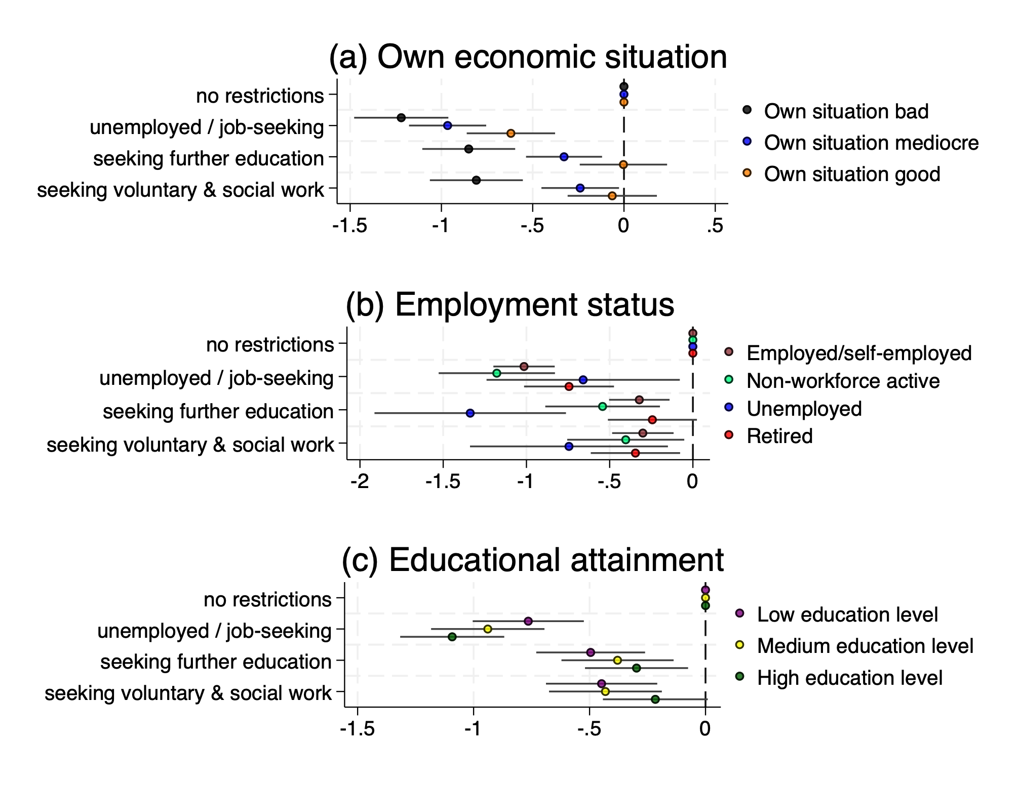

Note: Points show coefficients from random intercept models regressing support for basic income on five policy characteristics (generosity, individuality, universality, conditionality, and financing), contingent on (a) educational attainment, (b) own economic situation, and (c) employment status. Only coefficients for conditionality are shown here. Bars indicate 95% confidence intervals.

Figure A3: Variation in support for basic income among AfD supporters, contingent on conditionality.

