Appendix

Political alienation among basic income support recipients in Germany: The role of social exclusion and experiences with welfare state institutions

Authors: Nils Teichler & Stefanie Gundert

Contact: teichler@uni-bremen.de

**Table A1:** Regression table and KHB: BIS receipt and subjective social integration (pooled OLS analysis)

|  |  |  |
| --- | --- | --- |
|  | M1d: Subjective social integration | M2d: Subjective social integration |
|  | (1) | (2) |
| **Basic Income Support (BIS)** |  |  |
| No receipt of BIS | Ref. | Ref. |
|  |  |  |
| <2 years | -0.261*** | -0.0400 |
|  | 0.0341 | 0.0331 |
| Difference Δ1, mechanism |  | -0.221*** |
|  |  | 0.0206 |
| 2-5 years | -0.320*** | -0.0698 |
|  | 0.0371 | 0.0357 |
| Difference Δ2, mechanism |  | -0.251*** |
|  |  | 0.0208 |
| >5 years | -0.401*** | -0.110** |
|  | 0.0426 | 0.0407 |
| Difference Δ3, mechanism |  | -0.290*** |
|  |  | 0.0212 |
|  |  |  |
| **Material deprivation (index)** |  | -0.251*** |
|  |  | 0.0123 |
| **Social participation: go out** |  |  |
| rarely/never |  | Ref. |
| once a month (at least) |  | 0.209*** |
|  |  | 0.0168 |
| once a week (at least) |  | 0.355*** |
|  |  | 0.0217 |
| **Social participation: visits** |  |  |
| rarely/never |  | Ref. |
| once a month (at least) |  | 0.186*** |
|  |  | 0.0211 |
| once a week (at least) |  | 0.276*** |
|  |  | 0.0217 |
| **Civic engagement** |  | 0.168*** |
| Ref.: no engagement |  | 0.0188 |
|  |  |  |
| Constant | 3.474*** | 3.158*** |
|  | 0.0608 | 0.0605 |
| *N* | 18,906 | 18,906 |
| *R*2 | 0.138 | 0.223 |
| adj. *R*2 | 0.137 | 0.222 |

*Notes*: PASS 0622 v1 (2019-2021); own calculation;regression coefficients and standard errors (cluster-robust, person level); * *p* < 0.05, ** *p* < 0.01, *** *p* < 0.001; mediation analyses were performed using the STATA command KHB, example of interpretation: The difference Δ1 (-0.221) between the two models, with and without objective exclusion risks, represents the portion of the relationship between short-term BIS receipt and subjective integration that is explained by objective exclusion risks. Relative to the total relationship between short-term BIS receipt and subjective integration shown in M1d which is -0.261, this corresponds to an explanatory share of 85 percent (0.221/0.261).

Figure A1: The role of social exclusion in BIS recipients’ trust in government (pooled OLS analysis)

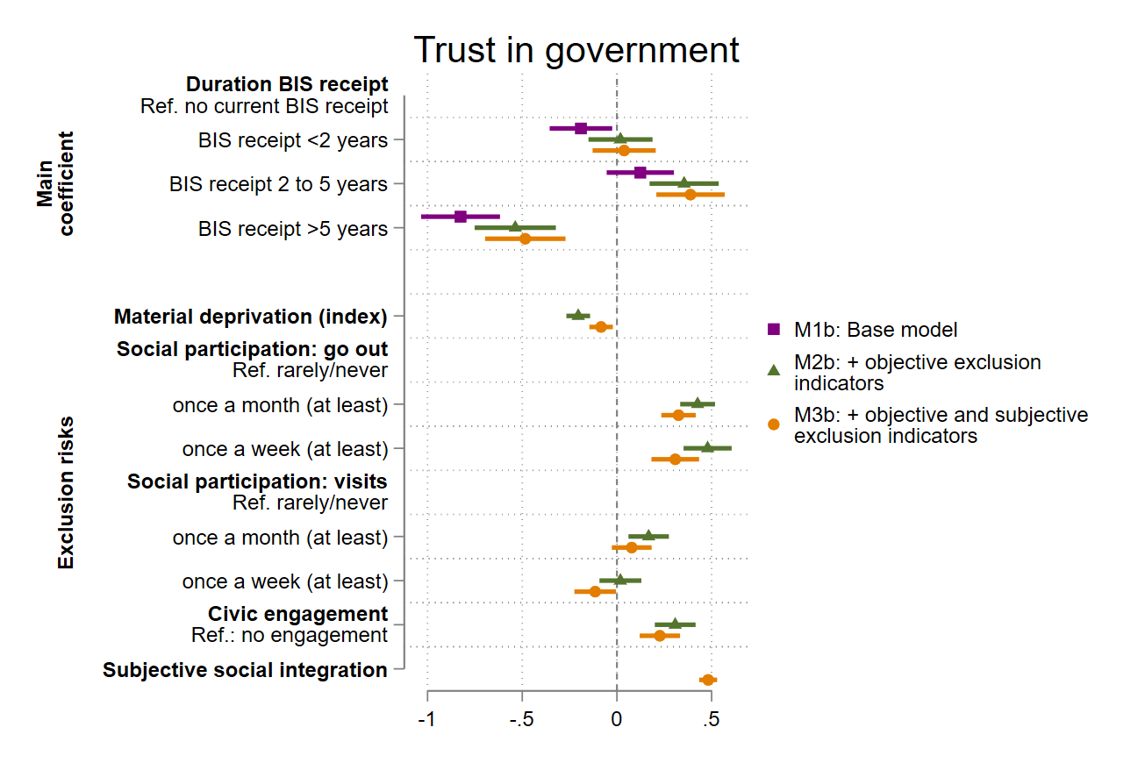

*Notes:* PASS 0622 v1 (2019-2021); own calculation; regression coefficients with 95% confidence intervals; n=18,906; cluster-robust standard errors (person level).

Figure A2: The role of social exclusion in BIS recipients’ satisfaction with democracy (pooled OLS analysis)

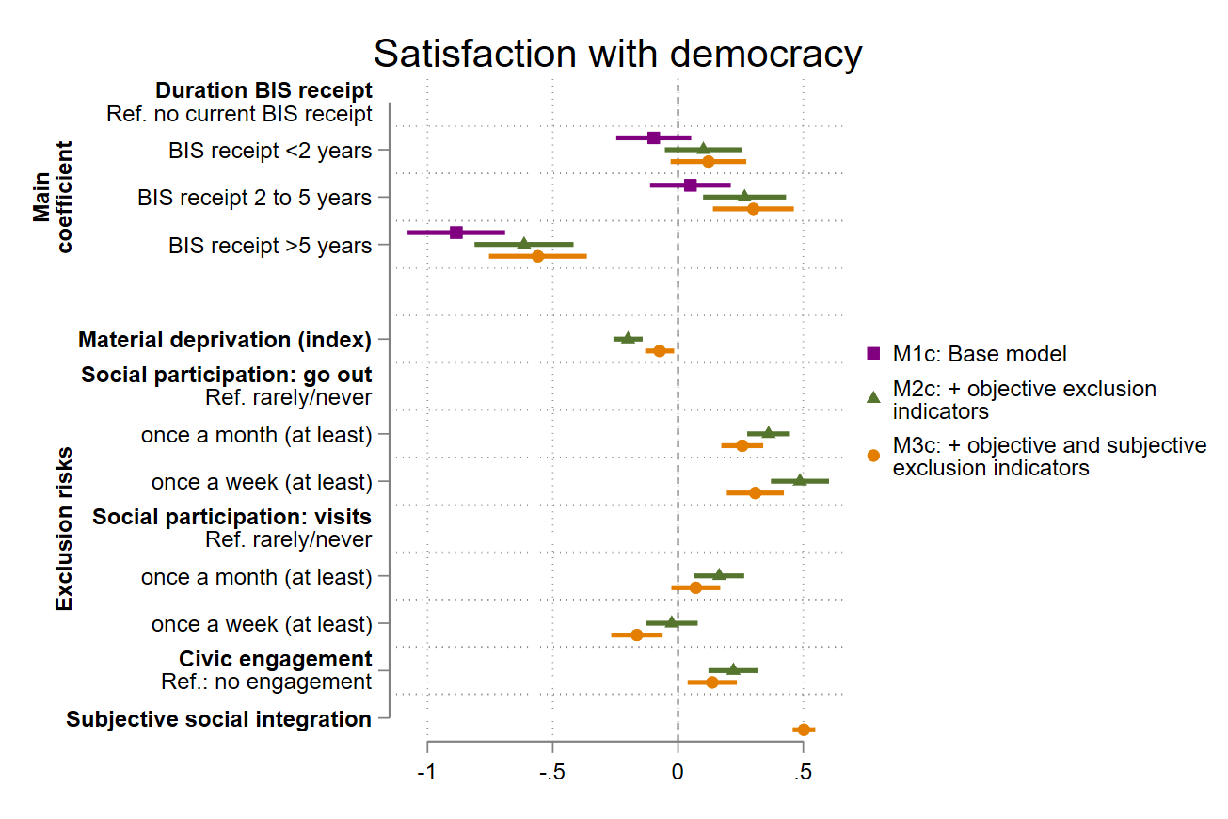

*Notes:* PASS 0622 v1 (2019-2021); own calculation; regression coefficients with 95% confidence intervals; n=18,906; cluster-robust standard errors (person level).

|  |  |  |  |  |  |  |  |  |  |
| --- | --- | --- | --- | --- | --- | --- | --- | --- | --- |
|  | M1a:  Trust in  political parties | M2a:  Trust in  political parties | M3a:  Trust in  political parties | M1b:  Trust in  government | M2b:  Trust in  government | M3b:  Trust in  government | M1c:  Satisfaction with  democracy | M2c:  Satisfaction with  democracy | M3c:  Satisfaction with  democracy |
|  | (1) | (2) | (3) | (4) | (5) | (6) | (7) | (8) | (9) |
| **Basic Income Support (BIS)** |  |  |  |  |  |  |  |  |  |
| No receipt of BIS | Ref. | Ref. | Ref. | Ref. | Ref. | Ref. | Ref. | Ref. | Ref. |
|  |  |  |  |  |  |  |  |  |  |
| <2 years | -0.321*** | -0.0860 | -0.0678 | -0.190* | 0.0187 | 0.0380 | -0.0970 | 0.101 | 0.121 |
|  | 0.0796 | 0.0817 | 0.0804 | 0.0843 | 0.0863 | 0.0850 | 0.0763 | 0.0785 | 0.0770 |
| Difference Δ1, mechanism |  | -0.235*** | -0.253*** |  | -0.209*** | -0.228*** |  | -0.198*** | -0.218*** |
|  |  | 0.0290 | 0.0380 |  | 0.0302 | 0.0398 |  | 0.0281 | 0.0390 |
| 2-5 years | -0.333*** | -0.0750 | -0.0432 | 0.123 | 0.355*** | 0.388*** | 0.0494 | 0.266** | 0.301*** |
|  | 0.0869 | 0.0893 | 0.0882 | 0.0906 | 0.0932 | 0.0921 | 0.0822 | 0.0845 | 0.0824 |
| Difference Δ2, mechanism |  | -0.258*** | -0.289*** |  | -0.231*** | -0.265*** |  | -0.216*** | -0.251*** |
|  |  | 0.0301 | 0.0388 |  | 0.0314 | 0.0407 |  | 0.0292 | 0.0398 |
| >5 years | -0.804*** | -0.495*** | -0.445*** | -0.826*** | -0.538*** | -0.484*** | -0.885*** | -0.615*** | -0.560*** |
|  | 0.0976 | 0.1000 | 0.0988 | 0.106 | 0.109 | 0.108 | 0.0993 | 0.101 | 0.0997 |
| Difference Δ3, mechanism |  | -0.309*** | -0.360*** |  | -0.289*** | -0.342*** |  | -0.270*** | -0.326*** |
|  |  | 0.0314 | 0.0398 |  | 0.0329 | 0.0419 |  | 0.0306 | 0.0409 |
|  |  |  |  |  |  |  |  |  |  |
| **Material deprivation (index)** |  | -0.245*** | -0.131*** |  | -0.204*** | -0.0834** |  | -0.199*** | -0.0733* |
|  |  | 0.0299 | 0.0297 |  | 0.0319 | 0.0317 |  | 0.0298 | 0.0295 |
| **Social participation: go out** |  |  |  |  |  |  |  |  |  |
| rarely/never |  | Ref. | Ref. |  | Ref. | Ref. |  | Ref. | Ref. |
| once a month (at least) |  | 0.357*** | 0.261*** |  | 0.426*** | 0.326*** |  | 0.361*** | 0.257*** |
|  |  | 0.0442 | 0.0437 |  | 0.0469 | 0.0463 |  | 0.0436 | 0.0426 |
| once a week (at least) |  | 0.398*** | 0.236*** |  | 0.479*** | 0.308*** |  | 0.487*** | 0.309*** |
|  |  | 0.0619 | 0.0615 |  | 0.0648 | 0.0642 |  | 0.0591 | 0.0582 |
| **Social participation: visits** |  |  |  |  |  |  |  |  |  |
| rarely/never |  | Ref. | Ref. |  | Ref. | Ref. |  | Ref. | Ref. |
| once a month (at least) |  | 0.125* | 0.0401 |  | 0.167** | 0.0778 |  | 0.164** | 0.0708 |
|  |  | 0.0508 | 0.0501 |  | 0.0544 | 0.0536 |  | 0.0508 | 0.0497 |
| once a week (at least) |  | 0.00332 | -0.123* |  | 0.0183 | -0.115* |  | -0.0250 | -0.164** |
|  |  | 0.0525 | 0.0520 |  | 0.0565 | 0.0560 |  | 0.0528 | 0.0523 |
| **Civic engagement** |  | 0.336*** | 0.259*** |  | 0.308*** | 0.227*** |  | 0.221*** | 0.136** |
| Ref.: no engagement |  | 0.0508 | 0.0502 |  | 0.0549 | 0.0544 |  | 0.0509 | 0.0501 |
| **Subjective social integration** |  |  | 0.456*** |  |  | 0.482*** |  |  | 0.503*** |
|  |  |  | 0.0227 |  |  | 0.0242 |  |  | 0.0230 |
| Constant | 2.202*** | 1.987*** | 0.548** | 2.585*** | 2.280*** | 0.758*** | 4.062*** | 3.814*** | 2.227*** |
|  | 0.154 | 0.160 | 0.170 | 0.163 | 0.169 | 0.182 | 0.151 | 0.157 | 0.171 |
| *N* | 18,906 | 18,906 | 18,906 | 18,906 | 18,906 | 18,906 | 18,906 | 18,906 | 18,906 |
| *R*2 | 0.0893 | 0.106 | 0.135 | 0.173 | 0.187 | 0.213 | 0.177 | 0.191 | 0.224 |

Table A2: Regression table and KHB: the role of social exclusion for BIS recipients’ political alienation (pooled OLS analysis)

*Notes*: PASS 0622 v1 (2019-2021); own calculation;regression coefficients and standard errors (cluster-robust, person level); * *p* < 0.05, ** *p* < 0.01, *** *p* < 0.001; mediation analyses were performed using the STATA command KHB, example of interpretation: The difference Δ3 (-0.326) between the models M1c (column 7) and M3c (column 9), with and without objective and subjective exclusion risks, represents the portion of the relationship between long-term BIS receipt and satisfaction with democracy that is explained by objective and subjective exclusion risks. Relative to the total relationship between long-term BIS receipt and satisfaction with democracy shown in model M1c, which is -0.885, this corresponds to an explanatory share of 37 percent (0.326/0.885).

Table A3: Descriptive statistics: experiences of BIS recipients in job centres

|  |  |  |  |  |
| --- | --- | --- | --- | --- |
|  | No BIS receipt | Low level of trust and support | High level of trust and support | total |
| No BIS receipt | 13,449 [100] | 0 | 0 | 13,449 [100] |
| <2 years | 0 | 1,196 [67.69] | 571 [32.31] | 1,767 [100] |
| 2-5 years | 0 | 1,257 [62.82] | 744 [37.18] | 2,001 [100] |
| >5 years | 0 | 1,041 [73.93] | 367 [26.07] | 1,408 [100] |
| total | 13,449 [72.21] | 3,494 [18.76] | 1,682 [9.03] | 18,625 [100] |

*Notes*: PASS 0622 v1 (2019-2021); own calculation; row percentages in square brackets.

**Figure A3:** Mean levels of political alienation (2019-2021)

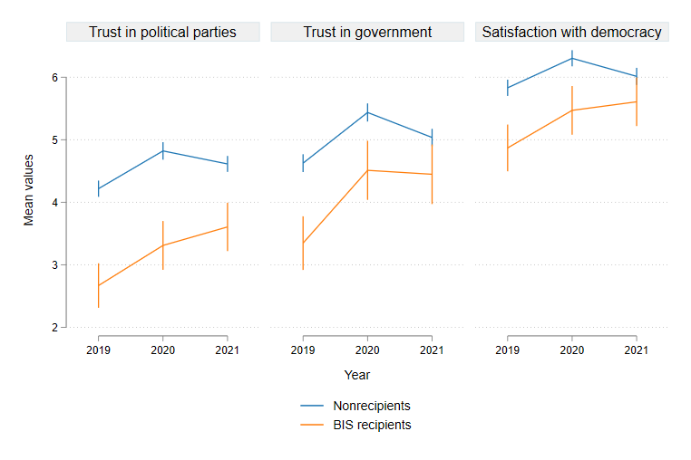

*Notes*: PASS 0622 v1 (2019-2021); own calculation; arithmetic means with 95% confidence intervals; each indicator is measured on an 11-point scale; weighted analysis.

Table A4: Fixed effects regression models

|  |  |  |  |  |  |  |  |  |  |
| --- | --- | --- | --- | --- | --- | --- | --- | --- | --- |
|  | M5a:  Trust in  political parties | M6a:  Trust in  political parties | M5b:  Trust in  government | M6b:  Trust in  government | M5c:  Satisfaction with democracy | M6c:  Satisfaction with democracy | M7a:  Trust in  political parties | M7b:  Trust in  government | M7c:  Satisfaction with democracy |
|  | (1) | (2) | (3) | (4) | (5) | (6) | (7) | (8) | (9) |
| **Basic Income Support (BIS)** |  |  |  |  |  |  |  |  |  |
| No receipt of BIS | Ref. | Ref. | Ref. | Ref. | Ref. | Ref. | *excluded* | *excluded* | *excluded* |
|  |  |  |  |  |  |  |  |  |  |
| <2 years | -0.10 | -0.07 | 0.03 | 0.05 | -0.04 | -0.02 | Ref. | Ref. | Ref. |
|  | (-0.91) | (-0.63) | (0.30) | (0.54) | (-0.44) | (-0.21) |  |  |  |
|  |  |  |  |  |  |  |  |  |  |
| 2-5 years | -0.25** | -0.21* | -0.01 | 0.02 | -0.16 | -0.13 | 0.02 | -0.03 | -0.16 |
|  | (-2.09) | (-1.78) | (-0.08) | (0.19) | (-1.63) | (-1.34) | (0.12) | (-0.25) | (-1.49) |
|  |  |  |  |  |  |  |  |  |  |
| >5 years | -0.42*** | -0.38** | -0.07 | -0.03 | -0.18 | -0.14 | -0.08 | -0.03 | -0.16 |
|  | (-2.61) | (-2.37) | (-0.49) | (-0.23) | (-1.20) | (-0.95) | (-0.37) | (-0.13) | (-0.79) |
|  |  |  |  |  |  |  |  |  |  |
| **Social exclusion indicators** |  | ✓ |  | ✓ |  | ✓ |  |  |  |
|  |  |  |  |  |  |  |  |  |  |
| **Experiences in job centres** |  |  |  |  |  |  |  |  |  |
| Low level of support & trust |  |  |  |  |  |  | Ref. | Ref. | Ref. |
| High level of support & trust |  |  |  |  |  |  | -0.08 | 0.16* | 0.17* |
|  |  |  |  |  |  |  | (-0.77) | (1.72) | (1.82) |
| Observations | 19,571 | 19,571 | 19,571 | 19,571 | 19,571 | 19,571 | 5,304 | 5,304 | 5,304 |

*Notes*:PASS 0622 v1 (2019-2021); own calculation; linear fixed effects regression models with robust standard errors; regression coefficients and *t* statistics in parentheses;

* *p* < 0.10, ** *p* < 0.05, *** *p* < 0.01; control variables: age (categorical), education, household type, region (Eastern/Western Germany), years affected by the COVID-19 pandemic (dummy); additional control variables for M5a-c and M6a-c: labour market status, interaction effect between BIS receipt and years affected by the COVID-19 pandemic; social exclusion indicators: material deprivation (index), social participation, civic engagement (dummy), subjective social integration.