Supplementary material

Number of abortions by ethnic group
Note that the recording of ethnicity during 2020 and 2021 was severely impacted by the Covid pandemic and changes to abortion procedures. The huge increase in “unknown” ethnicity in those years means estimates for all groups in those years are uncertain.
Supplementary figure 1: Number of abortions by recorded ethnicity, England, 2013 to 2021
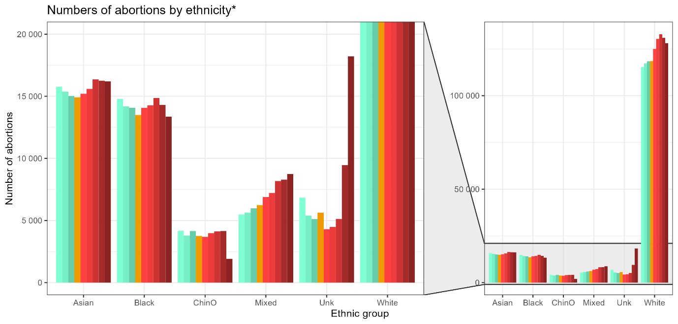
ChinO = Chinese or other ethnic group; Unk = unknown ethnic group

Model results
Supplementary table 1: Coefficients and p-values for the level-change and slope-change models, IMD deciles 1 to 4 only
Coefficient values show the change in the number of abortions associated with the model terms at each given combination of number of previous births IMD decile (restricted to the most deprived 4 deciles, for space).
In the level-change model the model terms were Time and Policy (whether the policy was in force or not). Time was significantly associated with increased numbers of abortions in all groups with 2+ previous births, while the policy itself was non-significantly associated with decreased numbers of abortions in most groups.
In the slope-change model the model terms were Time and Policy-time (how long the policy had been in force for, allowing it to have an increasing impact over time). Time was significantly associated with increased numbers of abortions in most groups with 2+ previous births, while the policy itself had no significant association with numbers of abortions among people with 2+ previous births.

IMD decile | Previous births | Change modelled | Time coefficient | p-value | Policy coefficient | p-value | Policy-time coefficient | p-value
1 | 0 | Level | 222.6 | 0.011 | -455.2 | 0.271 | NA | NA
2 | 0 | Level | 138.7 | 0.160 | -387.3 | 0.402 | NA | NA
3 | 0 | Level | 88.6 | 0.286 | -160.7 | 0.655 | NA | NA
4 | 0 | Level | 78.7 | 0.365 | -95.3 | 0.745 | NA | NA
1 | 1 | Level | 169.3 | 0.001 | -485.5 | 0.028 | NA | NA
2 | 1 | Level | 60.7 | 0.136 | -291.2 | 0.184 | NA | NA
3 | 1 | Level | 59.1 | 0.157 | -430.5 | 0.144 | NA | NA
4 | 1 | Level | 79.0 | 0.096 | -337.3 | 0.122 | NA | NA
1 | 2 | Level | 289.7 | 0.000 | -111.5 | 0.280 | NA | NA
2 | 2 | Level | 188.6 | 0.003 | -21.7 | 0.864 | NA | NA
3 | 2 | Level | 187.8 | 0.000 | -196.7 | 0.002 | NA | NA
4 | 2 | Level | 152.1 | 0.001 | -49.8 | 0.586 | NA | NA
1 | 3 | Level | 201.3 | 0.000 | 29.9 | 0.722 | NA | NA
2 | 3 | Level | 121.4 | 0.002 | 37.2 | 0.663 | NA | NA
3 | 3 | Level | 96.7 | 0.004 | -94.3 | 0.279 | NA | NA
4 | 3 | Level | 80.0 | 0.000 | -31.7 | 0.330 | NA | NA
1 | 4+ | Level | 176.9 | 0.000 | -31.6 | 0.657 | NA | NA
2 | 4+ | Level | 97.5 | 0.002 | -13.6 | 0.868 | NA | NA
3 | 4+ | Level | 79.7 | 0.000 | -48.5 | 0.179 | NA | NA
4 | 4+ | Level | 65.3 | 0.007 | -102.0 | 0.297 | NA | NA
1 | 0 | Slope | -196.3 | 0.035 | NA | NA | 429.3 | 0.004
2 | 0 | Slope | -246.3 | 0.078 | NA | NA | 400.3 | 0.049
3 | 0 | Slope | -123.0 | 0.259 | NA | NA | 229.7 | 0.158
4 | 0 | Slope | -166.5 | 0.156 | NA | NA | 282.7 | 0.119
1 | 1 | Slope | -66.8 | 0.547 | NA | NA | 199.9 | 0.268
2 | 1 | Slope | -156.9 | 0.044 | NA | NA | 213.0 | 0.053
3 | 1 | Slope | -251.3 | 0.015 | NA | NA | 300.9 | 0.027
4 | 1 | Slope | -117.0 | 0.163 | NA | NA | 178.0 | 0.146
1 | 2 | Slope | 176.5 | 0.010 | NA | NA | 118.2 | 0.102
2 | 2 | Slope | 118.7 | 0.038 | NA | NA | 81.6 | 0.243
3 | 2 | Slope | 113.2 | 0.115 | NA | NA | 55.2 | 0.460
4 | 2 | Slope | 85.9 | 0.030 | NA | NA | 71.9 | 0.146
1 | 3 | Slope | 209.8 | 0.016 | NA | NA | -5.0 | 0.928
2 | 3 | Slope | 100.7 | 0.042 | NA | NA | 32.2 | 0.499
3 | 3 | Slope | 38.7 | 0.342 | NA | NA | 53.6 | 0.343
4 | 3 | Slope | 95.4 | 0.009 | NA | NA | -24.7 | 0.398
1 | 4+ | Slope | 136.0 | 0.001 | NA | NA | 44.3 | 0.219
2 | 4+ | Slope | 40.8 | 0.126 | NA | NA | 67.0 | 0.115
3 | 4+ | Slope | 45.9 | 0.014 | NA | NA | 32.5 | 0.126
4 | 4+ | Slope | -8.6 | 0.678 | NA | NA | 71.8 | 0.091
 | Not subject to the limit |  |  |  | Increase in number of abortions
 | Subject to the limit |  |  |  | Fall in number of abortions
0.000 | p < 0.05

Number of abortions by region
Supplementary figure 2: Numbers of abortion by region, England, 2013 to 2021
