**Supplementary online material**

*New shades of conflict?*

*Theorising the multi-dimensional politics of eco-social policies.*

*Journal of Social Policy*

By *Torben Fischer and Giovanni Amerigo Giuliani*

**Content Analysis of Party Manifestos**

To identify a party’s positions on the two dimensions of conflict concerning eco-social policy, we assumed that they were expressed in national election manifestos. We therefore conducted a content analysis of party manifestos for the 2021 German election. The content analysis strategy is similar to that of Enggist and Pinggera (2022) and Giuliani (2024). To identify parties’ positions, we re-coded data as *quasi-sentences* from the Manifesto Project Dataset (Lehmann et al., 2024). The Manifesto Project Dataset provides access to the parties’ election manifestos, split into quasi-sentences. These quasi-sentences are assigned to a broad policy category, such as “Welfare State Expansion” or “Education Expansion.” These categories are too broad to detect specific positions regarding the two lines of conflicts and the four sub-dimensions. For this reason, we have created a new coding scheme.

First, we identified those categories within the Manifesto Project Dataset, which can theoretically include stances regarding eco-social policies. Such categories are the following:

“per402 Incentives: Positive”; “per403 Market Regulation”; “per404 Economic Planning”; “per405 Corporatism/Mixed Economy”; “per408 Economic Goals”; “per409 Keynesian Demand Management”; “per410 Economic Growth: Positive”; “per411 Technology and Infrastructure: Positive”; “per412 Controlled Economy”; “per416 Anti-Growth Economy: Positive”; “per501 Environmental Protection”; “per503 Equality: Positive”; “per504 Welfare State Expansion”; “per505 Welfare State Limitation”; “per506 Education Expansion”; “per507 Education Limitation”; “per701 Labour Groups: Positive”; “per702 Labour Groups: Negative”; “per703 Agriculture and Farmers: Positive”; “per416_1 Anti-Growth Economy: Positive”; “per416_2 Sustainability: Positive”; “per703_1 Agriculture and Farmers: Positive”; “per703_2 Agriculture and Farmers: Negative”.

We then identified in a first step all quasi-sentences which address eco-social risks, goals and/or policies. For re-coding a quasi-sentence as eco-social, we referred to Mandelli (2022: 334) and focused on “the interconnection between the social and the environmental spheres and […] how this can be addressed through eco-social policies”. If they were categorized as eco-social, we assigned them to one the two dimensions of conflict. This was a two-step procedure:

* First, we assigned the quasi-sentences to the first dimension of conflict – the *ideational approach* dimension. Once a quasi-sentence was included within this dimension of conflict, we coded its “sentiment”, that is whether the party takes a pro-trade-off or a pro-synergy stance.
* Second, we assigned the remaining quasi-sentences to the second dimension of conflict – the *design* dimension. Each of them was then assigned to one of the four subdimensions: I Sub-dimension: *Role of government*; II Sub-dimension: *Policy instruments*; III Sub-Dimension: *Policy beneficiaries;* IV Dimension: *Growth strategy.* Once a quasi-sentence was included in one of the four subdimensions, we coded its “sentiment”.

When the coding of single quasi-sentences proved problematic (mostly due to the vagueness of the wording), we decided to read all the manifestos – thus including quasi-sentences which do not belong to the codes previously indicated – to contextualise them. On several occasions, contextualization was crucial to properly code a vague quasi-sentence. Furthermore, the reading of the whole party manifestos has functioned as a sort of robustness check to be sure that no relevant quasi-sentences were left out. In terms of coding reliability, each author coded one half of the party manifestos. We then performed a cross-correspondence check. The assignment of the ambiguous quasi-sentences was then rediscussed among the authors and then coded accordingly.

The quantitative results of the content analysis were used to construct five eco-social policies indices (one for the first dimension of conflict, four for the second dimension) which measure the specific position (its intensity) adopted by parties. Below is the explanation of the indexes in detail. The indices resemble the method used by the Manifesto Project Dataset to build the RILE scale.

**First Dimension of conflict**: **Synergy vs. Trade-off**

For the first dimension-of-conflict index, the number of (positive) quasi-sentences on trade-off was subtracted from the number of (positive) quasi-stances on synergies and taken as a share of all quasi-stances on the first line of conflict. The value was then multiplied by 100:

First Dimension-of-conflict Index = $\frac{ proTrade_off-proSynergy}{proSynergy+proTrade_off}$* 100

**Second dimension of conflict**

**I Sub-dimension: *Role of government***

For the Sub-dimension I index, the number of (positive) quasi-sentences on state involvement was subtracted from the number of (positive) quasi-stances on market solution and taken as a share of all quasi-stances on the first dimension of conflict. The value was then multiplied by 100:

Sub-dimension I Index = $\frac{ proMarketSolution-proState Involvement}{proState Involvement+proMarketSolution}$* 100

**II Sub-dimension: *Policy instruments***

For the Sub-dimension II index, the number of (positive) quasi-sentences on social consumption (SC) was subtracted from the number of (positive) quasi-stances on social investment (SI) and taken as a share of all quasi-stances on the second dimension of conflict. The value was then multiplied by 100:

Sub-dimension II Index = $\frac{proSI- proSC}{proSC+proSI}$* 100

**III Sub-dimension: *Policy beneficiaries***

For the Sub-dimension III index, the number of (positive) quasi-sentences on selective measures was subtracted from the number of (positive) quasi-sentences on inclusive/universal measures quasi-stances and taken as a share of all quasi-stances on the third dimension of conflict. The value was then multiplied by 100:

Sub-dimension III Index = $\frac{ proUniversal-proSelective}{proUniversal+proSelective}$* 100

**IV Sub-dimension: *Growth strategy***

For the Sub-dimension IV index, the number of (positive) quasi-sentences on degrowth was subtracted from the number of (positive) quasi-stances on (green) growth and taken as a share of all quasi-stances on the fourth dimension of conflict. The value was then multiplied by 100:

Sub-dimension III Index = $\frac{ proGrowth-proDe_growth}{pproGrowth+proDe_growth}$* 100

Both indices range from -100 (proSynergy; proStateInvolvement; proSC; proSelective; proDegrowth) to +100 (proTradeOff; proMarketSolution; proSI; proUniversal; proGreenGrowth), with 0 meaning that there is a neutral position.

**Salience of Eco-social policies in German party manifestos**

To understand whether eco-social policy is a key issue for the German political parties, we also provided an indicator of its relative salience in the electoral manifestos. First, we calculated the percentage of all quasi-sentences devoted to eco-social risks and policies (regardless of the ideological direction of these quasi-sentences) in the parties’ programs. That gives a more precise indication regarding the extent to which eco-social policies entered the political agenda. Second, we also calculated the salience that political parties have put on each of the four sub-dimensions. Salience has been calculated as the share of the quasi-sentences dedicated to a specific sub-dimension on the total of the coded eco-social policy quasi-sentences.

**The German case study: Environmental Protection and Welfare State Salience in German party manifestos, 2017 and 2021**

Germany is an interesting case study for two reasons:

First, from a party politics perspective, the German party system in 2021 allows us to detect positions for all the core party families for which we have made some assumptions: the Christian Democrats/Conservatives (CDU/CSU), the Social Democrats (SPD), the Liberals (FDP), the Greens (Alliance 90/The Greens), the Radical Left (The Left), and the Far Right (AfD).

Second, in the 2021 elections, as shown in Fig. A. environmental protection has been a key topic of the electoral campaign, as the high level of electoral support for the Greens shows (14.8% of the votes). Furthermore, even the welfare state salience substantially scaled up: on average in 2021, 9.1% of the party manifestos were dedicated to welfare state issues, (+2.6 points compared to the 2017 elections).

**Fig. A**. Average Environmental Protection and Welfare State Salience in German party manifestos, 2017 and 2021

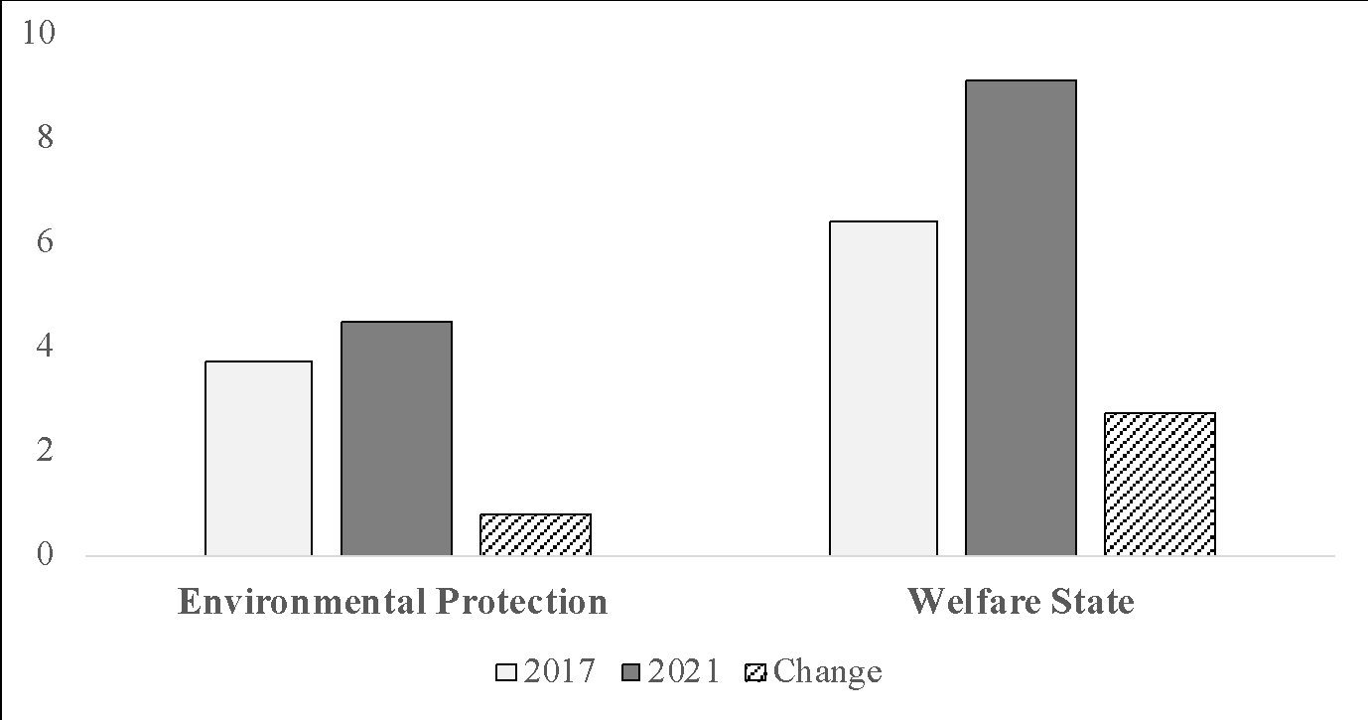

*Source*: Manifesto Project Dataset

*Note*: Salience is calculated as the share of quasi-sentences dedicated to a specific category. Environmental Protection salience= variable per501. Welfare State Salience= variables per504+per505. The values in the figure have been calculated by averaging all the parties’ scores in the two categories and weighted by the parties’ electoral share.

**References**

Enggist, M., and Pinggera, M. (2022), Radical right parties and their welfare state stances – not so blurry after all? *West European Politics*, 45(1), 102–128.

Giuliani, G.A. (2024). *The Mainstream Right and Family Policy Agendas in the Post-Fordist Age: Beyond Familialism?* Leeds, UK: Emerald Publishing.

Lehmann, P., Franzmann, S., Al-Gaddooa, D., Burst, T., Ivanusch, C., Regel, S., Riethmüller, F., Volkens, A., Weßels, B., & Zehnter, L. (2024). *The Manifesto Data Collection. Manifesto Project (MRG / CMP / MARPOR). Version 2024a.* Berlin: Wissenschaftszentrum Berlin für Sozialforschung (WZB) / Göttingen: Institut für Demokratieforschung (IfDem). https://doi.org/10.25522/manifesto.mpds.2024a

Mandelli, M. (2022), ‘Understanding eco-social policies: a proposed definition and typology’, *Transfer: European Review of Labour and Research*, 28, 3, 333–348.