Supplementary Materials
Supplementary Fig. S1. The volumetric water content, soil conductivity, and soil temperature in the first run of the experiment. D, drought; WW, well-watered; CC, corn monoculture; CJ, interspecific competition; JJ, Johnsongrass monoculture. The panels numbered 1 to 6 represent week 1 to week 6, showing change over time.
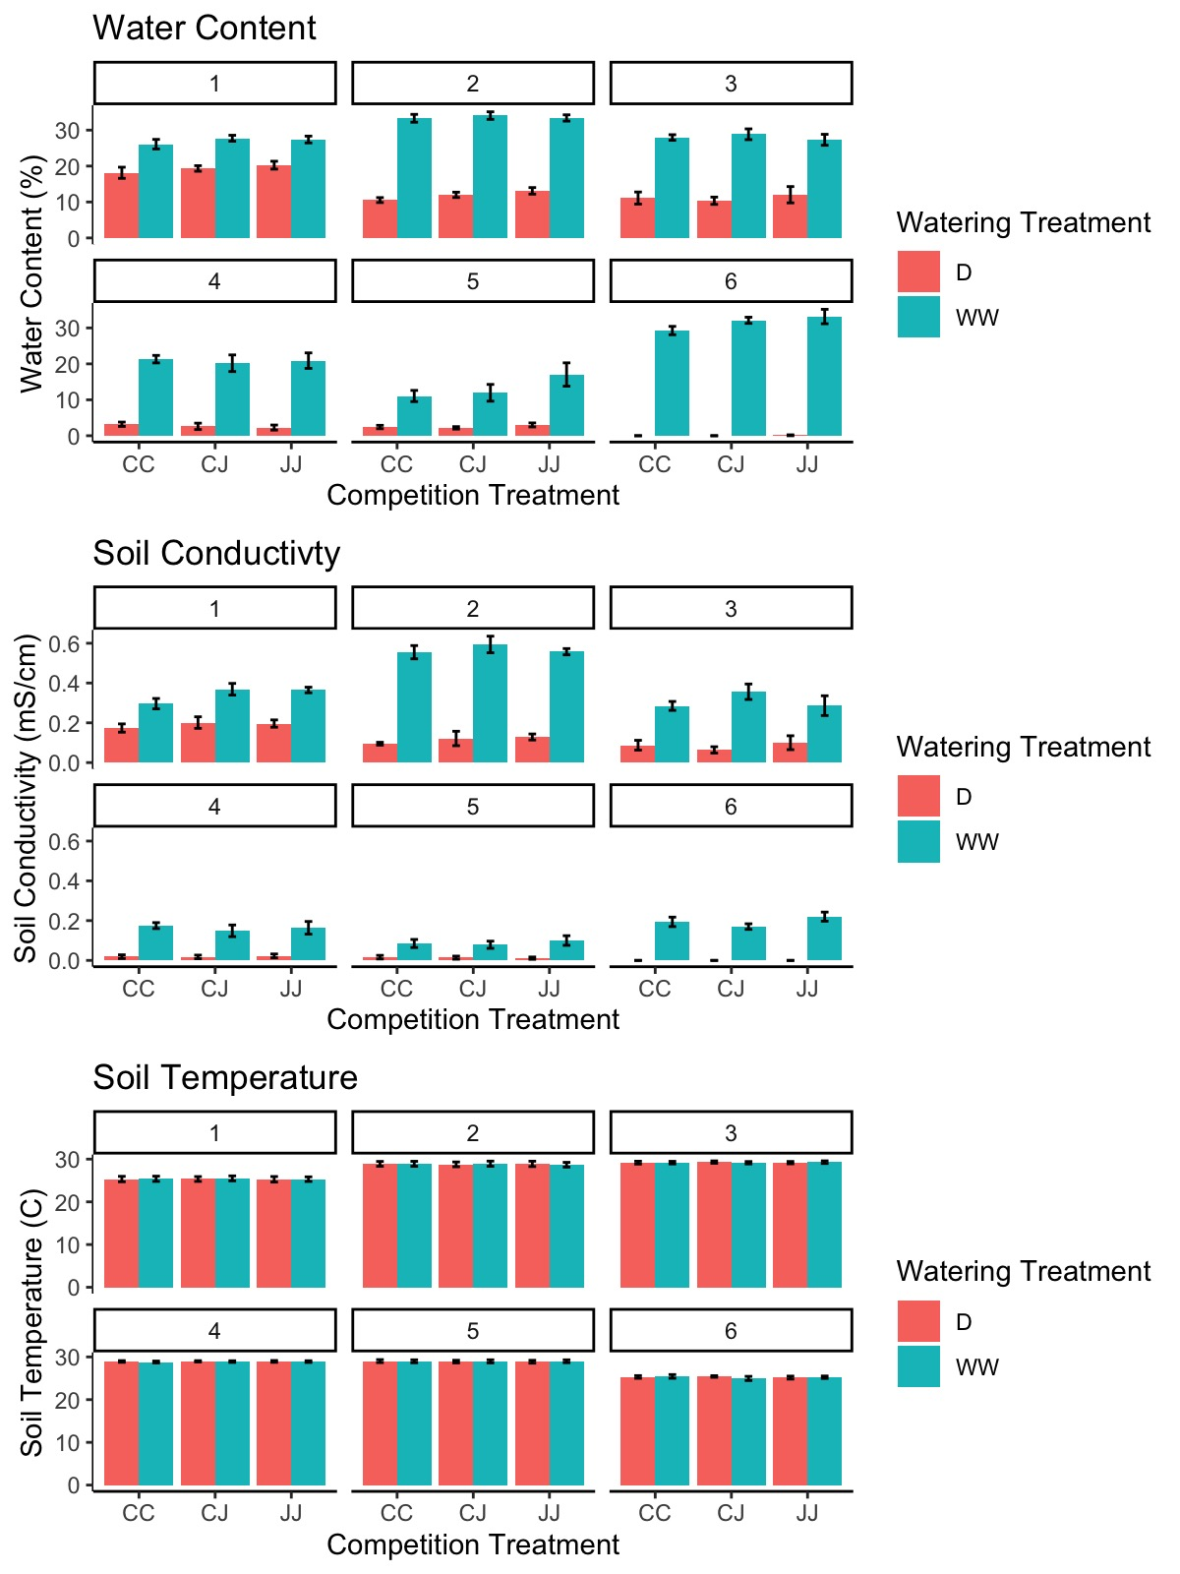
Supplementary Fig. S2. The volumetric water content, soil conductivity, and soil temperature in the second run of the experiment. D, drought; WW, well-watered; CC, corn monoculture; CJ, interspecific competition; JJ, Johnsongrass monoculture. The panels numbered 1 to 6 represent week 1 to week 6, showing change over time.
