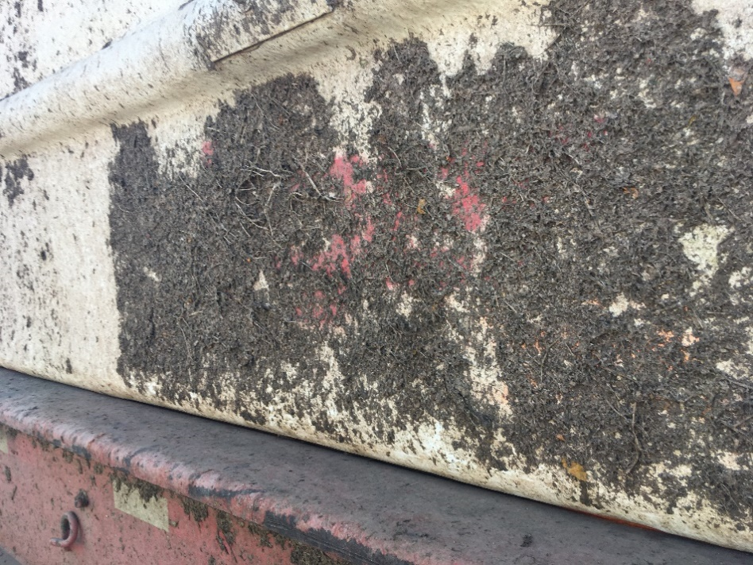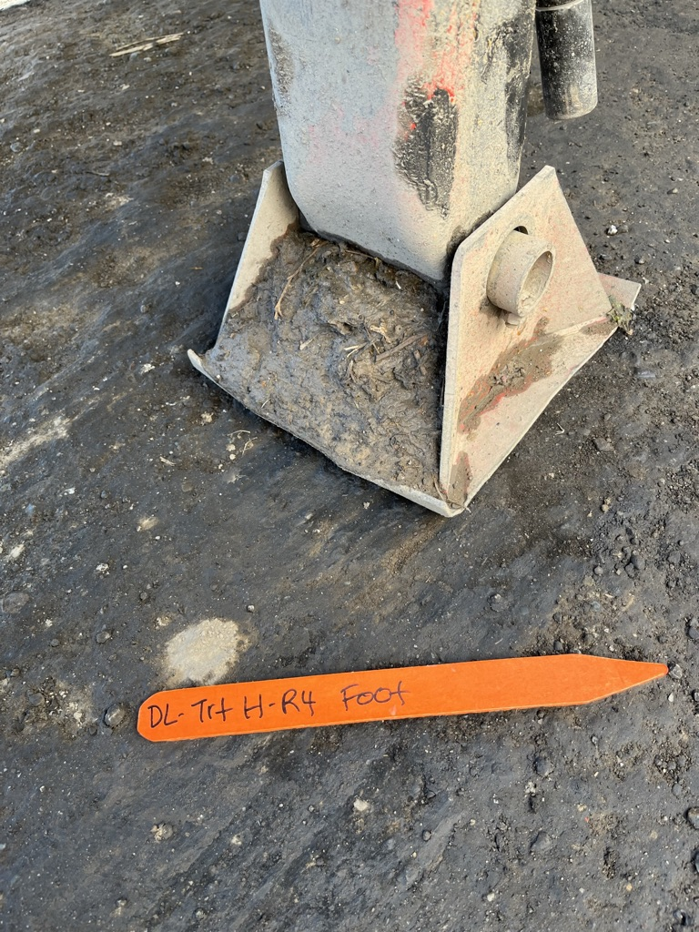

Supplemental Figure 1. Examples of trailer soil debris (left) and trailer plant debris (right) collected in situ from uncleaned trailers and used in sanitizer efficacy studies.