**Supplemental Materials**

Table S1. Seasonal and Total Precipitation (mm) and Mean Temperature (°C) at the Post Farm (Bozeman 6 W exp farm, MT) (NCEI, n.d.).

|  |  |  |  |  |  |  |  |  |  |
| --- | --- | --- | --- | --- | --- | --- | --- | --- | --- |
|  | Precipitation (mm) | | | | | Temperature (°C) | | | |
| Water Year | October-December | January-March | April-June | July- Sept-ember | Total | October-December | January-March | April-June | July-Sept-ember |
| 2012 | 43.9 | 44.8 | 131.1 | 26.0 | 245.7 | 2.1 | 0.8 | 11.1 | 18.7 |
| 2013 | 55.3 | 32.6 | 163.2 | 91.9 | 343.0 | 1.9 | -1.4 | 10.2 | 18.4 |
| 2014 | 53.2 | 79.8 | 153.3 | 110.0 | 396.3 | -0.1 | -3.0 | 10.0 | 16.8 |
| 2015 | 65.2 | 34.3 | 132.3 | 88.6 | 320.3 | 1.5 | 1.4 | 11.1 | 17.1 |
| 2016 | 105.4 | 49.3 | 115.3 | 99.7 | 369.7 | 0.1 | -0.3 | 11.8 | 16.6 |
| 2017 | 113.3 | 67.4 | 178.0 | 83.9 | 443.7 | 0.4 | -1.8 | 10.4 | 17.6 |
| 2018 | 112.3 | 78.3 | 217.6 | 46.3 | 454.5 | -0.1 | -2.9 | 10.4 | 16.1 |
| 2019 | 71.8 | 65.9 | 185.2 | 177.6 | 500.4 | 0.6 | -6.8 | 9.7 | 16.6 |

TABLE S2. Reduced ANOVA models that have removed the interaction between endophyte and A) *Astragalus mollissimus* variety (var. *mollissimus* or var. *thompsoniae*), and B) *Oxytropis sericea* generations, on overwinter mortality. These variables were measured for plants grown as pairs with or without the endophyte near Bozeman, MT.

|  |  |  |  |  |  |  |  |  |  |
| --- | --- | --- | --- | --- | --- | --- | --- | --- | --- |
|  |  | | | 1. *Astragalus*   *mollissimus*  Overwinter mortality | | | 1. *Oxytropis*   *sericea*  Overwinter mortality | | |
|  |  | | | (%) | | | (%) | | |
|  |  | | | n=1368 | | | n=2020 | | |
| Term | | df | Chi-  square | | P | Chi-square | | P |
| age | | 1 | 112.455 | | **<0.0001** | **466.094** | | **<0.0001** |
| year planted | | 1 | 8143.531 | | **<0.0001** | **5.541** | | **0.0186** |
| endophyte | | 1 | 0.697 | | 0.4038 | 1.694 | | 0.1931 |
| variety | | 1 | 21.84 | | **<0.0001** |  | |  |
| generation | | 2 |  | |  | **34.931** | | **<0.0001** |

Table S3. Two-way interaction ANOVA estimating the effect of endophyte (+ or -), *Astragalus mollissimus* variety (var. *mollissimus* or var. *thompsoniae*), and their interaction on stomatal conductance and transpiration variables when grown as pairs in a common garden from 2011 to 2020 (date of collection) near Bozeman, MT. P-values and F statistics were obtained by running a linear mixed model, interactions tested included endophyte by variety. Significance levels of P < 0.05 are in bold. The numerator degrees of freedom are in column df and the denominator degrees of freedom are in the df2 columns.

|  |  |  |  |  |  |  |  |
| --- | --- | --- | --- | --- | --- | --- | --- |
|  |  | A. gs | | | B. E | | |
|  |  | (mol CO2 m-2 s-1) | | | (mmol CO2 m-2 s-1) | | |
|  |  | n=77 | | | n=84 | | |
| Term | df | F | df2 | P | F | df2 | P |
| endophyte | 1 | 0.528 | 43 | 0.4714 | 0.01 | 53.2 | 0.9193 |
| variety | 1 | 0.639 | 64.7 | 0.4271 | **6.101** | **76.5** | **0.0157** |
| year of data | 1 | **21.887** | **49.6** | **<0.0001** | **34.788** | **49** | **<0.0001** |
| endophyte by variety | 1 | 1.161 | 69.8 | 0.285 | 2.626 | 76.5 | 0.1092 |

TABLE S4. Reduced ANOVA models that have removed the interaction between endophyte and variety, estimating the effect of endophyte (+ or -), and *Astragalus mollissimus* variety (var. *mollissimus* or var. *thompsoniae*) on growth and fecundity variables. These variables were measured for plants grown as pairs with or without the endophyte near Bozeman, MT. Models A & G: P-values and F statistics were obtained by running a linear mixed model, interactions tested included endophyte by generation. The numerator degrees of freedom are in column df and the denominator degrees of freedom are in the df2 columns. Models B-F: P-values and Chi-squares were obtained by running a generalized linear mixed model with a Poisson response distribution and log link for count responses, and a grouped binomial response distribution with a logit link for proportion out of total (%) responses, interactions tested depended on outcomes, but could have included year of data collection by endophyte, age by year of data collection, age by generation, and age by endophyte. The proportion germinated after 10 d response was not included in this table, as the original model did not test for the interaction between endophyte and variety because only one variety was tested for germination. Significance levels of P < 0.05 are in bold.

|  |  |  |  |  |  |  |  |  |  |  |  |  |  |  |  |  |  |
| --- | --- | --- | --- | --- | --- | --- | --- | --- | --- | --- | --- | --- | --- | --- | --- | --- | --- |
|  |  | A. Pnet | | | B. Reproductive stems | | C. Flowers | | D. Seed pods | | E. Mature seeds | | F. Seed viability | | G. Mean seed mass | | |
|  |  | (µmol CO2 m-2 s-1) | | | (no. plant -1) | | (no. stem -1) | | (no. stem-1) | | (no. pod -1) | | (%) | | (mg seed-1) | | |
|  |  | n=84 | | | n=56 | | n=373 | | n=424 | | n=46 | | n=43 | | n=44 | | |
| Term | df | F | df2 | P | Chi-square | P | Chi-square | P | Chi-square | P | Chi-square | P | Chi-square | P | F | df2 | P |
| year of data | 1 | 41.418 | 54.8 | **<0.0001** |  |  |  |  |  |  |  |  |  |  |  |  |  |
| endophyte | 1 | 0.03 | 35.3 | 0.8635 | 0.181 | 0.6704 | 0.099 | 0.753 | 1.253 | 0.263 | 0.052 | 0.8193 | 1.729 | 0.1885 | 0.189 | 22.7 | 0.6676 |
| variety | 1 | 0.823 | 65.1 | 0.3676 | 2.072 | 0.15 | 9.229 | **0.0024** | 14.495 | **0.0001** | 10.04 | **0.0015** | 5.544 | **0.0185** | 0.62 | 38.4 | 0.4361 |

Table S5. Two-way interaction ANOVA estimating the effect of endophyte (+ or -), *Oxytropis sericea* generations, and their interaction on stomatal conductance and transpiration variables when grown as pairs in a common garden from 2011 to 2020 (date of collection) near Bozeman, MT. P-values and F statistics were obtained by running a linear mixed model, interactions tested included endophyte by generation. Significance levels of P < 0.05 are in bold. The numerator degrees of freedom are in column df and the denominator degrees of freedom are in the df2 columns.

|  |  |  |  |  |  |  |  |
| --- | --- | --- | --- | --- | --- | --- | --- |
|  |  | A. gs | | | B. E | | |
|  |  | (mol CO2 m-2 s-1) | | | (mmol CO2 m-2 s-1) | | |
|  |  | n=691 | | | n=707 | | |
| Term | df | F | df2 | P | F | df2 | P |
| age | 1 | 0.029 | 141 | 0.8656 | 0.078 | 139.9 | 0.781 |
| year of data | 1 | 1.439 | 162.6 | 0.232 | **5.221** | **163.6** | **0.0236** |
| endophyte | 1 | 0.464 | 117.2 | 0.497 | 0.333 | 120 | 0.5649 |
| generation | 2 | 0.674 | 141.4 | 0.5112 | 2.602 | 143 | 0.0777 |
| endophyte by generation | 2 | 0.023 | 121.5 | 0.9774 | 0.228 | 123.6 | 0.7967 |

Table S6. Main effects ANOVA estimating the effect of endophyte (+ or -) and *Oxytropis sericea* generations on stomatal conductance and transpiration variables when grown as pairs in a common garden from 2011 to 2020 (date of collection) near Bozeman, MT. P-values and F statistics were obtained by running a linear mixed model. Significance levels of P < 0.05 are in bold. The numerator degrees of freedom are in column df and the denominator degrees of freedom are in the df2 columns.

|  |  |  |  |  |  |  |  |
| --- | --- | --- | --- | --- | --- | --- | --- |
|  |  | A. gs | | | B. E | | |
|  |  | (mol CO2 m-2 s-1) | | | (mmol CO2 m-2 s-1) | | |
|  |  | n=691 | | | n=707 | | |
| Term | df | F | df2 | P | F | df2 | P |
| age | 1 | 0.039 | 140.5 | 0.8438 | 0.096 | 139.2 | 0.7566 |
| year of data | 1 | 1.424 | 162.7 | 0.2344 | **5.512** | **163.5** | **0.0201** |
| endophyte | 1 | 0.466 | 118.8 | 0.4962 | 0.331 | 121.7 | 0.5664 |
| generation | 2 | 0.664 | 141.7 | 0.5166 | 2.641 | 143.3 | 0.0747 |

TABLE S7. Reduced ANOVA models that have removed the interaction between endophyte and generation, estimating the effect of endophyte (+ or -), and *Oxytropis sericea* generations on growth and fecundity variables. These variables were measured for plants grown as pairs with or without the endophyte near Bozeman, MT. Models A & G: P-values and F statistics were obtained by running a linear mixed model, interactions tested included endophyte by generation. The numerator degrees of freedom are in column df and the denominator degrees of freedom are in the df2 columns. Models B-F & G: P-values and Chi-squares were obtained by running a generalized linear mixed model with a Poisson response distribution and log link for count responses, and a grouped binomial response distribution with a logit link for proportion out of total (%) responses, interactions tested depended on outcomes, but could have included year of data collection by endophyte, age by year of data collection, age by generation, and age by endophyte. The count of flowers response was not included in this table, as removal of the interaction between endophyte and generation was not warranted. Significance levels of P < 0.05 are in bold.

|  |  |  |  |  |  |  |  |  |  |  |  |  |  |  |  |  |  |
| --- | --- | --- | --- | --- | --- | --- | --- | --- | --- | --- | --- | --- | --- | --- | --- | --- | --- |
|  |  | A. Pnet | | | B. Reproductive stems | | D. Seed pods | | E. Mature seeds | | F. Seed viability | | G. Mean seed mass | | | H. Germination after 10 days | |
|  |  | (µmol CO2 m-2 s-1) | | | (no. plant -1) | | (no. stem-1) | | (no. stem-1) | | (%) | | (mg seed-1) | | | (%) | |
|  |  | n=707 | | | n=508 | | n=4142 | | n=517 | | n=501 | | n=508 | | | n=503 | |
| Term | df | F | df2 | P | Chi-square | P | Chi-square | P | Chi-square | P | Chi-square | P | F | df2 | P | Chi-square | P |
| age | 1 | 3.844 | 142.3 | 0.0519 | 0.197 | 0.6568 | 2.116 | 0.1458 | **667.329** | **<0.0001** | **124.588** | **<0.0001** | 1.69 | 173.1 | 0.1954 | **401.799** | **<0.0001** |
| year of data | 1 | 1.881 | 164.4 | 0.1721 | **5.363** | **0.0206** | 0.008 | 0.93 | **289.116** | **<0.0001** | **3575.174** | **<0.0001** | 0.001 | 196 | 0.9785 | **14925.748** | **<0.0001** |
| endophyte | 1 | 0.075 | 119.1 | 0.7843 | 3.327 | 0.0682 | 1.795 | 0.1803 | 0.071 | 0.7905 | **6.213** | **0.0127** | 0.005 | 109.2 | 0.944 | 0.675 | 0.4114 |
| generation | 2 | 2.393 | 141 | 0.0951 | 4.373 | 0.1123 | 1.322 | 0.5162 | **53.672** | **<0.0001** | **113.017** | **<0.0001** | 2.234 | 146.4 | 0.1108 | **252.168** | **<0.0001** |
| year of data by endophyte | 1 |  |  |  | 2.203 | 0.1378 | 2.148 | 0.1428 |  |  |  |  |  |  |  |  |  |
| age by year of data | 1 |  |  |  | **14.271** | **0.0002** | **26.191** | **<0.0001** |  |  |  |  |  |  |  |  |  |
| age by generation | 2 |  |  |  | 4.454 | 0.1078 | 3.82 | 0.1481 |  |  |  |  |  |  |  |  |  |
| age by endophyte | 1 |  |  |  | **5.294** | **0.0214** | **5.631** | **0.0176** |  |  |  |  |  |  |  |  |  |

TABLE S8. Main effects ANOVA estimating the effect of endophyte (+ or -) and *Oxytropis sericea* generations on final harvest variables. These variables were measured for plants grown as pairs with or without the endophyte near Bozeman, MT. Models B & D-F: P-values and F-values were obtained by running a linear mixed model, interactions tested included endophyte by generation. The numerator degrees of freedom are in column df and the denominator degrees of freedom are in the df2 columns. Models A & C: P-values and Chi-squares were obtained by running a generalized linear mixed model with a Poisson response distribution and log link for count responses.

|  |  |  |  |  |  |  |  |  |  |  |  |  |  |  |  |  |  |
| --- | --- | --- | --- | --- | --- | --- | --- | --- | --- | --- | --- | --- | --- | --- | --- | --- | --- |
|  |  | A. Roots | | B. Root diameter | | | C. Reproductive stems | | D. Log stem mass | | | E. Log crown mass | | | F. Crown diameter | | |
|  |  | (no. plant-1) | | (mm) | | | (no. plant-1) | | (loge(g)) | | | (loge(g)) | | | (mm) | | |
|  |  | n=74 | | n=74 | | | n=74 | | n=74 | | | n=74 | | | n=74 | | |
| Term | df | Chi-square | P | F | df2 | P | Chi-square | P | F | df2 | P | F | df2 | P | F | df2 | P |
| endophyte | 1 | 0.304 | 0.5814 | 3.538 | 51.9 | 0.0656 | 0.027 | 0.8692 | **4.477** | **51.9** | **0.0392** | **4.297** | **51.9** | **0.0431** | 1.053 | 49 | 0.3099 |
| generation | 2 | 3.57 | 0.1678 | 0.821 | 57 | 0.4451 | 2.036 | 0.3613 | 2.614 | 57 | 0.082 | **4.32** | **57** | **0.0179** | 2.259 | 58.9 | 0.1134 |

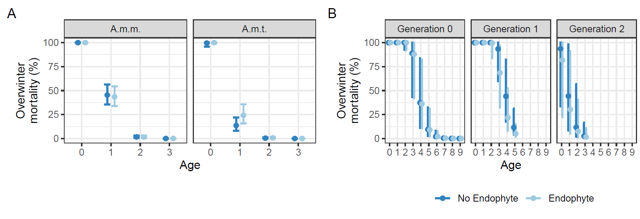

FIGURE S1. Marginal effects plots of overwinter mortality of *Astragalus mollissimus* variety *mollissimus* (*A.m.m.*), variety *thompsoniae* (*A.m.t.*), and *Oxytropis sericea* generation 0, 1, and 2 plants in response to the locoweed endophyte *Alternaria* section *Undifilum* [E- (dark blue) and E+ (light blue)] when grown as pairs in a common garden from 2011 to 2020 near Bozeman, MT. The data set includes 33 pairs of *Astragalus mollissimus* variety *mollissimus* (*A.m.m.*), 13 pairs of variety *thompsoniae* (*A.m.t.*), and 127 pairs of *Oxytropis sericea* plants. The plots are A. model predicted average overwinter mortality (%) by endophyte status and *Astragalus* *mollissimus* variety, B. model predicted average overwinter mortality (%) by endophyte status and *Oxytropis sericea* generation. Model predictions are based on holding all other variables at their marginal means. The points represent the model estimate with a 95% confidence interval for the estimated mean.

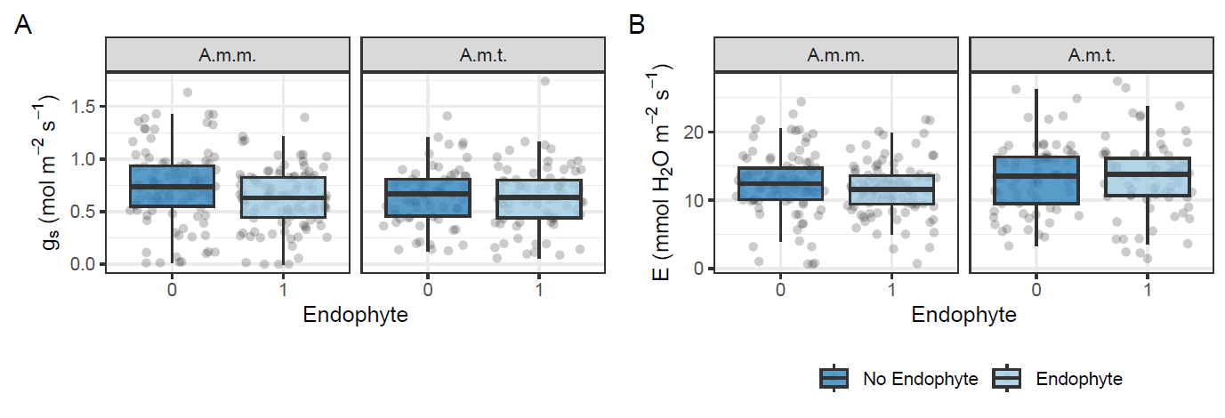

FIGURE S2. Boxplots of physiology of *Astragalus mollissimus* variety *mollissimus* (*A.m.m.*) and variety *thompsoniae* (*A.m.t.*) plants in response to the locoweed endophyte *Alternaria* section *Undifilum* [E- (dark blue) and E+ (light blue)] when grown as pairs in a common garden from 2011 to 2020 (date of collection) near Bozeman, MT. The data set includes 33 pairs of *Astragalus mollissimus* variety *mollissimus* (*A.m.m.*) and 13 pairs of variety *thompsoniae* (*A.m.t.*). Variables collected are A. conductance (gs) and B. transpiration (E). Box edges represent the 0.25 and 0.75 quartiles, solid line represents the median value, and whiskers extend to the minimum and maximum value or 1.5× the interquartile range, outliers are not identified. Points are the original data values with horizontal noise added to aid in visibility.

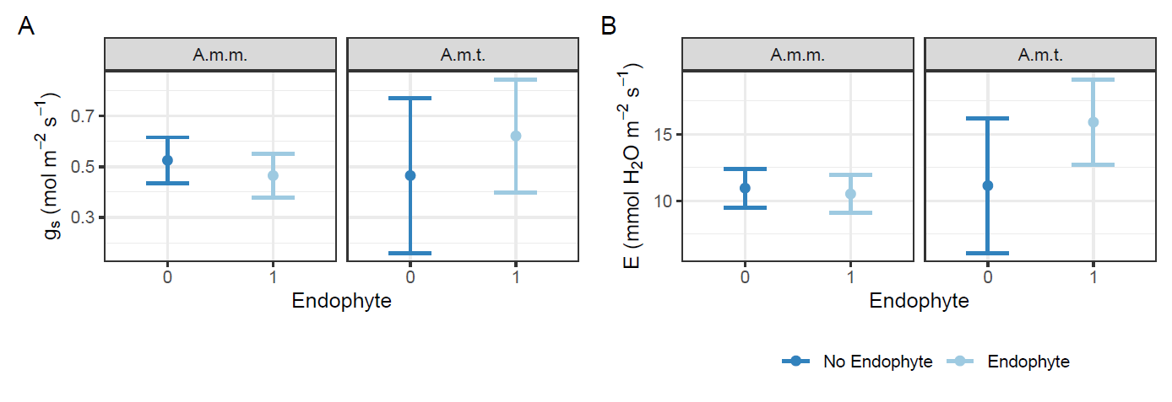

FIGURE S3. Marginal effects plots of physiology of *Astragalus mollissimus* variety *mollissimus* (*A.m.m*.) and variety *thompsoniae* (*A.m.t.*) plants in response to the locoweed endophyte *Alternaria* section *Undifilum* [E- (dark blue) and E+ (light blue)] when grown as pairs in a common garden from 2011 to 2020 (date of collection) near Bozeman, MT. The data set includes 33 pairs of *Astragalus mollissimus* variety *mollissimus* (*A.m.m*.) and 13 pairs of variety *thompsoniae* (*A.m.t.*). The plots are model predictions (holding all other variables at their marginal means) for A. conductance (gs) and B. transpiration (E). The points represent the model estimate with a 95% confidnce interal for the estimated mean.

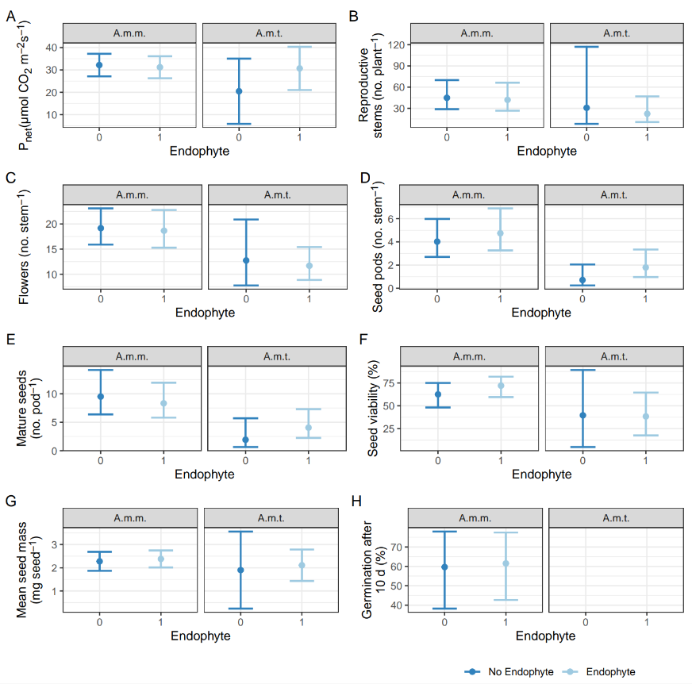

FIGURE S4. Marginal effects plots of physiology of *Astragalus mollissimus* variety *mollissimus* (*A.m.m*.) and variety *thompsoniae* (*A.m.t.*) plants in response to the locoweed endophyte *Alternaria* section *Undifilum* [E- (dark blue) and E+ (light blue)] when grown as pairs in a common garden from 2011 to 2020 (date of collection) near Bozeman, MT. The data set includes 33 pairs of *Astragalus mollissimus* variety *mollissimus* (*A.m.m*.) and 13 pairs of variety *thompsoniae* (*A.m.t.*). The plots are A. Pnet, B. reproductive stems per plant, C. flowers per stem, D. seed pods per stem, E. mature seeds per pod, F. percent seed viability, G. mean seed mass, and H. percent germination after 10 d, note that germination was not tested for *A.m.t.* The points represent the model estimate with a 95% confidence interval for the estimated mean.

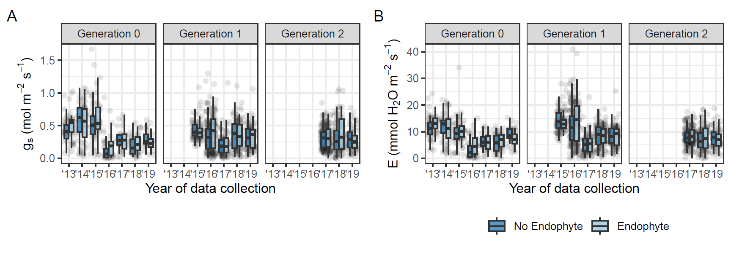

FIGURE S5. Boxplots of physiology of *Oxytropis sericea* generation 0, 1, and 2 plants in response to the locoweed endophyte *Alternaria* section *Undifilum* [E- (dark blue) and E+ (light blue)] when grown as pairs in a common garden across plant age (years) near Bozeman, MT. The data set includes 127 pairs of plants. Variables collected are A. conductance (gs) and B. transpiration (E). Box edges represent the 0.25 and 0.75 quartiles, solid line represents the median value, and whiskers extend to the minimum and maximum value or 1.5× the interquartile range, outliers are not identified. Points are the original data values with horizontal noise added to aid in visibility.

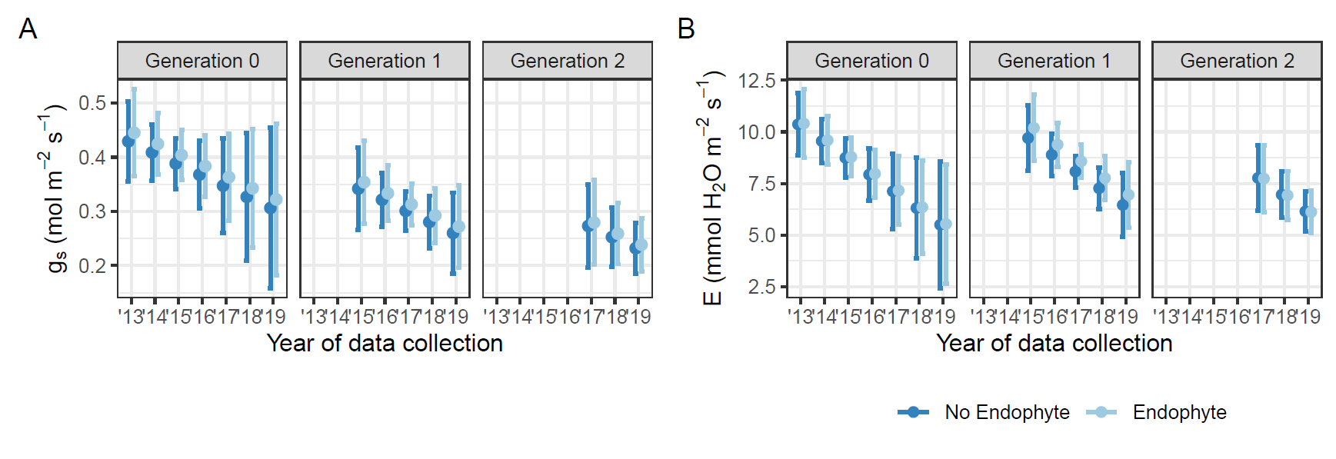

FIGURE S6. Marginal effects plots of physiology of *Oxytropis sericea* generation 0, 1, and 2 plants in response to the locoweed endophyte *Alternaria* section *Undifilum* [E- (dark blue) and E+ (light blue)] when grown as pairs in a common garden from 2011 to 2020 (date of collection) near Bozeman, MT. The data set includes 127 pairs of plants. The plots are model predictions (holding all other variables at their marginal means) for A. conductance (gs) and B. transpiration (E). The points represent the model estimate with a 95% confidence interval for the estimated mean.

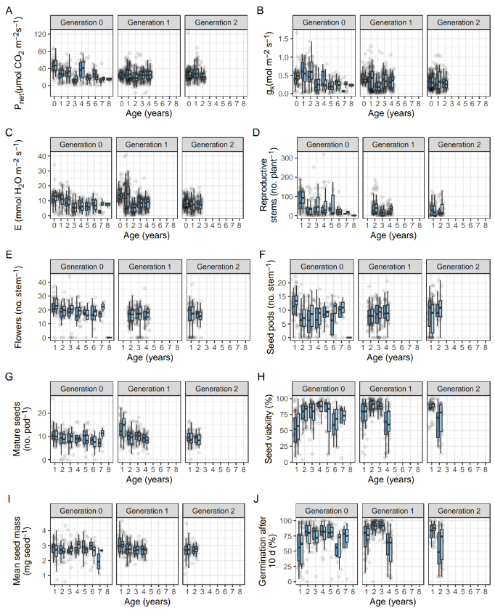

FIGURE S7. Boxplots of physiology, growth, and fecundity of *Oxytropis sericea* generation 0, 1, and 2 plants in response to the locoweed endophyte *Alternaria* section *Undifilum* [E- (dark blue) and E+ (light blue)] when grown as pairs in a common garden from 2011 to 2020 (years of data collection) near Bozeman, MT. The data set includes 127 pairs of plants. Variables collected are A. Pnet, B. conductance (gs), C. transpiration (E), D. reproductive stems per plant, E. flowers per stem, F. seed pods per stem, G. mature seeds per pod, H. percent seed viability, I. mean seed mass, and J. percent germination after 10 d. Box edges represent the 0.25 and 0.75 quartiles, solid line represents the median value, and whiskers extend to the minimum and maximum value or 1.5× the interquartile range, outliers are not identified. Points are the original data values with horizontal noise added to aid in visibility.

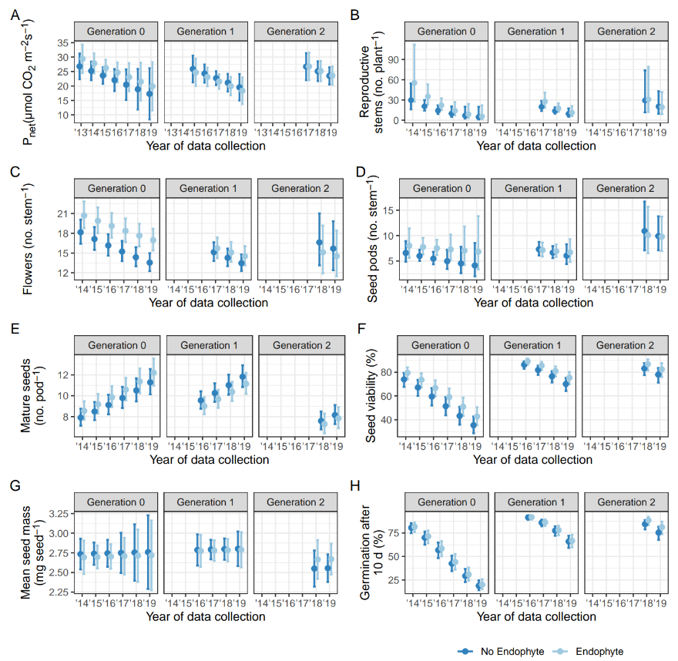

FIGURE S8. Marginal effects plots of physiology, growth, and fecundity of *Oxytropis sericea* generation 0, 1, and 2 plants in response to the locoweed endophyte *Alternaria* section *Undifilum* [E- (dark blue) and E+ (light blue)] when grown as pairs in a common garden from 2011 to 2020 (date of collection) near Bozeman, MT. The data set includes 127 pairs of plants. The plots are A. Pnet, B. reproductive stems per plant, C. flowers per stem, D. seed pods per stem, E. mature seeds per pod, F. percent seed viability, G. mean seed mass, and H. percent germination after 10 d, note that germination was not tested for *A.m.t.* The points represent the model estimate with a 95% confidence interval for the estimated mean.

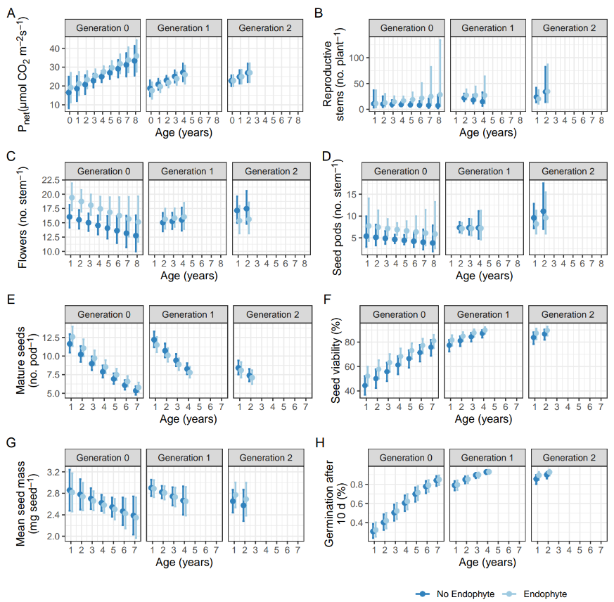

FIGURE S9. Marginal effects plots of physiology, growth, and fecundity of *Oxytropis sericea* generation 0, 1, and 2 plants in response to the locoweed endophyte *Alternaria* section *Undifilum* [E- (dark blue) and E+ (light blue)] when grown as pairs in a common garden across plant age (years) near Bozeman, MT. The data set includes 127 pairs of plants. The plots are model predictions (holding all other variables at their marginal means) A. Pnet, B. reproductive stems per plant, C. flowers per stem, D. seed pods per stem, E. mature seeds per pod, F. percent seed viability, G. mean seed mass, and H. percent germination after 10 d, note that germination was not tested for *A.m.t.* The points represent the model estimate with a 95% confidence interval for the estimated mean.

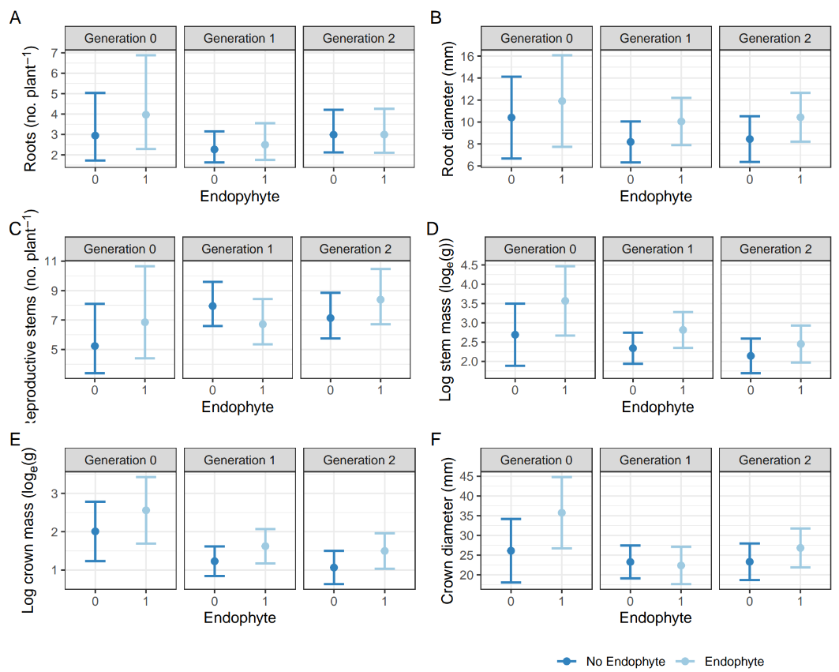

FIGURE S10. Marginal effects plots of final crown and root size parameters in 2020 of *Oxytropis sericea* generation 0, 1, and 2 plants in response to the locoweed endophyte *Alternaria* section *Undifilum* [E- (dark blue) and E+ (light blue)] when grown as pairs in a common garden from 2011 to 2020 near Bozeman, MT. The data set includes 127 pairs of plants. Plots are model predictions (holding all other variables at their marginal means) A. root count, B. root diameter, C. reproductive stems per plant, D. log (base e) stem mass, E. log (base e) crown mass, and F. crown diameter. The points represent the model estimate with a 95% confidence interval for the estimated mean.