**Supplementary Material**

**Water-Seeded Rice Seedling Response to Soil-Water Partitioning of Pendimethalin**

Aaron Becerra-Alvarez and Kassim Al-Khatib

**Supplementary Material 1:** Air and water temperature in the greenhouse after an application of pendimethalin in water-seeded rice at different rice growth stages.

Water temperature was only collected for the second and third experimental run because of data loggers in the water not working in the first run. The water used was tap water available to the city of Davis, CA which comes from the Sacramento River.



Figure 1. Daily air temperature minimum (white circle) and maximum (dark circle) in the greenhouse during the first experimental run. The temperature is averaged over three data loggers (HOBO Pendant Temp/Light 8K).



Figure 2. Daily air temperature minimum (white circle) and maximum (dark circle) in the greenhouse during the second experimental run. The temperature is averaged over three data loggers (HOBO Pendant Temp/Light 8K).



Figure 3. Daily air temperature minimum (white circle) and maximum (dark circle) in the greenhouse during the third experimental run. The temperature is averaged over three data loggers (HOBO Pendant Temp/Light 8K).



Figure 4. Daily water temperature minimum (white circle) and maximum (dark circle) in the greenhouse during the second and third experimental run. The temperature is averaged over three data loggers (HOBO Pendant Temp/Light 8K) placed inside a pot under the water level on the soil surface.

**Supplementary Material 2:** Analytical methods for quantification of pendimethalin and degradants p36 [1-(1-ethylpropyl)-5,6-dimethyl-7-nitro-1H-benximidazole], p44 [4-[(1-ethylpropyl) amino]-2-methyl-3,5-ditrobenzoic acid] and p48 [4,5-dimethyl-3-nitro-N2-(pentan-3-yl) benzene-1,2-diamine] in water samples after an application in water-seeded rice.

It is noted that plastic pots and containers were used in this research. Pendimethalin can bind and persist in plastic (Helweg et al. 2003; Eras et al. 2017). There is a potential 2-3% error in the concentration data because of using plastic and not glass (Helweg et al. 2003). Glass is commonly used for pendimethalin environmental residue studies in bodies of water (Senseman et al. 1996). Plastic pots were used in this study; however, we did not directly apply the pendimethalin to the flood water. Pendimethalin was applied on the soil surface with no flood, then, the pots were reflooded.

The frozen 50 ml water samples were thawed, and 10 g was weighed into clean 18 ml glass tubes. The samples were then spiked with 10 µl of 4 µg ml-1 of pendimethalin-d5 internal standard. The extraction was performed for pendimethalin (extraction A), degradants P36 and P44 (extraction B) and then for degradant P48 (extraction C) with 2 ml of pentane to a total volume of 6 ml pentene for each extraction.

* Extraction A (for Pendimethalin): No modification to sample; 10 mL water sample extracted with 2 ml pentane (3 times)
* Extraction B (for degradants P36 and P44): Acidified 10 ml water sample with 200 µ L acetic acid before extracting with 2 mL pentane (3 times)
* Extraction C (for degradant P48): Added 400 µ L of 25% ammonium hydroxide in water to 10 ml water sample before extracting with 2 ml pentane (3 times)

The final 6 ml pentene extracts were dried under nitrogen gas stream at room temperature in 8 ml glass tubes. The dried extracts were then dissolved in 400 µl of acetonitrile and vortexed for 20 s at 3000 rpm, then added 400 µl of water with 0.2% formic acid and vortexed again for 20 s at 3000 rpm. The three extracts were placed in separate 2 ml glass vials and analyzed at 2 µl injections with Ultra-High Performance Liquid Chromatography and tandem mass spectrometer (UHPLC-MS/MS). There was high variation recorded in the data acquired from the first run of samples and required re-processing of the 12 samples in run 1 with 2.5 mL water sample for each extraction (A, B, and C). All other volumes needed to be scaled down by 25% of the protocol, due to the limited sample volume.

An external calibration curve for pendimethalin was prepared in 50% acetonitrile, 50% water, 0.1% formic acid with pendimethalin concentration ranging from 0.0305 ng ml-1 to 250 ng ml-1 with each standard concentration containing 2 ng ml-1 of the pendimethalin-d5 internal standard for normalization. The LC column used was a Waters Acquity HSS T3, 18 µm, 2.1 µm by 150 mm.

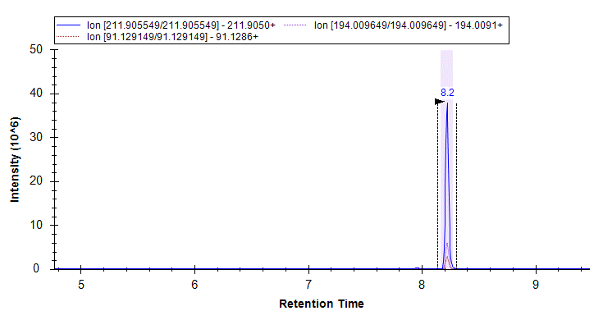

Pendimethalin in water of extract A MRM chromatogram

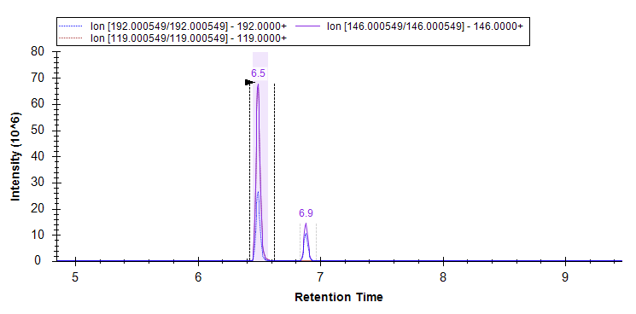

P36 in water of extract B MRM chromatogram

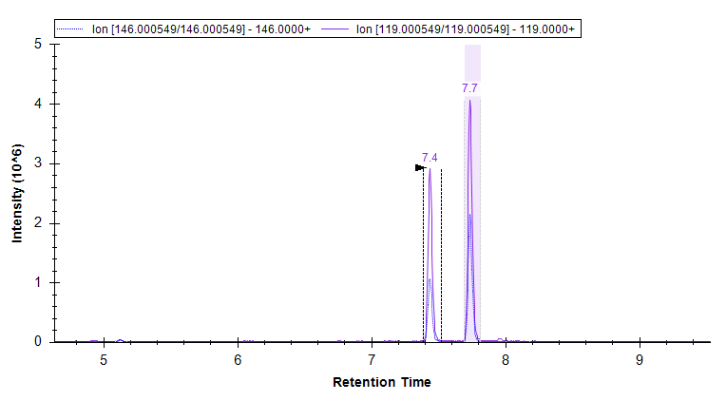

P48 in water of extract C MRM chromatogram

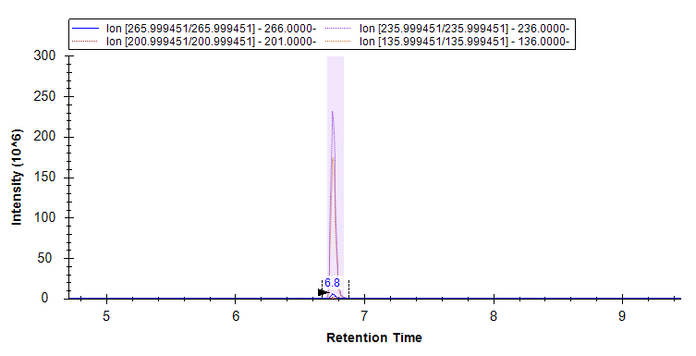

P44 in water of extract B MRM chromatogram

Three quality control checks were performed in the water sample analysis. (1) Instrument carryover checks where a clean solvent was injected after the standards and after quality control checks to account for any potential carryover was performed. (2) Solvent blanks were spiked with pendimethalin-d5 and processed with samples to capture reagent contamination at processing. (3) The quality control checks, and a standard were performed every 15 samples to check compound stability and instrument response. The relative standard deviation of peak areas was less than 10% for pendimethalin and less than 6% for P36.

**Supplementary Material 3:** Analytical methods for quantification of pendimethalin and degradants p36 [1-(1-ethylpropyl)-5,6-dimethyl-7-nitro-1H-benximidazole], p44 [4-[(1-ethylpropyl) amino]-2-methyl-3,5-ditrobenzoic acid] and p48 [4,5-dimethyl-3-nitro-N2-(pentan-3-yl) benzene-1,2-diamine] in soil samples after an application in water-seeded rice.

It is noted that plastic pots were used in this research. Pendimethalin can bind and persist in plastic (Helweg et al. 2003; Eras et al. 2017). There is a potential 2-3% error in the concentration data because of using plastic and not glass (Helweg et al. 2003). Plastic pots were used in this study; however, we did not directly apply the pendimethalin to the flood water. Pendimethalin was applied on the soil surface with no flood, then, the pots were reflooded. Pendimethalin binds strongly to the soil organic matter (Shaner 2012; Vighi et al. 2017); therefore, it is not expected for a significant amount of pendimethalin to readily move or leach to the plastic.

At time of analysis, 5 g of frozen soil samples were weighed into clean 50 ml tubes. The samples were then spiked with 60 µl of 10 µ ml-1 of pendimethalin-d5 internal standard. Sample extraction followed with 10 ml of 3 solvents sequentially. The solvent 1 was 2% hydrochloric acid in methanol, followed by solvent 2 made up of 70% methanol in 30% water, then solvent 3 made up of 50% methanol in 50% water. At each sequential extraction, the soil slurry was vortexed at 2,000 rpm for 30 min and sonicated in water for 10 min, and finally centrifuged at 3,000 rpm for 8 min. The extracts were decanted from soil sediments into clean 50 ml tubes, combining all 3 extraction solvents into a 30 ml pooled soil extract. The pooled soil extracts were then diluted 10 times in further pooled 60 µl soil extracts with 540 µl of 50% acetonitrile, 50% water, 0.1% formic acid in 2 ml glass vials in preparation for analysis on Ultra-High Performance Liquid Chromatography and tandem mass spectrometer (UHPLC-MS/MS).

An external calibration curve was prepared in acetonitrile with 0.0305 ng ml-1 to 250 ng ml-1 of pendimethalin with each standard concentration containing 2 ng ml-1 of pendimethalin-d5 internal standard. The LC column used was a Waters Acquity HSS T3, 18 µm, 2.1 µm by 150 mm.

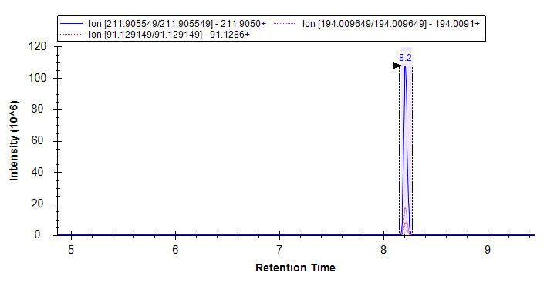

Pendimethalin in soil MRM chromatogram.

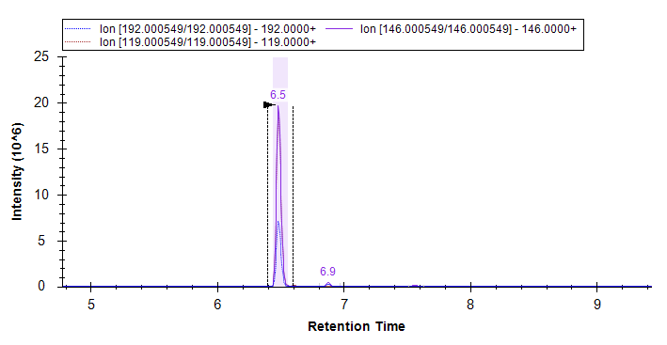

P36 in soil MRM chromatogram.

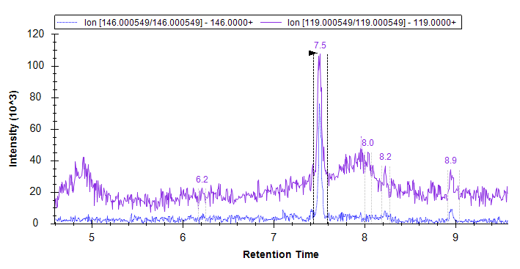

P48 in soil MRM chromatogram.

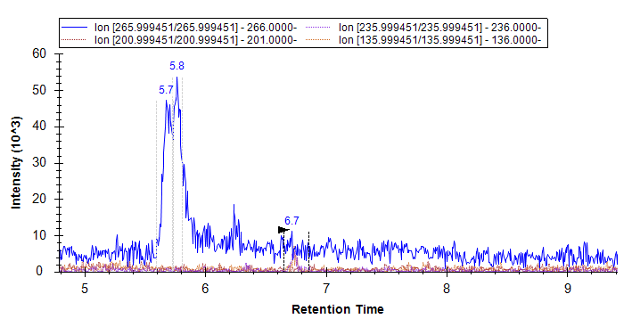

P44 in soil MRM chromatogram. The P44 values resulted below the lowest limit of quantification (<LLOQ).

Four quality control checks were performed in the soil sample methods. (1) Instrument carryover checks was carried out by injected a clean solvent after the standards and after quality control checks to account for any potential carryover. (2) Solvent blanks were spiked with pendimethalin-d5 and processed with samples to capture reagent contamination at processing. (3) The quality control checks and a standard were injected every 15 samples to check compound stability and instrument response resulting in a 1.93% relative standard deviation of peak areas for pendimethalin, 2.64% for P36 and P48. P44 degradant analysis were <LLOQ. (4) An internal standard recovery with pendimethlalin-d5 was added at 120 ng g-1 of soil to track recovery of the internal standard from the methods. The average recovery of pendimethalin was 113% with a 6% relative standard deviation.

**Supplementary Material 4:** Analytical methods for quantification of pendimethalin and degradants p36 [1-(1-ethylpropyl)-5,6-dimethyl-7-nitro-1H-benximidazole], p44 [4-[(1-ethylpropyl) amino]-2-methyl-3,5-ditrobenzoic acid] and p48 [4,5-dimethyl-3-nitro-N2-(pentan-3-yl) benzene-1,2-diamine] in rice shoot, crown region and root tissue samples after an application at three different growth stages in water-seeded rice.

*Preliminary analysis*

The objectives of the preliminary analysis were

1. To optimize an analytical method for quantification of pendimethalin and degradants in rice tissue samples
2. To confirm presence or absence of pendimethalin and the three degradants (P36, P48 and P44)
3. To test analysis of low sample amounts for accuracy and sensitivity and know what is the minimum tissue amount needed for an accurate analysis

The preliminary rice tissue samples used were 5 g of nontreated shoot, 5 g of nontreated root, 1 g of pendimethalin treated shoot and 1 g of pendimethalin treated root. The rice seedlings were treated at 3-leaf stage and sampled 14 DAT. The nontreated were 4- to 5-leaf growth stage at time of sampling.

100 mg of root and shoot tissue were extracted with 1:10 g ml-1 w/v acetonitrile, then cleaned up with QuEChERS (QuE Verde; Supelco) and without QuEChERS cleanup. The QuEChERS cleanup methods were derived from Zarebska et al. (2022) in fruit samples, Wumbei et al. (2015) in yams and Saha et al. (2014) in peanuts.

There was similar quantification of pendimethalin with QuEChERS cleanup and without QuEChERS cleanup in both the shoot and root tissue. However, pendimethalin degradants had higher signal without QuEChERS cleanup. Extraction and cleanup without QuEChERS served as the appropriate method to quantify pendimethalin and all three degradants in rice tissue.

The analysis with low tissue sample amounts was then performed. Three sample weights of 30 mg, 100 mg and 400 mg of shoot and root tissue were extracted with 1:10 g ml-1 acetonitrile and analyzed without QuEChERS cleanup. The results demonstrated pendimethalin could be quantified in samples as low as 30 mg; however, similar recovery in the internal standard of pendimethalin-d5 may suggest extraction efficiency is increased with lower tissue amounts. Greater amount of pendimethalin was recorded in 30 mg compared to 400 mg probably caused by increased extraction efficiency with smaller tissue amounts. Rice tissue amount of 100 mg were selected to be the appropriate sample amount; however, should be aliquoted from a total tissue sample of 500 mg or greater for best results.

*Pendimethalin quantification*

The 100 mg ± 2 mg of fresh weight tissue samples in the 2 ml tubes were spiked with 50 µ ml-1 of pendimethalin-d5 and 6 ceramic homogenizing beads were added to the tubes. The samples were extracted with 1:10 g tissue ml-1 of acetonitrile (w/v) and homogenized with a bead homogenizer at 6,000 rpm for 30 s cycles for a total of 10 cycles at 4 C. Magnesium sulfate at 60 mg was then added to extracts and vortexed at 2,500 rpm for 3 min. The, centrifuged at 12,000 rpm for 5 min at 4 C. The extract was then transferred to 2 ml glass vials for analysis while stored at -80 C. External calibration curves were prepared in acetonitrile with 0.0305 ng ml-1 to 250 ng ml-1 of pendimethalin with each standard concentration containing 50 ng ml-1 of pendimethalin-d5 for each tissue section of shoot, crown region and root. Analysis was carried out with Ultra-high Performance Liquid Chromatography-tandem mass spectrometry (UHPLC-MS/MS). The LC column used was a Waters Acquity HSS T3, 18 µm, 2.1 µm by 150 mm.

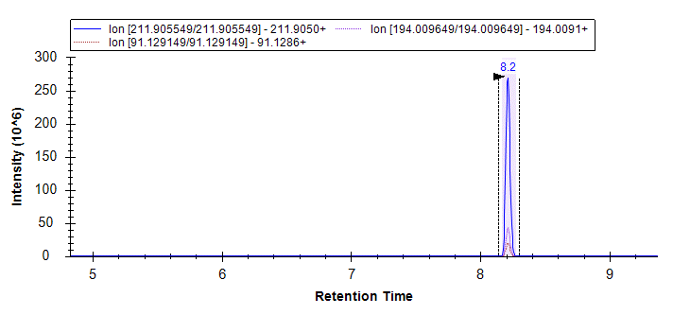

Pendimethalin in shoot tissue MRM chromatogram

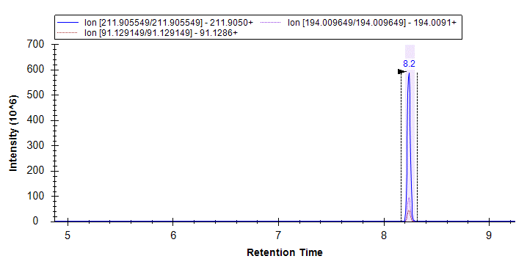

Pendimethalin in root tissue MRM chromatogram

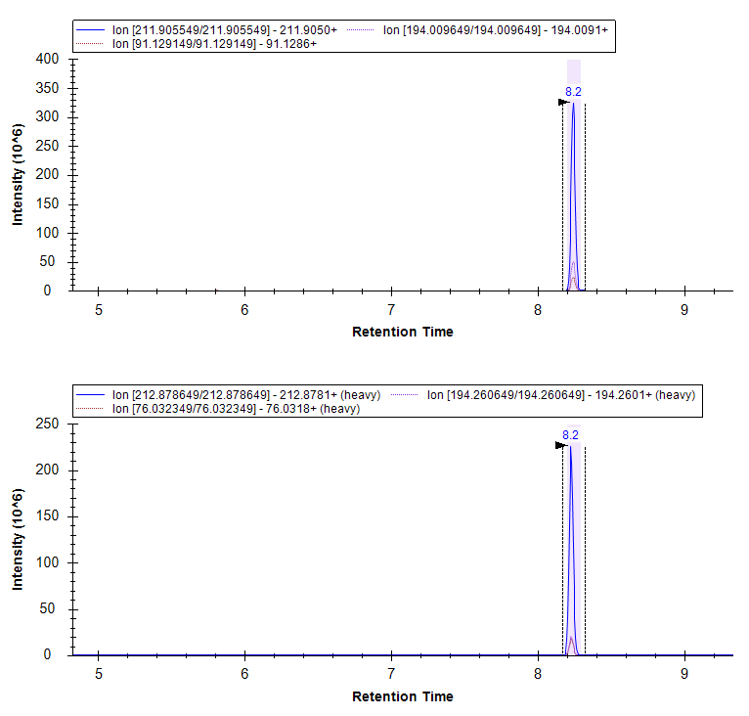

Pendimethalin in crown tissue MRM chromatogram

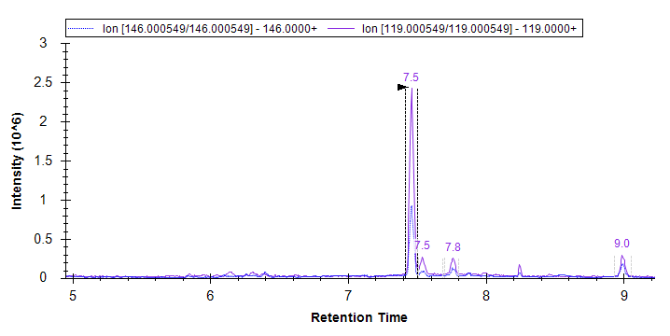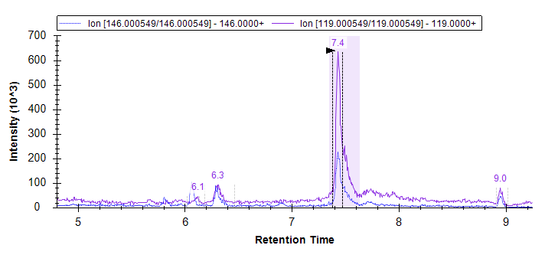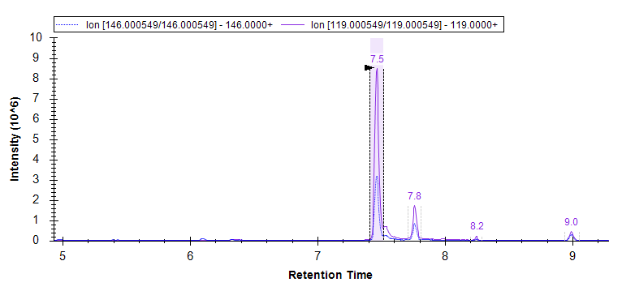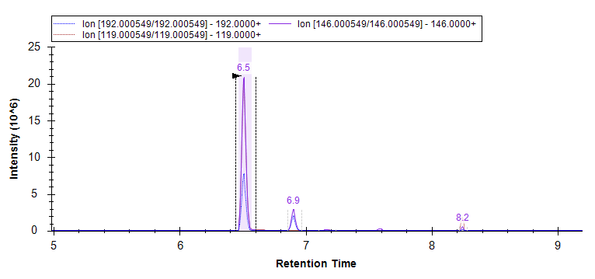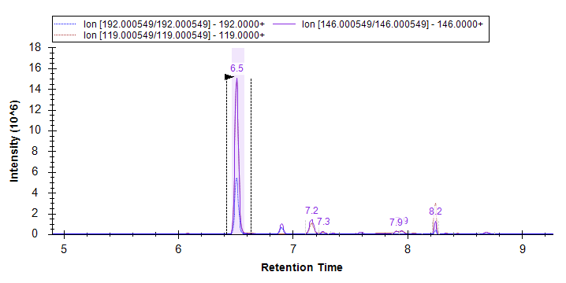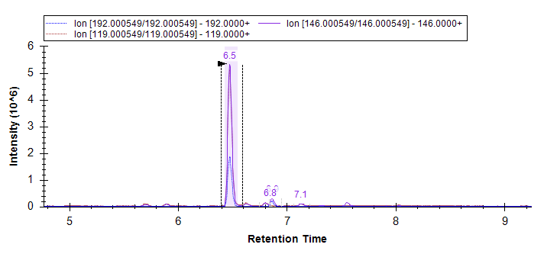

P36 in shoot tissue MRM chromatogram

P36 in crown tissue MRM chromatogram

P36 in root tissue MRM chromatogram

P48 in root tissue MRM chromatogram

P48 in crown tissue MRM chromatogram

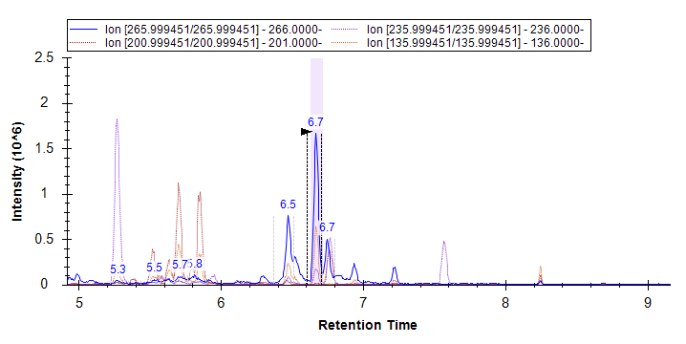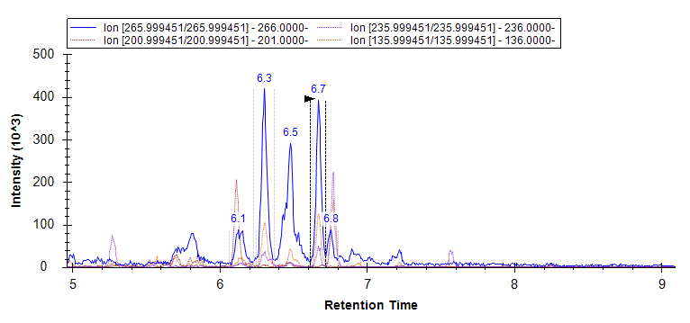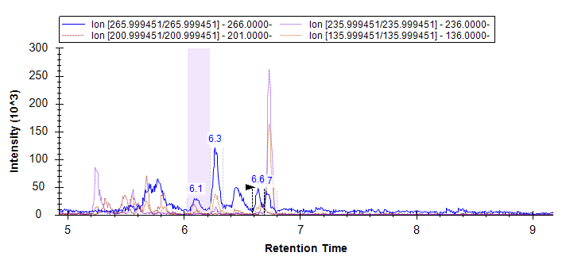

P48 in shoot tissue MRM chromatogram

P44 in root tissue MRM chromatogram

P44 in crown tissue MRM chromatogram

P44 in shoot tissue MRM chromatogram

Four quality control checks were performed in the tissue analysis. (1) Instrument carryover checks was carried out by injecting a clean acetonitrile after the standards and after quality control checks to account for any potential carryover. The acetonitrile blanks all recorded negative or below limit of quantitation. (2) Solvent blanks were spiked with pendimethalin-d5 and processed with samples to capture reagent contamination at processing, all blanks resulted negative or below limit of quantitation. (3) The quality control checks and a pendimethalin standard were injected every 15 samples to check compound stability and instrument response resulting in relative standard deviation of peak areas for pendimethalin at 3.08% for shoot, 4.49% for crown region and 2.57% for root. The relative standard deviation for the pendimethalin degradants were all below 13%. (4) An internal standard recovery with pendimethlalin-d5 was added at 500 ng g-1 of tissue to track recovery of internal standard from the methods. The average recovery was 88, 87 and 91% for shoot, crown and root tissue, respectively. The relative standard deviation was 13, 15, and 14% for shoot, crown and root tissue, respectively.

References

Eras J, Costa J, Vilarò F, Pelacho AM, Canela-Garayoa R, Martin-Closas L (2017) Prevalence of pesticides in postconsumer agrochemical polymeric packaging. Sci Total Environ 580:1530-1538

Helweg C, Mogensen BB, Sørensen PB, Madsen T, Bossi R, Rasmussen D, Petersen S (2003) Fate of pesticides in surface waters, laboratory and field experiments. Pestic Res 68:55-60. Accessed from <https://www2.mst.dk/udgiv/publications/2003/87-7972-949-5/html/helepubl_eng.htm#SubSection9.4.1>

Saha A, Bhaduri D, Pipariya A, Jain NK, Basak BB (2015) Behavior of pendimethalin and oxyfluorfen in peanut field soil: effects on soil biological and biochemical activities. Chemistry and Ecology 31(6):550-566

Senseman SA, Lavy TL, Daniel TC (1996) Monitoring groundwater for pesticides at selected mixing/loading sites in Arkansas. Environ Sci Technol 31(1):283-288

Shaner DL (2012) Field dissipation of sulfentrazone and pendimethalin in Colorado. Weed Technol 26(4):633-637

Vighi M, Matthies M, Solomon KR (2017) Critical assessment of pendimethalin in terms of persistence, bioaccumulation, toxicity, and potential for long-range transport. J Toxicol Environ Health Part B 20(1):1-21

Wumbei A, Abdul-Rahaman I, Abubakari A, López Dávila E, Spanoghe P (2019) Consumption risk assessment of pesticides residues in yam. Tunisian J Plant Prot (2):49-64

Zarębska M, Hordyjewicz-Baran Z, Wasilewski T, Zajszły-Turko E, Stanek N (2022) A new LC-MS method for evaluating the efficacy of pesticide residue removal from fruit surfaces by washing agents. Processes 10(4):793