## Complementary activity of Trifludimoxazin and Saflufenacil when used in combination for postemergence and residual weed control.

Parra et al. (2024)

**Supplementary Material**

Table 1. Set up on the climate chamber.

|  |  |  |  |
| --- | --- | --- | --- |
| Time | Temperature °C | Relative humidity % | Illuminance µmol m-2 s-1 |
| 0:00 a.m-4:00 a.m | 20 | 75 | 0 |
| 4:00 a.m-4:15 a.m | 20 | 75 | 60 |
| 4:15 a.m-8:00 a.m | 16 | 75 | 120 |
| 8:00 a.m-8:20 a.m | 16 | 75 | 120 |
| 8:20 a.m-10:00 p.m | 22 | 75 | 120 |
| 10:00 p.m-0:0 a.m | 16 | 75 | 120 |

Figure 1. Setup of residual activity trial. The highest rate was applicated directly under the control, the lowest rate at the bottom of the tray. a.i.: Active ingredient, Control: Water / no active ingredient, 1: Saflufenacil, 2: Trifludimoxazin, 3: Mixture of saflufenacil and trifludimoxazin, 4: Flumioxazin and 5: Tiafenacil.

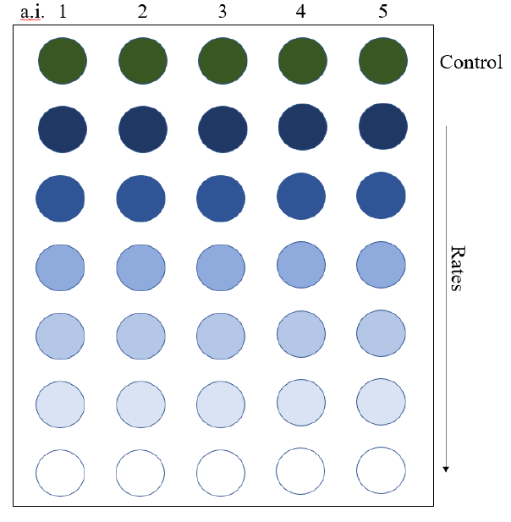

Figure 2. Set up Leaching rails for experiment preparation

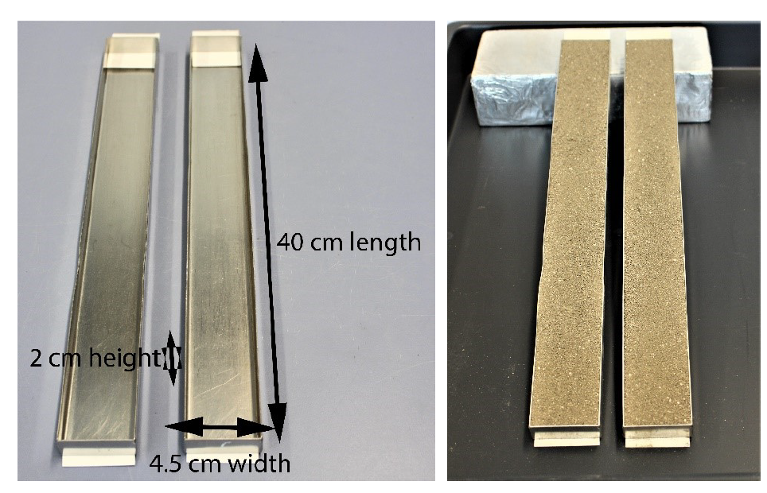

Figure 3: Results of the soil mobility trial. Shown are the means out of the two repetitions. NAAOF was used as bioindicator. Activity was measured in % plant damage compared to untreated control (PDCUs % control) Presented are the means (n=*2*) of the variants. Bars with no common letter are significantly different to the test group average after Scott and Knott, with an α = 0.05.

Ein Bild, das Text, Diagramm, Screenshot, parallel enthält.
