Supplementary Material
Title: Effect of center-pivot and sub-surface drip irrigation systems on growth and evapotranspiration of volunteer corn in corn, soybean, and sorghum

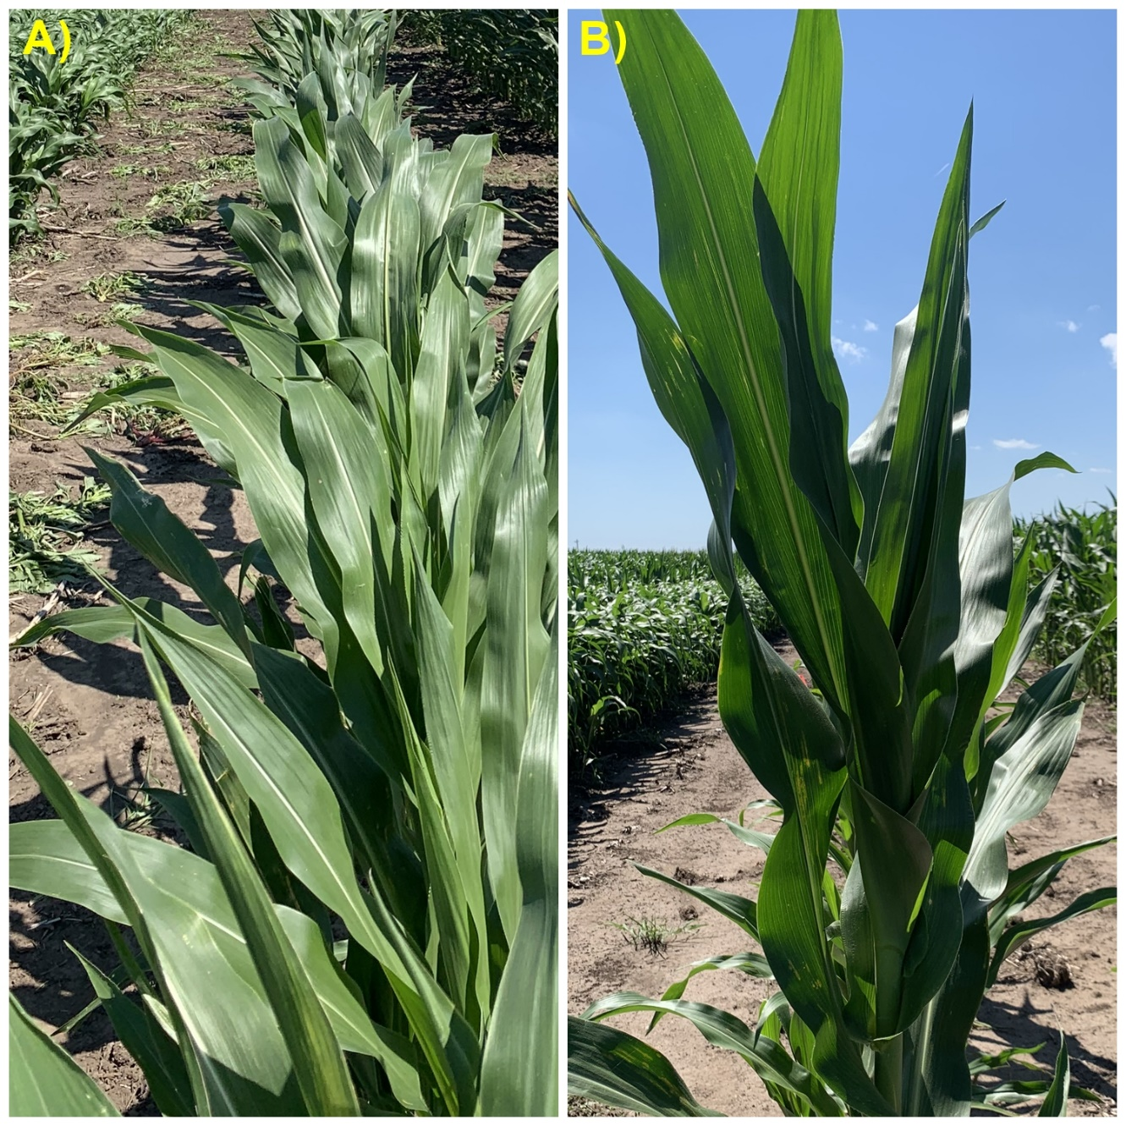
Figure S1: Fallow plot with volunteer corn plot having comparatively higher weed pressure which had been managed by hoeing in A) Center-pivot as compared to B) Sub-surface irrigation system 53 d after transplanting in 2021. These weeds were growing quickly after the first irrigation of the 2021 growing season which was applied a week before this photo was taken.

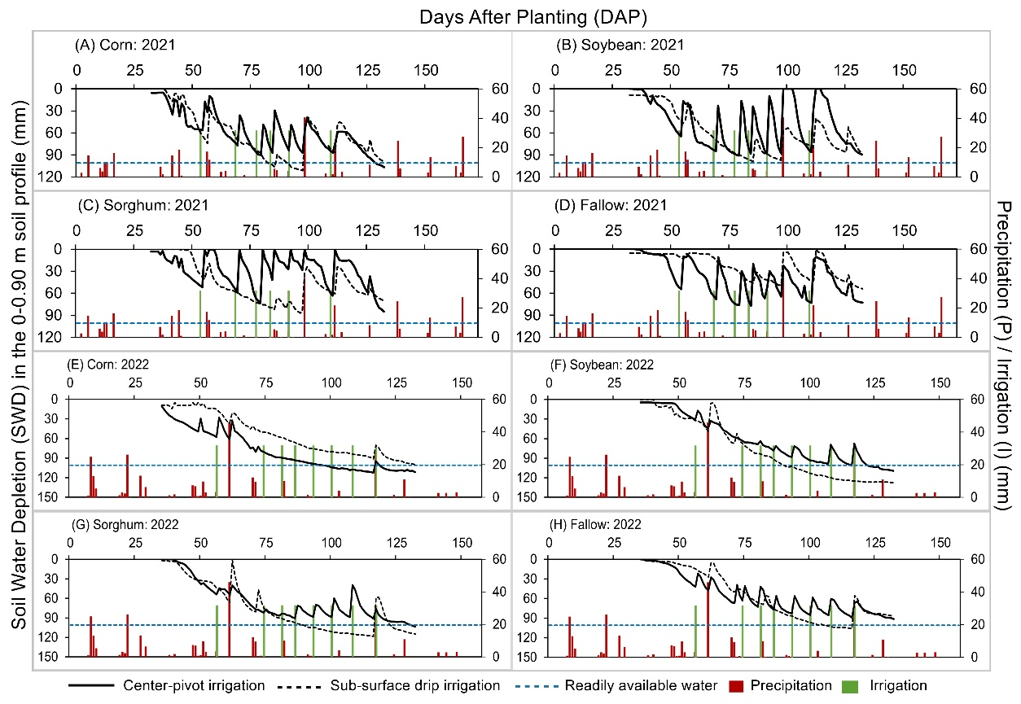
Figure S2: Soil water depletion (SWD; mm) in the 0-0.90 m soil profile by volunteer corn in corn, soybean, sorghum, and fallow in 2021 (A-D) and 2022 (E-H). The solid black line represents center-pivot irrigation, and the dashed black line represents sub-surface drip irrigation. The dashed blue represents readily available water. The red and green bars represent precipitation and irrigation events, respectively, on the secondary axis.

