Supplementary Material.
Table S1. Amaranthus palmeri source populations from Georgia (GA), North Carolina (NC) and Illinois (IL). The locality of each population is indicated, as well as the population latitude (°N) and longitude (°W).
 | Population | Location | State | Latitude (°N) | Longitude (°W)
1 | CO-GA | Colquitt Co. | GA | 31.141031 | -83.723125
2 | WO-GA | Worth Co. | GA | 31.3032 | -83.3932
3 | DO-GA | Dooly Co. | GA | 32.106095 | -83.777492
4 | MA-GA | Macon Co. | GA | 34.423982 | -84.129029
5 | LB-NC | Lumber Bridge | NC | 34.897865 | -79.047614
6 | ON-NC | Onslow Co. | NC | 34.90157 | -77.607704
7 | WN-NC | Wayne Co. | NC | 35.310539 | -78.078181
8 | RA-NC | Randolph Co. | NC | 35.55501 | -80.013807
9 | WL-NC | Wilson Co. | NC | 35.60278 | -78.071049
10 | CL-NC | Clayton | NC | 35.674307 | -78.512462
11 | JO-NC | Johnston Co. | NC | 35.674307 | -78.512462
12 | LI-NC | Linwood | NC | 35.726837 | -80.313716
13 | WA-NC | Wake Co. | NC | 35.781702 | -78.352149
14 | TA-NC | Tarboro | NC | 35.887358 | -77.443634
15 | UC-NC | UCPRS | NC | 35.897903 | -77.672789
16 | MR-NC | Martin Co. | NC | 35.979622 | -78.362871
17 | PH-NC | Pine Hill | NC | 36.360356 | -80.57341
18 | GL-IL | Gallatin Co. | IL | 37.629676 | -88.166345
19 | MD-IL | Madison Co. | IL | 38.691638 | -90.021769
20 | EF-IL | Effingham Co. | IL | 39.228864 | -88.525873
21 | CH-IL | Champaign Co. | IL | 40.074505 | -88.246533
22 | HE-IL | Henry Co. | IL | 41.447092 | -90.141592

Table S2. Individual plant sex assignment for Amaranthus palmeri in female isolation trial (ii) based on genetic markers for juveniles, and then phenotypic sex confirmation based on inflorescence observations.
Plant ID | Sex assignment  based on markers | Confirmed sex based on inflorescence
EFIL28_11 | Female | Female
COGA27_15 | Female | Female
WANC13_2 | Female | Female
EFIL28_4 | Female | Female
EFIL28_15 | Female | Female
WANC13_5 | Female | Female
ONNC5_1 | Female | Female
MAGA5_6 | Female | Female
ONNC5_6 | Female | Female
ONNC5_14 | Female | Female
MAGA5_11 | Female | Female
TANC33_6 | Female | Female
ONNC5_8 | Female | Female
TANC33_10 | Female | Female
MAGA5_15 | Female | Female
EFIL28_9 | Female | Female
COGA27_9 | Female | Female
RANC11_5 | Female | Female
EFIL28_6 | Female | Female
WANC13_14 | Female | Female
CHIL4_3 | Female | Female
HEIL17_13 | Female | Female
COGA27_8 | Female | Female
EFIL28_13 | Female | Female
EFIL28_2 | Female | Female
COGA27_14 | Female | Female
ONNC5_13 | Female | Female
EFIL28_7 | Female | Female
HEIL17_5 | Female | Female
ONNC5_11 | Female | Female
ONNC5_12 | Female | Female
TANC33_13 | Female | Female
MAGA5_3 | Female | Female
WANC13_4 | Female | Female
HEIL17_6 | Female | Female
MAGA5_7 | Female | Female
TANC33_7 | Female | Female
WANC13_9 | Female | Female
CHIL4_1 | Female | Female
CHIL13_1 | Female | Female
ONNC5_10 | Female | Female
TANC33_4 | Female | Female
RANC11_7 | Female | Male
WANC13_1 | Female | Male
WANC13_3 | Female | Male
RANC11_4 | Female | Male

Table S3. Seed production (all zero) for Amaranthus palmeri in female isolation trial (ii), along with the number of inflorescences produced, total length of inflorescences, and average length of inflorescences.
Plant ID | Number of seeds produced | Number of inflorescences | Total length of inflorescence (cm) | Average length of inflorescence (cm)
EFIL28_11 | 0 | 13 | 1362 | 104.77
COGA27_15 | 0 | 6 | 328 | 54.67
WANC13_2 | 0 | 10 | 247 | 24.70
EFIL28_4 | 0 | 15 | 1030 | 68.67
EFIL28_15 | 0 | 15 | 874 | 58.27
WANC13_5 | 0 | 5 | 346 | 69.20
ONNC5_1 | 0 | 19 | 1018 | 53.58
MAGA5_6 | 0 | 4 | 71 | 17.75
ONNC5_6 | 0 | 20 | 1267 | 63.35
ONNC5_14 | 0 | 14 | 538 | 38.43
MAGA5_11 | 0 | 17 | 1017 | 59.82
TANC33_6 | 0 | 24 | 1167 | 48.63
ONNC5_8 | 0 | 17 | 1653 | 97.24
TANC33_10 | 0 | 17 | 1273 | 74.88
MAGA5_15 | 0 | 17 | 883 | 51.94
EFIL28_9 | 0 | 25 | 1670 | 66.80
COGA27_9 | 0 | 7 | 165 | 23.57
RANC11_5 | 0 | 23 | 863 | 37.52
EFIL28_6 | 0 | 19 | 1216 | 64.00
WANC13_14 | 0 | 25 | 1639 | 65.56
CHIL4_3 | 0 | 18 | 2557 | 142.06
HEIL17_13 | 0 | 16 | 357 | 22.31
COGA27_8 | 0 | 0 | 0 | 0.00
EFIL28_13 | 0 | 25 | 1200 | 48.00
EFIL28_2 | 0 | 10 | 242 | 24.20
COGA27_14 | 0 | 11 | 648 | 58.91
ONNC5_13 | 0 | 22 | 791 | 35.95
EFIL28_7 | 0 | 16 | 658 | 41.13
HEIL17_5 | 0 | 20 | 1167 | 58.35
ONNC5_11 | 0 | 18 | 521 | 28.94
ONNC5_12 | 0 | 9 | 230 | 25.56
TANC33_13 | 0 | 22 | 2176 | 98.91
MAGA5_3 | 0 | 17 | 521 | 30.65
WANC13_4 | 0 | 1 | 37 | 37.00
HEIL17_6 | 0 | 32 | 1812 | 56.63
MAGA5_7 | 0 | 7 | 453 | 64.71
TANC33_7 | 0 | 16 | 244 | 15.25
WANC13_9 | 0 | 30 | 808 | 26.93
CHIL4_1 | 0 | 33 | 1137 | 34.45
CHIL13_1 | 0 | 33 | 1271 | 38.52
ONNC5_10 | 0 | 24 | 573 | 23.88
TANC33_4 | 0 | 30 | 444 | 14.80

Table S4. Best-fit models for variation in each of the seven morphological features of Amaranthus palmeri measured in female and male plants from 19 populations from eastern North America. Latitude, and population x sex were not significant in all cases; thus, models were reduced to a single fixed effect ‘Sex_Bagging’ (variable that combines whether a plant is female or male, and whether females were bagged) and the random effect population. Planned contrasts were performed between each level of the ‘Sex_Bagging’ variable to test whether there is a significant difference between females that are unbagged vs. bagged (F-Fbag), unbagged females and unbagged males (F-M), and bagged females and unbagged males (Fbag-M).
 |  |  |  |  |  | Contrasts
 | Variable | LMM model F | df | Model P | Pop’n P | F-Fbag  P | F-M  P | Fbag-M  P
(A) | Height | 6.5302 | 2, 528.67 | 0.0016 | 0.0076 | 0.9943 | 0.0166 | 0.0151
(B) | Stem diameter | 0.4374 | 2, 36.89 | 0.649 | 0.3445 | 0.6339 | 0.7538 | 0.9609
(C) | Total 2° branch length | 17.825 | 2, 78.27 | 4.178e-07 | 0.3042 | <0.0001 | 0.0271 | <0.0001
(D) | Total inflorescence length | 17.218 | 2, 65.19 | 9.913e-07 | 0.2821 | 0.0001 | 0.9643 | <0.0001
(E) | No. inflorescences | 2.0569 | 2, 50.10 | 0.1385 | 0.9885 | 0.9997 | 0.2278 | 0.1675
(F) | No. axillary inflorescences | 77.625 | 2, 60.27 | < 2.2e-16 | 0.3494 | 0.3909 | <0.0001 | <0.0001
 |  | GLM
(G) | 2° branches (binary) | χ²= 62.381 | 2 | 2.846e-14 |  | <0.0001 | 0.2659 | <0.0001

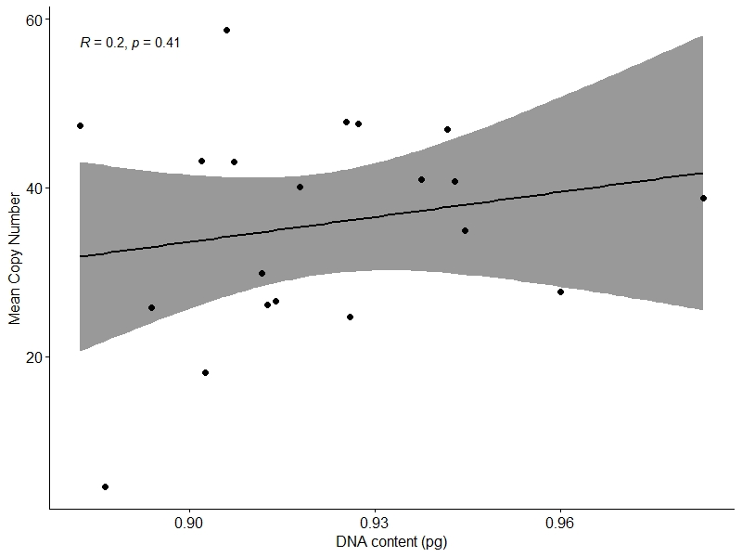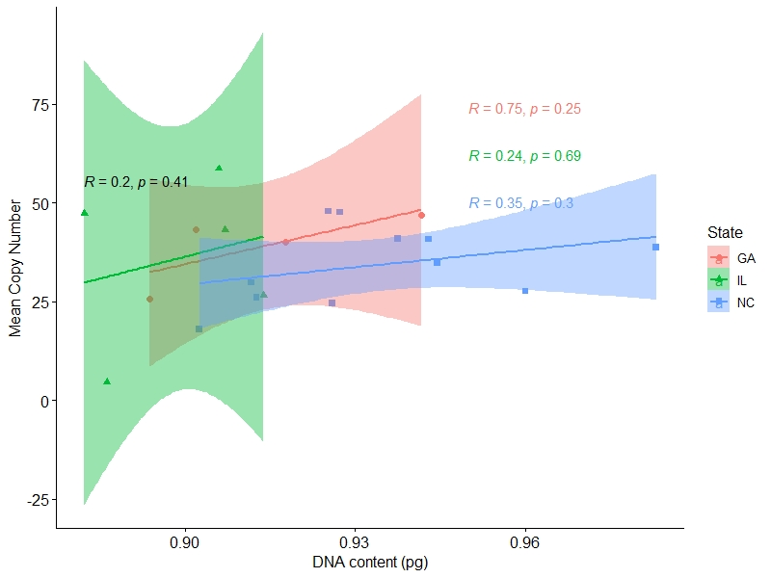
Figure S1. Linear relations between mean DNA content (pg) as estimated in this study and mean EPSPS copy number (estimated in Yakimowski et al. 2023) (a) across populations of Amaranthus palmeri from Georgia, North Carolina and Illinois and (b) estimated separately for population (GA – Georgia=red; NC – North Carolina=blue; IL – Illinois=green).

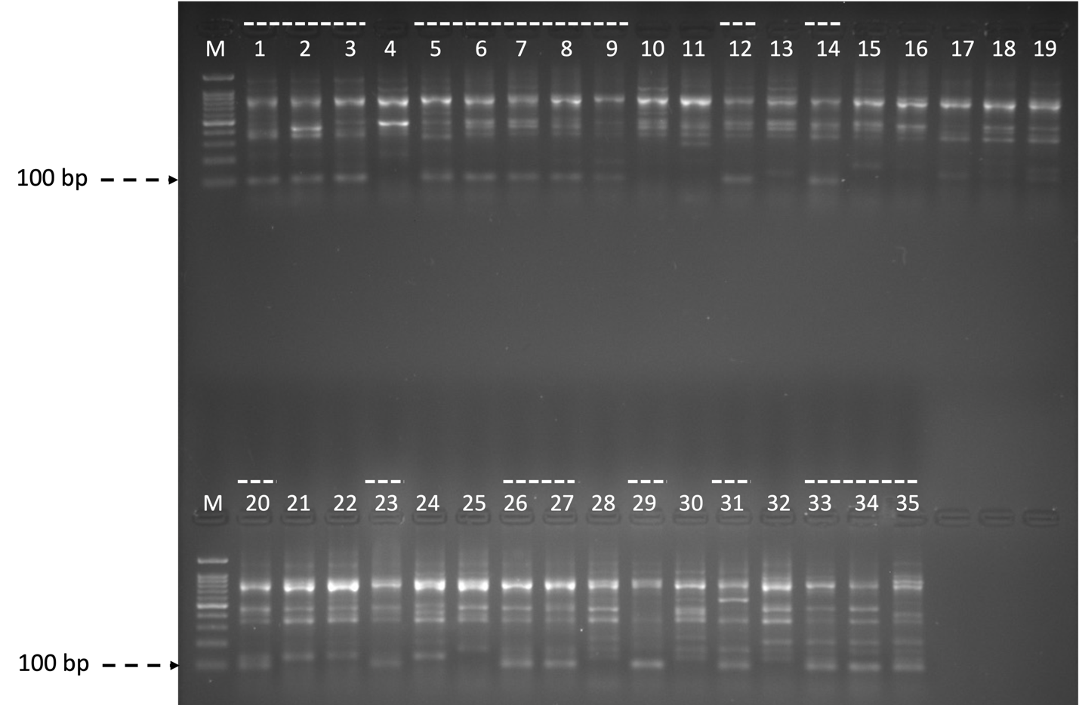
Figure S2. Example of male-specific genetic marker PCR product. Using the 100bp ladder on the far-left column of both rows, a band present of size ~100bp was used to assign sex phenotype as male (noted with a dashed line above). Individuals associated with this fragment were assumed male and discarded.

