Supplementary Material
Supplementary Table S1. Average and standard errors (± SE) of total number of waterhemp seedlings recorded from 7 to 70 days after treatment at 0.1 m⁻² quadrats in Brooklyn (BRO) and Janesville (ROK) in 2022 and 2033.
Cereal rye biomass (Mg ha⁻¹) | BRO |  | ROK
 | 2022 | 2023 | 2022 | 2023
--------- Mg ha⁻¹ --------- | ------------ Plants 0.1m⁻² ------------
0.0 | 28.3 (4.0) | 7.0 (1.6) | 189.3 (11.6) | 21.8 (6.5)
0.6 | 23.0 (4.3) | 5.0 (1.6) | 183.8 (3.3) | 31.0 (5.6)
1.2 | 28.5 (9.3) | 8.3 (2.7) | 122.8 (30.9) | 36.8 (1.9)
2.4 | 8.8 (0.9) | 6.5 (4.6) | 89.5 (32.4) | 56.0 (4.0)
4.8 | 6.0 (5.3) | 5.3 (2.3) | 24.3 (7.3) | 24.0 (4.8)
7.2 | 0.3 (0.3) | 0.8 (0.5) | 2.8 (1.9) | 0.8 (0.3)
9.6 | 0.5 (0.5) | 0.0 (0.0) | 1.0 (0.7) | 1.0 (1.0)
12.0 | 0.0 (0.0) | 0.0 (0.0) | 0.5 (0.5) | 0.3 (0.3)

Candidate model |  | Light transmittance | Amaranthus tuberculatus |  |  |  | Relative response index | Volumetric water content | Soil temperature
 |  |  | Density | Plant height | Biomass | Cumulative emergence
 |  | ----------------------------------------------------- AIC ----------------------------------------------------
Log-logistic | LL.3() | 1533.2 | 1734.7 | 1126.2 | 1729.6 | 436.0 | -160.3 | 876.6 | NC
 | LL.4() | 1516.6 | NC | 1118.8 | 1733.5 | 443.2 | -169.9 | 520.7 | 3370.8
Weibull | W1.3() | 1510.4 | NC | 1116.1 | 1725.7 | 425.0 | -154.3 | 877.5 | NC
 | W2.3() | 1558.8 | 1736.6 | 1135.0 | 1734.1 | 454.0 | -158.4 | NC | NC
 | W1.4() | 1511.4 | NC | 1118.6 | 1733.3 | 450.1 | -167.5 | 521.7 | 3370.1
 | W2.4() | 1524.9 | 1745.2 | 1118.3 | 1733.4 | 451.7 | -168.5 | 521.2 | 3371.6
Linear |  | 1918.5 | 1973.1 | 1332.5 | 1880.5 | 1311.1 | -47.2 | 710.9 | 3377.7
Quadratic |  | 1815.2 | 1970.8 | 1332.0 | 1818.8 | 1245.3 | -58.0 | 706.0 | 3367.9
Cubic |  | 1716.7 | 1970.8 | 1333.4 | 1818.2 | 1245.4 | -56.6 | 707.4 | 3370.0
Hormesis | CRS.4a() | NA | 1722.4 | NA | NA | 464.5 | NA | NA | NA
 | CRS.4b() | NA | 1722.3 | NA | NA | 470.8 | NA | NA | NA
 | CRS.4c() | NA | 1720.9 | NA | NA | 468.1 | NA | NA | NA
 | BC.4() | NA | 1721.8 | NA | NA | 446.2 | NA | NA | NA
Supplementary Table S2. Candidate models and AIC (Akaike information criterion) values for each response variable analyzed. Candidate models were compared through AIC, and the model with the lowest value (AIC in bold) within each response variable was selected.
ªNC: model failed to converge with these data.
^{b}NA: model not appropriate for these data.

Supplementary Table S3. Hourly mean temperature (C) at three cereal rye biomass doses (Mg ha⁻¹) recorded from 0 to 70 days after study establishment and linear regression parameter estimates, P, and R².
Hour of day | Biomass dose (Mg ha⁻¹) |  |  | Intercept |  | Slope |  | Quadratic |  | R²
 | 0.0 | 4.8 | 12.0 | Estimate | P | Estimate | P | Estimate | P
 | ------------- C -------------
0 h | 21.2 | 21.0 | 20.8 | 21.1 | <0.001 | -0.89 | <0.001 | 0.09 | 0.058 | 0.93
1 h | 20.7 | 20.7 | 20.6 | 20.7 | <0.001 | -0.23 | <0.001 | -0.09 | 0.046 | 0.52
2 h | 20.3 | 20.4 | 20.4 | 20.4 | <0.001 | 0.33 | <0.001 | -0.24 | <0.001 | 0.74
3 h | 19.8 | 20.2 | 20.2 | 20.1 | <0.001 | 0.81 | <0.001 | -0.38 | <0.001 | 0.93
4 h | 19.5 | 19.9 | 20.1 | 19.8 | <0.001 | 1.22 | <0.001 | -0.47 | <0.001 | 0.97
5 h | 19.2 | 19.7 | 19.9 | 19.6 | <0.001 | 1.54 | <0.001 | -0.55 | <0.001 | 0.98
6 h | 19.0 | 19.5 | 19.8 | 19.4 | <0.001 | 1.68 | <0.001 | -0.54 | <0.001 | 0.98
7 h | 19.2 | 19.5 | 19.7 | 19.5 | <0.001 | 1.09 | <0.001 | -0.26 | 0.001 | 0.94
8 h | 20.0 | 19.7 | 19.8 | 19.8 | <0.001 | -0.43 | <0.001 | 0.35 | <0.001 | 0.71
9 h | 21.2 | 20.2 | 20.0 | 20.5 | <0.001 | -2.57 | <0.001 | 1.15 | <0.001 | 0.97
10 h | 22.8 | 20.8 | 20.3 | 21.3 | <0.001 | -5.12 | <0.001 | 2.03 | <0.001 | 0.98
11 h | 24.4 | 21.6 | 20.7 | 22.3 | <0.001 | -7.62 | <0.001 | 2.80 | <0.001 | 0.99
12 h | 25.8 | 22.4 | 21.2 | 23.2 | <0.001 | -9.75 | <0.001 | 3.42 | <0.001 | 0.99
13 h | 27.0 | 23.0 | 21.6 | 24.0 | <0.001 | -11.41 | <0.001 | 3.86 | <0.001 | 0.99
14 h | 27.9 | 23.6 | 22.0 | 24.6 | <0.001 | -12.45 | <0.001 | 4.14 | <0.001 | 0.99
15 h | 28.3 | 23.9 | 22.2 | 25.0 | <0.001 | -12.70 | <0.001 | 4.18 | <0.001 | 0.99
16 h | 28.3 | 24.0 | 22.4 | 25.1 | <0.001 | -12.35 | <0.001 | 4.04 | <0.001 | 0.99
17 h | 27.8 | 23.9 | 22.4 | 24.9 | <0.001 | -11.33 | <0.001 | 3.70 | <0.001 | 0.99
18 h | 26.9 | 23.6 | 22.3 | 24.4 | <0.001 | -9.62 | <0.001 | 3.10 | <0.001 | 0.99
19 h | 25.8 | 23.2 | 22.1 | 23.8 | <0.001 | -7.68 | <0.001 | 2.40 | <0.001 | 0.99
20 h | 24.6 | 22.7 | 21.8 | 23.1 | <0.001 | -5.73 | <0.001 | 1.68 | <0.001 | 0.99
21 h | 23.5 | 22.2 | 21.6 | 22.5 | <0.001 | -3.96 | <0.001 | 1.04 | <0.001 | 0.99
22 h | 22.6 | 21.8 | 21.3 | 21.9 | <0.001 | -2.64 | <0.001 | 0.60 | <0.001 | 0.99
23 h | 21.8 | 21.4 | 21.0 | 21.5 | <0.001 | -1.64 | <0.001 | 0.31 | <0.001 | 0.98
Average | 23.2 | 21.6 | 21.0 | 22.0 | <0.001 | -4.64 | <0.001 | 1.52 | <0.001 | 0.99

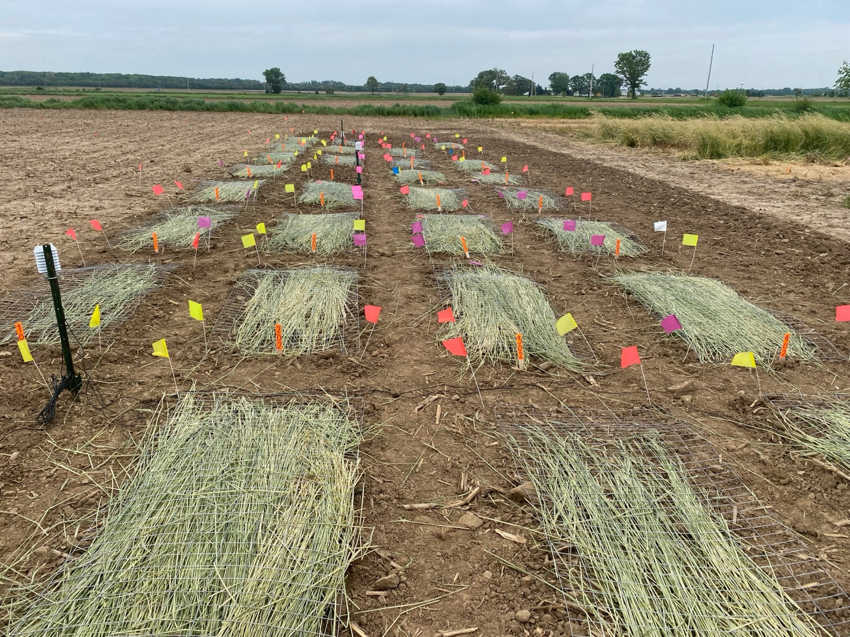
Supplementary Figure S1. Illustration of the methodology adopted.

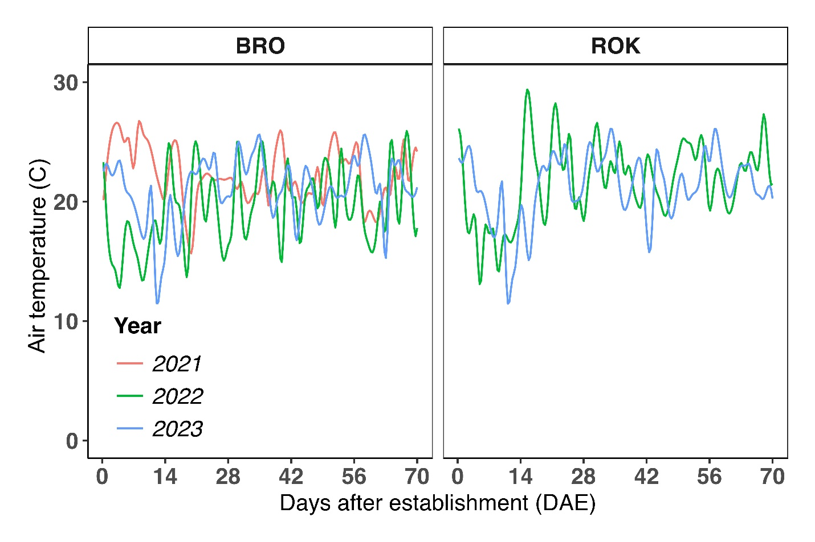
Supplementary Figure S2. Average daily air temperature (C) from 0 to 70 days after establishment (DAE) in Brooklyn (BRO) in 2021, 2022, and 2023, and Janesville (ROK) in 2022 and 2023. Note that the study was concluded within 42 DAE in BRO in 2021.

