Supplementary Table S1. Comparing the differences, estimate and P-values, of the curve parameters b, d and e estimated in the two experiments (Run1 and Run2) using Equation [1]:$f(t)=d/1+(exp(b(log⁡(t)-log⁡(e)))$, where d is the maximum sprouting; e is the time (days) at which 50% of the rhizomes had sprouted, and b is an absolute value proportional to the slope of f at time t, for different Solanum elaeagnifolium rhizome length (Length) and temperatures (Temp).
Parameter e comparison |  | Parameter d comparison |  | Parameter b comparison |  | Temp | Length
P-value | Estimate | P-value | Estimate | P-value | Estimate | (C) | (cm)
0.013* | -1.93 | 0.405 | -0.082 | 0.03* | -38.40 | 15 | 2.5
0.12 | 0.78 | 0.80 | -0.02 | 0.04* | 29.25 | 20
0.001* | -2.74 | 0.81 | 0.02 | 0.54 | -2.62 | 25
0.018* | -1.60 | 0.81 | -0.02 | 0.62 | 0.90 | 30
0.001* | -2.03 | 0.78 | 0.02 | 0.4 | 1.55 | 35
NA | NA | NA | NA | NA | NA | 40
0.001* | -3.13 | 0.8 | -0.02 | 0.30 | -7.04 | 15 | 5
0.36 | 0.82 | 0.14 | -0.17 | 0.005* | 7.05 | 20
0.78 | -0.12 | 0.8 | 0.02 | 0.4 | 2.37 | 25
0.89 | -0.79 | 0.81 | 0.03 | 0.9 | 0.17 | 30
0.04* | -0.87 | 0.74 | -0.02 | 0.05* | 3.05 | 35
0.97 | 0.02 | 0.63 | 0.05 | 0.46 | -1.54 | 40
0.001* | 1.57 | 0.33 | -0.11 | 0.30 | -9.63 | 15 | 7.5
0.16 | 0.78 | 0.62 | -0.05 | 0.8 | 0.64 | 20
0.24 | 0.38 | 0.86 | -0.01 | 0.65 | 1.12 | 25
0.07 | -0.07 | 0.75 | 0.02 | 0.64 | 1.14 | 30
0.001* | -1.18 | 0.72 | 0.02 | 0.39 | 1.54 | 35
0.007* | -1.16 | 0.81 | -0.02 | 0.06 | -3.87 | 40
0.7 | -0.20 | 0.33 | 0.03 | 0.66 | 1.70 | 15 | 10
0.48 | -0.37 | 0.76 | -0.02 | 0.08 | -2.82 | 20
0.7 | -0.2 | 0.81 | 0.03 | 0.2 | 2.00 | 25
0.65 | 0.13 | - | 0.00 | 0.46 | -0.88 | 30
0.18 | 0.34 | - | 0.00 | 0.69 | -0.56 | 35
0.40 | 0.40 | 0.46 | -0.08 | 0.1 | 2.70 | 40
*Significant comparisons P ≤ 0.05

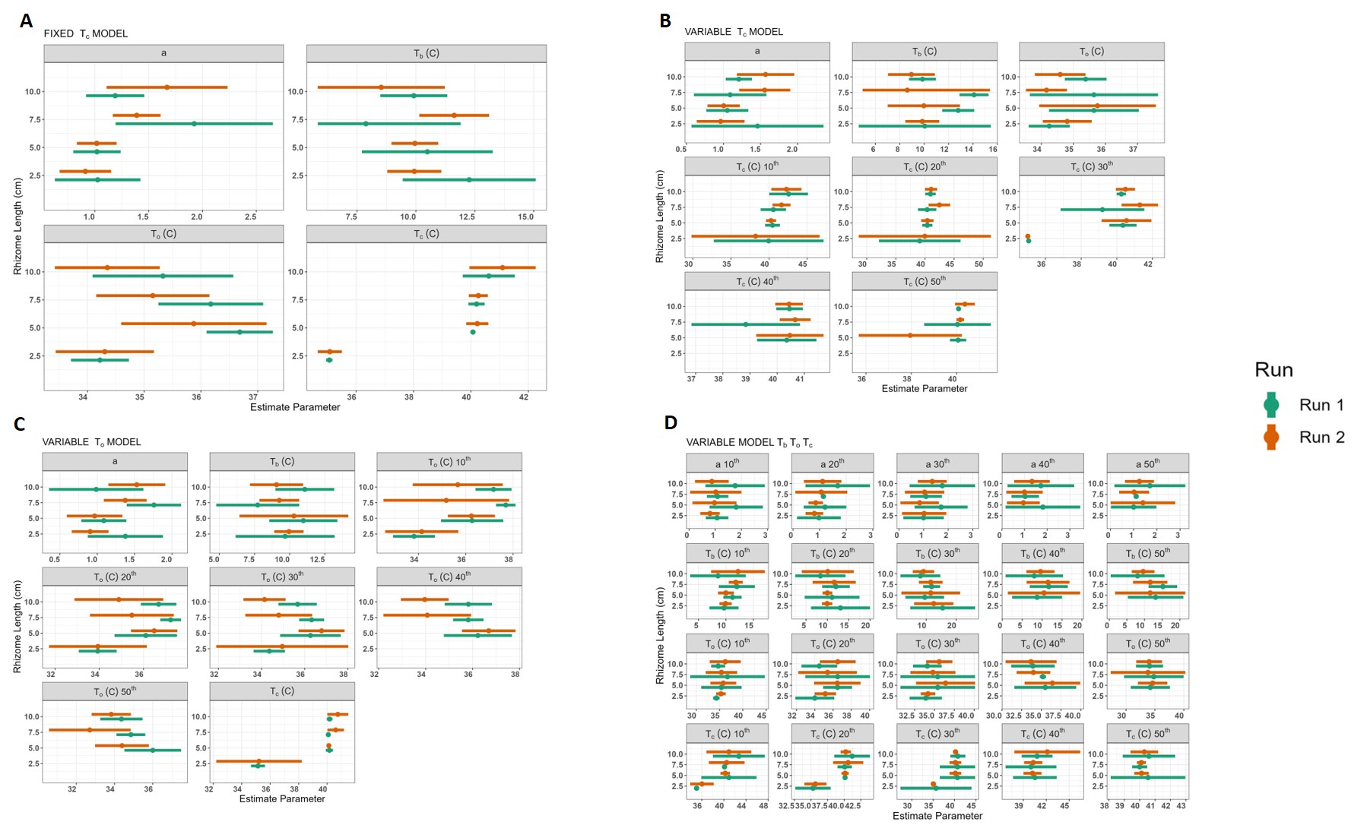

Supplementary Figure S1. Comparison of estimated cardinal temperatures T_{b} (base temperature), T_{o} (optimal temperature), T_{c} (ceiling temperature) and a (shape parameter) and their corresponding 95% confidence intervals for different Solanum elaeagnifolium rhizome length in the two experiments (Run1 and Run2) according to the four tested models: (A) 'FIXED T_{c} MODEL', (B) 'VARIABLE T_{c} MODEL', (C) 'VARIABLE T_{o} MODEL', and (D) 'VARIABLE T_{b}, T_{o}, T_{c} MODEL'

