Responses of Soil Seedbank and Aboveground Weed Communities to Globe Artichoke Cropping Systems: an On-Farm Analysis

Aurelio Scavo¹, Alessia Restuccia¹, Alessandro Di Martino¹, Giovanni Mauromicale¹

¹ Department of Agriculture, Food, and Environment (Di3A), University of Catania, 95123 Catania, Italy.

* Author for correspondence: Aurelio Scavo; Email: aurelio.scavo@unict.it

Supplementary Table S1. Geographical coordinates and agronomic management of all farms under study.
Farm | Geographical coordinates | Tillage | Type and time of fertilization | Active ingredient used for weed chemical control
1) ART
Buccheri 1 | 37°0'10.966"N, 14°22'52.194"E | Motocultivator after summer regrowth | Fertigation schedule from September with humic acids, seaweed, magnesium, potassium and calcium nitrate | Pyraflufen-ethyl (PiraMax EC); fluazifop-p-butyl (Belgard); oxyfluorfen (Wirk)
Pepi | 37°4'3.878"N, 14°27'12.46"E | / | Organic fertigation schedule from August with NPK fertilizer, organic matter and magnesium, potassium and calcium nitrate | /
Blanco 1 | 37°7'40.004"N, 14°20'21.242"E | Harrowing (‒10 cm) on September | / | Pyraflufen-ethyl (PiraMax EC); fluazifop-p-butyl (Fusilade max); oxyfluorfen (Goal)
2) past-ART
Di Modica | 37°7'35.321"N, 14°26'32.705"E | / | / | /
Buccheri 2 | 37°0'16.182"N, 14°23'12.685"E | Ploughing (‒20 cm) on September | / | /
Blanco 2 | 37°7'40.004"N, 14°20'21.242"E | Motocultivator on August | / | /
3) ART-WHEAT
Minardi 1 | 37°11'53.124"N, 14°18'53.705"E | Rotary tiller on October | Fertigation schedule from September with ammonium, potassium, magnesium and calcium nitrate, phosphate urea, humic acids and microelements | Pyraflufen-ethyl (PiraMax EC); fluazifop-p-butyl (Fusilade max)
Minardi 2 | 37°11'49.79"N, 14°19'4.418"E | Rotary tiller on October | Fertigation schedule from September with ammonium, potassium, magnesium and calcium nitrate, phosphate urea, humic acids and microelements | Pyraflufen-ethyl (PiraMax EC); fluazifop-p-butyl (Fusilade max)
Alessandrello | 37°1'29.978"N, 14°26'36.686"E | Harrowing (−25 cm) on November | / | /
Lo Iacono | 37°9'42.44"N, 14°20'26.614"E | Harrowing (−25 cm) on November | / | /
4) CONTROL
Di Martino A. | 37°9'21.28"N, 14°26'20.483"E | Subsoiling (−15 cm) on January and field bean green manure on March |  | /
Di Martino F. 1 | 37°8'45.769"N, 14°25'43.356"E | Subsoiling (−15 cm) on April-May | / | /
Di Martino F. 2 | 37°8'4.027"N, 14°25'30.36"E | Subsoiling (−15 cm) on April-May | / | /

Supplementary Table S2. Eigenvectors and eigenanalysis of the first three principal components (PCs) on 13 variables (7 major weeds for the soil seedbank and 6 for aboveground weeds) from the correlation matrix. The variables with the largest influence for each PC are in bold.
Variable | Weed soil seedbank |  |  |  | AbovegroundwWeeds
 | PC1 | PC2 | PC3 |  | PC1 | PC2 | PC3
AMAR | 0.406 | -0.326 | 0.322 |  | − | − | −
ANGAR | 0.026 | 0.608 | 0.273 |  | − | − | −
CHENAL | -0.073 | -0.622 | -0.269 |  | -0.002 | -0.913 | -0.033
CONVAR | − | − | − |  | -0.326 | 0.173 | 0.752
CYNDAC | − | − | − |  | 0.474 | 0.196 | 0.125
DACAEG | − | − | − |  | 0.547 | -0.041 | -0.001
DIPERU | − | − | − |  | 0.472 | 0.177 | -0.123
FALCO | -0.483 | -0.086 | -0.091 |  | − | − | −
FUMAR | -0.427 | -0.047 | 0.625 |  | − | − | −
PORTOL | 0.574 | -0.148 | 0.355 |  | − | − | −
SILENE | 0.291 | 0.325 | -0.474 |  | − | − | −
STELME | − | − | − |  | -0.384 | 0.257 | -0.635
Eigenvalue | 2.378 | 2.221 | 1.065 |  | 2.702 | 1.693 | 1.178
% Variance | 34.0 | 31.7 | 15.2 |  | 45.1 | 19.9 | 19.2
% Cumulative variance | 34.0 | 65.7 | 81.0 |  | 45.1 | 65.0 | 84.1
AMAR (Amaranthus retroflexus); ANGAR (Anagallis arvensis); CHENAL (Chenopodium album); CONVAR (Convolvulus arvensis); CYNDAC (Cynodon dactylon); DACAEG (Dactyloctenium aegyptium); DIPERU (Diplotaxis erucoides); FALCO (Fallopia convolvulus); FUMAR (Fumaria sp.); PORTOL (Portulaca oleracea); SILENE (Silene sp.); STELME (Stellaria media).
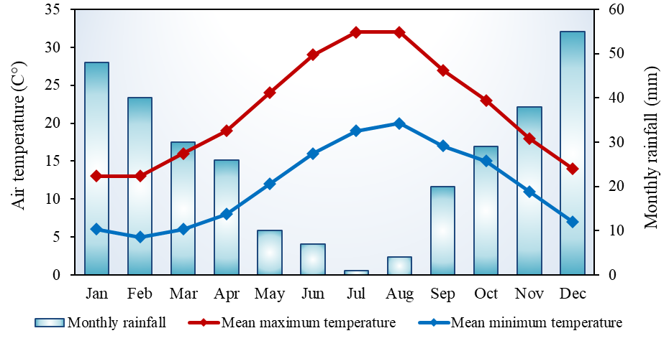
Supplementary Fig. S1. Total rainfall, maximum and minimum monthly temperatures during the 2021/2022 growing season in the experimental area (Niscemi, Caltanissetta, southern Italy).

