Supplement
Supplementary Figure S1. Stability of ‘M1’ and ‘M2’ alleles without harvest weed seed control (HWSC). The average values of the ’M1’ genes (Figure S1A) and the ‘M2’ genes (Figure S1C), and their standard deviation (SD) (Figures S1B and S1D, respectively) were reasonably stable over 30 years without HWSC, indicating the robustness of the population genetics used in this modelling. Legend: Different knockdown (knock) and post-emergence (post) herbicide efficacy combinations were examined.
Supplementary Figure S1
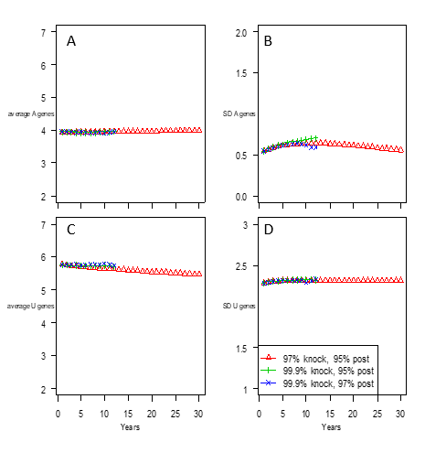
Average M1 alleles per plant
Average DFF of M2 alleles per plant
SD of M1 alleles
SD of M2 alleles
Years
Years

Supplementary table S1.
Gene name | Effect of each dominant allele on DFF | Mean copies of dominant allele in G₀ population | Standard deviation in G₀ population
M1 | Progressive; delays flowering by 6+ days | 4 | 0.5
M2 | delays flowering by 3 days | 6 | 2.3

