APPENDIX 1: OxCal Codes, Tables and Graphics
EL AMAREJO 1

S1.1. El Amarejo 1. Bayesian model: boundary-boundary
Plot()  {  Sequence()  {  Boundary("Start");  Phase("Amarejo")  {  R_Date("MAMS-63348",3528,17);  R_Date("MAMS-63357",3404,30);  R_Date("MAMS-63358",3320,17);  R_Date("MAMS-63353",3247,18);  R_Date("MAMS-63355",3245,21);  R_Date("MAMS-63354",3181,17);  R_Date("MAMS-63349",3168,16);  R_Date("MAMS-63350",3133,17);  R_Date("MAMS-63352",3096,17);  R_Date("MAMS-63356",2983,17);  R_Date("MAMS-63351",2955,16);  Span("Amarejo");  };  Boundary("End");  };  }; | 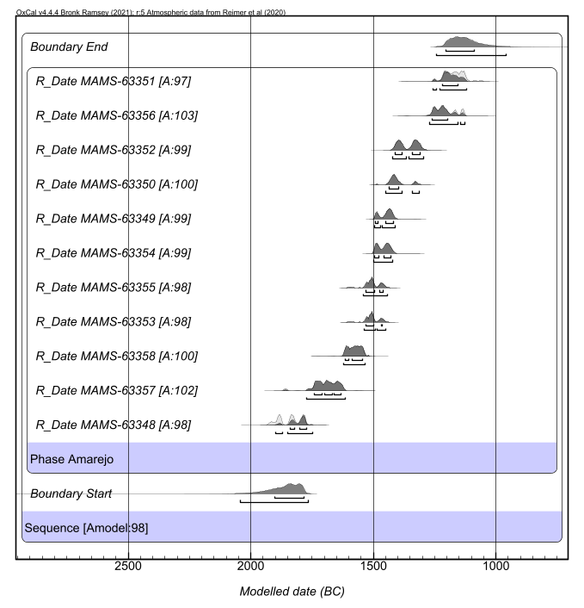

Name | Unmodelled (BC/AD) |  |  |  | Modelled (BC/AD) |  |  |  | Indices  ^{A}model=97.3  ^{A}overall=97.4
 | from_68.3 | to_68.3 | from_95.4 | to_95.4 | from_68.3 | to_68.3 | from_95.4 | to_95.4 | ^{A}comb | A | C
Sequence
Boundary Start |  |  |  |  | -1904 | -1784 | -2052 | -1768 |  |  | 96,4
Phase Amarejo
R_Date MAMS-63348 | -1895 | -1778 | -1930 | -1772 | -1841 | -1774 | -1901 | -1749 |  | 97,7 | 99,6
R_Date MAMS-63357 | -1741 | -1632 | -1868 | -1617 | -1741 | -1632 | -1772 | -1616 |  | 101,7 | 99,4
R_Date MAMS-63358 | -1614 | -1544 | -1622 | -1534 | -1614 | -1544 | -1622 | -1533 |  | 99,6 | 99,6
R_Date MAMS-63353 | -1532 | -1465 | -1538 | -1449 | -1531 | -1466 | -1539 | -1449 |  | 98 | 99,6
R_Date MAMS-63355 | -1532 | -1461 | -1540 | -1444 | -1531 | -1461 | -1541 | -1443 |  | 98,6 | 99,6
R_Date MAMS-63354 | -1495 | -1428 | -1499 | -1422 | -1495 | -1428 | -1499 | -1422 |  | 99,1 | 99,7
R_Date MAMS-63349 | -1492 | -1421 | -1497 | -1412 | -1492 | -1420 | -1497 | -1412 |  | 98,7 | 99,6
R_Date MAMS-63350 | -1436 | -1397 | -1448 | -1315 | -1436 | -1396 | -1449 | -1313 |  | 99,6 | 99,6
R_Date MAMS-63352 | -1411 | -1311 | -1422 | -1296 | -1411 | -1311 | -1422 | -1296 |  | 99,3 | 99,7
R_Date MAMS-63356 | -1260 | -1132 | -1267 | -1126 | -1261 | -1197 | -1271 | -1128 |  | 102,9 | 99,6
R_Date MAMS-63351 | -1212 | -1127 | -1257 | -1060 | -1220 | -1156 | -1259 | -1121 |  | 96,2 | 99,2
Span Amarejo |  |  |  |  | 571 | 670 | 546 | 750 |  |  | 99,3
Boundary End |  |  |  |  | -1203 | -1089 | -1243 | -959 |  |  | 96

S1.2. El Amarejo 1. Bayesian model: phase sequential analysis
Plot()  {  Phase()  {  Sequence()  {  Boundary("Start Chamber 1");  Phase("Chamber 1")  {  R_Date("MAMS-63348", 3528, 17);  R_Date("MAMS-63349", 3168, 16);  R_Date("MAMS-63350", 3133, 17);  R_Date("MAMS-63352", 3096, 17);  R_Date("MAMS-63351", 2995, 16);  Span("Chamber 1");  };  Boundary("End Chamber 1");  };  Sequence()  {  Boundary("Start Chamber 2");  Phase("Chamber 2")  {  R_Date("MAMS-63357", 3404, 30);  R_Date("MAMS-63358", 3320, 17);  R_Date("MAMS-63353", 3247, 18);  R_Date("MAMS-63355", 3245, 21);  R_Date("MAMS-63354", 3181, 17);  R_Date("MAMS-63356", 2983, 17);  Span("Chamber 2");  };  Boundary("End Chamber 2");  };  };  }; | 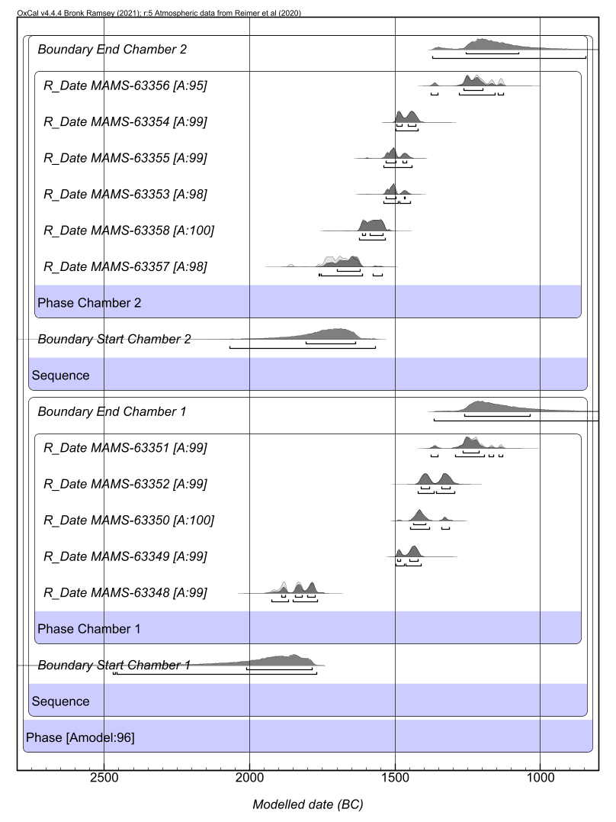

Name | Unmodelled (BC/AD) |  |  |  | Modelled (BC/AD) |  |  |  | Indices  ^{A}model=95.9  ^{A}overall⁼95.7
 | from_68.3 | to_68.3 | from_95.4 | to_95.4 | from_68.3 | to_68.3 | from_95.4 | to_95.4 | ^{A}comb | A | C
Phase
Sequence
Boundary Start Chamber 1 |  |  |  |  | -2013 | -1787 | -2471 | -1769 |  |  | 96,8
Phase Chamber 1
R_Date MAMS-63348 | -1895 | -1778 | -1930 | -1772 | -1890 | -1775 | -1926 | -1767 |  | 99,1 | 99,5
R_Date MAMS-63349 | -1492 | -1421 | -1497 | -1412 | -1492 | -1420 | -1497 | -1412 |  | 99,2 | 99,7
R_Date MAMS-63350 | -1436 | -1397 | -1448 | -1315 | -1436 | -1396 | -1449 | -1314 |  | 100 | 99,7
R_Date MAMS-63352 | -1411 | -1311 | -1422 | -1296 | -1411 | -1311 | -1422 | -1296 |  | 99,4 | 99,6
R_Date MAMS-63351 | -1266 | -1206 | -1369 | -1128 | -1268 | -1212 | -1376 | -1131 |  | 99,1 | 99,5
Span Chamber 1 |  |  |  |  | 522 | 637 | 457 | 713 |  |  | 99,5
Boundary End Chamber 1 |  |  |  |  | -1261 | -1037 | -1366 | -613 |  |  | 96
Sequence
Boundary Start Chamber 2 |  |  |  |  | -1806 | -1636 | -2069 | -1568 |  |  | 95,9
Phase Chamber 2
R_Date MAMS-63357 | -1741 | -1632 | -1868 | -1617 | -1700 | -1622 | -1762 | -1546 |  | 98,2 | 99,3
R_Date MAMS-63358 | -1614 | -1544 | -1622 | -1534 | -1613 | -1543 | -1622 | -1533 |  | 99,9 | 99,6
R_Date MAMS-63353 | -1532 | -1465 | -1538 | -1449 | -1531 | -1466 | -1538 | -1449 |  | 98 | 99,8
R_Date MAMS-63355 | -1532 | -1461 | -1540 | -1444 | -1531 | -1461 | -1541 | -1443 |  | 98,6 | 99,7
R_Date MAMS-63354 | -1495 | -1428 | -1499 | -1422 | -1495 | -1429 | -1499 | -1422 |  | 99,1 | 99,5
R_Date MAMS-63356 | -1260 | -1132 | -1267 | -1126 | -1265 | -1198 | -1376 | -1128 |  | 94,8 | 99,2
Span Chamber 2 |  |  |  |  | 377 | 501 | 260 | 567 |  |  | 99,4
Boundary End Chamber 2 |  |  |  |  | -1256 | -1075 | -1371 | -846 |  |  | 95,5

S1.3. Sum of probabilities of the radiocarbon dates of each of the chambers of the funerary monument of El Amarejo 1 (Figure 6)

Plot()  {  Sum("Chamber 1")  {  R_Date("AM1 MAMS-63348",3528,17);  R_Date("AM1 MAMS-63349",3168,16);  R_Date("AM1 MAMS-63350",3133,17);  R_Date("AM1 MAMS-63351",2995,16);  R_Date("AM1 MAMS-63352",3096,17);  };  }; | 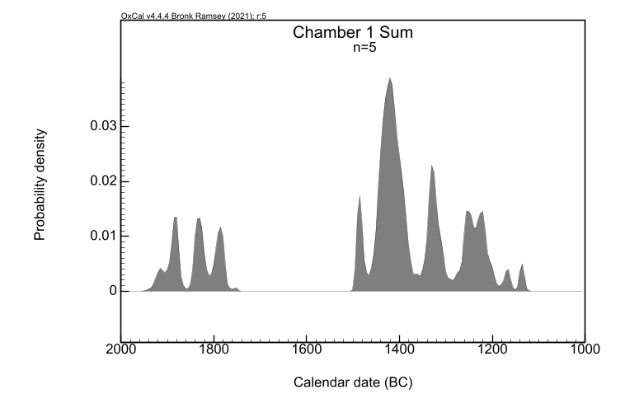
Plot()  {  Sum("Chamber 2")  {  R_Date("63353",3247,18);  R_Date("63354",3181,17);  R_Date("63355",3245,21);  R_Date("63356",2983,17);  R_Date("63357",3404,30);  R_Date("63358",3320,17);  };  }; | 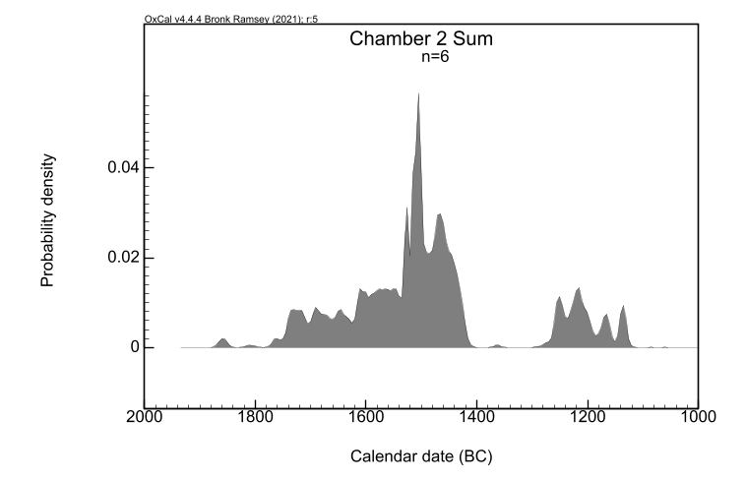

S1.4. Contemporaneity test of the dates MAMS-63351 and MAMS-63356 (Figure 7)
Plot()  {  R_Combine()  {  R_Date("MAMS-63351",2995,16);  R_Date("MAMS-63356",2983,17);  };  }; | 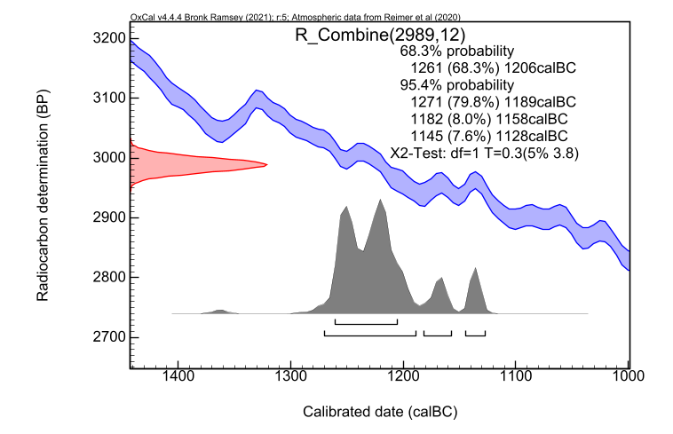

APPENDIX 2: OxCal Codes
¹⁴C Dates on funerary evidence in the Bronze Age of La Mancha

Site | Phase | Laboratory ID | Radiocarbon Age years BP | StD | Sample | Method | Reference | More info.
El Amarejo  Bonete (Albacete. ES) |  | MAMS-63348 | 3528 | 17 | Hominidae | AMS | This paper
 |  | MAMS-63349 | 3168 | 16 | Hominidae | AMS | This paper
 |  | MAMS-63350 | 3133 | 17 | Hominidae | AMS | This paper
 |  | MAMS-63351 | 2995 | 16 | Hominidae | AMS | This paper
 |  | MAMS-63352 | 3096 | 17 | Hominidae | AMS | This paper
 |  | MAMS-63353 | 3247 | 18 | Hominidae | AMS | This paper
 |  | MAMS-63354 | 3181 | 17 | Hominidae | AMS | This paper
 |  | MAMS-63355 | 3245 | 21 | Hominidae | AMS | This paper
 |  | MAMS-63356 | 2983 | 17 | Hominidae | AMS | This paper
 |  | MAMS-63357 | 3404 | 30 | Hominidae | AMS | This paper
 |  | MAMS-63358 | 3320 | 17 | Hominidae | AMS | This paper
Cerro de El Cuchillo  Almansa (Albacete. ES) |  | CNA-4056 | 3594 | 30 | Hominidae | AMS | Balsera 2022
 |  | CNA-4058 | 3585 | 30 | Hominidae | AMS | Balsera 2022
 |  | CNA-4060 | 3549 | 30 | Hominidae | AMS | Balsera 2022
 |  | CNA-4057 | 3492 | 30 | Hominidae | AMS | Balsera 2022
El Acequión  Albacete (Albacete. ES) | 2 | MAMS-17129 | 3677 | 25 | Hominidae | AMS | Balsera et al. 2016
 | 2 | MAMS-17128 | 3695 | 24 | Hominidae | AMS | Balsera et al. 2016
 | 3a | MAMS-17127 | 3616 | 24 | Hominidae | AMS | Balsera et al. 2016
 | 3b | MAMS-17131 | 3494 | 24 | Hominidae | AMS | Balsera et al. 2016
Bocapucheros  Almagro (Ciudad Real. ES) |  | Beta-574064 | 3470 | 30 | Hominidae | AMS | Benítez de Lugo et al. 2022 | δ13N: -18.8‰; δ15N: 11.04‰;  %C: 42.95;  %N: 15.68; C/N: 3.2
 |  | Beta-604904 | 3440 | 30 | Hominidae | AMS | Benítez de Lugo et al. 2022 | δ13N: -18.4‰; δ15N: 9.26‰;  %C: 37.45;  %N: 13.35; C/N: 3.3
Castillejo del Bonete  Terrinches (Ciudad Real. ES) |  | Beta-350768 | 3870 | 30 | Hominidae | AMS | Benítez de Lugo et al. 2020
 |  | Rome-1687 | 3720 | 70 | Hominidae | - | Benítez de Lugo et al. 2020
 |  | Poz-73665 | 3610 | 35 | Hominidae | AMS | Olalde et al. 2019 | δ13C: -18.4‰; δ15N: 10.7‰;  C/N: 3.14
 |  | PSUAMS-2077 | 3565 | 25 | Hominidae | AMS | Benítez de Lugo et al. 2020
El Azuer  Daimiel (Ciudad Real. ES) | 1 | Beta-229993 | 3780 | 40 | Hominidae | AMS | López Sáez et al. 2014
 | 1 | Ua-39246 | 3651 | 30 | Hominidae | AMS | Nájera et al. 2019
 | 2 | Beta-325510 | 4740 | 40 | Hominidae | AMS | Nájera et al. 2019 | Invalid
 | 2 | CNA-2873.1.1 | 3857 | 33 | Hominidae | AMS | Nájera et al. 2019 | Duplicate sample Ua-38416
 | 2 | Beta-375289 | 3640 | 30 | Hominidae | AMS | Nájera et al. 2019
 | 2 | Beta-229995 | 3620 | 50 | Hominidae | AMS | López Sáez et al. 2014
 | 2 | Ua-39248 | 3596 | 30 | Hominidae | AMS | Nájera et al. 2019
 | 2 | Ua-38416 | 3591 | 37 | Hominidae | AMS | Nájera et al. 2010 | Duplicate sample CNA-2873.1.1
 | 2 | Beta-229994 | 3580 | 40 | Hominidae | AMS | López Sáez et al. 2014
 | 2 | Ua-39247 | 3541 | 30 | Hominidae | AMS | Nájera et al. 2019
 | 3 | Beta-229996 | 3850 | 50 | Hominidae | AMS | Nájera et al. 2019 | Invalid
 | 3 | Beta-229991 | 3590 | 50 | Hominidae | AMS | Nájera et al. 2019
 | 3 | Ua-38414 | 3498 | 38 | Hominidae | AMS | López Sáez et al. 2014
 | 3 | Ua-38411 | 3473 | 35 | Hominidae | AMS | López Sáez et al. 2014 | Duplicate sample CNA-2874.1.1
 | 3 | Ua-38413 | 3457 | 37 | Hominidae | AMS | Nájera et al. 2019
 | 3 | Beta-230000 | 3450 | 40 | Hominidae | AMS | López Sáez et al. 2014
 | 3 | Ua-38412 | 3446 | 39 | Hominidae | AMS | Nájera et al. 2019
 | 3 | CNA-2874.1.1 | 3432 | 33 | Hominidae | AMS | Nájera et al. 2019 | Duplicate sample Ua-38411
 | 3 | Beta-325511 | 3410 | 40 | Hominidae | AMS | Nájera et al. 2019
 | 3 | Beta-229998 | 3400 | 40 | Hominidae | AMS | Nájera et al. 2019
 | 4 | Beta-230001 | 3330 | 40 | Hominidae | AMS | López Sáez et al. 2014
 | 4 | Beta-229992 | 3310 | 50 | Hominidae | AMS | López Sáez et al. 2014
 | 4 | Ua-38415 | 3172 | 36 | Hominidae | AMS | López Sáez et al. 2014
 | 4 | Beta-229997 | 3170 | 40 | Hominidae | AMS | Nájera et al. 2019
 | 4 | Beta-229999 | 3120 | 40 | Hominidae | AMS | López Sáez et al. 2014

APPENDIX 3: OxCal Codes and Tables
BRONZE AGE FUNERARY EVENTS IN LA MANCHA

S3.1. Bocapucheros. Bayesian model for funeral events
Plot()
{
Sequence("Bocapucheros")
{
Boundary ("Start");
Phase()
{
R_Date("Beta-574064",3470,30);
R_Date("Beta-604904",3440,30);
Span("");
};
Boundary("End");
};
};

Name | Unmodelled (BC/AD) |  |  |  | Modelled (BC/AD) |  |  |  | Indices  Amodel=100.7  Aoverall=100.8
 | from_68.3 | to_68.3 | from_95.4 | to_95.4 | from_68.3 | to_68.3 | from_95.4 | to_95.4 | ^{A}comb | A | C
Sequence
Bocapucheros
Boundary Start |  |  |  |  | -1989 | -1711 | -2576 | -1697 |  |  | 95,9
Phase
R_Date Beta-574064 | -1876 | -1743 | -1885 | -1692 | -1872 | -1701 | -1881 | -1693 |  | 100,2 | 99,1
R_Date Beta-604904 | -1871 | -1689 | -1879 | -1632 | -1871 | -1692 | -1879 | -1644 |  | 100,9 | 99,3
Span |  |  |  |  | 0 | 63 | 0 | 151 |  |  | 99,7
Boundary End |  |  |  |  | -1860 | -1572 | -1871 | -972 |  |  | 96,1

S3.2. El Castillejo del Bonete. Bayesian model for funeral events
Plot()
{
Sequence(Castillejo del Bonete-Burials)
{
Boundary ("Start");
Phase()
{
R_Date("Beta-350768",3870,30);
R_Date("Rome-1687",3720,70);
R_Date("Poz-73665",3610,35);
R_Date("PSUAMS-2077",3565,25);
Span("");
};
Boundary ("End");
};
};

Name | Unmodelled (BC/AD) |  |  |  | Modelled (BC/AD) |  |  |  | Indices  Amodel=96.2  Aoverall=96.4
 | from_68.3 | to_68.3 | from_95.4 | to_95.4 | from_68.3 | to_68.3 | from_95.4 | to_95.4 | ^{A}comb | A | C
Sequence
Castillejo del Bonete-Burials
Boundary Start |  |  |  |  | -2539 | -2240 | -3115 | -2202 |  |  | 95,9
Phase
R_Date Beta-350768 | -2452 | -2292 | -2462 | -2209 | -2398 | -2208 | -2456 | -2203 |  | 90,2 | 99,3
R_Date Rome-1687 | -2271 | -1984 | -2343 | -1905 | -2206 | -1984 | -2336 | -1929 |  | 102,3 | 99,4
R_Date Poz-73665 | -2026 | -1924 | -2127 | -1883 | -2026 | -1928 | -2125 | -1886 |  | 101,3 | 99,2
R_Date PSUAMS-2077 | -1949 | -1883 | -2017 | -1778 | -1951 | -1886 | -2022 | -1824 |  | 99,4 | 99,5
Span |  |  |  |  | 304 | 480 | 250 | 564 |  |  | 99,4
Boundary End |  |  |  |  | -1947 | -1707 | -2009 | -1171 |  |  | 96,8

S3.3. El Castillejo del Bonete. Bayesian model for all dated events
Plot()
{
Sequence("Castillejo del Bonete-All")
{
Boundary ("Start");
Phase()
{
R_Date("Poz-73606",4320,40);
R_Date("Beta-350768",3870,30);
R_Date("Rome-1687",3720,70);
R_Date("Poz-67168",3695,35);
R_Date("Poz-73665",3610,35);
R_Date("PSUAMS-2077",3565,25);
R_Date("UCIAMS-205912",3430,20);
R_Date("Poz-67167",3385,35);
Span("");
};
Boundary ("End");
};
};

Name | Unmodelled (BC/AD) |  |  |  | Modelled (BC/AD) |  |  |  | Indices  Amodel=101.7  Aoverall=101.6
 | from_68.3 | to_68.3 | from_95.4 | to_95.4 | from_68.3 | to_68.3 | from_95.4 | to_95.4 | ^{A}comb | A | C
Sequence
Castillejo del Bonete-All
Boundary Start |  |  |  |  | -3155 | -2907 | -3604 | -2884 |  |  | 96,7
Phase
R_Date Poz-73606 | -3010 | -2891 | -3076 | -2882 | -3005 | -2888 | -3025 | -2879 |  | 107 | 99,7
R_Date Beta-350768 | -2452 | -2292 | -2462 | -2209 | -2452 | -2292 | -2462 | -2210 |  | 99,9 | 99,8
R_Date Rome-1687 | -2271 | -1984 | -2343 | -1905 | -2272 | -1982 | -2342 | -1921 |  | 99,8 | 99,4
R_Date Poz-67168 | -2137 | -2033 | -2200 | -1972 | -2137 | -2033 | -2200 | -1971 |  | 99,7 | 99,8
R_Date Poz-73665 | -2026 | -1924 | -2127 | -1883 | -2026 | -1925 | -2127 | -1883 |  | 99,8 | 99,6
R_Date PSUAMS-2077 | -1949 | -1883 | -2017 | -1778 | -1949 | -1884 | -2017 | -1779 |  | 99,9 | 99,7
R_Date UCIAMS-205912 | -1862 | -1689 | -1872 | -1636 | -1862 | -1689 | -1873 | -1638 |  | 99,3 | 99,8
R_Date Poz-67167 | -1736 | -1623 | -1862 | -1543 | -1740 | -1629 | -1869 | -1562 |  | 99,4 | 99,7
Span |  |  |  |  | 1185 | 1308 | 1143 | 1400 |  |  | 99,7
Boundary End |  |  |  |  | -1709 | -1454 | -1751 | -1045 |  |  | 96,6

S3.4. Cerro del Cuchillo. Bayesian model for funeral events
Plot()
{
Sequence("Cerro del Cuchillo-Burials")
{
Boundary ("Start");
Phase()
{
R_Date("CNA-4056",3594,30);
R_Date("CNA-4058",3585,30);
R_Date("CNA-4060",3549,30);
R_Date("CNA-4057",3492,30);
Span("");
};
Boundary("End");
};
};
Name | Unmodelled (BC/AD) |  |  |  | Modelled (BC/AD) |  |  |  | Indices  Amodel=99.8 Aoverall=102
 | from_68.3 | to_68.3 | from_95.4 | to_95.4 | from_68.3 | to_68.3 | from_95.4 | to_95.4 | ^{A}comb | A | C
Sequence
Cerro del Cuchillo-Burials
Boundary Start |  |  |  |  | -2016 | -1901 | -2227 | -1835 |  |  | 98
Phase
R_Date CNA-4056 | -2013 | -1900 | -2033 | -1831 | -1949 | -1889 | -2019 | -1830 |  | 102,1 | 99,6
R_Date CNA-4058 | -2009 | -1892 | -2030 | -1826 | -1946 | -1888 | -2018 | -1827 |  | 108,8 | 99,6
R_Date CNA-4060 | -1942 | -1782 | -2013 | -1771 | -1938 | -1878 | -1970 | -1777 |  | 115 | 99,7
R_Date CNA-4057 | -1881 | -1751 | -1894 | -1698 | -1923 | -1836 | -1936 | -1765 |  | 81,4 | 99,5
Span |  |  |  |  | 0 | 118 | 0 | 205 |  |  | 99,3
Boundary End |  |  |  |  | -1907 | -1768 | -1935 | -1571 |  |  | 97,7

S3.5. Cerro del Cuchillo. Bayesian model for all dated events
Plot()
{
Sequence("Cerro del Cuchillo-All")
{
Boundary ("Start");
Phase()
{
R_Date("CNA-4056",3594,30);
R_Date("I-17449",3590,90);
R_Date("CNA-4058",3585,30);
R_Date("CNA-4060",3549,30);
R_Date("I-17447",3510,90);
R_Date("I-17448",3500,90);
R_Date("CNA-4057",3492,30);
R_Date("I-17445",3410,90);
R_Date("I-17446",3390,90);
Span("");
};
Boundary("End");
};
};

Name |  | Unmodelled (BC/AD) |  |  |  | Modelled (BC/AD) |  |  |  |  | Indices  Amodel=101.5  Aoverall=98.8
 | from_68.3 | to_68.3 | from_95.4 | to_95.4 | from_68.3 |  | to_68.3 | from_95.4 | to_95.4 | ^{A}comb |  | A | C
Sequence
Cerro del Cuchillo-All
Boundary Start |  |  |  |  | -1981 |  | -1901 | -2076 | -1834 |  |  |  | 96,6
Phase
R_Date CNA-4056 | -2013 | -1900 | -2033 | -1831 | -1941 |  | -1886 | -2011 | -1823 |  |  | 96,2 | 99,3
R_Date I-17449 | -2127 | -1775 | -2201 | -1691 | -1946 |  | -1826 | -1997 | -1766 |  |  | 117,6 | 99,2
R_Date CNA-4058 | -2009 | -1892 | -2030 | -1826 | -1937 |  | -1885 | -2010 | -1822 |  |  | 104,6 | 99,4
R_Date CNA-4060 | -1942 | -1782 | -2013 | -1771 | -1932 |  | -1830 | -1955 | -1776 |  |  | 114,6 | 99,6
R_Date I-17447 | -1954 | -1693 | -2132 | -1566 | -1931 |  | -1826 | -1976 | -1741 |  |  | 122,3 | 99,5
R_Date I-17448 | -1946 | -1691 | -2126 | -1546 | -1930 |  | -1826 | -1974 | -1740 |  |  | 119,7 | 99,3
R_Date CNA-4057 | -1881 | -1751 | -1894 | -1698 | -1894 |  | -1814 | -1926 | -1761 |  |  | 92 | 99,3
R_Date I-17445 | -1876 | -1564 | -1937 | -1504 | -1921 |  | -1817 | -1952 | -1710 |  |  | 78,9 | 99,4
R_Date I-17446 | -1867 | -1542 | -1923 | -1465 | -1919 |  | -1814 | -1950 | -1704 |  |  | 66,9 | 99,4
Span |  |  |  |  | 0 |  | 168 | 0 | 282 |  |  |  | 97,3
Boundary End |  |  |  |  | -1883 |  | -1753 | -1916 | -1636 |  |  |  | 96,9

S3.6. El Acequión. Bayesian model for funeral events
Plot()
{
Sequence("El Acequión-Burials")
{
Boundary ("Start");
Phase()
{
R_Date("MAMS-17128",3695,24);
R_Date("MAMS-17129",3677,25);
R_Date("MAMS-17127",3616,24);
R_Date("MAMS-17131",3494,24);
Span("");
};
Boundary("End");
};
};
Name | Unmodelled (BC/AD) |  |  |  | Modelled (BC/AD) |  |  |  | Indices  Amodel=96  Aoverall=95.5
 | from_68.3 | to_68.3 | from_95.4 | to_95.4 | from_68.3 | to_68.3 | from_95.4 | to_95.4 | ^{A}comb | A | C
Sequence
El Acequión-Burials
Boundary Start |  |  |  |  | -2236 | -2048 | -2586 | -1986 |  |  | 97
Phase
R_Date MAMS-17128 | -2136 | -2035 | -2195 | -1981 | -2126 | -2030 | -2190 | -1977 |  | 98,8 | 99,6
R_Date MAMS-17129 | -2133 | -1985 | -2141 | -1971 | -2127 | -1981 | -2138 | -1965 |  | 96,1 | 99,5
R_Date MAMS-17127 | -2024 | -1941 | -2108 | -1893 | -2023 | -1941 | -2035 | -1895 |  | 100,5 | 99,7
R_Date MAMS-17131 | -1881 | -1768 | -1889 | -1744 | -1887 | -1801 | -1921 | -1746 |  | 95,7 | 99,3
Span |  |  |  |  | 187 | 311 | 136 | 374 |  |  | 99,2
Boundary End |  |  |  |  | -1877 | -1690 | -1926 | -1333 |  |  | 98

S3.7. Motilla del Azuer. Bayesian model for funeral events

Plot()
{
Sequence()
{
Boundary("Start Phase 1");
Phase("1")
{
R_Date("AZ-1 Beta-229993",3780,40);
R_Date("AZ-1 Ua-39246",3651,30);
};
Boundary("Transition 1/2");
Phase("2")
{
R_Date("AZ-2 CNA-2873.1.2+Ua38416",3742,25);
R_Date("AZ-2 Beta-325505",3660,30);
R_Date("AZ-2 Beta-375289",3640,30);
R_Date("AZ-2 Beta-229995",3620,50);
R_Date("AZ-2 Ua-39248",3596,30);
R_Date("AZ-2 Beta-229994",3580,40);
R_Date("AZ-2 Ua-39247",3541,30);
};
Boundary("Transition 2/3");

Phase("3")
{
R_Date("AZ-3 Beta-229991",3590,50);
R_Date("AZ-3 Ua-38414",3498,38);
R_Date("AZ-3 Ua-38413",3457,37);
R_Date("AZ-3 CNA-2874.1.1+Ua38411",3451,25);
R_Date("AZ-3 Beta-230000",3450,40);
R_Date("AZ-3 Ua-38412",3446,39);
R_Date("AZ-3 Beta-325511",3410,40);
R_Date("AZ-3 Beta-229998",3400,40);
};
Boundary("Transition 3/4");
Phase("4")
{
R_Date("AZ-4 Beta-230001",3330,40);
R_Date("AZ-4 Beta-229992",3310,50);
R_Date("AZ-4 Ua-38415",3172,36);
R_Date("AZ-4 Beta-229997",3170,30);
R_Date("AZ-4 Beta-229999",3120,40);
};
Boundary("End Phase 4");
};
};

Name | Unmodelled (BC/AD) |  |  |  | Modelled (BC/AD) |  |  |  | Indices  Amodel=82.6  Aoverall=83.7
 | from_68.3 | to_68.3 | from_95.4 | to_95.4 | from_68.3 | to_68.3 | from_95.4 | to_95.4 | ^{A}comb | A | C
Sequence
Boundary Start Phase 1 |  |  |  |  | -2241 | -2084 | -2421 | -2047 |  |  | 95,7
Phase 1
R_Date AZ-1 Beta-229993 | -2285 | -2141 | -2344 | -2039 | -2203 | -2061 | -2273 | -2048 |  | 86,3 | 99
R_Date AZ-1 Ua-39246 | -2121 | -1960 | -2137 | -1938 | -2132 | -2092 | -2190 | -2047 |  | 79,5 | 99,7
Boundary Transition 1/2 |  |  |  |  | -2102 | -2051 | -2135 | -2034 |  |  | 99,7
Phase 2
R_Date AZ-2 CNA- 2873.1.2+Ua38416 | -2200 | -2058 | -2276 | -2037 | -2072 | -2040 | -2095 | -1984 |  | 69,7 | 99,8
Beta-325505 | -2131 | -1973 | -2137 | -1948 | -2048 | -1968 | -2105 | -1942 |  | 99,2 | 99,7
R_Date AZ-2 Beta-375289 | -2112 | -1950 | -2135 | -1900 | -2032 | -1962 | -2104 | -1904 |  | 109 | 99,8
R_Date AZ-2 Ua-39248 | -2014 | -1901 | -2034 | -1831 | -2019 | -1920 | -2027 | -1893 |  | 104,1 | 99,7
R_Date AZ-2 Beta-229994 | -2013 | -1886 | -2109 | -1774 | -2013 | -1905 | -2031 | -1882 |  | 109,5 | 99,8
R_Date AZ-2 Ua-39247 | -1933 | -1779 | -2008 | -1751 | -1946 | -1885 | -2020 | -1828 |  | 91,8 | 99,6
Boundary Transition 2/3 |  |  |  |  | -1928 | -1853 | -1956 | -1779 |  |  | 99,6
Phase 3
R_Date AZ-3 Beta-229991 | -2026 | -1885 | -2132 | -1772 | -1901 | -1772 | -1922 | -1746 |  | 52,4 | 99,4
 |  |  |  |  | Warning! Poor agreement - A= 52.4%(A'c= 60.0%)
R_Date AZ-3 Ua-38414 | -1884 | -1753 | -1928 | -1696 | -1850 | -1749 | -1892 | -1697 |  | 105,2 | 99,7
R_Date AZ-3 Ua-38413 | -1876 | -1694 | -1886 | -1641 | -1871 | -1697 | -1881 | -1687 |  | 104,1 | 99,5
R_Date AZ-3 CNA-2874.1.1+Ua38411 | -1872 | -1694 | -1880 | -1687 | -1869 | -1696 | -1876 | -1689 |  | 100,9 | 99,7
R_Date AZ-3 Beta-230000 | -1875 | -1690 | -1883 | -1634 | -1869 | -1695 | -1881 | -1676 |  | 105,3 | 99,7
R_Date AZ-3 Ua-38412 | -1874 | -1689 | -1881 | -1631 | -1870 | -1693 | -1881 | -1671 |  | 104,9 | 99,6
R_Date AZ-3 Beta-325511 | -1745 | -1629 | -1877 | -1564 | -1864 | -1676 | -1875 | -1627 |  | 98.1 | 99,5
R_Date AZ-3 Beta-229998 | -1742 | -1626 | -1874 | -1544 | -1767 | -1671 | -1872 | -1626 |  | 95.6 | 99,4
Boundary Transition 3/4 |  |  |  |  | -1711 | -1607 | -1763 | -1546 |  |  | 99,4
Phase 4
R_Date AZ-4 Beta-230001 | -1666 | -1533 | -1735 | -1508 | -1619 | -1535 | -1671 | -1506 |  | 108 | 99.7
R_Date AZ-4 Beta-229992 | -1623 | -1511 | -1738 | -1458 | -1611 | -1516 | -1675 | -1457 |  | 108.1 | 99.8
R_Date AZ-4 Ua-38415 | -1497 | -1418 | -1509 | -1322 | -1497 | -1424 | -1508 | -1401 |  | 104.4 | 99.6
R_Date AZ-4 Beta-229997 | -1496 | -1417 | -1505 | -1397 | -1496 | -1422 | -1503 | -1409 |  | 102 | 99.7
R_Date AZ-4 Beta-229999 | -1438 | -1306 | -1496 | -1275 | -1494 | -1391 | -1502 | -1317 |  | 93.5 | 99.2
Boundary End Phase 4 |  |  |  |  | -1440 | -1329 | -1482 | -1216 |  |  | 97.4

S3.8. Motilla de Santa María del Retamar. Bayesian model for all dated events
Plot()
{
Sequence("Retamar")
{
Boundary ("Start");
Phase()
{
R_Date("CSIC-797",3520,55);
R_Date("SUERC-92655",3569,27);
R_Date("CSIC-796",3585,55);
R_Date("Beta-591414",3590,30);
Span("Span");
};
Boundary("End");
};
};

Name | Unmodelled (BC/AD) |  |  |  | Modelled (BC/AD) |  |  |  | Indices  Amodel=126.3  Aoverall=124.5
 | from_68.3 | to_68.3 | from_95.4 | to_95.4 | from_68.3 | to_68.3 | from_95.4 | to_95.4 | ^{A}comb | A | C
Sequence Retamar
Boundary Start |  |  |  |  | -1999 | -1904 | -2153 | -1887 |  |  | 97,3
Phase
R_Date CSIC-797 | -1928 | -1767 | -2021 | -1691 | -1950 | -1879 | -2013 | -1786 |  | 93,2 | 99,5
R_Date SUERC-92655 | -1955 | -1883 | -2021 | -1778 | -1942 | -1893 | -2011 | -1831 |  | 117,5 | 99,7
R_Date CSIC-796 | -2027 | -1831 | -2133 | -1767 | -1953 | -1888 | -2027 | -1822 |  | 127,3 | 99,6
R_Date Beta-591414 | -2011 | -1896 | -2031 | -1829 | -1949 | -1894 | -2016 | -1881 |  | 111,2 | 99,7
Span |  |  |  |  | 0 | 67 | 0 | 174 |  |  | 98,8
Boundary End |  |  |  |  | -1939 | -1843 | -1968 | -1663 |  |  | 97,8

S3.9. El Cerro de la Encantada. Bayesian model for all dated events
Plot()
{
Sequence("Encantada")
{
Boundary ("Start");
Phase()
{
R_Date("CSIC-426",3250,50);
R_Date("CSIC-425",3260,50);
R_Date("CSIC-402",3280,50);
R_Date("CSIC-401",3290,50);
R_Date("CSIC-924",3330,25);
R_Date("CSIC-992",3330,35);
R_Date("CSIC-427",3330,50);
R_Date("CSIC-925",3390,25);
R_Date("CSIC-930",3470,25);
R_Date("CSIC-931",3480,30);
R_Date("CSIC-928",3500,20);
R_Date("CSIC-926",3550,25);
R_Date("CSIC-869",3570,50);
R_Date("CSIC-927",3660,20);
R_Date("CSIC-929",3890,25);
Span("Span");
};
Boundary("End");
};
};

Name | Unmodelled (BC/AD) |  |  |  | Modelled (BC/AD) |  |  |  | Indices  Amodel=92.8  Aoverall=92.6
 | from_68.3 | to_68.3 | from_95.4 | to_95.4 | from_68.3 | to_68.3 | from_95.4 | to_95.4 | ^{A}comb | A | C
Sequence Encantada
Boundary Start |  |  |  |  | -2450 | -2243 | -2550 | -2211 |  |  | 95,6
Phase
R_Date CSIC-426 | -1606 | -1447 | -1622 | -1422 | -1611 | -1494 | -1629 | -1433 |  | 99 | 99,3
R_Date CSIC-425 | -1609 | -1456 | -1664 | -1421 | -1612 | -1499 | -1668 | -1439 |  | 101,6 | 99,5
R_Date CSIC-402 | -1613 | -1503 | -1683 | -1439 | -1612 | -1510 | -1685 | -1453 |  | 103,3 | 99,5
R_Date CSIC-401 | -1614 | -1507 | -1687 | -1447 | -1614 | -1514 | -1731 | -1457 |  | 103,1 | 99,5
R_Date CSIC-924 | -1622 | -1543 | -1686 | -1518 | -1622 | -1543 | -1685 | -1520 |  | 100 | 99,4
R_Date CSIC-992 | -1628 | -1535 | -1731 | -1515 | -1628 | -1536 | -1731 | -1516 |  | 100,3 | 99,4
R_Date CSIC-427 | -1673 | -1532 | -1742 | -1501 | -1675 | -1533 | -1741 | -1504 |  | 101 | 99,3
R_Date CSIC-925 | -1732 | -1631 | -1746 | -1616 | -1733 | -1630 | -1746 | -1616 |  | 99,5 | 99,3
R_Date CSIC-930 | -1875 | -1744 | -1881 | -1696 | -1875 | -1743 | -1882 | -1696 |  | 99,4 | 99,6
R_Date CSIC-931 | -1878 | -1747 | -1888 | -1696 | -1878 | -1748 | -1888 | -1696 |  | 99,7 | 99,5
R_Date CSIC-928 | -1881 | -1772 | -1886 | -1750 | -1881 | -1772 | -1886 | -1751 |  | 99,5 | 99,6
R_Date CSIC-926 | -1939 | -1826 | -2008 | -1773 | -1940 | -1826 | -2007 | -1773 |  | 99,3 | 99,5
R_Date CSIC-869 | -2018 | -1783 | -2113 | -1751 | -2018 | -1784 | -2114 | -1755 |  | 99,4 | 99,2
R_Date CSIC-927 | -2127 | -1978 | -2135 | -1953 | -2126 | -1978 | -2135 | -1953 |  | 99,2 | 99,5
R_Date CSIC-929 | -2456 | -2344 | -2464 | -2294 | -2367 | -2209 | -2438 | -2205 |  | 71,3 | 98,6
Span |  |  |  |  | 750 | 902 | 673 | 954 |  |  | 99,1
Boundary End |  |  |  |  | -1524 | -1411 | -1562 | -1289 |  |  | 96,4

