**Accessing old carbon influence on TOC 14C age and environmental change from the recent sediments in Lake Shira, Russia**

Satabdi Misra1#, Dilyara Kuzina2#, Tzu-Tsen Shen1, Chun-Yen Chou1,

Anastasiya Yusupova2, Pavel Krylov2, Danis Nurgaliev2, Hong-Chun Li1, 3*

1Department of Geosciences, National Taiwan University, Taipei 10617, Taiwan, ROC

2Department of Geophysics and Geoinformation Technologies, Kazan (Volga Region) Federal University, Kazan 420008, Russia

3Frontiers Science Center for Deep Ocean Multispheres and Earth System, and Key Laboratory of Marine Chemistry Theory and Technology, Ministry of Education, Ocean University of China, Qingdao, China

**Supplement materials**

Table S1: Activities of measured nuclides by gamma spectrometry in Shira GC4. Ages were determined assuming a constant rate of supply model of 210Pb dating. 226Ra activities were determined by 214Pb activity at 353 kev on a gamma spectrometer.

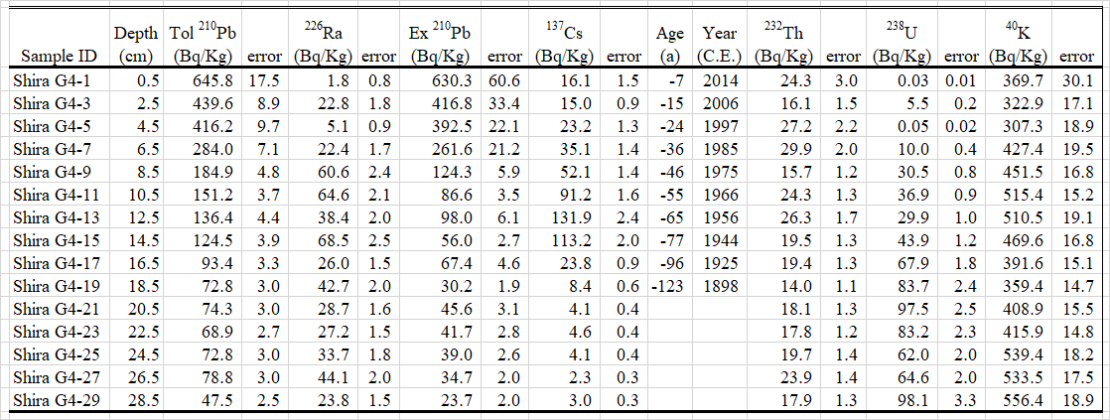

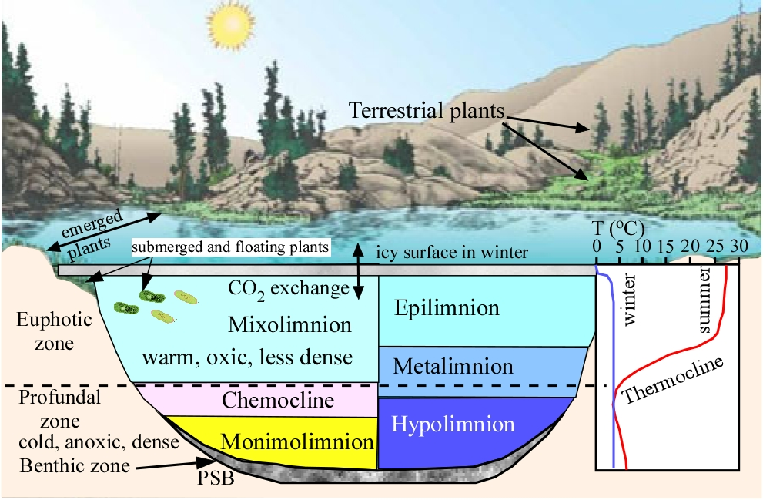

Fig. S1: Definitions of chemical and thermal stratifications in a lake (modified from an online figure <https://www.geo.arizona.edu/antevs/nats104/00lect17laklifzon.html>). PSB stands for purple sulphur bacteria which lives on the bottom of the lake.

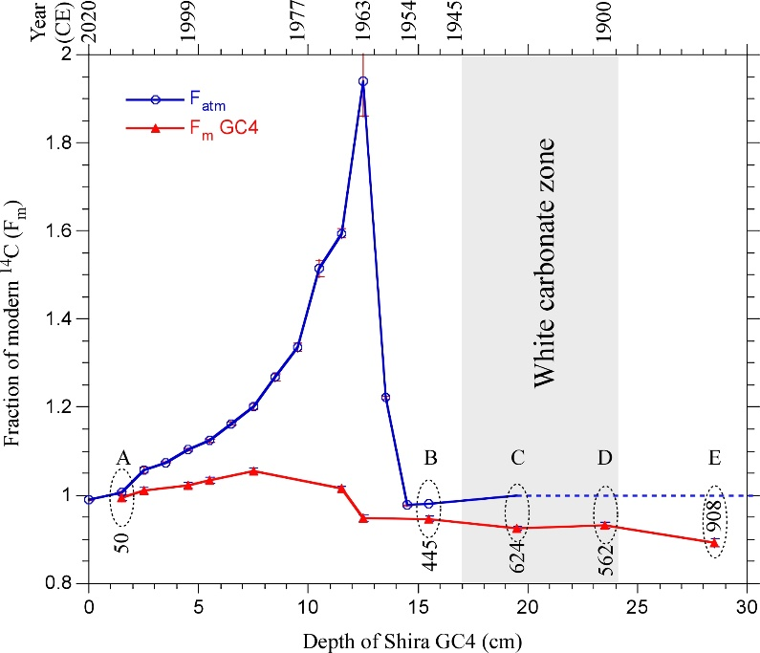

Fig. S2: Comparison of Fm (fraction of modern 14C) of the organic carbon in Shira GC4 sediments with the 14C activity of atmospheric CO2 which is inferred from tree ring measurements (Hua et al. 2013). The calendar year of the core is determined by 137Cs dating and the historic lake level (see text for explanation). A to E are the selected 14C ages with minimal OCI for estimating the old carbon influence, and the conventional 14C ages (yr BP) of these points are shown by the number near the red curve.

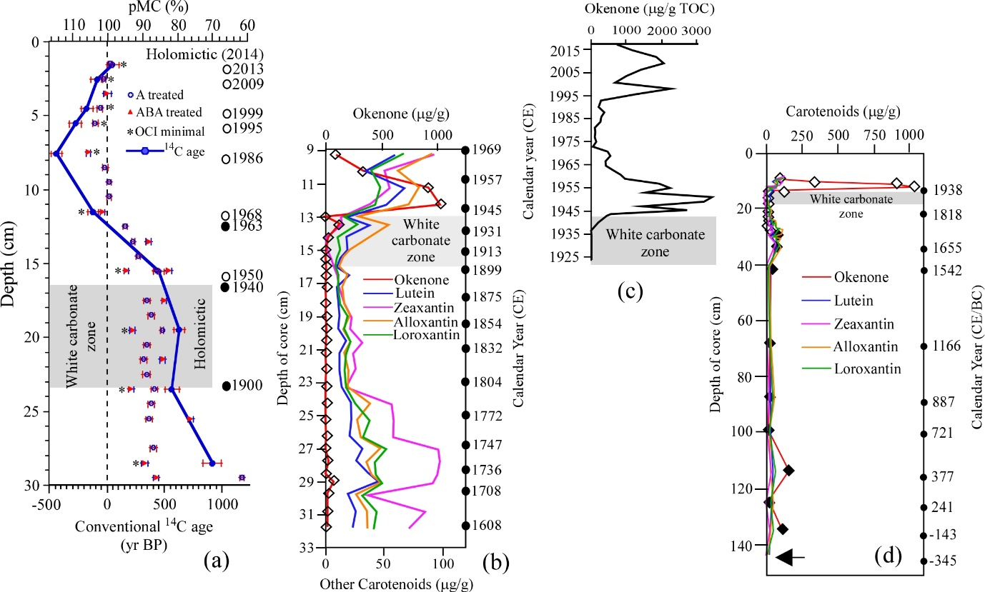

Fig. S3: Comparison of TOC 14C activities in the sediments from Shira GC4 with the Carotenoid contents in different cores from Lake Shira. (a) Measured 14C (percent modern carbon - pMC) and 14C age of organic carbon in the sediment samples from Shira GC4 (this study); (b) Carotenoid contents in Shira V-400 core (redrawn from Fig. 3 in Zykov et al. 2012); (c) Carotenoid contents in Shira Core 2016 (redrawn from Fig. 2 in Rogozin et al. 2020); (d) Carotenoid contents in Shira Core К-1550 (redrawn from Fig. 4 in Zykov et al. 2012).

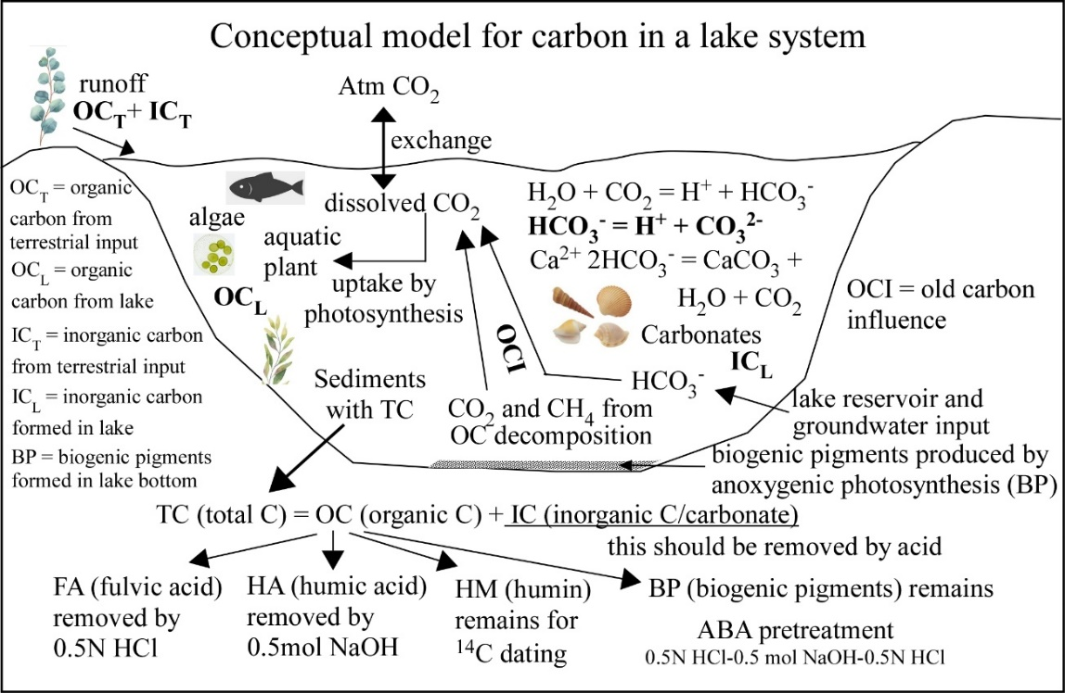

Fig. S4: A conceptual figure to illustrate carbon sources in a lake system, and the function of ABA pretreatment of lake sediment sample for 14C dating on organic carbon.

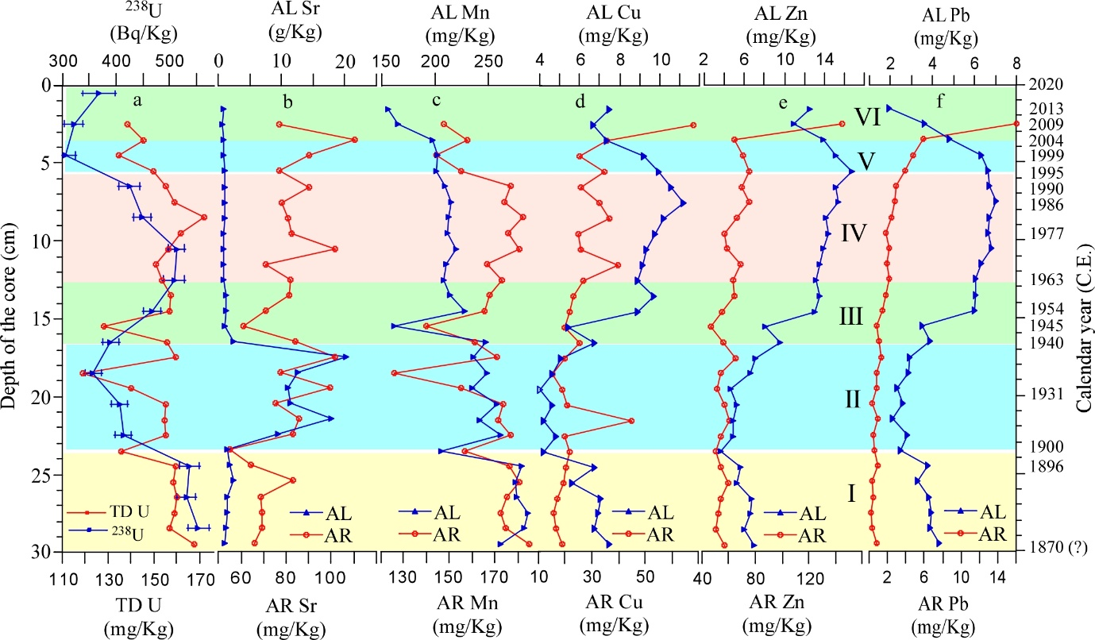

Fig. S5: 238U activity measured by gamma counter and elemental concentrations measured by ICPOES in the Lake Shira GC4 core in six zones. AL = acid-leachable; AR = Aqua Regia dissolution; TD (total concentration) = AL + AR. Note that the concentration units are different for different elements.

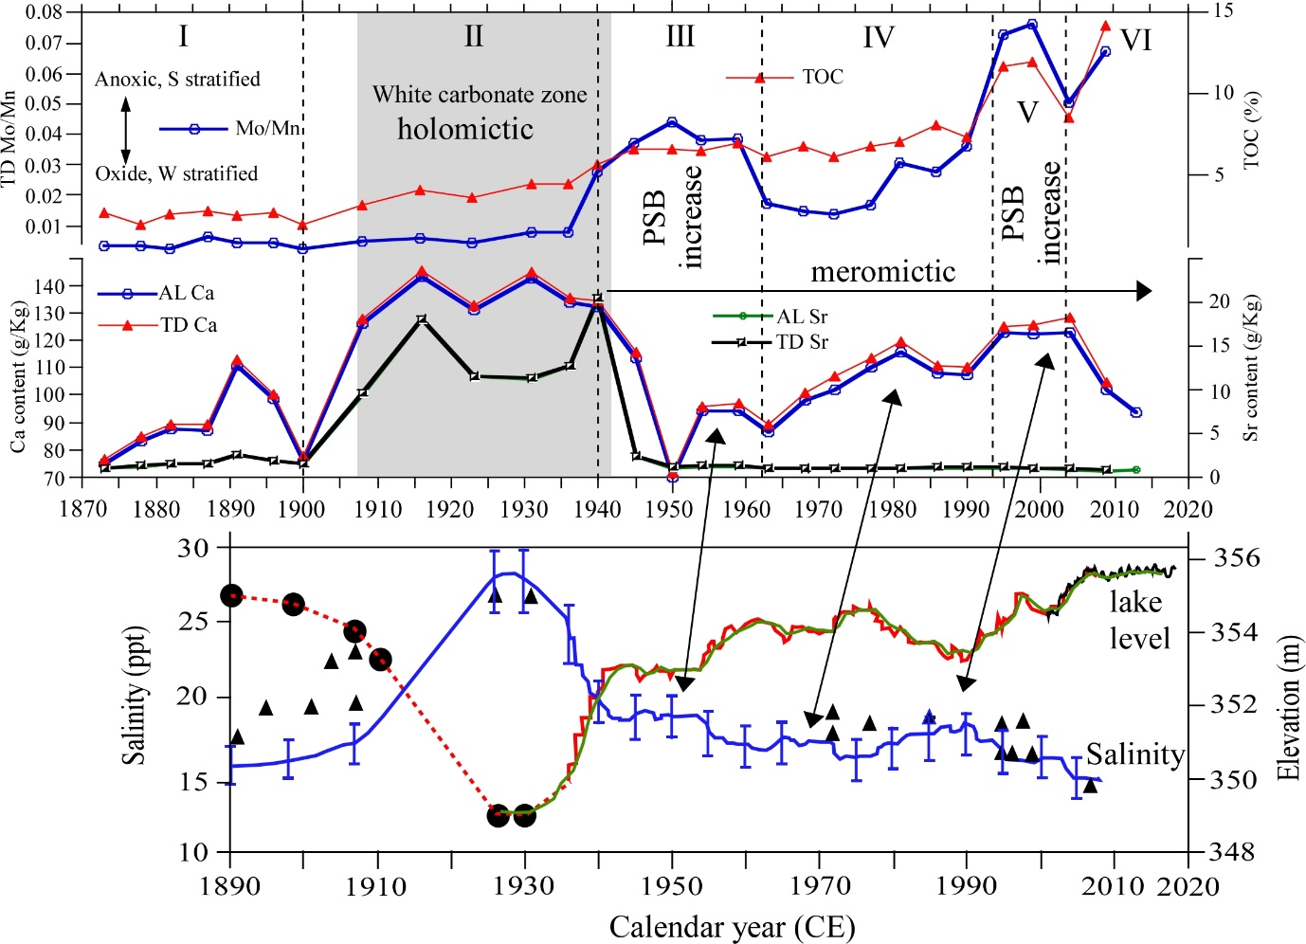

Fig. S6: Comparisons of reconstructed Shira lake condition changes with measured and modelled lake level and salinity with known dates. The lower panel of lake level and salinity redrawn from Fig. 4 in Rogozin et al. 2010. The upper panel shows the data from Shira GC4 of this study. The chronology of the core is based on 137Cs dating and the historic lake level (see text for explanation). PSB stands for purple sulphur bacteria. Ca and Sr contents reflect salinity changes of the lake. Mo/Mn indicates redox condition, higher Mo/Mn ratios reflect stronger anoxic conditions. TOC (%) reveals primary lake productivity. The vertical dotted lines separate the six zones. The double arrows show the possible correspondence of Ca contents to the measured salinity.

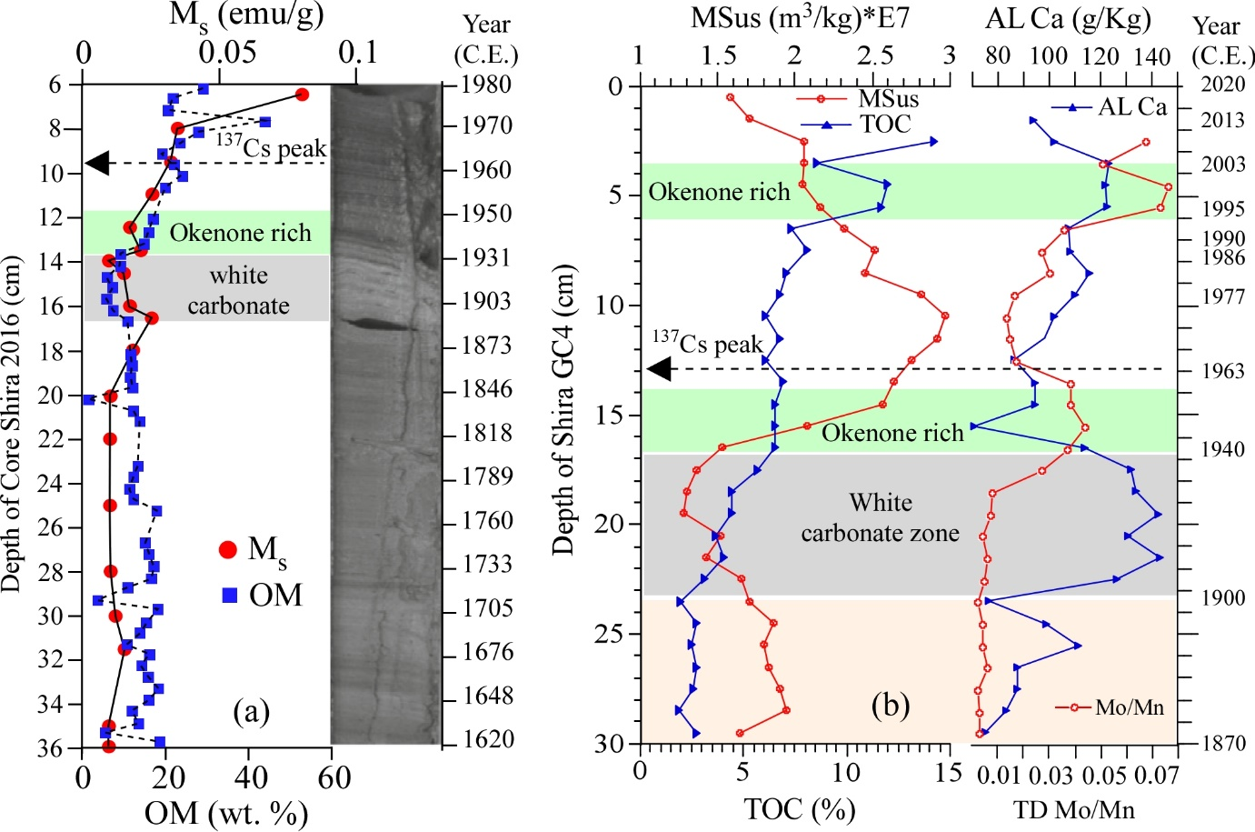

Fig. S7: Comparisons of magnetization of saturation (Ms) and organic material (OM) records in Core Shira 2016 (Rogozin et al. 2016) with the records of magnetic susceptibility (MSus), total organic carbon (TOC%), acid-leachable Ca concentration (AL Ca) and TD Mo/Mn in Shira GC4. The OM was measured by loss on ignition (LOI) at 550oC of dried sediment, whereas TOC% was measured by an Elemental Analyzer (EA). The grey zone denotes sediments with high carbonate zone. The green zone marks okenone increased layer when the lake was meromictic and the bottom of the lake had an anaerobic zone (Rogozin et al. 2020).