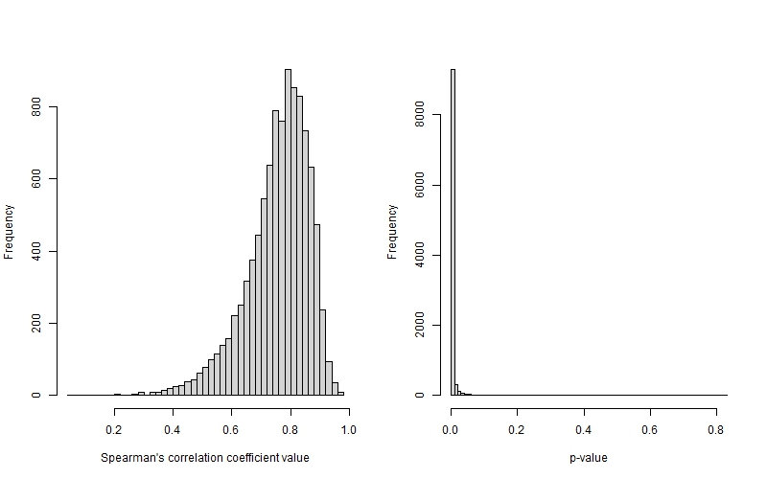

S5.Figure 1. Best case scenario correlations between absolute dates and the relative chronology

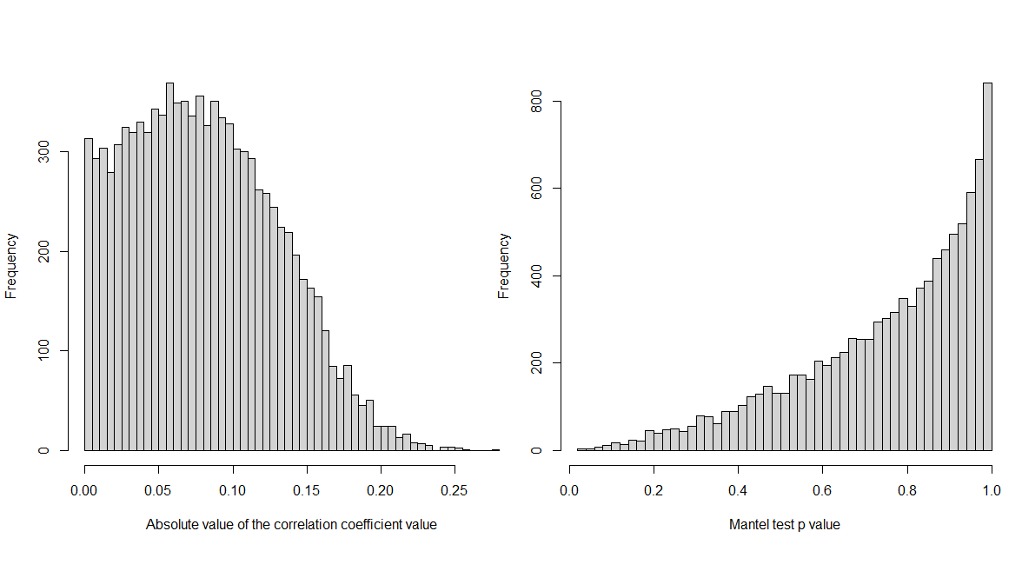

S5.Figure 2. Distribution of absolute values of the Mantel correlation between spatial and temporal distances between grave pairs (left panel) and their associated p values (right panel).