Supplementary Materials for

**Presence and implications of petrogenic organic carbon in Higher Himalayan Crystalline lake sediment**

Priyanka Singh1,2,3*, Vijayananda Sarangi4,5, Ravi Bhushan6, S. Nawaz Ali1, Shailesh Agrawal1, Pooja Tiwari1, Masud Kawsar1, Rajesh Agnihotri1, Prasanta Sanyal3, Kamlesh Kumar1, Biswajeet Thakur1, Manoj M. C. 1, Veerukant Singh1, Ankur Dabhi4, Anupam Sharma1, Kuldeep Prakash2, and P. Morthekai1

*Corresponding author: priyankaasingh10may@gmail.com

This PDF file includes:

Figs. S1 to S10

Additional material includes the following:

Data S1

Data S2

Data S3

Data S4

Data S5

1. **Quantification of OCpetro′s contribution to the lake sediment and its burial flux**

The biogenic (OCbio), pre-aged (OCpre-aged) and petrogenic (OCpetro) organic carbon were assumed to contribute to the total organic carbon (TOC, % of dry sediment) in the sediment. By considering the contribution from OCpre-aged is negligible except for 3 samples (KBPL 09, KBPL 05 and KBPL 01) and thus avoided these 3 samples, we approximated the 3 end member mixing model to binary mixture model where only OCpetro and OCbio contributed (Cui et al. 2016; Galy et al. 2011). This binary mixture model was done using 1) radiocarbon composition and 2) stable carbon isotope composition. The OCpetro was calculated from the intercepts and burial flux of OCpetro was calculated from the sediment rate.

The contribution of OCpetro was quantified using a three end member mixing model where biospheric (OCbio), pre-aged (OCpre-aged) and petrogenic (OCpetro) organic carbon contributed to the TOC (% weight of dry sediments) of the lake (Blair et al. 2003; Cui et al. 2016). This was done using both 1) radiocarbon and 2) stable carbon isotope compositions of the respective OCs.

Fmod x TOC (%) = Fmod-bio x OCbio (%) + Fmod-pre-aged x OCpre-aged (%) + Fmod-petro x OCpetro (%) … Eqn. 1

13C (‰) x TOC (%) = 13Cbio  (‰) x OCbio (%) + 13Cpre-aged  (‰) x OCpre-aged (%) + 13Cpetro  (‰) x OCpetro (%) … Eqn. 2

whereFmod, Fmod-bio, Fmod-pre-aged and Fmod-petro, are the radiocarbon compositions of the bulk TOC, OCbio, OCpre-aged and OCpetro in sediments, whereas 13C, 13Cbio, 13Cpre-aged and 13Cpetro, are the stable carbon isotope compositions of the respective OCs.

Assuming a negligible contribution from OCpre-aged except for the samples KBPL 01 (400 cm), KBPL 05 (235 cm) and KBPL 09 (110 cm), and excluding these 3 samples, we approximated to binary mixture model (Galy et al. 2008; Galy and Eglinton 2011). These 3 samples may have non-negligible OCpre-aged because prior to their deposition there were glaciations (LGM, YD and 8 kyr) that would have brought relatively more OCpre-aged along with OCpetro. It is reflected in relatively lower Fmod and higher TOC values for these samples. By replacing OCbio by (TOC – OCpetro) in Eqns. 1 & 2, and equating Fmod-petro to zero in Eqn. 1, the above equations become after rearrangements,

Fmod x TOC = Fmod-bio x TOC - Fmod-bio x OCpetro … Eqn. 3

13C x TOC = 13Cbio x TOC - (13Cbio -13Cpetro) x OCpetro … Eqn. 4

The OCpetro was calculated from the intercept of **Eqns. 3** and **4** and they are 0.06 ± 0.02 % (radiocarbon method, **Eqn. 3**; **Fig. S10 a**) and 0.07 ± 0.06 % (stable carbon composition method, **Eqn. 4**; **Fig. S10 b**) by assuming – 25.9 ± 1.7 ‰ for 13Cpetro (Menges et al. 2020). The calculated values of OCpetro are comparable to other Himalayan sites ranging from 0.02 to 0.08 % (Galy et al. 2008; Galy et al. 2011). The contribution of OCpetro (0.064 %, average of both methods) to TOC of all the samples ranges from 6 – 71 % with an average of 39 %. A positive correlation (r = 0.48, p-value = 0.192, n = 9; **Fig. S10 b**) between RAoffset and the percentage contribution of OCpetro to TOC suggest that OCpetro, not necessarily present in graphite form, significantly overestimates RA.

The method that we used to estimate OCpetro was adapted from Galy et al. (Galy and Eglinton 2011). It was a binary mixture model meaning that the total organic carbon (TOC) of each sample was contributed entirely by biogenic (OCbio) and petrogenic (OCpetro). We considered there was a negligible OCpre-aged flux in the lake except three samples (KBPL 09, KBPL 05, and KBPL 01) where they had significant OCpre-aged as they fall below the linear fitting (with smaller Fmod-pre-aged) in **Fig. S10a,b**. Hence, these samples (3 in no.) haven’t been included in the OCpetro calculation. Mostly this approach is followed for modern surface samples except a few (Copard et al. 2018; Galy et al. 2008; Galy and Eglinton 2011) where it was applied for the profile samples. In this study, it is assumed that each sample from each layer (following law of superposition) had contemporary biogenic (both terrestrial and aquatic input), pre-aged (older than the strata) and petrogenic organic carbon. Likewise all the samples from bottom layer to the top layer. The difference lies in the parameter Fmod-bio that is calculated from the slope of the linear equation following radiocarbon composition. This parameter is the spread in the radiocarbon age of the contemporary organic matter in Galy et al (Galy et al. 2008) method or residence time of OCbio in Galy and Eglinton method (Galy and Eglinton 2011). But we cannot infer anything from our slope i.e., Fmod-bio (4200 ± 400 years). Otherwise inference on the OCpetro is valid as the intercept won’t change with these scenarios.

**Estimation of burial flux of OCpetro**

From the slope of Eqn. 4, 13Cbio is calculated to be -23.6 ± 0.1 ‰. We had measured 13Cplant (‰) from collected 29 modern plant samples from the study area and the average value is – 28.5 ± 1.7 ‰ which suggest an enrichment of 4.9 ± 1.7 ‰ due the process of becoming OC from plant to profile samples (Staddon 2004).

The burial flux of OCpetro, ϕ(OCpetro) (g.yr-1) was, then, calculated as,

$φ\left({OC}_{petro}\right)=ρ ×A ×SR×\frac{{OC}_{petro}}{100}$… Eqn. 5

whereρ (g.cm-3), A (cm2), SR (cm.yr-1) and OCpetro (%) are the bulk sediment density (1.5 g.cm-3), area of the lake (0.58 km2), sedimentation rate and calculated petrogenic organic carbon by all three methods respectively. The OCpetrothat was buried in the studied lake was calculated as,

${OC}_{petro-buried}= <φ\left({OC}_{petro}\right)> ×$… Eqn. 6

where τ is the age of the lake (~ 16,000 years).

**Supplementary Figures**

|  |
| --- |
|  |

**Fig. S1.** Geological map (Jayangondaperumal et al. 2018) of the study region with study site (yellow circle).

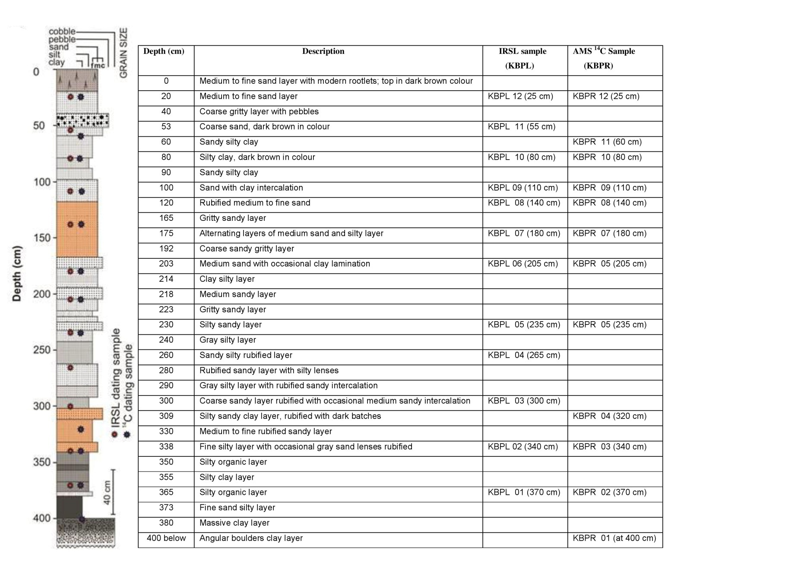

**Fig. S2.** Detailed lithology description of the studied lacustrine profile.

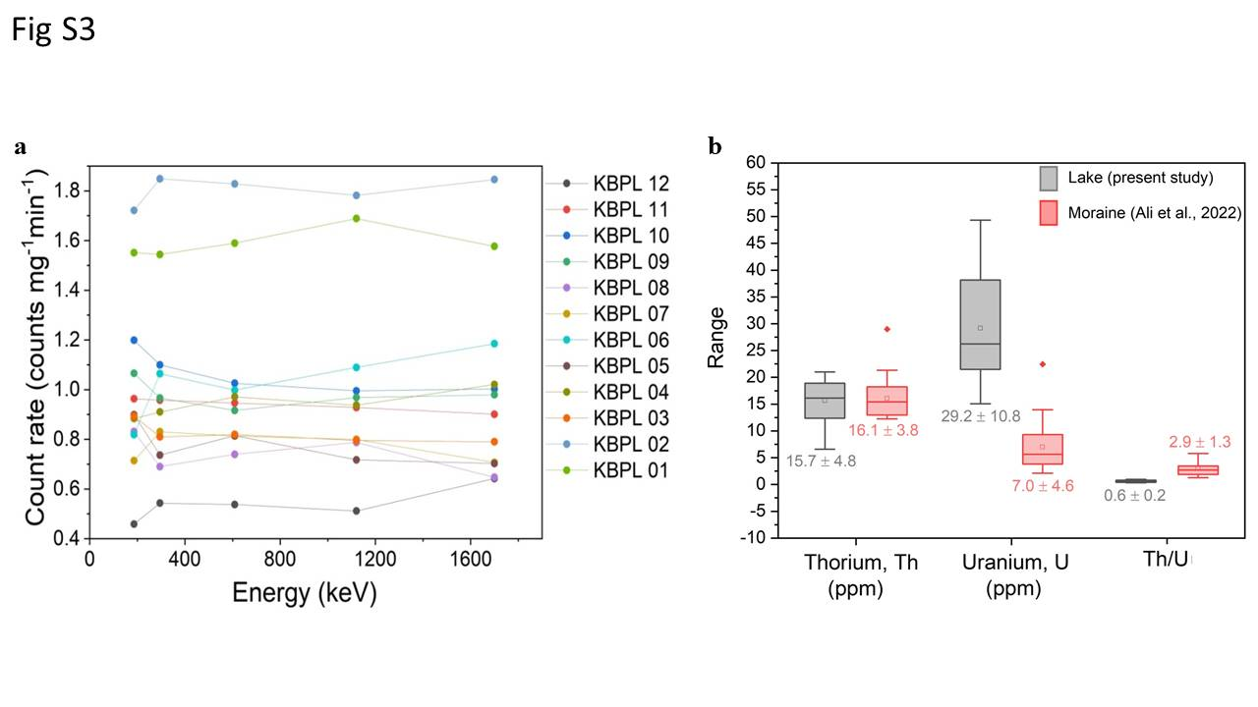

**Fig. S3. a)** Gamma detector efficiency corrected count rate (cts.m-1.mg-1) of 226Ra (186 keV; 0.11), 214Pb (295.2 keV; 0.19) and 214Bi (609.3 keV; 0.21, 1120.3 keV; 0.05, and 1700 keV; 0.03) are shown**.** This suggests that there is no disequilibrium in U-series. **b)** The concentration of Th (ppm), U (ppm) and the ratio of Th/U measured from the moraines in the study region (Ali et al. 2022) and the lake (present study) are given for comparison.

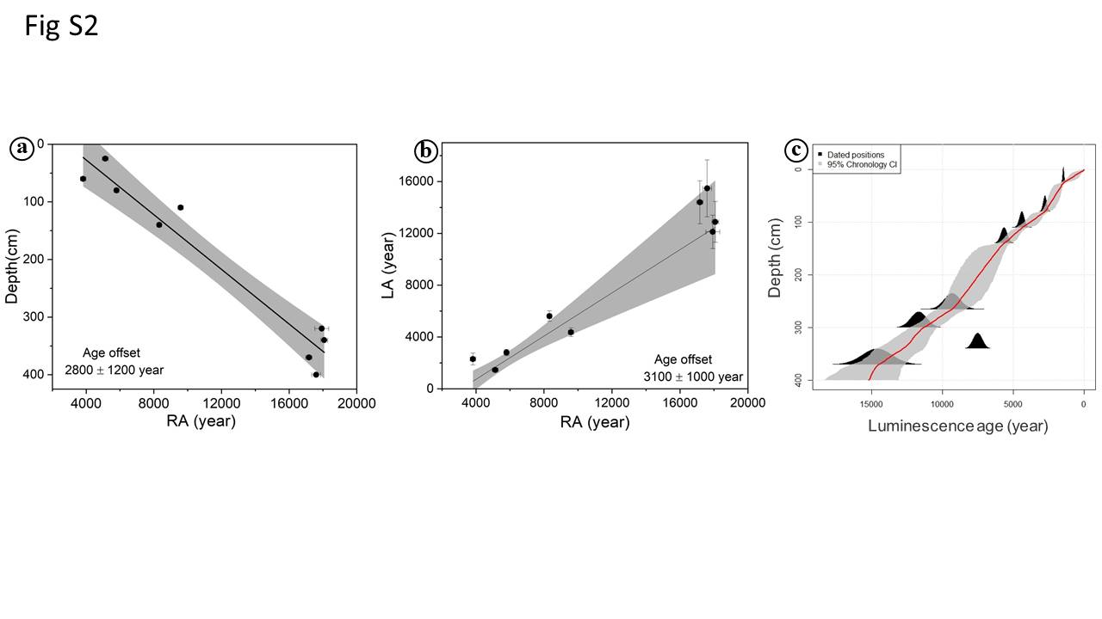

**Fig. S4.** The temporally non-varying age offset was calculated using different methods as described by Hou et al.(Hou et al. 2012). **(a)** The first method assumes a linear relationship between the depth and RA. Excluding the three intermediate samples, the extrapolated RA at a depth of 0 cm (age offset) yielded 2800±1200 years**. (b)** The second method rest on the assumption that there is a constant age offset between the RAs and any independent ages (LAs). The intercept of the linear fit between the measured (and calibrated) RAs and LAs yielded an age offset of 3100±1000 years**.** Because of the stratigraphically anomalous ages, the three intermediate samples were excluded for the above two methods. **(c)** As three luminescence dating samples (60, 320 and 400 cm) were not collected at the same depths as for RAs, the LAs were interpolated for those depths using Bayesian age-depth modelling using Bchron package (Haslett and Parnell 2008). Only 8 LAs (LAmeasured; excluding the three intermediate samples and sample at the depth of 55 cm) were used in this Bayesian age-depth modelling. RAoffset is given in **Data S5 (col. 2)**.

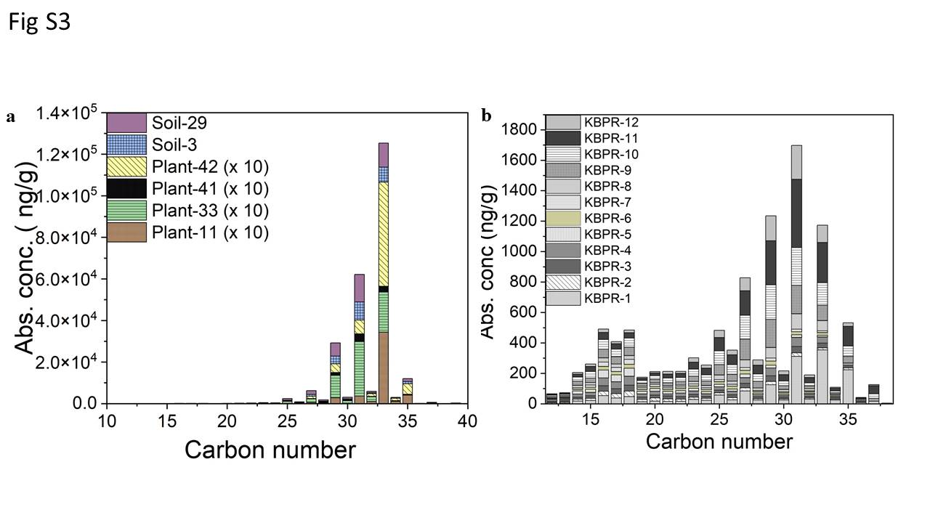

**Fig. S5.** Results of lipid *n*-alkane data. **(a)** Concentration of *n*-alkane (ng.g-1) distribution measured of modern plant samples (Type 11: Rhododendron sp.-Ericaceae, Type 33: Juniperus sp.- Cupressaceae, Type 41: Juniperus sp.- Cupressaceae, and Type 42: Grasses; all the plants are of C3 type) and two surface soil samples. **(b)** Also the 12 pit samples are shown. For better visibility, concentration values of plant samples were multiplied by 10. Various parameters calculated from the concentration of *n*-alkane data as shown in (b) are given in **Data S4 and S5 (cols. 11-17)**.



**Fig. S6.** Palynofacies plate showing structured organic matter (SOM; 1, 2, 3, 4, 6, 9, 12), degraded brown organic matter (DBOM; 5), opaque phytoclast (ChC; 7, 8, 11), pollens (13, 16, 17, 18), grass tissue remains (14, 15), fungal hyphae and spore (10, 19, 20), Botryococcus algae (21), amorphous organic matter (AOM; 22, 23). The quantified palynofacies data are given in **Data S5 (col. 3-7)**.

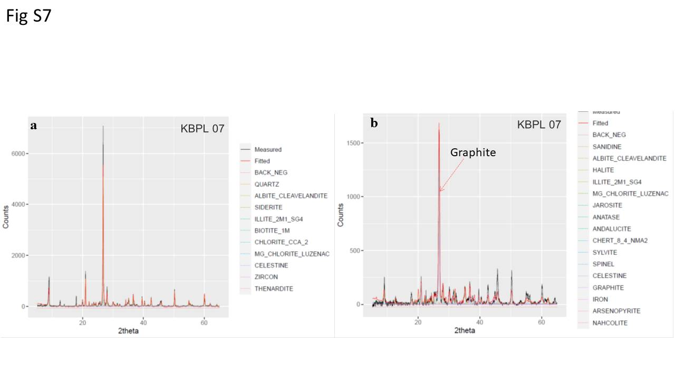

**Fig. S7.** XRD spectra measured of KBPL 07 chemically untreated (**a**; samples that were used to measure dose rate for luminescence ages) and treated with A-B-A method (**b**; samples that were used for 14C measurements) with the instrument of PANalytical Xpert’3 Powder irradiated with Cu target (Kα1 = 1.540598 A˚ and Kα2 = 1.544426 A˚) with a continuous scan type. The background subtracted XRD spectra were analyzed by comparing against rockjock mixtures dataset(Eberl 2003) using powdR package (Butler and Hillier 2021) and the results given in **Data S3**.

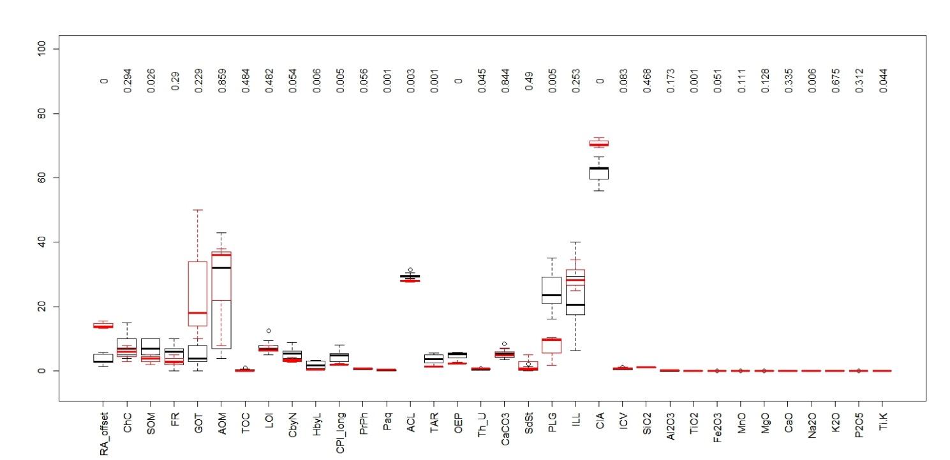

**Fig. S8.** Welch two samples t-test was performed using *t.test()* method in R environment (41) and the results are shown here. This was performed to see the intermediate samples (depth from 180 cm to 235 cm) are significantly different than the rest of the profile in terms of the measured supporting data by testing the means. The mean values of the intermediate samples are distinct on the basis of RAoffset (av. intermediate/av. rest of the profile = 14300/3600), ChC (5.6/7.3), AOM (27/26), FR(3/5), TOC (0.3/1), CPIlong (2.1/4.6), Paq (0.44/0.24), plagioclase (PLG=7.2/25), Th/U (0.8/0.5), ICV (0.99/0.69) and sand/silt (2/1).The values appeared at the top of the plot are p-values.

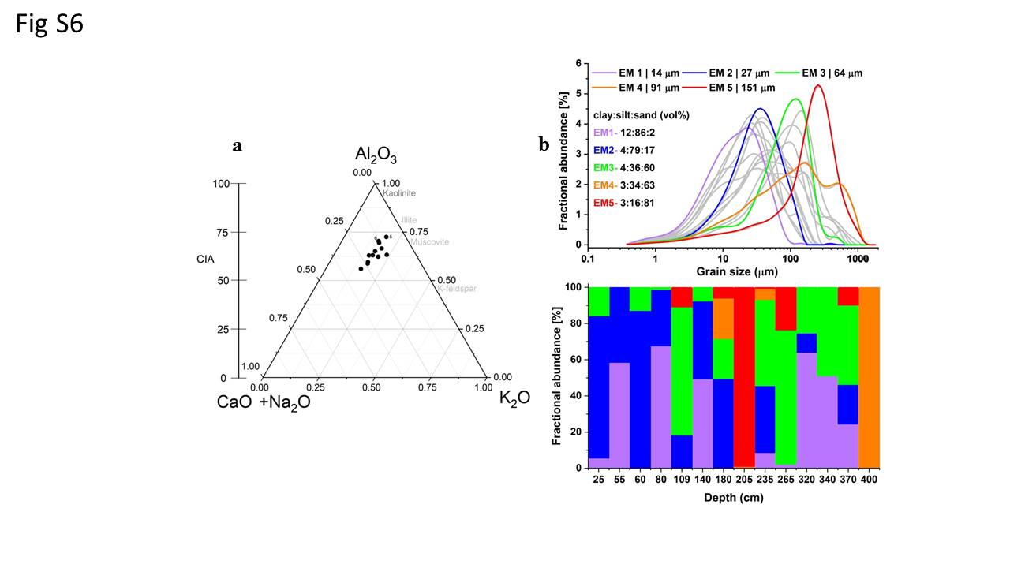

**Fig. S9.** Ternary diagram in which the samples can be positioned to know its weathered stage. This ternary diagram was constructed using the major oxides (Al2O3, K2O and CaO& Na2O) obtained from XRF measurements (**Data S5; cols. 25-34**). The chemical index of alteration*, CIA* (**Data S5; col. 23**) is given at the left side for comparison*.* KBPL 5 and 6 are labelled as they have large illite and small plagioclase proportion as observed from XRD analysis.

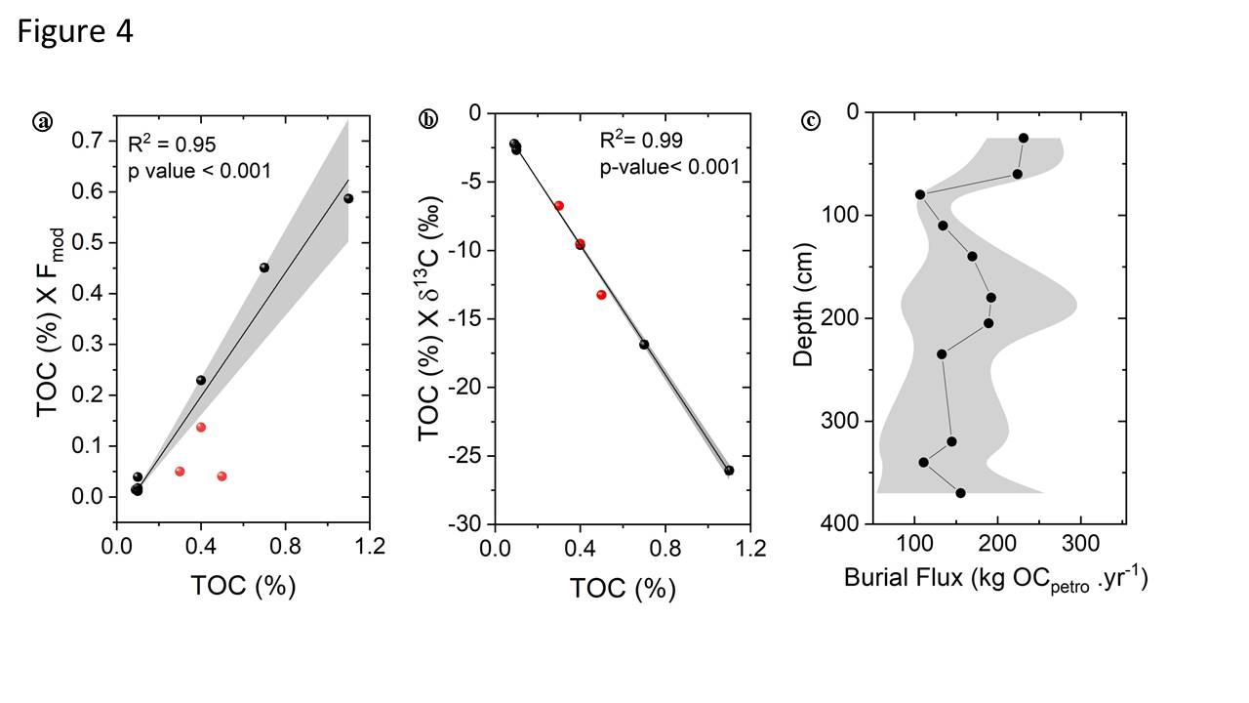

**Fig. S10.**The percentage contribution of OCpetro to the lake sediments calculated using binary mixture of biospheric and petrogenic organic carbon in terms of **a)** radiocarbon composition (0.06±0.02%) and **b)** stable carbon isotope composition (0.07±0.06%). The p-values for both plots are significant (< 0.001). Three samples (KBPL 09, KBPL 05 and KBPL 01, red circles) were excluded from the analyses as they might have non-negligible OCpre-aged. The lower Fmod for these 3 samples made them much deviated from the linear trend (a).**(c)**The burial flux of OCpetro to the lake with an average of 160±40 kg OCpetro.yr-1. The propagated error in some values are large because of large uncertainty in LAs and hence for better visibility the error bar is made using one fourth of the propagated error.

**Data S1.**

Details of how the average calibrated radiocarbon age and the errors of that were calculated using KBPR 05 as an example.

**Data S2.**

All the parameters that are required to calculate luminescence age (both fading uncorrected and uncorrected, the fading parameter, ′) are given in this file. This is the output generated by the online Dose Rate and Age Calculator v.1.2.

**Data S3.**

The measured and background subtracted XRD spectra and the analyzed results on a) bulk samples (chemically untreated samples that were extracted from the luminescence sample collecting pipes), b) samples on which AMS radiocarbon was measured, and c) extracted feldspar grains (KBPL 11 was not available as it was consumed during luminescence age estimation).

**Data S4.**

The *n*-alkane distribution data and their derived parameters. Compound specific (C29 and C31) stable carbon isotope data also given.

**Data S5.**

All the supporting data with depth are given in two categories namely biotic (2-17columns) and abiotic (18 – 35 columns). **Biotic**: Age difference between radiocarbon and luminescence dating methods (RAoffset), opaque phytoclast/charcoal (ChC), structured organic matter (SOM), fungal remains (FR), grass oxidized tissue (GOT), amorphous organic matter (AOM), total organic carbon (TOC), loss on ignition (LOI), the ratio between total organic carbon and total nitrogen (C/N), the ratio between high chain and low chain n-alkane (H/L), carbon preferential index (CPIlong), the ratio between pristine and phytane (PrPh), aquatic source n-alkane (Paq), average chain length (ACL), terrestrial over aquatic input n-alkanes (TAR), and odd over even predominance (OEP). **Abiotic**: the ratio between thorium and uranium (Th/U), inorganic calcium carbonate (CaCO3), the ratio between sand and silt proportion (Sd/St), plagioclase feldspar (PLG) and illite (ILL) proportion, chemical index of alteration (CIA), index of compositional variability (ICV), percentage of oxides of silicon (SiO2), aluminium (Al2O3), titanium (TiO2), iron (Fe2O3), manganese (MnO), magnesium (MgO), calcium (CaO), sodium (Na2O), potassium (K2O), phosphorous (P2O5) and the ratio between Ti and K.

**References:**

**Ali SN, Singh P, Arora P, Bisht P and Morthekai P** (2022) Luminescence dating of late pleistocene glacial and glacio-fluvial sediments in the Central Himalaya, India. *Quaternary Science Reviews* **284,** 107464.

**Blair NE, Leithold EL, Ford ST, Peeler KA, Holmes JC and Perkey DW** (2003) The persistence of memory: the fate of ancient sedimentary organic carbon in a modern sedimentary system. *Geochimica et Cosmochimica Acta* **67**(1)**,** 63-73. <https://doi.org/https://doi.org/10.1016/S0016-7037(02)01043-8>.

**Butler BM and Hillier S** (2021) powdR: An R package for quantitative mineralogy using full pattern summation of X-ray powder diffraction data. *Computers & Geosciences* **147,** 104662.

**Copard Y, Eyrolle F, Radakovitch O, Poirel A, Raimbault P, Gairoard S and Di-Giovanni C** (2018) Badlands as a hot spot of petrogenic contribution to riverine particulate organic carbon to the Gulf of Lion (NW Mediterranean Sea). *Earth Surface Processes and Landforms* **43**(12)**,** 2495-2509. <https://doi.org/https://doi.org/10.1002/esp.4409>.

**Cui X, Bianchi TS, Jaeger JM and Smith RW** (2016) Biospheric and petrogenic organic carbon flux along southeast Alaska. *Earth and Planetary Science Letters* **452,** 238-246.

**Eberl DD** (2003) User Guide to RockJock - A Program for Determining Quantitative Mineralogy from X-Ray Diffraction Data.

**Galy V, Beyssac O, France-Lanord C and Eglinton T** (2008) Recycling of Graphite During Himalayan Erosion: A Geological Stabilization of Carbon in the Crust. *Science* **322**(5903)**,** 943-945. <https://doi.org/doi:10.1126/science.1161408>.

**Galy V and Eglinton T** (2011) Protracted storage of biospheric carbon in the Ganges–Brahmaputra basin. *Nature Geoscience* **4**(12)**,** 843-847. <https://doi.org/10.1038/ngeo1293>.

**Galy V, France-Lanord C, Beyssac O, Lartiges B and Rhaman M** (2011) Organic Carbon Cycling During Himalayan Erosion: Processes, Fluxes and Consequences for the Global Carbon Cycle. In Lal R, Sivakumar MVK, Faiz SMA, Mustafizur Rahman AHM and Islam KR (eds), *Climate Change and Food Security in South Asia.* Dordrecht: Springer Netherlands, 163-181.

**Haslett J and Parnell A** (2008) A simple monotone process with application to radiocarbon-dated depth chronologies. *Journal of the Royal Statistical Society: Series C (Applied Statistics)* **57**(4)**,** 399-418. <https://doi.org/https://doi.org/10.1111/j.1467-9876.2008.00623.x>.

**Hou J, D'Andrea WJ and Liu Z** (2012) The influence of 14C reservoir age on interpretation of paleolimnological records from the Tibetan Plateau. *Quaternary Science Reviews* **48,** 67-79. <https://doi.org/https://doi.org/10.1016/j.quascirev.2012.06.008>.

**Jayangondaperumal R, Thakur VC, Joevivek V, Rao PS and Gupta AK** (2018) Introduction. In Jayangondaperumal R, Thakur VC, Joevivek V, Rao PS and Gupta AK (eds), *Active Tectonics of Kumaun and Garhwal Himalaya.* Singapore: Springer Singapore, 1-40.

**Menges J, Hovius N, Andermann C, Lupker M, Haghipour N, Märki L and Sachse D** (2020) Variations in organic carbon sourcing along a trans-Himalayan river determined by a Bayesian mixing approach. *Geochimica et Cosmochimica Acta* **286,** 159-176. <https://doi.org/https://doi.org/10.1016/j.gca.2020.07.003>.

**Staddon PL** (2004) Carbon isotopes in functional soil ecology. *Trends in Ecology & Evolution* **19**(3)**,** 148-154. <https://doi.org/https://doi.org/10.1016/j.tree.2003.12.003>.