Supplementary Figure 1.

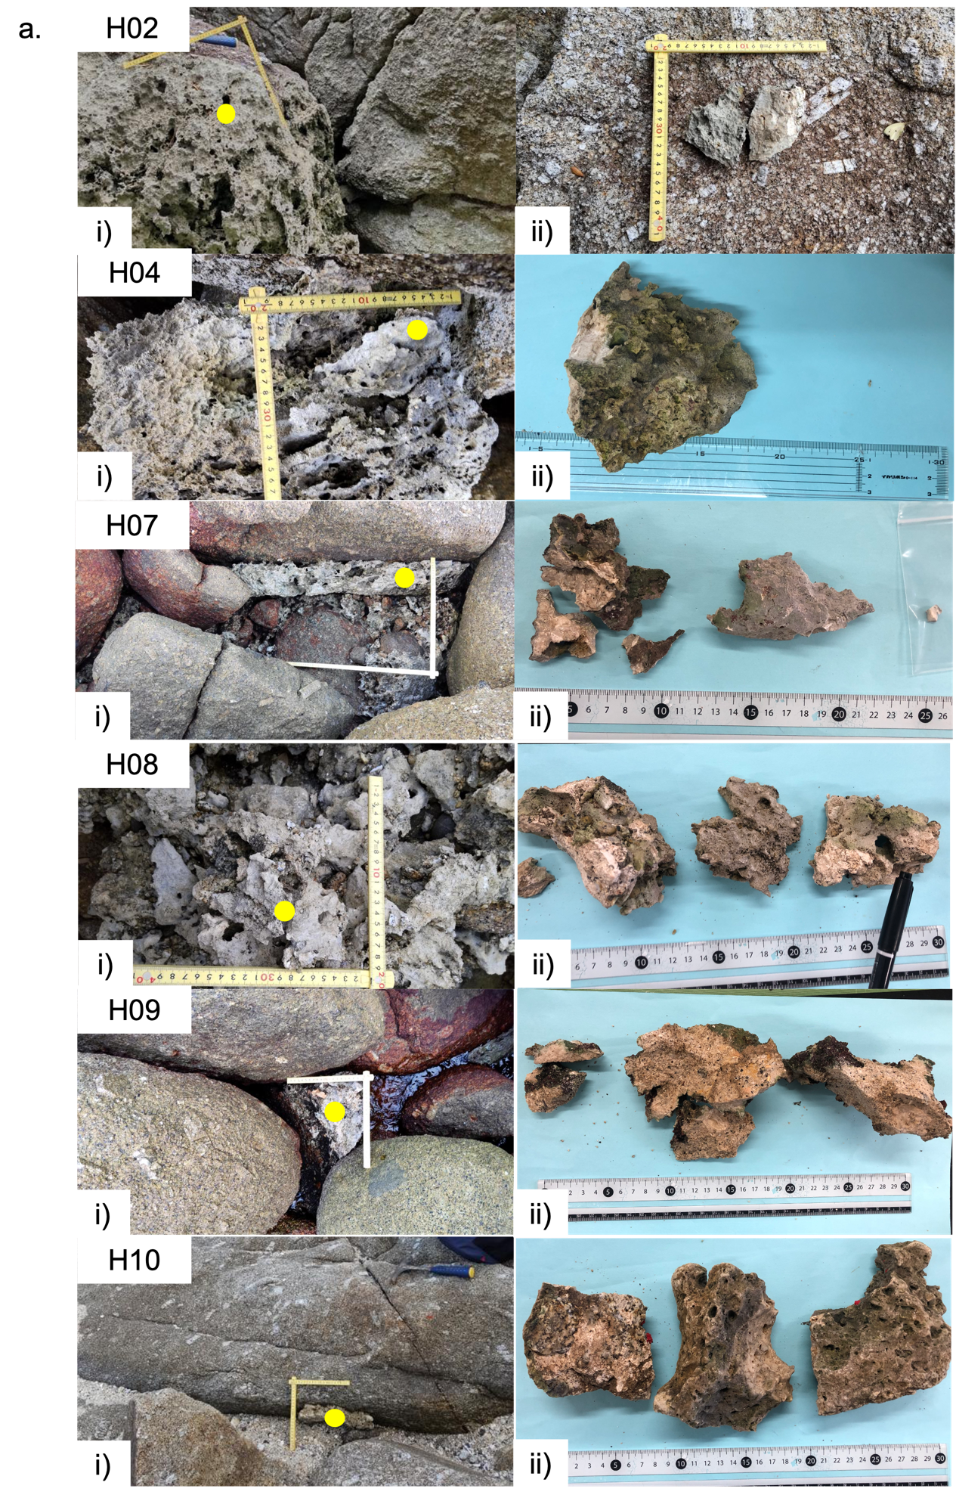

*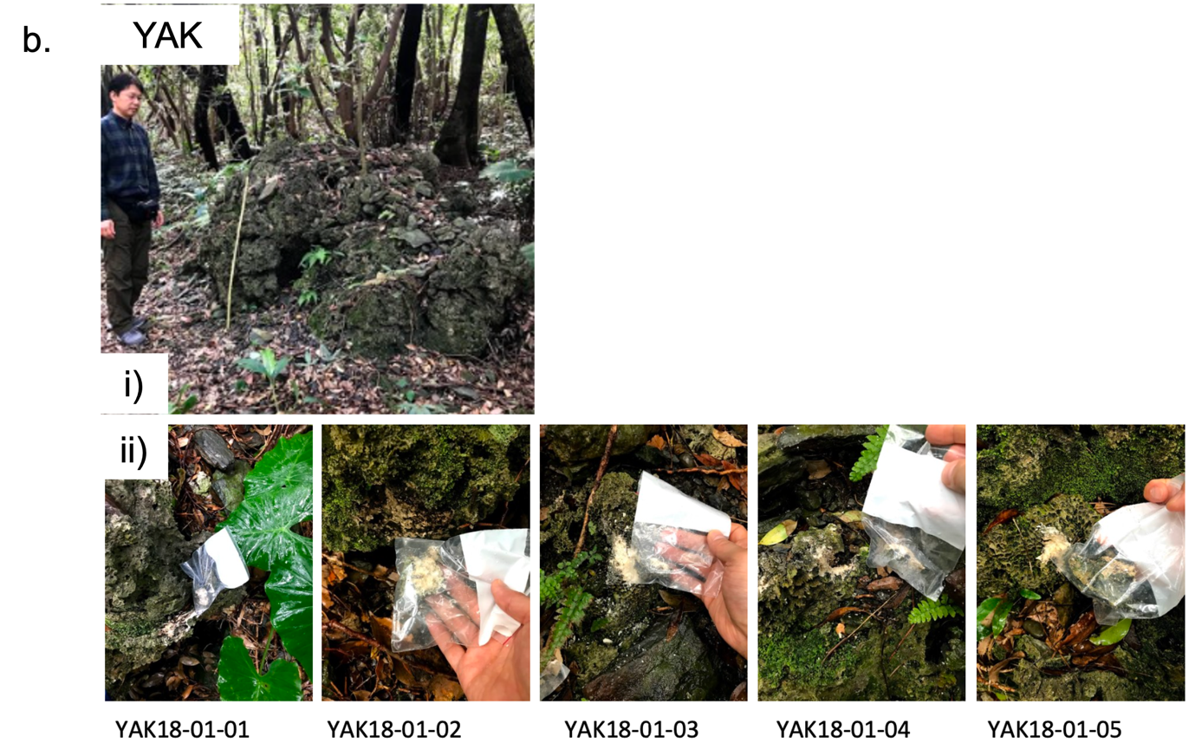*

*Supplementary Figure 1 – a) Yoshida Coast (YYD) boulders that were sampled showing i), the boulder in the field, where the sampling site is marked by a yellow circle and ii), the sample transported to AORI. b) The Miyanoura (YAK) boulder i), in the field and ii), the five samples taken from it.*