### Supplementary Information 1 (SI1):

### Full set of CIO results

### Sample BIF-E19

|  |  |  |  |  |  |
| --- | --- | --- | --- | --- | --- |
| **Calendar Year (CE)** | **Δ14C (‰)** | **± σ (‰)** | **Batch nr** | **T-statistic** | **χ2-test** |
| 1049 | -8.00 | 3.46 | 1 | 0.117 | Pass |
| 1049 | -6.52 | 2.60 | 2 |
| 1050 | -5.15 | 2.60 | 1 | 0.005 | Pass |
| 1050 | -4.90 | 2.60 | 2 |
| 1051 | -7.50 | 2.77 | 1 | 0.422 | Pass |
| 1051 | -8.11 | 2.59 | 2 |
| 1051 | -9.84 | 2.59 | 2 |
| 1052 | -7.37 | 3.46 | 1 | 0.176 | Pass |
| 1052 | -5.51 | 2.77 | 2 |
| 1053 | -6.01 | 3.29 | 1 | 0.311 | Pass |
| 1053 | -8.60 | 3.28 | 2 |
| 1054 | -5.14 | 2.95 | 1 | 0.284 | Pass |
| 1054 | -7.36 | 2.94 | 2 |
| 1055 | -1.91 | 2.44 | 1 | 0.004 | Pass |
| 1055 | -1.66 | 2.96 | 2 |
| 1056 | -3.15 | 2.78 | 1 | 0.030 | Pass |
| 1056 | -2.53 | 2.26 | 2 |
| 1057 | 0.34 | 2.79 | 1 | 2.542 | Pass |
| 1057 | -5.74 | 2.60 | 2 |

Table 1-SI: Full set of results for sample BIF-E19 for each batch measured, and respective χ2-test between repeated samples, performed at the 95% probability, where the test is passed when the t-statistic of the set of repeated samples is less than the threshold value (3.841 for 2 samples, 5.991 for 3 samples)

Figure 1-SI: Comparison between the two different batches analyzed in this study for sample BIF-E19.

### Sample APT-C02

|  |  |  |  |  |  |
| --- | --- | --- | --- | --- | --- |
| **Calendar Year (CE)** | **Δ14C (‰)** | **± σ (‰)** | **Batch nr** | **T-statistic** | **χ2-test** |
| 1275 | -17.66 | 2.57 | 1 | 2.910 | Pass |
| 1275 | -11.65 | 2.41 | 2 |
| 1276 | -11.64 | 2.41 | 1 | 1.098 | Pass |
| 1276 | -15.08 | 2.23 | 2 |
| 1277 | -14.47 | 2.41 | 1 | 0.316 | Pass |
| 1277 | -12.62 | 2.24 | 2 |
| 1278 | -15.44 | 2.40 | 1 | 2.024 | Pass |
| 1278 | -10.77 | 2.24 | 2 |
| 1279 | -10.28 | 2.42 | 1 | 0.374 | Pass |
| 1279 | -12.37 | 2.41 | 2 |
| 1280 | -8.18 | 2.25 | 1 | 0.795 | Pass |
| 1280 | -11.01 | 2.24 | 2 |
| 1281 | -10.03 | 2.24 | 1 | 0.807 | Pass |
| 1281 | -13.10 | 2.58 | 2 |
| 1282 | -12.61 | 2.07 | 1 | 0.864 | Pass |
| 1282 | -9.65 | 2.42 | 2 |
| 1283 | -8.66 | 2.42 | 1 | 0.182 | Pass |
| 1283 | -10.02 | 2.07 | 2 |

Table 2-SI: Full set of results for sample APT-C02 for each batch measured, and respective χ2-test between repeated samples, performed at the 95% probability, where the test is passed when the t-statistic of the set of repeated samples is less than the threshold value (3.841 for 2 samples)

### 

### Figure 2-SI: Comparison between the two different batches analyzed in this study for sample APT-C02.

### Sample R14.0123.121

|  |  |  |  |  |  |
| --- | --- | --- | --- | --- | --- |
| **Calendar Year (CE)** | **Δ14C (‰)** | **± σ (‰)** | **Batch nr** | **T-statistic** | **χ2-test** |
| 531 | -25.02 | 2.67 | 1 | N/A | N/A |
| 532 | -22.16 | 2.43 | 1 | N/A | N/A |
| 533 | -23.20 | 2.50 | 1 | N/A | N/A |
| 534 | -22.51 | 2.64 | 1 | N/A | N/A |
| 535 | -22.65 | 2.37 | 1 | N/A | N/A |
| 536 | -23.18 | 2.44 | 1 | N/A | N/A |
| 537 | -23.18 | 2.43 | 1 | 0.216 | Pass |
| 537 | -24.73 | 2.28 | 2 |
| 538 | -23.03 | 2.45 | 1 | 0.081 | Pass |
| 538 | -23.97 | 2.22 | 2 |
| 539 | -22.93 | 2.51 | 1 | N/A | N/A |
| 540 | -21.75 | 2.52 | 1 | 1.403 | Pass |
| 540 | -25.65 | 2.12 | 2 |
| 541 | -23.34 | 2.63 | 1 | 0.000 | Pass |
| 541 | -23.38 | 2.19 | 2 |
| 542 | -21.11 | 2.43 | 1 | 0.030 | Pass |
| 542 | -21.69 | 2.34 | 2 |
| 543 | -19.77 | 1.75 | 1 | N/A | N/A |
| 544 | -19.00 | 2.59 | 1 | 0.418 | Pass |
| 544 | -21.24 | 2.30 | 2 |
| 545 | -17.87 | 2.52 | 1 | N/A | N/A |
| 546 | -17.06 | 2.65 | 1 | N/A | N/A |
| 547 | -19.92 | 2.55 | 1 | N/A | N/A |
| 548 | -19.03 | 2.58 | 1 | N/A | N/A |
| 549 | -19.66 | 2.49 | 1 | 0.821 | Pass |
| 549 | -22.67 | 2.20 | 2 |
| 550 | -19.61 | 2.54 | 1 | 0.004 | Pass |
| 550 | -19.83 | 2.31 | 2 |

Table 3-SI: Full set of results for sample R14.0123.121 for each batch measured, and respective χ2-test between repeated samples, performed at the 95% probability, where the test is passed when the t-statistic of the set of repeated samples is less than the threshold value (3.841 for 2 samples)



### Figure 3-SI: Comparison between the two different batches analyzed in this study for sample R14.0123.121.

### Supplementary Information 2 (SI2):

### Comparison between datasets: This study & Brehm et al. (2021)

### Event Candidate 1052 CE

|  |  |  |  |  |  |
| --- | --- | --- | --- | --- | --- |
| **Calendar Year (CE)** | **Δ14C (‰)** | **± σ (‰)** | **Study** | **T-statistic** | **χ2-test** |
| 1049 | -7.05 | 2.08 | This study | 0.687 | Pass |
| 1049 | -9.0 | 1.1 | Brehm et al. (2021) |
| 1050 | -5.03 | 1.84 | This study | 1.026 | Pass |
| 1050 | -7.5 | 1.6 | Brehm et al. (2021) |
| 1051 | -8.53 | 1.53 | This study | 0.001 | Pass |
| 1051 | -8.6 | 1.6 | Brehm et al. (2021) |
| 1052 | -6.24 | 2.16 | This study | 3.235 | Pass |
| 1052 | -10.6 | 1.1 | Brehm et al. (2021) |
| 1053 | -7.31 | 2.32 | This study | 0.793 | Pass |
| 1053 | -4.8 | 1.6 | Brehm et al. (2021) |
| 1054 | -6.25 | 2.08 | This study | 1.020 | Pass |
| 1054 | -3.6 | 1.6 | Brehm et al. (2021) |
| 1055 | -1.81 | 1.88 | This study | 0.250 | Pass |
| 1055 | -2.9 | 1.1 | Brehm et al. (2021) |
| 1056 | -2.77 | 1.75 | This study | 0.807 | Pass |
| 1056 | -4.9 | 1.6 | Brehm et al. (2021) |
| 1057 | -2.92 | 2.08 | This study | 3.576 | Pass |
| 1057 | -8.0 | 1.7 | Brehm et al. (2021) |

Table 4-SI: Comparison and respective χ2-test between same year samples from averaged dataset of this study and averaged dataset from Brehm et al. (2021). The χ2-test is performed at the 95% probability, where the test is passed when the t-statistic of the set of same year samples is less than the threshold value (3.841 for 2 samples).

### Event Candidate 1279 CE

|  |  |  |  |  |  |
| --- | --- | --- | --- | --- | --- |
| **Calendar Year (CE)** | **Δ14C (‰)** | **± σ (‰)** | **Study** | **T-statistic** | **χ2-test** |
| 1275 | -14.46 | 1.76 | This study | 0.399 | Pass |
| 1275 | -13.0 | 1.5 | Brehm et al. (2021) |
| 1276 | -13.50 | 1.64 | This study | 0.174 | Pass |
| 1276 | -12.6 | 1.4 | Brehm et al. (2021) |
| 1277 | -13.48 | 1.64 | This study | N/A | N/A |
| 1278 | -12.95 | 1.64 | This study | 0.527 | Pass |
| 1278 | -10.9 | 2.3 | Brehm et al. (2021) |
| 1279 | -11.33 | 1.71 | This study | 0.023 | Pass |
| 1279 | -10.9 | 2.3 | Brehm et al. (2021) |
| 1280 | -9.60 | 1.59 | This study | 1.652 | Pass |
| 1280 | -5.9 | 2.4 | Brehm et al. (2021) |
| 1281 | -11.35 | 1.69 | This study | 4.680 | Fail |
| 1281 | -5 | 2.4 | Brehm et al. (2021) |
| 1282 | -11.36 | 1.57 | This study | 3.113 | Pass |
| 1282 | -6.3 | 2.4 | Brehm et al. (2021) |
| 1283 | -9.44 | 1.71 | This study | 3.794 | Pass |
| 1283 | -3.7 | 2.4 | Brehm et al. (2021) |

Table 5-SI: Comparison and respective χ2-test between same year samples from averaged dataset of this study and averaged dataset from Brehm et al. (2021). The χ2-test is performed at the 95% probability, where the test is passed when the t-statistic of the set of same year samples is less than the threshold value (3.841 for 2 samples).

### Supplementary Information 3 (SI3):

### Time shift 1052-1054 CE

Hereby we explore the possibility that a mistake is present in one of the dendrochronologies. To account for that, we perform a time-shift of 2 years to one of the datasets, namely the one of this study, in such a way that the biggest rise in Δ14C happens in the same year for both datasets. However, performing this change does not change the outcome of the comparison, as all the same year data points pass the χ2-test and are in agreement between each other at 2σ probability.

|  |  |  |  |  |  |
| --- | --- | --- | --- | --- | --- |
| **Calendar Year (CE)** | **Δ14C (‰)** | **± σ (‰)** | **Study** | **T-statistic** | **χ2-test** |
| 1049 | -9 | 1.1 | Brehm et al. (2021) | 0.062 | Pass |
| 1049 | -8.53 | 1.53 | This study (2-years offset) |
| 1050 | -7.5 | 1.6 | Brehm et al. (2021) | 0.220 | Pass |
| 1050 | -6.24 | 2.16 | This study (2-years offset) |
| 1051 | -8.6 | 1.6 | Brehm et al. (2021) | 0.210 | Pass |
| 1051 | -7.31 | 2.32 | This study (2-years offset) |
| 1052 | -10.55 | 1.1 | Brehm et al. (2021) | 3.340 | Pass |
| 1052 | -6.25 | 2.08 | This study (2-years offset) |
| 1053 | -4.8 | 1.6 | Brehm et al. (2021) | 1.467 | Pass |
| 1053 | -1.81 | 1.88 | This study (2-years offset) |
| 1054 | -3.6 | 1.6 | Brehm et al. (2021) | 0.123 | Pass |
| 1054 | -2.77 | 1.75 | This study (2-years offset) |
| 1055 | -2.85 | 1.1 | Brehm et al. (2021) | 0.001 | Pass |
| 1055 | -2.92 | 1.90 | This study (2-years offset) |

### Table 6-SI: Comparison and respective χ2-test between same year samples from averaged dataset of this study and averaged dataset from Brehm et al. (2021). The dataset of this study has been shifted 2 years into the past to account for the possibility of an error in the dendrochronology. The χ2-test is performed at the 95% probability, where the test is passed when the t-statistic of the set of same year samples is less than the threshold value (3.841 for 2 samples).

### 

### Figure 4-SI: Comparison between the datasets from Brehm et al. (2021) and from this study over the 1052 event candidate. The dataset of this study has been shifted 2 years into the past to account for the possibility of an error in the dendrochronology.

### Supplementary Information 4 (SI4):

### Additional ticktack analysis for this study

In this section we show the results of performing the ticktack analysis using the method “*flexible_sinusoid_affine_variant*” instead of the method “*spike_only*”.

This method, apart from inferring parameters such as *Start Date*, *Duration* and *Area* of the possible event that it is looking for, like already done in the “*spike_only*” method, infers other parameters, such as *Gradient*, *Phi*, and *Amplitude*. It allows the model to fit to the data a sinusoid of phase *Phi* and amplitude *Amplitude,* and a trend given by the parameter *Gradient.*

In order to allow a 11-year sinusoidal fit, the dataset need to be long enough to fit at least two full period. As this was not possible with the new datasets presented in this study, we overcame this obstacle analyzing different datasets:

For the 775 CE event, the dataset published by Miyake et al. 2012.

For the 1052CE event candidate, we concatenated our dataset with the dataset from Eastoe et al. 2019, averaging together the measurements corresponding to overlapping years.

Similarly, for the 1052CE event candidate, we concatenated our dataset with the dataset from Brehm et al. 2021, averaging together the measurements corresponding to overlapping years.

For the 540s CE feature, we used our original dataset presented in this study, as it allowed this analysis.

The results of each analysis are reported below.

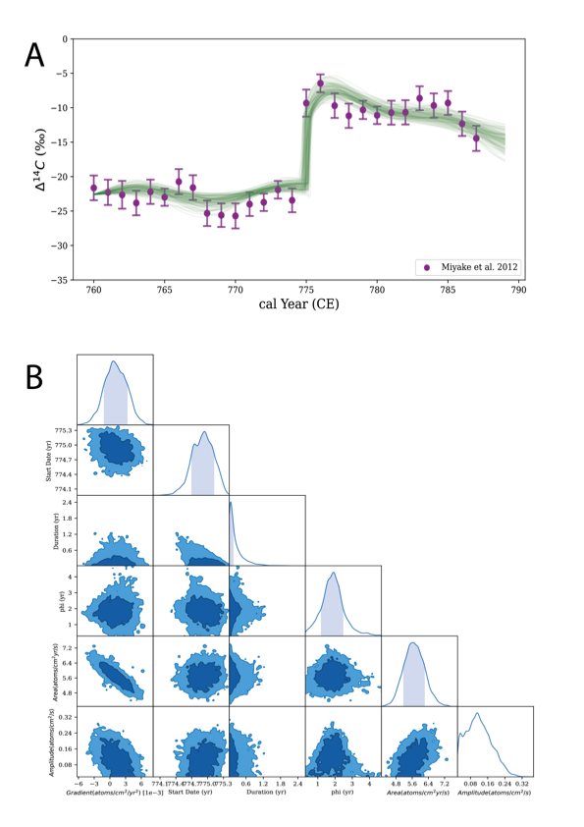**Figure 5-SI: On the top (A), the 14C time series from Miyake et al. (2012). The green lines are the ticktack model results. On the bottom (B), results of the ticktack analysis over the same dataset, showing the surface distribution of the modelled posterior parameters.**

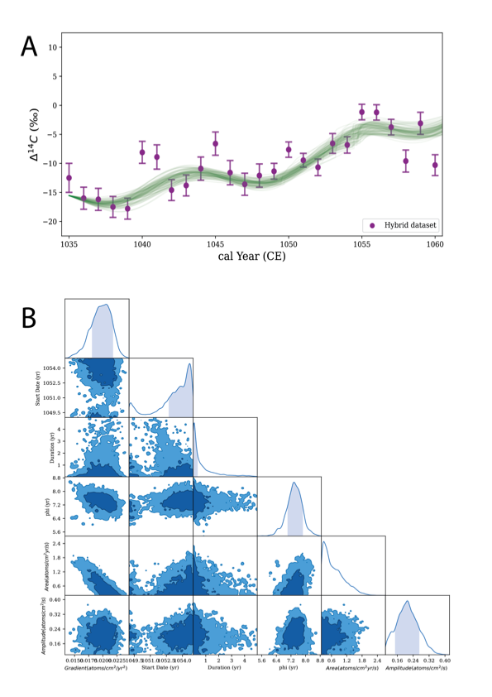**Figure 6-SI: On the top (A), the 14C hybrid time series, result of concatenating and averaging our dataset with the dataset from Eastoe et al. (2019). The green lines are the ticktack model results. On the bottom (B), results of the ticktack analysis over the same dataset, showing the surface distribution of the modelled posterior parameters.**

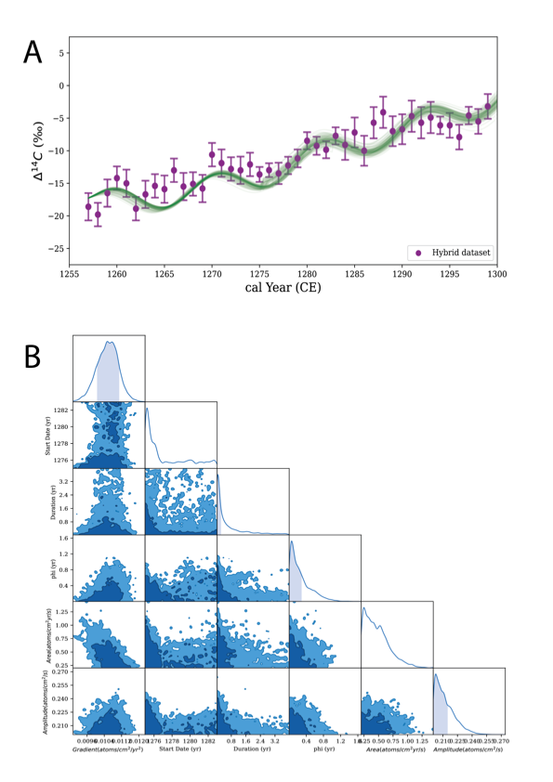**Figure 7-SI: On the top (A), the 14C hybrid time series, result of concatenating and averaging our dataset with the dataset from Brehm et al. (2021). The green lines are the ticktack model results. On the bottom (B), results of the ticktack analysis over the same dataset, showing the surface distribution of the modelled posterior parameters.**

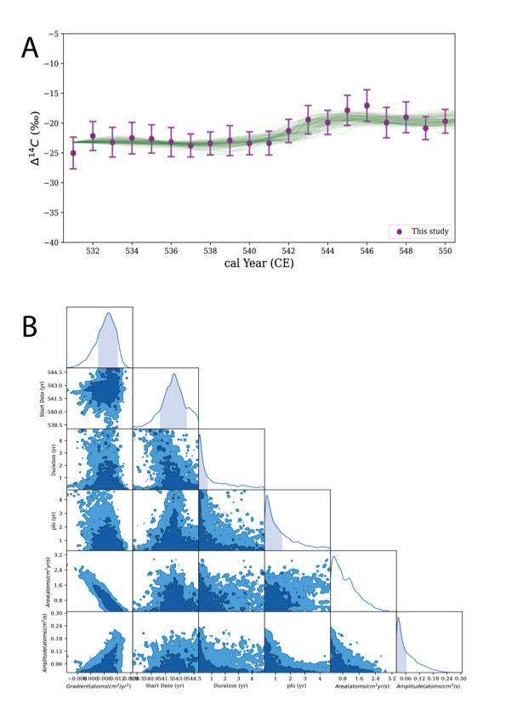**Figure 8-SI. On the top (A), results of the 14C analysis over the sample 14.0123.121. The green lines are the ticktack model results. On the bottom (B), results of the ticktack analysis over the same dataset, showing the surface distribution of the modelled posterior parameters.**

### Supplementary Information 5 (SI5):

### Dendrochronology of Historic England samples

Radiocarbon measurements were obtained from two timbers that had been previously sampled for ring-width dendrochronology. Both samples had been prepared for measurement and tree-ring analysis by polishing with a belt sander using progressively finer belts down to a fineness of 400 grit, and the annual growth rings had been marked out. Dissection was undertaken by Alison Arnold and Robert Howard at the Nottingham Tree-Ring Dating Laboratory. Prior to sub-sampling the samples were checked against the tree-ring width data to ensure that the specimens contained the required rings. Once this was determined the selected annual growth rings were split from the rest of the sample using a chisel or scalpel blade. Each sample consisted of a complete annual growth ring, including both earlywood and latewood. The sub-sample was then weighed and placed in a labelled bag.

#### BIF-E19

This sample consisted of a radial slice taken for dendrochronology from an oak beam removed in 2013 during underpinning works from beneath the presbytery wall of Furness Abbey, Barrow-in Furness, Cumbria, UK (54.14°N, 3.20°W). Timbers were removed from ‘slots’ beneath the wall, and off-cut baulk sections taken and stored on site. From these cross-sectional slices were taken for dendrochronology, which were subsequently reduced to radial slices. This oak timber contained 174 heartwood rings, spanning AD 983 – AD 1156 and ended at the heartwood/sapwood transition.

The tree-ring analysis of the timbers from the foundation raft of the presbytery wall at Furness Abbey has been fully reported by Arnold *et al* (2015). Cross-sections were obtained from 43 oak timbers from the raft, of which 41 had ring-width series that could be measured reliably. These growth-ring widths were measured to a precision of 0.01 mm. The data of the measured samples were then compared with each other using the Litton/Zainodin grouping procedure (Laxton *et al* 1988; Litton and Zainodin 1991). BIF-E19 crossmatched with 31 other samples at a minimum *t*-value of *t*=5.0, and their ring-width series were combined at their indicated offset positions to form BIFESQ01, a site chronology with an overall length of 182 rings. This site chronology is dated as spanning AD 975–1156 (Table 7-SI).

|  |  |  |  |
| --- | --- | --- | --- |
| Reference chronology | Span of chronology | *t-*value | Reference |
| Eastgate, Beverley, Yorkshire | AD 858–1310 | 7.5 | Groves 1992 |
| Lamb Hotel, Nantwich, Cheshire | AD 941–1276 | 7.1 | Tyers 2004a |
| Second Wood Street, Nantwich, Cheshire | AD 932–1509 | 6.8 | Tyers 2005 |
| Annetwell Street, Carlisle, Cumbria | AD 930–1219 | 6.6 | Groves 1990 |
| Dundas Wharf, Bristol | AD 770–1202 | 6.6 | Nicholson and Hillam 1987 |
| Peterborough Cathedral nave, Cambridgeshire | AD 887–1225 | 6.2 | Tyers 1999 |
| Peterborough Cathedral transepts, Cambridgeshire | AD 921–1194 | 6.2 | Tyers 2004b |
| Lancaster Castle, Lancashire | AD 950–1404 | 5.9 | Arnold *et al* 2016 |
| Oakham Castle, Oakham, Rutland | AD 923–1153 | 5.8 | Arnold and Howard 2013 |
| Hansacre Hall, Staffordshire | AD 965–1279 | 5.5 | Esling *et al* 1990 |

*Table 7-SI: Results of the cross-matching of site sequence BIFESQ01 and relevant independent site reference chronologies when the first-ring date is AD 975 and the last-ring date is AD 1156 (*t*-values after Baillie and Pilcher 1973).*

The raw ring-width data of all the measured samples from the foundation raft of the presbytery wall at Furness Abbey can be found in Arnold *et al* (2015) and at <https://www.ncei.noaa.gov/access/paleo-search/study/36973>.

#### APT-C02

This sample consisted of duplicate cores taken for dendrochronology from the tiebeam of truss 6, in the north aisle of the church of St Leonard, Apethorpe, Northamptonshire, UK (52.55°N, 0.49°W). This oak timber contained 181 heartwood rings, spanning AD 1211 – AD 1391 and ended at the heartwood/sapwood transition.

The tree-ring analysis of the roofs of the chancel and aisles of Apethorpe church has been fully reported by Arnold and Howard (2008a). Core samples from 30 oak timbers were obtained from the roofs, of which 24 had sufficient (> 54) rings to proceed with analysis. Their growth-ring widths were measured to a precision of 0.01 mm. The two ring-width series from APT-C02 cross-matched with a *t*-value of 41.5, and were combined before further analysis. The data of the measured samples were then compared with each other using the Litton/Zainodin grouping procedure (Laxton *et al* 1988; Litton and Zainodin 1991). APT-C02 crossmatched with five other samples at a minimum *t*-value of *t*=4.5, and their ring-width series were combined at their indicated offset positions to form APTCSQ01, a site chronology with an overall length of 193 rings. This site chronology is dated as spanning AD 1211–1403 (Table 8-SI).

|  |  |  |  |
| --- | --- | --- | --- |
| Reference chronology | Span of chronology | *t*-value | Publication |
| Black Hostelry, Ely Cathedral, Cambridgeshire | AD 1233–1376 | 10.0 | Arnold *et al* 2004 |
| Reading Waterfront, Berkshire | AD 1160–1407 | 9.4 | Groves *et al* 1997 |
| Bede House, Lyddington, Rutland | AD 1245–1494 | 9.2 | Howard *et al* 2015 |
| 19 Henley Street, Alcester, Warwickshire | AD 1322–1393 | 9.1 | Alcock *et al* 1989 |
| Ulverscroft Priory, Charnwood Forest, Leicestershire | AD 1219–1463 | 8.8 | Arnold *et al* 2008 |
| Flore’s House, Oakham, Rutland | AD 1173–1392 | 8.7 | Hurford *et al* 2008 |
| Apethorpe Hall, Apethorpe, Northamptonshire | AD 1292–1639 | 8.2 | Arnold and Howard 2008b |
| Abbey Farm Barns, Thetford, Norfolk | AD 1237–1428 | 8.2 | Howard *et al* 2000 |
| Chicksands Priory, Chicksands, Bedfordshire | AD 1200–1541 | 7.8 | Howard *et al* 1998 |
| Abbey Gatehouse, Kingswood, Gloucestershire | AD 1307–1428 | 7.4 | Arnold *et al* 2003 |

*Table 8-SI: Results of the cross-matching of site sequence APTCSQ01 and relevant independent site reference chronologies when the first-ring date is AD 1211 and the last-ring date is AD 1403 (*t*-values after Baillie and Pilcher 1973).*

The raw ring-width data of all the measured samples from the roofs of the chancel and aisle of the church of St Leonard, Apethorpe can be found in Arnold and Howard (2008a) and at <https://www.ncei.noaa.gov/access/paleo-search/study/36974>.

**References**

Alcock, N W, Warwick University, Howard, R E, Laxton, R R, and Litton, C D, Nottingham University Tree-ring Dating Laboratory, and Miles, D H, 1989 List 31 no 8 – Leverhulme Cruck Project Results: 1988, *Vernacular Architect,* **20**, 43–5

Arnold, A, and Howard, R E, 2008a *St Leonard’s Church, Main Street, Apethorpe, Northamptonshire: tree-ring analysis of timbers*, English Heritage Research Department Report Series, **85/2008**

Arnold, A J, and Howard, R E, 2008b *Apethorpe Hall, Apethorpe, Northamptonshire: Tree-ring Analysis of Timbers*, English Heritage Res Dep Rep Ser, **87/2008**

Arnold, A J, and Howard, R E, 2013 *Oakham Castle, Oakham, Rutland, Tree-ring Analysis of Timbers*, English Heritage Research Department Report Series, **23/2013**

Arnold, A, J, Howard, R E, and Litton C D, 2003 *Tree-ring Analysis of Timbers from Kingswood Abbey Gatehouse, Kingswood, Gloucestershire*, Centre for Archaeol Rep, **21/2003**

Arnold, A J, Howard, R E, Laxton, R R, Litton, C D, and Simpson, W G 2004 – *A Dendrochronological Study of the Monastic Buildings at Ely*, Centre for Archaeol Rep, **74/2004**

Arnold, A J, Howard, R E, and Tyers, C, 2008 *Ulverscroft Priory, Ulverscroft, Charnwood Forest, Leicestershire, tree-ring analysis of timbers*, English Heritage Research Department Report Series, **48/2008**

Arnold, A J, Howard, R E, Dunbar, E, Tyers, C, and Marshall, P, 2015 *Furness Abbey, Barrow-in-Furness, Cumbria: tree-ring analysis and radiocarbon dating of the presbytery wall foundation raft timbers*, Historic England Research Report Series, **47/2015**

Arnold, A J, Howard, R E, and Tyers, C, 2016 *Lancaster Castle, Castle Park, Lancaster, Tree-ring Analysis of Oak and Pine Timbers in the Keep and Gatehouse*, Historic England Research Report Series, **35/2016**

Baillie, M G L, and Pilcher, J R, 1973 A simple cross-dating program for tree-ring research, *Tree-Ring Bull*, **33**, 7–14

Esling, J, Howard, R E, Laxton, R R, Litton, C D, and Simpson, W G, 1990 List 33 no 8a/b – Nottingham University Tree-ring Dating Laboratory Results: general list, *Vernacular Architect*, **21**, 37–40

Groves, C, 1990 *Tree-ring analysis and dating of timbers from Annetwell Street, Carlisle, Cumbria, 1981-84*, English Heritage Ancient Monuments Laboratory Report, **49/1990**

Groves, C, 1992 Tree-ring analysis of timbers, in *Excavations at 33-35 Eastgate, Beverley, 1983-86* (eds D H Evans and D G Tomlinson), Sheffield Excavation Report, **3**, 256–65

Groves, C, Hillam, J, and Pelling-Fulford, F, 1997 Dendrochronology, in *Excavations on Reading Waterfront sites 1979–1988* (eds J W Hawkes and P J Fasham), Wessex Archaeol Rep, **5**, 64–70

Howard, R E, Laxton, R R, and Litton, C D, 1998 *Tree-ring analysis of timbers from Chicksands Priory, Chicksands, Bedfordshire,* English Heritage Ancient Monuments Laboratory Report, **30/1998**

Howard, R E, Laxton, R R, and Litton, C D, 2000 *Tree-ring analysis of timbers from the Barn and Cottage, Abbey Farm, Thetford, Norfolk,* English Heritage Ancient Monuments Laboratory Report, **48/2000**

Howard, R E, Arnold, A J, and Tyers, C, 2015 *The Bede House, Church Lane, Lyddington, Rutland: Tree-ring Analysis of Oak Timbers*, Historic England Res Rep Ser, **37/2015**

Hurford, M, Arnold, A J, Howard, R E, and Tyers, C 2008 *Tree-ring Analysis of Timbers from Flore’s House, High Street, Oakham, Rutland,* English Heritage Res Dep Res Rep, **94/2008**

Laxon, R R, Litton, C D, and Zainodin, H J, 1988 An objective method for forming a master ring-width sequence, *P A C T*, **22**, 25–35

Litton, C D, and Zainodin, H J, 1991 Statistical models of dendrochronology, *J Archaeol Sci*¸**18**, 29–40

Nicholson, R A, and Hillam, J, 1987 *A dendrochronological analysis of oak timbers from Dundas Wharf, Bristol, 1982–83*, English Heritage Ancient Monuments Laboratory Report, **33/1987**

Tyers, I, 1999 *Tree-ring analysis of oak timber from Peterborough Cathedral, Peterborough, Cambridgeshire: Structural timbers from the Nave Roof and North-West Portico*, English Heritage Ancient Monuments Laboratory Report, **9/1999**

Tyers, I, 2004a *Dendrochronological spot-dates of samples from the Lamb Hotel (site 11000), Nantwich, Cheshire*, ARCUS Report, **573v**

Tyers, I, 2004b *Tree-ring analysis of oak boards and structural timbers from the Transepts, Presbytery, and Tower of Peterborough Cathedral, City of Peterborough*, English Heritage Ancient Monuments Laboratory Report, **77/2004**

### *Tyers, I, 2005 Dendrochronological spot-dates of samples from Second Wood Street (site E696), Nantwich, Cheshire, ARCUS Report, 573w*

### Supplementary Information 6 (SI6):

### Dendrochronology Laboratory at BAAC

This sample constitutes of an oak plank which was part of the lining of a water well found at a site near present day Ruiselede in Belgium. The practical execution of tree-ring analysis on an archaeological timber find involves four steps: sampling, preparing the sample, measuring the tree-ring pattern and cross dating the measurement with the reference dataset. The sampling was executed by hand saw. The sequence of the growth rings is made visible by cutting a radial ‘runway’ from the inner to the outer growth ring with razor blades. The ring withs were measured microscopically on a measurement table of SCIEM ([www.sciem.com](http://www.sciem.com)) with a resolution of 0,01 mm and analyzed with PAST5, a dendrochronological software program. Dendrochronological matches are described numerically using the following statistical calculations: the percentage of Parallel Variation or *Gleichlaufigkeit* (%PV) and the *t-*value by Hollstein (1980).

#### 14.0123.121

The sample consists of a radial from an oak plank (find number 775) from a the lining of a water well (feature number 11104, structure number 52) removed in 2014 during archaeological excavations works at a site near present day Ruiselede in Belgium [51°2′0″N, 03°23′0″E]. The measurement series of the timber is 14.013.121 and contains 196 heartwood rings, spanning AD 451 – AD 646.

The tree-ring analysis of the timber from the water well is fully reported by Doeve (2017). In total 15 timbers from five water wells were analyzed. The measurement series 14.0123.121 is one of eight series from oak planks which cross dated well into a tree group 14.0123.oakTG (*t-*value of *t*=10,03 and %PV=68,93). This group with a length of 296 tree ring crossmatched strongly with the reference chronologies NLVLAA01 (Table 8-SI).

|  |  |  |  |  |
| --- | --- | --- | --- | --- |
| Reference chronology | Span of chronology | *t-*value | *%PV* | Reference |
| NLVLAA01 | AD -211–1104 | 14 | 72,6 | Jansma & Hanraets 2004 |

*Table 8-SI: Results of the cross-matching of site sequence 14.0123.oakTG (*t*-values after Hollstein 1980).*

The raw ring-width data of all the measured samples from the timbers can be found in Doeve (2017) and at <https://doi.org/10.34894/8K5TOF>.

**References**

Doeve, P., 2017: *Dendrochronologische onderzoek Ruiselede waterputten* (BAAC project 14.0123), https://doi.org/10.34894/8K5TOF, DataverseNL, V1.

Hollstein, E. 1980: Mitteleuropäische Eichenchronologie, in *Trierer Grabungen und Forschungen, Band XI* Phillip Von Zabern, Mainz am Rhein.

Jansma, E. & E. Hanraets, 2004: Dating Flanders – towards a Flemish tree-ring chronology of oak. in Jansma E, Bräuning A, Gärtner H, Schleser G (eds.) (2004) *TRACE - Tree Rings in Archaeology, Climatology and Ecology, Vol. 2: Proceedings of the DENDROSYMPOSIUM 2003*, May 1st – 3rd 2003, Utrecht, the Netherlands. (Schriften des Forschungszentrums Jülich, Reihe Umwelt Vol. 44), 131 – 138.