Supplementary:
A time-integrated sampler for radiocarbon analysis of aquatic methane
MH Garnett and JF Dean
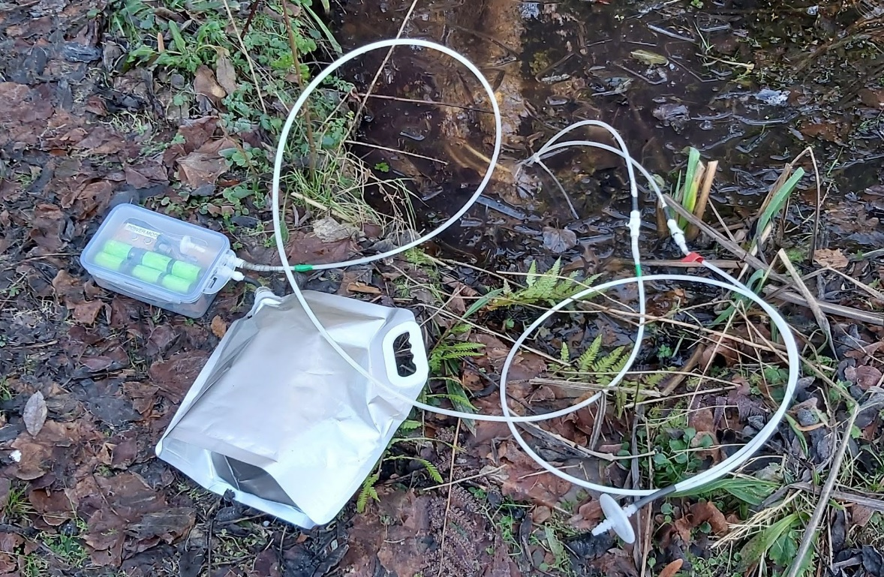
Figure S1. Example of field-deployment of the new sampling kit (coils of hydrophobic tubing are submerged underwater).

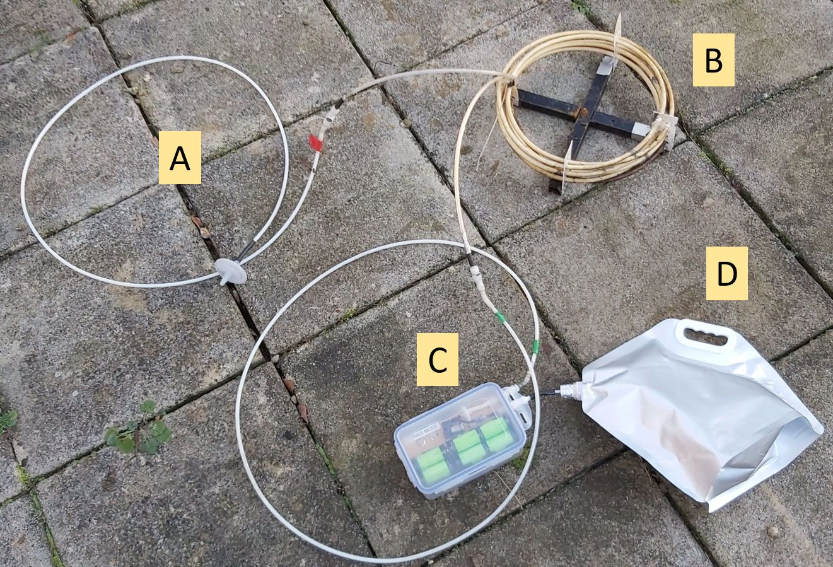
Figure S2. Components. A = gas inlet tubing with hydrophobic filter. B = coils of gas-permeable hydrophobic tubing. C = pump unit. D = foil gas bag for sample storage.
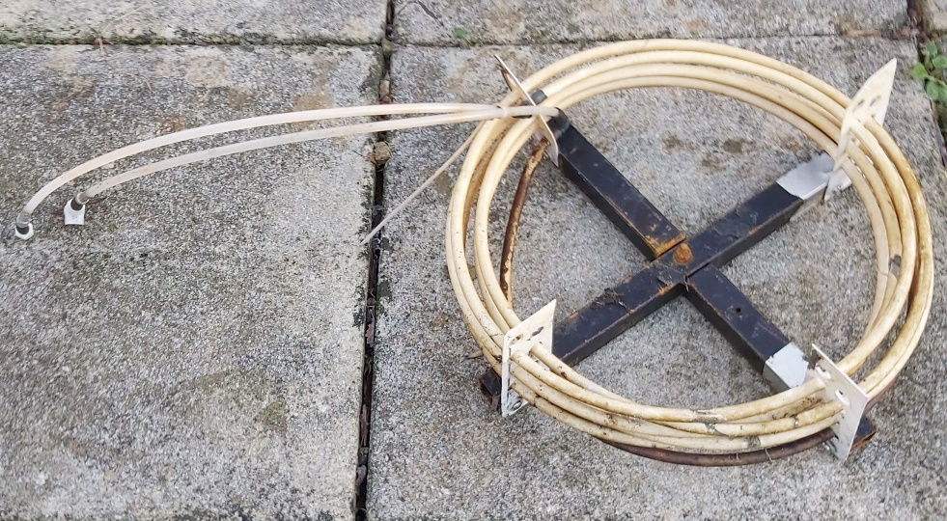
Figure S3. Coils of gas-permeable hydrophobic tubing mounted on metal frame.

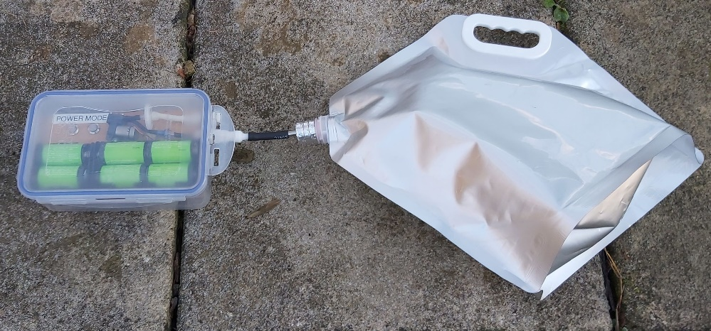
Figure S4. Pump unit connected to a foil gas bag.

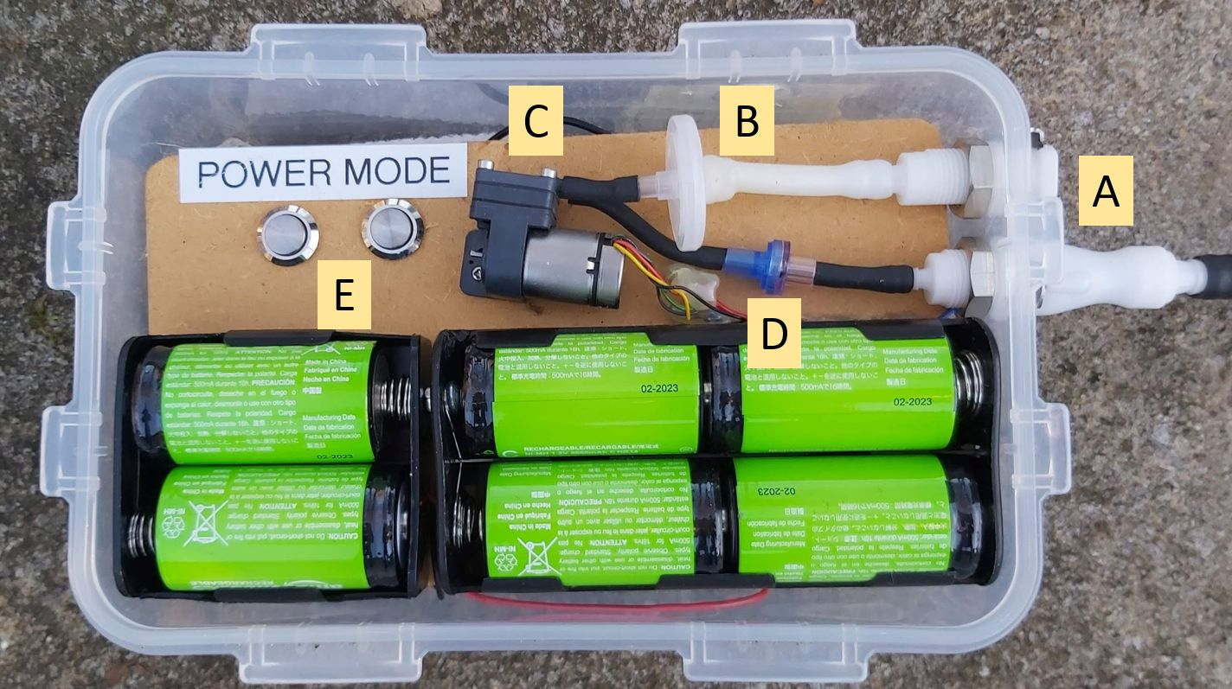
Figure S5. Pump unit: A = couplings for connecting to hydrophobic coils (upper) and foil gas bag (lower). B = hydrophobic filter on gas inlet. C = air pump. D = non-return / check valve. E = power on/off and mode switches (mode is either time-integrated sampling or pump continuously on). Note that the Arduino microcontroller is located below the wood panel and is not visible.

