LAS ARNILLAS
The tomb of Las Arnillas is in Sedano Valley, in the upper part of one of La Lora moorlands, between the Moradillo and Cabillas rivers, at 1036 m.a.s.l. It has coordinates x=444363 and y=4729508 (UTM 30T). The intervention revealed up to five archaeological levels. Level III corresponds to the burial with human remains and funerary objects, and level V was the layer under the mound.
The construction characteristics of the tomb allowed it to be classified as a passage tomb, with a polygonal chamber of about 4 m in diameter and a covered passage with an NW-SE orientation (12 m). Eight or nine orthostats were estimated to have delimited the chamber, but only six have survived. The excavation reports (Delibes et al. 1986; Rojo-Guerra 1993) describe the disposition of the bone remains as follows:
- The volume of the ossuary was between 14 and 15 m, divided between the passage and the chamber.
In the areas of the chamber closest to the orthostats, the ossuary occupied about half a meter of space.
- The areas with more density of skeletal remains were found in the highest parts of the tomb. These areas corresponded to those covered by slabs, and they were better preserved.
- In the area of the passage near the entrance, a lintel had collapsed. This collapse probably occurred due to alterations to the tomb (Delibes et al. 1986; Rojo-Guerra 1993). These stones were part of the burial level. It was, therefore, concluded that they had fallen at some point during the tomb's use, perhaps as a deliberate act of closure.
- The human remains were entirely commingled. Nevertheless, some articulated skeletons could be identified:
- A flexed lower limb was connected to a pelvis in the northern sector of the chamber. This partial anatomic connection could not be identified later in the study.
- Despite the anatomical separation from other skeletal elements in the enclosure, most inhumations were initially identified as primary deposits. The anatomical separation was attributed to later removals or relocations, both functional and ritual. The identification of deliberate secondary deposits suggested the intentionality of these relocations. For example, thirteen skulls ("nest of skulls"?) were found in the passage between C-II and C-IV. There is also a remarkable pile of long bones. During the anthropological study, the skulls were identified, but they did not represent the NMI. It was, therefore, decided to date another set of bones.
- In addition, two secondary bone deposits were identified at the eastern end of sectors C-I and C-IV. These were reportedly identified as long bones, pelvis and skull, and unconnected vertebrae groups. Unfortunately, they were not identified in the graphic reports or the anthropological study.
On the other hand, another remarkable feature of Las Arnillas is the discovery of post-Neolithic materials (Delibes et al. 1986):
A) Bell-Beaker elements: fragments of Ciempozuelos-style incised pottery, and V-perforated buttons were found, all from the "disturbed level of the chamber". One of the buttons had a double cross perforation, a unique model, while the other had parallels in the Pyrenees, confirming the existence of cultural influences from this area.
B) Iron-Bronze: A fibula, possibly from the 8th century BC (800-700 BC) and probably associated with globular pottery, a glass bead, and a more recent V-shaped button with an animal head were found. These objects are attributed to the transition from the Late Bronze Age to the Iron Age.
C) Historic period: Iberian and Roman painted pottery were found. Finally, the discovery of a "cornado de vellón de Fernando IV de Aragón acuñado en Pamplona a partir de 1513" is mentioned. Stratigraphically, it coincides with the period when domestic animals were thrown into the disturbed area of the dolmen (upper non-burial levels).
The interior of the chamber was covered with 2 m of black sediment (the burial was found in level III). It contained material from different periods, from the Late Neolithic and Bronze Age to the Modern Age, most of which corresponded to domestic fauna (bovids, equids, suids, and ovicaprids) (Delibes et al. 1986; 1993; Rojo-Guerra 1993; Delibes 2010).
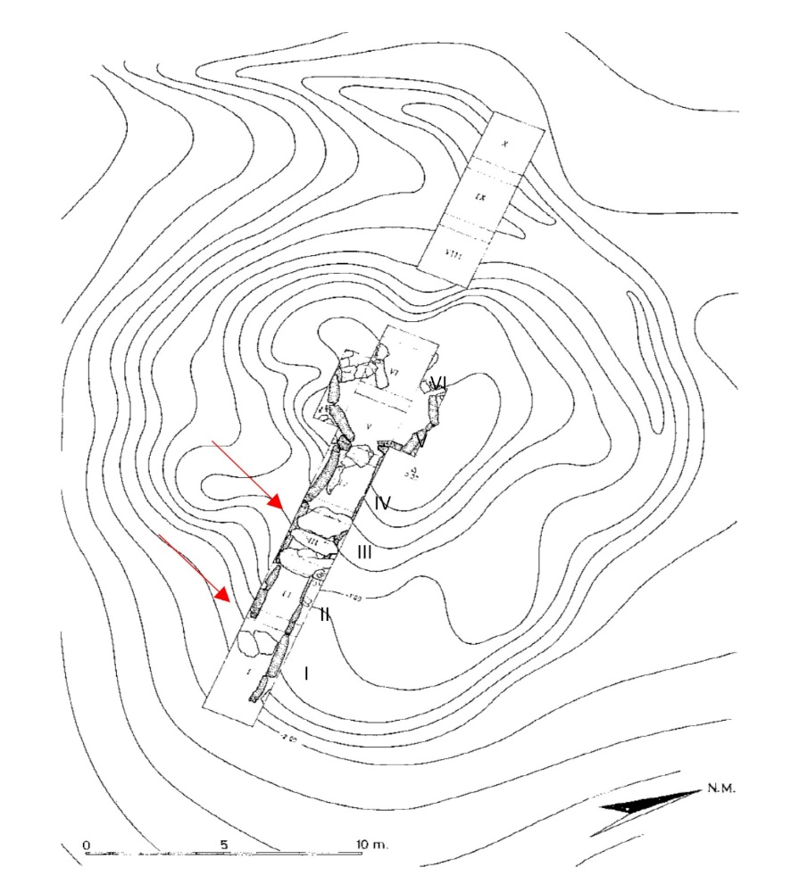

Fig. S1. Planimetry and sectors of the Arnillas (modified from Delibes et al. 1986; author: A. Rodríguez González). The red arrows indicate the covered areas of the passage.

MORECO
El Moreco is one of the largest passage tombs in the La Lora group of megaliths in Burgos (Delibes and Rojo-Guerra, 2002; Delibes, 1996, 2000; Delibes et al. 2010). It is located at the following coordinates (UTM 30T): x=443273 y=4733704 at 1062 m.a.s.l., in a geographical depression between the Hoya de Huidobro to the north and the Los Llanos moorlands to the south. The megalithic monument has been constantly looted throughout history. For this reason, the chamber was destroyed at the time of its excavation (1985). Consequently, only a small part of the ossuary is preserved under one of the collapsed orthostats (Rojo-Guerra 1993).
The tomb, one of the most monumental in La Lora, consisted of a mound just over two meters high and 27 meters in diameter. Five orthostats were found in the center of the burial chamber. For the archaeological intervention, the site was divided into sectors of different sizes (between 6x2 and 2x4 m), both in the crater area and other parts of the burial mound.
Only part of the passage and half of the chambered orthostats survived. It is estimated that the passage may have measured up to 10.5 m. Despite the continuous destruction at El Moreco, the evidence allows us to conclude that the passage was deliberately closed. Firstly, the passage structure appeared too unstable to support a ceiling. Secondly, the closure could only have been deliberate, as evidenced by the complete absence of archaeological remains in the passage and a limestone infill.
The remains of the ossuary were not found in the chamber either, and only the part under the fallen orthostat was preserved. In contrast, many objects were found, including geometric microliths, flint blades, and arrowheads, materials that coincide with all the megalithic phases previously identified at La Lora.
As for the temporality of El Moreco, a ¹⁴C date obtained from charcoal collected 192 cm below the mound dates it to the end of the 5th millennium BC (Delibes and Rojo-Guerra 1997). Interesting studies were also carried out on the possible construction phases based on the pedological characteristics of the soil beneath the mound. One of the works, based on the composition of the paleo soil (Hoyos 1990 in Delibes et al. 2010), suggests the existence of a previous barrow as a possible refoundation of the tomb (Delibes and Rojo-Guerra 2002:26) and perhaps related to the blocking of the passage. Another study analyzed the pollen (López, 1988 in Delibes et al. 2010), confirming the surrounding land's use as agricultural fields (Delibes 2000: 96).
In this case, too, we do not indicate the context in which the bones were found. The excavation reports only show the destruction of the site. Only a small part of the ossuary was saved, buried under one of the orthostats removed from the chamber. The rest of the bones collected came from the surface of the burial mound, where they are thought to have arrived as "later contributions from the chamber."
It was also impossible to identify a previous phase of the tomb's construction with the poor temporal information we have. Therefore, we assume that this tomb's construction must have occurred at least shortly after the ground preparation for the building that still exists today, possibly at the beginning of IV millennium cal BC.
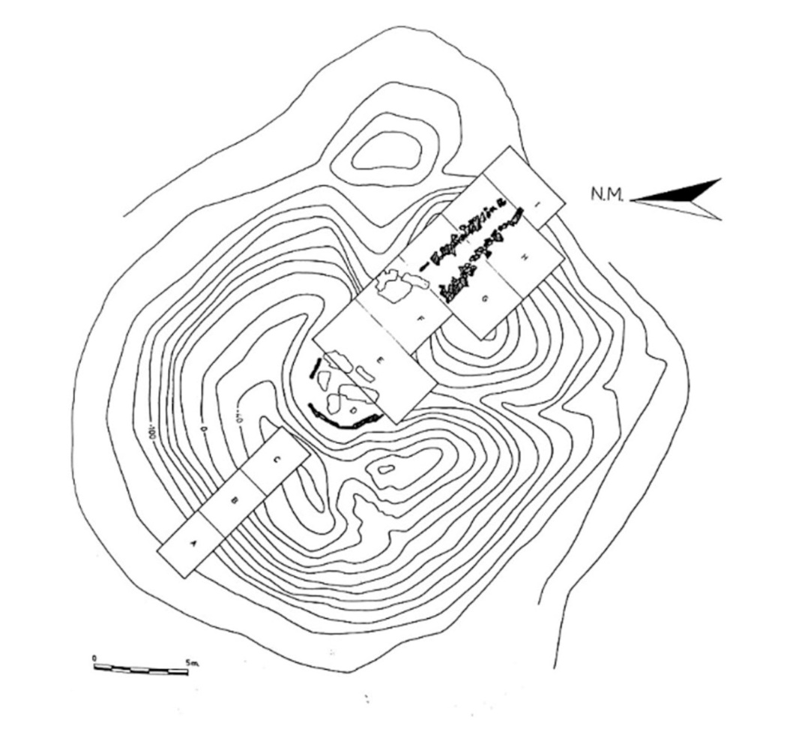

Fig. S2. Sectors excavated in El Moreco (Rojo-Guerra 1993; author: A. Rodríguez González).

LA CABAÑA
La Cabaña is located on an upper moorland platform surrounded by fields, about 3 kilometers from the village of Sargentes de La Lora. Its coordinates (UTM 30T) are x=426634 y=4735898 at 1058 m above sea level. During the archaeological intervention, an NE/SW-oriented excavation was carried out, covering the entire surface occupied by the chamber. Subsequently, the excavation was extended to the north and southeast of the chamber, along the passage, and into the barrow (Rojo-Guerra 1993; Delibes et al. 1993).
The surface of the chamber was circular, approximately 3.17 m in diameter. It was delimited by seven 2 m long orthostats, six in situ. The passage faced southeast. It was about 5.5 m long (Rojo-Guerra 1993; Delibes et al. 1993). Three flat roof slabs covered the contact area between the passage and the chamber. In addition, at the end of the passage, there were four slabs across the axis of the passage. They could have blocked the access, although no other evidence supported the hypothesis that the passage was intentionally closed.
In each of the sectors, it was possible to distinguish different levels of sedimentation. It was possible to identify a first layer of different tonalities and disturbed materials, bones, recent pottery and remains of weapons. Logically, this level corresponded to the removals that had occurred in historical times, the last significant event being the Spanish Civil War (Rojo-Guerra 1993; Delibes et al. 1993). The next level was found at about 135 cm, where a large collapsed block was documented in the chamber's center. This block preserved a small part of the ossuary and grave goods, all buried after the collapse.
Archaeological levels were identified in the covered area of the passage. Bones and some archaeological elements were found there. There was also a deposited skull and long bones with no anatomical connection. These may have resulted from deliberate regrouping (Delibes et al. 1993). None were identified in the archaeological record.
The human remains were not recorded according to location and were considered a single burial level. However, the excavation reports show that the ossuary was disturbed, probably as a result of various historical lootings (Rojo-Guerra 1993; Delibes et al. 1993). On the other hand, two areas with bones are mentioned in the passage: one in the covered part and the other in the uncovered part. In the uncovered area, the bones were found scattered in a layer of stones and earth in no apparent order (Rojo-Guerra 1993). The covered area contained a greater volume of bones and some material objects (ibid.:165).
Archaeological material was also recovered from the interior of the chamber. In contrast to other passage tombs, no materials, such as Bell-Beaker elements, were found that are typical of post-Neolithic funerary use. In total, geometric, denticulate, and flint scrapers, necklace beads, animal bone spatula idols, a sandstone mill, and at least one pedunculate arrowhead with bilateral retouches would date the funerary use of the dolmen to the end of the 4th millennium BC (Rojo-Guerra 1993; Delibes and Rojo-Guerra, 1997). Recent wheel-thrown pottery of unknown date was also found (Rojo-Guerra 1993).
Only one absolute date (GrN-18670: 5240+65 BP) between 4225-3972 cal BC (1 σ) or 4252-3951 cal BC (2 σ) had been obtained from previous chronological studies at La Cabaña. This dating was recovered from the level under the mound immediately before the dolmen. It was, therefore, considered to date an event that preceded the tomb's construction (Delibes and Rojo-Guerra 1997). However, the recent characteristics of the archaeological objects and their architecture made it possible to attribute to this megalithic monument chronology similar to other passage tombs in the area, such as El Moreco or Las Arnillas (Delibes 2000: 95).
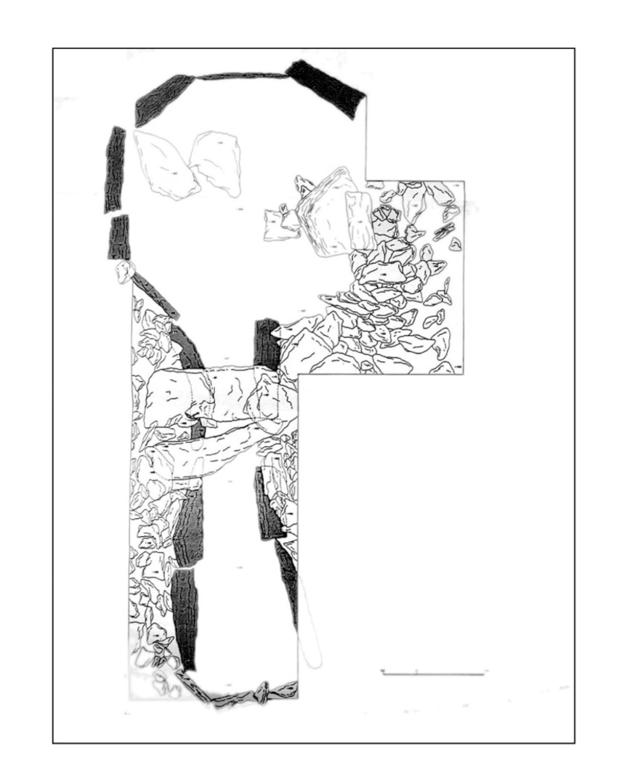

Fig. S3. Plan of La Cabaña (Rojo-Guerra 1993; author: A. Rodríguez González).

FUENTEPECINA
The necropolis of Fuentepecina has four megalithic tombs located in a limestone moor 7.5 kilometers from the village of Sedano. The tombs are Fuentepecina I, Fuentepecina II, Fuentepecina III, and Fuentepecina IV. Tombs I and IV are located north of the moor, while tombs II and III are in the southernmost part of the moor. All four are no more than 250 m from each other (Delibes 2000: 92). The exact position follows the UTM coordinates (ETRS89): x = 441.196; y =4.724.558, and at an altitude of 988 m.a.s.l. This area frequently floods due to its endorheic nature (Moreno 2001: 328).
FUENTEPECINA I
Fuentepecina I is a mound with a circular base, 15 meters in diameter, and only one meter high. At the time of excavation, recent damage was observed (Rojo-Guerra 1993; Delibes et al. 1993). Two archaeological interventions were carried out: one to the southeast, covering the area of the chamber and passage, and another to the northwest, covering part of the intact mound.
After the excavation, it was possible to document the structure of the chamber. Only four orthostats remained in situ out of the original nine. The diameter of the chamber was estimated to be around 2.5 meters, and it was probably oval.
Regarding the sedimentation levels, a layer of very dark sediment was distinguished in the chamber space. It was mixed with abundant stones and bones without anatomical connections. The area with the highest accumulation of bones was outside the chamber behind the orthostats in the northeast quadrant. According to the records, this is where the disturbed levels from the chamber were deposited.
Regarding sedimentation levels, a layer of very dark sediment was found in the chamber space, mixed with abundant stones and bones without order or anatomical association. The area with the greatest concentration of bones was on the outside of the chamber, behind the orthostats in the northeast quadrant. This level is probably the most disturbed.
Without any evidence, it was initially thought that the passage had been dismantled after the last looting. Subsequently, three slabs were identified as a possible passageway, which would have been only 1.34 meters long. It would, therefore, belong to the category of simple dolmens with a short passage or be considered a 'transitional' typology (Delibes 2000; Delibes and Rojo-Guerra 2002; Delibes 2010; Delibes et al. 2023). Another possibility, not considered at the time, is that the passage was removed as an act of closure. However, no evident remodeling is described in the excavation reports.
The simplicity of its architecture was linked to the greater antiquity of the archaeological objects, among which geometric microliths, spatulas -which could fit the typology known as San Martín-El Miradero- and several lignite beads stand out. On the other hand, retouched arrowheads, usually found in phases close to the Chalcolithic, were not found. These more archaic elements are part of the grave goods of the four tombs of Fuentepecina, a circumstance repeated in other dolmens with similar characteristics and proven antiquity, such as the dolmen of Los Zumacales in Valladolid (Alonso et al. 2015; Santa Cruz et al. 2020b). Therefore, according to the chronotypological sequence, Fuentepecina I would belong to the megalithic phase of the Meseta implantation (Delibes et al. 1986). On the other hand, lignite beads have also been found, which seem to be more closely related to the "Arnillas horizon," i.e., the large passage tombs, so that a more prolonged funerary use cannot be ruled out (Delibes and Rojo-Guerra 2002; Delibes 2010; Delibes et al. 2010). We can conclude that a priori Fuentepecina I could have been in use after the other tombs were closed.
Among the materials from Fuentepecina I, more recent elements have also been found, such as fragments of Hispanic terra sigillata or wheel-thrown pottery, all of which could be evidence of multiple lootings in historic times.
Previous radiocarbon analyses have only provided a date for charcoal from under the mound, placing the tomb's construction at the end of the 5th millennium BC (Delibes and Rojo-Guerra 1997; Rojo-Guerra 1993).
FUENTEPECINA II
Fuentepecina II was excavated later in the 1990s (Delibes et al. 1993). Located about 290 m south of Fuentepecina I, it was the only one of the four to be found almost intact. The mound has an oval shape and is half a meter high.
From east to west, the maximum length of the mound was about 17.5 meters. A small chamber was also discovered. It was pentagonal, with a diameter of less than 1 m, and consisted of 7 orthostats. The simplicity of its architecture, characterized by the absence of a passage, is the constructive peculiarity of Fuentepecina II. Instead, the tomb of Fuentepecina II had an adjacent space of about 60 cm on the SE side. Thus, this enclosed space may have provided a different access solution. Individuals were possibly deposited through this vestibule, which was covered with a horizontal slab after the burial ceremony (Delibes 2010: 19).
As for the bone remains, they were found in the chamber in total anatomical disarticulation. There was a remarkable disproportion between the skull and the postcranial elements, with abundant long bones among the latter. Objects accompanying the skeletal remains are related to the early stages of megalithic activity in the northern Sub-Plateau. Among them were Arcaic geometric microliths such as triangles, trapezoids and segments, flint blades, quartz crystals, slate necklace beads, two green variscite and steatite beads, and two animal bone spatulas (Delibes et al. 1993). The lack of later reuse or modification suggests a relatively short funerary use, similar to other megalithic monuments typical of the early megalithic phases (Delibes 2010: 31). Therefore, it could be the earliest amortized tomb, preceding Fuentepecina I and Fuentepecina IV, which will be described below.
In addition, this tomb provided two dates obtained under the mound dated on charcoal, one of which delays the chronology to the 7th millennium BC. This dating is a clear example of the so-called "old wood effect" since it would date an event well before the construction of the Fuentepecina II. The other dating, however, provided a time frame that was more consistent with the construction characteristics and the typology of the archaeological materials. This dating places the tomb's construction in the last centuries of the 5th millennium BC, making it one of the oldest megalithic monuments of La Lora sequence.
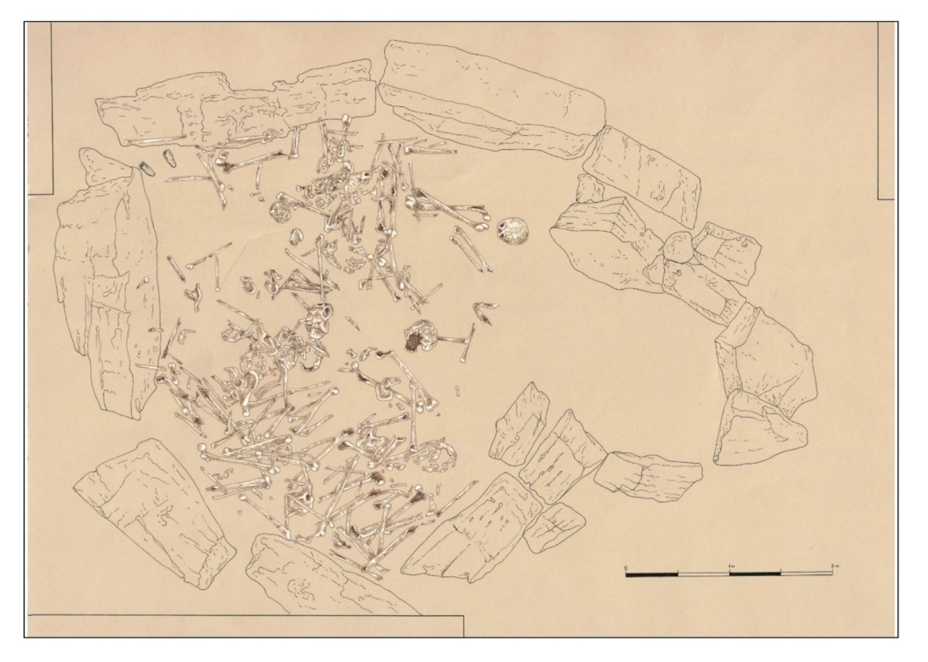
Fig. S4. Plan and distribution of skeletal remains in Fuentepecina II (Author: A. Luis Repiso).

FUENTEPECINA IV
Fuentepecina IV is the worst preserved. It had no real megalithic structure, so it has been suggested that it belongs to the category of unstructured mounds, especially given its proximity to El Rebolledo (Delibes and Rojo-Guerra, 2002: 22-23; Delibes et al. 2023). In addition, the bone remains were found directly on the ground (Delibes et al. 1993). This location contributed to a higher degree of deterioration of the bones. In addition, a shepherd's shelter affected the preservation of the monument.
The tomb consists of a small mound about 10 meters in diameter and one meter high but with a poorly defined chamber space. The simplicity of the mound contrasts sharply with the richness of the grave goods recovered. These include a large collection of geometric microliths and flint flakes, beads of various materials such as shale and other minerals, quartz prisms, and ten polished axes (Delibes 2010: 41).
A charcoal date found under the mound dates its construction to between the end of the 5th millennium BC and the beginning of the 4th millennium BC. From this, it can be concluded that the three analyzed tombs could have been contemporary during the early stages of the megalithic activity at La Lora.
The four tombs' proximity, archaism, and other aspects, such as taphonomic preservation, have made it possible to relate them in time. The general conservation of the Fuentepecina complex is very similar and is strongly characterized by bone demineralization and the action of roots. The three burials' taphonomic condition is very different from the rest of the dolmens of La Lora. It should be remembered that the toponym of the tombs' location refers to the "pecina," i.e., a bog with decomposing organic matter. Nicholson (1996) shows that solid demineralization and matrix loss are common in podsol or previous bog environments, producing acidic contexts.
Furthermore, fungal damage is usually not recorded in these levels, as in this megalithic assemblage, yet advanced demineralization is documented. The conditions of preservation in a more acidic environment than the rest of the dolmens have led to different taphonomic characteristics, resulting in poorer preservation of the skeletons. These preservation characteristics are homogeneous between bones from other collections and those from different dolmens.
LA CISTA
The tomb is located in the valley of Fuenteblanquilla, at coordinates (UTM 30T): x=445870 y=4733846, and at an altitude of 1054 m.a.s.l. The surrounding area is characterized by some clayey soils with shallow soils (Delibes 2010).
Before the intervention, two large, elongated stone blocks were visible on the site in parallel, forming an almost free-standing structure. Behind these blocks was also a group of stones that could have belonged to the ancient mound (Rojo-Guerra 1993). A square of about 4 m₂ was prepared for the excavation, divided into an eastern and a western sector. Subsequently, an extension to the west was made to define the structural characteristics of the tumulus. A final excavation was carried out 4 m to the east to recover materials that could have come from removing the mound and the chamber (Rojo-Guerra 1993; Delibes et al. 1993).
After the excavation, it was confirmed that it was a cist formed by two large limestone orthostats about 2.20 m long and 1 m high. Another orthostat must have initially completed the boundary of the chamber on the west side. The southern and eastern quadrants have been severely affected by the construction of road BU-V-5032 through the southern part of the site. As a result of these alterations, only two levels could be distinguished (Rojo-Guerra 1993):
- Upper level I: composed of randomly arranged stones mixed with the surface level.
- Lower level II: located directly on the limestone soil of the moor. It consisted of dark sediments on which the bones were arranged without anatomical connection.
White flint knives, triangular and rectangular geometric microliths, a polished ophite axe, numerous necklace beads of different shapes and materials, as well as lignite, coral, and talc tubular beads and flat bone washers, representative of the "Las Arnillas horizon," which were also later documented in the Duero Valley and associated with the latest stages of megalithic activity in the Nothern Sub-plateau (Delibes 2010; Delibes et al. 2010; Zapatero 2012; 2015). The documentation of large lamellar tools was evidence of the relative modernity of the La Cista burial goods. Whitish flint arrowheads with denticulate retouching were found, also associated with more recent phases. Thus, despite preserving a simple structure like the Fuentepecina tombs, the objects from La Cista were more recent (Delibes and Rojo-Guerra 1997).
CIELLA
Before the intervention, the site was looted in 1976, as evidenced by the numerous craters that destroyed the dolmen. For this reason, the intervention project began in 1977 and lasted until 1981 (Delibes et al. 1982).
The tomb was circular and had a diameter of 18 meters. Due to numerous destructions, only three large orthostats remained in the north of the standing chamber. A sector of 4 m₂ was drawn in the area of the crater and extended by another 4 m₂ to define the southern boundary of the chamber. In 1981, new sectors were opened in the passage and the mound, and the sector was extended to the west to define the limit of the chamber on that side.
The excavation was carried out in artificial layers of 10 cm. On this basis, the following stratigraphic units were defined (Delibes et al. 1982; Rojo-Guerra 1993):
1. Surface level I: vegetation level, where some archaeological materials were found.
2. Archaeological level II: layer of dark clays. Archaeological material and historical intrusions were found at this level.
3. Level III: This layer was found in some areas of the chamber and tumulus, defined by dark and black colored stains and some archaeological material. It was considered the burial level.
4. Stage IV: This is a natural moorland formed by archaeologically sterile whitish limestone on which some orthostats rested.
After the excavation, it was possible to verify that the tomb was oriented to the east. The passage was about 4.5 m long, although only five orthostats were found in situ (Delibes et al. 1982; 1993; Rojo-Guerra 1993). At the end of the passage, large stones were found that could have been used during the 'prehistory period' to block the entrance. The chamber could have been polygonal, with a maximum diameter of about 3.5 m, formed by seven orthostats (Delibes et al. 1982).
As for the material recovered, only the lithic pieces stand out since numerous blades and geometrical microliths were found. But above all, there were large flakes and two arrowheads, more recent than those from Fuentepecina. These arrowheads were the first found in Burgos (Delibes et al. 1982; 1993). One has a flattened back with abrupt retouching, while the other is cruciform in pink flint with bifacial retouching and, therefore, could be from different contexts (Delibes et al. 1982).
Most of the elements documented in Ciella were also found in other sites, such as Las Arnillas. Calcite necklace beads were abundant. There was also a polished axe of exogenous gneiss, probably votive, and a fragment of a millstone of red sandstone from Sedano. Above all, the Ciella trousseau is remarkable for the presence of beaker vessels and pots, which, already at the end of the Chalcolithic period, indicated probable funerary reuse (Delibes et al. 1982). The Bell Beaker pottery was found directly on the moor outside the dolmen, almost at the beginning of the passage.
Finally, materials from the historical period have been found, such as terra sigillata or a bronze metal fragment that could be a Late Roman T-shaped pin (Delibes et al. 1982; 1993).
It is clear, therefore, that the time frame of Ciella is extensive, although the only date provided for this dolmen comes, as usual, from a level below the mound. It was made on charcoal (5290 ± 40 BP) and offered dates calibrated between 4243 and 3991 cal BC (2 σ). This chronological framework would place it among the burials classified as "transitional", as in the case of Valdemuriel or San Quirce. They are slightly more recent than the simple structures of the necropolis of Fuentepecina (Delibes and Rojo-Guerra 1997).
SAN QUIRCE
This tomb is located between a small limestone platform and the valley of the San Quirce stream, at UTM coordinates (ETRS89) x=43353535 and y=4726260, at 993 m.a.s.l. The site takes its name from an old hermitage in its surroundings, where remains of a Christian necropolis have been found (Rojo-Guerra 1993; Delibes et al. 1993).
The mound was about 16 m in diameter and over a meter high. As for the chamber, only three orthostats were visible before the excavation (Rojo-Guerra 1993). In addition, other stones could be seen aligned to the southeast of the mound, which was interpreted as a possible passage. The excavation was carried out in quadrants, using the chamber and the passage as reference points. In the first quadrant, a square of 4x4 meters was excavated. It was divided into east-west sectors and then extended by half a meter to the north, where the extension of the ossuary was located. In addition, another trench of about 2x8 m was opened in the mound to check its structural characteristics.
Only two orthostats from the east and two from the west were preserved because most of the chamber and passage were destroyed. The chamber may have been up to 2 m in diameter and was probably circular. The burial level was at the end of the raised orthostats in the eastern sector. Another layer with abundant bone and pottery remains was found in the western sector, associated with a burial that may have been "displaced from its original position and destroyed by the collapse" (Rojo-Guerra 1993).
The passage is one of the other constructional characteristics of the tomb of San Quirce. It must have been a short time, not more than 4m. The only artifacts found in the passage were pottery, but there was no evidence of a burial level. There is also the possibility of the closure of the San Quirce passage, as documented in other tombs since a slab was found over a pile of stones, perhaps artificial.
In addition, there were four levels at the San Quirce site (Rojo-Guerra 1993). These levels are not identified in the bone record.
- Level III: an artificial moorland pit in which human bones and funerary material were found.
- Level IV: The intact burial level at the foot of the in situ orthostats.
Archaeological materials were found dispersed throughout the different levels and sectors. For example, pottery fragments and flint flakes were found in the mound section (Rojo-Guerra 1993). In the passageway and the cleaning area of the southeast quadrant, pottery - probably some intrusive - was also documented, as well as small flint blades and microliths. In addition, more recent pottery was found in the chamber, Roman glass - probably from the second half of the 2nd century - and mixed bones in the surface level of the northwest collapse zone (Íbid: 285). All this was evidence of a long history of intrusions and looting that would have significantly altered the tomb's structure.
Finally, another set of materials was found at the prehistoric burial level. This set was related to the Late Neolithic period. Among them were geometric microliths, a polished axe, limestone slabs, flint blades and knives, a fragment of marine shell, a polished boar tusk, calcareous necklace beads, and, as an intrusive element but of historical date, a large vessel that could well be of Bronze Age date (Rojo-Guerra 1993; Delibes et al. 1993). The ossuary was found without anatomical connections. However, there were groups of long bones, especially femurs, stacked on each other, perhaps intentionally placed in this way during the Neolithic ceremonial period.
The numerous signs of intervention after the burial provide a complicated time frame for interpreting the chronology of the tomb. The grave goods show a certain archaism, as the triangular microliths found among the flint pieces are reminiscent of the classical Cocina type with an appendix associated with Mediterranean Epipalaeolithic contexts (Delibes 1996; Zapatero 2012; 2015).
On the other hand, the numerous later intrusions are consistent with the chronological framework provided by the absolute 14C dates obtained in a previous study. The two radiocarbon dates correspond well after the 4th millennium BC (Delibes and Rojo-Guerra 1997). The most recent is from the lower level (GrN-14492: 1180 + 110 BP), but it may well respond to historical intrusions between the first three and five centuries AD in calibrated dates. The other dating comes from the burial level (GrN-14493: 3770 + 190 BP). The calibrated dates place us between 2857-1690 cal BC, a period that includes some funerary reuses documented in dolmens such as Las Arnillas or El Moreco (Santa Cruz et al. 2020a), having a statistical deviation of almost 200 years. This sample is evidence of a possible last-use event, most likely related to the "intrusive burial" associated with the Bronze Age materials (Rojo-Guerra 1993; Delibes et al. 1993).

