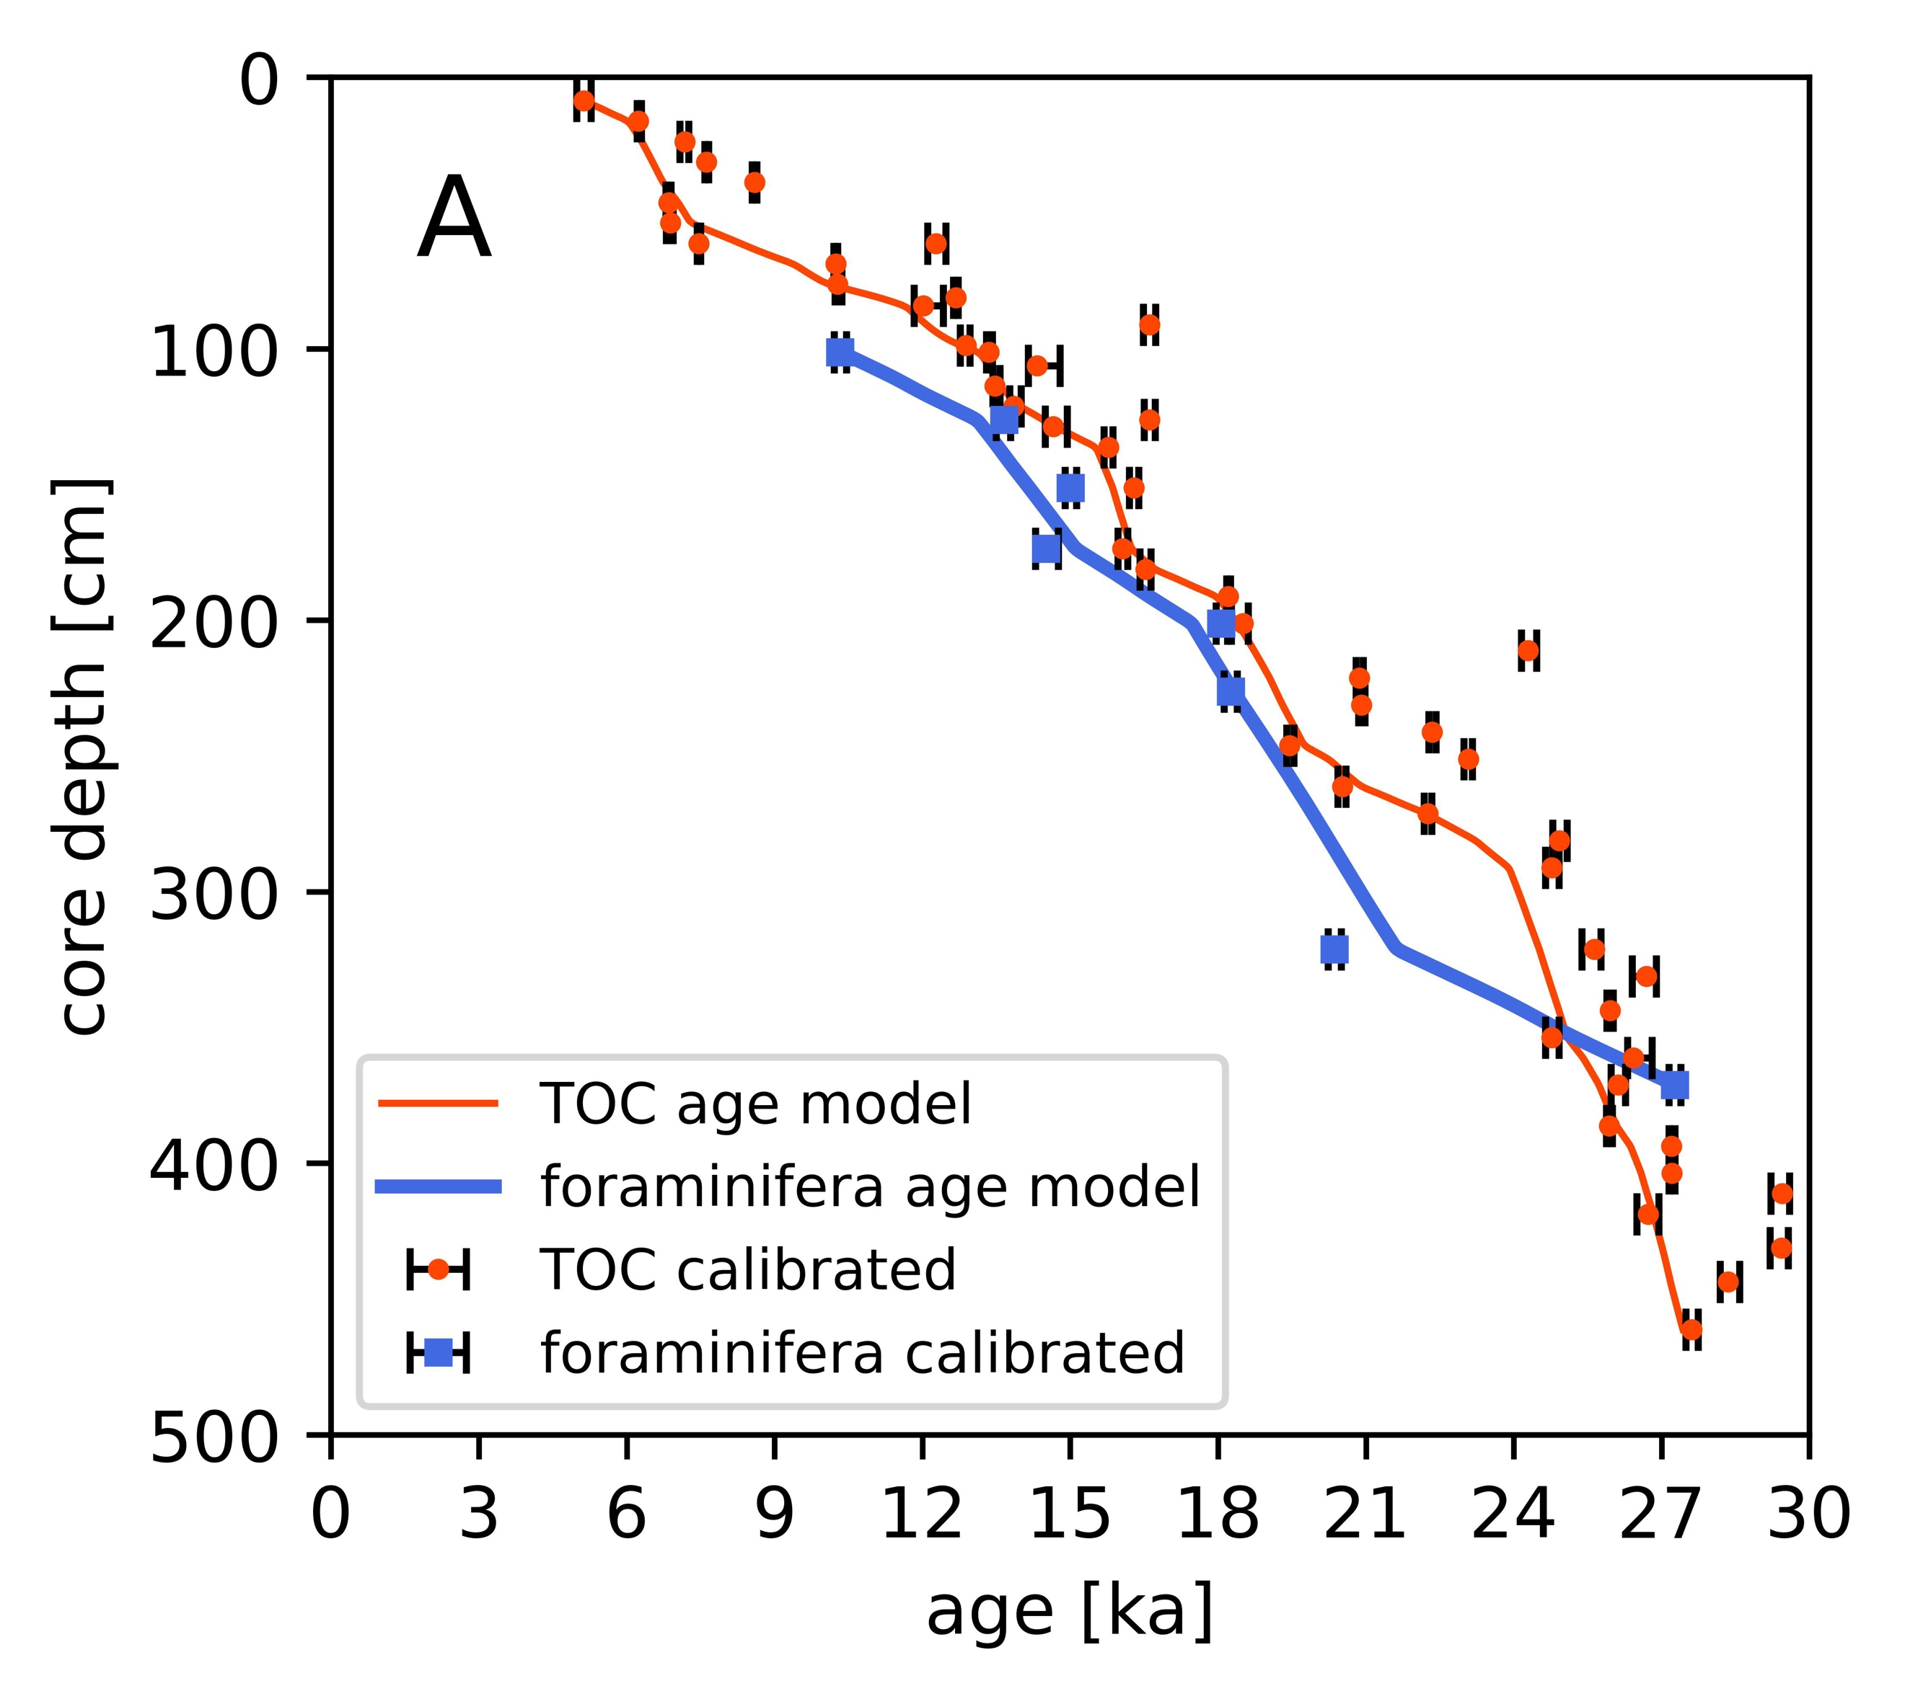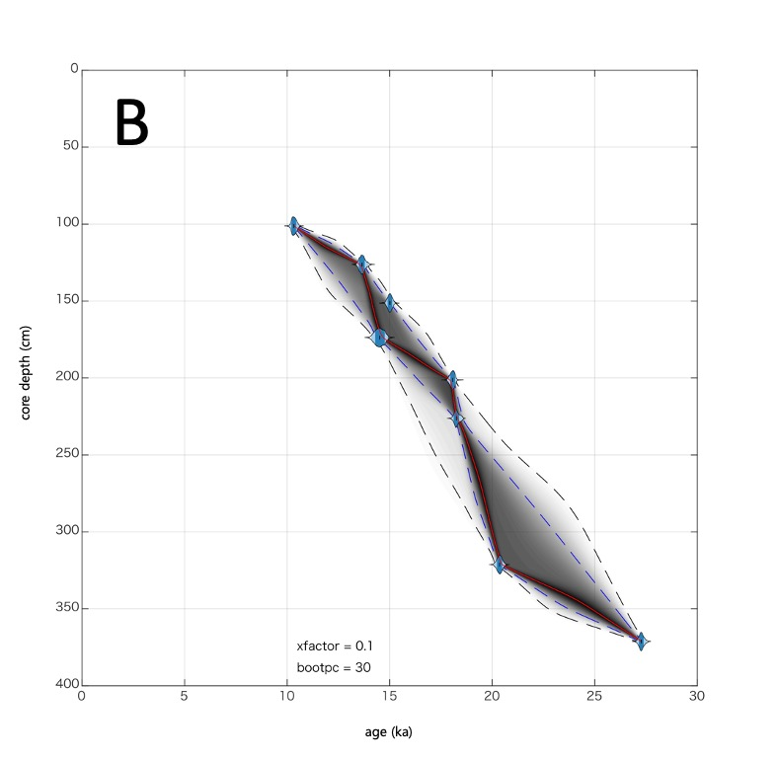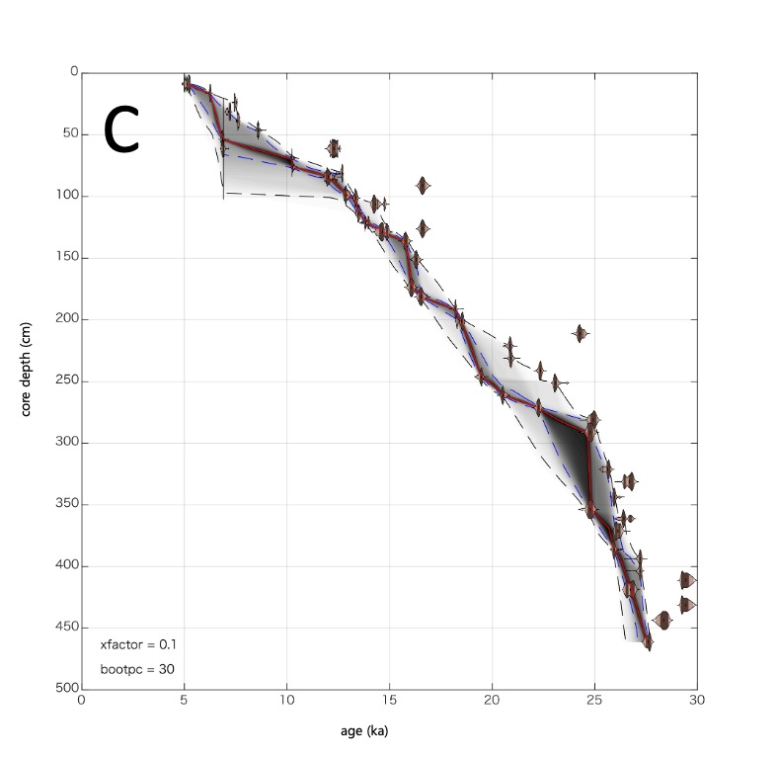
Appendix A (A) Calibrated age points (dots) and the age-depth model constrained by Undatable (lines) of Core MD05-2970. The red solid line and circle dots correspond to the data for radiocarbon dates for TOC (48 samples). The blue dashed-dot line and square dots correspond to the data for radiocarbon dates for planktonic foraminifera (12 samples). (B) The age-depth of Core MD05-2970 based on radiocarbon dating on planktonic foraminifera. (C) The age-depth of Core MD05-2970 based on radiocarbon dating on TOC.

Appendix B Summary of radiocarbon measurements in this study.
Lab code | type | Depth | ¹⁴C age | Cal BP | δ¹³C
(YAUT-) |  | (cmbs) | ± 1σ | 68.30% | ‰
075403 | TOC | 7.5-10 | 4460 ± 33 | 5275-4979 | -18.87
075404 | TOC | 15-17.5 | 5450 ± 35 | 6292-6209 | -16.55
082802 | TOC | 20-22.5 | 6042 ± 31 | 6941-6804 | -23.38
075405 | TOC | 22.5-25 | 6561 ± 37 | 7500-7427 | -19.75
075406 | TOC | 30-32.5 | 6248 ± 36 | 7253-7077 | -16.21
075409 | TOC | 37.5-40 | 6760 ± 37 | 7659-7580 | -23.28
075411 | TOC | 45-47.5 | 7821 ± 40 | 8635-8548 | -21.87
075413 | TOC | 52.5-55 | 6016 ± 35 | 6897-6794 | -20.89
075415 | TOC | 60-62.5 | 10399 ± 46 | 12473-12103 | -24.44
075416 | TOC | 67.5-70 | 9094 ± 42 | 10274-10203 | -22.43
075417 | TOC | 75-77.5 | 9123 ± 43 | 10364-10227 | -22.41
082804 | TOC | 80-82.5 | 10652 ± 42 | 12722-12627 | -24.22
075418 | TOC | 82.5-85 | 10275 ± 56 | 12425-11832 | -26.42
075419 | TOC | 90-92.5 | 13723 ± 58 | 16732-16481 | -25.23
075423 | TOC | 97.5-100 | 10971 ± 56 | 12959-12769 | -21.78
075424 | TOC | 100-102.5 | 11468 ± 50 | 13419-13301 | -20.40
075425 | TOC | 105-107.5 | 12329 ± 52 | 14791-14151 | -23.04
075426 | TOC | 112.5-115 | 11611 ± 49 | 13575-13428 | -17.35
075428 | TOC | 120-122.5 | 11956 ± 50 | 13999-13770 | -20.94
082805 | TOC | 125-127.5 | 13724 ± 50 | 16720-16495 | -23.65
075429 | TOC | 127.5-130 | 12476 ± 52 | 14940-14493 | -21.80
075431 | TOC | 135-137.5 | 13153 ± 54 | 15865-15682 | -20.15
075433 | TOC | 150-152.5 | 13513 ± 55 | 16384-16200 | -20.54
075438 | TOC | 172.5-175 | 13348 ± 55 | 16166-15967 | -16.07
075439 | TOC | 180-182.5 | 13680 ± 57 | 16634-16415 | -15.30
078502 | TOC | 190-192.5 | 14874 ± 50 | 18246-18176 | -21.03
082809 | TOC | 200-202.5 | 15090 ± 55 | 18607-18263 | -24.05
078504 | TOC | 210-212.5 | 20228 ± 71 | 24461-24156 | -24.24
078505 | TOC | 220-222.5 | 17289 ± 63 | 20942-20801 | -22.94
082811 | TOC | 230-232.5 | 17338 ± 63 | 20974-20845 | -21.39
078509 | TOC | 240-242.5 | 18412 ± 78 | 22417-22277 | -19.45
082812 | TOC | 245-247.5 | 16109 ± 59 | 19540-19392 | -22.89
078511 | TOC | 250-252.5 | 19186 ± 76 | 23155-22988 | -22.59
078512 | TOC | 260-262.5 | 16993 ± 62 | 20594-20433 | -23.32
078513 | TOC | 270-272.5 | 18299 ± 68 | 22334-22178 | -23.43
078515 | TOC | 280-282.5 | 20672 ± 83 | 25076-24784 | -23.71
078516 | TOC | 290-292.5 | 20556 ± 72 | 24915-24642 | -20.32
078517 | TOC | 320-322.5 | 21257 ± 76 | 25769-25378 | -21.70
078519 | TOC | 330-332.5 | 22307 ± 88 | 26888-26404 | -20.39
078523 | TOC | 342.5-345 | 21726 ± 83 | 26018-25883 | -20.08
078524 | TOC | 352.5-355 | 20558 ± 75 | 24920-24640 | -24.43
078525 | TOC | 360-362.5 | 22185 ± 80 | 26806-26308 | -22.76
078526 | TOC | 370-372.5 | 21876 ± 78 | 26261-25976 | -20.74
078528 | TOC | 385-387.5 | 21697 ± 85 | 25998-25874 | -21.25
078529 | TOC | 392.5-395 | 22848 ± 92 | 27271-27147 | -18.12
078531 | TOC | 402.5-405 | 22848 ± 86 | 27269-27152 | -22.16
078532 | TOC | 410-412.5 | 25170 ± 99 | 29592-29213 | -21.01
078533 | TOC | 417.5-420 | 22413 ± 81 | 26944-26495 | -21.55
078536 | TOC | 430-432.5 | 25152 ± 97 | 29570-29200 | -19.50
078537 | TOC | 442.5-445 | 24159 ± 99 | 28581-28182 | -25.04
078538 | TOC | 460-462.5 | 23410 ± 87 | 27736-27495 | -19.26
077711 | Foraminifera (T. sacculifer) | 100-102.5 | 9612 ± 77 | 10460-10211
077712 | Foraminifera (T. sacculifer) | 125-127.5 | 12300 ± 106 | 13788-13499
077713 | Foraminifera (T. sacculifer) | 150-152.5 | 13176 ± 50 | 15125-14897
077714 | Foraminifera (T. sacculifer, G. ruber) | 172.5-175 | 12873 ± 106 | 14760-14296
077718 | Foraminifera (T. sacculifer, G. ruber) | 200-202.5 | 15606 ± 71 | 18191-17954
077719 | Foraminifera (T. sacculifer) | 222.5-225 | 15787 ± 58 | 18388-18123
077725 | Foraminifera (T. sacculifer) | 320-322.5 | 17613 ± 73 | 20496-20231
077726 | Foraminifera (T. sacculifer) | 370-372.5 | 23907 ± 94 | 27387-27149
*δ¹³C values presented here are AMS-δ¹³C data.

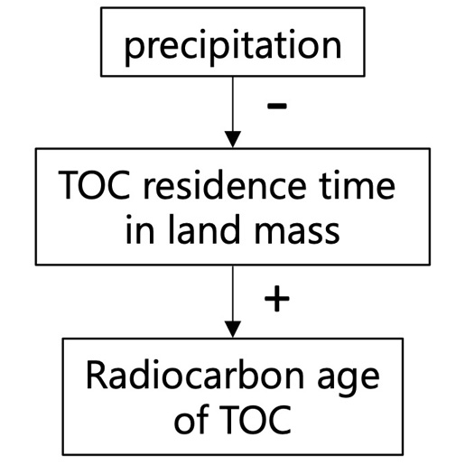
Appendix C Proposed relation between the amount of rainfall and the radiocarbon ages of TOC.

