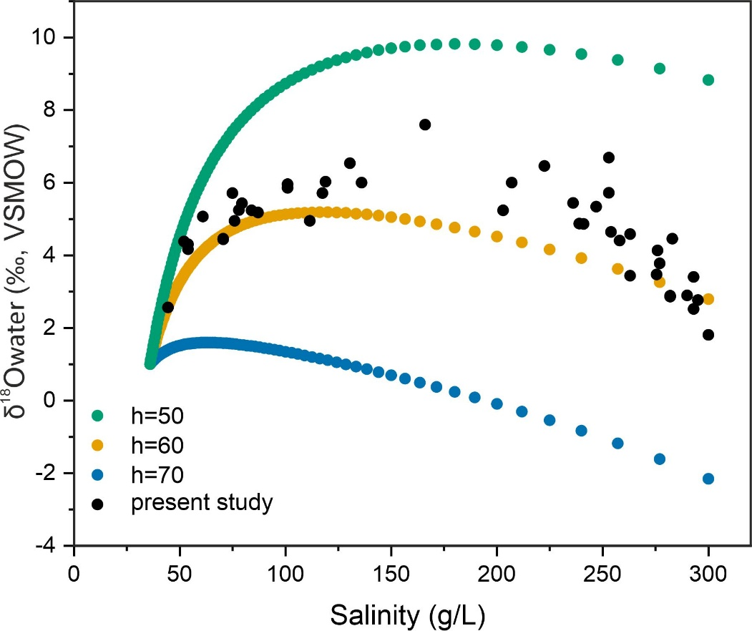
Supplementary Figure 1: The salinity vs δ¹⁸O plot of the (1) evaporating saline water with an original salinity of 36 g/L under different humidities (modeled data) and (2) water in the open marine, subtidal, intertidal and supratidal areas of the Arabian Gulf adjacent to Abu Dhabi emirate (data from this study and Lokier and Steuber, 2006).
Craig-Gordon Model
The Craig-Gordon (C-G) model is used to estimate the oxygen isotope fractionation during the evaporation of fresh or saline water by considering the isotopic composition of the initial water, temperature, relative humidity, ambient vapour isotopic composition, diffusion, and/or mixing at the water-air interface, and the thermodynamic activity (salinity) of water. The initial model quantified these variables separately. However, a modified model by Gonfiantini et al. (2018), called the unified C-G model, simultaneously quantifies all the controlling variables involved in evaporation and mimics the results of the laboratory water evaporation experiments conducted under different conditions. Hence, this modified model is followed in the present study to calculate the oxygen isotope composition of the evaporated water.
There are three fractionations involved in the evaporation of liquid water to vapour. (1) The first one is the equilibrium fractionation when liquid water transforms into vapour and forms a layer of saturated vapour above the water surface. The equilibrium fractionation factor, $α_{eq}$, is defined as:
$$α_{eq}= \frac{R_{w}}{R_{v}}---------(1)$$
Where $R_{w}$ is the oxygen isotope ratio of water and $R_{v}$ is the oxygen isotope ratio of the vapour. The $α_{eq}$ is a function of temperature (T), which is experimentally quantified by Majoube (1971) as follows:
${lnα}_{eq}=aT^{-2}+bT^{-1}+$ c $---------(2)$
At equilibrium, the values of these coefficients are: a = 1137, b = -0.4156, and c = -0.00207. In the model, a temperature of 31 ⁰C for freshwater, an average of the groundwater temperature from coastal to 50 km inland Abu Dhabi and Dubai, and 32 ⁰C for Gulf (marine) water (Lokier and Steuber, 2009) are used for calculating $α_{eq}$.
(2) The second fractionation happens when the vapour escapes the equilibrium layer by molecular or turbulent diffusion to the free atmosphere, and the fractionation factor, $α_{diff}^{X}$, is defined as:
$$α_{diff}^{X}= \frac{R_{V}}{R_{esc}}----------(3)$$
$$α_{diff }^{X}≈X\left(α_{diff}-1\right)+1-------(4)$$
Where $R_{esc}$ is the oxygen isotope ratio of vapour escaping the equilibrium layer, $α_{diff}$ is the isotope fractionation factor due to molecular diffusion, and X is the turbulence index. When X = 1, vapour escapes from the layer only by molecular diffusion, and the isotope fractionation factor is $α_{diff}$. Commonly accepted $α_{diff}$ value is 1.0258 for oxygen (Merlivat, 1978). When X = 0, vapour escapes only by turbulent diffusion, which is non-fractionating, and hence, the fractionation factor $α_{diff}^{X}$is 1. An X value of 0.4 is used for the model, which is the average of the turbulence index reported from deserts in Africa and Australia (Gonfiantini et al., 2018).
(3) Third fractionation occurs when the vapour reverses its path to the virtual saturated vapour layer at the water-air interface and gets captured by the liquid water via the re-equilibration process. Its oxygen isotope ratio is defined by R_{cap} and is related to the oxygen isotope ratio of vapour in the free atmosphere ($R_{A}$) by:
$$R_{cap}= \frac{R_{A}}{α_{diff}^{X}}-------(5)$$
Considering all the factors above, the oxygen isotope ratio of the evaporated water ($δ_{w}$) is as follows:
$$δ_{w}= \left(δ_{0 }+1+ \frac{A}{B} \left(δ_{A}+1\right)\right) f^{B}- \left(1+ \frac{A}{B} \left(δ_{A}+1\right)\right)-----(6)$$
$$A= - \frac{h}{α_{diff}^{X}\left(γ-h\right)}---------(7)$$
$$B= \frac{γ}{{α_{eq}α}_{diff}^{X}\left(γ-h\right)}-1-----(8)$$
$$γ= -0.000543f^{-2}-0.018521f^{-1} +0.99931----(9)$$
The oxygen isotope composition of the initial water is denoted by $δ_{0 }$. The most negative δ¹⁸O value of -6.0 ‰, recorded in cluster I (text figure 10), is considered as $δ_{0 }$for freshwater and +1.0 ‰ is considered as $δ_{0 }$for Gulf water with a salinity of 35 g/L (unpublished data). Relative humidity is denoted by h, which varies from 0 % to 95 % for freshwater evaporation and 50 % to 70 % for Gulf water evaporation (Patlakas et al., 2019). The thermodynamic activity coefficient of water is denoted by γ. A γ value of 1 is used for freshwater and <1 (0.98-0.76) for marine water. The residual fraction of the water is denoted by f, which varies from 0 to 1 in the model. The model suggests that the lighter water molecules vaporize faster during evaporation than the heavier ones, gradually increasing the δ¹⁸O of the residual liquid. Besides, the rate of evaporation increases with a decrease in humidity.

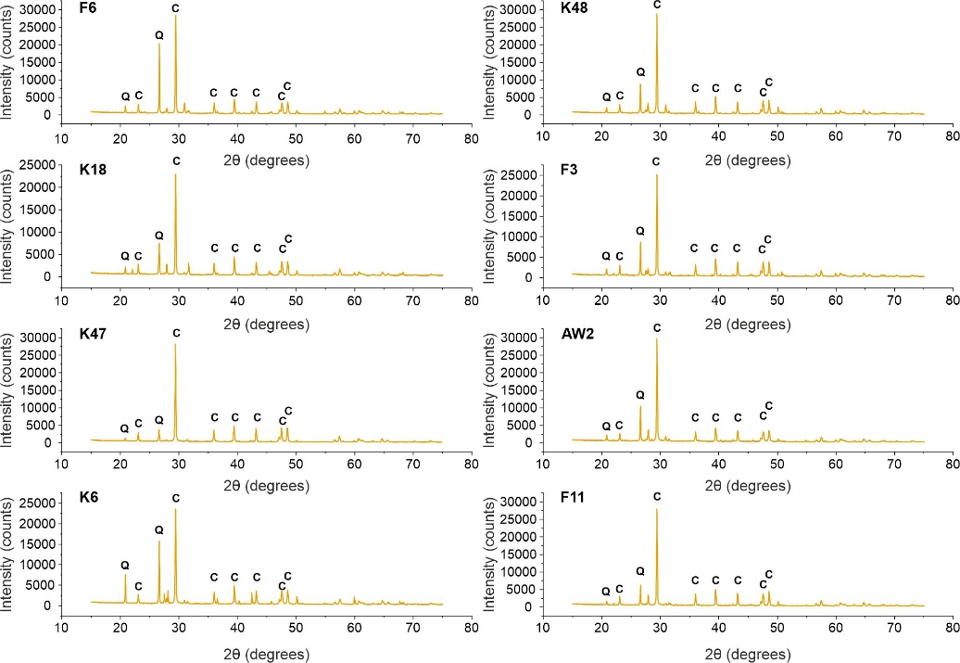
Supplementary Figure 2: The XRD patterns of the Ghayathi Formation samples. Note the predominance of calcite (C) and quartz (Q) and the absence of aragonite (A).

References
- Gonfiantini, R., Wassenaar, L.I., Araguas-Araguas, L. and Aggarwal, P.K., 2018. A unified Craig-Gordon isotope model of stable hydrogen and oxygen isotope fractionation during fresh or saltwater evaporation. Geochimica et Cosmochimica Acta, 235, pp.224-236.
- Lokier, S. and Steuber, T., 2009. Large‐scale intertidal polygonal features of the Abu Dhabi coastline. Sedimentology, 56(3), pp.609-621.
- Majoube, M., 1971. Oxygen‐18 and deuterium fractionation between water and steam. J. Clim. Phys., 68(10), p.1423.
- Merlivat, L., 1978. Molecular diffusivities of H₂¹⁶O, HD¹⁶O, and H₂¹⁸O in gases. The Journal of Chemical Physics, 69(6), pp.2864-2871.
- Patlakas, P., Stathopoulos, C., Flocas, H., Kalogeri, C. and Kallos, G., 2019. Regional climatic features of the Arabian Peninsula. Atmosphere, 10(4), p.220.
- Wood, W.W., Sanford, W.E. and Habshi, A.R.S.A., 2002. Source of solutes to the coastal sabkha of Abu Dhabi. Geological Society of America Bulletin, 114(3), pp.259-268.

