**Supplementary Materials for:**

**A geometric morphometric approach to identifying recent and fossil woodratmolars with remarks on late Pleistocene *Neotoma* *macrotis* from Rancho La Brea**

Nathaniel S. Foxa, b, *, Jessica L. Bloisa,c

aEnvironmental Systems Graduate Group, 5200 North Lake Road, University of California, Merced, CA, USA 95343

bCurrent Address: Museum of Geology, 501 East St. Joseph Street, South Dakota School of Mines and Technology, Rapid City, SD, USA 57701

Email: [n.s.fox01@gmail.com](mailto:n.s.fox01@gmail.com)

cDepartment of Life and Environmental Sciences, 5200 North Lake Road, University of California, Merced, CA, USA 95343

Email: [jblois@ucmerced.edu](mailto:jblois@ucmerced.edu)

\**Corresponding author*

**Supplementary Table 1.** List of all extant and fossil *Neotoma* species examined. The University of California Museum of Vertebrate Zoology (MVZ) and South Dakota School of Mines and Technology Museum of Geology (SDSM) catalog number, latitudinal coordinate, longitudinal coordinate, year of capture (Year), county, and state of each specimen is included. Asterisks indicate specimens that were removed for wear sensitivity analysis either for having nearly unworn or very worn dentition. For each fossil specimen, the Natural History Museum of Los Angeles County Project 23 number (LACMP23 #), anatomical element, and associated Rancho La Brea Project 23 deposit is listed as well.

|  |  |  |  |  |  |  |
| --- | --- | --- | --- | --- | --- | --- |
| Catalog number | Species | Latitude | Longitude | Year | County | State |
| MVZ 1160 | *N. albigula* | 33.57277 | -116.067 | 1908 | Riverside | CA |
| MVZ 1161 | *N. albigula*\* | 33.57277 | -116.067 | 1908 | Riverside | CA |
| MVZ 7174 | *N. albigula*\* | 33.1426 | -115.865 | 1909 | Imperial | CA |
| MVZ 7189 | *N. albigula* | 32.7352 | -115.967 | 1909 | Imperial | CA |
| MVZ 7321 | *N. albigula* | 33.333 | -115.833 | 1909 | Imperial | CA |
| MVZ 7323 | *N. albigula* | 33.333 | -115.833 | 1909 | Imperial | CA |
| MVZ 7325 | *N. albigula* | 33.333 | -115.833 | 1909 | Imperial | CA |
| MVZ 7326 | *N. albigula* | 33.333 | -115.833 | 1909 | Imperial | CA |
| MVZ 7479 | *N. albigula* | 32.7923 | -115.606 | 1909 | Imperial | CA |
| MVZ 7558 | *N. albigula* | 32.87883 | -116.044 | 1909 | San Diego | CA |
| MVZ 10463 | *N. albigula* | 34.023 | -114.541 | 1910 | Riverside | CA |
| MVZ 10464 | *N. albigula* | 34.023 | -114.541 | 1910 | Riverside | CA |
| MVZ 10465 | *N. albigula* | 33.4167 | -114.685 | 1910 | Imperial | CA |
| MVZ 10466 | *N. albigula* | 33.4167 | -114.685 | 1910 | Imperial | CA |
| MVZ 10467 | *N. albigula* | 33.18 | -114.7 | 1910 | Imperial | CA |
| MVZ 10471 | *N. albigula* | 33.18 | -114.7 | 1910 | Imperial | CA |
| MVZ 10477 | *N. albigula* | 32.7654 | -114.529 | 1910 | Imperial | CA |
| MVZ 10479 | *N. albigula* | 32.7654 | -114.529 | 1910 | Imperial | CA |
| MVZ 10481 | *N. albigula* | 32.7654 | -114.529 | 1910 | Imperial | CA |
| MVZ 10482 | *N. albigula* | 32.7654 | -114.529 | 1910 | Imperial | CA |
| MVZ 10483 | *N. albigula* | 32.7654 | -114.529 | 1910 | Imperial | CA |
| MVZ 10486 | *N. albigula* | 32.7314 | -114.749 | 1910 | Imperial | CA |
| MVZ 10487 | *N. albigula* | 32.7314 | -114.749 | 1910 | Imperial | CA |
| MVZ 161983 | *N. albigula* | 33.0994 | -115.923 | 1980 | Imperial | CA |
| MVZ 234515 | *N. albigula* | 33.64 | -116.139 | 2014 | Riverside | CA |
| MVZ 234517 | *N. albigula* | 33.64 | -116.139 | 2015 | Riverside | CA |
| MVZ 234520 | *N. albigula* | 33.53999 | -116.079 | 2015 | Riverside | CA |
| MVZ 234521 | *N. albigula* | 33.53999 | -116.079 | 2015 | Riverside | CA |
| MVZ 27864 | *N. albigula* | 32.87883 | -116.044 | 1918 | San Diego | CA |
| MVZ 39621 | *N. albigula* | 32.60139 | -115.00 | 1928 | Baja California | CA |
| MVZ 62601 | *N. albigula* | 33.60856 | -114.593 | 1934 | Riverside | CA |
| MVZ 7559 | *N. albigula* | 32.87883 | -116.044 | 1909 | San Diego | CA |
| MVZ 7577 | *N. albigula* | 32.87883 | -116.044 | 1909 | San Diego | CA |
| MVZ 7578 | *N. albigula* | 32.87883 | -116.044 | 1909 | San Diego | CA |
| MVZ 7579 | *N. albigula* | 32.87883 | -116.044 | 1909 | San Diego | CA |
| MVZ 84637 | *N. albigula* | 32.6827 | -115.251 | 1938 | Imperial | CA |
| MVZ 84638 | *N. albigula* | 32.6827 | -115.251 | 1938 | Imperial | CA |
| MVZ 84639 | *N. albigula* | 32.6827 | -115.251 | 1938 | Imperial | CA |
| MVZ 84803 | *N. albigula* | 32.6827 | -115.251 | 1938 | Imperial | CA |
| MVZ 95009 | *N. albigula* | 33.22694 | -116.33 | 1941 | San Diego | CA |
| MVZ 13370 | *N. cinerea* | 41.16756 | -122.861 | 1911 | Trinity | CA |
| MVZ 13381 | *N. cinerea* | 41.34264 | -122.692 | 1911 | Siskiyou | CA |
| MVZ 15539 | *N. cinerea* | 36.09286 | -118.226 | 1911 | Tulare | CA |
| MVZ 15546 | *N. cinerea* | 36.48861 | -118.208 | 1911 | Inyo | CA |
| MVZ 15551 | *N. cinerea* | 36.48861 | -118.208 | 1911 | Inyo | CA |
| MVZ 22330 | *N. cinerea* | 37.77411 | -119.26 | 1915 | Tuolumne | CA |
| MVZ 22332 | *N. cinerea* | 37.8785 | -119.367 | 1915 | Tuolumne | CA |
| MVZ 23103 | *N. cinerea*\* | 37.78762 | -119.341 | 1915 | Mariposa | CA |
| MVZ 23109 | *N. cinerea* | 37.78762 | -119.341 | 1915 | Mariposa | CA |
| MVZ 23111 | *N. cinerea* | 37.87338 | -119.171 | 1915 | Mono | CA |
| MVZ 121991 | *N. cinerea* | 41.58702 | -123.692 | 1957 | Del Norte | CA |
| MVZ 121993 | *N. cinerea*\* | 41.93184 | -123.543 | 1957 | Siskiyou | CA |
| MVZ 128770 | *N. cinerea* | 39.43165 | -120.248 | 1955 | Nevada | CA |
| MVZ 132508 | *N. cinerea* | 41.84132 | -120.904 | 1963 | Modoc | CA |
| MVZ 132509 | *N. cinerea*\* | 41.84132 | -120.904 | 1963 | Modoc | CA |
| MVZ 132714 | *N. cinerea* | 39.72751 | -122.844 | 1949 | Glenn | CA |
| MVZ 132715 | *N. cinerea* | 39.72751 | -122.844 | 1952 | Glenn | CA |
| MVZ 218378 | *N. cinerea*\* | 40.88837 | -120.181 | 2006 | Lassen | CA |
| MVZ 220747 | *N. cinerea* | 40.40637 | -121.361 | 2007 | Plumas | CA |
| MVZ 220748 | *N. cinerea* | 40.40637 | -121.361 | 2007 | Plumas | CA |
| MVZ 222826 | *N. cinerea*\* | 39.46031 | -120.285 | 2008 | Sierra | CA |
| MVZ 224334 | *N. cinerea* | 36.43453 | -118.283 | 2009 | Tulare | CA |
| MVZ 224650 | *N. cinerea* | 39.3057 | -120.517 | 2009 | Placer | CA |
| MVZ 23112 | *N. cinerea* | 37.87338 | -119.171 | 1915 | Mono | CA |
| MVZ 232199 | *N. cinerea*\* | 38.66816 | -119.91 | 2009 | Alpine | CA |
| MVZ 24997 | *N. cinerea* | 36.7938 | -118.581 | 1916 | Fresno | CA |
| MVZ 33719 | *N. cinerea*\* | 40.45969 | -121.442 | 1923 | Shasta | CA |
| MVZ 34865 | *N. cinerea* | 40.4147 | -121.532 | 1924 | Tehama | CA |
| MVZ 35207 | *N. cinerea* | 40.801 | -120.612 | 1924 | Lassen | CA |
| MVZ 57071 | *N. cinerea* | 40.49 | -123.523 | 1932 | Trinity | CA |
| MVZ 57072 | *N. cinerea* | 40.48086 | -123.481 | 1932 | Trinity | CA |
| MVZ 59068 | *N. cinerea* | 40.87485 | -123.732 | 1933 | Humboldt | CA |
| MVZ 59072 | *N. cinerea*\* | 40.87485 | -123.732 | 1933 | Humboldt | CA |
| MVZ 59073 | *N. cinerea* | 40.87485 | -123.732 | 1933 | Humboldt | CA |
| MVZ 64967 | *N. cinerea* | 40.18778 | -123.045 | 1932 | Trinity | CA |
| MVZ 65425 | *N. cinerea* | 41.39539 | -122.378 | 1935 | Siskiyou | CA |
| MVZ 65495 | *N. cinerea* | 41.40182 | -122.454 | 1934 | Siskiyou | CA |
| MVZ 69443 | *N. cinerea* | 41.91065 | -122.926 | 1935 | Siskiyou | CA |
| MVZ 69446 | *N. cinerea* | 41.91065 | -122.926 | 1935 | Siskiyou | CA |
| MVZ 51944 | *N. cinerea* | 42.7805 | -112.3628 | 1932 | Bannock | ID |
| SDSM 117647 | *N. cinerea* | 44.048 | -103.330 | 1969 | Pennington | SD |
| SDSM 117648 | *N. cinerea* | 44.048 | -103.330 | 1969 | Pennington | SD |
| SDSM 171654 | *N. cinerea* | 44.048 | -103.330 | 1970 | Pennington | SD |
| SDSM 171655 | *N. cinerea* | 44.048 | -103.330 | 1970 | Pennington | SD |
| SDSM 171656 | *N. cinerea* | 44.048 | -103.330 | 1970 | Pennington | SD |
| SDSM 171657 | *N. cinerea* | 44.048 | -103.330 | 1970 | Pennington | SD |
| SDSM 171658 | *N. cinerea* | 44.048 | -103.330 | 1970 | Pennington | SD |
| SDSM 171659 | *N. cinerea* | 44.048 | -103.330 | 1970 | Pennington | SD |
| SDSM 171660 | *N. cinerea* | 44.048 | -103.330 | 1970 | Pennington | SD |
| SDSM 171661 | *N. cinerea* | 44.048 | -103.330 | 1969 | Pennington | SD |
| SDSM 171662 | *N. cinerea* | 44.057 | -103.311 | 1971 | Pennington | SD |
| SDSM 171663 | *N. cinerea* | 44.057 | -103.311 | 1971 | Pennington | SD |
| MVZ 195212 | *N. fuscipes*\* | 36.27004 | -121.064 | 2000 | Monterey | CA |
| MVZ 195213 | *N. fuscipes*\* | 36.27004 | -121.064 | 2000 | Monterey | CA |
| MVZ 195986 | *N. fuscipes* | 37.11999 | -121.1 | 1999 | Merced | CA |
| MVZ 196356 | *N. fuscipes* | 37.86557 | -122.152 | 1999 | Contra Costa | CA |
| MVZ 196360 | *N. fuscipes* | 35.7504 | -120.773 | 2000 | San Luis Obispo | CA |
| MVZ 196363 | *N. fuscipes* | 35.7504 | -120.773 | 2000 | San Luis Obispo | CA |
| MVZ 196371 | *N. fuscipes* | 35.72531 | -120.654 | 2000 | San Luis Obispo | CA |
| MVZ 196382 | *N. fuscipes*\* | 35.61446 | -120.688 | 2000 | San Luis Obispo | CA |
| MVZ 196388 | *N. fuscipes* | 41.70796 | -121.981 | 1998 | Siskiyou | CA |
| MVZ 196391 | *N. fuscipes* | 41.70796 | -121.981 | 1998 | Siskiyou | CA |
| MVZ 196392 | *N. fuscipes* | 41.66421 | -121.94 | 1998 | Siskiyou | CA |
| MVZ 196400 | *N. fuscipes*\* | 40.36344 | -122.958 | 1998 | Shasta | CA |
| MVZ 196404 | *N. fuscipes* | 39.34502 | -122.665 | 1998 | Colusa | CA |
| MVZ 196415 | *N. fuscipes*\* | 40.26732 | -121.773 | 1998 | Tehama | CA |
| MVZ 196416 | *N. fuscipes* | 38.57045 | -122.716 | 1998 | Sonoma | CA |
| MVZ 196417 | *N. fuscipes* | 38.57045 | -122.716 | 1998 | Sonoma | CA |
| MVZ 196564 | *N. fuscipes* | 36.84171 | -121.476 | 1999 | San Benito | CA |
| MVZ 196565 | *N. fuscipes* | 36.84171 | -121.476 | 1999 | San Benito | CA |
| MVZ 196566 | *N. fuscipes* | 36.84171 | -121.476 | 1999 | San Benito | CA |
| MVZ 197373 | *N. fuscipes* | 35.08698 | -119.776 | 2000 | San Luis Obispo | CA |
| MVZ 206894 | *N. fuscipes* | 37.78888 | -122.146 | 2003 | Alameda | CA |
| MVZ 216804 | *N. fuscipes* | 37.9043 | -122.175 | 2004 | Contra Costa | CA |
| MVZ 217863 | *N. fuscipes* | 40.66361 | -120.793 | 2006 | Lassen | CA |
| MVZ 218015 | *N. fuscipes* | 37.88603 | -122.125 | 2004 | Contra Costa | CA |
| MVZ 218708 | *N. fuscipes* | 37.38171 | -121.737 | 2004 | Santa Clara | CA |
| MVZ 219021 | *N. fuscipes* | 38.0054 | -122.475 | 2006 | Marin | CA |
| MVZ 219027 | *N. fuscipes* | 38.00053 | -122.491 | 2006 | Marin | CA |
| MVZ 219537 | *N. fuscipes* | 41.2311 | -120.398 | 2006 | Modoc | CA |
| MVZ 219572 | *N. fuscipes* | 41.2311 | -120.398 | 2006 | Modoc | CA |
| MVZ 219598 | *N. fuscipes* | 40.38944 | -122.183 | 2007 | Tehama | CA |
| MVZ 220636 | *N. fuscipes* | 40.84853 | -120.768 | 2007 | Lassen | CA |
| MVZ 221488 | *N. fuscipes*\* | 38.90445 | -121.015 | 2008 | El Dorado | CA |
| MVZ 221493 | *N. fuscipes* | 38.91554 | -121.011 | 2008 | El Dorado | CA |
| MVZ 221496 | *N. fuscipes*\* | 38.89364 | -121.023 | 2008 | El Dorado | CA |
| MVZ 221614 | *N. fuscipes* | 39.23901 | -120.754 | 2008 | Placer | CA |
| MVZ 221625 | *N. fuscipes* | 39.19489 | -120.832 | 2008 | Placer | CA |
| MVZ 223078 | *N. fuscipes* | 41.34133 | -120.605 | 2008 | Modoc | CA |
| MVZ 225109 | *N. fuscipes*\* | 40.9176 | -122.24 | 2008 | Shasta | CA |
| MVZ 225235 | *N. fuscipes* | 38.31666 | -122.339 | 2006 | Napa | CA |
| MVZ 230700 | *N. fuscipes* | 35.32762 | -120.864 | 2007 | San Luis Obispo | CA |
| MVZ 15510 | *N. lepida* | 36.5051 | -118.102 | 1911 | Inyo | CA |
| MVZ 16789 | *N. lepida* | 37.80021 | -118.529 | 1912 | Mono | CA |
| MVZ 26336 | *N. lepida* | 37.79747 | -118.568 | 1917 | Mono | CA |
| MVZ 26337 | *N. lepida* | 36.43934 | -117.611 | 1917 | Inyo | CA |
| MVZ 5370 | *N. lepida* | 34.7347 | -118.424 | 1904 | Los Angeles | CA |
| MVZ 5371 | *N. lepida* | 34.7347 | -118.424 | 1904 | Los Angeles | CA |
| MVZ 5383 | *N. lepida* | 34.7347 | -118.424 | 1904 | Los Angeles | CA |
| MVZ 5384 | *N. lepida* | 34.7347 | -118.424 | 1904 | Los Angeles | CA |
| MVZ 6182 | *N. lepida*\* | 34.3628 | -116.858 | 1905 | San Bernardino | CA |
| MVZ 6968 | *N. lepida* | 34.7347 | -118.424 | 1904 | Los Angeles | CA |
| MVZ 114334 | *N. lepida* | 40.3619 | -120.232 | 1950 | Lassen | CA |
| MVZ 149261 | *N. lepida* | 33.7457 | -114.504 | 1974 | Riverside | CA |
| MVZ 149264 | *N. lepida* | 33.7457 | -114.504 | 1974 | Riverside | CA |
| MVZ 195260 | *N. lepida* | 32.88713 | -114.828 | 2000 | Imperial | CA |
| MVZ 195262 | *N. lepida* | 32.88713 | -114.828 | 2000 | Imperial | CA |
| MVZ 195320 | *N. lepida* | 34.574 | -115.796 | 2000 | San Bernardino | CA |
| MVZ 195928 | *N. lepida* | 35.61617 | -118.253 | 2000 | Kern | CA |
| MVZ 196355 | *N. lepida* | 34.81681 | -115.662 | 1998 | San Bernardino | CA |
| MVZ 197160 | *N. lepida* | 41.58266 | -120.033 | 2001 | Modoc | CA |
| MVZ 197164 | *N. lepida* | 41.58266 | -120.033 | 2001 | Modoc | CA |
| MVZ 198672 | *N. lepida*\* | 34.36273 | -116.856 | 2002 | San Bernardino | CA |
| MVZ 199789 | *N. lepida* | 35.37369 | -118.163 | 2002 | Kern | CA |
| MVZ 199799 | *N. lepida* | 35.46656 | -118.235 | 2002 | Kern | CA |
| MVZ 202450 | *N. lepida* | 37.0694 | -118.293 | 2003 | Inyo | CA |
| MVZ 215634 | *N. lepida* | 32.88713 | -114.828 | 2005 | Imperial | CA |
| MVZ 215704 | *N. lepida*\* | 33.79832 | -114.561 | 2005 | Riverside | CA |
| MVZ 215714 | *N. lepida* | 33.80568 | -116.18 | 2005 | Riverside | CA |
| MVZ 219371 | *N. lepida* | 37.33035 | -118.089 | 2007 | Inyo | CA |
| MVZ 220815 | *N. lepida* | 40.52303 | -120.473 | 2007 | Lassen | CA |
| MVZ 220820 | *N. lepida* | 40.52438 | -120.467 | 2007 | Lassen | CA |
| MVZ 223713 | *N. lepida* | 37.91354 | -118.459 | 2009 | Mono | CA |
| MVZ 223717 | *N. lepida* | 37.80368 | -118.456 | 2009 | Mono | CA |
| MVZ 42463 | *N. lepida*\* | 34.4737 | -117.785 | 1929 | Los Angeles | CA |
| MVZ 60231 | *N. lepida* | 35.4609 | -118.22 | 1933 | Kern | CA |
| MVZ 77609 | *N. lepida* | 40.3619 | -120.232 | 1936 | Lassen | CA |
| MVZ 79371 | *N. lepida* | 41.5816 | -120.072 | 1937 | Modoc | CA |
| MVZ 79372 | *N. lepida*\* | 41.5816 | -120.072 | 1937 | Modoc | CA |
| MVZ 80245 | *N. lepida* | 35.1303 | -115.386 | 1938 | San Bernardino | CA |
| MVZ 86546 | *N. lepida* | 35.784 | -115.931 | 1939 | San Bernardino | CA |
| MVZ 95024 | *N. lepida* | 33.37102 | -114.731 | 1940 | Imperial | CA |
| MVZ 17971 | *N. macrotis* | 39.57029 | -121.555 | 1912 | Butte | CA |
| MVZ 196593 | *N. macrotis* | 39.04221 | -120.71 | 1998 | Placer | CA |
| MVZ 196594 | *N. macrotis* | 39.04221 | -120.71 | 1998 | Placer | CA |
| MVZ 24678 | *N. macrotis* | 38.75449 | -120.635 | 1916 | El Dorado | CA |
| MVZ 17966 | *N. macrotis* | 38.40863 | -120.919 | 1912 | Amador | CA |
| MVZ 207663 | *N. macrotis* | 37.66281 | -120.48 | 2004 | Stanislaus | CA |
| MVZ 207681 | *N. macrotis* | 37.51207 | -120.398 | 2004 | Merced | CA |
| MVZ 116723 | *N. macrotis* | 37.09064 | -119.721 | 1952 | Madera | CA |
| MVZ 24990 | *N. macrotis* | 36.7938 | -118.581 | 1916 | Fresno | CA |
| MVZ 108716 | *N. macrotis* | 36.66462 | -121.741 | 1937 | Monterey | CA |
| MVZ 16760 | *N. macrotis* | 36.58926 | -118.11 | 1912 | Inyo | CA |
| MVZ 196422 | *N. macrotis* | 36.37851 | -121.557 | 1999 | Monterey | CA |
| MVZ 108722 | *N. macrotis*\* | 36.31007 | -121.568 | 1936 | Monterey | CA |
| MVZ 231876 | *N. macrotis* | 36.11381 | -117.757 | 2015 | Inyo | CA |
| MVZ 108748 | *N. macrotis* | 36.01413 | -121.515 | 1937 | Monterey | CA |
| MVZ 222721 | *N. macrotis* | 35.96326 | -118.231 | 2008 | Tulare | CA |
| MVZ 196504 | *N. macrotis*\* | 35.89846 | -121.259 | 2001 | Monterey | CA |
| MVZ 196533 | *N. macrotis* | 35.7504 | -120.773 | 2000 | San Luis Obispo | CA |
| MVZ 196538 | *N. macrotis* | 35.7504 | -120.773 | 2000 | San Luis Obispo | CA |
| MVZ 196540 | *N. macrotis* | 35.7504 | -120.773 | 2000 | San Luis Obispo | CA |
| MVZ 196542 | *N. macrotis* | 35.7504 | -120.773 | 2000 | San Luis Obispo | CA |
| MVZ 14052 | *N. macrotis* | 35.38948 | -120.607 | 1911 | San Luis Obispo | CA |
| MVZ 107648 | *N. macrotis* | 35.34967 | -119.765 | 1947 | Kern | CA |
| MVZ 196780 | *N. macrotis* | 34.88378 | -118.658 | 2001 | Kern | CA |
| MVZ 5548 | *N. macrotis* | 34.818 | -118.884 | 1904 | Ventura | CA |
| MVZ 5340 | *N. macrotis*\* | 34.812 | -119.146 | 1904 | Ventura | CA |
| MVZ 198325 | *N. macrotis* | 34.79703 | -118.861 | 2001 | Los Angeles | CA |
| MVZ 196556 | *N. macrotis*\* | 34.61285 | -119.927 | 1998 | Santa Barbara | CA |
| MVZ 3925 | *N. macrotis* | 34.441 | -119.26 | 1906 | Ventura | CA |
| MVZ 125883 | *N. macrotis* | 34.41816 | -117.789 | 1955 | Los Angeles | CA |
| MVZ 125890 | *N. macrotis* | 34.28244 | -117.166 | 1953 | San Bernardino | CA |
| MVZ 3926 | *N. macrotis*\* | 34.27364 | -119.266 | 1906 | Ventura | CA |
| MVZ 5544 | *N. macrotis* | 34.26928 | -118.336 | 1904 | Los Angeles | CA |
| MVZ 176217 | *N. macrotis* | 34.13631 | -116.768 | 1974 | San Bernardino | CA |
| MVZ 114487 | *N. macrotis* | 34.10341 | -118.444 | 1951 | Los Angeles | CA |
| MVZ 84558 | *N. macrotis* | 33.88442 | -116.994 | 1938 | Riverside | CA |
| MVZ 2352 | *N. macrotis* | 33.67608 | -117.517 | 1908 | Orange | CA |
| MVZ 7573 | *N. macrotis* | 33.21 | -116.6 | 1909 | San Diego | CA |
| MVZ 196535 | *N. macrotis* | 35.7503974 | -120.773 | 2000 | San Luis Obispo | CA |
| MVZ 201919 | *N. macrotis* | 37.71515 | -119.665 | 2003 | Mariposa | CA |
| LACMP23 number | **Element** | **Lat.** | **Long.** | **Deposit** | **County** | **State** |
| 28509 | left m1 | 34.0638 | -118.355 | 1 | Los Angeles | CA |
| 31175 | left m1 | 34.0638 | -118.355 | 14 | Los Angeles | CA |
| 31976 | left m1 | 34.0638 | -118.355 | 14 | Los Angeles | CA |
| 33922 | right m1 | 34.0638 | -118.355 | 14 | Los Angeles | CA |
| 34168 | left m1 | 34.0638 | -118.355 | 14 | Los Angeles | CA |
| 35665 | right m1 | 34.0638 | -118.355 | 7B | Los Angeles | CA |
| 35668 | right m1 | 34.0638 | -118.355 | 7B | Los Angeles | CA |
| 35780 | right m1 | 34.0638 | -118.355 | 7B | Los Angeles | CA |
| 35782 | left m1 | 34.0638 | -118.355 | 7B | Los Angeles | CA |
| 35806 | right m1 | 34.0638 | -118.355 | 7B | Los Angeles | CA |
| 35934 | left m1 | 34.0638 | -118.355 | 7B | Los Angeles | CA |
| 36312 | right m1 | 34.0638 | -118.355 | 7B | Los Angeles | CA |
| 40158 | right m1 | 34.0638 | -118.355 | 13 | Los Angeles | CA |
| 40402 | left m1 | 34.0638 | -118.355 | 13 | Los Angeles | CA |
| 40662 | right m1 | 34.0638 | -118.355 | 14 | Los Angeles | CA |
| 40663 | left dentary with m1-m2 | 34.0638 | -118.355 | 14 | Los Angeles | CA |

**Supplementary Table 2.** Discriminant analysis of principle components classification statistics of models built with wear-vetted extant *Neotoma* species data from the first (top) and second (bottom) landmarking repetition. These datasets contain the same landmark data as their respective repetitions in Table 3 but exclude the 28 specimens marked in Supplementary Table 1 as having either nearly unworn or very worn molars. All 28 landmark variables are included in the analysis. The first 16 of 24 principal components were retained for each repetition as suggested via the ‘xvalDapc’ cross-validation function in the R package ‘adegent’ (Jombart et al., 2023). Columns indicate predicted species affinities; rows indicate actual species affinities. % Correct = the percentage of specimens correctly assigned to their species group.

|  |  |  |  |  |  |  |
| --- | --- | --- | --- | --- | --- | --- |
| Replicate 1 Model | Na | Nc | Nf | Nl | Nm | % Correct |
| Na | 36 | 1 | 0 | 1 | 0 | 94.7 |
| Nc | 0 | 31 | 0 | 0 | 0 | 100 |
| Nf | 1 | 0 | 28 | 0 | 3 | 87.5 |
| Nl | 3 | 0 | 0 | 32 | 0 | 88.6 |
| Nm | 2 | 0 | 4 | 0 | 29 | 82.9 |
| Total predicted group membership accuracy = 91.2% | | | | | | |
| Replicate 2 Model | **Na** | **Nc** | **Nf** | **Nl** | **Nm** | **% Correct** |
| Na | 31 | 2 | 0 | 3 | 2 | 81.6 |
| Nc | 0 | 31 | 0 | 0 | 0 | 100 |
| Nf | 1 | 0 | 27 | 0 | 4 | 84.4 |
| Nl | 4 | 0 | 0 | 31 | 0 | 88.6 |
| Nm | 1 | 0 | 4 | 1 | 29 | 82.9 |
| Total predicted group membership accuracy = 87.1% | | | | | | |

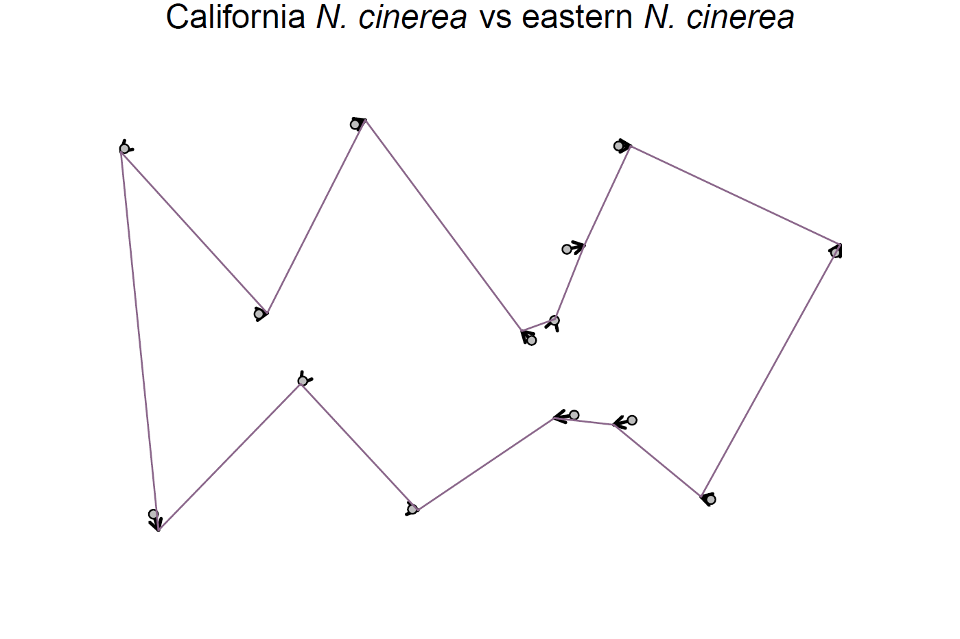

**Supplementary Figure 1.** Vector displacement plot comparing the mean m1 landmark shape configuration of extant California *N*. *cinerea* (n = 39) with eastern specimens sampled from Idaho and South Dakota (n = 13) using the first landmarking repetition. Sampled specimens are shown in Supplementary Table 1. Arrows indicate the magnitude and direction of vector displacement between the reference and target groups. Plots were created using the ‘define.links’ and ‘plotRefToTarget’ functions in the R package geomorph (Adams et al., 2024).

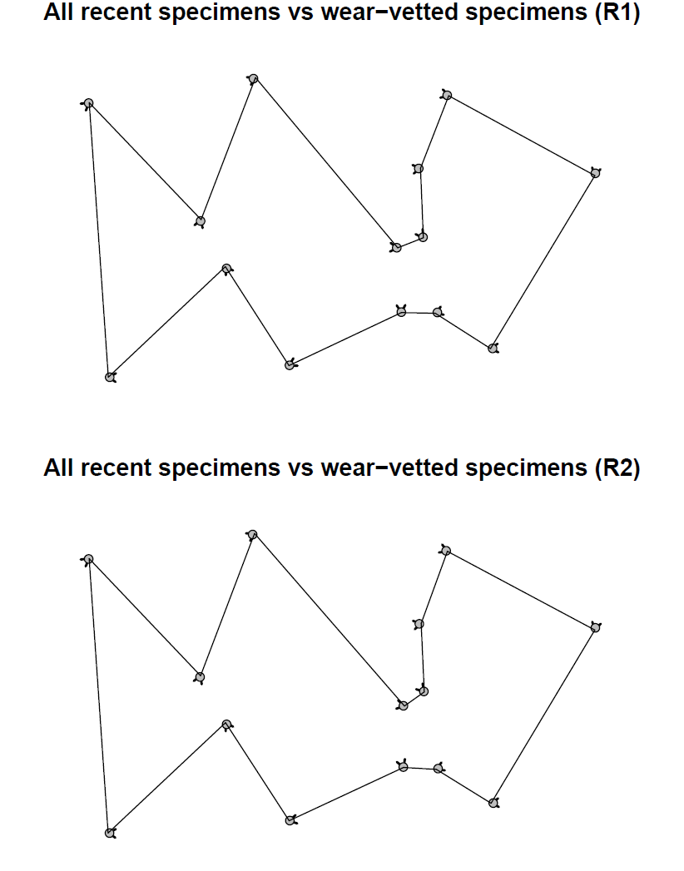

**Supplementary Figure 2.** Vector displacement plots of mean m1 landmark shape configurations across all five extant *Neotoma* species examined between datasets unvetted (n = 199) and vetted (n = 171) for specimens with nearly unworn and very worn molars. Comparisons of the first landmarking repetition (R1) are shown on top and comparisons of the second repetition (R2) are shown below. Arrows indicate the magnitude and direction of vector displacement between the reference and target groups. Plots were created using the ‘define.links’ and ‘plotRefToTarget’ functions in the R package geomorph (Adams et al., 2024).

**References**

Adams, D., Collyer, M., Kaliontzopoulou, A., Baken, E., 2024. *geomorph: Geometric Morphometric Analyses of 2D and 3D Landmark Data*. https://CRAN.R-project.org/package=geomorph.

Jombart, T., Kamvar, Z.N., Collins, C., Lustrik, R., Beugin, M.-P., Knaus, B.J., Solymos, P., *et al*., 2023. *Adegenet: Exploratory Analysis of Genetic and Genomic Data*. https://cran.r-project.org/web/packages/adegenet.