**SUPPLEMENTARY INFORMATION**

**Pleistocene aardvark (*Orycteropus afer*) burrow traces on South Africa’s Cape coast**

LINKS TO DRONE VIDEOS

Site 1: <https://youtu.be/6FMiSWuFRWw?si=Bf3oaUIdO19NV3D6>  
  
Site 2: <https://youtu.be/Uy2Q8O7SpH4?si=rT3bd70YjgVdwGtK>  
  
Site 3: <https://youtu.be/Ym1-l7pfrDs?si=7pbZaueLMcxxt7wW>

Site 4: <https://youtu.be/DTRDPZplOfI?si=6JJ3THVmxlumy1J5>  
  
Site 5: <https://youtu.be/w4V5313t_T4?si=d6_7RR6hssH9IbbQ>

PHOTOGRAMMETRY DETAILS

 

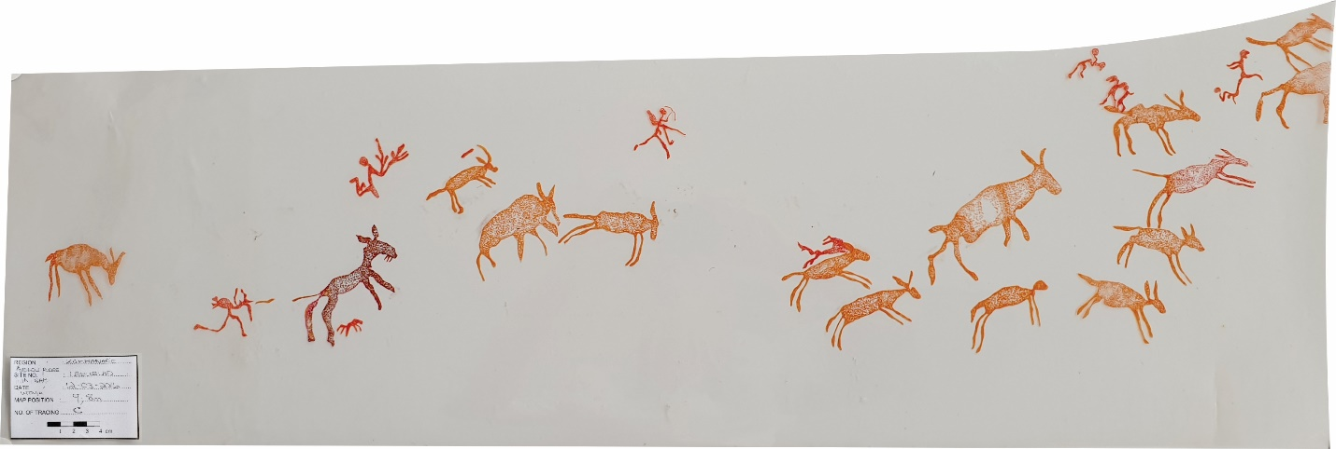

**Figure S1.** Probable aardvark images from Leeublad in the Kammanassie Mountains in the Little Karoo; the scale at bottom left is in cm.