Supplementary material to the manuscript Late Glacial to Holocene fluvial dynamics in the Upper Rhine alluvial plain, France

Mubarak Abdulkarim¹, Laurent Schmitt², Alexander Fülling¹, Claire Rambeau², Damien Ertlen², Daniela Mueller¹, Stoil Chapkanski^{3,4}, Frank Preusser¹

¹Institute of Earth and Environmental Science, University of Freiburg, Freiburg, Germany
²Laboratoire Image, Ville, Environnement (LIVE UMR 7362), CNRS/Université de Strasbourg/ENGEES, Strasbourg, France
³University of Rouen Normandy, IDEES Laboratory, UMR 6266, CNRS, 17 Rue Lavoisier, 76821, Mont Saint-Aignan, France.
⁴Laboratoire de Géographie Physique (UMR-8591), CNRS/Université Paris 1, Thiais, France

Correspondance : Mubarak Abdulkarim (maabdul21@gmail.com)

Table S1. Sediment samples used for SMIR Analysis and their corresponding provenance.
Sample | Depth (cm) | Paleochannel | F1 score | F2 score | Provenance
Bz-80 | 80 | Baltzenheim | 3.13497 | -0.63227 | Rhine
Bz-170 | 170 | Baltzenheim | 5.66522 | -1.64574 | Rhine
Bz-205 | 205 | Baltzenheim | 4.86522 | 0.01314 | Rhine
Bz-240 | 240 | Baltzenheim | 5.47708 | -1.06857 | Rhine
Az1a-160 | 160 | Artzenheim 1a | 1.4217 | 3.48013 | Rhine
Az1a-190 | 190 | Artzenheim 1a | 1.80151 | 3.08989 | Rhine
Az1a-260 | 260 | Artzenheim 1a | 3.74843 | -0.80864 | Rhine
Az1a-330 | 330 | Artzenheim 1a | 3.59479 | -4.45291 | Rhine
Az1a-370 | 370 | Artzenheim 1a | 4.59596 | -1.84842 | Rhine
Az1a-495 | 495 | Artzenheim 1a | 3.50719 | 1.59602 | Rhine
Az1b-70 | 70 | Artzenheim 1b | 4.10557 | -3.95271 | Rhine
Az1b-95 | 95 | Artzenheim 1b | 2.94381 | -2.31035 | Rhine
Az1b-150 | 150 | Artzenheim 1b | 4.921 | -3.28696 | Rhine
Az1b-190 | 190 | Artzenheim 1b | 3.26126 | 2.90166 | Rhine
Az2-74 | 74 | Artzenheim 2 | 2.59293 | 4.61569 | Rhine
Az2-84 | 84 | Artzenheim 2 | 0.66688 | 3.16581 | Ill
Az2-145 | 145 | Artzenheim 2 | 3.42005 | 1.31356 | Rhine
Az2-195 | 195 | Artzenheim 2 | 5.2543 | -2.30054 | Rhine
Az2-240 | 240 | Artzenheim 2 | 2.66675 | 6.24061 | Rhine
Az2-260 | 260 | Artzenheim 2 | 2.36715 | 3.26387 | Rhine
Az2-289 | 289 | Artzenheim 2 | 4.74525 | 0.44537 | Rhine
Jebs-165 | 165 | Jebsheim | -1.82867 | 4.16674 | Ill
Jebs-258 | 258 | Jebsheim | -2.05677 | 1.19214 | Ill
Jebs-288 | 288 | Jebsheim | 0.13642 | 2.56785 | Ill
Jebs-322 | 322 | Jebsheim | 1.10817 | 2.39723 | Ill
Jebs-382 | 382 | Jebsheim | 6.90288 | -0.75091 | Rhine
Jebs-435 | 435 | Jebsheim | 2.35346 | 3.83044 | Rhine
Jebs-445 | 475 | Jebsheim | 6.20088 | -0.48439 | Rhine
NB-52 | 52 | Blind | 1.68284 | 1.3886 | Ill
NB-73 | 73 | Blind | 1.0057 | 2.05365 | Ill
NB-94 | 94 | Blind | 0.17053 | 3.81472 | Ill
NB-174 | 174 | Blind | 4.98935 | -0.37144 | Rhine
NB-184 | 284 | Blind | 6.77104 | -1.69699 | Rhine
Ried-49 | 49 | Riedbrunnen | 5.51655 | -5.11823 | Rhine
Ried-88 | 88 | Riedbrunnen | 1.7758 | -0.59528 | Rhine
Ried-143 | 143 | Riedbrunnen | 5.92328 | -0.69337 | Rhine
Ried-175 | 175 | Riedbrunnen | 2.53821 | 1.45605 | Rhine
Lv-14 | 14 | Ill levee | 0.2605 | 1.79203 | Ill
Lv-44 | 44 | Ill levee | -1.52902 | 3.85076 | Ill
Lv-64 | 64 | Ill levee | -0.2998 | 2.30749 | Ill
Lv-89 | 89 | Ill levee | -3.94927 | 3.64591 | Ill
Lv-139 | 139 | Ill levee | -1.43046 | 4.30416 | Ill
Lv-169 | 169 | Ill levee | -2.98162 | 4.31626 | Ill
Lv-179 | 179 | Ill levee | -2.93311 | 3.35819 | Ill
Lv-189 | 189 | Ill levee | -2.30462 | 3.13662 | Ill
Orch-60 | 60 | Orchbach | -1.17305 | 2.81876 | Ill
Orch-90 | 90 | Orchbach | -0.77475 | 3.48261 | Ill
Orch-140 | 140 | Orchbach | -0.86718 | 6.36807 | Ill
Orch-180 | 180 | Orchbach | 0.74631 | 5.1757 | Ill
Orch-240 | 240 | Orchbach | -0.62999 | 6.31018 | Ill
Orch-270 | 270 | Orchbach | 0.76073 | 3.52174 | Ill
Orch-290 | 290 | Orchbach | 5.91634 | -0.25067 | Rhine
Wz-35 | 35 | Wurzelbrunnen | -1.64698 | 2.36506 | Ill
Wz-95 | 95 | Wurzelbrunnen | -1.60005 | 3.6977 | Ill
Wz-105 | 105 | Wurzelbrunnen | 1.28418 | 1.87163 | Ill
Wz-135 | 135 | Wurzelbrunnen | 4.9094 | -3.09423 | Rhine
Wz-145 | 145 | Wurzelbrunnen | 3.48199 | 0.29019 | Rhine
Wz-165 | 165 | Wurzelbrunnen | 3.80239 | -0.69647 | Rhine
Wz-175 | 175 | Wurzelbrunnen | 2.49581 | 0.77396 | Rhine
Dach-50 | 50 | Daschsbrunnen | -2.44764 | -0.10171 | Ill
Dach-80 | 80 | Daschsbrunnen | -2.91498 | 3.59932 | Ill
Dach-95 | 95 | Daschsbrunnen | 0.46317 | -0.15684 | Ill
Dach-120 | 120 | Daschsbrunnen | 1.21363 | 1.42745 | Ill
Dach-150 | 150 | Daschsbrunnen | 4.04304 | -0.87393 | Rhine
Spt-50 | 50 | Spitzbrunnen | -2.80136 | 1.94714 | Ill
Spt-70 | 70 | Spitzbrunnen | -1.29549 | -0.47425 | Ill
Spt-94 | 94 | Spitzbrunnen | -1.76451 | -0.08511 | Ill
Spt-121 | 121 | Spitzbrunnen | -1.28101 | 1.72158 | Ill
Spt-140 | 140 | Spitzbrunnen | -2.22799 | -1.68873 | Vosges
Spt-160 | 160 | Spitzbrunnen | -3.20119 | -0.2915 | Vosges
Spt-180 | 180 | Spitzbrunnen | -3.36054 | -0.44793 | Vosges

Table S2. Measurement protocol for IRSL screening.
Step | Treatment | Observed
1 | Preheat (250°C, 60 s, 5°C/s)
2 | IRSL (IR LEDs, 850 nm, 90 s, 50°C) | L_{n} (natural signal)
3 | Test dose (22 Gy)
4 | Preheat (250°C, 60 s, 5°C/s)
5 | IRSL (IR LEDs, 850 nm, 90 s, 50°C) | T_{n} (test dose signal)

Table S3. Modified SAR measurement protocol used for D_{e} determination.
Step | Treatment | Observed
1 | Preheat (270°C, 60 s, 3°C/s)
2 | IRSL  (IR LEDs, 850 nm, 100 s, 50°C) | L_{x IR-50}  (natural or regenerated signal, IRSL)
3 | pIR  (IR LEDs, 850 nm, 100 s, 250°C) | L_{x pIR-50}  (natural or regenerated signal, pIR)
4 | Test dose
5 | Preheat (270°C, 0 s, 3°C/s)
6 | IRSL  (IR LEDs, 850 nm, 100 s, 50°C) | T_{x IR-50}  (test dose signal, IRSL)
7 | pIR  (IR LEDs, 850 nm, 100 s, 250°C) | T_{x pIR-50}  (test dose signal, pIR)
8 | Hot bleach  (IR LEDs, 850 nm, 40 s, 290°C)
9 | Dose (R1-R3, R0, RR)
10 | Return to step 1

Table S4. Summary data of dose rate relevant elements (K, Th, U), average water content (W_{a}) during burial, and dose rates.
Sample | Paleochannel | W_{a}  (%) | K  (%) | Th  (ppm) | U  (ppm) | Cosmic dose rate (Gy/ka) | Total dose rate (Gy/ka)
Bz-30 cm | Baltzenheim | 18 ± 5 | 1.2 ± 0.1 | 4.7 ± 0.2 | 1.4 ± 0.1 | 0.22 ± 0.02 | 2.38 ± 0.12
Bz-80 cm | Baltzenheim | 24 ± 3 | 1.2 ± 0.1 | 5.1 ± 0.3 | 1.3 ± 0.1 | 0.19 ± 0.02 | 2.27 ± 0.12
Bz-170 cm | Baltzenheim | 17 ± 5 | 1.2 ± 0.1 | 3.9 ± 0.2 | 0.9 ± 0.1 | 0.17 ± 0.02 | 2.19 ± 0.14
Bz-190 cm | Baltzenheim | 12 ± 2 | 1.2 ± 0.1 | 2.4 ± 0.1 | 0.8 ± 0.1 | 0.17 ± 0.02 | 2.13 ± 0.09
Bz-240 cm | Baltzenheim | 12 ± 3 | 1.1 ± 0.1 | 5.0 ± 0.3 | 1.8 ± 0.1 | 0.15 ± 0.02 | 2.44 ± 0.14
Az1a-65 cm | Artzenheim 1a | 22 ± 2 | 1.4 ± 0.1 | 7.5 ± 0.4 | 1.9 ± 0.2 | 0.20 ± 0.02 | 2.67 ± 0.24
Az1a-170 cm | Artzenheim 1a | 27 ± 1 | 1.6 ± 0.1 | 9.0 ± 0.5 | 2.0 ± 0.2 | 0.17 ± 0.02 | 2.84 ± 0.22
Az1a-360 cm | Artzenheim 1a | 27 ± 2 | 1.0 ± 0.1 | 6.2 ± 0.3 | 2.4 ± 0.2 | 0.13 ± 0.01 | 2.22 ± 0.16
Az1a-460 cm | Artzenheim 1a | 15 ± 3 | 1.2 ± 0.1 | 2.5 ± 0.1 | 0.7 ± 0.1 | 0.12 ± 0.02 | 2.03 ± 0.12
Az1b-40 cm | Artzenheim 1b | 22 ± 1 | 1.2 ± 0.1 | 6.1 ± 0.3 | 2.0 ± 0.2 | 0.21 ± 0.02 | 2.42 ± 0.15
Az1b-70 cm | Artzenheim 1b | 18 ± 2 | 0.8 ± 0.1 | 5.2 ± 0.3 | 1.7 ± 0.1 | 0.20 ± 0.02 | 1.97 ± 0.14
Az1b-175 cm | Artzenheim 1b | 18 ± 1 | 1.1 ± 0.1 | 5.6 ± 0.3 | 1.7 ± 0.1 | 0.17 ± 0.02 | 2.37 ± 0.12
Az2-35 cm | Artzenheim 2 | 26 ± 2 | 1.0 ± 0.1 | 9.1 ± 0.5 | 2.4 ± 0.2 | 0.21 ± 0.02 | 2.58 ± 0.20
Az2-60 cm | Artzenheim 2 | 29 ± 3 | 1.1 ± 0.1 | 11.8 ± 0.6 | 2.8 ± 0.2 | 0.20 ± 0.02 | 2.94 ± 0.29
Az2-85 cm | Artzenheim 2 | 22 ± 2 | 1.6 ± 0.1 | 9.3 ± 0.5 | 1.7 ± 0.6 | 0.19 ± 0.02 | 2.93 ± 0.29
Az2-260 cm | Artzenheim 2 | 13 ± 1 | 1.2 ± 0.1 | 2.7 ± 0.1 | 0.9 ± 0.1 | 0.15 ± 0.02 | 2.15 ± 0.12
Jebs-190 cm | Jebsheim | 15 ± 3 | 1.5 ± 0.1 | 4.5 ± 0.2 | 2.8 ± 0.2 | 0.17 ± 0.02 | 2.92 ± 0.14
Jebs-410 cm | Jebsheim | 14 ± 3 | 0.8 ± 0.1 | 3.8 ± 0.2 | 0.9 ± 0.1 | 0.14 ± 0.01 | 1.86 ± 0.11
NB-40 cm | Blind | 27 ± 1 | 1.2 ± 0.1 | 16.0 ± 0.8 | 5.5 ± 0.3 | 0.21 ± 0.02 | 4.29 ± 0.35
NB-90 cm | Blind | 28 ± 1 | 1.4 ± 0.1 | 11.3 ± 0.6 | 3.0 ± 0.2 | 0.19 ± 0.02 | 3.20 ± 0.23
NB-130 cm | Blind | 14 ± 3 | 0.7 ± 0.1 | 4.0 ± 0.2 | 1.7 ± 0.1 | 0.18 ± 0.02 | 2.01 ± 0.12
NB-190 cm | Blind | 13 ± 2 | 0.5 ± 0.0 | 2.7 ± 0.1 | 1.0 ± 0.1 | 0.17 ± 0.02 | 1.60 ± 0.20
Ried-55 cm | Riedbrunnen | 24 ± 2 | 0.5 ± 0.0 | 4.9 ± 0.3 | 1.6 ± 0.1 | 0.20 ± 0.02 | 1.58 ± 0.12
Ried-70 cm | Riedbrunnen | 19 ± 2 | 0.7 ± 0.0 | 4.9 ± 0.3 | 1.7 ± 0.1 | 0.20 ± 0.02 | 1.85 ± 0.14
Ried-95 cm | Riedbrunnen | 24 ± 1 | 1.1 ± 0.1 | 7.7 ± 0.4 | 2.3 ± 0.2 | 0.19 ± 0.02 | 2.55 ± 0.10
Ried-130 cm | Riedbrunnen | 15 ± 3 | 1.2 ± 0.1 | 4.7 ± 0.2 | 2.1 ± 0.1 | 0.18 ± 0.02 | 2.54 ± 0.11
Orch-40 cm | Orchbach | 28 ± 2 | 1.6 ± 0.1 | 17.8 ± 0.9 | 5.5 ± 0.3 | 0.21 ± 0.02 | 4.71 ± 0.39
Orch-160 cm | Orchbach | 32 ± 1 | 1.3 ± 0.1 | 17.9 ± 0.9 | 3.1 ± 0.2 | 0.17 ± 0.02 | 3.59 ± 0.28
Orch-178 cm | Orchbach | 22 ± 2 | 1.4 ± 0.1 | 8.6 ± 0.4 | 2.7 ± 0.2 | 0.17 ± 0.02 | 2.93 ± 0.12
Orch-225 cm | Orchbach | 14 ± 3 | 1.5 ± 0.1 | 3.9 ± 0.2 | 1.3 ± 0.1 | 0.16 ± 0.02 | 2.56 ± 0.13
Orch-270 cm | Orchbach | 12 ± 2 | 1.5 ± 0.1 | 3.3 ± 0.2 | 1.2 ± 0.1 | 0.15 ± 0.01 | 2.52 ± 0.12
Lv-15 cm | Ill levee | 17 ± 3 | 2.1 ± 0.1 | 7.5 ± 0.4 | 2.4 ± 0.2 | 0.24 ± 0.02 | 3.54 ± 0.38
Lv-65 cm | Ill levee | 20 ± 2 | 1.8 ± 0.1 | 9.2 ± 0.5 | 2.9 ± 0.2 | 0.20 ± 0.02 | 3.40 ± 0.35
Lv-130 cm | Ill levee | 30 ± 2 | 1.7 ± 0.1 | 18.5 ± 0.9 | 5.6 ± 0.3 | 0.18 ± 0.02 | 4.76 ± 0.39
Lv-190 cm | Ill levee | 18 ± 2 | 2.0 ± 0.1 | 7.0 ± 0.4 | 1.9 ± 0.1 | 0.17 ± 0.02 | 3.22 ± 0.14
Wz-40 cm | Wurzelbrunnen | 18 ± 2 | 1.6 ± 0.1 | 18.4 ± 0.9 | 6.0 ± 0.4 | 0.19 ± 0.02 | 5.39 ± 0.43
Wz-95 cm | Wurzelbrunnen | 36 ± 2 | 1.6 ± 0.1 | 15.8 ± 0.8 | 5.7 ± 0.3 | 0.21 ± 0.02 | 4.29 ± 0.33
Wz-105 cm | Wurzelbrunnen | 16 ± 3 | 1.7 ± 0.1 | 8.4 ± 0.4 | 2.4 ± 0.2 | 0.19 ± 0.02 | 3.25 ± 0.14
Wz-170 cm | Wurzelbrunnen | 12 ± 2 | 1.6 ± 0.1 | 3.3 ± 0.2 | 1.0 ± 0.1 | 0.17 ± 0.02 | 2.59 ± 0.14
Dach-30 cm | Daschsbrunnen | 32 ± 2 | 1.7 ± 0.1 | 19.0 ± 1.0 | 7.5 ± 0.4 | 0.22 ± 0.02 | 5.33 ± 0.48
Dach-80 cm | Daschsbrunnen | 24 ± 3 | 1.9 ± 0.1 | 10.0 ± 0.5 | 4.0 ± 0.2 | 0.19 ± 0.02 | 3.91 ± 0.30
Dach-115 cm | Daschsbrunnen | 14 ± 1 | 2.5 ± 0.2 | 7.5 ± 0.4 | 2.4 ± 0.2 | 0.18 ± 0.02 | 3.90 ± 0.18
Dach-150 cm | Daschsbrunnen | 19 ± 2 | 1.6 ± 0.1 | 4.2 ± 0.2 | 1.0 ± 0.1 | 0.17 ± 0.02 | 2.52 ± 0.13
Spt-30 cm | Spitzbrunnen | 28 ± 1 | 1.7 ± 0.1 | 18.3 ± 0.9 | 7.0 ± 0.4 | 0.22 ± 0.02 | 5.31 ± 1.41
Spt-60 cm | Spitzbrunnen | 32 ± 3 | 1.6 ± 0.1 | 19.2 ± 1.0 | 7.8 ± 0.4 | 0.20 ± 0.02 | 5.34 ± 0.46
Spt-85 cm | Spitzbrunnen | 32 ± 2 | 2.0 ± 0.1 | 20.2 ± 1.0 | 11.2 ± 0.6 | 0.19 ± 0.02 | 6.71 ± 0.56
Spt-135 cm | Spitzbrunnen | 12 ± 2 | 3.1 ± 0.2 | 10.0 ± 0.5 | 4.1 ± 0.2 | 0.18 ± 0.02 | 5.03 ± 0.20
Spt-180 cm | Spitzbrunnen | 12 ± 1 | 1.9 ± 0.1 | 7.6 ± 0.4 | 1.9 ± 0.1 | 0.17 ± 0.02 | 3.34 ± 0.15

Table S5. Equivalent dose (D_{e}) data for all samples. The presented values are calculated using either the Central Age Model (CAM, Galbraith et al., 1999), or the Minimum Age Model (for coarse grained samples only). nm/na = number of measured and accepted aliquots; OD= overdispersion.
Sample | Paleochannel | nm/na | OD IRSL (%) | CAM D_{e} IRSL  (Gy) | MAM D_{e} IRSL  (Gy) | OD  pIR  (%) | CAM D_{e} pIR  (Gy) | MAM D_{e} pIR  (Gy)
Bz-30 cm | Baltzenheim | 16/16 | 7 | 6.0 ± 0.1 | 6.1 ± 0.2 | 14 | 15.1 ± 0.5 | 14.1 ± 0.9
Bz-80 cm | Baltzenheim | 16/16 | 9 | 5.8 ± 0.1 | 5.8 ± 0.3 | 17 | 13.7 ± 0.6 | 11.5 ± 0.8
Bz-170 cm | Baltzenheim | 16/16 | 11 | 6.2 ± 0.2 | 5.9 ± 0.3 | 19 | 16.2 ± 0.8 | 14.2 ± 1.0
Bz-190 cm | Baltzenheim | 16/14 | 9 | 5.9 ± 0.2 | 6.0 ± 0.3 | 16 | 16.5 ± 0.7 | 14.8 ± 1.1
Bz-240 cm | Baltzenheim | 16/15 | 9 | 6.5 ± 0.2 | 6.5 ± 0.3 | 13 | 16.1 ± 0.6 | 14.6 ± 1.1
Az1a-65 cm | Artzenheim 1a | 7/7 | 0 | 1.2 ± 0.1 |  | 16 | 2.7 ± 0.2
Az1a-170 cm | Artzenheim 1a | 7/7 | 11 | 5.3 ± 0.3 |  | 6 | 8.0 ± 0.2
Az1a-360 cm | Artzenheim 1a | 7/7 | 6 | 15.5 ± 0.4 |  | 9 | 27.4 ± 1.0
Az1a-460 cm | Artzenheim 1a | 16/16 | 9 | 13.1 ± 0.3 | 13.1 ± 0.6 | 10 | 20.8 ± 0.5 | 20.8 ± 1.0
Az1b-40 cm | Artzenheim 1b | 7/7 | 4 | 10.2 ± 0.2 |  | 2 | 18.3 ± 0.2
Az1b-70 cm | Artzenheim 1b | 7/7 | 4 | 18.2 ± 0.3 |  | 2 | 33.3 ± 0.5
Az1b-175 cm | Artzenheim 1b | 16/16 | 6 | 13.6 ± 0.2 | 13.6 ± 0.5 | 7 | 22.4 ± 0.4 | 22.4 ± 0.9
Az2-35 cm | Artzenheim 2 | 7/7 | 7 | 5.7 ± 0.2 |  | 5 | 9.2 ± 0.2
Az2-60 cm | Artzenheim 2 | 7/7 | 16 | 28.4 ± 1.9 |  | 8 | 36.0 ± 1.2
Az2-85 cm | Artzenheim 2 | 7/7 | 4 | 29.03 ± 1.9 |  | 16 | 45.3 ± 3.1
Az2-260 cm | Artzenheim 2 | 16/16 | 6 | 19.1 ± 0.3 | 19.1 ± 0.7 | 12 | 27.4 ± 1.2 | 26.7 ± 0.9
Jebs-190 cm | Jebsheim | 16/16 | 6 | 20.9 ± 0.3 | 20.9 ± 0.7 | 9 | 29.0 ± 0.7 | 28.9 ± 1.4
Jebs-410 cm | Jebsheim | 16/16 | 6 | 23.3 ± 0.4 | 23.3 ± 0.7 | 8 | 37.0 ± 0.8 | 37.0 ± 1.7
NB-40 cm | Blind | 7/7 | 0 | 4.1 ± 0.1 |  | 5 | 8.4 ± 0.2
NB-90 cm | Blind | 7/7 | 5 | 4.1 ± 0.1 |  | 13 | 7.8 ± 0.4
NB-130 cm | Blind | 16/16 | 12 | 17.2 ± 0.5 | 15.9 ± 1.0 | 12 | 29.6 ± 0.9 | 28.3 ± 1.7
NB-190 cm | Blind | 16/15 | 16 | 26.2 ± 1.1 | 24.7 ± 1.2 | 22 | 59.0 ± 3.3 | 45.2 ± 4.1
Ried-55 cm | Riedbrunnen | 7/7 | 7 | 9.8 ± 0.3 |  | 20 | 15.1 ± 1.2
Ried-70 cm | Riedbrunnen | 7/7 | 10 | 24.6 ± 1.0 |  | 6 | 32.7 ± 0.9
Ried-95 cm | Riedbrunnen | 16/16 | 7 | 21.7 ± 0.4 | 21.7 ± 0.6 | 4 | 31.0 ± 0.4 | 31.0 ± 0.8
Ried-130 cm | Riedbrunnen | 16/16 | 5 | 22.5 ± 0.3 | 22.5 ± 0.8 | 6 | 31.0 ± 0.5 | 31.0 ± 0.8
Orch-40 cm | Orchbach | 7/7 | 7 | 4.9 ± 0.2 |  | 11 | 16.3 ± 0.7
Orch-160 cm | Orchbach | 7/7 | 5 | 27.6 ± 0.6 |  | 5 | 38.2 ± 0.8
Orch-178 cm | Orchbach | 16/16 | 5 | 24.1 ± 0.4 | 24.1 ± 0.6 | 6 | 33.4 ± 0.6 | 34.4 ± 1.3
Orch-225 cm | Orchbach | 16/16 | 8 | 23.8 ± 0.5 | 23.8 ± 1.0 | 5 | 33.3 ± 0.5 | 33.3 ± 0.9
Orch-270 cm | Orchbach | 16/16 | 6 | 23.2 ± 0.4 | 23.8 ± 1.0 | 5 | 32.7 ± 0.5 | 32.8 ± 1.2
Lv-15 cm | Ill levee | 16/16 | 23 | 3.7 ± 0.2 | 2.8 ± 0.3 | 21 | 17.4 ± 0.9 | 13.1 ± 1.1
Lv-65 cm | Ill levee | 16/16 | 28 | 3.9 ± 0.3 | 2.7 ± 0.3 | 33 | 15.7 ± 1.3 | 11.4 ± 0.8
Lv-130 cm | Ill levee | 7/7 | 8 | 7.7 ± 0.3 |  | 19 | 18.2 ± 1.4
Lv-190 cm | Ill levee | 16/16 | 4 | 6.8 ± 0.1 | 6.8 ± 0.2 | 10 | 13.6 ± 0.3 | 13.6 ± 0.7
Wz-40 cm | Wurzelbrunnen | 7/7 | 0 | 6.7 ± 0.1 |  | 6 | 16.2 ± 0.4
Wz-95 cm | Wurzelbrunnen | 7/7 | 2 | 7.6 ± 0.1 |  | 0 | 30.0 ± 0.4
Wz-105 cm | Wurzelbrunnen | 16/16 | 5 | 32.1 ± 0.4 | 32.1 ± 0.8 | 5 | 45.4 ± 0.7 | 45.4 ± 1.7
Wz-170 cm | Wurzelbrunnen | 16/15 | 9 | 27.0 ± 0.6 | 27.0 ± 0.8 | 8 | 40.4 ± 0.8 | 40.4 ± 1.4
Dach-30 cm | Daschsbrunnen | 7/7 | 11 | 4.9 ± 0.2 |  | 11 | 14.5 ± 0.7
Dach-80 cm | Daschsbrunnen | 7/7 | 11 | 8.2 ± 0.3 |  | 15 | 13.6 ± 0.8
Dach-115 cm | Daschsbrunnen | 16/16 | 10 | 29.1 ± 0.7 | 29.1 ± 0.8 | 5 | 43.0 ± 0.6 | 43.0 ± 1.1
Dach-150 cm | Daschsbrunnen | 16/13 | 7 | 26.1 ± 0.6 | 26.1 ± 0.7 | 9 | 38.4 ± 1.0 | 38.4 ± 1.9
Spt-30 cm | Spitzbrunnen | 7/7 | 5 | 3.1 ± 0.8 |  | 2 | 10.3 ± 0.2
Spt-60 cm | Spitzbrunnen | 7/7 | 6 | 4.5 ± 0.1 |  | 3 | 13.7 ± 0.2
Spt-85 cm | Spitzbrunnen | 7/7 | 0 | 6.6 ± 0.1 |  | 3 | 19.1 ± 0.3
Spt-135 cm | Spitzbrunnen | 16/16 | 6 | 33.2 ± 0.5 | 33.2 ± 0.9 | 5 | 54.2 ± 0.8 | 54.2 ± 2.0
Spt-180 cm | Spitzbrunnen | 16/16 | 7 | 36.5 ± 0.7 | 36.5 ± 1.4 | 5 | 60.7 ± 0.9 | 60.7 ± 1.6

Table S6. IRSL and pIR age summary for all samples. The ages were calculated using CAM D_{e} values, except for coarse grained samples with OD values above 10%. For the latter, the MAM D_{e} was applied for age calculation. Fading corrections were performed for the IRSL signal following Huntley and Lamothe (2001), using an average (central value) fading rate of 3.7 ± 0.2 % per decade (normalized to 2 days). Ages utilized for geochronological considerations are highlighted in bold.
Sample | Paleochannel | Model IRSL | IRSL age uncor.  (ka) | IRSL age corr.  (ka) | Model pIR | pIR age  (ka)
Bz-30 cm | Baltzenheim | CAM | 2.5 ± 0.1 | 3.5 ± 0.2 | MAM | 5.9 ± 0.45
Bz-80 cm | Baltzenheim | CAM | 2.6 ± 0.1 | 3.5 ± 0.2 | MAM | 5.1 ± 0.4
Bz-170 cm | Baltzenheim | CAM | 2.8 ± 0.2 | 3.9 ± 0.3 | MAM | 6.5 ± 0.6
Bz-190 cm | Baltzenheim | CAM | 2.8 ± 0.1 | 3.8 ± 0.2 | MAM | 6.9 ± 0.6
Bz-240 cm | Baltzenheim | CAM | 2.7 ± 0.2 | 3.7 ± 0.2 | MAM | 6.0 ± 0.5
Az1a-65 cm | Artzenheim 1a | CAM | 0.4 ± 0.0 | 0.6 ± 0.1 | CAM | 1.0 ± 0.1
Az1a-170 cm | Artzenheim 1a | CAM | 1.9 ± 0.1 | 2.5 ± 0.2 | CAM | 2.8 ± 0.2
Az1a-360 cm | Artzenheim 1a | CAM | 6.9 ± 0.5 | 9.8 ± 0.8 | CAM | 12.3 ± 1.0
Az1a-460 cm | Artzenheim 1a | CAM | 6.5 ± 0.4 | 9.0 ± 0.6 | CAM | 10.2 ± 0.6
Az1b-40 cm | Artzenheim 1b | CAM | 4.2 ± 0.3 | 5.8 ± 0.4 | CAM | 7.5 ± 0.5
Az1b-70 cm | Artzenheim 1b | CAM | 9.2 ± 0.6 | 12.9 ± 1.0 | CAM | 16.9 ± 1.2
Az1b-175 cm | Artzenheim 1b | CAM | 5.7 ± 0.3 | 8.0 ± 0.4 | CAM | 9.4 ± 0.5
Az2-35 cm | Artzenheim 2 | CAM | 2.2 ± 0.2 | 3.0 ± 0.2 | CAM | 3.6 ± 0.3
Az2-60 cm | Artzenheim 2 | CAM | 9.7 ± 1.0 | 13.6 ± 1.4 | CAM | 12.2 ± 0.1
Az2-85 cm | Artzenheim 2 | CAM | 9.9 ± 1.0 | 14.0 ± 1.4 | CAM | 15.5 ± 1.6
Az2-260 cm | Artzenheim 2 | CAM | 8.9 ± 0.5 | 12.5 ± 0.7 | MAM | 12.4 ± 0.8
Jebs-190 cm | Jebsheim | CAM | 7.2 ± 0.3 | 10.0 ± 0.5 | CAM | 9.9 ± 0.5
Jebs-410 cm | Jebsheim | CAM | 12.5 ± 0.7 | 17.7 ± 1.2 | CAM | 19.8 ± 1.2
NB-40 cm | Blind | CAM | 0.9 ± 0.1 | 1.3 ± 0.1 | CAM | 2.0 ± 0.2
NB-90 cm | Blind | CAM | 1.3 ± 0.1 | 1.7 ± 0.1 | CAM | 2.4 ± 0.2
NB-130 cm | Blind | CAM | 8.5 ± 0.5 | 12.0 ± 0.8 | MAM | 14.1 ± 1.1
NB-190 cm | Blind | MAM | 15.5 ± 1.9 | 22.0 ± 2.9 | MAM | 28.3 ± 4.1
Ried-55 cm | Riedbrunnen | CAM | 6.2 ± 0.5 | 8.7 ± 0.7 | CAM | 9.5 ± 1.0
Ried-70 cm | Riedbrunnen | CAM | 13.3 ± 1.0 | 18.9 ± 1.5 | CAM | 17.7 ± 1.3
Ried-95 cm | Riedbrunnen | CAM | 8.5 ± 0.4 | 11.9 ± 0.6 | CAM | 12.1 ± 0.5
Ried-130 cm | Riedbrunnen | CAM | 8.9 ± 0.4 | 12.4 ± 0.7 | CAM | 12.2 ± 0.6
Orch-40 cm | Orchbach | CAM | 1.0 ± 0.01 | 1.4 ± 0.1 | CAM | 3.5 ± 0.3
Orch-160 cm | Orchbach | CAM | 7.7 ± 0.6 | 10.8 ± 1.0 | CAM | 10.6 ± 0.8
Orch-178 cm | Orchbach | CAM | 8.2 ± 0.3 | 11.5 ± 0.6 | CAM | 11.4 ± 0.5
Orch-225 cm | Orchbach | CAM | 9.3 ± 0.5 | 13.1 ± 0.7 | CAM | 13.0 ± 0.7
Orch-270 cm | Orchbach | CAM | 9.2 ± 0.4 | 12.9 ± 0.7 | CAM | 13.0 ± 0.6
Lv-15 cm | Ill levee | MAM | 0.8 ± 0.1 | 1.1 ± 0.1 | MAM | 3.7 ± 0.3
Lv-65 cm | Ill levee | MAM | 0.8 ± 0.1 | 1.1 ± 0.1 | MAM | 3.4 ± 0.3
Lv-130 cm | Ill levee | CAM | 1.6 ± 0.1 | 2.2 ± 0.2 | CAM | 3.8 ± 0.4
Lv-190 cm | Ill levee | CAM | 2.1 ± 0.1 | 2.9 ± 0.1 | CAM | 4.2 ± 0.2
Wz-40 cm | Wurzelbrunnen | CAM | 1.3 ± 0.1 | 1.7 ± 0.1 | CAM | 3.0 ± 0.3
Wz-95 cm | Wurzelbrunnen | CAM | 1.8 ± 0.1 | 2.4 ± 0.2 | CAM | 7.0 ± 0.5
Wz-105 cm | Wurzelbrunnen | CAM | 9.9 ± 0.4 | 13.9 ± 0.7 | CAM | 14.0 ± 0.6
Wz-170 cm | Wurzelbrunnen | CAM | 10.4 ± 0.6 | 14.7 ± 0.9 | CAM | 15.6 ± 0.8
Dach-30 cm | Daschsbrunnen | CAM | 0.9 ± 0.1 | 1.2 ± 0.1 | CAM | 2.7 ± 0.3
Dach-80 cm | Daschsbrunnen | CAM | 2.1 ± 0.2 | 2.9 ± 0.2 | CAM | 3.5 ± 0.3
Dach-115 cm | Daschsbrunnen | CAM | 7.5 ± 0.4 | 10.4 ± 0.6 | CAM | 11.0 ± 0.5
Dach-150 cm | Daschsbrunnen | CAM | 10.3 ± 0.5 | 14.6 ± 0.9 | CAM | 15.2 ± 0.8
Spt-30 cm | Spitzbrunnen | CAM | 0.6 ± 0.2 | 0.8 ± 0.2 | CAM | 2.0 ± 0.2
Spt-60 cm | Spitzbrunnen | CAM | 0.8 ± 0.1 | 1.1 ± 0.1 | CAM | 2.6 ± 0.2
Spt-85 cm | Spitzbrunnen | CAM | 1.0 ± 0.1 | 1.3 ± 0.1 | CAM | 2.9 ± 0.2
Spt-135 cm | Spitzbrunnen | CAM | 6.6 ± 0.3 | 9.2 ± 0.5 | CAM | 10.8 ± 0.4
Spt-180 cm | Spitzbrunnen | CAM | 10.9 ± 0.5 | 15.4 ± 0.8 | CAM | 18.2 ± 0.8

Table S7. Drill core locations
Core | Geographic coordinates
Baltzenheim | 48°05'53.6" N, 7°33'01.9" E
Artzenheim 1a | 48°06'28.8" N, 7°32'15.2" E
Artzenheim 1b | 48°06'28.7" N, 7°32'16.3" E
Artzenheim 2 | 48°06'50.3" N, 7°30'46.3" E
Jebsheim | 48°07'33.3" N, 7°28'06.1" E
Blind | 48°07'55.7" N, 7°27'08.3" E
Riedbrunnen | 48°09'19.4" N, 7°26'46.2" E
Orchbach | 48°09'45.7" N, 7°25'54.7" E
Natural levee of the Ill | 48°09'35.9" N, 7°25'30.3" E
Wurzelbrunnen | 48°09'51.6" N, 7°25'07.9" E
Daschsbrunnen | 48°09'44.8" N, 7°24'43.0" E
Spitzbrunnen | 48°09'25.5" N, 7°24'00.8" E

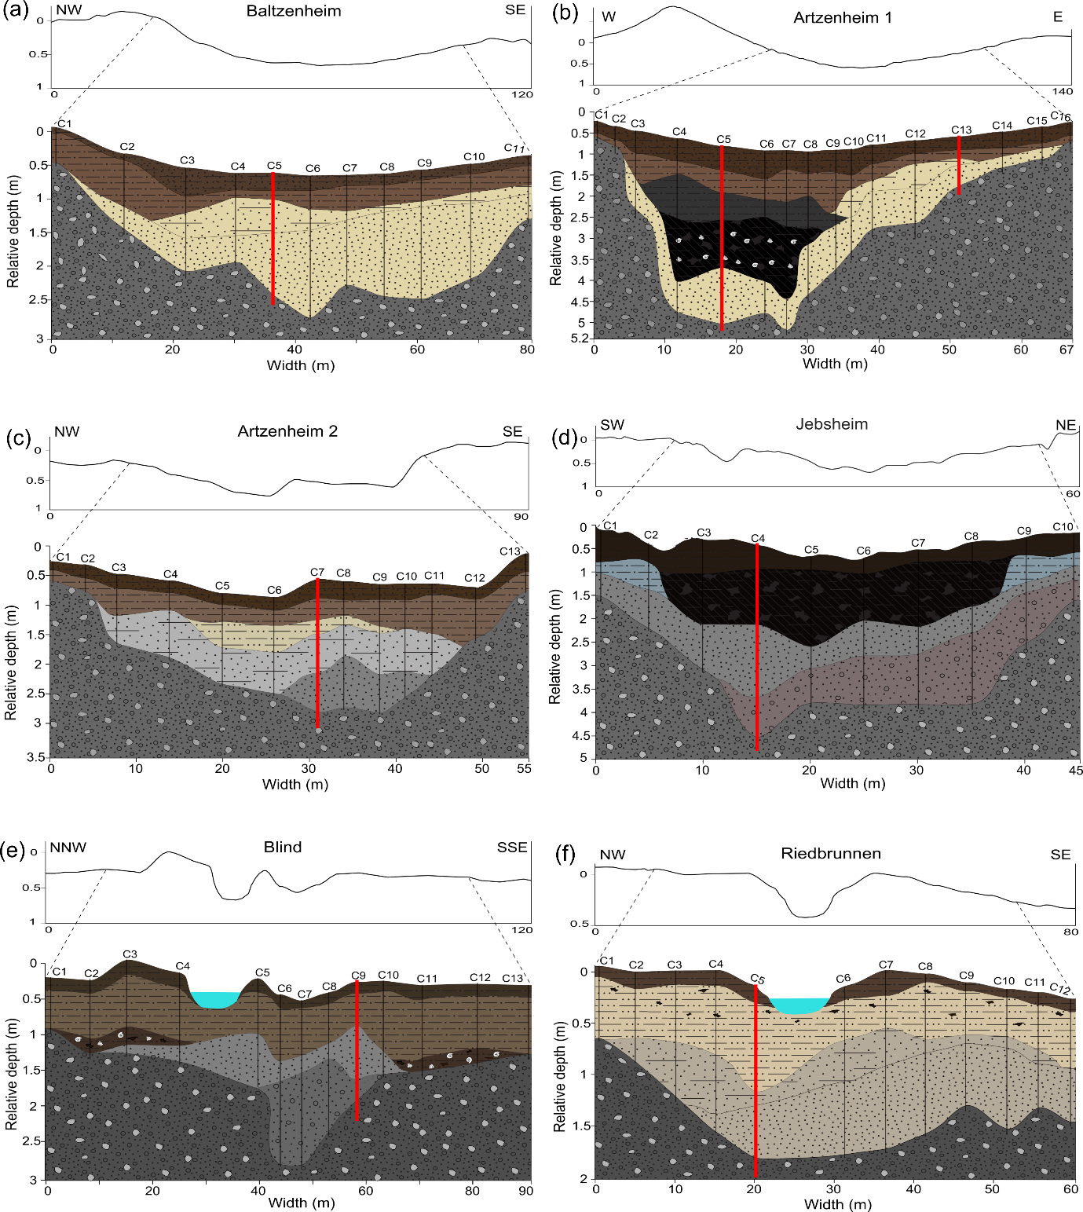
Figure S1. Schematic cross-sections of the investigated paleochannels illustrating their internal structure and stratigraphy based on augured corings and field descriptions. Modified from Abdulkarim et al. (2022). For legend please see next page.

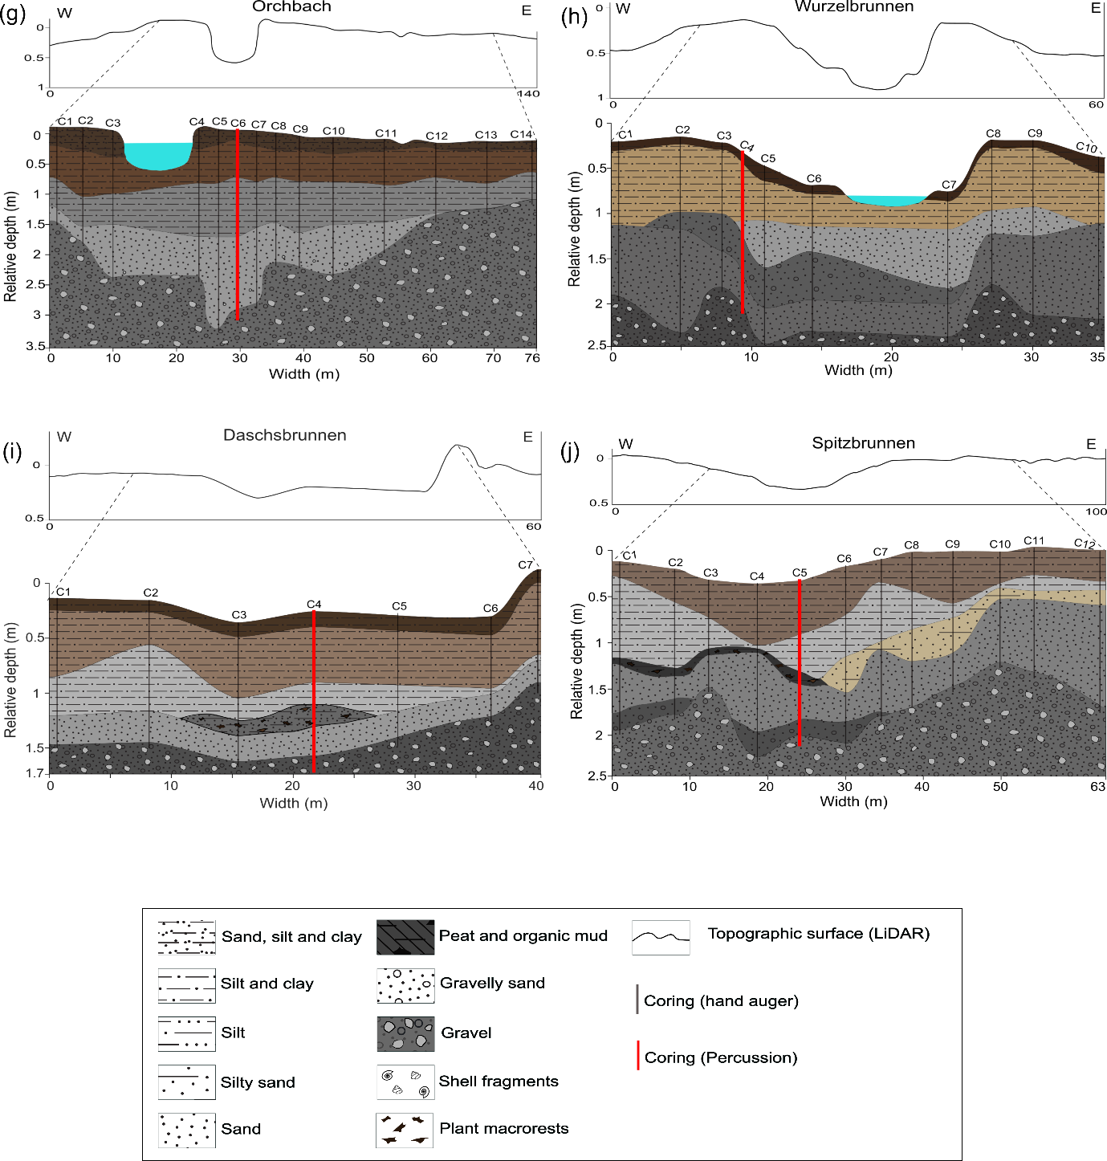
Figure S1 continued.

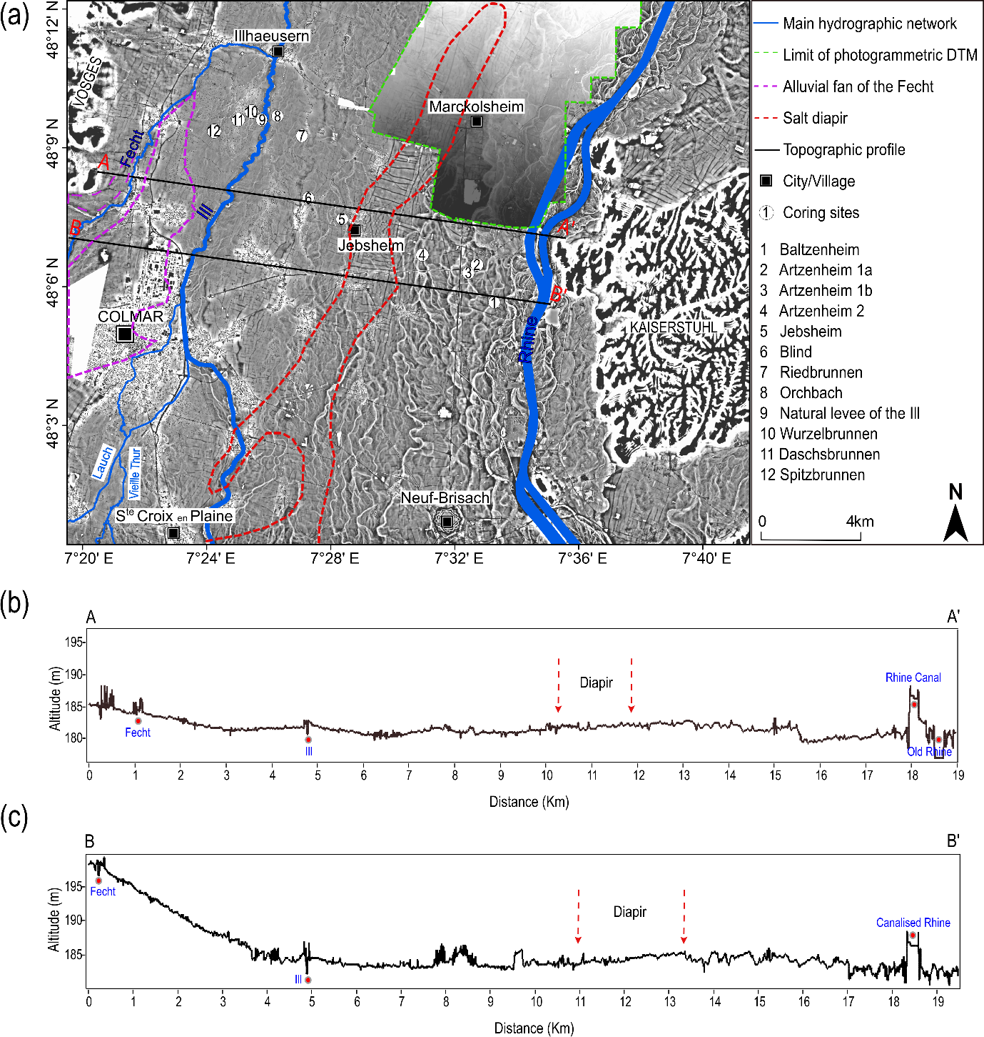
Figure S2. (a) LiDAR DEM and photogrammetric DTM of the study area, with the main river network, alluvial fan of the Fecht, and salt diapir. (b) Topographic profile along line A–A`. (c) Topographic profile along line B–B`. Modified from Abdulkarim et al. (2022). Data sources: LiDAR DEM: Regional Council of Grand Est and the European Collectivity of Alsace; photogrammetric DTM: IGN France.

References
Abdulkarim, M., Chapkanski, S., Ertlen, D., Mahmood, H., Obioha, E., Preusser, F., Rambeau, C., Salomon, F., Schiemann, M., Schmitt, L., 2022. Morpho-sedimentary characteristics of Holocene paleochannels in the Upper Rhine alluvial plain, France. E&G Quaternary Science Journal 71, 191–212. https://doi.org/10.5194/egqsj-71-191-2022
Galbraith, R.F., Roberts, R.G., Laslett, G.M., Yoshida, H., Olley, J.M., 1999. Optical dating of single and multiple grains of quartz from Jinmium rock shelter, northern Australia: part I, experimental design and statistical models. Archaeometry 41, 339–364. https://doi.org/10.1111/j.1475-4754.1999.tb00987.x
Huntley, D.J., Lamothe, M., 2001. Ubiquity of anomalous fading in K-feldspars and the measurement and correction for it in optical dating. Canadian Journal of Earth Sciences 38, 1093–1106. https://doi.org/10.1139/e01-013

