Supplementary Information:

East River, Colorado glacial chronology and paleoclimate reconstructions for the latest Pleistocene
Brendon J. Quirk, Isaac J. Larsen, Alan J. Hidy

This file contains supplementary Figure S1 and Figure S2.

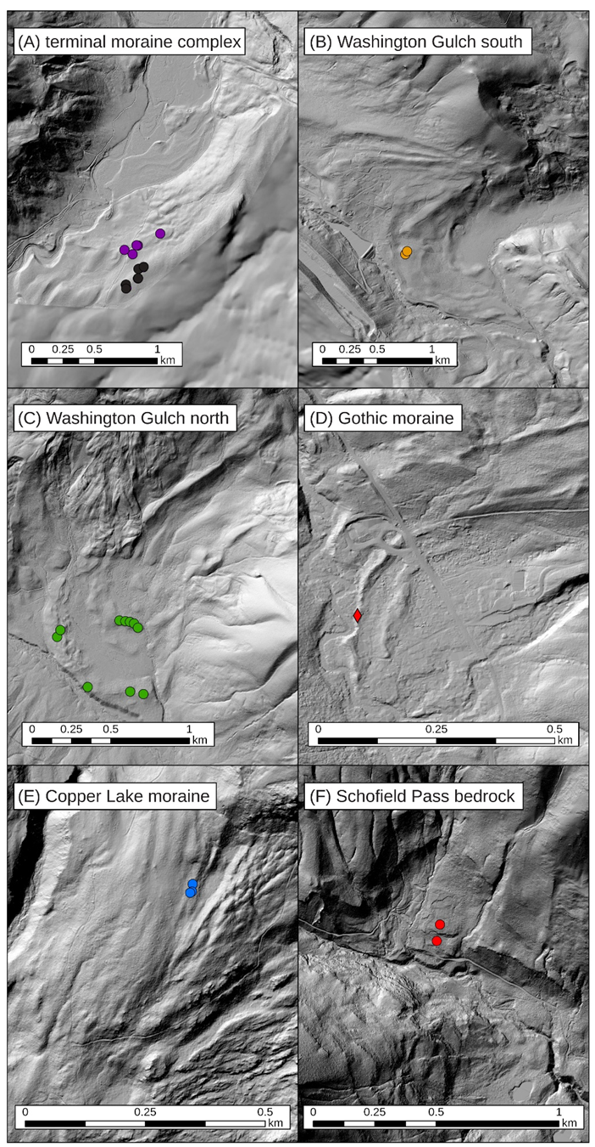
Figure S1. Lidar-derived shaded relief maps for sites with cosmogenic ¹⁰Be exposure age (circles) and depth profile (diamond) sample locations shown. Panels A-F and colors correspond to locations marked shown in Figure 1 and probability density functions in Figure 3.

Figure S2. Field photos of the soil pit at the Gothic moraine where the depth profile samples were collected. The pit extended to a depth of 150 cm. The general soil profile consisted of an A horizon extending from the top of the mineral soil to a depth of 12 cm, a Bw horizon extending from 12 to 50 cm depth, and two Bt horizons with depth intervals of 50 to 89 cm and 89 to 150+ cm, respectively.
