Supplementary Material for:
A new MIS 5 to MIS 2 speleothems record from Sandkraal Cave on the South African south coast
Kerstin Braun^{1,2}*, Miryam Bar-Matthews^{2,3}, Avner Ayalon³, Alan Matthews⁴, Tami Zilberman³, Natalya Zolotova⁵, Richard M. Cowling², Panagiotis Karkanas^{6,2}, Hayley Cawthra^{7,2}, Erich C. Fisher^{8,2}, R Lawrence Edwards⁹, Xianglei Li⁹, Curtis W. Marean^{1,2}
¹ Institute of Human Origins, School of Human Evolution and Social Change, Arizona State University, Tempe, Arizona, USA
² African Centre to Coastal Palaeoscience, Nelson Mandela University, Gqeberha [Port Elisabeth], Eastern Cape, South Africa
³ Geological Survey of Israel, Jerusalem, Israel
⁴ Fredy and Nadine Herrmann Institute of Earth Sciences, The Hebrew University of Jerusalem, Jerusalem, Israel
⁵ School of Earth and Space Exploration, Arizona State University, Tempe, Arizona, USA
⁶ Malcom H. Wiener Laboratory for Archaeological Science, American School of Classical Studies, Athens, Greece
⁷ Geophysics and Remote Sensing Unit, Council for Geoscience, Western Cape regional office, South Africa
⁸The Interdisciplinary Center for Archaeology and Human Behavior, Universidade do Algarve, Faro, Portugal
^{9N}. H. Winchell School of Earth and Environmental Sciences, University of Minnesota, Minneapolis, MN 55455
*corresponding author: kbraun2@asu.edu, PO Box 874101, Tempe, AZ 85287, USA
Appendix1
Descriptions of individual samples from Sandkraal Cave:
Ages measured on the samples are listed in Supplementary Table 1.
Sample 162807 is a stalactite that was found broken off outside the current cave. It is about 20 cm long and has a diameter of 6 cm. A white porous overgrowth has formed on the sample and similar deposits are found on many speleothems that are now located outside the cave. The overgrowth on 162807 wraps around the sample and also penetrates into the sample near the center where the initial soda straw was located (Supplementary Figure 4a). The clean stalactite was dated by 4 dating analyses with results between 58.3 (162807-A) and 13.2 ka (162807- B) and uranium concentrations of ~ 2 ppm. The overgrowth was dated twice in different parts of the sample with ages of 3.9 and 4.5 ka and 16 and 18 ppm of uranium, respectively. The high uranium concentrations suggests that the overgrowth may be aragonite. Petrographic analysis and SEM imaging show large crystals (few cm long) with an elongated columnar fabric (Supplementary Figure 5a). The stable isotope record was sampled near the widest part where the stalactite broke off perpendicular to the visible lamination. The dating results suggest that there are two hiatuses at 3.5 and 15.5 mm depth. The top 3.5 mm are the white overgrowth which was in this part of the sample only dated by one age, so there is no age model for this section. The hiatus at 1.5 mm depth is marked by a thick white lamina.
Sample 357387 was found on the ground outside the cave. The sample is a composite of several deposits, most likely a stalactite and drapery that grew into a column. Section A of the sample is a piece of drapery with a thickness of about 10 cm. The central part of the sample (~2cm thick) is of a clear grey color and was dated with two analyses to 91.5 (357387-H) and 94.9 ka (357387-C). This part of the sample is separated from the rest of the sample by two thick white laminae. The outer part of the sample is light brown in color with common lamination that was dated to 39.2 (357387-D) and 29.6 ka (357387-F). A small section of this outer part was possibly recrystallized and now has a light brown color with no lamination (Supplementary Figure 4b). This part was dated to 38.6 ka (357387-E) near the dating location of 357387-D. The stable isotope record was drilled across the clear grey and brown laminated parts of the sample, avoiding the recrystallized part. Section B of the sample is a stalactite with a diameter of about 8 cm width (Supplementary Figure 4c). The sample is light brown in color with only little visible lamination. On one side, the brown speleothem is overlain by a thinly laminated light grey sand rich deposit of about 2cm thickness. The oldest part at the center of section B was dated to 38.0 ka (357387-I). The edges of the brown speleothem deposit were dated to 26.7 ka (357387-B) and 23.4 ka (357387-A). The sandy deposit was not dated. The stable isotope record was sampled across the width of the sample. Part 357387-B1 extends from the center of the sample to the edge where age 357387-B was taken. Part 357387-B2 is the section of the isotope records stretching from the center to the side where the tufa is deposited on top of the sample (Supplementary Figure 4c). Age analyses 357387-a and 357387-G were measured on this side. Since the grey sandy deposit was not dated and it can be expected that there is a hiatus between the deposition of the brown speleothem and the grey deposit the stable isotope analyses measured in the grey deposit were not included in the composite record.
Samples 428464 – 428467 are small pieces of flowstone, that were cut from a succession of the former flowstone floor of the cave that is still attached to the east wall of the opening outside the cave. Sample 428464 was taken at the top of the succession. Ages on this sample were analyzed from two distinct sections that are rotated against each other by 90 ° (Supplementary Figure 4d. The sections and how they align with each other is shown in Supplementary Figure 4d). The whole piece is about 9 cm tall with light beige white and yellow colors. Lamination is common throughout but becomes more distinct in the bottom 2 cm including some thick white and dark brown layers. 4 ages on this sample were analyzed at the Geological Survey of Israel on the section where the stable isotopes were also sampled. An additional 13 dating samples were drilled on the section that was cut on a rotated piece of the flowstone and analyzed at the University of Minnesota. Dating results range between 49.2 and 77.9 ka (428464-F, 428464-A) with only two outliers (428464-C and 428464-E).
Sample 428465 is about 5 cm thick with a light grey to brown color and wavy lamination (Supplementary Figure 4d). Dating results for the sample were between 85.2 (428465-B) and 101.0 ka (428465-A). The stable isotope record was drilled in two section across the sample.
Sample 428466 is a small piece of flowstone of about 3.5 cm thickness with a light grey to brown color (Supplementary Figure 4d). The sample was dated by four U-Th analyses with results between 107.8 (428466-D) and 146.5 ka (428466-A). Age 428466-A falls within late MIS 6 and would suggest that the cave was closed in this interval and remained closed also during the sea level high stand of MIS 5e. The old age would also mean that there was a strong change in the deposition rate of the sample and it is considerably older than the ages analyzed on 428467 which is stratigraphically below 428466-A. We therefore treat the result of 428466-A as an outlier.
Sample 428467 is a layered mix of sand and secondary carbonate and marks the base of the flowstone sequence on the outside of SK1 (Supplementary Figure 4 d). Only one date on the sample gave a result of 120.4 ka (428467-A).
The sample 460362 is a cross-section of the false flowstone floor that deposited on the debris cone that closed the cave. The sample was cut with a diamond tipped chainsaw and broke into two pieces during sampling. The break occurred about in the middle of the sample along a layer that is very porous and rich in detrital material.
Sample 460362-1 is the top half of this flowstone cross-section. The sample is about 30 cm tall and 10 cm wide. The original flowstone floor is mostly dark brown to olive colored with common laminations (Supplementary Figure 4e). This flowstone is overlain by a about 3cm thick layer of light grey tufa that wraps around the edge where the flowstone floor broke off. The tufa overgrowth was dated by two U-Th analyses to (460362-E and 460362-F) to 5.9 and 2.2 ka. Below the tufa, at a depth of 22.8 mm the dates analyzed on the sample indicate another hiatus in sample deposition with an age somewhere between 58.4 (460362-1D) and 77.6 ka (460362-1-Q). The stable isotope values for both δ¹⁸O and δ¹³C above this hiatus are several ‰ higher than for the lower parts of the sample suggesting that the hiatus at 22.8 mm marks the shift from closed cave conditions to more open-cave tufa deposition. The section of the flowstone deposit included in the composite stable isotope records was dated by six analyses with results ranging from 77.6 to 90.2 ka. One age sample, 460362-1-C, near the bottom of this section of the flowstone close to the porous and detrital-rich section was possibly affected by contamination from the layer and gave an age that was younger than expected based on the other dating results. This age is thus considered an outlier.
Sample 460362-2 is the bottom part of the flowstone cross-section with a dark brown to light grey and olive color (Supplementary Figure 4f). It too had a loosely attached about 3cm thick tufa overgrowth when first sampled, this layer broke off due to vibrations during drilling. The remaining sample is about 23 cm high and 6 cm wide. It was dated with eight U-Th analyses giving results between 31.9 and 101.0 ka. Several ages were younger than expected for this sample based on the stratigraphy of the sample, results for the majority of dating samples and the ages of 460362-1. These were excluded from the age models.
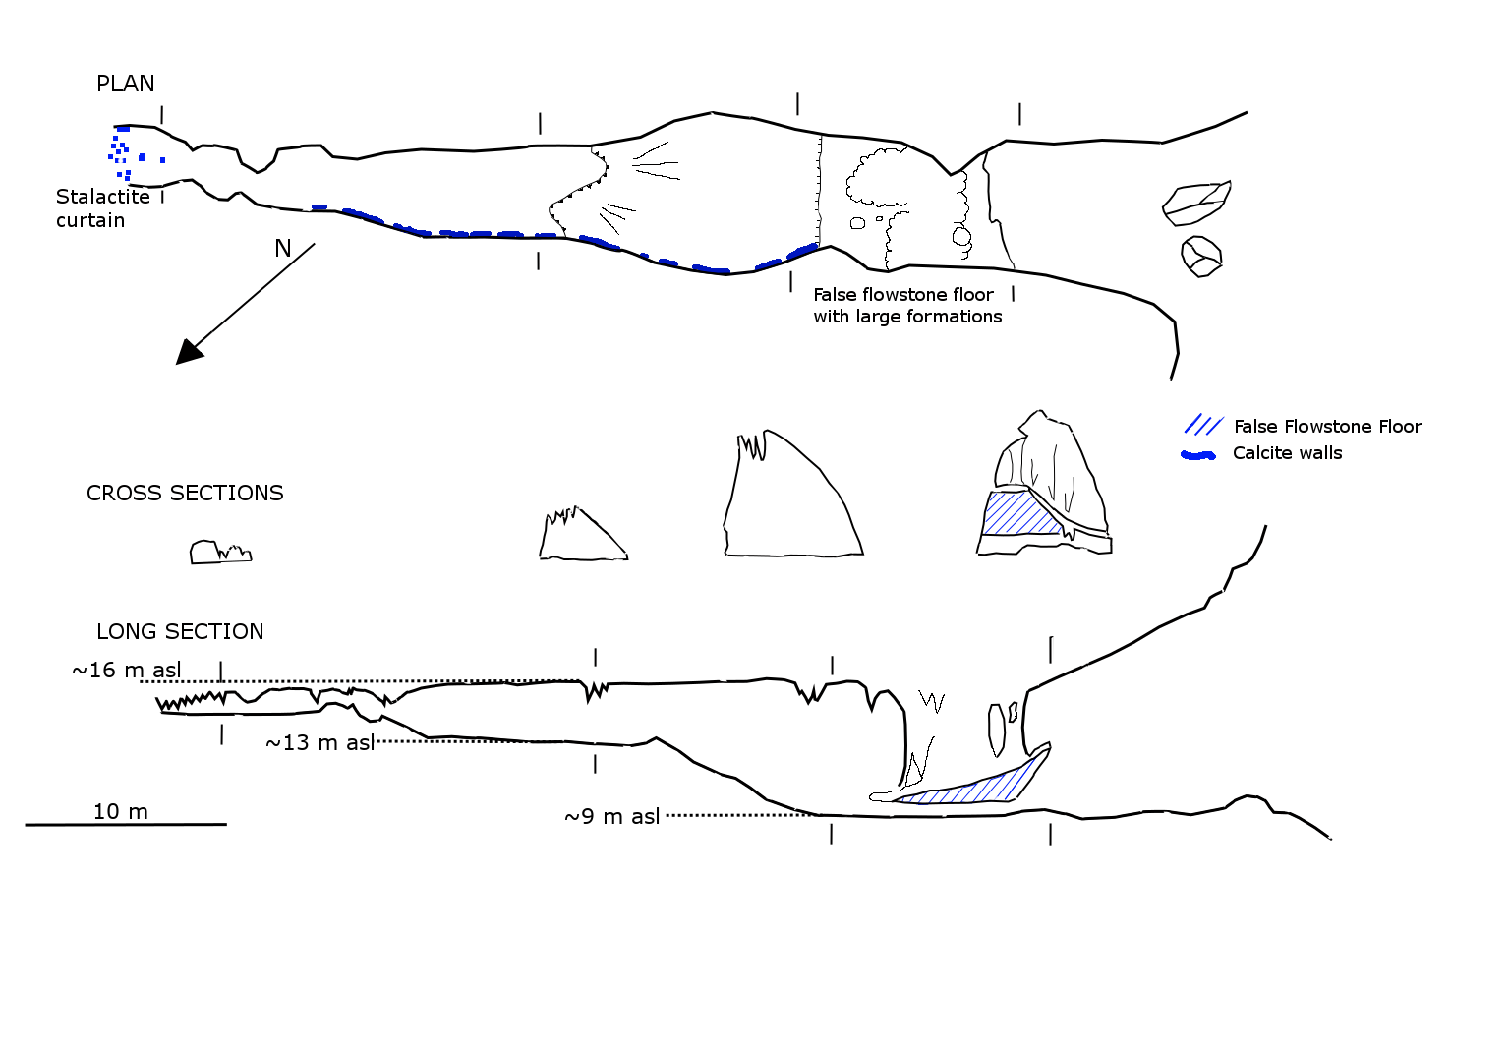
Supplementary Figure 1: Map of SK1 drawn by the South African Speleological Association (Cape Section), originally published in “The Free Caver” number 17, June 1984; modified from Soper (2007).
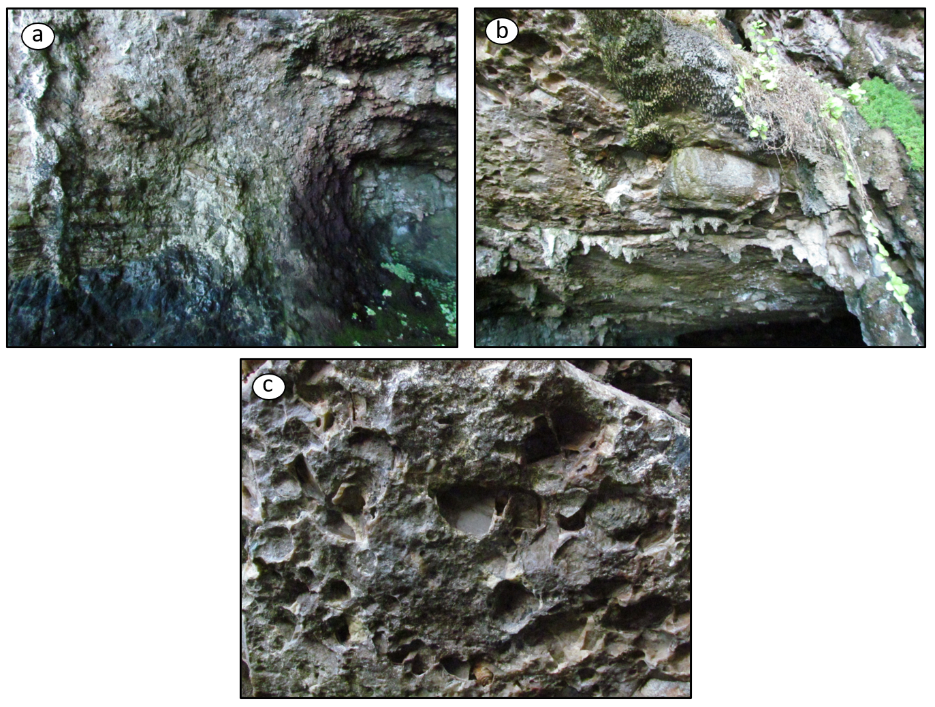
Supplementary Figure 2: Photos taken near the entrance of SK1 under the overhanging false flowstone floor. a. Colluvium, remnants of the material that used to close the cave adhering to the west wall of the cave entrance Height of the ceiling visible in the image is ~2m next to the colluvium. b. Boulder (~30 cm wide) cemented into the bottom of the false flowstone floor. c. Outlines of smaller rocks and pebbles (diameters of the outlines are between 3 and 5 cm).
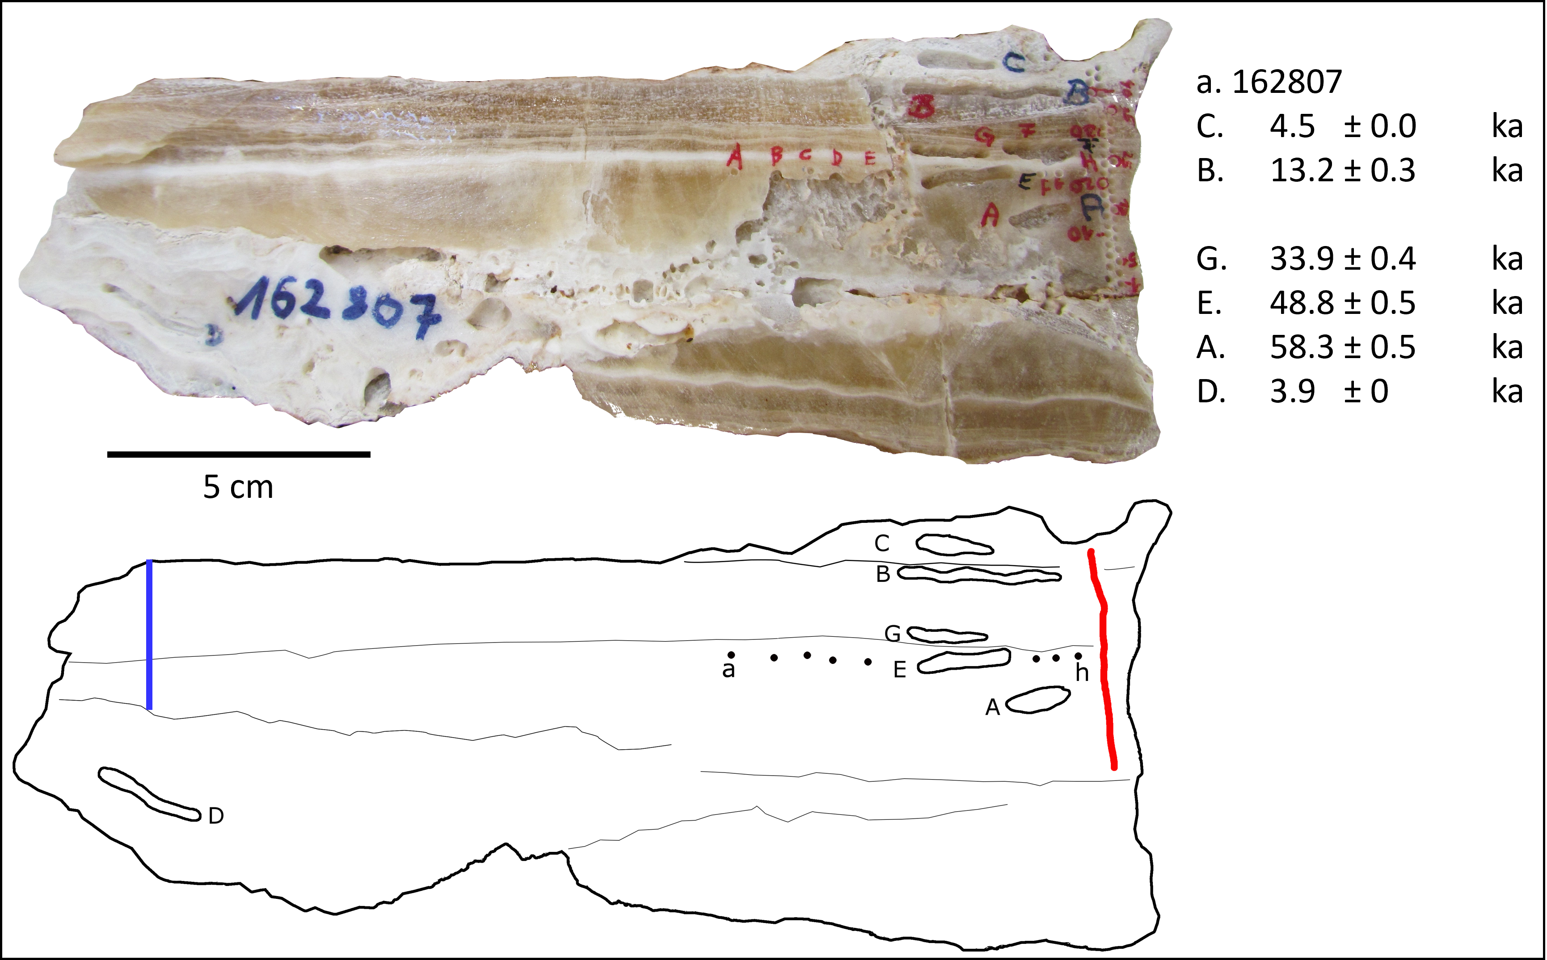
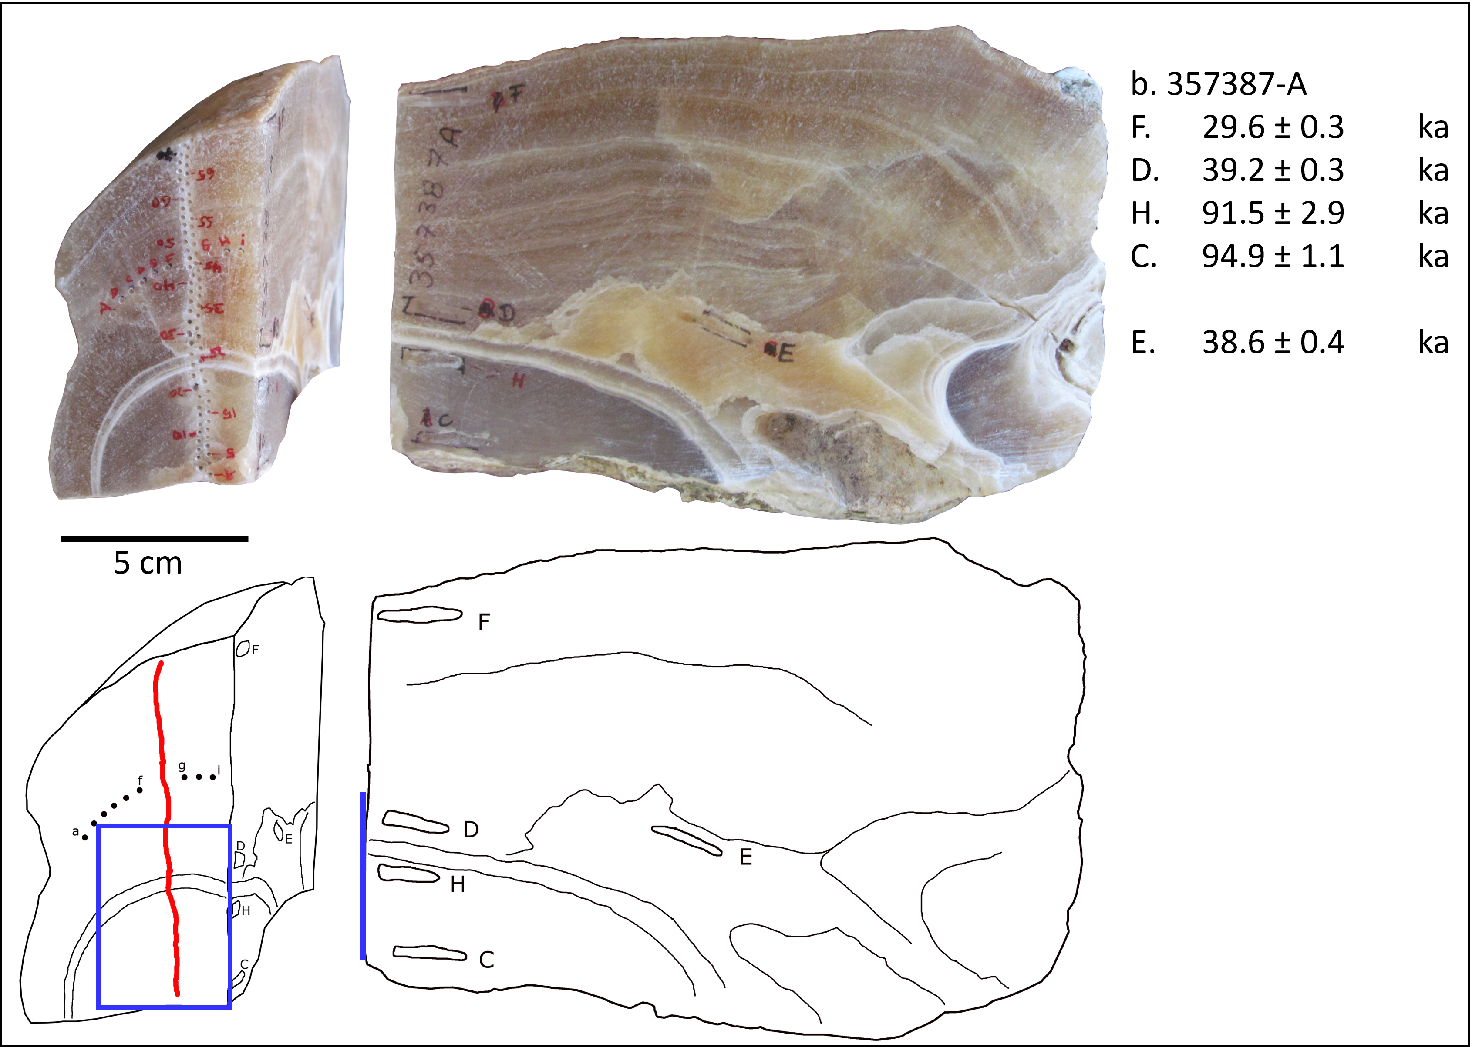
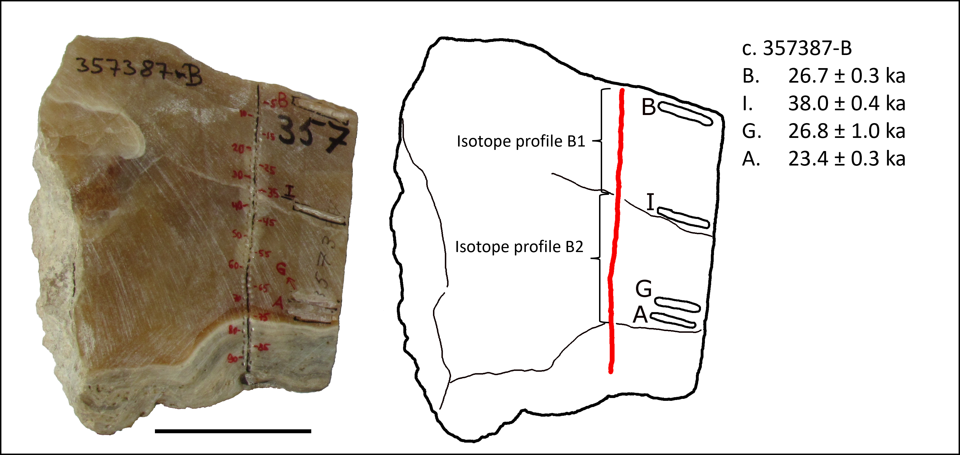
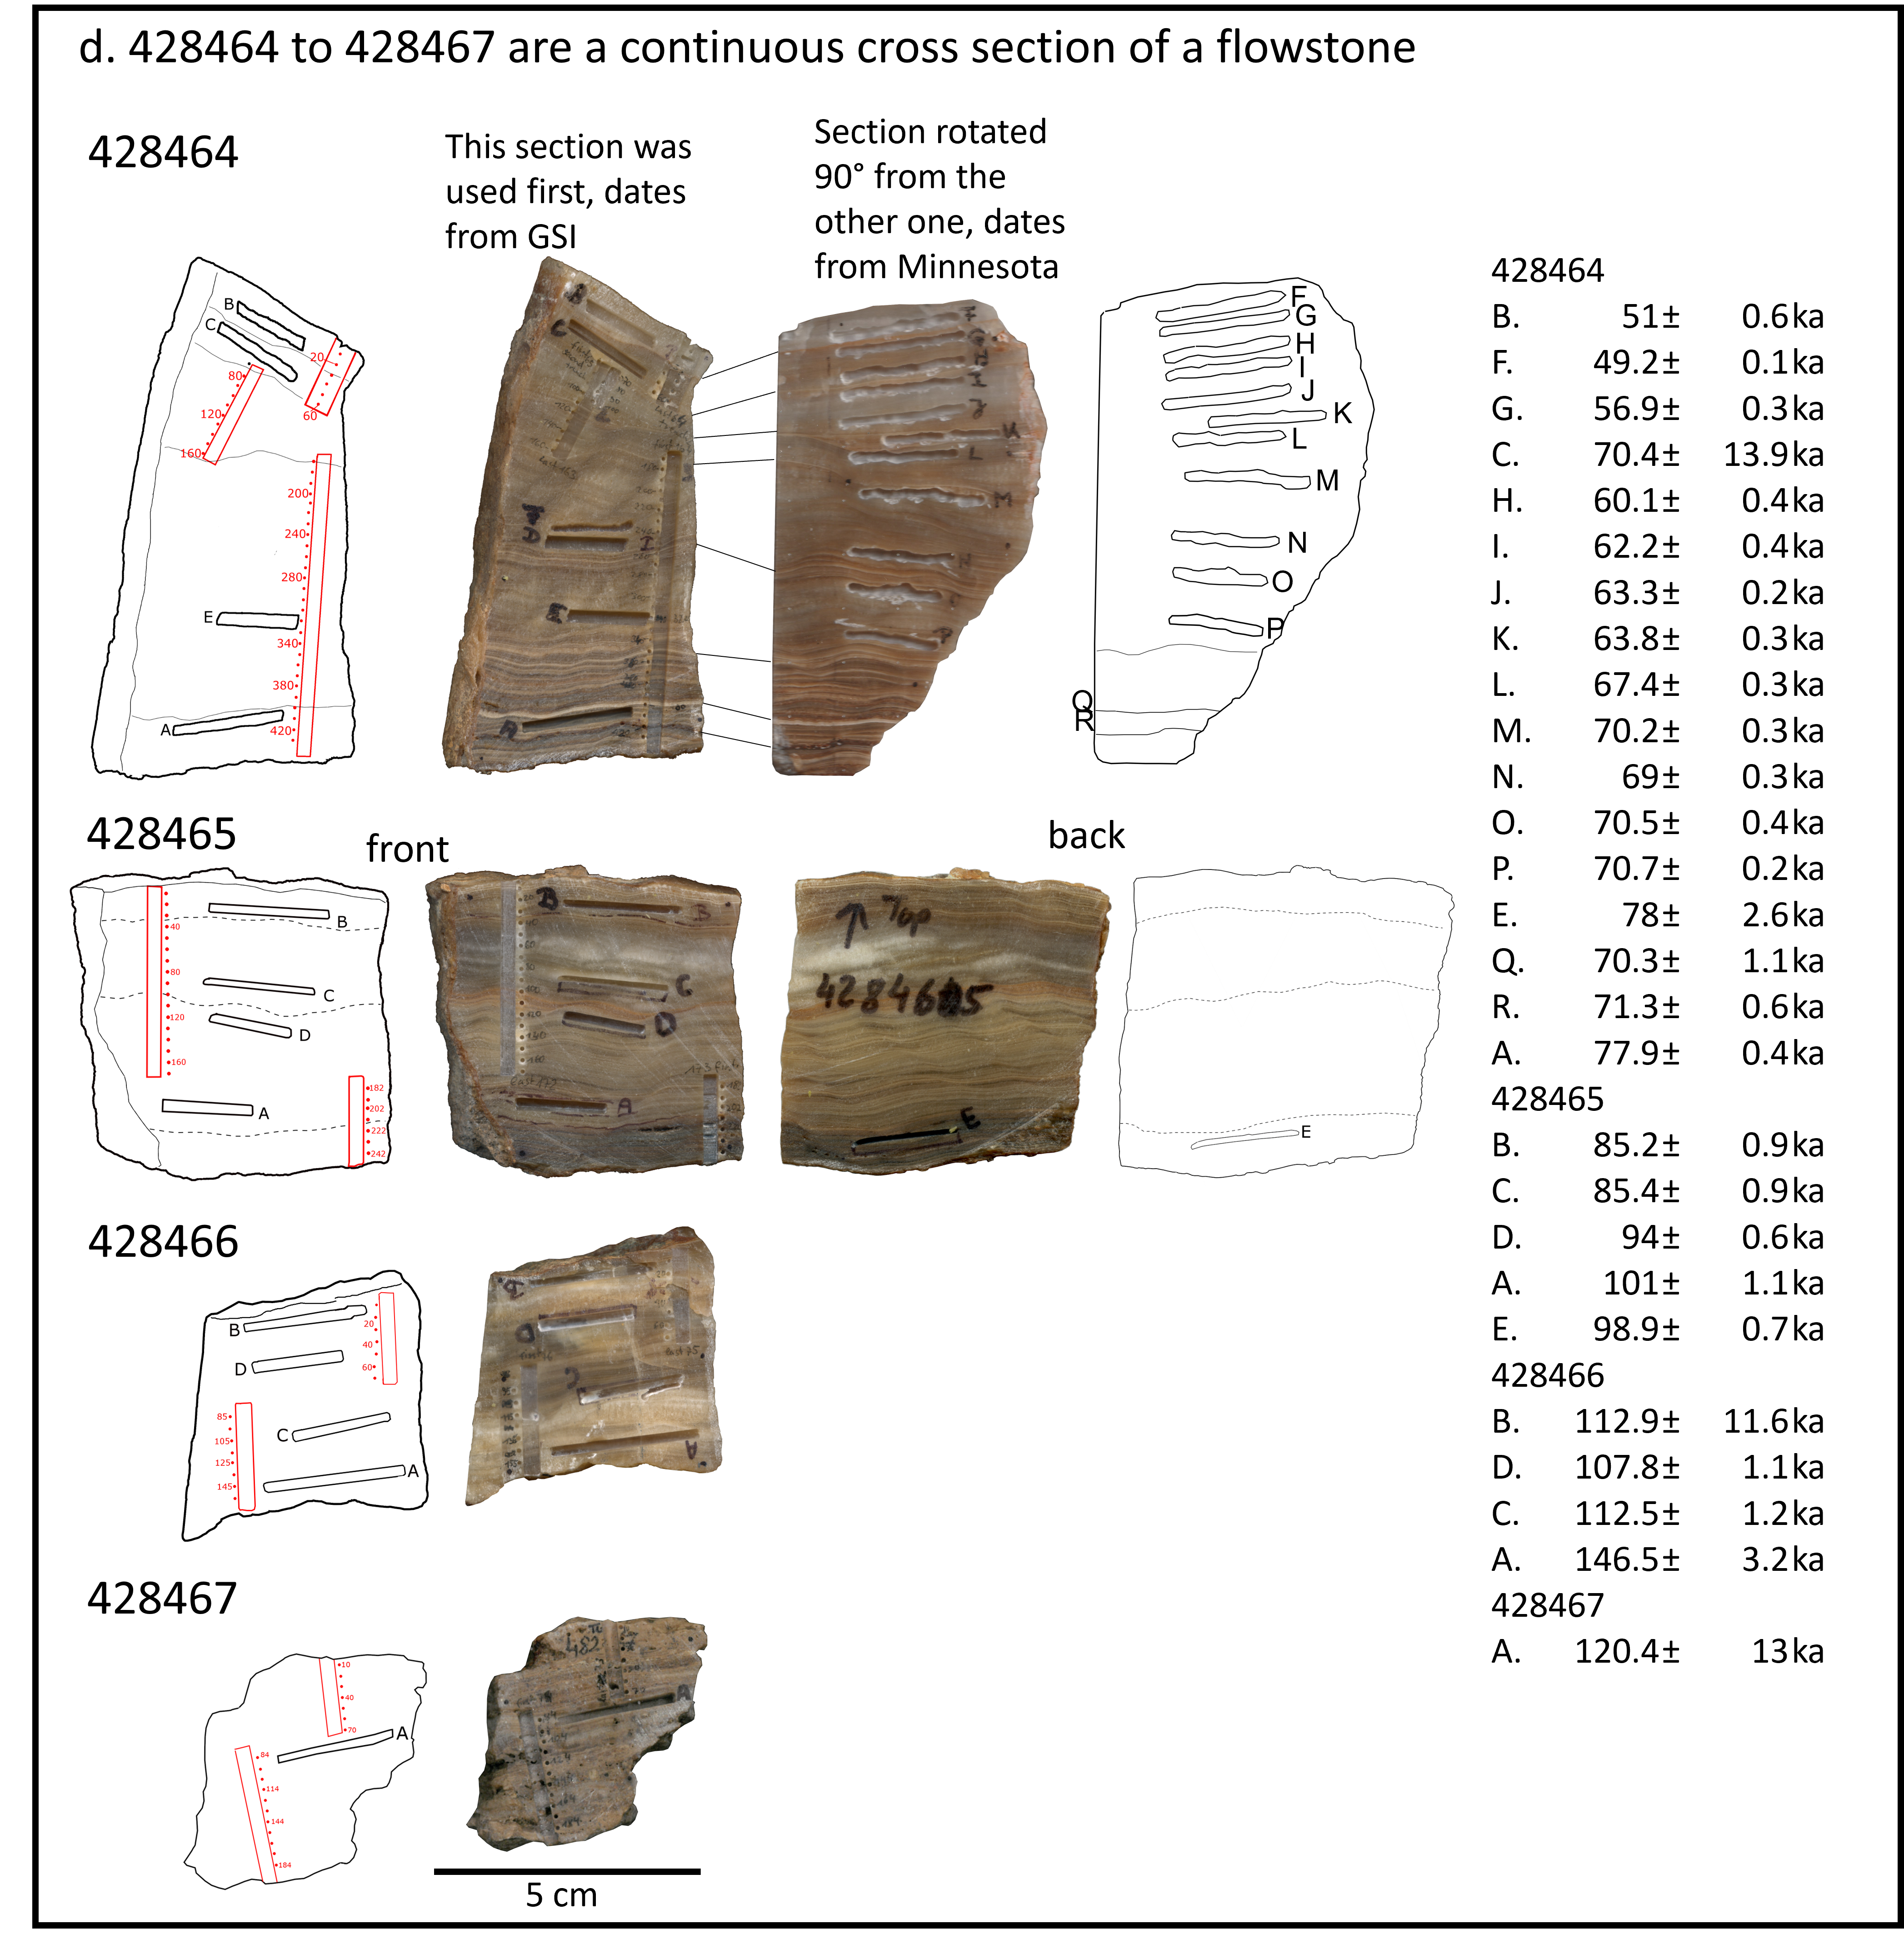
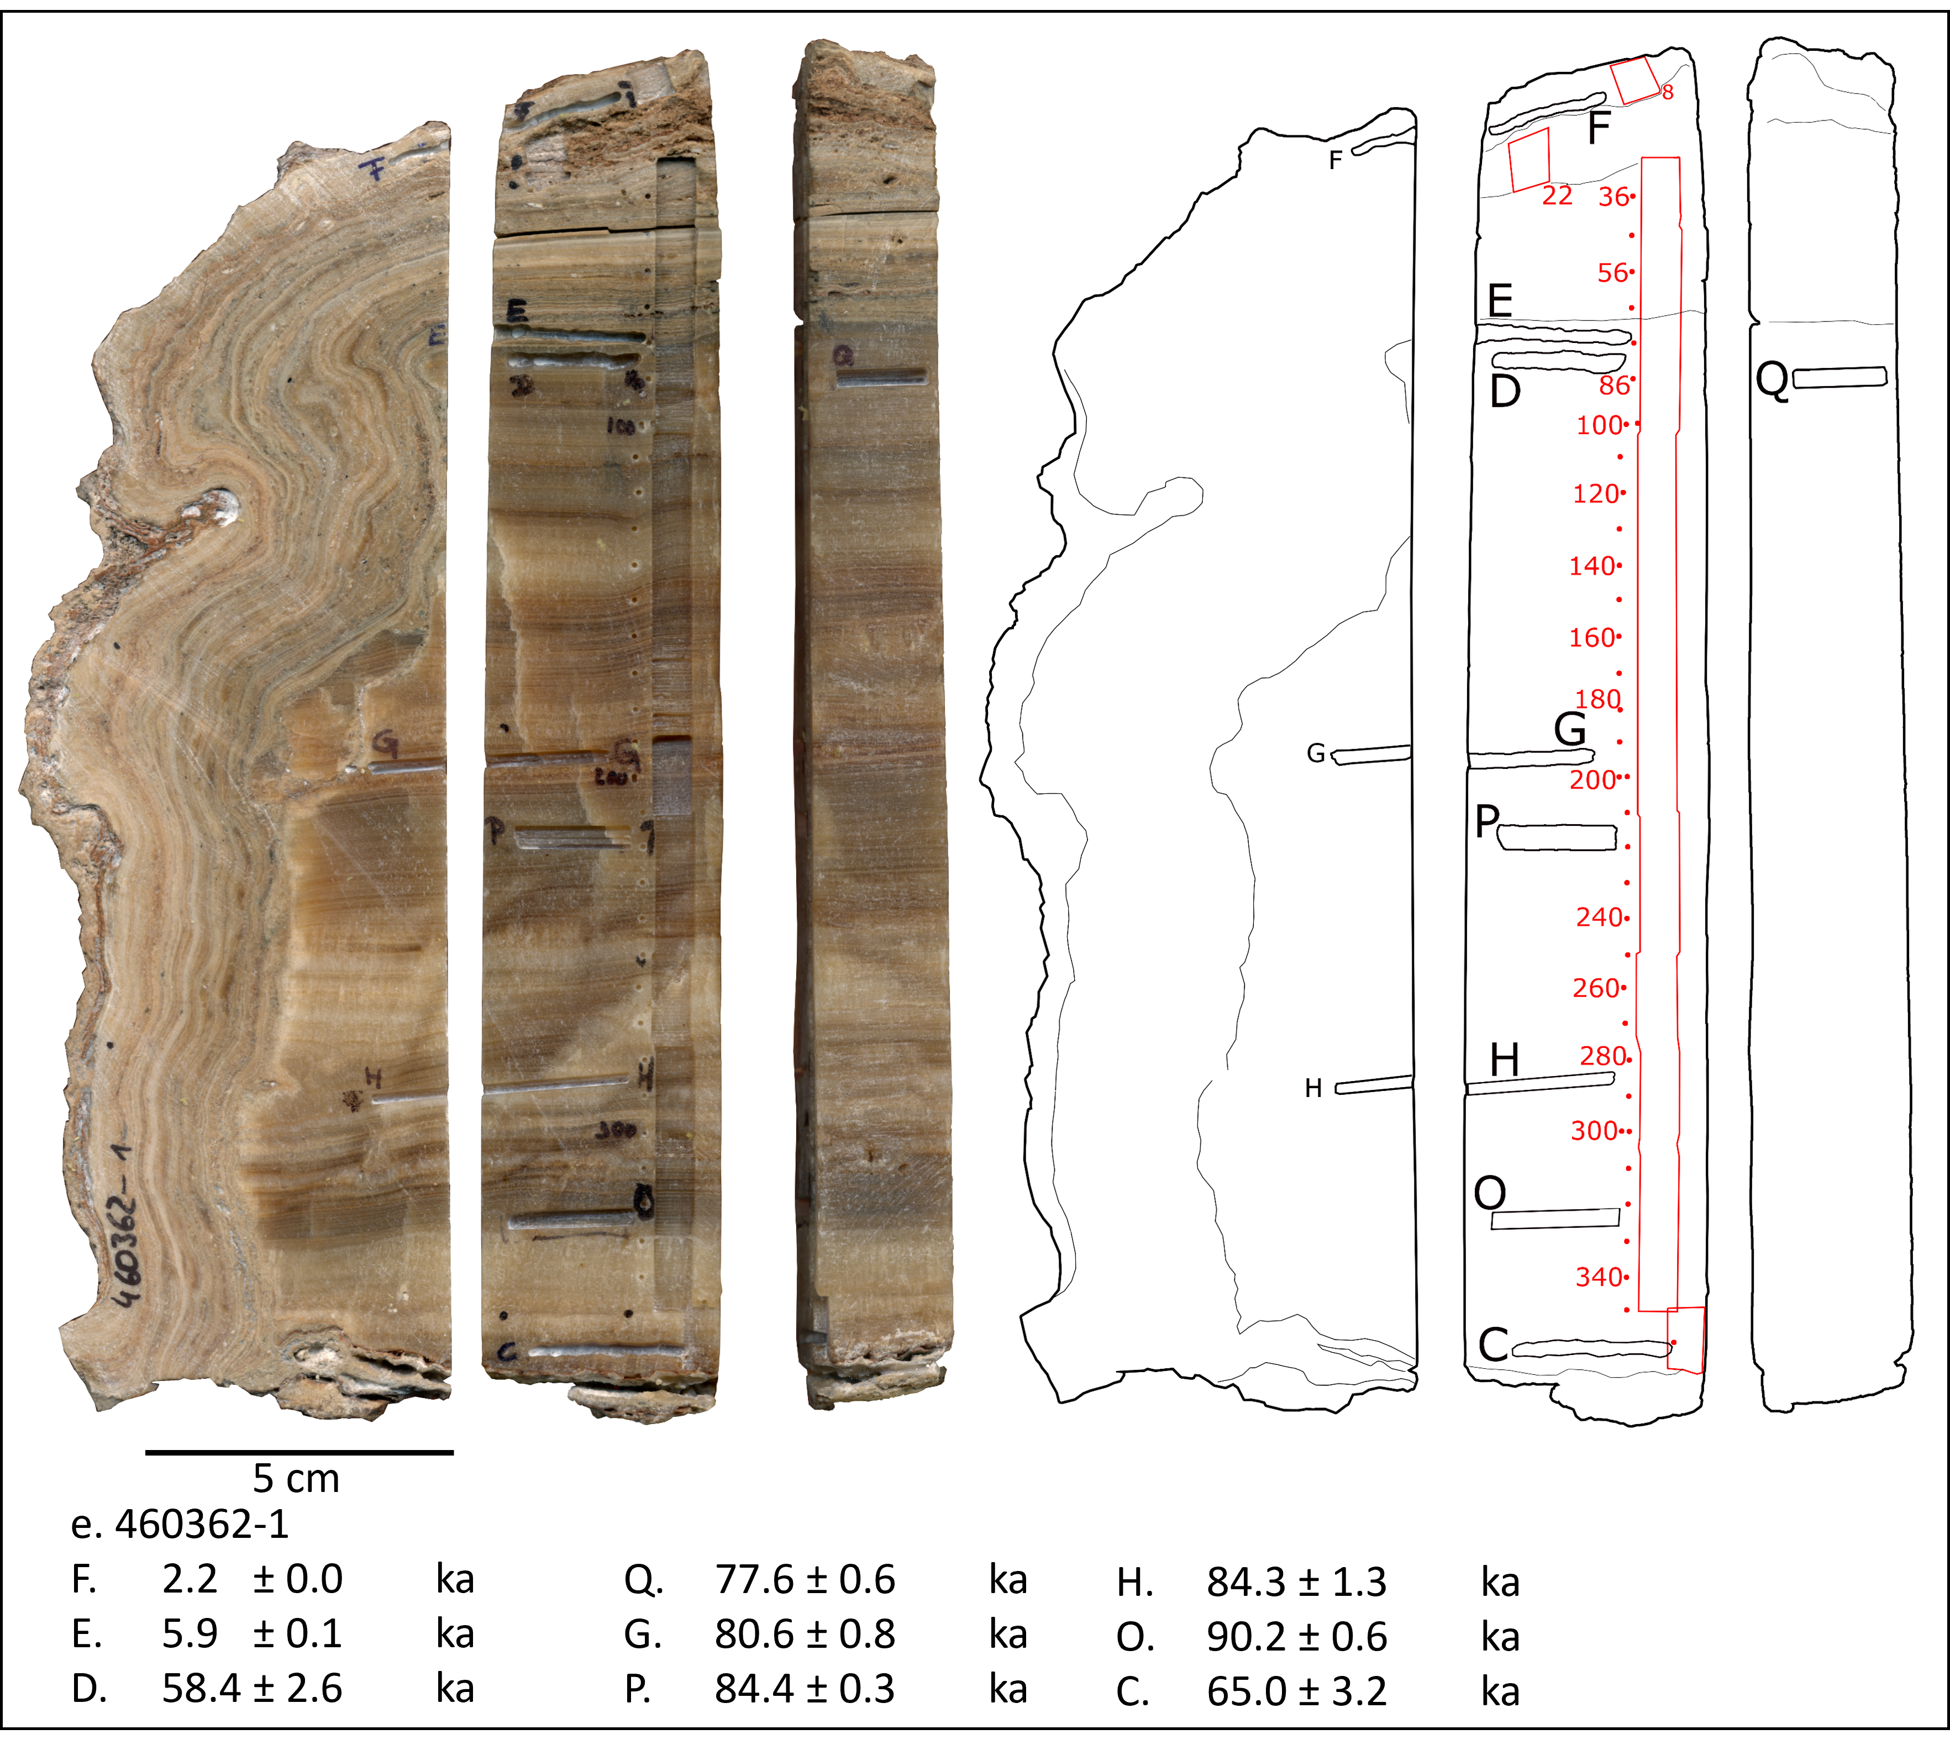
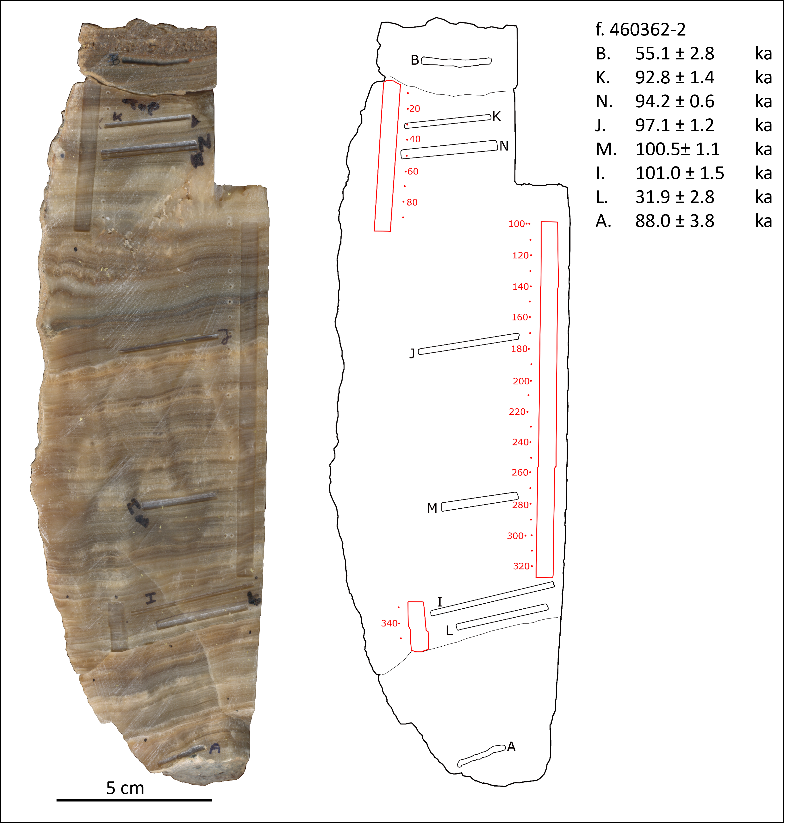
Supplementary Figure 3: Images of samples from SK1; outlines of samples with locations of dating samples (black) and isotopic records (red) are also shown. On speleothems where stable isotopes were sampled using the micromill, the sampling trench is outlines in red and red dots adjacent to or inside the trench show the locations of individual holes that were drilled every 10 stable isotope samples. Dating results with 2σ errors are given in stratigraphic order for each sample. Locations of thin sections are marked in blue in a and b, the box marks a thin section parallel to the surface in the image, lines mark thin sections prepared perpendicular to the surface in the image. Black dots with letters in a and b mark the locations of sampling for Hendy tests in samples 162807 and 357387-A.
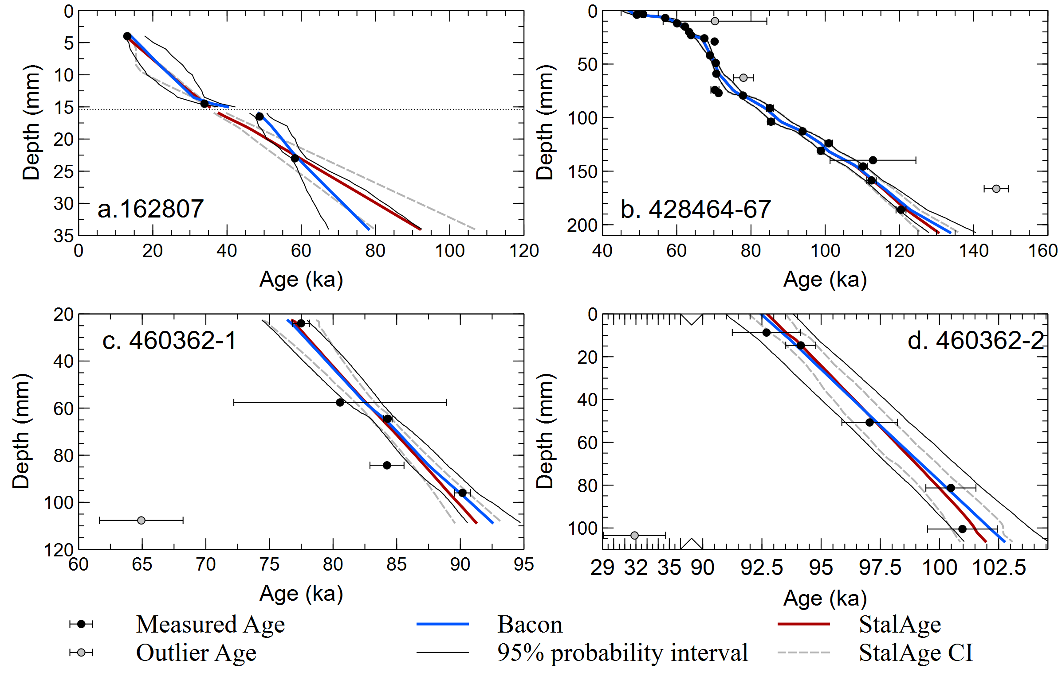
Supplementary Figure 4: Comparisons of age models created using Bacon (Blaauw and Christen, 2011)and StalAge (Scholz and Hoffmann, 2011) for speleothems from SK1 where StalAge age modelling was feasible. There is good overlap between the age model except in 162807 where StalAge can only be applied when including all ages disregarding the hiatus.
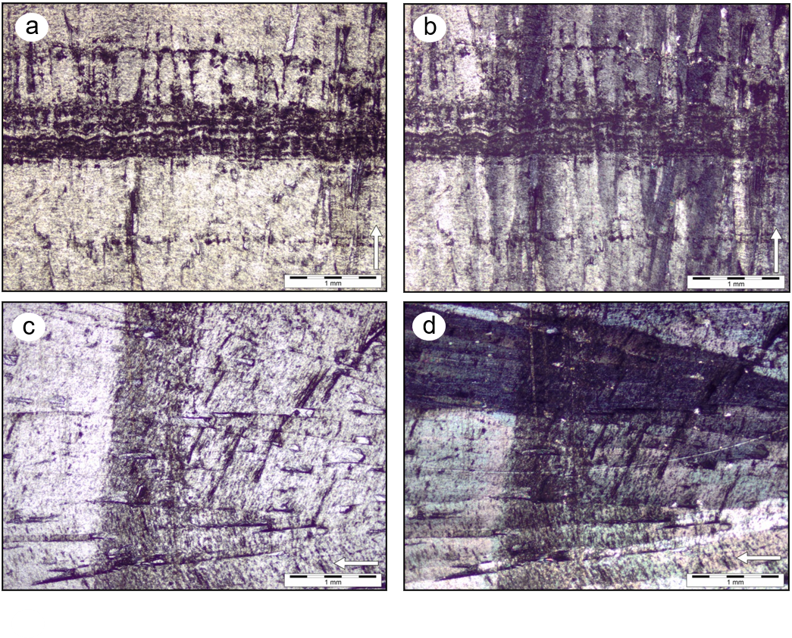
Supplementary Figure 5: Images of thin sections prepared from samples 357387-A and 162807. a. Image of lamination in sample 357387-A in nonpolarized light. b. Same view as in a. in polarized light showing the elongated columnar crystals continuing through the lamination. c. Image of lamination visible in sample 162807 in non-polarized light. d. Same view as in c. in polarized light showing the elongated columnar fabric of the crystals and continuous growth through the lamination. white arrows indicate growth direction of the speleothems.
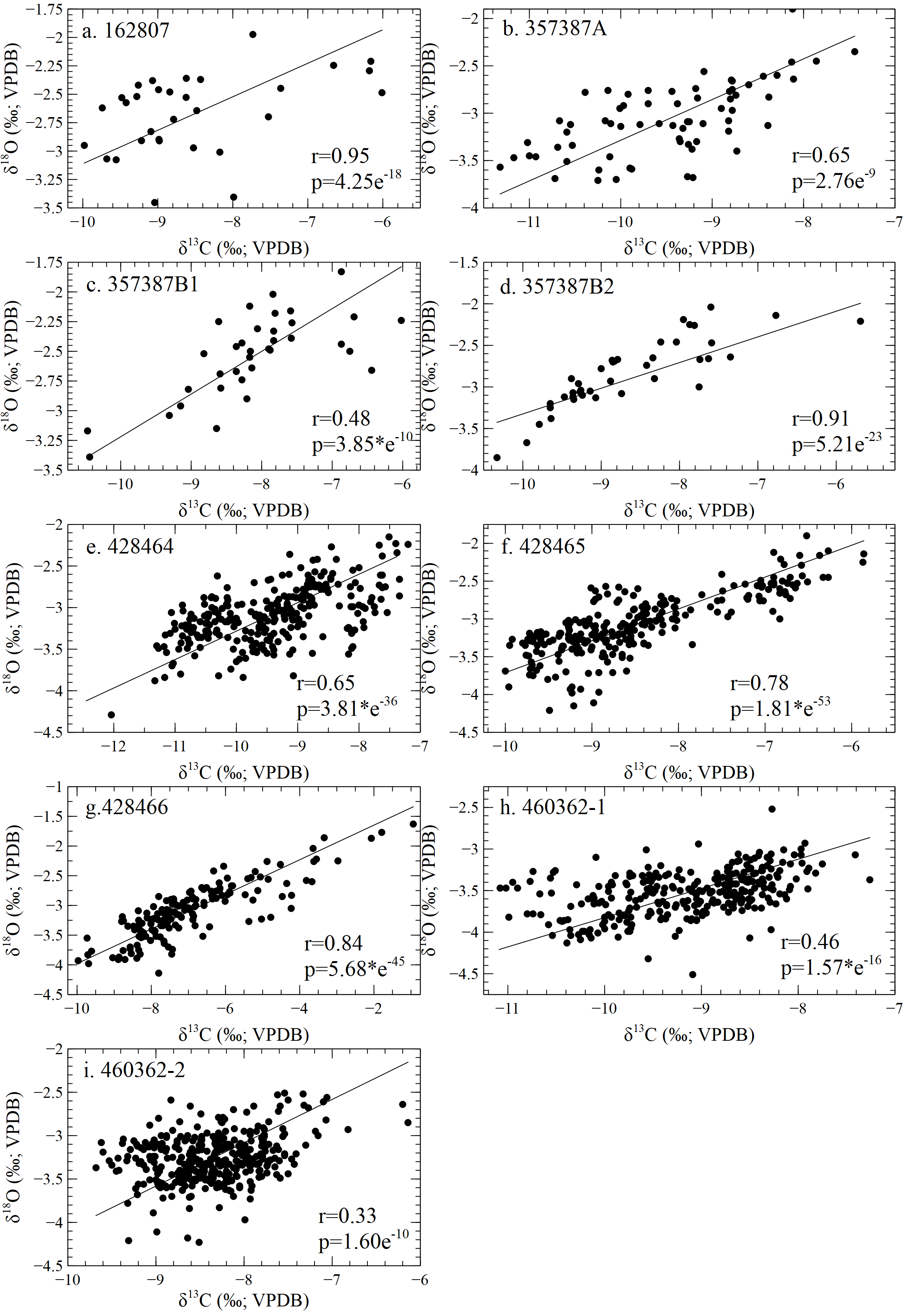
Supplementary Figure 6: Measured δ¹³C plotted against δ¹⁸O for samples from SK1. Regression lines were calculated using reduced major axis regression. Sample numbers, Pearson’s r and p-values are given in the graphs.

References
Bar-Matthews, M., Ayalon, A., Kaufman, A.J., 1997. Late Quaternary Paleoclimate in the Eastern Mediterranean Region from Stable Isotope Analysis of Speleothems at Soreq Cave, Israel. Quat. Res. 47, 155–168. doi:10.1006/qres.1997.1883
Bar-Matthews, M., Marean, C.W., Jacobs, Z., Karkanas, P., Fisher, E.C., Herries, A.I.R., Brown, K.S., Williams, H.M., Bernatchez, J.A., Ayalon, A., Nilssen, P.J., 2010. A high resolution and continuous isotopic speleothem record of paleoclimate and paleoenvironment from 90-53 ka from Pinnacle Point on the south coast of South Africa. Quat. Sci. Rev. 29, 2131–2145. doi:10.1016/j.quascirev.2010.05.009
Braun, K., Bar-Matthews, M., Ayalon, A., Zilberman, T., Matthews, A., 2017. Rainfall isotopic variability at the intersection between winter and summer rainfall regimes in coastal South Africa (Mossel Bay, Western Cape Province). South African J. Geol. 120, 323–340. doi:10.25131/gssajg.120.3.323
Braun, K., Bar-Matthews, M., Matthews, A., Ayalon, A., Cowling, R.M., Karkanas, P., Fisher, E.C., Dyez, K.A., Zilberman, T., Marean, C.W., 2019. Late Pleistocene records of speleothem stable isotopic compositions from Pinnacle Point on the South African south coast. Quat. Res. 91, 265–288. doi:10.1017/qua.2018.61
Braun, K., Bar-Matthews, M., Matthews, A., Ayalon, A., Zilberman, T., Cowling, R.M., Fisher, E.C., Herries, A.I.R., Brink, J.S., Marean, C.W., 2020. Comparison of climate and environment on the edge of the Palaeo-Agulhas Plain to the Little Karoo (South Africa) in Marine Isotope Stage 5 – 3 as indicated by speleothems. Quat. Sci. Rev. 235, 105803. doi:10.1016/j.quascirev.2019.06.025
Caley, T., Kim, J.-H., Malaizé, B., Giraudeau, J., Laepple, T., Caillon, N., Charlier, K., Rebaubier, H., Rossignol, L., Castañeda, I.S., Schouten, S., Sinninghe Damsté, J.S., 2011. High-latitude obliquity as a dominant forcing in the Agulhas current system. Clim. Past 7, 1285–1296.
Carr, A.S., Chase, B.M., Mackay, A., 2016. Mid to Late Quaternary Landscape and Environmental Dynamics in the Middle Stone Age of Southern Africa, in: Africa from MIS 6-2: Population Dynamics and Paleoenvironments. pp. 23–47.
Chase, B.M., 2010. South African palaeoenvironments during marine oxygen isotope stage 4: a context for the Howiesons Poort and Still Bay industries. J. Archaeol. Sci. 37, 1359–1366. doi:10.1016/j.jas.2009.12.040
Chase, B.M., Meadows, M.E., 2007. Late Quaternary dynamics of southern Africa’s winter rainfall zone. Earth-Science Rev. 84, 103–138. doi:10.1016/j.earscirev.2007.06.002
Dorale, J.A., Liu, Z., 2009. Limitations of Hendy test criteria in judging the paleoclimatic suitability of speleothems and the need for replication. J. Cave Karst Stud. 71, 73–80.
Engelbrecht, F.A., Marean, C.W., Cowling, R.M., Engelbrecht, C.J., Neumann, F.H., Scott, L., Nkoana, R., O’Neal, D., Fisher, E.C., Shook, E., Franklin, J., Thatcher, M., McGregor, J.L., Van der Merwe, J., Dedekind, Z., Difford, M., Potts, A.J., Engelbrecht, C.J., Nkoana, R., O’Neal, D., Fisher, E.C., Shook, E., Franklin, J., Neumann, F.H., Scott, L., Thatcher, M., McGregor, J.L., Van der Merwe, J., Dedekind, Z., Difford, M., 2019. Downscaling Last Glacial Maximum climate over southern Africa. Quat. Sci. Rev. 226, 105879. doi:10.1016/J.QUASCIREV.2019.105879
Hendy, C.H., 1971. The isotopic geochemistry of speleothems - I. The calculation of the effects of different modes of formation in the isotopic composition of speleothems and their applicability as paleoclimate indicators. Geochim. Cosmochim. Acta 35, 801–824.
Peeters, F.J.C., Acheson, R., Brummer, G.-J.A., de Ruijter, W.P.M., Schneider, R.R., Ganssen, G.M., Ufkes, E., Kroon, D., 2004. Vigorous exchange between the Indian and Atlantic oceans at the end of the past five glacial periods. Nature 430, 661–665. doi:10.1038/nature02785
Soper, G.A., 2007. Caves of the Southern and Eastern Cape. South African Spelaeol. Assoc. Bull. 39, 119.
Stuut, J.-B.W., Prins, M.A., Schneider, R.R., Weltje, G.J., Jansen, J.H.F., Postma, G., 2002. A 300-kyr record of aridity and wind strength in southwestern Africa: inferences from grain-size distributions of sediments on Walvis Ridge, SE Atlantic. Mar. Geol. 180, 221–233. doi:10.1016/s0025-3227(01)00215-8
Van Zinderen Bakker, E.M., 1976. The Evolution of Late-Quaternary Palaeoclimates of Southern Africa. Palaeoecol. Africa 9, 160–202.
Venter, J.A., Brooke, C.F., Marean, C.W., Fritz, H., Helm, C.W., 2020. Large mammals of the Palaeo-Agulhas Plain showed resilience to extreme climate change but vulnerability to modern human impacts. Quat. Sci. Rev. 235, 106050. doi:10.1016/j.quascirev.2019.106050

