Supporting Information for

East Asian monsoon variations in loess-desert transition zone (northern China) during the past 14 ka and their comparison with TraCE21K simulation results
Yao Gu¹, Huayu Lu¹*, Jingjing Wang¹, Hongyan Zhang¹, Wenchao Zhang², Chenghong Liang¹, Jiang Wu^{1, 3}
¹ School of Geography and Ocean Science, Nanjing University, Nanjing 210023, China.
² School of Earth Sciences and Resources, China University of Geosciences (Beijing), Beijing 100083, China.
³ School of Geography, Nanjing Normal University, Nanjing 210023, China
* Corresponding author: Huayu Lu (huayulu@nju.edu.cn)

Contents of this file

Figures S1 to S4
Tables S1

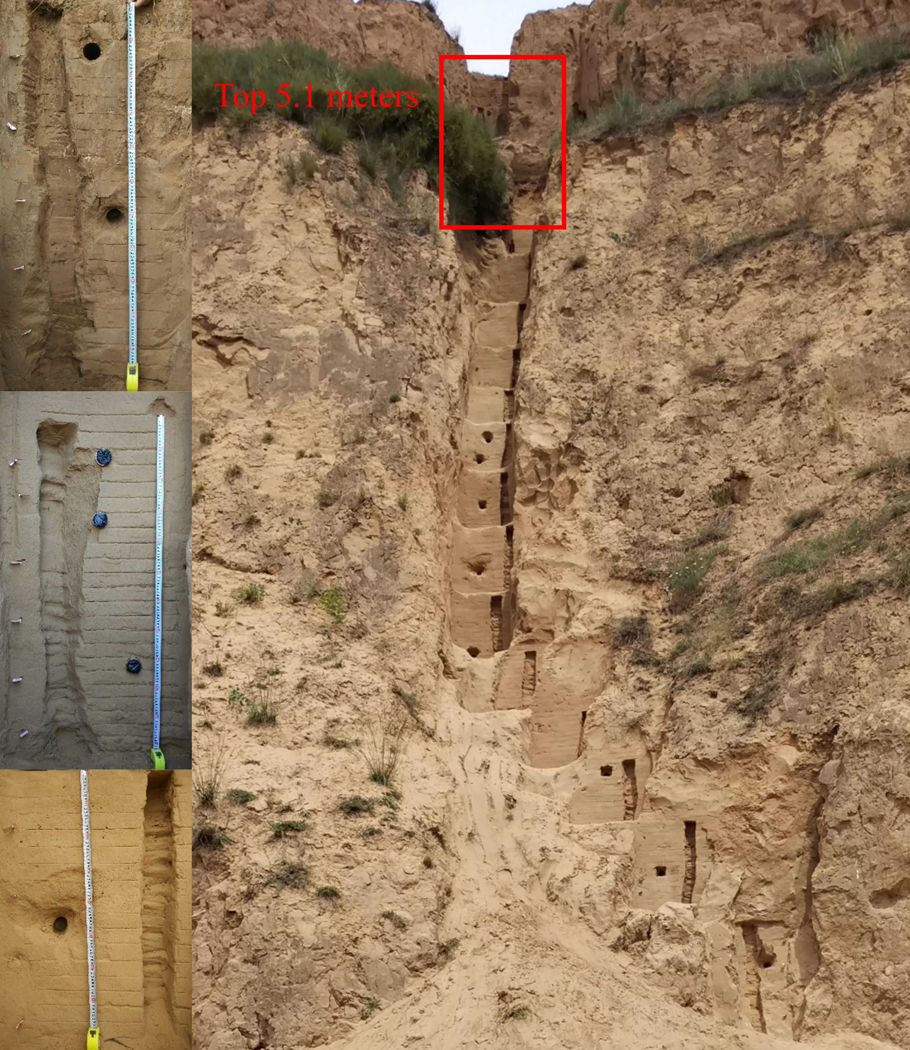

Figure S1 Photo of ZBT section. The whole section has a thickness of 16.8 m and there is a hiatus at 5.1 m. The left is typical pictures of paleosol layer, sandy soil layer, and sand layer.

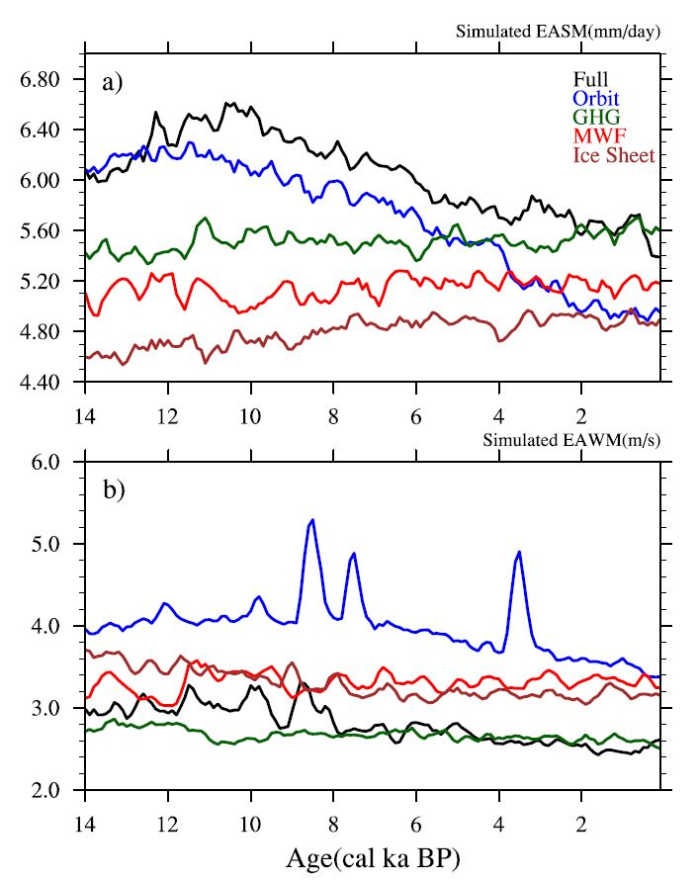
Figure S2 East Asian summer monsoon and winter monsoons in TraCE21K and four single-forcing experiments. The TraCE21 experiment with all forcing (Full, black), insolation forcing (Orbit, blue), greenhouse gases forcing (GHG, dark green), meltwater flux forcing (MWF, red), and ice sheet forcing (Ice Sheet, brown).
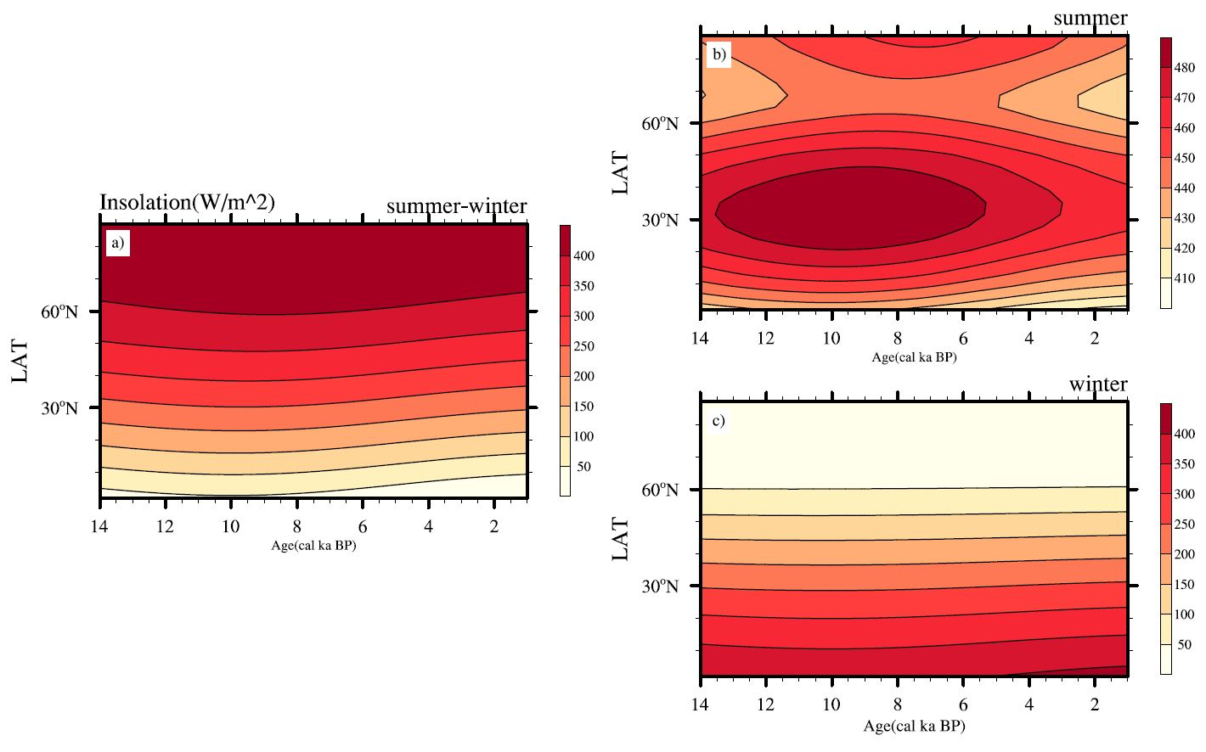
Figure S3 Insolation variations in the Northern Hemisphere during the Holocene. a: summer (June, July, August) minus winter (December, January, February); b: summer; c: winter. The summer insolation slightly decreased, but the winter insolation slightly increased. Therefore, summer cooling and winter warming decrease the seasonality threshold, resulting in the EASM and EAWM decreasing synchronously over the Holocene.

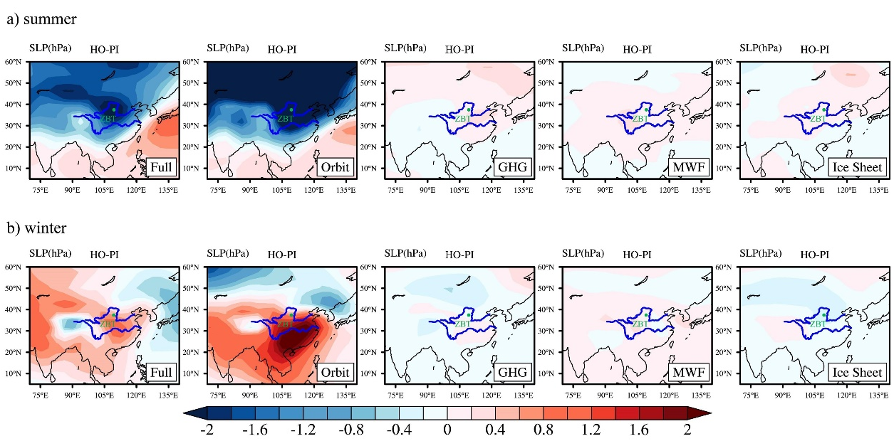
Figure S4 Holocene optimum (7-5 ka, HO) summer (a) and winter (b) sea-level pressure (SLP) minus pre-industrial period (PI) simulated by TraCE21K, with all forcing (Full), insolation forcing (Orbit), greenhouse gas forcing (GHG), meltwater flux forcing (MWF), and ice sheet forcing (Ice Sheet). Insolation-forced sea-level pressure changes lead to both an increased pressure gradient from land to sea and from high latitudes to low latitudes during summer, thus strengthening the EASM, while the effects of other forcings are limited. During winter, orbital forcing increased the land-to-sea pressure gradient, therefore enhancing the EAWM. However, the high-latitude to low-latitude pressure gradient, and the pressure of some crucial areas that are highly sensitive to the EAWM, such as the Siberian High, decreased. Meanwhile, high-latitude forcing, such as the MWF and Ice Sheet, compensates for the pressure decrease and plays an important role in strengthening the EAWM, highlighting both high- and low-latitude forcing on the East Asian monsoon system.

Table S1 AMS ¹⁴C ages and OSL ages of the ZBT loess-paleosol section
AMS ¹⁴C ages of ZBT section |  |  |  |  | OSL ages of the same section (Wu et al., 2019)
Depth (m) | Lab code | ¹⁴C age  (yr BP) | Calibrated age range  (2σ, cal BP) |  | Depth (m) | Quartz age (yr) | pIRIR₂₉₀ age (yr)
 |  |  | min | max
0 | NJU1102 | 1165±19 | 1003 | 1175
0.1 | NJU1103 | -197±21 | 1955# | 1957#
0.2 | NJU1104 | 1687±22 | 1538 | 1690
0.3 | NJU1105 | 1875±23 | 1735 | 1875
0.4 | NJU1106 | 2409±26 | 2352 | 2681
0.5 | NJU1107 | 2418±21 | 2356 | 2680 | 0.55 | 2400±200 | 2900±400
0.6 | NJU1108 | 3261±25 | 3410 | 3565 | 0.65 | 2900±200 | 2200±400
0.7 | NJU1109 | 3243±25 | 3396 | 3560
0.8 | NJU1110 | 3063±24 | 3211 | 3358
0.9 | NJU1111 | 4223±27 | 4651 | 4854
1 | NJU1112 | 4695±27 | 5322 | 5578
1.1 | NJU1113 | 4849±27 | 5486 | 5650 | 1.15 | 3300±200 | 3100±400
1.2 | NJU1114 | 4420±27 | 4872 | 5263
1.3 | NJU1115 | 4391±26 | 4870 | 5040
1.4 | NJU1116 | 5141±25 | 5761 | 5981
1.5 | NJU1117 | 4631±26 | 5306 | 5460
1.6 | NJU1118 | 5341±25 | 6003 | 6263 | 1.65 | 4700±400 | 6400±500
1.7 | NJU1119 | 5395±25 | 6128 | 6283
1.8 | NJU1120 | 5803±30 | 6505 | 6673
1.9 | NJU1121 | 5611±28 | 6312 | 6447
2 | NJU1122 | 5922±29 | 6669 | 6830
2.1 | NJU1123 | 5812±26 | 6507 | 6714
2.2 | NJU1124 | 5152±25 | 5769 | 5989 | 2.25 | 5800±400 | 5500±500
2.3 | NJU1125 | 6332±26 | 7175 | 7319
2.4 | NJU1126 | 6568±27 | 7428 | 7556
2.5 | NJU1127 | 6613±27 | 7443 | 7568
2.6 | NJU1128 | 7119±29 | 7871 | 8015
2.7 | NJU1129 | 7574±28 | 8353 | 8417
2.8 | NJU1130 | 7940±30 | 8643 | 8980 | 2.85 | 14100±1000 | 13600±1400
2.9 | NJU1131 | 8393±32 | 9308 | 9492 | 2.95 | 10600±700 | 9500±500
3 | NJU1132 | 8190±27 | 9031 | 9256
3.1 | NJU1133 | 8755±30 | 9611 | 9896
3.2 | NJU1134 | 8823±31 | 9703 | 10136 | 3.25 | 14200±1500 | 16800±1100
3.3 | NJU1135 | 9340±35 | 10433 | 10668 | 3.35 | 11000±1600 | 12200±500
3.5 | NJU1136 | 8554±35 | 9489 | 9552
3.7 | NJU1137 | 7016±34 | 7762 | 7940
3.9 | NJU1138 | 9807±43 | 11171 | 11276
4.1 | NJU1139 | 10398±45 | 12067 | 12519
4.3 | NJU1140 | 10584±47 | 12424 | 12681
4.5 | NJU1141 | 6631±33 | 7444 | 7576
4.7 | NJU1142 | 9085±40 | 10185 | 10372
4.9 | NJU1143 | 10679±53 | 12562 | 12718 | 4.95 | 14500±1200 | 14600±800
5 | NJU1144 | 11706±52 | 13429 | 13712
5.1 | NJU1145 | 12073±55 | 13766 | 14086
# data calibrated through the post bomb atmospheric NH2 curve (Hua et al., 2013)

References
Hua, Q., M. Barbetti & A. Z. Rakowski., 2013. Atmospheric Radiocarbon for the Period 1950-2010. Radiocarbon 55, 2059-2072. doi: 10.2458/azu_js_rc.v55i2.16177
Wu, J., H. Y. Lu, S. W. Yi, Z. W. Xu, Y. Gu, C. H. Liang, et al., 2019. Establishing a high-resolution luminescence chronology for the Zhenbeitai sand-loess section at Yulin, North-Central China. Quaternary Geochronology 49, 78-84. doi: 10.1016/j.quageo.2018.03.013

