**Implications of the geochemistry of L1LL1 (MIS2) loess in Poland for paleoenvironment and new normalizing values for loess-focused multi-elemental analyses**

**Supplementary figures**

**Fig. S1**. The variability of granulometric composition (divided into individual fractions) at Biały Kościół (A), Złota (B) and Tyszowce (C). The main pedo- and lithostratigraphic units are shown. Legend of lithological markings consistent with Fig. 2.

**Fig. S2**. Shepard's (1954) triangular diagram, based on Wentworth's (1922) classification, for the supplementary research sites.

**Fig. S3**. A-CN-K ternary diagram (Nesbitt and Young, 1984) of the Złota loess-palaeosol samples (after Skurzyński et al., 2020, modified). CaO* (Ca in silicates) was calculated according to McLennan (1993). Dashed lines – CIA values of 65 and 85. Stratigraphical labelling system after Kukla and An (1989), modified by Marković et al. (2008, 2015). U.M.* means “underlying material”.

**Fig. S4**. A-CN-K ternary diagram (Nesbitt and Young, 1984) of the Biały Kościół samples. Only L1LL1 loess is shown. CaO* (Ca in silicates) was calculated according to McLennan (1993). Dashed lines – CIA values of 65 and 85. Stratigraphical labelling system after Kukla and An (1989), modified by Marković et al. (2008, 2015).

**Fig. S5**. A-CN-K ternary diagram (Nesbitt and Young, 1984) of the Tyszowce samples. Only L1LL1 loess is shown. CaO* (Ca in silicates) was calculated according to McLennan (1993). Dashed lines – CIA values of 65 and 85. Stratigraphical labelling system after Kukla and An (1989), modified by Marković et al. (2008, 2015).

**Table S1.** Method detection limits (MDL) and precision (RSD – relative standard deviation) for investigated elements and oxides. RSD was presented separately for each of the four independent measurement series, based on the analysis of the same standard STD SO-19 (Biały Kościół, i.e. BK - 6; Złota, i.e. ZŁ - 5; Tyszowce, i.e. TY - 10; Zaprężyn, Strzyżów, Odonów and Branice, i.e. Z+S+O+B - 3 markings). The RSD value should be understood as the percentage average deviation from the mean value (e.g. 60.40 ± 0.18 means that the standard deviation is ± 0.18% of the mean value of 60.40%). The results are presented in the form obtained from an external laboratory, i.e. major elements and chromium are converted to oxides and expressed in wt%, trace elements and rare earth elements are presented in ppm.

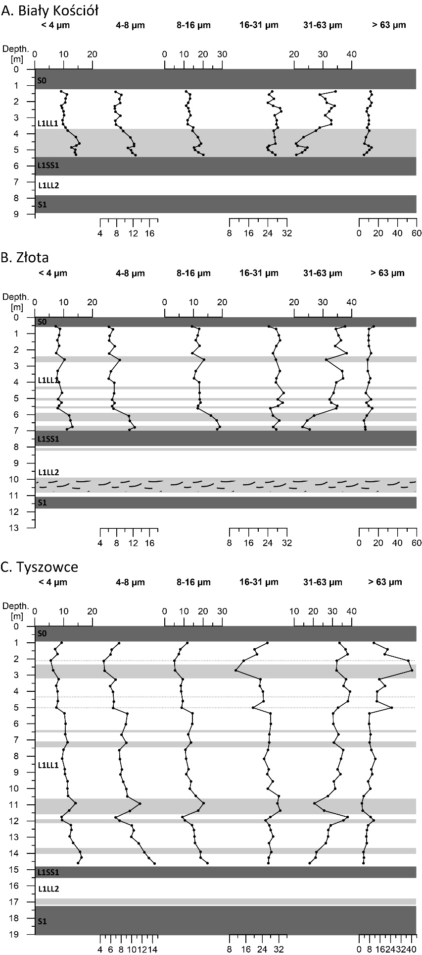

**Fig. S1**. The variability of granulometric composition (divided into individual fractions) at Biały Kościół (A), Złota (B) and Tyszowce (C). The main pedo- and lithostratigraphic units are shown. Legend of lithological markings consistent with Fig. 2.

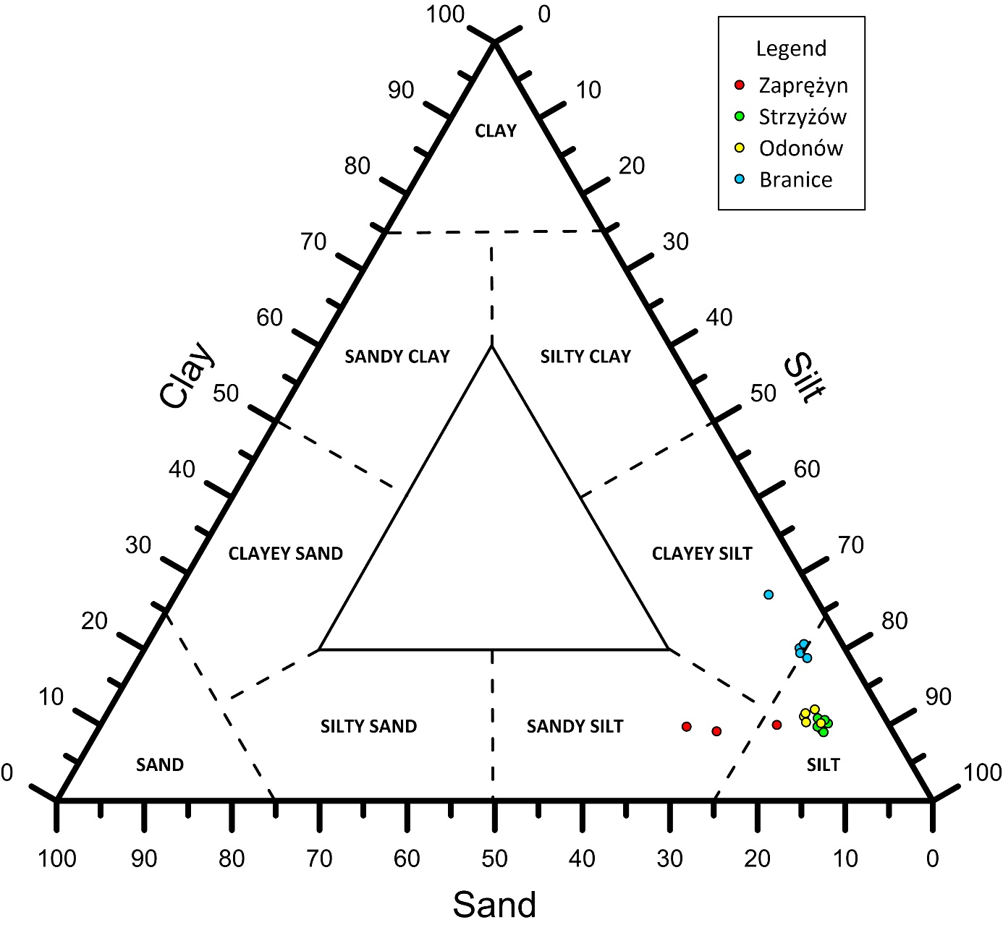

**Fig. S2**. Shepard's (1954) triangular diagram, based on Wentworth's (1922) classification, for the supplementary research sites.



**Fig. S3**. A-CN-K ternary diagram (Nesbitt and Young, 1984) of the Złota loess-palaeosol samples (after Skurzyński et al., 2020, modified). CaO* (Ca in silicates) was calculated according to McLennan (1993). Dashed lines – CIA values of 65 and 85. Stratigraphical labelling system after Kukla and An (1989), modified by Marković et al. (2008, 2015). U.M.* means “underlying material”.



**Fig. S4**. A-CN-K ternary diagram (Nesbitt and Young, 1984) of the Biały Kościół samples. Only L1LL1 loess is shown. CaO* (Ca in silicates) was calculated according to McLennan (1993). Dashed lines – CIA values of 65 and 85. Stratigraphical labelling system after Kukla and An (1989), modified by Marković et al. (2008, 2015).



**Fig. S5**. A-CN-K ternary diagram (Nesbitt and Young, 1984) of the Tyszowce samples. Only L1LL1 loess is shown. CaO* (Ca in silicates) was calculated according to McLennan (1993). Dashed lines – CIA values of 65 and 85. Stratigraphical labelling system after Kukla and An (1989), modified by Marković et al. (2008, 2015).

**Table S1**. Method detection limits (MDL) and precision (RSD – relative standard deviation) for investigated elements and oxides. RSD was presented separately for each of the four independent measurement series, based on the analysis of the same standard STD SO-19 (Biały Kościół, i.e. BK - 6; Złota, i.e. ZŁ - 5; Tyszowce, i.e. TY - 10; Zaprężyn, Strzyżów, Odonów and Branice, i.e. Z+S+O+B - 3 markings). The RSD value should be understood as the percentage average deviation from the mean value (e.g. 60.40 ± 0.18 means that the standard deviation is ± 0.18% of the mean value of 60.40%). The results are presented in the form obtained from an external laboratory, i.e. major elements and chromium are converted to oxides and expressed in wt%, trace elements and rare earth elements are presented in ppm.

